Alireza Limooie

**Geometric Noise Augmentation for Roof Graph Reconstruction**

Date: 14/07/2025

horizontal line

**1. Objective & Background**

Following the successful implementation of the cumulative, threshold-based noise model detailed in the previous report, the primary objective of this work period was twofold:

1. To further enhance the geometric augmentation pipeline, bringing its output to a state of near-parity with real-world detector data.
2. To train and evaluate the reconstruction model on this new, more challenging and realistic data, identifying new performance benchmarks and challenges.

This report details the significant advancements made in data augmentation and analyzes the model's current performance, highlighting the re-emergence of specific training challenges that require a refined approach to our loss function strategy.

**2. Advancements in Geometric Augmentation**

The data augmentation system has been significantly upgraded to more accurately simulate the complex and correlated errors produced by automated line detectors. The goal was to move beyond simple topological changes and introduce more nuanced geometric distortions. The new augmentations, built upon the existing cumulative framework, include:

* **Correlated Coordinate Noise:** The magnitude of random Gaussian noise and parallel shift noise applied to edge coordinates is now directly proportional to the edge's effective_noise level. This creates a highly realistic scenario where edges that are topologically damaged (e.g., at risk of deletion or subdivision) are also the most geometrically inaccurate.
* **Dynamic Structural Changes:** The subdivision and duplication augmentations are now more varied. An edge marked for subdivision can be broken into a random number of segments (e.g., 2 to 4), and duplicated edges are created with a wider range of random perpendicular offsets.
* **Confidence Score as a Feature:** The effective_noise level for each edge is inverted (1.0 - noise) to create a "confidence score." This score is now fed directly into the model as an input feature, giving it explicit information about the likely quality of each input segment.

These enhancements have produced a training dataset that is a far more rigorous and representative proxy for the messy, unpredictable data we encounter from real-world systems. The model is no longer learning from cleanly delineated problems but from a complex mixture of geometric and topological errors.

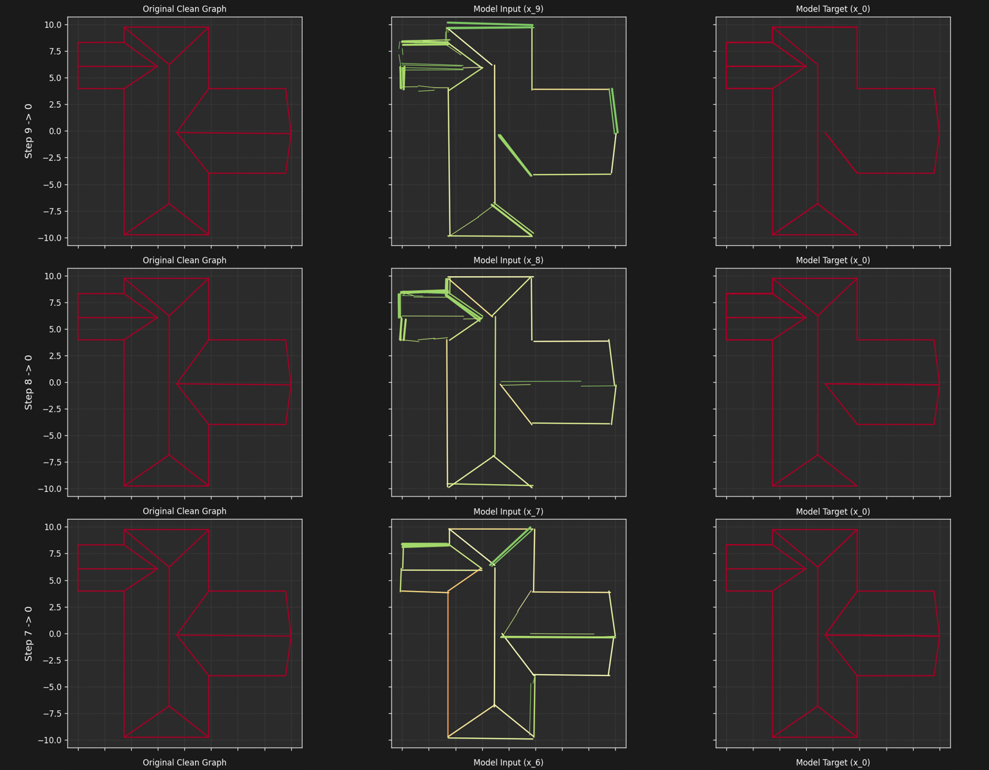

augmented data sample

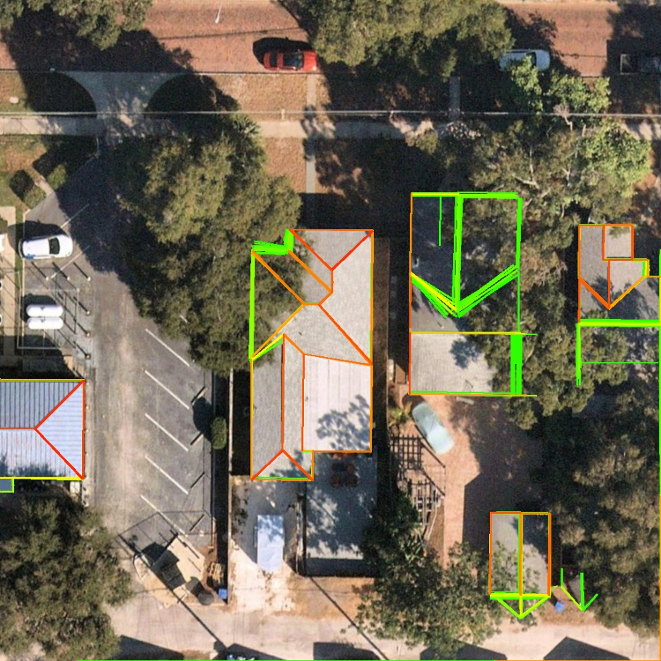

real data sample

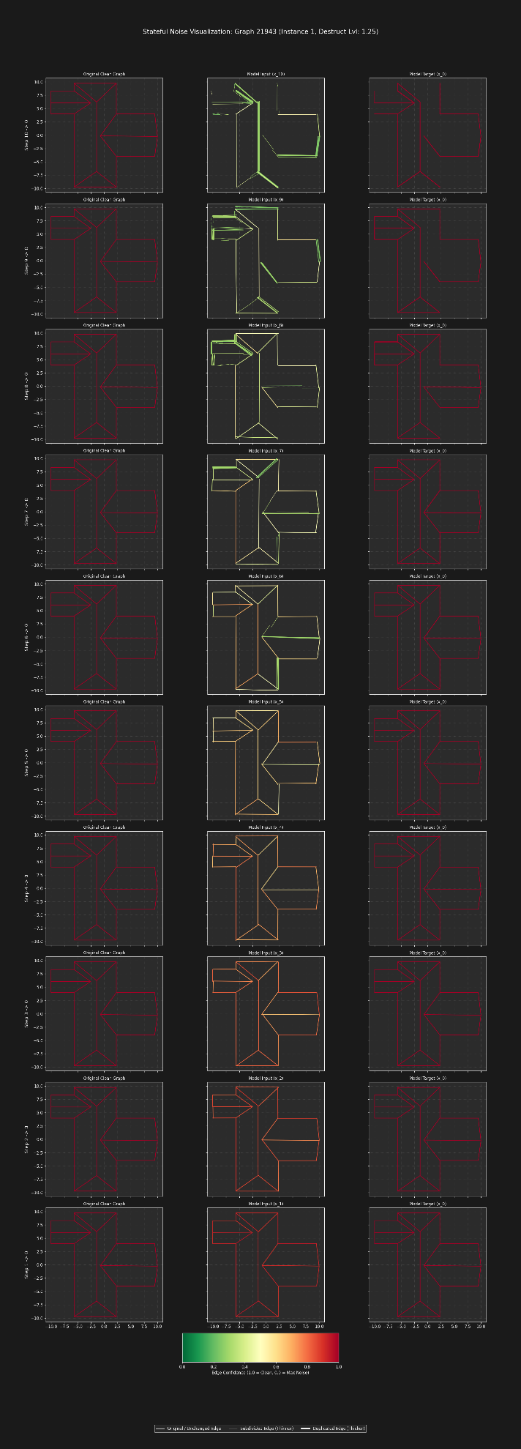

**3. Model Performance & Current Challenges**

Training has commenced on the new, high-fidelity augmented data. While the reconstruction quality shows promise, the increased difficulty has resurfaced challenges related to loss function stability, particularly with the connectivity loss.

* **The Instability of Connectivity Loss:**   
  The connectivity loss is designed to enforce structural integrity by pulling the endpoints of connected segments together. With the previous, simpler data, this loss was relatively stable. However, on the new, more complex data, we observe a significant regression:
  + **Previous Behavior (Mitigated):** In early prototypes, the connectivity loss would cause the entire graph to collapse into a single point, achieving a perfect connectivity score at the cost of zero geometric accuracy.

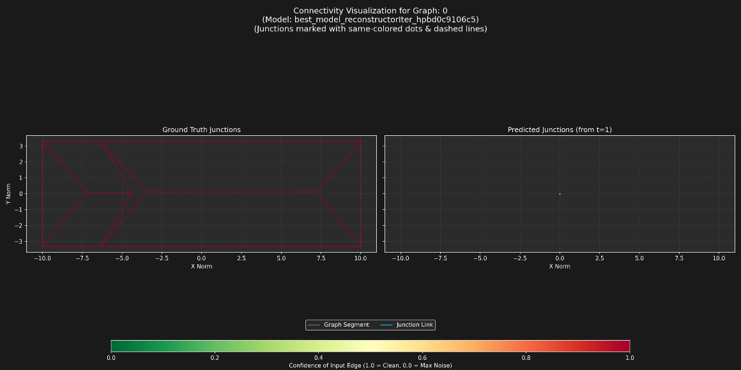

* + **Current Behavior (New Challenge):** The model no longer collapses the graph to a single point. However, it has found a new, undesirable local minimum. The connectivity loss aggressively **shrinks the overall scale of the graph**, pulling all connected points towards the graph's centroid. This results in topologically connected but geometrically compressed and inaccurate reconstructions, as seen in Figure 2.

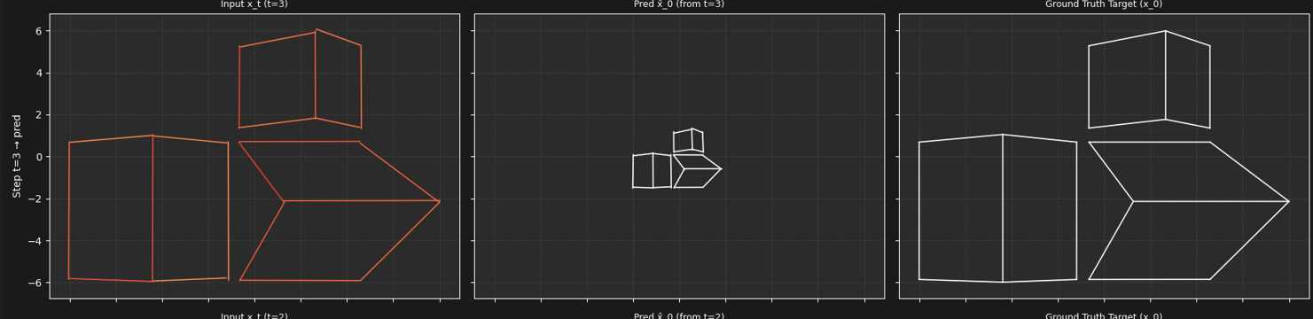

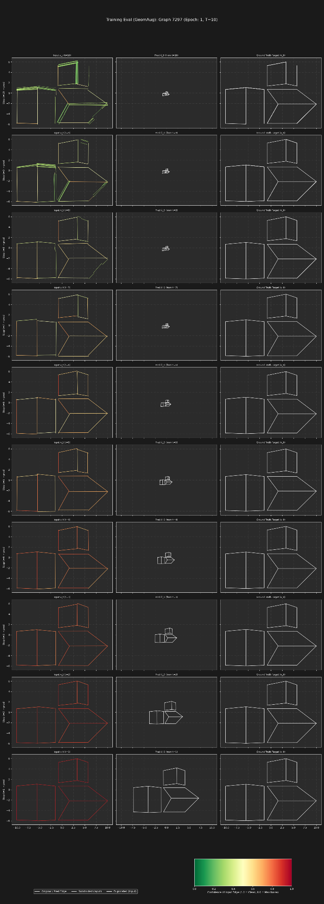

* **Potential Friction Between Loss Components:**   
  A key area of investigation is the potential for friction between the reconstruction and connectivity losses. The two objectives may be creating a conflict: the reconstruction loss attempts to move coordinates to their correct absolute positions, while the aggressive connectivity loss pulls them inward toward the graph's center. This potential antagonism is a likely explanation for the model's difficulty in converging, possibly causing the total loss to fluctuate or plateau at a high value.

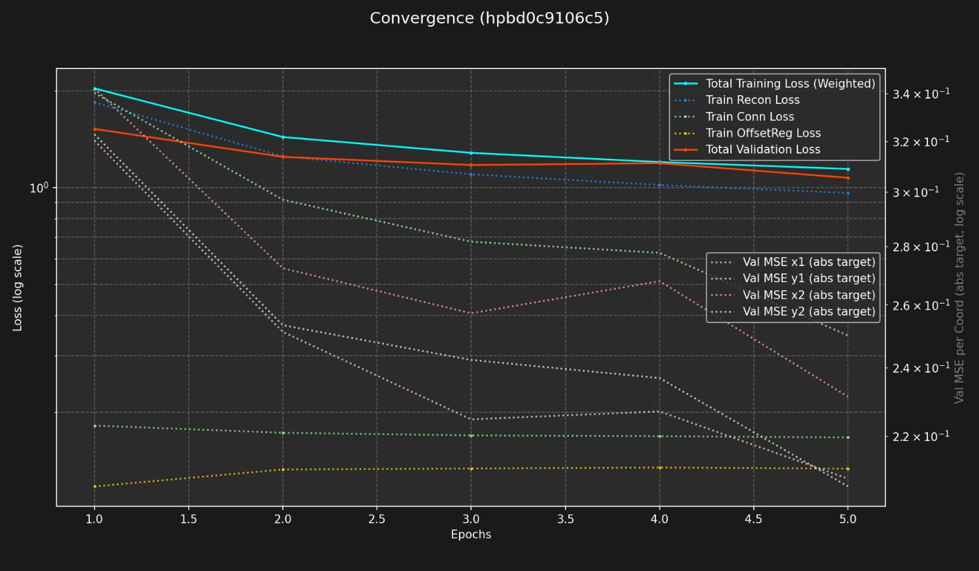

loss curve of model using both reconstruction and connectivity losses

**4. Future Work & Next Steps**

The primary focus is now on resolving the loss function instability to unlock the model's potential on this superior dataset.

1. **Establish a Reconstruction Baseline:** An experiment is currently underway to train the model using **only the reconstruction loss**. This will allow us to evaluate its ability to handle the new geometric and topological noise without the confounding influence of the connectivity loss. We will let this run for a significant number of epochs to establish a firm performance baseline.

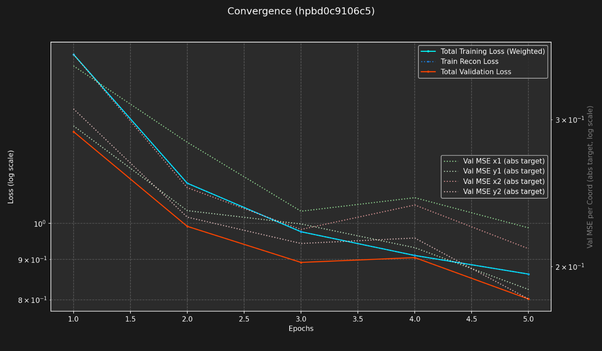 loss curve of model using only the reconstruction loss

1. **Stabilize Connectivity Loss:** The immediate next step is to make the connectivity loss usable. Several strategies will be explored:
   * **Loss Weight Annealing:** Introduce the connectivity loss gradually, starting with a weight of zero and slowly increasing it over the course of training. This may allow the model to first learn the general geometry before enforcing strict connectivity.
   * **Loss Formulation Redesign:** Modify the loss from a squared distance (L2) to a formulation less sensitive to large distances, such as Log-Cosh or a capped L1 loss. This should reduce the aggressive "pulling" effect on distant points.
   * **Introduce a Scale-Invariant Regularizer:** Add a new loss term that penalizes the model for reducing the overall size or total edge length of the graph, directly counteracting the shrinking effect.
2. **Phased Training:** Explore a multi-stage training regimen. The model could be trained for a set number of epochs with only the reconstruction loss, then "unfrozen" and fine-tuned with a stable version of the connectivity loss. This would allow the model to learn coarse geometry first, followed by fine-grained structural refinement.