Alireza Limooie

**Roof Graph Edge Classification Progress Report**

Date: 24/04/2025

horizontal line

**1. Introduction**

This report outlines the progress made on the project focused on classifying lines within roof structure plans. The primary objective is to automatically categorize lines derived from top-down roof views into six distinct types: Eave, Flashing, Hip, Rack, Ridge, and Valley. Recent activities have centered on developing and training an advanced analytical model, implementing effective data preparation techniques including generating variations, addressing the challenge of infrequent categories within the data, and refining the overall system. Key accomplishments include the successful setup of the core model, the application of data variation and category weighting methods to enhance learning and manage data imbalances, and the achievement of positive initial results on test data.

**2. Model Overview**

The core of the classification system is an analytical model specifically designed to process sequences of lines representing a roof structure.

* **Functionality:** The model examines a set of defined characteristics for each line (such as its length, angle, and standardized position) and analyzes the relationships between lines within the context of the complete roof structure.
* **Input:** It utilizes a predefined set of 16 calculated characteristics for each roof line. These details are determined after standardizing the orientation and scale of the lines based on the overall roof plan.
* **Output:** Based on its analysis, the model assigns each line to one of the six predefined categories.

**3. Data Preparation and Enhancement**

A comprehensive data preparation process is employed to ensure the roof plan data is suitable for the model:

* **Source Data:** The process begins with files containing the line coordinates and their correct classifications for numerous roof plans.
* **Standardization:** Line data is standardized for consistency. This includes establishing a uniform orientation for line endpoints and scaling coordinates relative to the dimensions of each roof plan.
* **Characteristic Calculation:** Key characteristics are calculated for each standardized line.
* **Data Variation (Augmentation):** To improve the model's ability to handle variations found in real-world data, slightly modified versions of the original roof plans are generated (e.g., by introducing minor variations to line positions). This enhances the model's robustness.
* **Final Structuring:** The prepared data, including original and varied examples, is organized into a format suitable for model training.

**4. Addressing Data Imbalance**

The dataset contains a noticeable imbalance, with some roof part categories (particularly 'Flashing') appearing much less frequently than others.

* **Mitigation Strategy:** To ensure the model gives adequate attention to these less common categories, a weighting technique was applied during the training phase. This method adjusts the model's focus, giving greater importance to correctly classifying the underrepresented categories without disproportionately skewing the results.

**5. Model Training and Performance Evaluation**

The analytical model was trained using the prepared dataset.

* **Training Data:** The model learned from a substantial dataset consisting of tens of thousands of roof plan examples (including the generated variations). Performance was monitored using a separate validation set.
* **Training Process:** The training involved multiple cycles to allow the model to learn and refine its classifications. The category weighting strategy was active throughout.
* **Evaluation:** The final model was evaluated on a distinct test set containing nearly 1,000 previously unseen roof plans.
* **Results:**
  + The model achieved a final **Overall Accuracy of 93.6%** on the test set.
  + Performance for the more common roof line categories (Eave, Hip, Rack, Ridge, Valley) was consistently high, with individual scores generally exceeding 90%.
  + The model encountered more difficulty with the rare **'Flashing'** category, achieving a lower performance score for this specific type compared to the others. This indicates a need for further refinement in identifying this category accurately.
  + Despite the challenge with 'Flashing', the overall weighted performance across all categories remains strong.

**Table 1: Training Report**

| **Number of trainable parameters** | **Model Size** | **Number of Training graphs** | **Number of Validation graphs** | **Number of Training Epochs** | **Training Time** |
| --- | --- | --- | --- | --- | --- |
| **18,927,122** | **82.0 MB** | **49438** | **8724** | **100** | **231.76 minutes** |

**Table 2: Final Test Set Performance Summary**

| **Metric** | **Score** | **Notes** |
| --- | --- | --- |
| **Overall Accuracy** | 93.6% | Percentage of all lines correctly classified |
| **Weighted Average Score** | 94% | Overall score considering category frequency |
| **Individual Class Scores** |  | (Approximate performance indication) |
| Eave | ~95% |  |
| Flashing | ~56% | Lower performance, indicating area for improvement |
| Hip | ~96% |  |
| Rack | ~92% |  |
| Ridge | ~95% |  |
| Valley | ~93% |  |

some samples:

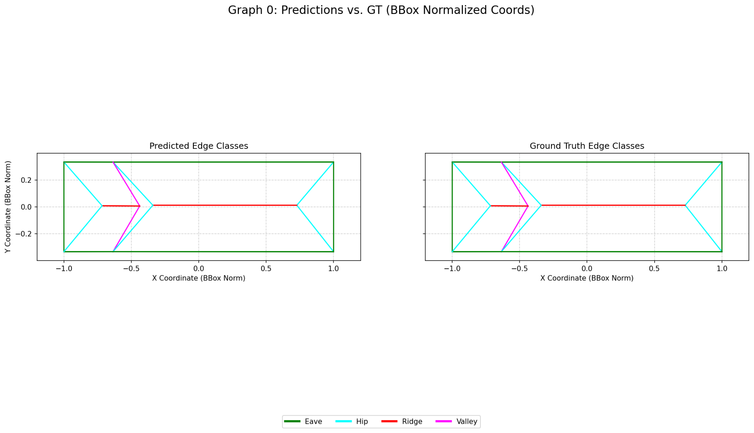

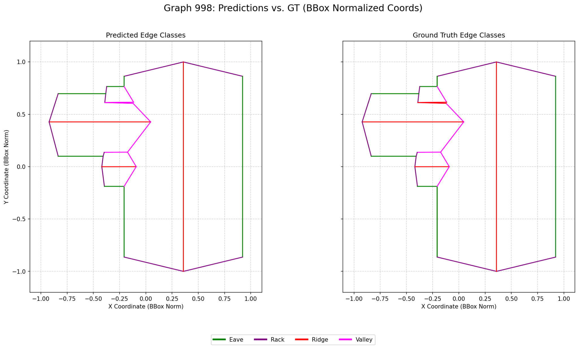

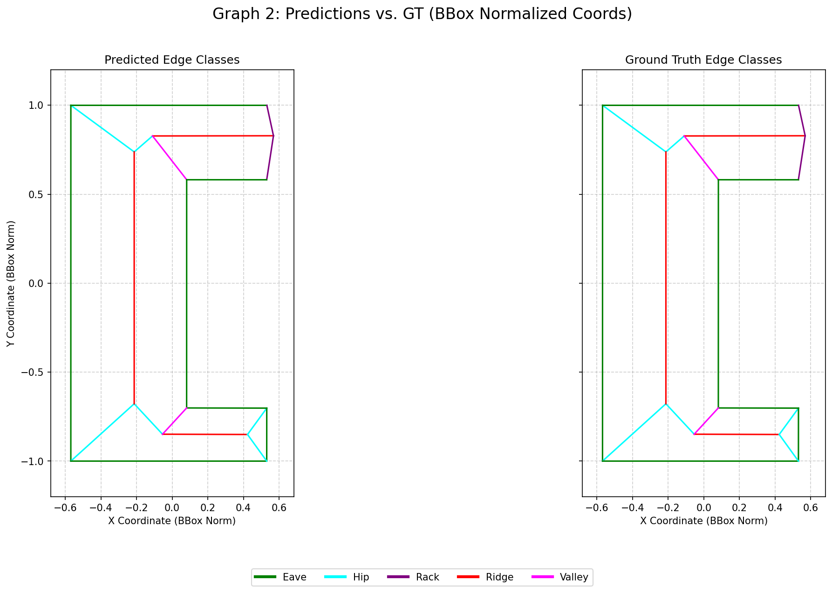

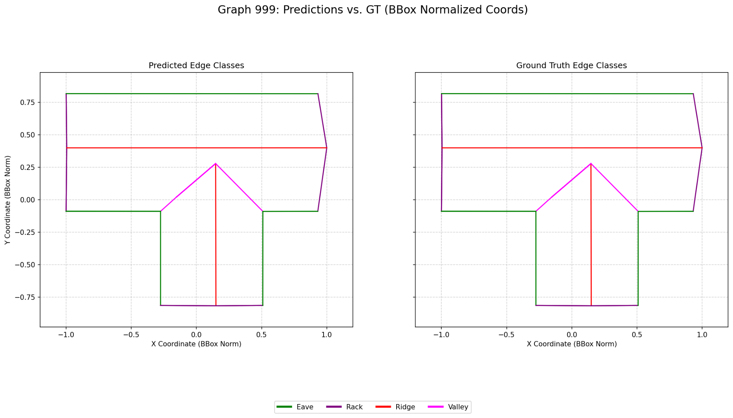

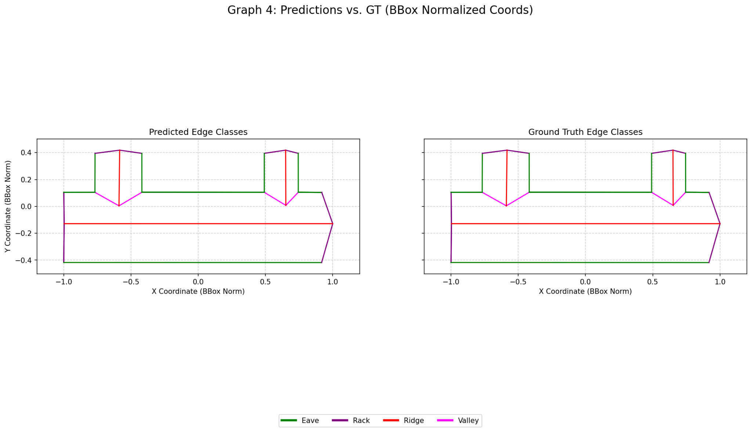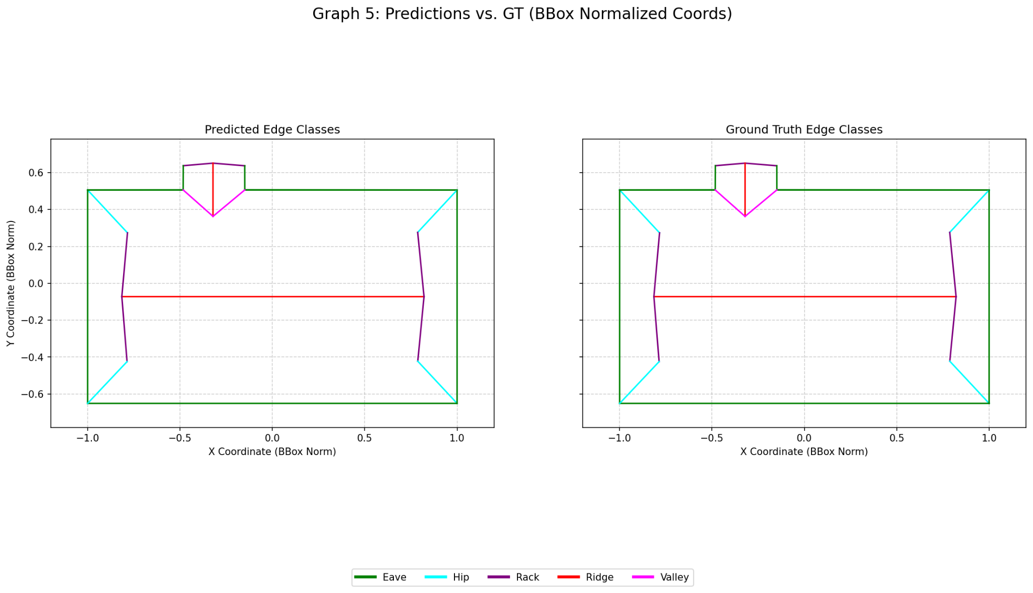

**6. Future Work**

The next phase of work will focus on the following areas:

* **Optimize Model Settings:** Systematically explore different configuration settings to potentially enhance overall performance.
* **Improve 'Flashing' Classification:** Investigate and implement techniques specifically aimed at improving the identification of the 'Flashing' category. This may include alternative methods for handling data imbalance or targeted data generation strategies.
* **Refine Data Variation Methods:** Experiment with different approaches to generating varied data to further improve model robustness.

**Conclusion**

Significant progress has been achieved in developing the automated system for classifying roof structure lines. The current model, supported by effective data preparation and techniques to address category imbalance, demonstrates high overall accuracy (93.6%) on test data. Performance on common line types is strong. The primary remaining challenge is enhancing the model's ability to accurately identify the infrequent 'Flashing' category. Future efforts will prioritize refining the model and specifically addressing this challenge to improve performance on all categories.