An analysis of 2 methods of stock market valuation and Report on the Valuation of S&P 500 and FTSE 100

Name: Sambit Kumar Samanta Student Id: ss4083
Person Id: H00508467 Advanced Valuation of Financial Markets
Coursework I
Words: 2180

Contents

Introduction: Price vs Value |  | 3
Section 1: Methods of Stock Valuation |  | 3
 | The Superior Ratio: The Q Ratio | 3
 | Why Q is the best measure? | 3
 | Challenges | 5
 | The Inferior Ratio: Yield Ratios and Yield Differences | 5
 | Why Yield Ratios and Yield Differences are the worst measure? | 5
 | Evidence | 5
Section 2: Current Valuation of US and UK Stock Markets |  | 6
 | US Stock Market Valuation | 6
 | Factors Driving S&P 500 returns | 9
 | UK Stock Market Valuation | 10
 | Factors Driving FTSE 100 returns | 12
 | Investment Outlook and Risks | 13
Conclusion |  | 14
References |  | 15

Introduction: Price vs Value
Financial markets move constantly with price fluctuations. Efficient Market Hypothesis suggests that price and value of a business are identical as all known information is immediately absorbed and reflected in the market however, prices are driven by liquidity, market sentiment and short term macro-economic surprises (Shiller, 2015). Value on the contrary reflects the economic worth of the business. Prices can deviate from the value of the business however history shows that prices eventually move towards long term average.
The report examines two ways of valuing stock markets and identifies strengths and weaknesses in valuation methods and applies the valuation methods to the US and UK stock markets and evaluates how S&P500 and FTSE100 are valued and how a fund manager might position themselves today based on the valuation, risk and long-term performance.

Section 1: Methods of Stock Valuation
The Superior Ratio: The Q Ratio
The Q ratio is defined as the ratio of the market value of companies to the replacement cost of their assets estimating if a company is overvalued, undervalued or fairly valued. Equilibrium occurs when market value equals replacement cost (Tobin, 1969; Tobin and Brainard, 1977).
Why Q is the best measure?
- Stability- Corporate Earnings or dividends are highly volatile and can be distorted by cyclical forces. Corporate profits fluctuate macroeconomic conditions but the replacement cost of assets rises slowly and steadily under normal circumstances making Q less sensitive to short term fluctuations (Wright et al., 2004; Smithers, 2025).
- Mean Reversion- The tendency of Q to revert back to its mean gives it the power of prediction. If returns were random walk, then it would be unpredictable and the risk of holding stocks would grow indefinitely. Because Q tends to revert to its mean, it is possible to value over long term and determine whether the market is overvalued or undervalued.
- Arbitrage - market value cannot permanently exceed replacement cost. If Q is above 1, buying assets through the stock market is expensive than building them directly. This triggers new supply through IPO thus increasing supply and forcing returns down and prices back towards its long-term mean. When the Q is below 1, acquiring existing firms becomes cheaper than building new ones encouraging mergers, acquisitions and restructuring. This “build vs buy” mechanism ensures that extreme deviations in Q are temporary.

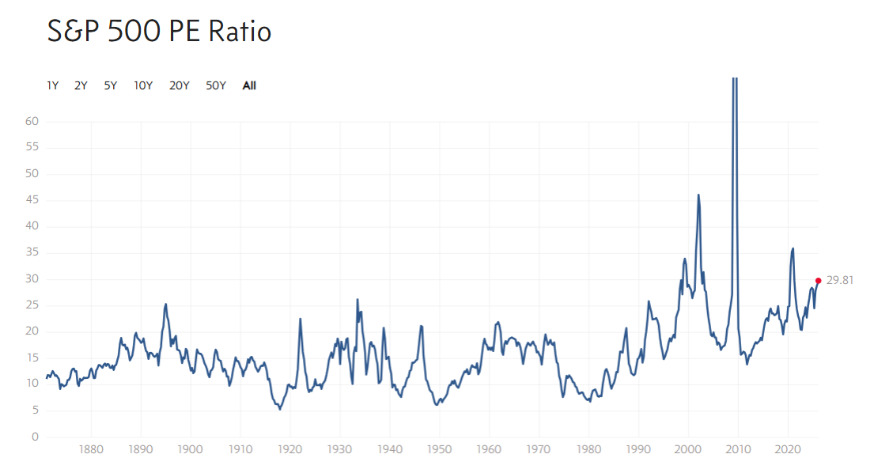
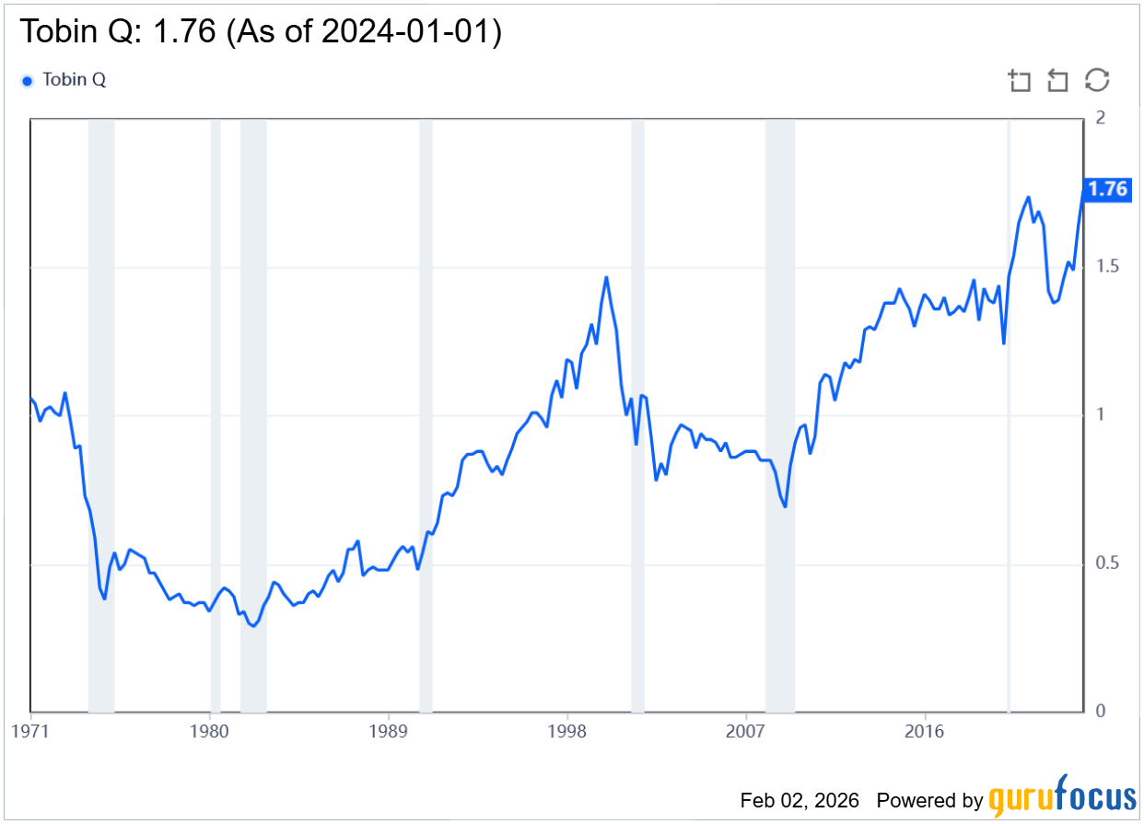
Q Ratio of S&P 500

During the global financial crisis in early 2009, corporate earnings failed massively resulting in P/E ratio of S&P 500 going over 100x. An investor looking only at the PE ratio would conclude that stocks are very expensive and may sell them. At this very moment, the Q ratio was 0.66. Q ratio predicted that market was undervalued. This happens because Q ignores temporary earnings spike and looks at the assets. Tobin’s Q remains stable because the “replacement cost” of a factory does not drop to zero just because the factory had a bad year.
Challenges
Q ratio suffers from the problem of measurability. Calculating replacement cost requires high quality national accounts like US Federal’s reserve Z1 report however other markets often lack or have imperfect data and have difficulty accounting for inflation on assets (Federal Reserve, 2025). Critics also argue that Q does not account for intangibles (Corrado et al., 2009; GMO, 2025). Today companies like Nvidia and Microsoft derive value from intangibles whose replacement cost is difficult to determine which raises the ‘neutral´ Q. Q may provide imperfect result during period of rapid economic change like rapid inflation.
The Inferior Ratio: Yield Ratios and Yield Differences
Yield Ratios and Yield Differences (often called the Bond Yield Ratio) are considered the one of the worst methods of valuation as they fail all the 5 key tests as a measure of value (Asness, 2003).
Why Yield Ratios and Yield Differences are the worst measure?
- No Mean Reversion- Historical data shows that bond yields do not return to a stable average because bond yields fluctuate wildly with inflation, the ratio drift indefinitely. As the ratio does not mean revert, it cannot satisfy the condition of prediction.
- Inflation Illusion- The model is considered a bad measure as it fails to distinguish between nominal assets (bonds) to real assets (stocks). Bonds provides a fixed nominal income that is destroyed by inflation whereas stocks are right to physical assets where dividends and earnings grow with inflation and that serve as a long-term hedge against inflation. This leads to an illusion that stocks are more attractive during low inflation due to lower discount rate but ignore the fact that falling inflation also lowers future nominal growth of dividends thus cancelling out any gain (Asness, 2003).

Evidence
During the global financial crisis, the Fed model failed to warn investors of the impending crash, while Tobin’s Q signalled that the market was dangerously overvalued. In 2007, during the pre-crash peak, the 10-year treasury yield was around 4.5%-5% while the S&P 500 earning yield was close to 5.5%. This means that the stock yields were slightly higher than the bond yields indicating the Fed model would predict stocks to be fairly valued or even cheap relative to bonds. During this time, the Q ratio was slightly above 1 which is higher than the historical average of 0.7.

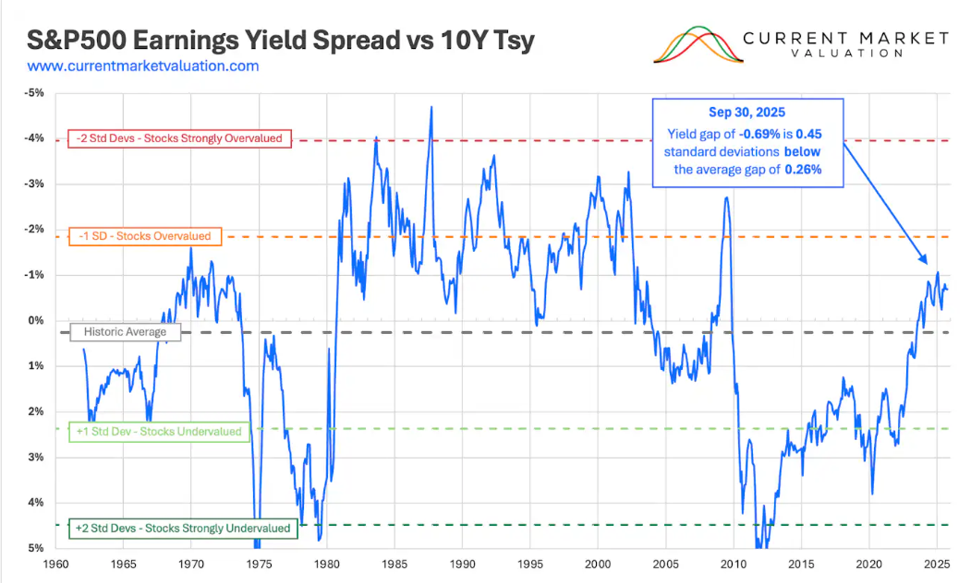
The weaknesses of Fed model make it an unreliable predictor for modern, policy influenced financial markets. Unfortunately, they are often used by stock brokers to artificially produce optimistic predictions to sell shares.
Section 2: Current Valuation of US and UK Stock Markets
US Stock Market Valuation
The US stock market is currently considered to be overvalued as per Q ratio at 1.76 above the historical average of 0.84. Shiller’s P/E (cyclically adjusted price to earnings) is 40.32 (3.69 using natural logs) compared to the historical average of 17.33 (2.89 using natural logs).
The valuation shows that US is highly overvalued similar to the dot com bubble of 2000s and its subsequent crash. However as per interview head of U.S. equity strategy at Bank of America, AI led stock market is still stable and not in bubble territory yet (Axios, 2025). In another interview to the Wall Street Journal, the head chief global equity strategist at Goldman Sachs observed that we are not in an AI bubble yet as AI companies are still profitable and cash rich (The Wall Street Journal, 2024).
An analysis of past crashes reveal that crashes often happened when the weekly close (chart limitations) of S&P 500 fell below the 200-day moving average and fails to move back. An analysis of the current S&P 500 reveals that closing levels are still above the 200-day moving average.
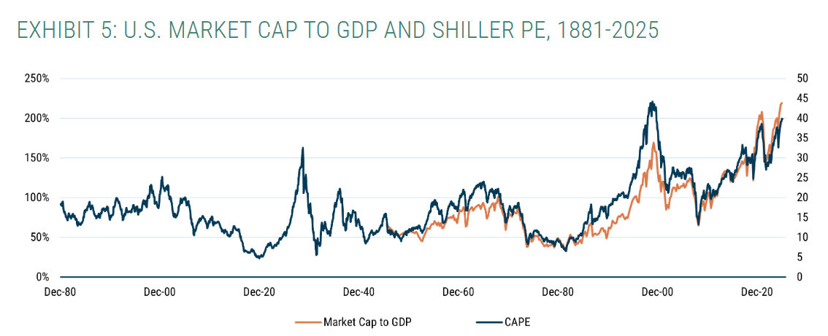
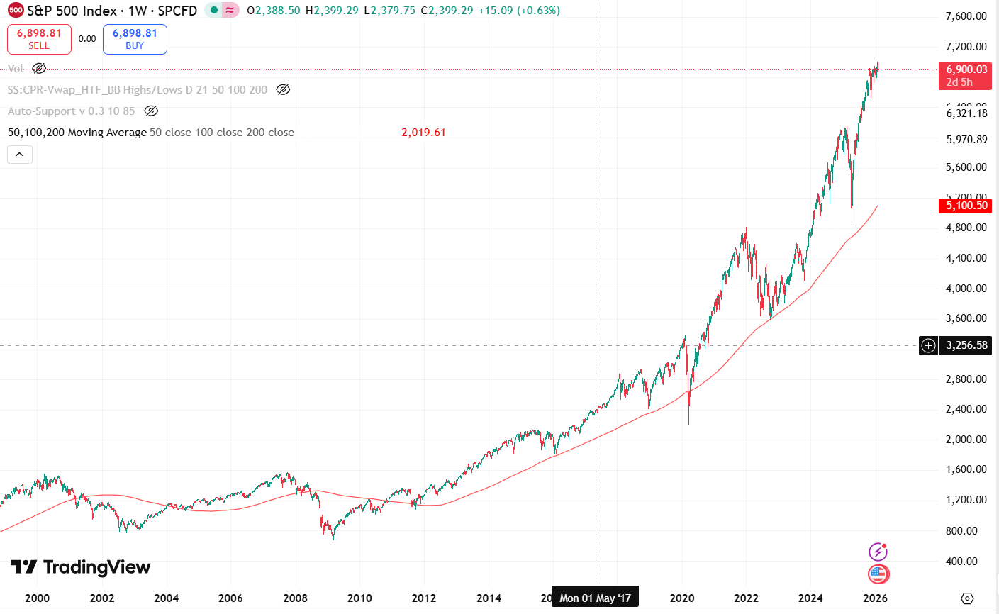

Past financial crashes also reveal that crashes happened during moments of increasing BBB 10-year treasury spreads. As shaded in the graph below, crashes generally show very high levels of spread generally above 2% (dot com crash) and reaching as high as 7.84% (global financial crash). The current spread at 0.94% indicates confidence in corporate credit and overall easy financial conditions.

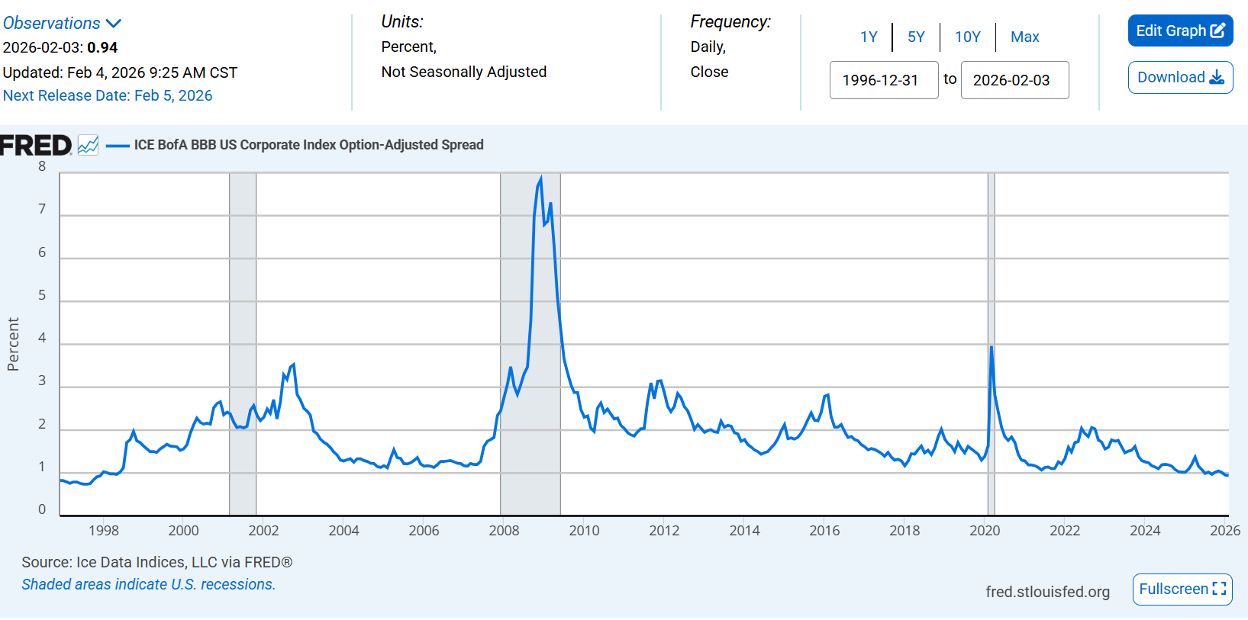
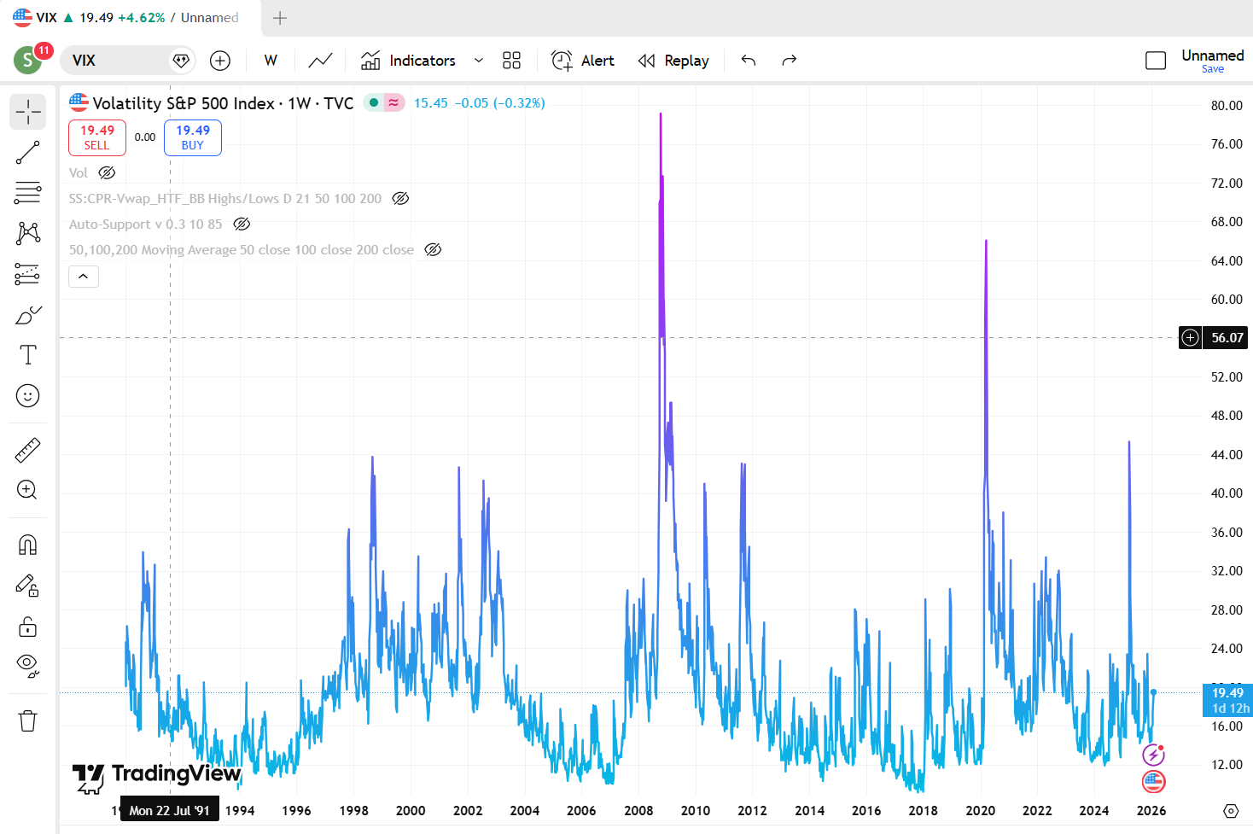
The S&P 500 CBOE Volatility Index which measures the market sentiment and perceived risk in the market over a 30-day period. Historically, values, below 20 are considered stable whereas values above 30 are considered highly risky. All major crashes, since the development of the index recorded high levels of VIX which might allow us to predict a market crash in the current US market.

The current VIX level is at 19.6 (approximate) which places it the stable category. However, in the current market scenario which is highly overvalued as per Q ratio, volatility level above 30 will indicate extreme market volatility and trigger a massive sale of the overvalued stocks especially that of the magnificent 7.
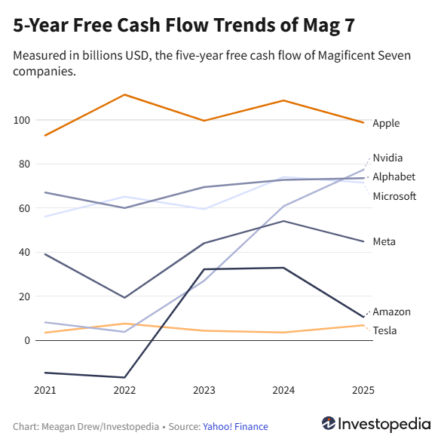
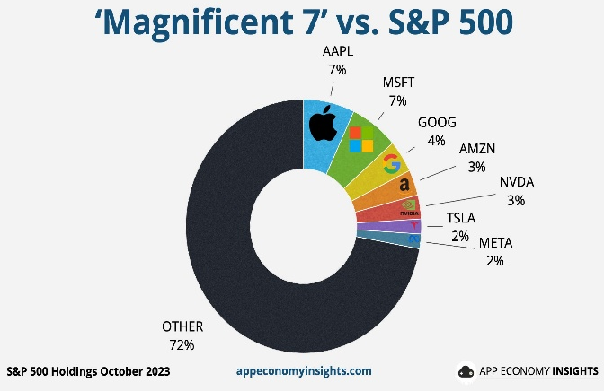

28% of the current US market is dominated by 7 stocks known as the magnificent 7. This makes the market more susceptible to changes in these companies. The growth is primarily driven by Nvidia due to demand for its semiconductor chips due to the AI demand. 4 of 7 companies spent $400 billion on CAPEX took on 108 billion in debt 2025 driving 90% of capex, 80% of earnings growth since the launch of ChatGPT (Bloomberg News, 2025).
Factors Driving S&P 500 returns
- AI and Tech Dominance easing- S&P 500 is currently being driven by AI and tech sector however their influence is easing. Mag 7 contributed 63% of returns in 2023 but now contribute around 43% in 2025. Profit growth is also widening in sectors like financials, utilities materials.
- Resilient market despite Volatility- even though volatility increased over the past 2 years to 19.6, it is still below long-term average of 20.2 indicating resilient markets.
- Bond Yield Stability- US 10 Year treasury yields have mostly remained stable. With stronger growth expectation primarily driven by AI boom, stock returns are expected to rise.
- Earnings driven Growth- An increasing share of earnings-based growth reduces chances of a bubble forming and aligns price appreciation with corporate performance making future returns more predictable and less sentiment driven. This means that the market is resting more on fundamental strength and not just optimistic sentiment.
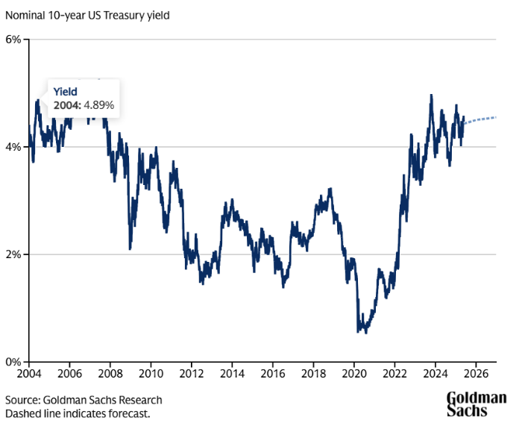
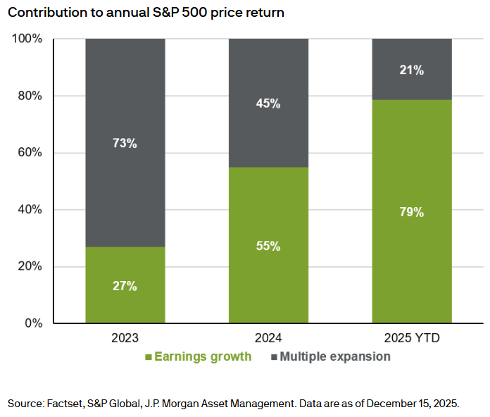
- Interest Rates- Fed rate cuts lower discount rates leading to higher valuations leading to higher S&P 500 returns.

UK Stock Market Valuation
The UK stock market does not have publicly available data to calculate Q. Hence, we will use Price to Fair Value by Morningstar is selected as closest available valuation proxy (Morningstar, 2025).
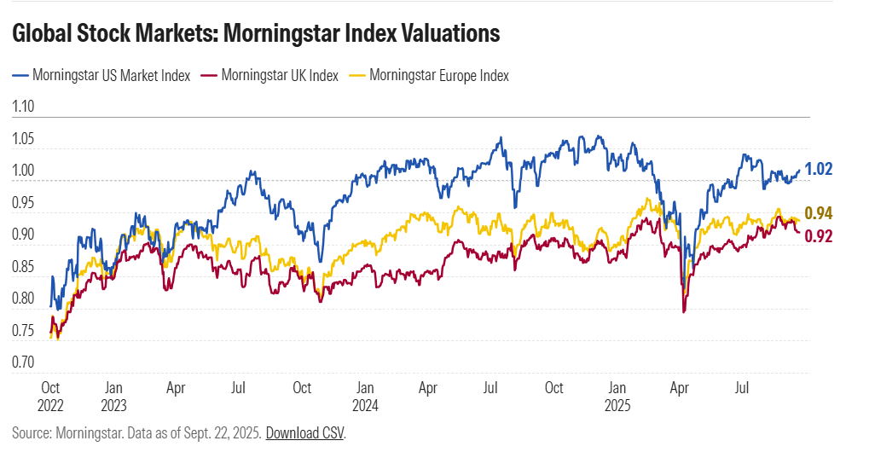
The UK stock market is undervalued at 0.92 making UK market attractive than the US market due to steep valuations in the US market. The buffer indicator calls the measure as fairly valued.
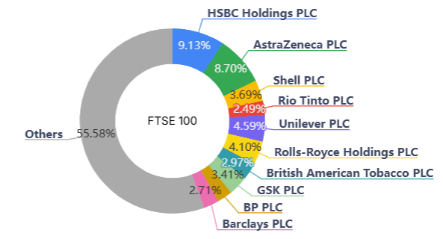
Market breadth analysis shows that market is dominated by financials, commodities and consumer staples rather than tech dominance in the USA with FTSE 100’s returns just as varied across sectors.
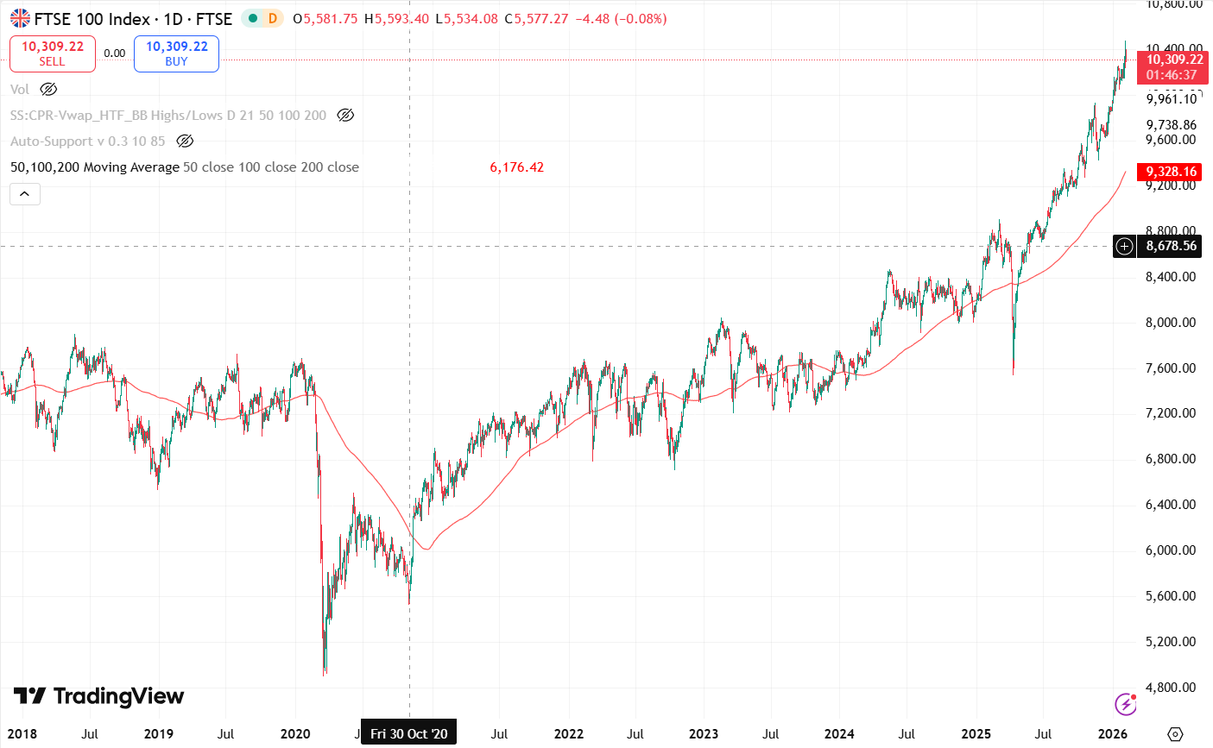
FTSE is above the 200-day moving average signalling for further upward movement. Furthermore, the P/E ratio is 14.87 and CAPE Ratio is 20.19 which is close to their average P/E ratio of 15.67 and CAPE of 17 indicating that FTSE is fairly valued.

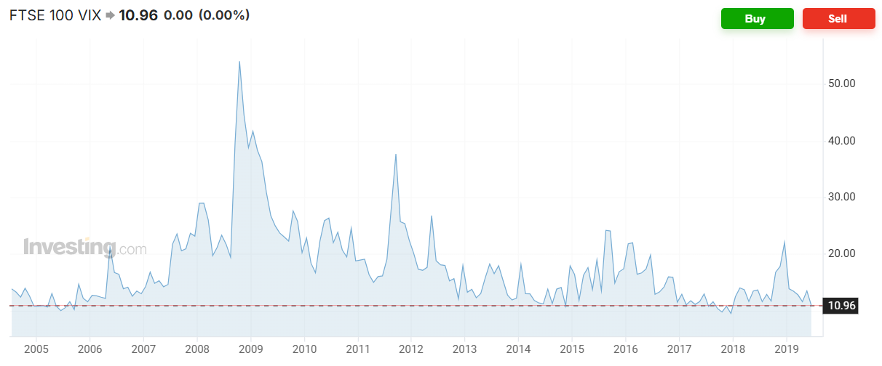
The volatility of the index is at 10.96 which is close to its mean indicating stable markets and no current market stress. Moreover, the market valuation reveals the FTSE to be undervalued which indicates a higher potential for growth.

The 10‑year gilt yield is currently 4.566%. Despite this relatively high risk‑free rate, the FTSE still appears undervalued versus its long‑run P/E and CAPE averages. However, any further rise in gilt yields would put additional downward pressure on equity valuations.
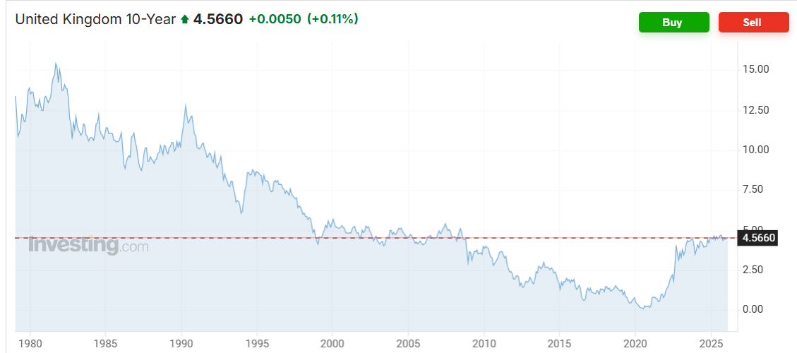
Factors Driving FTSE 100 returns
- Sector Composition- FTSE 100 is heavily weighted to ‘Old Economy’ stocks which deal in energy, mining and financials rather than technology, so it relies less on multiple expansion. Therefore, its valuation has remained low compared to the US stock market.
- Interest Rates- Expectations of changes in interest rates affect discount rates which affect valuations. Rate cuts will increase valuations which affect FTSE performance.
- Exchange Rate- Most FTSE constituents earn a large share of revenues overseas, so a weaken pound benefits exporters which often increases earnings and often share prices.
- Value Market status- FTSE is seen as a haven for value stocks. As the index trades at a discount compared to US and European markets, it attracts high dividend and value-based investors.
- Commodity Prices- Strong performance in precious metals, defence and financial sectors due to geopolitical tension affect earnings making the index to commodity cycles rather than pure multiple expansion.

Investment Outlook and Risks
US Market
The valuations of US market are very high and close to dotcom crash levels due to AI boom. However, the bigger market player has seen increase in market value (Soni, 2025; The Guardian, 2026). AI based companies are spending massively on CAPEX expansion like OpenAI is projected to lose 14 billion in 2026 due to expansion, model training and other costs. There are also threat of other models like the Chinese DeepSeek which built a premier model at a lower cost of $5.6 million (Forbes Finance Council, 2025; Guinness Global Investors, 2024). This triggered a $1 trillion sell off with Nvidia losing $592 billion in a single day, the largest single day loss in US stock history.

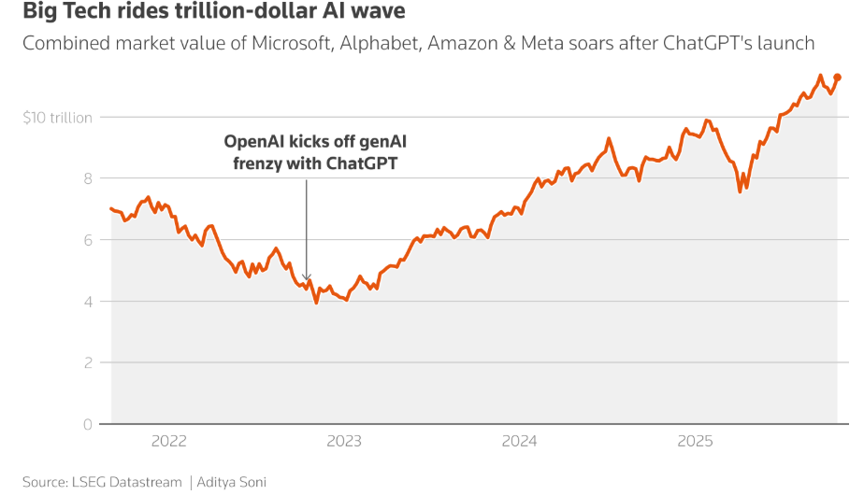
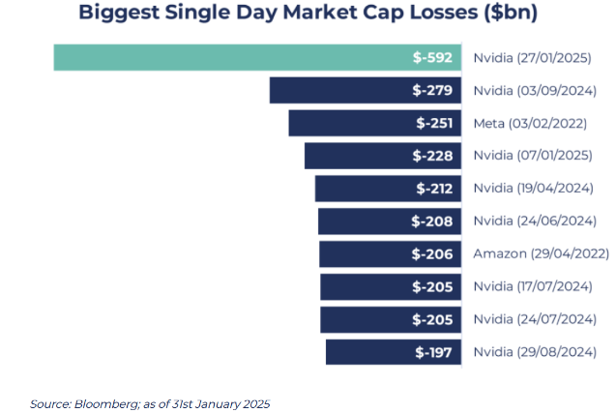

UK Market
The market continues to trade at a discount which attracts value investors. Controlling inflation and expectations of rate cuts by Bank of England are improving market sentiment for domestic sectors like real estate supported by strong cash flows and attractive dividend yields. This means the market is cautiously optimistic rather than outright bullish.
Conclusion: Fund Manager View and Action Plan
A fund manager may choose to keep 55% in US stock due to further potential AI-based higher valuations lead by multiples growth to capture the AI boom and 40% in UK as safe value-based market. The portfolio might be hedged by 5% out of the money put options on US AI stocks in the short term with decreasing weights in US stocks and increasing in UK stocks over the long term to manage downside risk as 1 tech breakthrough can lead to massive correction in the US market. No currency risks are considered in the above valuations.

Reference:
Wright, S., Smithers, A., Warburton, P., Pepper, G., Goldberg, J., Brodie, H., Riley, B. & Napier, R. (2004) Practical history of financial markets. Edinburgh Business School, Heriot-Watt University.
Le Bris, D. (2015). Shiller, Robert J.: Irrational exuberance. Revised and expanded third edition. Journal of Economics, 117(2), pp.185–187. doi:https://doi.org/10.1007/s00712-015-0462-4.
Tobin, J. (1969). A General Equilibrium Approach to Monetary Theory. Journal of Money, Credit and Banking, [online] 1(1), pp.15–29. doi:https://doi.org/10.2307/1991374.
Tobin, J. and Brainard, W. (1977) ‘Asset Markets and the Cost of Capital’, in Nelson, R. and Balassa, B. (eds.) Economic Progress, Private Values and Public Policy. Amsterdam: North-Holland, pp. 235–262.
Smithers.co.uk. (2025). q & FAQs | Andrew Smithers - Author. [online] Available at: https://smithers.co.uk/q_faqs/.
‌www.federalreserve.gov. (n.d.). The Fed - Financial Accounts of the United States - Z.1 - Current Release. [online] Available at: https://www.federalreserve.gov/releases/z1/.
Corrado, C., Hulten, C. and Sichel, D. (2009) ‘Intangible Capital and U.S. Economic Growth’, Review of Income and Wealth, 55(3), pp. 661–685.
‌Gmo.com. (2025). Valuing AI: Extreme Bubble, New Golden Era, or Both. [online] Available at: https://www.gmo.com/europe/research-library/valuing-ai-extreme-bubble-new-golden-era-or-both_viewpoints/ [Accessed 7 Feb. 2026].
Goldmansachs.com. (2023). Why AI stocks aren’t in a bubble. [online] Available at: https://www.goldmansachs.com/insights/articles/why-ai-stocks-arent-in-a-bubble.
‌Morningstar, I. (2025). European Stock Market Outlook: Where Investors Can Find Value in Q4 | Morningstar UK. [online] Morningstar, Inc. Available at: https://global.morningstar.com/en-gb/markets/european-stock-market-outlook-where-investors-can-find-value-q4.
Soni, A. (2025). Big Tech to report earnings under specter of AI bubble. Reuters. [online] 27 Oct. Available at: https://www.reuters.com/business/retail-consumer/big-tech-report-earnings-under-specter-ai-bubble-2025-10-27/.
Guardian staff reporter (2026). Big tech results show investor demand for payoffs from heavy AI spending. [online] the Guardian. Available at: https://www.theguardian.com/technology/2026/jan/29/big-tech-earnings-reports-ai [Accessed 5 Feb. 2026].
‌Guinnessgi.com. (2025). How has DeepSeek affected the AI Market for investors? [online] Available at: https://www.guinnessgi.com/insights/how-has-deepseek-affected-ai-market-investors.
‌Stlouisfed.org. (2024). ICE BofA BBB US Corporate Index Option-Adjusted Spread. [online] Available at: https://fred.stlouisfed.org/series/BAMLC0A4CBBB/.
‌Gurufocus.com. (2025). Tobin Q Charts, Data. [online] Available at: https://www.gurufocus.com/economic_indicators/99/tobin-q.
‌www.currentmarketvaluation.com. (n.d.). Price/Earnings Analysis Indicates Stock Market is Overvalued. [online] Available at: https://www.currentmarketvaluation.com/models/price-earnings.php.
‌Current Market Valuation. (2025). Current Market Valuation | Data-Driven US Stock Market Valuation Models. [online] Available at: https://currentmarketvaluation.com/ [Accessed 4 Feb. 2026].
‌Investing.com UK. (2019). FTSE 100 VIX Index Today (VFTSE) Live Share Price. [online] Available at: https://uk.investing.com/indices/ftse-100-vix.
Investing.com UK. (n.d.). United Kingdom 10-Year Bond Yield. [online] Available at: https://uk.investing.com/rates-bonds/uk-10-year-bond-yield.
Gspublishing.com. (2024). Updating our long-term return forecast for US equities to incorporate the current high level of market concentration. [online] Available at: https://www.gspublishing.com/content/research/en/reports/2024/10/18/29e68989-0d2c-4960-bd4b-010a101f711e.html.
Jpmorgan.com. (2023). What’s driving stock market returns? [online] Available at: https://am.jpmorgan.com/us/en/asset-management/adv/insights/market-insights/market-updates/on-the-minds-of-investors/whats-driving-stock-market-returns/ [Accessed 4 Feb. 2026].
Thompson, C. (2024). Magnificent 7 Stocks: What You Need to Know. [online] Investopedia. Available at: https://www.investopedia.com/magnificent-seven-stocks-8402262.
Drew, M. (2025). The Mag 7 in Charts: How Big Tech Dominates the Market. [online] Investopedia. Available at: https://www.investopedia.com/the-mag-7-in-charts-how-big-tech-dominates-the-market-11866473.

‌

‌

