Behavioural Finance, Efficient Market Hypothesis and Narrative Driven Momentum in US and Indian Equity Markets: An Empirical Analysis of ARM Holdings and Eternal Limited

Name: Sambit Kumar Samanta
Student Id: ss4083
Person Id: H00508467
Advanced Valuation of Financial Markets
Coursework II

Contents |  |  |  | Page No
1. | Introduction |  | 3
2. | ARM Holdings (Nasdaq: ARM): Post-IPO AI Momentum |  | 4
 |  | - Price Data | 4
 |  | - Behavioural Analysis | 4
3. | Eternal Limited (formerly: Zomato Limited) (NSE: ETERNAL.NS): Profitability Narrative Momentum |  | 6
 |  | - Price Data | 6
 |  | - Behavioural Analysis | 7
4. | Verdict: Is Behavioural Finance useful for making Real Investment Decisions |  | 7
5. | References |  | 9

Introduction
The Efficient Market Hypothesis (EMH) by Fama in 1970 states that share prices instantaneously capture all information so consistently earning returns above market returns is not possible. Prospect Theory challenges this notion (Kahneman and Tversky, 1979, p. 263). Prospect theory argues people do not act as perfectly rational agents. As shown in Figure 1, Prospect Theory value function deviates from rational behaviour in three ways. Firstly, people feel losses twice as intense for the same amount gains. This is known as loss aversion (Shefrin and Statman, 1985). Secondly the psychological impact of outcomes diminishes as they grow larger. Thirdly, people compare prices to a relative reference rather than in absolute terms. Together these produce an effect called the disposition effect where there is a tendency to sell winning stocks too early and hold losing stocks too long (Shefrin and Statman, 1985). The concave gain regions and convex loss regions produces momentum. Concavity induces early selling of winners while convexity prevents selling of losers. This report evaluates these claims by comparing ARM Holdings in the US stock market and Eternal Limited in India stock market.
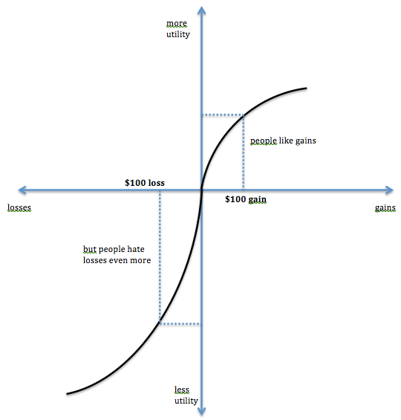
Figure 1: Prospect Theory Value Function. The S-shaped curve is concave for gains and convex for losses. It is steeper below the reference point showing loss aversion and disposition effect.

ARM Holdings (Nasdaq: ARM): Post-IPO AI Momentum
Price Data
ARM Holdings is a Cambridge based semiconductor company whose architecture is used in 99% of the world’s smartphone. It got listed on the NASDAQ on September 14, 2023 at USD 56.10 (10% premium to its IPO price of USD 51) (Attarwala, 2023). It eventually rose to peak of USD 186.46 (closing price) on July 10, 2024 giving a total return of around 266% in under 10 months. The biggest catalyst for this growth was the 2024 February earnings where management framed their results ( 14% yearly revenue growth and 63% yearly growth in trailing free cash flow) around AI infrastructure narrative (Arm Holdings plc, 2024) presenting their licensing-based royalty business as indispensable foundation of every AI device globally. The share price rose 48% in a single session surge on the very next day and gained over 93.4% over the 3 following sessions (Figure 2).
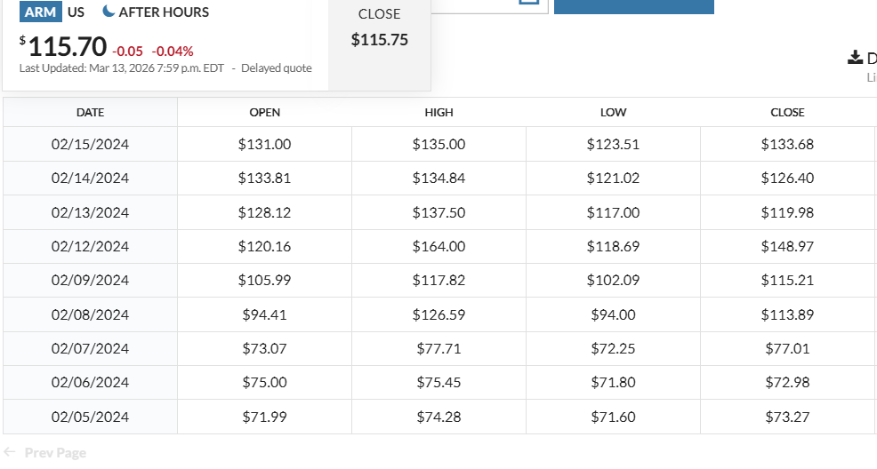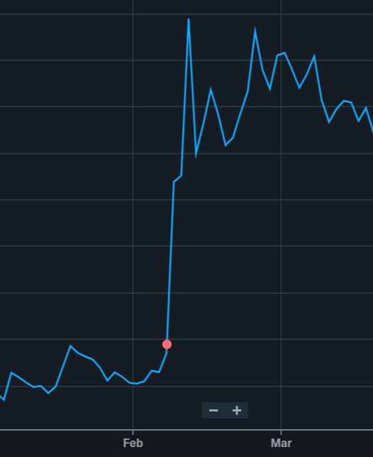
Figure 2: ARM Stock performance. The red dot indicates declaration of performance on 02/08/2024 after which stock prices increased massively (left). Corresponding table showing the prices (right). Source: Yahoo Finance and Market Watch
Morningstar (2023) assigned a fair value of USD 34 which is below the IPO price stating it could not justify USD 51 IPO price at 59 times EBIT for fiscal 2024. The gap between USD 34 and USD 186.46 peak shows a 448% overvaluation due to AI based narrative relative independent rational analysis.
Behavioural Analysis
According to Prospect Theory, ARM’s momentum was explained through two phases. In the underreaction phase, investors focussed on ARM’s Pre-AI valuation factors and then started incorporating the new AI narrative producing slow, sustained upward drift which became a source of medium-term price momentum. Medium-term price momentum is the empirical pattern when the stocks with high returns over the past 3-12 months continue outperforming while past losers continue underperforming over subsequent years (Jegadeesh and Titman, 1993). ARM’s February 2024 earnings heavily focus on AI narratives even more than financial results wherein it talks about converting USD 824 million of quarterly licensing revenue into an AI infrastructure monopoly (Arm Holdings plc, 2024). This led to skewness preference among investors. Morningstar failed to justify USD 51 at 59 times EBIT, they predicted a USD 34 at 41 times EBIT. So, investors were not just buying expected future cash flows but trying to get a lottery like exposure which is an extreme trail scenario where every AI chip in every data centre, smartphone, IOT device pays royalty to ARM. In the overreaction phase, institutional herding took over as portfolio managers did not want to risk their career by not selecting ARM which was currently giving triple digit returns. Therefore, to save their career, they also started buying ARM regardless of valuation. This overreaction leads to eventual mean reversion (De Bondt and Thaler, 1985). Fama himself acknowledges momentum as a “premier anomaly” which cannot be explained by rational asset pricing.
On the supply side, there was loss aversion and endowment effect at play. ARM has been owned by Softbank since 2016. So, when investors started receiving shares at USD 51 at the IPO, it became a reference point. When prices began to rise, investors refused to sell because they overvalued their holdings which is also known as the endowment effect. Loss aversion makes realising a wining position feel riskier than riding it because any subsequent fall would be perceived as a loss compared to its peak. As profits accumulate, diminishing sensitivity further reduces the urgency to exit even when valuations reach extreme levels. During late-stage momentum, mental accounting starts playing a role. Investors who already made large profits treat those profits as house money and use them to fund additional purchases at high prices (Thaler, 1980). Rational portfolio theory treats these gains as real wealth that should be managed with the same financial discipline as any other capital. But mental accounting, treat these gains as ‘found money’ that investors did not start with and thus is less painful than the original capital to lose it. Thus , investors who made early gains continue to buy ARM stocks even after the performance report at very high prices with the money made from the earlier gains adding to buying pressure further pushing prices. Mental accounting leads investors to compare the then market price with the purchase price instead of rationally comparing whether the market price is still a good price to continue holding the stock. Thus, sellers who have the highest incentive to sell are also the ones least likely to sell. Arbitrageurs who correctly identified overvaluation keep facing mark-to-market losses before any mean reversion, their own loss aversion makes rational trading psychologically unsustainable (Frazzini, 2006). The risk and pain faced by arbitrageurs increases with the size of mispricing, so the best place to correct the overvaluation have the strongest incentive to reduce their positions rather than expand them known as same sign condition. In the correction phase, sunk cost behaviour among late buyers who refuse to exit treating their expenditure to hold on rather than exit rationally.

Eternal Limited (formerly: Zomato Limited) (NSE: ETERNAL.NS): Profitability Narrative Momentum
Price Data
Eternal Limited (formerly Zomato Limited) is India’s dominant food delivery and quick commerce platform. It got listed in 23 July 2021 at INR 125.85 on an issue price of INR 76 which is a gain of 65.59% after which it spent eighteen months below its listing price due to loss making history. Eternal incurred losses of INR 12,230 million in FY2022 and INR 9,710 million in FY2023 (Zomato, 2024). This extended period below the IPO reference point placed long-term holders in the loss domain of Prospect Theory’s value function (Figure 1). This changed when Eternal posted its first ever quarterly profit for the period ending June 2023. Management framed this not as a marginal financial improvement but as proof of structural profitability in India’s consumer technology platform presenting its quick commerce brand Blinkit as a gateway to India’s rapidly expanding digital consumer economy of millions of smartphone users. The stock rose from an opening price INR 60.65 on 1st January, 2023 to an all-time high INR 368.45 on 16 October, 2025 (Figure 3) showing a gain of 508% in about 33 months. This pattern is consistent with Sehgal Balakrishnan’s (2002) evidence that momentum profits exist in Indian equities and underreaction and overreaction are not fully arbitraged away.

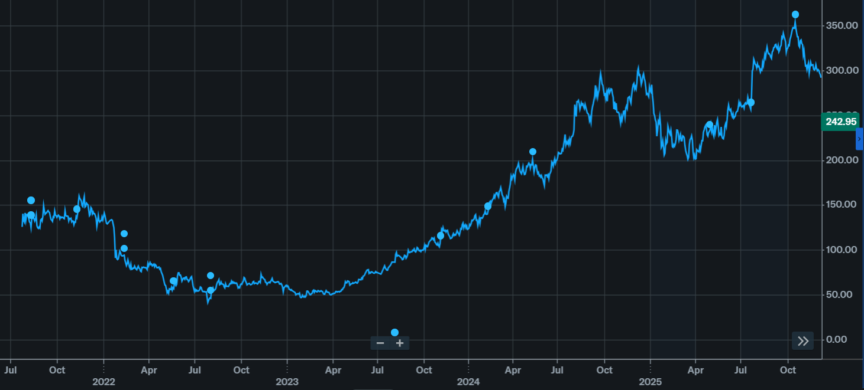
Figure 3: Eternal Limited (formerly Zomato Limited) showing listing price of INR 125.85 and subsequent fall to INR 60.65 on 1st January, 2023 and then a subsequent rise in prices to INR 304.70 on 9th December, 2024 and INR 368.45 on 16th October, 2025. Source Yahoo Finance.

Behavioural Mechanisms
For the full year of 2024, Eternal reported a net profit INR 3510 million and an EPS of 0.398 (Zomato, 2024) and INR 5270 million and an EPS of INR 0.364 (Zomato, 2025). This means a Price Earnings ratio 765 times trailing earnings of 2024 and 1012 times in 2025. No reasonable set of inputs and assumptions would give such high fair value under standard DCF model Price earning based frameworks for a firm with only INR 3510 million and INR 5270 million in earnings. This is possible only through skewness and probability weighting causing investors to overweight the extreme tail scenario of total performance dominance beyond its objective probability. Eternal’s (formerly Zomato) INR 3510 million annual profit was used to depict consumer technology performance dominance narrative. In January, Eternal’s Q3 earnings miss triggered a correction from INR 304.70 to INR 194.80 before eventually reaching all time high of INR 368.45 demonstrating that sunk cost behaviour and renewed skewness seeking can sustain momentum through corrections. Both had underreaction where early positive signals were slowly captured in the price while institutional herding took over during the overreaction phase due to career risk and mental accounting treatment pushed prices far beyond fundamental justification. Momentum tends to be stronger in India because retail investors dominate trading volumes, short selling infrastructure is less developed for many stocks and smaller arbitrage capital makes behavioural underreaction and overreaction more persistent.

Verdict: Is Behavioural Finance useful for making Real Investment Decisions
The ARM and Eternal cases challenges EMH because mispricing did not arise in obscure and illiquid stocks where information inefficiency is expected, but in stocks which are highly liquid and heavily analysed by institutions and prices should have been correctly predicted by EMH as efficient. ARM was trading at 448% overvaluation and Eternal traded at 765 times trailing earnings in 2024 and 1012 in 2025. This information was publicly available and the market incorporated it as a confirmation of narrative rather than as reason for caution. This means that investment decisions were not governed by processing rational information that EMH would predict but that factors that Prospect theory identifies like loss aversion, probability weighting and reference point dependence would cause investors to overvalue extreme tail scenarios far beyond their objective likelihood of happening.
My view is that behavioural finance is practically useful. Its predictive power lies not in identifying when a correction will happen but in identifying conditions in which prices will diverge from fundamental value and mechanisms that will sustain the divergence. Both ARM Holdings and Eternal had their prices driven by narratives of potential dominance in very large markets which disconnected price from earnings reality. Institutional herding, due to career risk and skewness preference made investors systematically overweight the extreme tail scenario rather than pricing expected cash flows. Endowment effect and mental accounting supressed rational selling that would have otherwise corrected prices.
The limitation of behavioural finance as an investment tool is that investors are subject to the same cognitive biases that generate the mispricing that they seek to exploit. A short seller who correctly identified overvaluation of ARM at USD 120 faced loss aversion as the stock climbed to USD 186.46. A portfolio manager who identified Eternal’s 765-times PE ratio faced career risk if he underweighted the stock as it rose further and other portfolio managers were overweighting it. Loss aversion makes rational trade feel too painful to hold, sunk cost delays exit and probability overweighting makes overvaluation justified. Behavioural finance explains why prices deviate from fundamental value in predictable ways and pre-commit cognitive deviations like valuation-based exit rule (against disposition effect), stop loss (against sunk cost paralysis), base rate anchoring (against probability weighting and take safeguards against narrative framing and herding). ARM and Eternal did not make investors lose money because they lacked information. They lost money because they lacked the discipline to act on it. Behavioural finance does not offer formula to beat the market, it offers a framework for not being by your own mind.

References:
Attarwala, F. (2023) ‘British chip designer Arm debuts on Nasdaq in biggest US IPO since 2021’, Investopedia, 14 September. Available at: https://www.investopedia.com/british-chip-designer-arm-debuts-on-nasdaq-in-biggest-us-ipo-since-2021-7969648 (Accessed: 15 March 2026).
Arm Holdings plc. (2024) Q3 FYE24 results presentation. Investor presentation, 7 February. Available at: https://investors.arm.com (Accessed: 15 March 2026)
Correonero, J. (2023). Arm Holdings Stock: A Wide Moat, but We Think It’s Expensive. [online] Morningstar, Inc. Available at: https://www.morningstar.com/stocks/arm-holdings-stock-wide-moat-we-think-its-expensive (Accessed: 15 March 2026).
De Bondt, W. F. M. and Thaler, R. (1985) ‘Does the stock market overreact?’, The Journal of Finance, 40(3), pp. 793–805.
Frazzini, A. (2006) ‘The disposition effect and underreaction to news’, The Journal of Finance, 61(4), pp. 2017–2046.
Jegadeesh, N. and Titman, S. (1993) ‘Returns to buying winners and selling losers: Implications for stock market efficiency’, The Journal of Finance, 48(1), pp. 65–91
Kahneman, D. and Tversky, A. (1979) ‘Prospect theory: An analysis of decision under risk’, Econometrica, 47(2), pp. 263–291.
Sehgal, S. and Balakrishnan, I. (2002) ‘Contrarian and momentum strategies in the Indian capital market’, Vikalpa, 27(1), pp. 13–20.
Shefrin, H. and Statman, M. (1985) ‘The disposition to sell winners too early and ride losers too long: Theory and evidence’, The Journal of Finance, 40(3), pp. 777–790.
Thaler, R. (1980) ‘Toward a positive theory of consumer choice’, Journal of Economic Behavior and Organization, 1(1), pp. 39–60.
Yahoo Finance. (2026) ‘Arm Holdings plc (ARM) stock price, news, quote & history’, Yahoo Finance. Available at: https://finance.yahoo.com/quote/ARM/
Yahoo Finance. (2026) ‘ETERNAL.NS interactive stock chart | ETERNAL LIMITED stock’, Yahoo Finance. Available at: https://finance.yahoo.com/chart/ETERNAL.NS
Zomato Ltd (2024) Annual Report FY2024. Gurugram: Zomato Ltd. Available at: https://www.zomato.com/investor-relations (Accessed: 15 March 2026).
Zomato Limited. (2025) Eternal: Annual report 2024–25. Available at: https://b.zmtcdn.com/investor-relations/Eternal_Annual_Report_2024-25.pdf (Accessed: 15 March 2026).​

