Financial Repression in India: A Critical Analysis of Instruments and Effects on the Indian Economy
(1960-1991)

Name: Sambit Kumar Samanta
Student ID: ss4083
Person ID: H00508467
Emerging Financial Market
Coursework I
Word Count: 1416
Contents
Introduction |  | 3
Instruments of Financial Repression in India |  | 3
 | Banking Sector Nationalisation and Control | 3
 | High Reserve and Liquidity Requirements | 4
 | Priority Sector Lending | 5
 | Exchange Rate Control | 6
Theoretical Framework |  | 7
Empirical Evidence on Indian Economy |  | 8
 | Impact on Savings behaviour | 8
 | Investment Productivity and Resource Misallocation | 9
 | Effect on Growth and Financial Development | 10
Conclusion |  | 10
References |  | 11

Introduction: What is Financial Repression?
Financial Repression is defined by McKinnon (1973) and Shaw (1973) refers to a set of government policies implemented to manage its fiscal obligations by channelling funds from private sector to public sector using mechanisms like artificially low interest rates, high reserve requirements and directed credit allocation. It allows a government to reduce its debt burden over time and stabilize economy in the short term but often at the cost of real returns for savers when inflation exceeds regulated interest rates (World Economic Forum, 2025).
India an emerging market, financial repression was carried out from the 1960s until the 1991 economic liberalisation. India’s experience with financial repression and subsequent liberalization allows us to compare the effects of financial repression under the McKinnon-Shaw Framework. This essay examines India’s financial repression and the various instruments used during the financial repression in India and their effect on the economy, savings, investment and overall financial development.

Instruments of Financial Repression in India
Banking Sector Nationalisation and Control
In 1969 the Indian government nationalised 14 the largest private sector banks followed by 6 more in 1980 bringing majority of the Indian banking and financial system under public ownership. The then Prime Minister Indira Gandhi justified nationalisation as means to ensure that credit was available to priority sectors like agriculture, small scale industry and economically disadvantaged groups which are generally neglected by private banks (DeLong, 2003).
Nationalization of banks allowed implementation of interest rate controls, lending directives and ensured demand for government securities. However, it also introduced political considerations into credit allocation creating principal-agent problems thus reducing banking efficiency.

High Reserve and Liquidity Requirements (CRR and SLR)
The Reserve Bank of Indian (RBI) raised the Cash Reserve Ratio (CRR) from 4% of bank deposits to 15% by 1980s and Statutory Liquidity Requirement (SLR) from 20% to 38.5% by 1990 meaning banks were holding over 50% of their deposits in cash or government securities. These were generally low yielding assets which hardly covered their cost of funds. This increased the spread between the lending and deposit rates and reduced the demand for credit. This pushed many savers towards other forms of saving in the form gold or real estate.
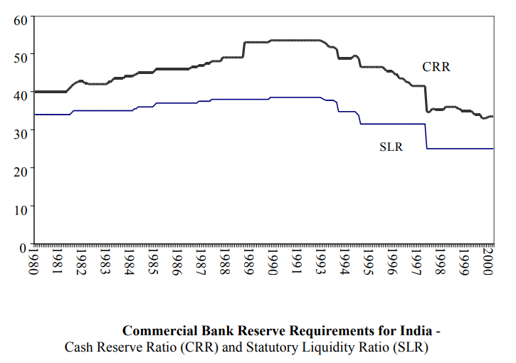
Interest Rate Control and Administered Pricing
India’s financial repression regime is characterised by extensive interest rate controls. Until the liberalisation of reforms of the early 1990s, the Reserve Bank of India (RBI) maintained a complex system of administered lending and deposit rates based on sector, loan size and maturity (Demetriades and Luintel, 1997). These controls kept real interest rates negative during the 1970s and 1980s averaging -2% annually (Krishnan, 2009). From the McKinnon-Shaw perspective negative real interest rates should discourage financial savings and encourage consumption and investment. However, India’s aggregate savings increased from 10% of GDP in the early 60s to 20% of GDP by the late 80s. This is likely because while financial savings may have decreased, total savings increased due to other factors like rising incomes, demographic changes and other factors (Ang, 2008).
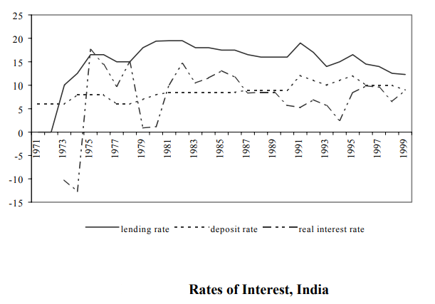
Priority Sector Lending
Commercial Banks were mandated to allocate 40% of their credit to designated “priority sectors” at subsidized rates with specific targets for agriculture and small-scale industries. These requirements allocated credit based on social and developmental criteria rather than risk-adjusted expected returns.
Exchange Rate Control
During the financial repression regime of India, the exchange rate was tightly controlled and largely pegged with occasional discrete adjustments. The Indian Rupee was pegged first to sterling and then to a basket of currencies from 1975 only seeing infrequent discrete adjustments until the 1991 crisis forced devaluation and transition to a managed float system (Kletzer and Kohli, 2008). Capital controls restricted external borrowing and generally prohibited residents from holding foreign assets. These controls which are a feature of financial repression restricted the movement of capital and allowed the government to maintain negative real domestic interest rates and ensured domestic base for government securities.
This entire system depended on the current account being manageable. When India’s fiscal deficit widened in 1980s due to external borrowing and having a fixed exchange rate, foreign exchange reserved depleted very fast leading to the balance of payment crisis in 1991 which also led to the economic reforms of 1991 (DeLong, 2003). This is how exchange rate can make financial repression vulnerable.
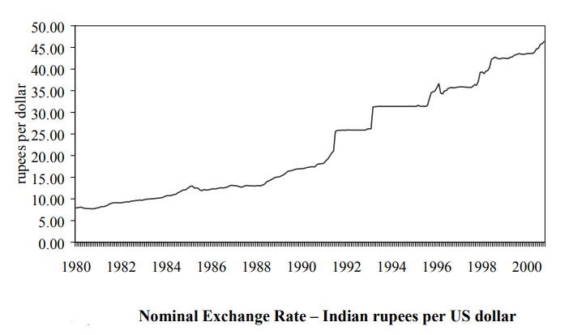

Theoretical Framework: The McKinnon-Shaw Framework
McKinnon (1973) and Shaw (1973) state that policies which are part of financial repression have a negative effect on savings, investment and economic growth. Such policies create multiple distortions which reduce economic welfare. The McKinnon-Shaw model states that financial repression especially negative real interest rates reduces both quantity and quality of savings and investment. By keeping deposit rates artificially low, financial repression discourages financial savings which reduces resources available for productive investment. Simultaneously, subsidized lending rates lead to excess demand for credit which leads to allocation of resources based on factors other than economic merit like political connections or otherwise favoured connections. High reserve requirements function as implicit tax on financial intermediation and create a wedge between deposit and lending rates. This tax can lower the rate of economic growth by reducing the efficiency of capital allocation.
Thus, the implicit argument of this framework is that by allowing interest rates to reach market determined levels and removing directed lending policies would raise savings rate, improve capital allocation and accelerate growth.

Empirical Evidence on the Indian Economy
Impact of Savings Behaviour
Financial repression keeps nominal interest rates artificially low while inflation remains high. This leads to negative real interest rates. This reduces incentive to save in formal banking institutions and pushes household savers towards gold, land and other informal channel of savings seeking to hedge against inflation. This reduces the availability of funds to be lent out as investment thus leads to weaker credit creation.
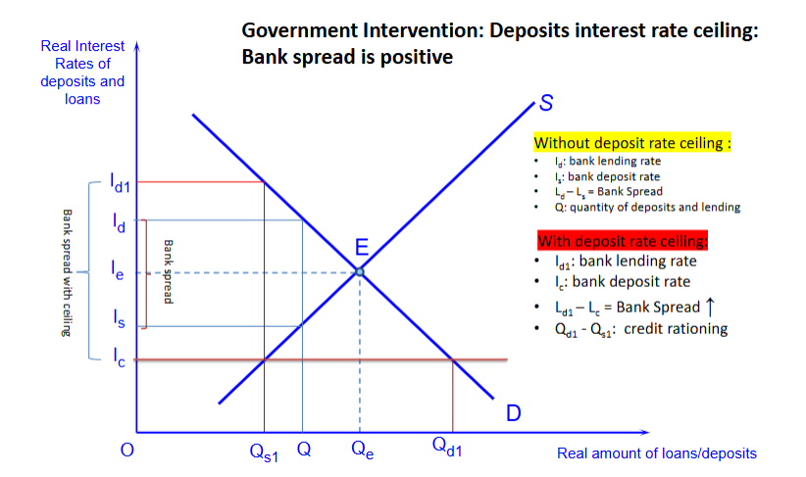
In India, as predicted by McKinnon-Shaw model, formal financial savings in total household savings declined from approximately 50% to 40%. However, India’s average savings rate increased during financial repression. It rose from 10% to 20% to GDP by the late 1980s (Krishna, 2009). This paradox happened because financial repression reduced formal financial savings however other factors like income growth and demographic factors channelled them towards unproductive channels. Thus, financial repression changed the composition of savings rather than the habit of savings.
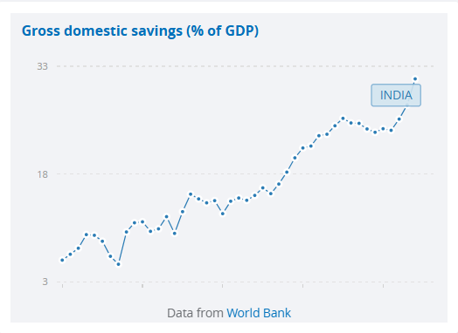

Investment Productivity and Resource Misallocation
Analysis of priority sector lending requirements find that non-performing loan ratios averaged 18% for priority sector compared to 12% for non-priority lending during the 1980s (Banerjee and Duflo, 2014). Capital-intensive public sector manufacturing had a marginal product of capital at 8% -12% in spite of receiving disproportionate credit access while credit rationed private sector firms showed marginal products exceeding 20% (DeLong, 2003). This means that directed credit financed projects with lower expected returns which is an indication of resources misallocation. Empirical analysis of financial repression using econometric models estimate that the allocative inefficiency created by interest rate controls and directed lending reduced the total factor of productivity growth by 0.5% to 1.0% points annually (Demetriades and Luintel, 1997).
Effect on Growth and Financial Development
Financial repression constrained India’s financial sector development. The ratio of bank deposits to GDP and stock market capitalisations to GDP remained low by international standards throughout the 1970s and 1980s (Ang, 2008). Limited competition and innovation meant that India entered the 1990s with poorly performing banking sector. From the period of 1950 to 1991, India achieved a growth of approximately 3.5% annually. However, growth increased to 7% annually in the 1990s and beyond after liberalization.

Conclusion
India’s financial repression from 1969 to 1991 provides evidence that these policies reduced allocative efficiency, impacted savings and constrained financial sector development. The high reserve requirements, interest rate controls, directed lending, capital account restrictions distorted credit allocation towards less productive use, stunted financial development collectively contributed to India’s persistently mediocre growth rate during 1960s to 1980s. India’s growth accelerated after 1991 due to a combination of financial liberalisation, industrial deregulation and institutional reforms.
India’s experience demonstrates that financial repression involves trade-off between efficiency, stability and developmental objectives and not just costs to be eliminated. Complete financial liberalisation with regulatory checks and financial institutional development could have generated potentially high costs in the form of financial instability.
For emerging markets like India, the debate should not be over whether to or not to repress financial development in the country but to develop instruments and policies for eventual liberalisation at minimal loss of efficiency. Therefore, financial development is a gradual process and not simply a matter of removing controls.

References:
- Banerjee, A.V. and Duflo, E. (2014). Do Firms Want to Borrow More? Testing Credit Constraints Using a Directed Lending Program. The Review of Economic Studies, 81(2), pp.572–607. doi:https://doi.org/10.1093/restud/rdt046.

- ‌DeLong, J.B. (2012). India Since Independence: An Analytic Growth Narrative. [online] Available at: https://www.researchgate.net/publication/246458096_India_Since_Independence_An_Analytic_Growth_Narrative.

- Demetriades, P.O. and Luintel, Kul B (1997). The Direct Costs of Financial Repression: Evidence from India. The Review of Economics and Statistics, [online] 79(2), pp.311–320. doi:https://doi.org/10.2307/2951464.
- ‌Loizos, K. (2018) ‘The financial repression–liberalization debate: taking stock, looking for a synthesis’, Journal of Economic Surveys, 32(2), pp. 440–468. doi:10.1111/joes.12195.

- ‌McKinnon, R.I. (2010) Money and capital in economic development. Washington, DC: Brookings Institution Press. doi:10.5771/9780815718499.

- Stiglitz, J.E. (1993). The Role of the State in Financial Markets. The World Bank Economic Review, 7(suppl 1), pp.19–52. doi:https://doi.org/10.1093/wber/7.suppl_1.19.

- Demetriades, P.O. and Luintel, Kul B (1997). The Direct Costs of Financial Repression: Evidence from India. The Review of Economics and Statistics, [online] 79(2), pp.311–320. doi:https://doi.org/10.2307/2951464.

- SuperMoney. (2023). MSCI Emerging Markets Index: What It Is, How It Works, and Examples - SuperMoney. [online] Available at: https://www.supermoney.com/encyclopedia/msci-emerging-markets-index.

- MSCI (2024). Market Classification. [online] Msci.com. Available at: https://www.msci.com/indexes/index-resources/market-classification.

- Ang, J.B. (2008) Finance and inequality: the case of India. Monash University Department of Economics Working Paper No. 08/08. Available at: https://www.monash.edu/__data/assets/pdf_file/0004/925510/finance_and_inequality_the_case_of_india.pdf

- Mishra, T. (2025). Economic Liberalization in India, Background, Reforms, Impact. [online] Oliveboard. Available at: https://www.oliveboard.in/blog/economic-liberalization-in-india

- Kletzer, K.M. and Kohli, R. (2002). Financial Repression and Exchange Rate Management in Developing Countries: Theory and Empirical Support from India. SSRN Electronic Journal. doi:https://doi.org/10.2139/ssrn.315841.

- Kletzer, K.M. (2004) ‘Liberalizing capital flows in India: financial repression, macroeconomic policy, and gradual reforms’. Santa Cruz, CA: University of California, Santa Cruz, Department of Economics. Available at: https://escholarship.org/uc/item/3kj2w649 (Accessed 9 February 2026).

- Mukherjee, B. and Yadav, V. (2024). Financial Crisis Prevention and Repression in India and Brazil. pp.249–291. doi:https://doi.org/10.1007/978-3-031-55893-1_7.

- Whiting, K. (2025). What is financial repression – and should countries embrace it as debt climbs? [online] World Economic Forum. Available at: https://www.weforum.org/stories/2025/03/financial-repression-debt-management/.

- International Monetary Fund (2003). Global financial stability report : market developments and issues. Washington, D.C.: International Monetary Fund.
- Lawrence, P. (2003). Financial Liberalisation in India: measuring relative progress by. [online] Available at: https://assets.publishing.service.gov.uk/media/57a08d1240f0b64974001618/R7968b.pdf

- International Monetary Fund (2006) China and India learning from each other: reforms and policies for sustained growth. Washington, DC: International Monetary Fund. Available at: https://www.imf.org/external/pubs/ft/seminar/2006/chiind/eng/chiind7.pdf (Accessed 10 February 2026).

- Callen, T., Reynolds, P. and Towe, C.M. (2001). India at the crossroads : sustaining growth and reducing poverty. Washington, D.C.: International Monetary Fund.

- IE-manager (2016). What is double financial repression? [online] Indian Economy. Available at: https://indianeconomy.com/splclassroom/what-is-double-financial-repression/ [Accessed 12 Feb. 2026].

- Hanson, J., Fry, C. and Building, G. (2001). Working Paper No. 104 Indian Banking: Market Liberalization and the Pressures for Institutional and Market Framework Reform. [online] Available at: https://kingcenter.stanford.edu/sites/g/files/sbiybj16611/files/media/file/104wp_0.pdf.

- Have India’s Financial Market Reforms Changed Firms’ Corporate Financing Patterns? (2002). Asian Development Bank, [online] (38). Available at: https://www.adb.org/publications/have-indias-financial-market-reforms-changed-firms-corporate-financing-patterns.

- The World Bank (2025). India | Data. [online] Worldbank.org. Available at: https://data.worldbank.org/country/india.

