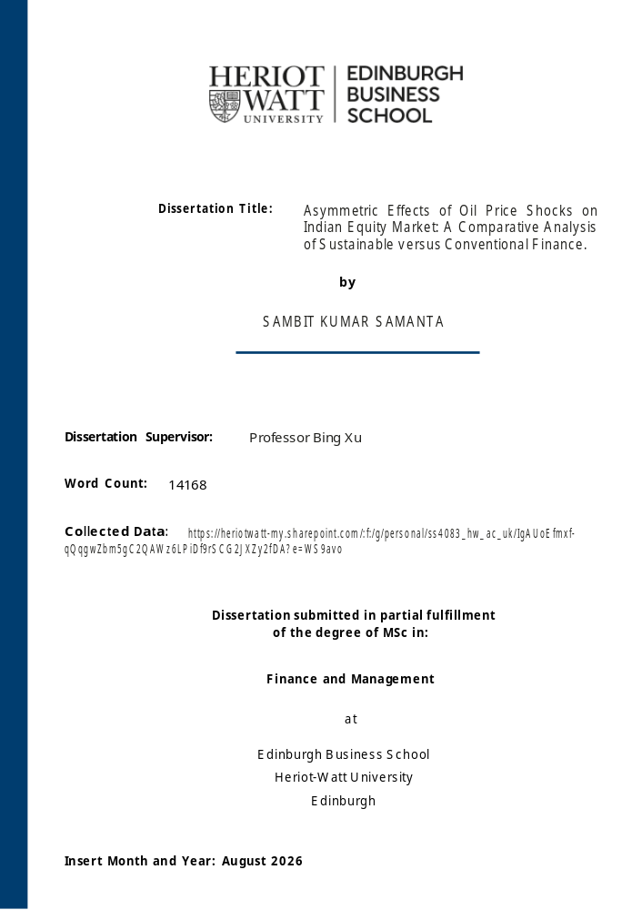
Course code: | C31AF
Type of assessment: | Individual
Coursework Title: | Asymmetric Effects of Oil Price Shocks on Indian Equity Market: A Comparative Analysis of Sustainable vs. Conventional Finance.
Student Name: | SAMBIT KUMAR SAMANTA

*Each student contributing to a group assignment must sign and upload their own declaration form

Declaration of Authorship. By signing this form:

- I declare that the work I have completed for individual assessment OR the work I have contributed to a group assessment, is entirely my own. I have NOT taken the ideas, writings or inventions of another person and used these as if they were my own. My submission or my contribution to a group submission is expressed in my own words. Any uses made within this work of the ideas, writings or inventions of others, or of any existing sources of information (books, journals, websites, etc.) are properly acknowledged and listed in the references and/or acknowledgements section.

- I confirm that I have read, understood and followed the University’s Regulations on plagiarism as published on the University’s website, and that I am aware of the penalties that I will face should I not adhere to the University Regulations.

- I confirm that I have read, understood and avoided the different types of plagiarism explained in the University guidance on Academic Integrity and Plagiarism

Student Signature (type your name): Sambit Kumar Samanta

Date: 14/08/2026

Upload a signed copy to the ‘Declaration of Authorship’ Canvas Assessment page.
This will give you access to the Assignment Upload page.
For group submissions, each group member must sign and upload the form
via their own user account.

SCHOOL OF SOCIAL SCIENCES
DISSERTATION SUBMISSION FORM

Please tick: | Undergraduate |  | Postgraduate | ✓

STUDENT ID NUMBER: | H | 0 | 0 | 5 | 0 | 8 | 4 | 6 | 7
STUDENT NAME: | SAMBIT KUMAR SAMANTA

PROGRAMME:(e.g. MA Accountancy and Finance; MSc International Business Management) | Msc Finance and Management

DISSERTATION TITLE: | Asymmetric Effects of Oil Price Shocks on Indian Equity Market: A Comparative Analysis of Sustainable versus Conventional Finance.
DISSERTATION SUPERVISOR: | Professor Bing Xu

Dissertation hand-in deadline  (date specified for hand-in) | 14-08-2026
All students are advised to keep a duplicate copy of all work submitted for reference.
DECLARATION:
I confirm that the work submitted is my own or that it reflects my contribution to a group submission. The submission is expressed in my own/the group’s words. Any uses made within this work of the writing of other authors or of any existing source is properly acknowledged, and a list of references used is included. The University Ethical Code of Practice and the Schools' guidelines on plagiarism as contained within the SML handbook have been understood and followed.
SIGNATURE OF STUDENT: | Sambit Kumar Samanta
DATE: | 14-08-2026

Submission:
This form should be attached to your coursework and submitted in the applicable box (Hopper) to which the course is assigned:
- Business Management (code: C1)
- Accountancy, Economics and Finance (codes: C2 and C3)
- Languages and Intercultural Studies (codes C4)

Abstract
This dissertation examines whether global crude-oil price movements and domestic inflation are associated asymmetrically with India’s conventional (Nifty 100) and sustainable (Nifty 100 ESG) equity markets and whether ESG index retains an independently identifiable relationship after broad-market co-movement is accounted for. India is among the world’s largest oil importers and is exposed to global oil price volatility through both a corporate cash flow channel and a domestic inflation channel. The dissertation covers January 2013 to December 2024 spanning the COVID-19 shock and the 2022 Russia-Ukraine war price spike and addresses three research questions. (1) Do rising oil prices affect the two indices more negatively in the long run than falling prices affect them positively? (2) How does the sustainable index’s response to Indian CPI inflation compare with the conventional index? (3) Does any asymmetric relationship remain once the 2022 war window is accounted for? Two parallel NARDL models are estimated using 143 monthly observations. Oil price changes are decomposed into positive and negative partial sums, CPI inflation alongside a COVID-19 dummy and a war dummy with the Nifty 100 included as a market control in the ESG model. Both models provide evidence of long-run relationship. For RQ1, the Wald test finds no statistically significant long run asymmetry between positive and negative oil-price movements in either index. For RQ2, the conventional Nifty 100 has a statistically significant positive long-run CPI coefficient whereas the sustainable index’s CPI coefficient is statistically indistinguishable from 0 after broad-market co-movement is accounted for. This is conditional comparison rather than concrete evidence due to lack of cross-equation test. For RQ3, the bounds and Wald test results are materially unchanged with or without the war dummy which confirms that these findings are not driven by the 2022 war shock. No independently identifiable long-run oil-price asymmetry in either index. The ESG relationship weakens once conventional market exposure accounted for. Future research should examine sector-level ESG characteristics, quantify the overlap between two indices and introduce RBI repo rate and formally test cross-equation CPI sensitivity over an extended sample period.
Acknowledgements

I, Sambit Kumar Samanta, confirm that this dissertation is entirely my own work and that all sources consulted in its preparation have been fully and accurately acknowledged and referenced in accordance with the guidance on plagiarism provided in Section 10.
I would like to express my sincere gratitude to the Chair of the School’s Ethics Committee for reviewing and granting approval for this study. The research relies exclusively on secondary, publicly available data from official government, central bank, stock exchanges and does not involve collection of primary data or the participation of human subjects at any stage.

I am grateful to my supervisor, Professor Bing Xu for her guidance, patience and constructive feedback throughout the course of the dissertation. Her guidance and feedback to engage critically with the subject was invaluable in helping me shape the direction of the study.

I would like to thank Heriot-Watt University for providing access to the academic resources, software and library facilities that made this research possible.

Finally, I would like to thank my family and friends for their love and support throughout this study.

Sambit Kumar Samanta
SAMBIT KUMAR SAMANTA
Student Id: H00508467
14-08-2026
Table of Contents

Abstract |  |  |  | i
Acknowledgements |  |  |  | ii
Declaration |  |  |  | iii
List of Tables |  |  |  | vi
List of Figures |  |  |  | vi
Chapter 1: Introduction |  |  |  | 1
Chapter 2: Literature Review |  |  |  | 4
2.1 |  | Oil Price Shocks and Macroeconomic Transmission |  | 4
2.2 |  | Asymmetric Price Adjustment |  | 5
2.3 |  | Cross Country and Panel Evidence |  | 6
2.4 |  | The Nonlinear Autoregressive Distributed Lag (NARDL) Framework |  | 8
2.5 |  | India-Specific Evidence |  | 10
2.6 |  | Energy Shocks and Sustainable Finance |  | 12
2.7 |  | Synthesis and Research Gap |  | 14
2.8 |  | Research Aim, Objectives and Questions |  | 15
Chapter 3: Methodology |  |  |  | 17
3.1 |  | Research Philosophy |  | 17
3.2 |  | Research Strategy and Design |  | 17
3.3 |  | Data Collection |  | 18
3.4 |  | Data Preparation |  | 19
3.5 |  | Model Specification |  | 20
3.6 |  | Estimation Procedure |  | 22
3.7 |  | Ethical Considerations |  | 23
3.8 |  | Chapter Summary |  | 23
Chapter 4: Empirical Results and Discussion |  |  |  | 24
4.1 |  | Introduction |  | 24
4.2 |  | Stationarity and Structural Break Diagnostics |  | 24
4.3 |  | Lag Order Selection |  | 25
4.4 |  | Conventional Nifty 100: Model 1 |  | 25
4.5 |  | Nifty 100 ESG: Model 2 |  | 31
4.6 |  | Summary of all Findings |  | 38
 |  | 4.6.1 | Research Question 1: Long-Run Oil Price Asymmetry | 39
 |  | 4.6.2 | Research Question 2: Conventional versus Sustainable Inflation Transmission | 40
 |  | 4.6.3 | Research Question 3: Are equity indices stable after the War window | 41
 |  | 4.6.4 | Comparability of Fit Statistics across Models | 41
4.7 |  | Chapter Summary |  | 42
Chapter 5: Discussion |  |  |  | 43
5.1 |  | Introduction |  | 43
5.2 |  | Research Question 1: Long-Run Oil Price Asymmetry |  | 43
5.3 |  | Research Question 2: Conventional and Sustainable Approaches to the Inflation Channel |  | 44
5.4 |  | Research Question 3: Stability Across the War window |  | 45
5.5 |  | Dilution rather Insulation |  | 46
Chapter 6: Conclusions |  |  |  | 47
6.1 |  | Summary of the Study |  | 47
6.2 |  | Addressing the Research Questions |  | 47
6.3 |  | Implications for Practitioners |  | 48
6.4 |  | Implications for Academic Research |  | 49
6.5 |  | Limitations |  | 50
6.6 |  | Future Research |  | 51
References |  |  |  | 52
Appendices |  |  |  | 56
 | Appendix A: Unit Root and Structural Break Test Results |  |  | 56
 | Appendix B: Full OLS Regression and Bounds/Wald Test Output |  |  | 58
 | Appendix C: Diagnostic Test Output |  |  | 70
 | Appendix D: Data Sources and Variable Construction |  |  | 77

List of Tables

4.1 | Lag Order Selection | 25
4.2 | Nifty 100 Bounds Test and Wald Asymmetry Test | 26
4.3 | Nifty 100 Diagnostic Test Summary | 27
4.4 | Nifty 100 Long Run Multipliers (Bootstrap and Bewley 2SLS) | 29
4.5 | Nifty 100 ESG Bounds Test and Wald’s Asymmetry Test | 32
4.6 | Nifty 100 ESG Diagnostic Test Summary | 33
4.7 | Nifty 100 ESG Long Run Multipliers (Bootstrap and Bewley 2SLS) | 35
4.8 | Cross Model Summary of Key Findings | 38

List of Figures

4.1 | Nifty 100 CUMSUM Test | 27
4.2 | Nifty 100 CUMSUMSQ Test | 27
4.3 | Effect of OilPlus shock on Nifty 100 | 29
4.4 | Effect of OilMinus shock on Nifty 100 | 30
4.5 | Effect of CPI Inflation on Nifty 100 | 30
4.6 | Nifty 100 ESG CUMSUM Test | 34
4.7 | Nifty 100 ESG CUMSUMSQ Test | 34
4.8 | Effect of OilPlus shock on Nifty 100 ESG | 36
4.9 | Effect of OilMinus shock on Nifty 100 ESG | 36
4.10 | Effect of CPI Inflation on Nifty 100 ESG | 37

Chapter 1: Introduction
India is one of the world’s fastest growing economies. India is the world’s third largest importer of oil after China and United States of America at 243.2 million metric tons of crude oil in 2024-2025 (Ministry of Petroleum and Natural Gas, 2025). This accounts for 87.8% of India’s total crude oil supply in 2024-2025. Therefore, global oil price movements directly affect India’s domestic inflation and financial markets. Oil price increases act like an external cost to India’s economy unlike net oil exporters who benefit fiscally from increasing oil prices. This raises input costs across sectors such as transport, agriculture, manufacturing and services and these costs are typically passed through quickly to consumers via fuel prices, household spending and the valuations of listed companies. In contrast the effect of falling prices on these same variables tends to happen more slowly and less completely. The differential speed of adjustment is the starting point for this dissertation.
Traditional linear models usually assume symmetry in prices movements implying that a rise in oil prices will have an equal and opposite effect to a fall in oil prices. However empirical evidence frequently challenges this assumption. Companies often raise the price of goods more quickly to protect profit margins. On the other hand, drop in costs are often not passed onto the consumers at the same speed. This phenomenon was described as the “rockets and feathers” effect (Bacon, 1991), which is often observed in many energy, retail and financial markets. At the firm level, an increase in oil prices reduces profit margins and lowers expected future cash flows. At the household level, increase in oil prices increases the overall cost of living because oil is an input in the production of most goods and services. This dissertation report examines both of these transmission mechanisms by studying stock market returns and consumer price inflation. An empirical question remains whether this asymmetric transmission mechanism operates uniformly across all firms or whether it varies according to firm-level characteristic such as environmental, sustainability and governance practices.
The primary aim of this study is to examine and compare two segments of equity in Indian stock markets. The first is the conventional Nifty 100 Index which tracks the hundred largest and most liquid companies listed on the National Stock Exchange in India. The second one is the Nifty 100 ESG that tracks a diversified basket of large capital companies that maintain higher Environmental, Social and Governance (ESG) compliance scores. Both indices are considered alongside the Indian Consumer Price Index (CPI), which measures the change in price level faced by domestic households. According to the theoretical framework presented by, exogenous oil price shocks affect stock returns by changing expected corporate cash flows (Abhyankar, Xu and Wang, 2013). The purpose of this dissertation is to understand whether ESG-compliant firms exhibit a different pattern of exposure to oil price shocks and inflation when compares to conventional market benchmark. This would provide evidence for treating ESG allocation as a hedge against energy driven market volatility, including geopolitically-driven market volatility during incidents such as 2022 Russia-Ukraine war. Although there is significant literature on the oil-equity asymmetry for individual ESG-screened indices, no study was identified that applies a directionally decomposed NARDL model to a broad, cross-sectoral Indian ESG index compared explicitly against its conventional counterpart. This dissertation addresses that gap.
The period of this study starts from January 2013 to December 2024. This provides a twelve-year period to provide the high number of monthly observations to make the econometric estimation and to cover multiple different oil price regimes rather than a single shock incident. This includes the price drop of oil in 2014-2016 in which prices fell from $111.80 per barrel in June 2014 to $30.70 per barrel in January 2016 It also includes the 2020 COVID-19 demand shock during which Brent crude fell from $18.38 per barrel in April 2020 and the 2022 Russia-Ukraine war during which the price of Brent crude rose from $86.51 per barrel in January 2022 to $122.71 per barrel in June 2022 (U.S. Energy Information Administration, 2026). The increase during Russia Ukraine war was a 42% increase over five months. The study introduces two structural dummy variables to capture the two shocks. One dummy variable captures the COVID-19 shock from March-April 2020 and the second to capture the February-June 2022. This is done in order to minimise the impact of these shocks while estimating the transmission relationship across the entire 12-year sample.
The primary aim of this dissertation is to use a quantitative, time series econometric approach to evaluate and compare how the global crude oil price shock and inflation is transmitted asymmetrically to the conventional Nifty 100 and the sustainable Nifty 100 ESG equity markets of India during the time horizon of January 2013 to December 2024.
The structure of the dissertation is as follows. The literature review in Chapter 2 reviews the existing literature on oil price, transmission of increases and decreases, asymmetric adjustment and the relationship between energy shocks and sustainable finance. Chapter 3 explains the quantitative method used, which involved identification of data sources and the Nonlinear Autoregressive Distributed Lag (NARDL) estimation procedure. The empirical results for the conventional and sustainable equity indices are presented in chapter 4. The results are then discussed in relation to the existing literature and areas of similarity and difference are identified in chapter 5. The dissertation is summarised and its implications and limitations would be stated and will be concluded in chapter 6.

Chapter 2: Literature Review
2.1 Oil Price Shocks and Macroeconomic Transmission
The relationship between oil price movements and stock markets has been a focus of macroeconomic research after it was found that oil price increases preceded seven out of eight post war recessions in the United States (Hamilton, 1983). It helped us understand that oil is not just a part of the overall commodity price inflation but it is a macroeconomic shock variable in itself. Oil functioned as an essential input across wide range of production processes in an economy so a sharp increase in prices increases costs throughout an economy and reduces output and indirectly corporate profits and therefore equity valuations.
A meaningful share of the output decline which was historically attributed to oil shocks was found to be the result of monetary policy response to those oil price shocks rather than the oil price shocks themselves (Bernanke et al., 1997). Central banks raise interest rates to contain the effects of inflation due to increase in oil prices. The Central Bank starts tightening monetary policy that reduces investment, employment and financial asset prices. Thus, there are two different mechanisms by which an oil price shock can affect equity returns. First there is a direct increase in cost that reduces the cash flows to individual firms which affects their equity valuations. Second there is a policy response to the oil price shock that raises the economy wide interest rate.
This is particularly relevant to India. The Reserve Bank of India raised its cumulative interest rate by cumulative 250 basis points across 2022-2023 period. This was in response to the inflation caused by increasing oil prices driven by the Russia-Ukraine war (Reserve Bank of India, 2023). Weaknesses in Indian equities during this period can be explained by the direct reduction in corporate profit margins due to higher input costs as well as the higher domestic interest rates on the present value of future corporate cash flows due to rising interest rates as a result of reactionary monetary policy. As the econometric design adopted in this dissertation measures the combined effect of oil prices on equity returns rather than separating out the transmission mechanism itself, we are unable to distinguish whether it was due to reduced corporate profits or effects of monetary policy and it is acknowledged as limitation and will be further discussed in chapter 5.
The transmission of oil price shocks into the Japanese stock returns revealed that equity valuations were affected primarily by changing expected future cash flows rather than by general interest rate investors use to discount the future cash flows (Abhyankar, Xu and Wang, 2013). This finding is used to justify the study of index returns rather than economic output as a whole and is central theme in this dissertation. It is the same idea that is used when comparing Indian conventional equities with ESG screened Indian equities.

2.2 Asymmetric Price Adjustment
Mork (1989) further worked on Hamilton’s analysis by separating oil price changes into increases and decreases and tested whether their effects on the economy were of equal magnitude but in opposite direction during a period of sustained rise and fall of oil prices. It was found that when oil prices rise there was a significant decrease in economic activity. However, when oil prices fall, there was not a similar increase in economic activity. This shows that changes in level of oil prices do not have a symmetric effect on the economy. Therefore, separating oil prices into oil price increases and oil price decreases is necessary to understand its relationship with the economy and ultimately with the stock market accurately.
In the United Kingdom it was found that retail fuel prices rose very quickly when wholesale cost of fuel rose but fell slowly when the wholesale cost of fuel prices fell (Bacon, 1991). Bacon referred to this effect as the “rockets and feathers” effect where prices rise fast like a rocket but falls slowly like a feather. Firms are quick to increase prices to protect their margins and therefore pass on the costs to the consumers but have limited commercial incentive to reduce prices to enjoy higher margins.
Together, Mork (1989) and Bacon (1991) point to two related but distinct sources of asymmetry. Mork’s evidence shows asymmetric response of economic output to oil prices changes which is macroeconomic effect. Bacon’s evidence shows the asymmetric speed of price adjustment at the retail market level in response to changes in oil prices where prices rise fast but fall slowly which is microeconomic behaviour. These two sources of asymmetry can be connected to equity pricing through the cash-flow channel as identified by Abhyankar, Xu and Wang (2013) who show that equity valuations respond to oil shocks primarily through changes in expected future cash flows rather than through discount rate. If firms are similarly asymmetric in absorbing or passing through oil driven cost changes, a rise in oil prices should compress expected cash flows and therefore firm valuations by more than equivalent fall in oil price expands firm valuations.
This dissertation studies the effects of oil on equity index. An index is a collection of multiple firms and reflects the combined behaviour of many companies at once. This means that if asymmetry is found in index returns, it could arise from how oil price changes affect firm’s profits or asymmetry in how quickly profits absorb the effect of oil prices changes or from both. The model used in this dissertation not able to differentiate between the two and this is accepted as a limitation. On the basis of this information, it is hypothesised that an increase in oil prices reduce value of both equity indices by a greater degree than an equivalent fall increases them. This dissertation treats this as an empirical hypothesis to be tested rather than an established premise and as none of the studies reviewed above test it directly at the level of a diversified Indian equity index and this is examined in Research Question 1.

2.3 Cross Country and Panel Evidence
Cunado and Perez de Gracia (2005) examined the relationship between oil prices, economic activity and inflation across six Asian economies using quarterly data from 1975 to 2002. They found that oil price shocks had a significant short-run effect on both inflation and economic output. However, there was no stable long-run relationship between oil and inflation and economic output. The effect was stronger when oil prices were measured in local currency than in US Dollars and asymmetry was found in some countries but not in all the countries that were studied. Thus, asymmetry is not a uniform property with one closely related regional panel.
Salisu and Isah (2017) applied a NARDL model to a panel of both oil importing and exporting countries built on the positive and negative decomposition of oil prices. They found that share prices in both groups responded asymmetrically to oil price changes. The effect was stronger in oil importing countries. Thus, it points towards asymmetry as a general feature of oil-importer equity markets unlike Cunado and Perez de Gracia (2005).
In the UK, oil price changes were used to predict out-of-sample stock returns and the effect was found to vary substantially by sector (Xu, 2015). It was positive for oil producing sectors and negative for oil consuming sector such as consumer goods and healthcare. The evidence for directional asymmetry was comparatively weak in this study and held true only for a small subset of sectors.
When these studies are read together, it implies that the presence and strength of the oil-inflation and oil-equity asymmetry is sensitive to sector composition and country context and is not uniform for any country. Evidence from Salisu and Isah (2017) supports importer-wide asymmetry. Xu (2015) shows asymmetry can be sector specific and Cunado and Perez de Gracia (2005) shows that oil-economic activity may not be stable across countries at all. None of the three tells us what pattern should be expected for India which has its own currency regime, sector composition and is an oil dependent economy.
This the main reason we are focusing this dissertation on a single country. India is highly dependent on oil and a fuel pricing system that is being gradually deregulated. In a multi-country study factors such as currency regime, energy subsidies, import dependence differ across each economy and is averaged out when multiple countries are involved and does not describe any one country accurately. A single country study also allows for the sample period to be chosen around the oil price history that is most relevant to the study rather than being affected by what data is available across multiple countries and economies at once. Focusing on India allows this dissertation sample period to be focused around the 2020 Covid 19 demand shock while led to fall in oil prices and the 2022 price rise linked to Russia Ukraine war which gives us variation in both the direction and the size of oil price movements against which the question of asymmetry can be tested.
A single country focus on India also avoids a further problem that is in several countries retail oil prices are determined by the government rather than by market. In that case, international changes in oil prices do not produce the same domestic price change as expected. India too had a similar system but has gradually shifted towards market pricing over the sample period used in our dissertation.

2.4 The Nonlinear Autoregressive Distributed Lag (NARDL) Framework
Several econometric approaches have been used to study the asymmetric transmission of oil. Singhal and Ghosh (2016) use a VAR-DCC-GARCH model to examine volatility spillover and time varying correlation between oil and equity market but does not test whether equity returns respond asymmetrically to rising and falling oil prices. Jain and Ghosh (2013) use a linear cointegration and Granger causality tests which establishes long-run relationship but assume the rise and fall in oil prices have the equal and opposite effect in equity returns. Mishra and Acharya (2022) use panel quantile regression to show the relationship between oil and the stock returns of renewable energy firms in India. Salisu and Isah (2017) and Mishra and Acharya (2024) apply NARDL which test directional asymmetry but consists of multiple countries or firms which averages out the country specific effects. Abu-Bakar and Masih (2018) apply both ARDL and NARDL to the same Indian inflation data. They find no relationship in the ARDL model and significant asymmetric relationship under NARDL. These studies demonstrate that the appropriate method depends on the questions being asked. Since this dissertation focus on asymmetric relationships within a single country at the level of diversified equity index, a quadrivariate NARDL is the most appropriate method.
Pesaran, Shin and Smith (2001) developed what is known as the bounds test. It provides a valid test to determine the existence of a long run relationship between variables even when they are not of the same type. Some variables are stable over a period time whereas other variables become stable only when their period-to-period become stable over time. Earlier cointegration models require every model to be of the same type so that a valid test could be run which made it very difficult to test actual economic data. By removing this requirement, bounds testing allowed for various combinations of variables to be tested together.
Shin, Yu and Greenwood-Nimmo (2014) extended the linear ARDL bounds testing framework into the Nonlinear ARDL (NARDL) model which has been used in this dissertation. The NARDL approach allows an independent variable to be decomposed into separate partial sums series. In our dissertation, the independent variable oil price is decomposed into two separate partial sums series. One partial sum series includes all the positive changes in oil price. The other partial sum series includes all the negative changes in oil price. Including both series as separate independent variables within a single equation allows both of them to express its own effects on the resulting variable rather than forcing them to have the same effect. It allows us to conduct a Wald test to check whether the effect of rise in oil prices is different from the effect of fall in oil prices. Thus, it helps us test whether the effect of symmetric or asymmetric rather than assuming it. It is important to note that both the bounds test and the Wald test establish statistical association and the presence or absence of asymmetric relationship but neither tests can identify through which oil prices influence equity returns. Any causal interpretation is offered later in the dissertation rather than established directly by the econometric results.
Since the two partial sums of the decomposed variable and their past values are closely linked to the original variable, the individual independent variables and their lagged values are highly correlated with each other. This is why NARDL studies relies on overall test results like the bounds testing and Wald test rather than trying to interpret each individual lag coefficient on its own. The bounds test also does not require every variable to be of the same type, but it still requires that no variable needs more than one round of differencing to become stable. For this reason, we will test the series for stability before starting estimation.
A feature of the NARDL method is the dynamic multiplier, which tracks month by month how the cumulative effect of an increase or a decrease in an independent variable builds up on dependent variable. The dynamic multipliers for oil-price rises and falls together with their confidence bands, show whether any asymmetry in adjustment appears gradually over time or only after the system has finally adjusted. They are used alongside the long-run coefficients and the Wald test.
This dissertation uses a NARDL framework and uses the log of Consumer Price Index (CPI) as a further independent variable along with the positive and negative partial sums of changes of log of oil prices. This allows each equation to capture both the long-run and short-run responses to oil changes and the domestic price level within a single framework.

2.5 India-Specific Evidence
Singhal and Ghosh (2016) studied volatility spillover which is the transmission of risk and uncertainty from sharp movements in crude oil prices and the changing correlation between international crude oil prices and Indian share indices between 2006 and 2015 using a VAR-DCC-GARCH model. They found that volatility spillover from the oil market into the overall Indian stock market was not statistically significant but it was significant for specific sectors including automotive, power and finance and the correlation between oil and shares changed over time. Their model tests volatility co-movement rather than long-run directional asymmetry.
Jain and Ghosh (2013) studied the long-term relationship between global oil prices, precious metals and Indian Rupee US Dollar exchange rate. They found that there is a long-run relationship when the exchange rate or gold price is treated as dependent variable because India imports majority of its crude oil and a large share of its precious metals which are in US Dollars. Therefore, fluctuations in international oil and metal prices are reflected in the Indian economy through exchange rate movements that affects inflation. Equity returns are not tested in this study so while it establishes that oil shocks reach the Indian equity through exchange rate and precious metal channels, it offers no gap evidence whether that transmission extends to equity valuations which this dissertation addresses.
Abu-Bakar and Masih (2018) applied a NARDL model directly to India, asking whether oil prices into domestic inflation is symmetric or asymmetric. The linear ARDL model found no association between oil prices and inflation. However, the NARDL model found a long-run relationship that was also asymmetric. That is domestic prices rose when global oil prices rose but did not fall by a significant amount when global oil prices fell. This is evidence of the “rockets and feathers” pattern that was described Bacon (1991). This is evidence that a linear model can conceal an asymmetric relationship that a nonlinear may reveal. This dissertation aims to conduct a similar study on the Indian market but the focus is on equity returns rather than inflation and extends the same NARDL logic to a different transmission stage.
Goel et al. (2025) studied the asymmetric effects of gold prices, oil prices and the rupee-dollar exchange rate on the Nifty 50 index, using daily data from 2022 to 2024 and found that only significant long-run effect only for negative gold price shocks. While this confirms an Indian equity index can be modelled in a NARDL model as a dependent variable, oil was treated as one of three regressors in a two-year period rather than as the primary object of the study. This is narrower and more asset specific asymmetry than the twelve-year oil-based comparison that is used in this dissertation.
Soni et al. (2026) applied a NARDL model to study India’s electricity generation which examines how fiscal deficit, transmission deficit and per capita GDP affects supply of energy. This confirms the NARDL applicability beyond Indian financial markets. However, its focus on the electricity supply rather than asset prices means it offers no direct evidence on the equity-transmission channel which is the focus of this dissertation. Suresh G., Naveen R. and Naveenan R. V. (2026) tested whether oil prices have an asymmetric effect on inflation in India, using monthly Brent Crude and Wholesale Price index data from 1997 to 2025. The results confirm long-run asymmetry but no significant short run asymmetry. The study also finds a stronger and persistent effect of inflation due to rise in oil prices than when it falls. However, the dependent variable is price index rather than equity returns so it finds the same “rockets and feathers” but at a different point in the transmission channel.
Taken together, these studies confirm that NARDL is well established in the Indian empirical literature but not to oil price asymmetry as a central research question for a broad twelve-year equity index. This next section turns to a related strand of literature about whether ESG screened indices in India or globally respond differently from conventional indices when exposed to oil price shocks.

2.6 Energy Shocks and Sustainable Finance
Sustainable finance has emerged as an important tool to influence investment decision to take into account the Environmental (E), Social (S) and Governance (G) factors into investment decisions alongside conventional financial criteria. New studies have begun to look at whether ESG characteristics of a portfolio or a firm change when exposed to oil price shocks.
Mishra and Acharya (2022) studied the effect of the oil price changes on the pricing of renewable energy firms listed in India by using a quantile regression approach. They found that renewable energy stock returns respond to oil price changes mainly at the extremes of the return distribution and this relationship is predominantly positive and strongest in bullish market conditions. That means that renewable energy becomes relatively more attractive as fossil fuel costs rise. However, the study did not test for asymmetry nor does it provide evidence that renewable energy stocks are shielded from oil price shocks. Mishra and Acharya (2024) extended their earlier work using a panel NARDL model applied to Indian renewable energy companies and tested whether relationship between oil price changes and their share returns. Only the stock returns of the independent renewable goods and services companies showed asymmetric long-term effects. Other subgroups of renewable energy companies and the entire sample did not show this asymmetric effect. Both studies focus on a narrow classification of firms specifically renewable energy companies. Such firms compete directly with fossil fuels for revenue, so any relationship between their share returns and oil prices may reflect competition between them rather than ESG compliance and resilience to oil shocks. For example, renewable energy may become relatively attractive as fossil fuel rise, rather than actual ESG compliance.
Instead of narrow firms, evidence from broad ESG indices is more directly comparable to the requirements of this dissertation. Duan et al. (2024) apply a NARDL framework to the Dow Jones Sustainability World Index which is a broad ESG screened global index. It was found that the impact of oil shocks on green investment depended on the sources of the shock and its time horizon. Demand shocks produce asymmetric effects in the short run which become symmetric in the long run whereas supply shocks show no significant obvious asymmetric effects. On the other hand, impact of risk shocks is symmetric in the short run and asymmetric in the long run. Uncertain events like COVID-19 also affects green investment. This shows that broad ESG indices can also show a measurable and asymmetric relationship with oil shocks. However, Duan et al. (2024) decompose oil shocks by source rather than by its direction does not directly test the “rockets and feathers” form of asymmetry that motivates this dissertation.
In India, Chalissery, Nishad and Milinth (2025) study the relationship between oil price uncertainty and three ESG screened indices, BSE GREENEX, BSE CARBONEX and BSE ESG100 from 2019 to 2023 using wavelet coherence and asymmetric time-varying parameter vector autoregression. They find that Indian ESG investments are not entirely shielded from oil price uncertainty and the relationship intensifies during periods of market stress. There is also evidence of existence of asymmetry in oil shock spillover. However, the study does not separate the direction of the oil shock from the scale of the oil shock or compare the ESG index with a conventional benchmark. Thus, existing literature suggests that ESG indices are not immune to oil price shocks whether in India or globally. What is missing is a study applies directionally decomposed oil shocks to Indian ESG index within a NARDL model and compare against a conventional benchmark and that has been adopted in this dissertation.
The Nifty 100 ESG used in this dissertation is constructed across multiple sectors including companies from the broader Nifty 100 Index that has been screened for ESG compliance rather than selecting them by sector. It therefore includes companies from multiple sectors like banking, information technology, fast moving consumer goods and many more. A test on the oil sensitivity of the Nifty 100 ESG Index would indicate whether ESG compliance specifically governance and sustainability characteristics has a different pattern of exposure to energy shocks. This dissertation aims to test an India-based ESG equity index within NARDL framework. Any ESG related advantage should lead to reduced exposure to oil shocks because better governance and sustainable approach should be able to manage to oil shocks more effectively. This dissertation does not adopt this as an assumption as a starting point. Instead, it tests whether ESG compliance is linked to reduced sensitivity or no actual difference or is the difference due to how closely an ESG index tracks the overall market and not due to any specific ESG qualities.
This dissertation has practical relevance. If the Nifty 100 ESG Index is found to carry a materially different long-run exposure to oil price and CPI shocks than the conventional Nifty 100 Index net of its co-movement, this would be consistent but not proof that ESG screened indexes and stocks provide a way of managing energy related specifically oil related risks rather than any separate preference based on environmental or governance characteristics alone. If no meaningful difference is found after taking into account the ESG’s index close tracking of the broader market is taken into account, then the resilience of the ESG screened index is due to a general market exposure rather than any ESG characteristics. Thus, it would mean that the ESG index’s apparent exposure is due to correlation with the conventional index rather than the ESG specific channel.

2.7 Synthesis and Research Gap
The two dependent variables are the monthly log returns of the Nifty 100 Index and the Nifty 100 ESG Index each of them modelled separately. The key independent variables are the positive and negative partial sums of Brent crude oil price changes which has been constructed using the method developed by Shin, Yu and Greenwood-Nimmo (2014) along with log of Indian CPI to capture the domestic cost of living. The March-April 2020 and February-June 2022 periods acting as dummy variables to account for the COVID-19 demand shock and the Russia-Ukraine supply shock.
Three specific gaps in the existing literature can be identified from the literature review. First, although the NARDL method has been applied to Indian data, it has been directed at inflation (Abu-Bakar and Masih, 2018), electricity generation (Soni et al., 2026), wholesale price inflation (Suresh G., Naveen R. and Naveenan R. V., 2026) or Nifty 50 (Goel et al., 2025) and compared against gold and exchange rate over a short period rather than a single country comparison of oil price asymmetry across a conventional and sustainability screened equity index. Second, no study combines the oil price channel which is the corporate cash flow mechanism with the domestic CPI channel which is the household cost of living mechanism in a single four-variable NARDL system for Indian equity returns. Third (Duan et al., 2024) applied NARDL framework to a global index and Chalissery, Nishad and Milinth (2025) examine Indian ESG using methods that do not separate the direction of oil shocks or benchmark it against the conventional index in the same study. Therefore, how Indian ESG like the Nifty 100 ESG responds asymmetrically in the long run to directionally decomposed oil shocks when compared to conventional benchmark remains unexamined.
This dissertation addresses these three gaps directly by estimating two parallel four variable NARDL models. One model estimates the conventional Nifty 100 Index and the other for the Nifty 100 ESG Index. Each of them includes a positive and negative oil price partial sums alongside domestic CPI inflation, over a period of January 2013 to December 2024. This design allows a direct comparison of a ESG screened index against the conventional market benchmark, none of which has been available together within the literature reviewed above.

2.8 Research Aim, Objectives and Questions
In light of gaps identified above, this dissertation has the following aim, objectives and research questions.
Aim
To examine and compare how global crude oil price shocks and inflation are asymmetrically transmitted to India’s sustainable (Nifty 100 ESG) and conventional (Nifty 100) equity markets over the period from January 2013 to December 2024.
Objectives
- To compile a monthly dataset of Brent crude oil prices, Nifty 100 ESG returns, Nifty 100 returns and Indian CPI using data from January 2013 to December 2024 from public sources.
- To conduct statistical tests, including non-stationarity tests and identify structural breaks associated with the 2020 COVID-19 and the 2022 energy price shock.
- To estimate two NARDL models, incorporating structural dummy variables for March-April 2020, February-June 2022 periods with Nifty 100 added as an additional market control variable in the Nifty 100 ESG model.
- To test for long run asymmetry via Wald coefficients and to verify long run cointegrating relationships between oil price shocks, inflation and equity return on both the indices.
- To generate dynamic multiplier estimates that show the cumulative adjustment of both the equity indices after the oil shocks.
Research Questions
Research Question 1: Do oil prices affect the returns of the Nifty 100 ESG index and the conventional Nifty 100 Index more negatively in the long run than falling prices affect them positively?
Research Question 2: How does the sustainable Nifty 100 ESG index respond to domestic CPI inflation under energy price shocks when compared with conventional Nifty 100 baseline?
Research Question 3: Does the asymmetric cointegrating relationship observed across both equity indices remain stable once the 2022 Russia-Ukraine war period is accounted for or is it materially driven by that period alone?

Chapter 3: Methodology
This chapter sets out the quantitative research design used to answer the three research questions which covers data sourcing and transformation, the NARDL specification and the estimation and robustness procedures applied to both models. Whether rising and falling oil prices affect Indian equity returns (RQ1), how the Nifty 100 ESG Index responds to domestic inflation when compared to the conventional Nifty 100 under oil price shock (RQ2) and whether the asymmetric relationship identified is stable once the 2022 Russia-Ukraine war period is taken into account (RQ3). These questions are addressed through the five objectives set out in literature review compiling a monthly dataset of oil prices, equity returns and inflation and testing each series for stationarity and structural breaks and estimating two NARDL models. The Nifty 100 is also added as market control variable in the ESG model. This formally tests for long-run symmetry and generating dynamic multiplier estimates to communicate the results to fund managers and households.

3.1 Research Philosophy
In a positivist approach, oil prices, equity returns and inflation and is treated as objective and measurable phenomenon governed by relationships that can be tested statistically and independent of the researcher’s own interpretation or involvement in generating the data. The interpretivist approach on the other hand is concerned with how individual investors or households subjectively experience an oil price shock which emphasizes on lived experiences rather than numerical patterns. As this dissertation relies entirely on time-series data from official sources and tests whether there is a statistical relationship between the variables, hence this is a positivist approach of research.

3.2 Research Strategy and Design
The dissertation uses a purely quantitative time series econometric design. No qualitative methods such as interviews, surveys or case studies are used at any stage of the research and no results have been obtained from any qualitative data at any point. The data is quantitative from data collection to model estimation to interpretation of results. As the data consists of measurable and directional relationship between oil prices, equity index returns and inflation, it is a quantitative study. Since there are no perceptions, motivations or lived experiences of an individual is involved, a qualitative or mixed method study has not been used.
Since there are no human participants involved at any stage of the research, there is no need to draw a sample from a wider group of possible participants. The data consists of monthly observations available for Brent crude oil prices, the Nifty100 Index, the Nifty 100 ESG Index and the Indian Consumer Price Index over the period from January 2013 to December 2024. This provides us with 144 monthly observations of each series of which 143 are usable observations. The first differences are used to construct the oil price partial sums. The twelve-year period was deliberate design choice to get a higher number of monthly observations as there are limited degrees of freedom due to the fixed length of monthly time series and the number of lagged terms already required by the NARDL model.

3.3 Data Collection
All data used in this dissertation are secondary and are drawn from free, publicly available sources. No primary data is collected at any stage. The Europe Brent Spot Price free on board (FOB) in US dollars per barrel, is obtained directly from the U.S. Energy Information Administration (U.S. Energy Information Administration, 2026). This nominal series is used directly without any adjustment. Monthly closing levels for the Nifty 100 Index and the Nifty 100 ESG are obtained from the National Stock Exchange website. The INR/USD exchange rate and the Reserve Bank of India’s repo rate are also retrieved from the Reserve Bank of India’s Reference rate strictly to provide contextual background. The exchange rate and the interest rate are not included as regressor in either NARDL model.
No survey, interview or other primary data collection instrument is used at any point in this dissertation and no recruitment of participants were made or responses were received or population samples were drawn as the dissertation does not collect data from human participants at any stage of the research.
3.4 Data Preparation
Each level series is converted into natural log before use. LNOP is the natural log for the Brent crude price, LNNIFTY100 is the natural log for Nifty 100, LNESG is the natural log for Nifty 100 ESG and LNCPI is the natural log for CPI. The monthly change in log of oil price is ∆LNOP which is then decomposed into two cumulative partial sums series (Shin, Yu and Greenwood-Nimmo, 2014)
POS is the sum of only the positive monthly changes in log of oil prices observed since the start of the sample and NEG is the sum of the only the negative monthly changes in log of oil prices observed since the start of the sample. Two dummy variables are constructed to control for known structural anomalies within the sample. D2020 is equal to one for the months of March and April 2020 and zero for the rest of the sample period. D2022 is equal to one for the months of February to June 2022 and zero for the rest of the sample period.
Before estimation, each series is tested for stationarity using the Augmented Dickey-Fuller (ADF) test and the Kwiatkowski-Phillips-Schmidt-Shin (KPSS) tests in tandem. The two tests are used together because they take opposing null hypotheses. The ADF test assumes a series is non stationary (null hypotheses) unless strong evidence rules this out by rejecting the null hypotheses indicating stationarity. The KPSS test assumes a series is stationary (null hypotheses) unless strong evidence rules this out by rejecting the null hypotheses indicating non stationarity. Running both on every series rather than relying on either alone provides a more reliable check on the sample data where a single root test can lack the power to distinguish between a genuinely stationary series from a slow-moving series. The Zivot-Andrews test is also applied to every series to identify any single large structural break endogenously rather than simply assuming in advance that the Covid-19 period or the 2022 energy shock are the only relevant break points in the data. Bounds testing required that no variable included in the model is integrated of an order higher than one. Any series found to require two rounds of differencing before becoming stationary would therefore need to be reconsidered before proceeding since the NARDL framework used in this dissertation is not statistically valid when applied to such a series.
Because the positive and negative oil partial sums are cumulative measures and the NARDL includes lags, correlation among lagged independent variables are expected. High VIFs do not by themselves invalidate the joint bounds test or Wald tests, but they reduce precision in individual lag coefficients and therefore individual lag estimates are interpreted cautiously.

3.5 Model Specification
Two parallel NARDL models are estimated. One for each of the equity index. The first equation is the NARDL equation for the NIFTY100.

∆LNNIFTY_{t} = α + ρ.LNNIFTY_{t-1} + θ⁺.POS_{t-1} + θ⁻.NEG_{t-1} + φ.LNCPI_{t-1} + Σδ_{i}∆LNNIFTY_{t-i} + Σπ_{i}⁺.∆POS_{t-i +} Σπ_{i}⁻.∆NEG_{t-i} + Σλ_{i}∆LNCPI_{t-i} + γ₁.D2020 + γ₂.D2022 + ε_{t}

The second equation is identical in structure but uses LNESG as the dependent variable and adds LNNIFTY_{t-1} as an independent variable with its own short run lagged differences. This allows the ESG index’s performance to be isolated over and above the general Indian market movements rather than measure only in absolute terms.
The second equation is the NARDL equation for the NIFTY100ESG

∆LNESG_{t} = α + ρ.LNESG_{t-1} + θ⁺.POS_{t-1} + θ⁻.NEG_{t-1} + φ.LNCPI_{t-1} + ω. LNNIFTY_{t-1} + Σδ_{i}∆LNESG_{t-i} Σπ_{i}⁺.∆POS_{t-i +} Σπ_{i}⁻.∆NEG_{t-i} + Σλ_{i}∆ LNCPI_{t-I} + Σξ_{i}.∆LNNIFTY_{t-i} + γ₁.D2020 + γ₂.D2022 + ε_{t}

The dependent variable in each equation which are ∆LNNIFTY_{t} and ∆LNESG_{t} is the monthly change in the log index level calculated as the current month’s log level minus the previous month’s log level. This is the equal to the monthly percentage return on the index.
Each equation combines a long-run and a short-run component. The long run components consist of the independent variables which are lagged by one period (t-1). The coefficient ρ is the coefficient on its own lagged variable. It indicates how fast the index converges to its long-run equilibrium on a monthly basis. The coefficients θ⁺ and θ⁻ are the coefficients of the lagged partial sums of oil price increases and decreases with the equity index. The coefficient φ is the coefficient of natural log of CPI which measures the long run influence of domestic influence. In ESG equation, ω is the coefficient on the lagged values of Nifty100. It captures the long run relationship between the ESG index and the conventional Nifty100.
The short-run component consists the lagged first differences which are represented by the symbol ∆ and the period (t-i). The i starts from 1 and goes till the optimal lag length. These variables reflect the short-term adjustment just before the index converges to its long run equilibrium. The δ_{i} is the index’s own short-term movement. The coefficients π⁺ and π⁻ measures the short-run response to the oil price increases and decreases. The coefficient λ represents the short-term impact of inflation. In the ESG equation ξ represents the short run movements of the ESG index with the conventional index. The dummy variables D2020_{t} and D2022_{t} represents the lockdown and the war periods respectively. The α represents the intercept and the ε_{t} is the error term.
This equation shows the two transmission channels discussed in chapter 1 and 2. The positive and negative oil price partial sums (POS and NEG) capture asymmetric oil price effects that reflects the corporate cash-flow channel (Abhyankar, Xu and Wang, 2013). The LNCPI represents the household cost of living channel. This setup enables a direct comparison in the Indian context.
The long run asymmetric effects coefficients of β⁺ = -θ⁺/ρ and β⁻ = -θ⁻/ρ which are measure the percentage change in equity index due to the increase and decrease in oil prices respectively. Research Question (RQ1) is addressed by comparing the magnitudes of β⁺ and β⁻ using the Wald test.

3.6 Estimation Procedure
Lag lengths for each variable in both the equations are selected by using the Akaike Information Criterion (AIC) and the Schwarz Bayesian Information Criterion (SBIC) by keeping the lag structure as short as the sample size of 143 monthly observation allows. The bounds test is then applied to each equation to confirm whether a genuine long-run relationship exists among LNNIFTY100, LNESG, POS, NEG and LNCPI before any long-run coefficient is interpreted or discussed. After we have confirmed cointegration, we will run a Wald test to formally test whether positive and negative oil shocks have the same short-run effect (θ⁺ = θ⁻) in the short run and the same in the long run (β⁺ = β⁻). Any rejection of either of them is evidence for asymmetry which are reported in Chapter 4 and directly answers RQ1.
Dynamic multipliers are generated for both equations to trace the month-to-month cumulative adjustment of each equity index due to positive and negative oil shocks. They provide a visual path of adjustment rather than only its final long-run value. This shows the path towards long-run equilibrium and complements the Wald test. CUMSUM and CUMSUMSQ stability tests are applied to the regression residuals to check whether the estimated coefficient remains stable over the full sample period or whether they change abruptly at some point during the sample period. As a final robustness check, both equations are re-estimated without the D2022 war dummy removed to establish whether the asymmetric relationship that were identified is still valid without the Russia-Ukraine war period specifically or is it materially dependent on that period alone. All estimation is carried out in Gretl for both equations. Initial estimation was attempted in EViews 14 Student Lite but was abandoned after the model returned a near-singular matrix error. This is a consequence of the structural collinearity between the OIL_POS and OIL_NEG partial-sum series. Gretl's QR-decomposition-based estimator handled this collinearity without numerical instability and was used for all reported results.

3.7 Ethical Considerations
This dissertation uses exclusively secondary, publicly available data obtained from official government, central bank and stock exchange resources. No human participants were recruited at any stage and no primary data was collected via any survey, interview or observation and no personal or sensitive data was collected or processed at any point in the research. Therefore, no informed consent procedure is applicable to this dissertation. The principal ethical requirement in this dissertation is the accurate sourcing and the honest reporting of all the data that has been used in this dissertation.

3.8 Chapter Summary
This dissertation adopts a positivist and purely quantitative research based on monthly observations starting from January 2013 to December 2024. Two NARDL models compare the Nifty 100 with the Nifty 100 ESG. The Nifty 100 is included as an additional market-control variable in the ESG model. This chapter describes how each series is collected, transformed and tested for stationarity and structural breaks. It also specified the two NARDL equations and sets out the estimation procedures used to test for long-run asymmetry and structural stability. Chapter 4 will present the results generated by the stationarity and structural break tests for each series, the bounds test and Wald test results for both equations and the dynamic multipliers which we will use to compare the conventional and sustainable indices.

Chapter 4: Empirical Results and Discussion
4.1 Introduction
This chapter present the empirical findings from the two non-linear ARDL models from January 2013 to December 2024. Both specifications include the positive and the negative partial sums of Brent crude oil price changes, the log level of the CPI, a COVID-19 lockdown dummy (March-April 2020) and a Russia-Ukraine war dummy (February-June 2022). The chapter establishes stationarity, structural-break evidence, lag selection, bounds test, Wald asymmetry test, error-correction estimates, diagnostics and dynamic multipliers. The final section compares the result against the three research questions.

4.2 Stationarity and Structural Break Diagnostics
All five levels variables (Nifty 100, Nifty 100 ESG, CPI and the positive and negative oil partial sums) were tested for stationarity using the Augmented Dickey-Fuller (ADF) test, the Kwiatkowski-Phillips-Schmidt-Shin (KPSS) and the Zivot-Andrews (ZA) test (Appendix A, Table 1). All three tests agreed that every level variable is non-stationary and integrated of order one, I(1). All four first-differenced series were confirmed stationary I(0) and no variable was found to be integrated to the order of two (Appendix A, Table 2). One conflict arose OIL_NEG where the KPSS test failed to reject stationarity because the deterministic trend had absorbed the variation in the series. This was resolved by re-estimating under a constant-only specification which helped confirm non-stationarity which is in line with the ADF result.
The Zivot-Andrews test identified the single most-significant structural break in the series. Four out of the five variables broke in between January and September 2020 which is consistent with the COVID-19 shock and supports the inclusion of the March-April 2020 dummy. The conventional Nifty 100 broke in June 2022 which coincides with the peak of the Russia-Ukraine oil spike and the RBI’s monetary policy. The CPI level series showed no statistically significant break at any conventional level due to its highly non-stationary character.

4.3 Lag Order Selection
Lag order was selected using the Akaike Information Criterion (AIC) and Schwarz Bayesian Information Criterion (BIC) and tested down from a maximum of 13 lags. For Nifty 100 AIC selected 3 lags, BIC selected 1 lag. For Nifty 100 ESG, AIC selected 2 lags and BIC selected 1 lag. AIC was adopted as the primary criterion as it does not penalise as heavily as BIC for additional parameters and is also consistent with the criterion applied in the NARDL model (Shin, Yu and Greenwood-Nimmo, 2014).
Table 4.1: Lag Order Selection
Criterion | NIFTY 100 | NIFTY 100 ESG
AIC | 3 | 2
BIC | 1 | 1
Final Lag Order Used | 3 | 2

4.4 Nifty 100: Model 1
The unrestricted OLS regression reports an R² of 0.9898 (adjusted R² of 0.9884). This high value should not be taken as evidence of high explanatory power in itself as the unrestricted NARDL model includes lagged levels of the dependent variable as well as other regressors which inflates fit statistic in the regression. The joint significance of the included regressors is confirmed by the overall F-test [F(17,122) = 697.28, p = 8.3e-113] however, individual lag coefficients are interpreted cautiously as the lagged terms are highly correlated. The more informative evidence for the research questions comes from the bounds test, Wald test, error-correction term, and diagnostic checks reported below.
Table 4.2: Nifty 100 Bounds Test and Wald Asymmetry Test
Test | With War Dummy | Without War Dummy
Bounds test (cointegration) | F(4, 122) = 15.509,  p-value = 2.77051e-010 | F(4, 123) = 15.8174,  p-value = 1.80173e-010
Upper I(1) bound at 1% (k=3) | 5.61 | 5.61
Cointegration confirmed? | Yes | Yes
Wald Asymmetry test | F(1, 122) = 0.000295109, p-value = 0.98632 | F(1, 123) = 0.0658539, p-value = 0.797901
Significant Asymmetry | No | No

The bounds test result (reported in Table 4.2) exceeds upper I(1) critical bounds of 5.61 at (k=3) at the 1% significance (Pesaran, Shin and Smith, 2001) irrespective of the presence of the war dummy. This is evidence of a genuine long run cointegrating relationship exists between the conventional Nifty 100, the oil partial sums and the CPI that does not depend on the 2022 shock.
The Wald asymmetry test restricts the sum of long run coefficients of the positive and negative oil partial sum to be equal. The regression returned F(1, 122) = 0.000295109 with a p-value = 0.98632 when the dummy is included and F(1, 123) = 0.0658539 with a p-value = 0.797901 when the war dummy is not included. Both results fail to reject the null hypothesis of long-run symmetry, indicating that there is no statistically significant asymmetry between oil price rises and falls for the conventional index.

Table 4.3: Nifty 100 Diagnostic Test Summary
Diagnostic | Result | Conclusion
CUMSUM (Harvey-Collier) | t(121) = -1.86827,  p-value= 0.06414 | Insignificant at 5% but significant at 10%
CUMSUMSQ | No boundary breaches | Stable
Breusch-Godfrey | LMF = 1.334, p = 0.267 | No autocorrelation
VIF- OilPlus, OilMinus and CPIInflation | Approx. 850 to 4600 | High Multicollinearity
VIF- War and Covid Dummy | War= 1.433,  Covid= 3.108 | Weak Multicollinearity

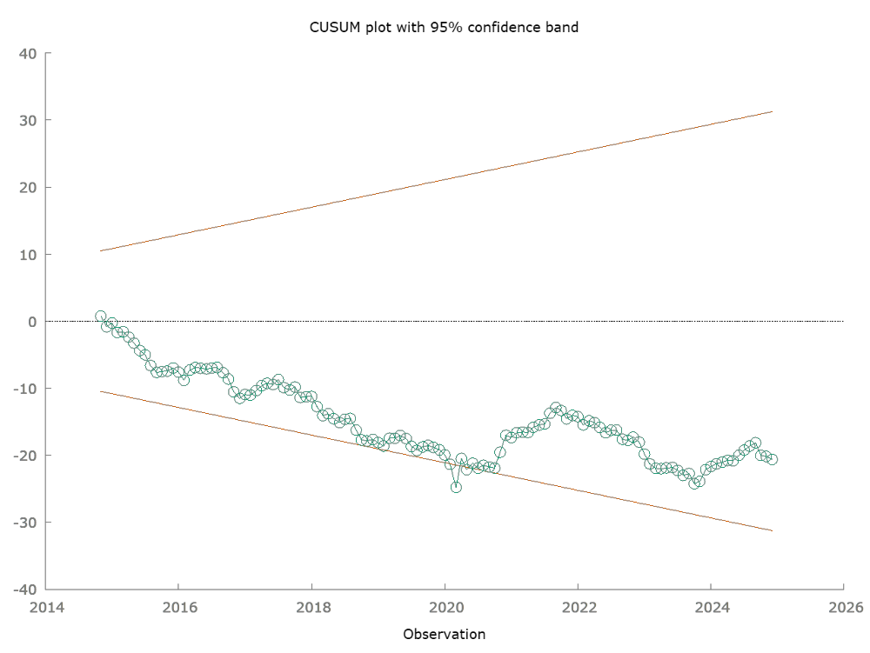
Figure 4.1: Nifty 100 CUMSUM Test
Table 4.3 summarises the diagnostic tests. Parameter stability is borderline. The CUMSUM (Harvey-Collier) statistic is significant at the 10% but not 5% level which is consistent with the mild drift traceable to the 2014-2016 oil price collapse and the 2016 demonetisation rather than formal structural break. CUMSUMSQ shows no boundary breaches which confirms stable residual variance. No residual autocorrelation is present. Variance Inflation Factors are high for oil and CPI lag terms which is expected when testing lagged partial sums jointly and negligible for dummy variables. This does not compromise the bounds test and the Wald test conclusions but limits interpretation of individual lag coefficients.
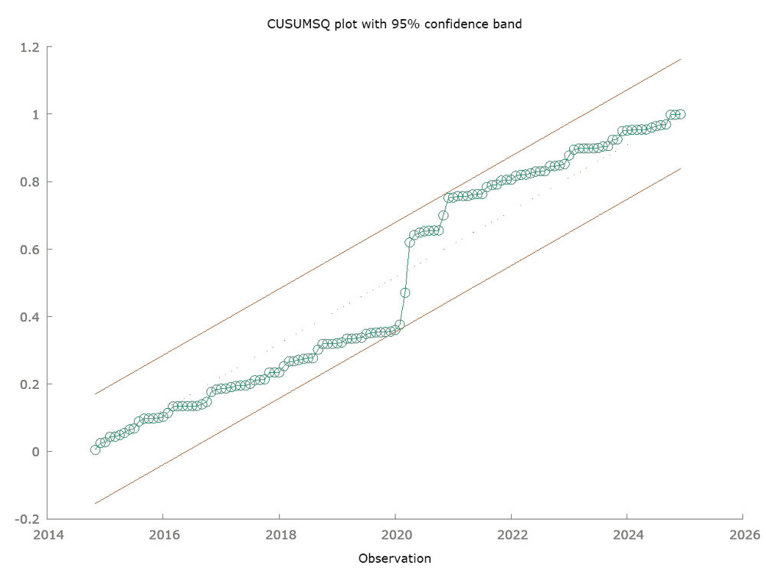
Figure 4.2: Nifty 100 CUMSUMSQ Test

Table 4.4 Nifty 100 Long Run Multipliers (Bootstrap and Bewley 2SLS)
Variable | Bootstrap Mean (S.D) | Bewley 2SLS (S.D.) | Remarks (at 95% confidence)
OilPlus | 0.0841 (0.1014) | 0.1087 (0.1275) | Not distinguishable from 0
OilMinus | 0.0944 (0.1025) | 0.1064 (0.1308) | Not distinguishable from 0
CPI | 2.5675 (1.1600) | 2.4443 (1.5771) | Distinguishable from 0
Error Correction | -0.2212 (0.0662) | - | -22.12% adjustment every month

The bootstrap long-run multipliers (999 iterations) and the Bewley’s 2SLS are given in the table 4.4. The Bootstrap Long run are the main multipliers and the Bewley is here as supporting figures for the bootstrap estimates. The error-correction coefficient was -0.2212 indicating that approximately 22.12% of any short-run deviation from the long-run equilibrium is corrected each month.
The dynamic multiplier graphs provide a descriptive dimension beyond what formal tests establish.
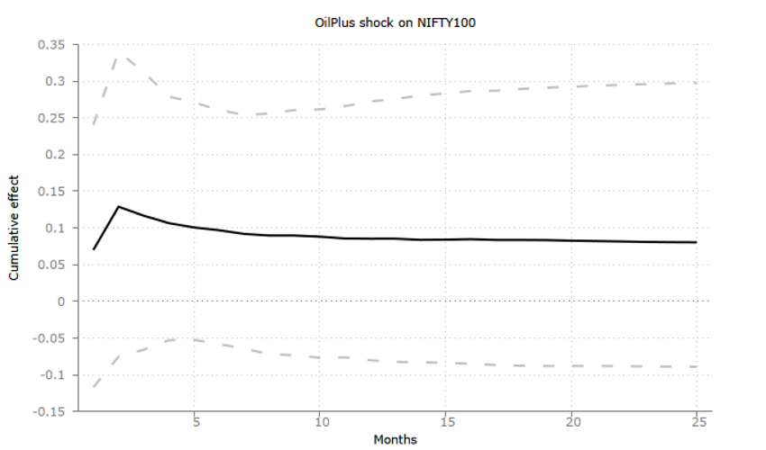Figure 4.3: Effect of OilPlus shock on Nifty 100

After a positive oil-price shock, the cumulative effect on the Nifty 100 rises initially before plateauing approximately to 0.8 to 0.9 by the end of the 24-month period. This is consistent with the reported long-run multiplier of 0.0841.
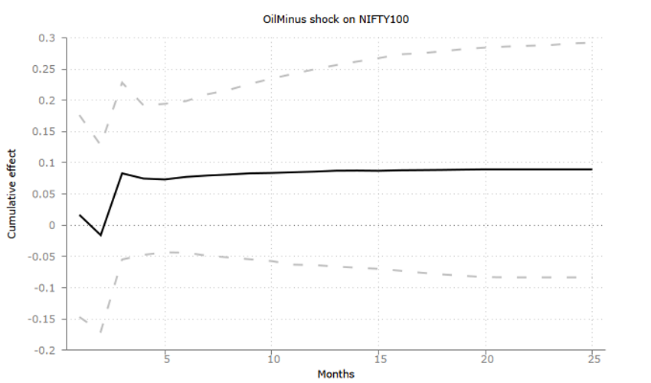
Figure 4.4: Effect of OilMinus shock on Nifty 100
After a negative oil shock, the cumulative effect on the Nifty 100 first dips and then climbs to a plateau near 0.9 by the end of the 24-month period which is consistent with the long-run multiplier of 0.0944.
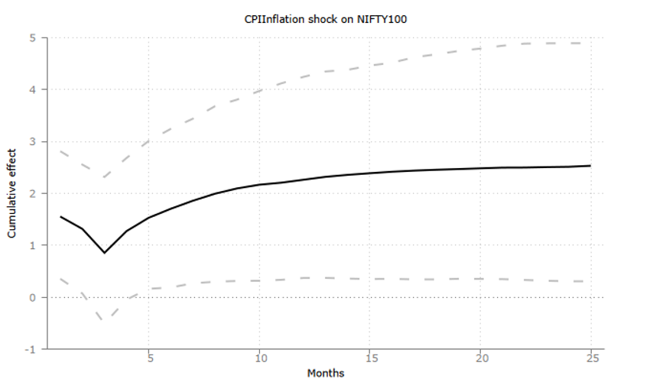
Figure 4.5: Effect of CPI Inflation on Nifty 100
The CPI also dips before to rising to a level of approximately of 2.5 which is consistent with the long-run multiplier of 2.5675. The confidence bands for the oil shocks include 0 consistently indicating that the point estimates cannot be distinguished from 0. Only the CPI remains mostly positive except for short temporary dip. Confidence bands include 0 throughout the full 24-month period which means that the point estimates suggest an overshoot and correct rather than a gradual build of asymmetry in adjustment speed.
This pattern indicates that the absence of long-run asymmetry confirmed by the Wald’s Asymmetry test (Table 4.4) shows us the final effect and not the path that it takes to reach it. The positive oil shock is absorbed rapidly which is shown by the graph before settling. The negative oil shock is absorbed much more slowly and does not overshoot. As the paths converge to statistically indistinguishable levels, the speed and shape of the of the cumulative effect on Nifty 100 should be read as a descriptive observation rather than as evidence of asymmetry under RQ1. CPI is the only independent variable whose long run effect is both economically and statistically different from 0.

4.5 Nifty 100 ESG: Model 2
The unrestricted OLS regression achieved an R² of 0.999714 (adjusted R² of 0.999677). The very high R² is explained by the inclusion of closely related Nifty 100 index as a market-control variable. It should be interpreted as evidence for strong broad-market co-movement rather than as evidence of ESG-specific explanatory power. The more informative evidence for the research questions comes from the bounds test, Wald test, error-correction term, and diagnostic checks reported below.

Table 4.5: Nifty 100 ESG Bounds Test and Wald’s Asymmetry Test
Test | With War Dummy | Without War Dummy
Bounds test (cointegration) | F(5, 124) = 784.579,  p-value = 5.112e-092 | F(5, 125) = 823.325,  p = 7.94e-094
Upper I(1) bound at 1% (k=4) | 5.06 | 5.06
Cointegration confirmed? | Yes | Yes
Wald’s Asymmetry test | F(1,124) = 0.160773,  p-value = 0. 689136 | F(1,125)=0.152308,  p-value=0.697004
Significant Asymmetry | No | No
Here k=4 as Nifty 100 is an additional variable in Model 2 in addition to CPI, positive and negative oil partial sums. Value of K is from (Pesaran, Shin and Smith, 2001)

The bounds test is F(5, 124) = 784.579 (p-value = 5.112e-092) with the war dummy included and F(5, 125) = 823.325 (p = 7.94e-094) without the war dummy. Both figures exceed the upper I(1) critical bound of 5.06 (Pesaran, Shin and Smith, 2001) at 1% significance level at k=4, where Nifty 100 is the fourth variable which confirms that cointegration is robust irrespective of the war dummy. The Wald’s asymmetry test returned F(1,124) = 0.160773 (p-value = 0. 689136) with the war dummy and F(1,125)=0.152308 (p-value=0.697004) without it. Both results fail to reject the null hypothesis of long run symmetry indicating that there is no statistically significant asymmetry in the variables.

Table 4.6: Nifty 100 ESG Diagnostic Test Summary
Diagnostic | Result | Conclusion
CUMSUM (Harvey-Collier) | t(123) = 0.457626,  p-value = 0.648 | Insignificant at 10%
CUMSUMSQ | No boundary breaches | Stable
Breusch-Godfrey (order 2) | LMF = 1.076, p = 0.344 | No autocorrelation
VIF- OilPlus, OilMinus and CPIInflation | Approx. 850 to 4600 | High Multicollinearity
VIF- Nifty 100 and its lags | Approx 100 to 3300 | High Multicollinearity
VIF- War and Covid Dummy | War= 1.581,  Covid= 3.209 | Weak Multicollinearity

Table 4.6 summarises the diagnostic tests. Parameter stability is supported by the CUMSUM statistic which is not significant. This is stronger than Model’s 1 borderline pass. The CUMSUMSQ also shows no boundary breaches and no residual autocorrelation was observed to be present. Variance Inflation Factors (VIF) are high for the oil, CPI and Nifty 100 lag returns which reflects both expected own-lag collinearity and the close co-movement between the indices while the dummy variables remain low. This does not affect the joint test conclusions but limits the interpretation of the individual lag coefficients.
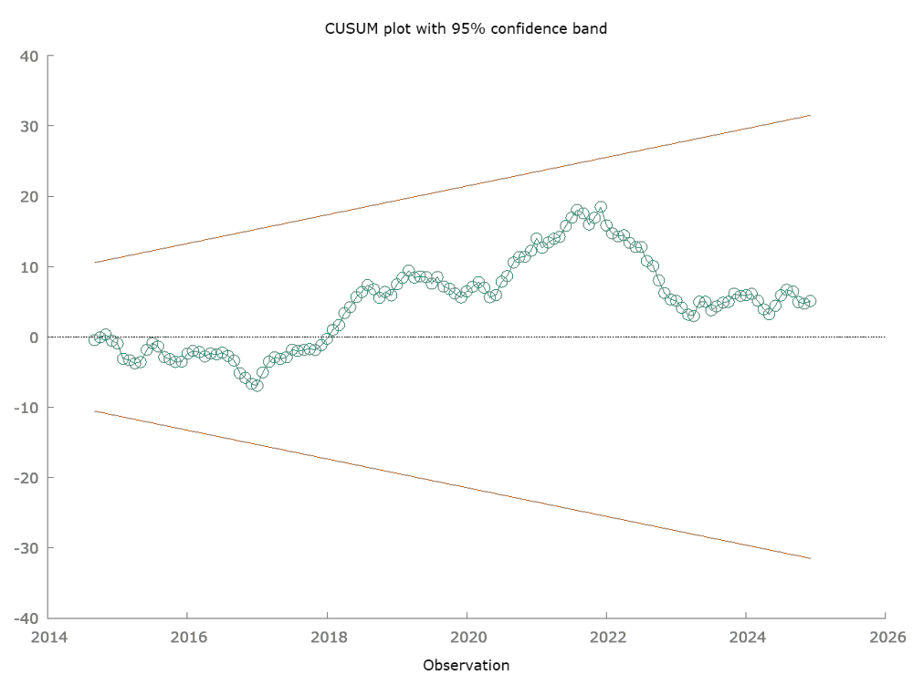
Figure 4.6: Nifty 100 ESG CUMSUM Test
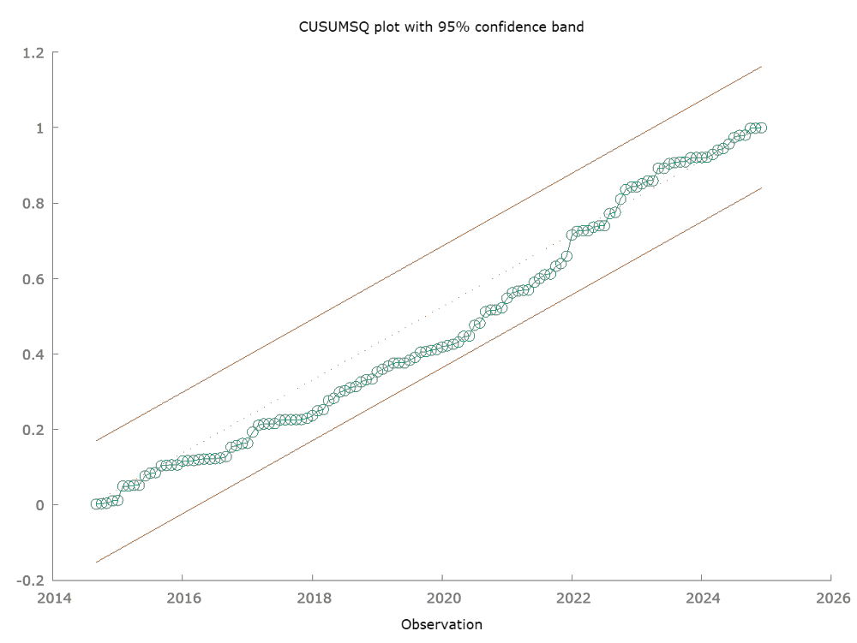
Figure 4.7: Nifty 100 ESG CUMSUMSQ Test
Table 4.7 Nifty 100 ESG Long Run Multipliers (Bootstrap and Bewley 2SLS)
Variable | Bootstrap Mean (S.D) | Bewley 2SLS (S.D.) | Remarks (at 95% confidence)
OilPlus | 0.0186 (0.0573) | 0.0375 (0.0838) | Not distinguishable from 0
OilMinus | -0.0107 (0.0631) | 0.0018 (0.0628) | Not distinguishable from 0
CPI | 0.0024 (0.8882) | 0.0540 (1.3212) | Not distinguishable from 0
Nifty 100 | 0.9368 (0.1541) | 0.8823 (0.2329) | Distinguishable from 0
Error Correction | -0.1135 (0.0579) | - | -11.35% adjustment every month

The bootstrap long-run multipliers (999 iterations) and the Bewley’s 2SLS are given in the table 4.7. The Bootstrap Long run are the main multipliers and the Bewley is here as supporting figures for the bootstrap estimates. The error-correction coefficient was -0.1135 indicating that approximately 11.35% of any short-run deviation from the long-run equilibrium is corrected each month. Unlike Nifty 100 (Model 1) the CPI is not distinguishable from 0. Meanwhile, Nifty 100 is the only which is distinguishable from 0.
The dynamic multiplier paths for Nifty 100 ESG (model 2) are less pronounced than Nifty 100 (model 1).
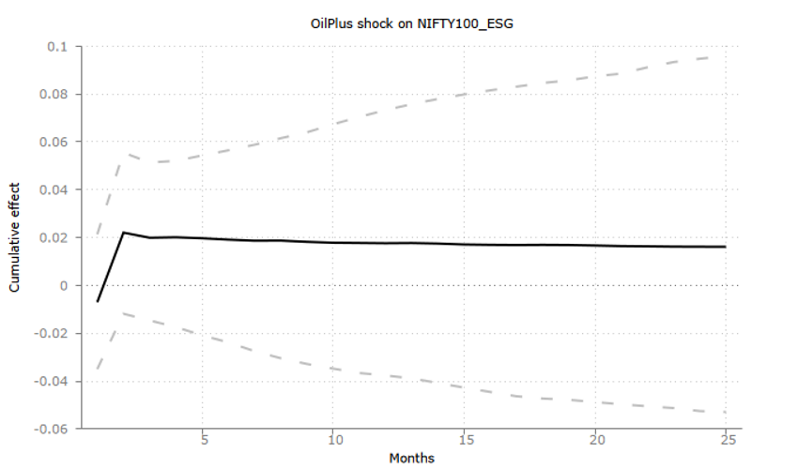Figure 4.8: Effect of OilPlus shock on Nifty 100 ESG
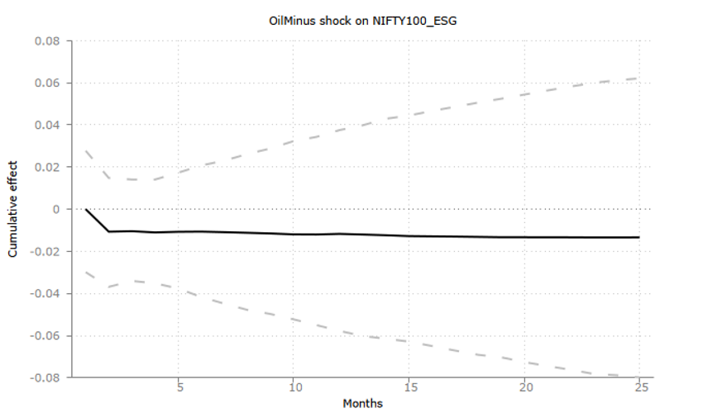
Figure 4.9: Effect of OilMinus shock on Nifty 100 ESG
The response to a positive oil shock rises to a small peak of 0.02 and plateaus out slightly below. The response to a negative oil shock dips to approximately 0.015 before flattening to a plateau.
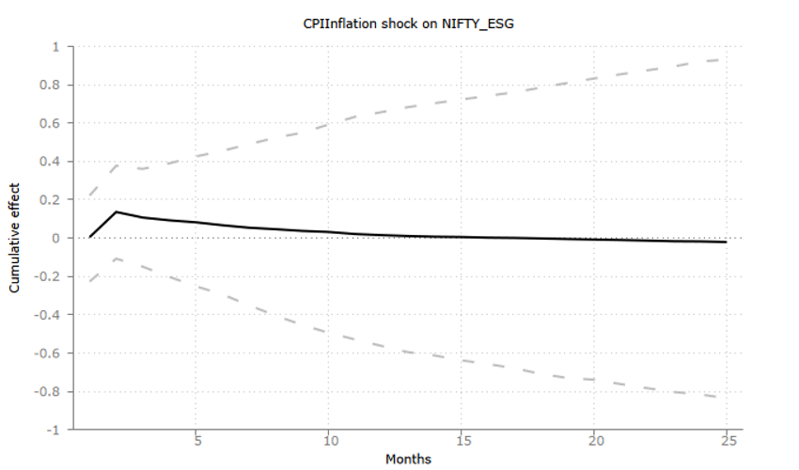
Figure 4.10: Effect of CPI Inflation on Nifty 100 ESG
The CPI after a small early bump falls back to 0. Confidence bands include 0 in all the 3 cases within the 2-year period from 2022 to 2024. This means that none of Nifty 100 ESG (Model 2) individual dynamic multipliers are distinguishable from 0 at any point.
The adjustments paths in Model 2 are comparatively flat and muted when compared to Model 1’s more pronounced where it overshoots and then corrects itself. Thus, the transmission to the sustainable index is not only statistically weaker once the market is controlled for but also slower and shallower in shape.

4.6 Summary of all Findings
This section draws the model-specific results of section 4.4 and 4.5 together and the organises them around our 3 research questions. Table 4.8 summarises the key figures that we will reference throughout the dissertation.
Table 4.8: Cross Model Summary of Key Findings
Results | Nifty 100 (Model 1) | Nifty 100 ESG (Model 2)
Cointegration (with War Dummy) | YES  F(4, 122) = 15.509,  p-value = 2.77051e-010 | YES  F(5, 124) = 784.579,  p-value = 5.112e-092
Cointegration (without War Dummy) | YES  F(4,123) = 15.8174,  p = 1.80e-10 | YES  F(5, 125) = 823.325,  p = 7.94e-094
Long-run Asymmetry (with War Dummy) | NO  F(1, 122) = 0.000295109, p-value = 0.98632 | NO  F(1,124) = 0.160773,  p-value = 0. 689136
Long-run Asymmetry (without War Dummy) | NO  F(1, 123) = 0.0658539,  p-value = 0.797901 | NOF(1, 125) = 0.152308,  p = 0.697004
Parameter Stability (CUMSUM) | p-value= 0.06414  Insignificant at 5% but significant at 10% | p-value = 0.648  Insignificant at 10%
Error Correction Speed | -0.2212 | -0.1135
Long-run CPI multiplier | 2.5675  (distinguishable from 0) | 0.0024  (indistinguishable from 0)
Structural break | June 2022 | Sept 2020

4.6.1 Research Question 1: Long-Run Oil Price Asymmetry
RQ1 asks whether rising oil prices have a more negative long-run effect on equity returns than falling oil prices have a positive effect. The Wald test found no statistically significant difference between the cumulative long-run positive (OilPlus) and negative (OilMinus) oil prices in either model with or without the war dummy. Model 1 reported F(1, 122) = 0.000295109 and p-value = 0.98632 while Model 2 reported F(1,125)=0.152308 and p-value=0.697004. This does not provide any evidence to reject the null hypothesis of long-run asymmetry under RQ1 and therefore does not support “rockets and feathers” pattern as described by (Bacon, 1991) in aggregate equity returns over the sample period.
Salisu and Isah (2017) find that across a panel of oil-importing and oil-exporting economies that oil spikes penalise equity indices roughly twice as severely as equivalent falls benefit them. However, our dissertation which solely focuses on India does not replicate that pattern for either of our chosen indices. The result instead aligns with Cunado and Perez de Gracia (2005) who finds asymmetric oil-macroeconomy transmission in some but not all of the six Asian economies studied and with Xu (2015) where UK sector level evidence for directional asymmetry is sector specific. The results indicate that asymmetric transmission is not a universal property of all equity markets but that it depends of the country and sector context.
The equity-symmetry finding is complimentary rather than inconsistent with Abu-Bakar and Masih (2018) finding that there is significant long-run asymmetry between oil and CPI in India since the two-studies test asymmetry in different transmission stages (CPI pass-through versus equity valuation). Taken together, they suggest the ‘rockets and feathers’ pattern may survive at the inflation stage of Indian oil-price transmission while not extending to the equity-pricing stage. However, in this dissertation which estimates CPI and equity return channels jointly cannot provide evidence that the Nifty 100 ESG Index exhibits a long-run oil-price asymmetry which is different from the conventional Nifty 100 and should not be interpreted as a causal effect of ESG compliance. We therefore cannot reject RQ1 for either equity segment.

4.6.2 Research Question 2: Conventional versus Sustainable Inflation Transmission
RQ2 asks how the sustainable ESG model responds to domestic CPI under energy market stress when broad-market co-movement is taken into account. Model 1 estimates a positive long-run CPI multiplier of 2.5675 which is statistically distinguishable from 0. Model 2 estimates a long-run CPI multiplier of 0.0024 which is not statistically distinguishable from zero. This is evidence that the ESG index has no independently detectable CPI relationship once broad-market co-movement is taken into account. The two coefficients are estimated in different equations and no formal cross testing was done, hence this is not evidence that CPI coefficient in model 2 is significantly lower than Model 1.
This collapse is due to the inclusion of the Nifty 100 as a control variable in model 2 where the long run coefficient is 0.9368 (S.D. = 0.1541) which is the only estimated long-run relationship that is distinguishable from 0. Once broad-market co-movement is netted out, the ESG index’s own independent sensitivity to CPI becomes statistically undetectable. This suggests that any CPI effect in the Nifty 100 ESG Index is likely coming from its strong link with the wider market (Nifty 100) rather than from a separate sustainability related channel.
This finding does not indicate that ESG-screened Indian equities are immune to inflationary pressure in general. Chalissery, Nishad and Milinth (2025) found that Indian ESG-screened indices are not fully shielded from oil price uncertainty and the exposure intensifies during market stress. Our results tell us that once the ESG index’s co-movement with the conventional market is explicitly controlled within the same equation, then no separate identifiable CPI channel remains. This test is more specific test than volatility-spillover used in Chalissery, Nishad and Milinth (2025) and it also differs from the Duan et al. (2024) where global ESG index does not include a conventional index and therefore cannot separate ESG-specific channel from broad market co-movement.
This pattern is also visible at the level of individual coefficients. The CPI terms are statistically significant in Model 1 but not in Model 2. The conventional Nifty 100 retains a clear precisely estimated positive long-run inflation exposure whereas the Nifty 100 ESG Index’s own exposure does not exhibit a statistically distinguishable inflation effect after considering its correlation with the conventional market is considered.
4.6.3 Research Question 3: Are equity indices stable after the War window
RQ3 asks whether the long-run relationship and the absence of asymmetry observed in either model is dependent on the February-June 2022 war window. For both models, the bounds test and Wald test results are unchanged irrespective of whether dummy is present or not. This supports the interpretation that the main findings are not solely driven by the 2022 war period. The \war-dummy coefficient indicates a disturbance but they do not provide evidence for a structural break.
The robustness evidence indicates that the cointegration and the lack of long-run asymmetry are stable and are not materially dependent on the 2022 war period in either model. This is important as the war dummy is itself individually significant in both unrestricted regressions (model 1: p-value = 0.0226; model 2 : p-value = 0.0463) which suggests that the February-June 2022 period genuinely disrupted both indices but the present design cannot distinguish the direct oil-price effect from the monetary policy effect. Excluding the 2022 war dummy leaves the bound test and Wald test conclusions remain unchanged. Although the war dummy captures a disturbance, the evidence for long run asymmetry is not driven the war period.
4.6.4 Comparability of Fit Statistics across Models
Nifty 100 ESG (Model 2) R² (0.999714), overall F-statistic (F(16, 124) = 27087.43) and bounds test F-statistic (F(5, 124) = 784.579) are all substantially larger than their Nifty 100 (Model 1) counterparts (R² = 0.989813), (F(17, 122) = 697.2765); F(4, 122) = 15.509). This does not mean that Model 2 is better specified or more successful in capturing the effects oil and CPI.
When the long-run level terms are jointly restricted to 0, the standard error increases from 0.043593 to 0.0526841 (approx. 20.85%) in Model 1 and from 0.007883 to 0.0441539 (approx. 460.12%) in Model 2. This larger reaction in Model 2 is because restricting Model 2 forces the Nifty 100 control variable to 0 along with oil and CPI. The unrestricted Nifty 100 control coefficient (0.974995) alone is responsible for the majority of Model 2’s explanatory power. This comparison reinforces that Model 2 is dominated by the broad-market co-movement.
The same mechanism is also applicable in the Variance Inflation Factors for the Nifty 100 and its lags and the Nifty 100 ESG and its own lags. The high VIFs reflect close co-movement between the indices and correlation introduced by the model specification. While they do not automatically invalidate the joint bounds test or Wald test however, they reduce precision in individual coefficient estimates. Model 2 is therefore interpreted as a conditional comparison rather than identification of independent ESG effect.

4.7 Chapter Summary
Across both models, the bounds tests provide strong evidence of long-run relationship between equity returns, oil price and CPI and this relationship holds robustly whether or not the 2022 war window is included or not (RQ3). Neither the conventional nor the sustainable index shows statistically significant long-run directional asymmetry between oil price rises and falls and therefore ESG compliance does not meaningfully change the character of oil price transmission (RQ1). Model 1 reports a statistically significant positive long-run CPI coefficient whereas the CPI coefficient in Model 2 is not statistically distinguishable from zero once its co-movement with the broader market is taken into account (RQ2). However, it should not be interpreted that ESG characteristics lowers sensitivity to inflation.

Chapter 5: Discussion
5.1 Introduction
This dissertation compares the long-run transmission of global crude oil price shocks and domestic inflation to India’s conventional (Nifty 100) and sustainable (Nifty 100 ESG) equity markets over 2013-2024 with Nifty 100 included as an additional market-control variable using a Nonlinear Autoregressive Distributed Lag (NARDL) framework. Three research questions were aimed to be answered by the empirical analysis. Whether oil price increases have a more severe long-run effect on equity returns rather than oil price decreases (RQ1). How the ESG index’s exposure to CPI inflation compares with the conventional benchmark (RQ2). Whether the cointegrating relationship identified in both models is a stable structural feature of the sample or an artefact of the 2022 Russia-Ukraine war window (RQ3). This chapter draws on the findings from chapter 4 to each research question and compares them to literature reviewed in chapter 2. It helps us understand the main theme of the dissertation which is whether ESG compliance provides insulation from energy and inflation shocks.

5.2 Research Question 1: Long-Run Oil Price Asymmetry
The Wald coefficient-restriction does not reject equality between the long-run OilPlus and OilMinus multipliers in either model with or without the war dummy (Table 4.4 and 4.7). Thus, neither the conventional Nifty 100 nor the sustainable Nifty 100 ESG index exhibits statistically significant long-run directional asymmetry. The evidence is therefore consistent with long-run symmetry but it should not be interpreted as proof that effects are exactly equal. Instead, the available evidence is insufficient to reject the symmetry restriction.
This finding diverges to some extent from much of the oil literature that motivated the study’s design. Mork (1989) and Bacon (1991) established the theoretical basis for asymmetric transmission of oil prices which was the “rockets and feathers” phenomenon. Salisu and Isah (2017) applies a nonlinear panel ARDL framework across seventeen net oil-importing economies and found that oil price spikes penalise equity indices roughly twice as severely as equivalent drops benefit them. The absence of any detectable asymmetry in either Indian index is therefore departure from the above literature and not evidence for them.
One plausible explanation is the level at which transmission is being measured. Bacon (1991) describes his “rockets and feathers” retail fuel pricing mechanism where firms facing rising wholesale costs pass them through quickly to preserve margins but are slow to lower prices when costs fall. This mechanism is rooted in retail pricing challenges, menu costs and firm-level strategic behaviour. Equity index returns reflect forward-looking aggregated investor expectations about future corporate cash flows and discount rates. If equity investors incorporate expected direction and magnitude of oil shock effects efficiently and quickly then oil like asymmetry which is found in retail fuel prices may not appear in monthly equity data. This interpretation is a possible explanation rather than a mechanism identified in this study and would be explored in a future research study.

5.3 Research Question 2: Conventional and Sustainable Approaches to the Inflation Channel
Model 1 estimates a long-run CPI multiplier of 2.5675 which is statistically distinguishable from 0. Model 2 on the other hand estimated a long-run CPI multiplier of 0.0024 which is not statistically distinguishable from zero after broad-market co-movement is taken into account. The results show a significant CPI relationship in the conventional index but no independently identifiable CPI relationship in the ESG screened index.
This difference between the two models happens due to the inclusion of Nifty 100 as a control variable in Model 2. The Nifty 100 has long-run coefficient of 0.9368 which is broad-market co-movement. Once it is considered in the model 2, the ESG index’s own CPI coefficient is not independently identifiable. This is the dissertation’s central comparative finding which is addressed in RQ 2. The conventional index retains a clear positive long-run inflation exposure while the ESG index’s inflation exposure cannot be distinguished from zero once market co-movement is taken into account.
This result is directly comparable with the theoretical framework of Abhyankar, Xu and Wang (2013) under which external oil and inflation shocks can disrupt expected corporate cash flows. A further aim of the dissertation was to examine whether ESG compliance is associated with greater insulation from these shocks. The evidence obtained here does not support such insulation that ESG screened indices would have over conventional indices. Rather than showing that ESG compliant firms would experience a smaller or delayed cash-flow shock from inflation, the results indicate that the ESG index’s independently detectable CPI sensitivity is not statistically significant once co-movement with the conventional Nifty 100 is controlled for. This weakens but does not causally disprove the cash-flow insulation hypothesis.
This finding also addresses the literature gap identified in chapter 2. Mishra and Acharya (2022) documented an asymmetric oil-equity return relationship for Indian renewable energy firms specifically using NARDL approach. However, their analysis was restricted to renewable energy companies. The literature reviewed in this dissertation does not identify a study that applies a comparable NARDL model to a broad, cross-sectoral Indian ESG index. The present findings suggest that sector specific insulation reported for renewable energy firms does not necessarily generalise to a diversified ESG-screened Index once broad-market co-movement is taken into account.

5.4 Research Question 3: Stability Across the War window
The bounds test and the Wald test F statistics are materially unchanged when the war dummy is excluded for both the models (table 4.10). Both bound test statistics remain comfortably above their respective upper bounds and both Wald tests fail to reject symmetry. This robustness check supports the conclusions that the study’s principal findings are not solely driven by the six-month 2022 war window.

5.5 Dilution rather Insulation
Taken together, the findings do not support the claim that ESG screening provides an identifiable insulation from oil-price or inflation shocks in the estimated models which originally motivated this dissertation study. No statistically significant asymmetry was detected in either index. More importantly, the sustainable index’s independently identifiable CPI sensitivity becomes indistinguishable from zero once broad market co-movement is accounted for. The more defensible interpretation would be “dilution rather than insulation”. The study identifies a reduction in the detectable CPI sensitivity in the ESG model but does not state that ESG screening caused that reduction.
This weakens the cash-flow insulation hypothesis that motivated the study and is in contrast to earlier Indian studies such as Singhal and Ghosh (2016) and Jain and Ghosh (2013) which rely on linear frameworks which are not designed to separate a sustainability-specific channel from broad-market co-movement in the first place. By explicitly controlling for the conventional index (Nifty 100) within the ESG equation, this dissertation is able to address a gap that was not explored earlier. An ESG index’s apparent sensitivity may be due to its correlation with the conventional market it is drawn from rather than being independently identifiable as a separate effect. This distinction between apparent relationship and an independently verified relationship is a principal empirical contribution of the dissertation within the Indian context.

Chapter 6: Conclusions
6.1 Summary of the Study
This dissertation examined whether the global crude oil price shocks and domestic inflation transmit asymmetrically and differentially to India’s conventional (Nifty 100) and sustainable (Nifty 100 ESG) equity markets from January 2013 to December 2024 using two related NARDL models. This dissertation is motivated by a gap in the preexisting literature. There is absence of any quadrivariate NARDL study applying a broad, cross-sectoral ESG index rather than a narrow environmental or sustainable portfolio. This study estimated two parallel quadrivariate NARDL models by decomposing Brent crude oil price changes into positive and negative partial sums and testing for long-run asymmetry, cointegration and structural stability with the Nifty 100 included as an additional control in the sustainable model to assess whether the ESG index exhibits an independent relationship beyond broad-market co-movement. The models were estimated using Gretl and the ADMBP add-on which provides long-run multiplier and dynamic multiplier charts.
6.2 Addressing the Research Questions
The results obtained and discussed in Chapter 4 and 5 can be summarised against the three research questions. RQ1 asks whether rising oil prices affect equity returns more severely than falling oil prices benefit them. The Wald test found no statistically significant difference between the positive and negative oil-price effects in either Nifty 100 and Nifty 100 ESG model. Therefore, there is insufficient evidence to reject the null hypothesis of long-run symmetry. RQ2 asks how the ESG index’s inflation sensitivity compares with the conventional Nifty 100. The conventional Nifty 100 has a statistically significant positive long-run CPI coefficient whereas the ESG model’s CPI coefficient was not statistically distinguishable from zero after co-movement with the conventional index (nifty 100) was controlled for. RQ3 asks whether the relationship is unchanged if the 2022 Russia-Ukraine war window is excluded from the model. Both the bounds test and Wald test results were materially unchanged irrespective of whether the war dummy is present or absent in the model. It confirms that the underlying relationship is not specifically driven by the war period.
6.3 Implications for Practitioners
This dissertation study is significant for portfolio managers and institutional investors who are constructing or marketing ESG-labelled equity products in the Indian market. The evidence does not support marketing the Nifty 100 ESG Index as an independently identifiable protection from inflation or oil-price shocks. Once co-movement with Nifty 100 is accounted for, the Nifty 100 ESG index’s independently detectable the long-run CPI sensitivity is not statistically distinguishable from zero. This should not be interpreted as evidence that ESG products are unaffected by inflation or oil shocks. Rather, it means that no inflation or energy-related shock insulation that can be specifically attributable to ESG screening is detected in the estimated model. Risk models and marketing materials that frame ESG allocation as a hedge against oil-price shocks or inflationary shocks in the Indian equity markets should be revisited in light of this finding.
For households and macro-economic analysts, the estimated long-run oil-price effects do not differ significantly in either index. This suggests that the “rockets and feathers” pattern documented in retail fuel pricing does not straightforwardly apply to aggregated equity index returns in the market over the sample period. This distinction matters for how energy shocks are communicated to retail investors. The households face asymmetric cost of living pressure from rising fuel prices at the point of consumption however the evidence we obtained from our tests indicates that equity markets appear to price in the long-run consequences of oil price movements in either direction once the shock has been fully absorbed in the system.
The positive long-run CPI multiplier identified in the conventional model (Nifty 100) also carries a direct implication for asset allocation during inflationary pressure on the economy. When CPI inflation rises, the conventional index’s long-run level also rises within the model’s specification. For practitioners the conventional index’s inflation exposure remains a useful input for inflation-based asset allocation but the absence of a comparable independently identifiable channel in the ESG index means these products based on the ESG-screened index should not be marketed as a hedge against oil or inflation as per the evidence presented in this dissertation.

6.4 Implications for Academic Research
This dissertation’s principal academic contribution is comparative and methodological. The extended NARDL equation for the ESG index has the conventional index entered as an explicit control variable. This separates the ESG index’s sensitivity from the sensitivity of broad-market co-movement which earlier Indian studies which relied on linear, symmetric, single-equation frameworks were not designed to draw. This finding does not support cash-flow insulation hypothesis that motivated the study. Instead, it suggests that external oil shocks may still disrupt the expected cash flows as it was originally believed. The evidence in this dissertation indicates that ESG compliance does not provide an independently identifiable insulation against energy shocks in the Indian large-cap segment. Before Indian NARDL applications had examined diversified ESG portfolios only within narrow renewable-energy sector. This dissertation study extends that work to a broad ESG index dominated by banking, technology and consumer services.
The result of this dissertation that no long-run asymmetry was found in either equity index also leads to broader question about whether asymmetric energy transmission which is well established at the retail-price level also hold true at the individual national equity markets. The evidence in the Indian market does not support such generalisation at the aggregate index level which suggests that the strength of asymmetric transmission may depend on the sector composition, portfolio composition and other factors under study rather than being a common feature of oil-equity relationships. Future comparative work based on India and other net oil-importing countries would help establish whether this is a feature which is specific to the Indian equity market or a broader pattern of asymmetry being a retail-price phenomenon rather than an asset-price one.

6.5 Limitations
There are several limitations to this study. These limitations vary in how directly they bear on the dissertation’s main findings. The most important is the high multicollinearity associated with the oil partial sums in Model 2 and the close relationship between the Nifty 100 and Nifty 100 ESG indices and the inability to separate inflation transmission from monetary policy response and the aggregate index-level design. These limitations mean that the findings should be interpreted as conditional associations rather than as causal evidence that ESG screening change shock transmission.
The primary estimation was conducted on Gretl after EViews produced near-singular matrix. The use of bootstrap and Bewley estimators provide an internal robustness check within Gretl. The results have not been independently replicated on a second full estimation platform. There is a reproducibility limitation rather than evidence that Gretl estimates are incorrect.
The second limitation is the comparability of the two models that was necessary to assess the ESG relationship conditional on broad-market co-movement. Model 2 includes Nifty 100 as a control even though the ESG index is closely related to the conventional Nifty 100 index. The R² and bounds statistic of Model 2 is driven by partly by broad-market co-movement between the two indices. This is structural feature of the model design and should not be interpreted as evidence of an independent ESG effect. The fit statistics of the two models should not be compared directly to claim that one is better than the other.
Third, the stability test for Model 1 was marginal at 10%. The dissertation’s structural dummies address the 2020 COVID-19 lockdown and the 2022 war window specifically but the 2014-2016 global oil price collapse and other possible changes in the data were not assigned a dedicated structural dummy. This limits the strength of any claim that the long-run parameters are stable over the sample period.
Fourth, the Variance Inflation Factors are high for oil and CPI lag terms in both models and the Nifty 100 term in Model 2. The bounds test and the Wald test address the relevant restrictions rather than relying on individual coefficients. However, multicollinearity reduces the precision of individual coefficient estimates. Individual lags coefficients should therefore not be used as evidence to interpret the timing or magnitude of transmission.
Fifth the CPI coefficient captures a combined association between the domestic price level and the equity index. The models cannot distinguish between oil-cost channel, monetary policy channel or other inflation-related mechanisms. The RBI policy response to the 2022 inflation is not directly addressed in this model. Therefore, the CPI coefficient should not be interpreted as a pure causal inflation effect.
Finally, the analysis is conducted at the aggregate index level. It therefore does not identify firm-level or sector level differences. It does not examine the extent to which the constituent firms overlap between the two indices. Because the ESG index is derived from the broader market, this overlap is important while making a comparative study. In addition, the structural dummies identify only two discrete shocks within the sample period. Other structural changes are not modelled explicitly but are instead absorbed into the long-run relationship. This may consequently understate the extent to which the estimated coefficients may vary over smaller periods within the sample.

6.6 Future Research
A simple extension of this dissertation study would be to decompose the ESG index by sector and explicitly quantify the constituents overlap with a conventional index, to determine whether the low inflation sensitivity found here applies consistently across the ESG index or is specific to the most conventionally-related ESG shares in the ESG index. Future research could also use a direct measure of monetary policy such as the RBI repo rate to distinguish inflation, oil-cost and monetary policy response channel. Finally, a larger sample size and cross-validating the Gretl-based estimates against an alternative software platform when the multicollinearity constraints that affected EViews estimation in this study are resolved, would strengthen confidence in the long-run multipliers reported which could not be done in this dissertation due to time constraints. Future work should use a formal cross-equation framework or bootstrap test to compare the CPI coefficients across both the indices to test if inflation sensitivities are statistically different.
References
Abhyankar, A., Xu, B. and Wang, J. (2013). Oil Price Shocks and the Stock Market: Evidence from Japan. The Energy Journal, [online] 34(2), pp.199–222. Available at: https://www.jstor.org/stable/41970486.
Abu-Bakar, M. and Masih, M. (2018). Is the oil price pass-through to domestic inflation symmetric or asymmetric? new evidence from India based on NARDL. doi:10.13140/RG.2.2.20039.19363.
Bacon, R.W. (1991). Rockets and feathers: the asymmetric speed of adjustment of UK retail gasoline prices to cost changes. Energy Economics, 13(3), pp.211–218. doi:10.1016/0140-9883(91)90022-r.
Bernanke, B.S., Gertler, M., Watson, M. and Friedman, B.M. (1997). Systematic Monetary Policy and the Effects of Oil Price Shocks. Brookings Papers on Economic Activity, 1997(1), p.91. doi:10.2307/2534702.
Breusch, T.S. (1978). Testing for Autocorrelation in Dynamic Linear Models. Australian Economic Papers, [online] 17(31), pp.334–355. doi:10.1111/j.1467-8454.1978.tb00635.x.
Caldara, D. and Iacoviello, M. (2022). Measuring geopolitical risk. American Economic Review, [online] 112(4), pp.1194–1225. doi:10.1257/aer.20191823.
Caldara, D. and Iacoviello, M. (2026). Country-Specific GPR: Europe (North and East). [online] www.matteoiacoviello.com. Available at: https://www.matteoiacoviello.com/gpr_country_files/gprc_neeu.htm.
Chalissery, N., Nishad, T.M. and Milinth, P. (2025). Are oil price shocks driving india’s sustainable sector? A closer look at crisis-induced dynamics. Sustainability Accounting, Management and Policy Journal, [online] 16(6), pp.1779–1806. doi:10.1108/SAMPJ-11-2024-1247.
Cottrell, A. and Lucchetti, R. (2022). Gretl User’s Guide Gnu Regression, Econometrics and Time-series Library. [online] Available at: https://gretl.sourceforge.net/gretl-help/gretl-guide.pdf [Accessed 13 July 2026].
Cunado, J. and Perez de Gracia, F. (2005). Oil prices, economic activity and inflation: evidence for some Asian countries. The Quarterly Review of Economics and Finance, 45(1), pp.65–83. doi:10.1016/j.qref.2004.02.003.
Duan, K., Tan, J., Ren, X. and Taghizadeh-Hesary, F. (2024). How does green investment respond differently to decomposed oil shocks? Resources policy, [online] 92, p.104997. doi:10.1016/j.resourpol.2024.104997.
Godfrey, L.G. (1978). Testing Against General Autoregressive and Moving Average Error Models when the Regressors Include Lagged Dependent Variables. Econometrica, 46(6), pp.1293–1301. doi:10.2307/1913829.
Goel, H., Bajaj, P., Gupta, S., AlKhawaja, A. and Dsouza, S. (2025). Nexus between stock market and macroeconomic indicators: An NARDL approach - ProQuest. [online] Proquest.com. Available at: https://www.proquest.com/openview/cc5321ae10842b62495fe2feda8ebaba/1?pq-origsite=gscholar&cbl=4368392.
Gretl Command Reference (2020). Gretl command reference. [online] Sourceforge.net. Available at: https://gretl.sourceforge.net/gretl-help/cmdref.html.
Hamilton, J. D (1983). Oil and the Macroeconomy since World War II. Journal of Political Economy, [online] 91(2), pp.228–248. doi:10.2307/1832055.
Harvard Extension School (2021). What Is Sustainable Finance and Why Is It Important? | Harvard Extension School. [online] Harvard Extension School. Available at: https://extension.harvard.edu/blog/what-is-sustainable-finance-and-why-is-it-important/#Sustainable-Finance-Jobs-on-the-Rise.
Jain, A. and Ghosh, S. (2013). Dynamics of global oil prices, exchange rate and precious metal prices in India. Resources Policy, 38(1), pp.88–93. doi:10.1016/j.resourpol.2012.10.001.
Kwiatkowski, D., Phillips, P.C.B., Schmidt, P. and Shin, Y. (1992). Testing the null hypothesis of stationarity against the alternative of a unit root. Journal of Econometrics, 54(1–3), pp.159–178. doi:10.1016/0304-4076(92)90104-y.
Ministry of Petroleum and Natural Gas (2023). IPNG Annual Report 2022–23. [online] Ministry of Petroleum and Natural Gas, Government of India. Available at: https://mopng.gov.in/files/TableManagements/IPNG-Annual-Report-2022-23-web.pdf [Accessed 12 Apr. 2026].
Ministry of Petroleum and Natural Gas (2025). Indian Petroleum & Natural Gas Statistics 2024–25: IPNG statistics report 2024–25. [online] Ministry of Petroleum and Natural Gas. Available at: https://mopng.gov.in/files/TableManagements/2026-02-25-141451-b06fw-IPNG_Statistics-Report_2024-25.pdf [Accessed 12 July 2026].
Mishra, L. and Acharya, R.H. (2022). Oil price effect on asset pricing of renewable energy firms in India: A panel quantile regression approach. International journal of energy sector management, [online] 17(5), pp.904–924. doi:10.1108/ijesm-11-2021-0017.
Mishra, L. and Acharya, R.H. (2024). The Asymmetric Interaction Between Oil Price Change and Stock Returns of the Renewable Energy Companies in India: A Panel NARDL Approach. Asia-Pacific Financial Markets, [online] 32(1), pp.103–116. doi:10.1007/s10690-024-09447-w.
Mork, K.A. (1989). Oil and the Macroeconomy When Prices Go Up and Down: An Extension of Hamilton’s Results. Journal of Political Economy, [online] 97(3), pp.740–744. Available at: https://www.jstor.org/stable/1830464?seq=1.
NSE Indices Limited (2018). Historical Data. [online] Niftyindices.com. Available at: https://www.niftyindices.com/reports/historical-data.
Pesaran, M.H., Shin, Y. and Smith, R.J. (2001). Bounds Testing Approaches to the Analysis of Level Relationships. Journal of Applied Econometrics, [online] 16(3), pp.289–326. doi:10.2307/2678547.
Reserve Bank of India (2023). Reserve Bank of India - Annual Report. [online] Rbi.org.in. Available at: https://www.rbi.org.in/Scripts/AnnualReportPublications.aspx?Id=1374.
Reserve Bank of India (2024). Reserve Bank of India - Annual Report. [online] Rbi.org.in. Available at: https://www.rbi.org.in/scripts/AnnualReportPublications.aspx?Id=1403.
Reserve Bank of India (2026). Reserve Bank of India - Reference Rate Archive. [online] Www.rbi.org.in. Available at: https://www.rbi.org.in/scripts/ReferenceRateArchive.aspx.
Salisu, A.A. and Isah, K.O. (2017). Revisiting the oil price and stock market nexus: A nonlinear Panel ARDL approach. Economic Modelling, 66, pp.258–271. doi:10.1016/j.econmod.2017.07.010.
Schwert, G.W. (1989). Why does stock market volatility change over time? The Journal of Finance, 44(5), p.1115. doi:10.2307/2328636.
Schwert, G.W. (2002). Tests for Unit Roots: A Monte Carlo Investigation. Journal of Business & Economic Statistics, [online] 20(1), pp.5–17. Available at: https://www.jstor.org/stable/1392146.
Shin, Y., Yu, B. and Greenwood-Nimmo, M. (2014). Modelling Asymmetric Cointegration and Dynamic Multipliers in a Nonlinear ARDL Framework. Festschrift in Honor of Peter Schmidt: Econometric methods and applications, pp.281–314. doi:10.1007/978-1-4899-8008-3_9.
Singhal, S. and Ghosh, S. (2016). Returns and volatility linkages between international crude oil price, metal and other stock indices in India: Evidence from VAR-DCC-GARCH models. Resources Policy, 50, pp.276–288. doi:10.1016/j.resourpol.2016.10.001.
Soni, K., Vedi Sivasankar, Ramadas Sendhil and Anandan Pouchepparadjou (2026). Investigating the asymmetric impact of energy on India’s development: insights from the NARDL model. Technological Sustainability, [online] 5(1), pp.61–77. doi:10.1108/TECHS-08-2025-0175.
Suresh G., Naveen R. and Naveenan R. V. (2026). Oil Price and Inflation in India: Exploring Asymmetric Relationship with the NARDL Approach. FIIB Business Review. doi:10.1177/23197145261421703.
Tarassow, A. (2021). The ADMBP addon for gretl. [online] Available at: https://gretl.sourceforge.net/current_fnfiles/unzipped/ADMBP.pdf.
U.S. Energy Information Administration (2026). Europe Brent Spot Price FOB (dollars per barrel), Monthly Series (RBRTE). [online] www.eia.gov. Available at: https://www.eia.gov/dnav/pet/hist/LeafHandler.ashx?n=PET&s=RBRTE&f=M.
Xu, B. (2015). Oil prices and UK industry-level stock returns. Applied Economics, 47(25), pp.2608–2627. doi:10.1080/00036846.2015.1008760.

Appendices
Appendix A: Unit Root and Structural Break Test Results
This appendix reports the full Augmented Dickey-Fuller (ADF), Kwiatkowski-Phillips-Schmidt-Shin (KPSS), and Zivot-Andrews (ZA) test results underlying the stationarity conclusions summarised in Section 4.2.
Table A1: Unit Root and Structural Break Tests – Level Variables
Variable | ADF Tau | ADF P-value | KPSS | KPSS at 1% Critical Value | Zivot-Andrews Break Date | Conclusion
NIFTY100_ESG | -2.801 | 0.1969 | 0.155 | 0.216 | Sept 2020 (5%) | I(1)
NIFTY100 | -2.825 | 0.1879 | 0.193 | 0.216 | June 2022 (10%) | I(1)
LN_CPI | -1.170 | 0.9154 | 0.412 | 0.216 | Nov 2016 (n.s.) | I(1)
OIL_POS | -2.424 | 0.3670 | 0.465 | 0.216 | Apr 2020 (1%) | I(1)
OIL_NEG (with trend and constant) ¹ | -2.469 | 0.3439 | 0.113¹ | 0.216¹ | Jan 2020 (5%) | -
OIL_NEG (constant only) ¹ | -2.469 | 0.3439 | 2.906¹ | 0.737¹ | Jan 2020 (5%) | I(1)

Note: OIL_NEG is a cumulative sum of negative oil price changes and therefore follows a downward deterministic trend. When KPSS test is estimated with constant and trend, the trend absorbs much of the variation in the series which gives us an artificially low KPSS statistic (0.113, p value > 10% ) which fails to stationarity and is in conflict with the ADF result. To avoid this problem, the KPSS test is re-estimated with a constant only. This time the test statistic (2.906) is exceeds the critical value and the p value was less than 1%. Thus, taken together both ADF and KPSS conclude OIL_NEG is non-stationary at levels.

Table A2: Unit Root and Structural Break Tests for First Differenced Variables
Variables | ADF Tau | ADF P-value (at 1%) | KPSS | KPSS at 1% Critical Value | Zivot-Andrews Break Date | Conclusion
NIFTY100_ESG (returns) | -11.874 | 2.685e-25 | 0.039 | 0.737 | May 2020 (5%) | I(0)
NIFTY100 (returns) | -12.064 | 6.476e-26 | 0.044 | 0.737 | Sep 2020 (10%) | I(0)
CPI (log of change) | -8.315 | 5.839e-14 | 0.057 | 0.737 | May 2019 (1%) | I(0)
BrentChange (log of change) | -9.285 | 6.156e-17 | 0.114 | 0.737 | Apr 2020 (1%) | I(0)

ADF regressions for first-differenced series were estimated with constant only as it is consistent which is appropriate for a series in changes rather than levels. Maximum lag length was calculated by Gretl using Schwert (1989) rule to13 lags [max lags= 12*(143/100)^(1/4) for T=143] with the optimal lag automatically by minimising the AIC. All four series are confirmed stationary from both directions and satisfies the integration-order requirement for the bounds test.

Appendix B: Full OLS Regression and Bounds/Wald Test Output
Table B1: Model 1 (Nifty 100) Unrestricted OLS coefficient table
Model 1: OLS, using observations 2013:05-2024:12 (T = 140)
Dependent variable: NIFTY100
Variables | Coefficient | Std. Error | t-ratio | p-value
const | −0.418604 | 1.08198 | −0.3869 | 0.6995
OilPlus | 0.0661490 | 0.0983910 | 0.6723 | 0.5027
OilPlus_1 | 0.0240427 | 0.140066 | 0.1717 | 0.8640
OilPlus_2 | −0.0506671 | 0.137955 | −0.3673 | 0.7141
OilPlus_3 | −0.0226662 | 0.0788728 | −0.2874 | 0.7743
OilMinus | 0.0100941 | 0.0832210 | 0.1213 | 0.9037
OilMinus_1 | −0.0469713 | 0.125429 | −0.3745 | 0.7087
OilMinus_2 | 0.120504 | 0.123890 | 0.9727 | 0.3326
OilMinus_3 | −0.0671229 | 0.0747099 | −0.8984 | 0.3707
CPIInflation | 1.51459 | 0.664635 | 2.279 | 0.0244**
CPIInflation_1 | −1.32103 | 1.08569 | −1.217 | 0.2260
CPIInflation_2 | −0.376646 | 1.08772 | −0.3463 | 0.7297
CPIInflation_3 | 0.562142 | 0.655170 | 0.8580 | 0.3926
CovidDummy | −0.142058 | 0.0547366 | −2.595 | 0.0106**
WarDummy | −0.0548786 | 0.0237667 | −2.309 | 0.0226**
NIFTY100_1 | 0.710876 | 0.0965863 | 7.360 | 2.36e-011 ***
NIFTY100_2 | 0.0747955 | 0.122138 | 0.6124 | 0.5414
NIFTY100_3 | 0.0592501 | 0.0901838 | 0.6570 | 0.5124

R-squared | 0.989813 | Adjusted R-squared | 0.988393
F(17, 122) | 697.2765 | P-value(F) | 8.3e-113
rho | 0.039520

*** significant at 1%, ** significant at 5%, * significant at 10%
Table B2: Model 1 (Nifty 100) Bounds Test (with War Dummy)
Restriction set:
1: b[NIFTY100_1] = 0
2: b[OilPlus] = 0
3: b[OilMinus] = 0
4: b[CPIInflation] = 0
Test statistic: F(4, 122) = 15.509, with p-value = 2.77051e-010
Variables | Coefficient | std. error | t-ratio | p-value
const | 0.18538 | 1.20474 | 0.1539 | 0.878
OilPlus | 0 | 0 | NA | NA
OilPlus_1 | 0.142866 | 0.110166 | 1.297 | 0.1971
OilPlus_2 | −0.105667 | 0.166387 | −0.6351 | 0.5265
OilPlus_3 | −0.00627481 | 0.094913 | −0.06611 | 0.9474
OilMinus | 0 | 0 | NA | NA
OilMinus_1 | −0.0449290 | 0.084584 | −0.5312 | 0.5962
OilMinus_2 | 0.141353 | 0.146626 | 0.964 | 0.3369
OilMinus_3 | −0.0828715 | 0.08384 | −0.9884 | 0.3248
CPIInflation | 0 | 0 | NA | NA
CPIInflation_1 | 1.32331 | 0.78079 | 1.695 | 0.0926*
CPIInflation_2 | −2.01702 | 1.22249 | −1.650 | 0.1014
CPIInflation_3 | 1.13225 | 0.781558 | 1.449 | 0.1499
CovidDummy | −0.266647 | 0.043943 | −6.068 | 1.41e-08***
WarDummy | −0.0677151 | 0.027598 | −2.454 | 0.0155**
NIFTY100_1 | 0 | 0 | NA | NA
NIFTY100_2 | 0.666614 | 0.108443 | 6.147 | 9.60e-09***
NIFTY100_3 | 0.079218 | 0.108153 | 0.7325 | 0.4652

Standard error of the regression = 0.0526841

Table B3: Model 1 (Nifty 100) Wald Asymmetry Test (with War Dummy)
Restriction:
b[OilPlus] + b[OilPlus_1] + b[OilPlus_2] + b[OilPlus_3] - b[OilMinus] - b[OilMinus_1] - b[OilMinus_2] - b[OilMinus_3] = 0
Test statistic: F(1, 122) = 0.000295109, with p-value = 0.986322

Restricted estimates:
Variables | coefficient | std. error | t-ratio | p-value
const | −0.436966 | 0.167065 | −2.616 | 0.01**
OilPlus | 0.066292 | 0.097638 | 0.679 | 0.4984
OilPlus_1 | 0.023917 | 0.139306 | 0.1717 | 0.864
OilPlus_2 | −0.0506412 | 0.137385 | −0.3686 | 0.7131
OilPlus_3 | −0.0228681 | 0.077674 | −0.2944 | 0.7689
OilMinus | 0.010311 | 0.081926 | 0.1259 | 0.9001
OilMinus_1 | −0.0470442 | 0.124847 | −0.3768 | 0.707
OilMinus_2 | 0.12056 | 0.123342 | 0.9774 | 0.3303
OilMinus_3 | −0.0671266 | 0.074405 | −0.9022 | 0.3687
CPIInflation | 1.51816 | 0.628747 | 2.415 | 0.0172**
CPIInflation_1 | −1.32235 | 1.07855 | −1.226 | 0.2225
CPIInflation_2 | −0.376692 | 1.08329 | −0.3477 | 0.7286
CPIInflation_3 | 0.564252 | 0.64094 | 0.8804 | 0.3804
CovidDummy | −0.142018 | 0.054464 | −2.608 | 0.0102**
WarDummy | −0.0548297 | 0.0235 | −2.333 | 0.0213**
NIFTY100_1 | 0.710857 | 0.096186 | 7.39 | 1.95e-011***
NIFTY100_2 | 0.074751 | 0.121613 | 0.6147 | 0.5399
NIFTY100_3 | 0.059085 | 0.089307 | 0.6616 | 0.5095

Standard error of the regression = 0.0434151

Table B4: Model 2 (Nifty 100 ESG) Unrestricted OLS coefficient table
Model 3: OLS, using observations 2013:04-2024:12 (T = 141)
Dependent variable: NIFTY100_ESG

Variables | Coefficient | Std. Error | t-ratio | p-value
const | −0.0407628 | 0.177420 | −0.2298 | 0.8187
OilPlus | −0.00650397 | 0.0164486 | −0.3954 | 0.6932
OilPlus_1 | 0.0343969 | 0.0245955 | 1.399 | 0.1645
OilPlus_2 | −0.0262978 | 0.0143104 | −1.838 | 0.0685*
OilMinus | −0.000476658 | 0.0152779 | −0.03120 | 0.9752
OilMinus_1 | −0.00971283 | 0.0224687 | −0.4323 | 0.6663
OilMinus_2 | 0.0102651 | 0.0122673 | 0.8368 | 0.4043
CPIInflation | 0.0280569 | 0.123110 | 0.2279 | 0.8201
CPIInflation_1 | 0.103113 | 0.187973 | 0.5486 | 0.5843
CPIInflation_2 | −0.128870 | 0.118092 | −1.091 | 0.2773
CovidDummy | 0.00902405 | 0.0100567 | 0.8973 | 0.3713
WarDummy | −0.00908378 | 0.00451402 | −2.012 | 0.0463**
NIFTY100 | 0.974995 | 0.0163637 | 59.58 | 4.12e-093***
NIFTY100_1 | −0.853641 | 0.0902137 | −9.462 | 2.53e-016 ***
NIFTY100_2 | −0.0837744 | 0.0941434 | −0.8899 | 0.3753
NIFTY100_ESG_1 | 0.882995 | 0.0900150 | 9.809 | 3.67e-017 ***
NIFTY100_ESG_2 | 0.0744123 | 0.0944853 | 0.7876 | 0.4325

R-squared | 0.999714 | Adjusted R-squared | 0.999677
F(16, 124) | 27087.43 | P-value(F) | 2.1e-211
rho | −0.030003

*** significant at 1%, ** significant at 5%, * significant at 10%

Table B5: Model 2 (Nifty 100 ESG) Bounds Test (with War Dummy)
Restriction set
1: b[NIFTY100_ESG_1] = 0
2: b[OilPlus] = 0
3: b[OilMinus] = 0
4: b[CPIInflation] = 0
5: b[NIFTY100] = 0

Test statistic: F(5, 124) = 784.579, with p-value = 5.112e-092

Restricted estimates:
Variables | Coefficient | std. error | t-ratio | p-value
const | 1.00394 | 0.910398 | 1.103 | 0.2722
OilPlus | 0 | 0 | NA | NA
OilPlus_1 | 0.098548 | 0.081536 | 1.209 | 0.229
OilPlus_2 | −0.0736463 | 0.076415 | −0.9638 | 0.337
OilMinus | 0 | 0 | NA | NA
OilMinus_1 | −0.0450041 | 0.056563 | −0.7956 | 0.4277
OilMinus_2 | 0.050727 | 0.060295 | 0.8413 | 0.4017
CPIInflation | 0 | 0 | NA | NA
CPIInflation_1 | 0.66786 | 0.601612 | 1.11 | 0.269
CPIInflation_2 | −0.545341 | 0.5935 | −0.9189 | 0.3599
CovidDummy | −0.111434 | 0.039572 | −2.816 | 0.0056***
WarDummy | −0.0728640 | 0.023633 | −3.083 | 0.0025***
NIFTY100 | 0 | 0 | NA | NA
NIFTY100_1 | 0.708153 | 0.097288 | 7.279 | 2.93e-11***
NIFTY100_2 | −1.01740 | 0.198369 | −5.129 | 1.04e-06***
NIFTY100_ESG_1 | 0 | 0 | NA | NA
NIFTY100_ESG_2 | 1.1626 | 0.185936 | 6.253 | 5.45e-09***

Standard error of the regression = 0.0441539

Table B6: Model 2 (Nifty 100 ESG) Wald Asymmetry Test (with War Dummy)
Restriction:
b[OilPlus] + b[OilPlus_1] + b[OilPlus_2] - b[OilMinus] - b[OilMinus_1] - b[OilMinus_2] = 0

Test statistic: F(1, 124) = 0.160773, with p-value = 0.689136

Restricted estimates:
Variables | coefficient | std. error | t-ratio | p-value
const | −0.103126 | 0.085079 | −1.212 | 0.2278
OilPlus | −0.00662583 | 0.016391 | −0.4042 | 0.6867
OilPlus_1 | 0.034504 | 0.024511 | 1.408 | 0.1617
OilPlus_2 | −0.0270123 | 0.014151 | −1.909 | 0.0586*
OilMinus | 0.000807 | 0.014889 | 0.0542 | 0.9569
OilMinus_1 | −0.0105519 | 0.022296 | −0.4733 | 0.6368
OilMinus_2 | 0.010611 | 0.012196 | 0.8701 | 0.3859
CPIInflation | 0.045993 | 0.114311 | 0.4023 | 0.6881
CPIInflation_1 | 0.090533 | 0.184713 | 0.4901 | 0.6249
CPIInflation_2 | −0.116982 | 0.113926 | −1.027 | 0.3065
CovidDummy | 0.009177 | 0.010016 | 0.9163 | 0.3613
WarDummy | −0.00907841 | 0.004499 | −2.018 | 0.0457**
NIFTY100 | 0.974812 | 0.016302 | 59.8 | 7.95e-094***
NIFTY100_1 | −0.853191 | 0.089903 | −9.490 | 2.04e-016***
NIFTY100_2 | −0.0911263 | 0.09203 | −0.9902 | 0.324
NIFTY100_ESG_1 | 0.882211 | 0.089691 | 9.836 | 2.94e-017***
NIFTY100_ESG_2 | 0.081319 | 0.09259 | 0.8783 | 0.3815

Standard error of the regression = 0.00785671

Appendix C: Diagnostic Test Output
Table C1: Model 1 (Nifty 100) Breusch-Godfrey Test for Autocorrelation
Breusch-Godfrey test for autocorrelation up to order 3
OLS, using observations 2013:05-2024:12 (T = 140)
Dependent variable: uhat
Variable | coefficient | std. error | t-ratio | p-value
Const | 0.083705 | 1.08541 | 0.07712 | 0.9387
OilPlus | 0.002086 | 0.102961 | 0.02026 | 0.9839
OilPlus_1 | 0.02069 | 0.14117 | 0.1466 | 0.8837
OilPlus_2 | −0.00648127 | 0.140431 | −0.04615 | 0.9633
OilPlus_3 | −0.00960293 | 0.081397 | −0.1180 | 0.9063
OilMinus | −0.0172723 | 0.083946 | −0.2058 | 0.8373
OilMinus_1 | 0.074151 | 0.130952 | 0.5662 | 0.5723
OilMinus_2 | −0.0992891 | 0.133822 | −0.7419 | 0.4596
OilMinus_3 | 0.046123 | 0.078493 | 0.5876 | 0.5579
CPIInflation | −0.225598 | 0.672803 | −0.3353 | 0.738
CPIInflation_1 | 1.05462 | 1.20812 | 0.8729 | 0.3844
CPIInflation_2 | −1.38021 | 1.29848 | −1.063 | 0.29
CPIInflation_3 | 0.582587 | 0.737155 | 0.7903 | 0.4309
CovidDummy | −0.0276881 | 0.056405 | −0.4909 | 0.6244
WarDummy | −0.0120538 | 0.025277 | −0.4769 | 0.6343
NIFTY100_1 | −0.560545 | 0.32585 | −1.720 | 0.088*
NIFTY100_2 | 0.838702 | 0.455645 | 1.841 | 0.0682*
NIFTY100_3 | −0.304156 | 0.271933 | −1.118 | 0.2656
uhat_1 | 0.598537 | 0.333479 | 1.795 | 0.0752*
uhat_2 | −0.415721 | 0.323395 | −1.285 | 0.2011
uhat_3 | 0.01411 | 0.115225 | 0.1225 | 0.9027

Unadjusted R-squared = 0.032530
Test statistic: LMF = 1.333733,
with p-value = P(F(3,119) > 1.33373) = 0.267

Table C2: Model 2 (Nifty 100 ESG) Breusch-Godfrey Test for Autocorrelation
Breusch-Godfrey test for autocorrelation up to order 2
OLS, using observations 2013:04-2024:12 (T = 141)
Dependent variable: uhat
Variables | coefficient | std. error | t-ratio | p-value
const | 0.039521 | 0.18015 | 0.2194 | 0.8267
OilPlus | 0.000306 | 0.016444 | 0.0186 | 0.9852
OilPlus_1 | −0.00164653 | 0.024607 | −0.06691 | 0.9468
OilPlus_2 | 0.001461 | 0.014349 | 0.1018 | 0.9191
OilMinus | −0.000466467 | 0.015311 | −0.03047 | 0.9757
OilMinus_1 | 0.005073 | 0.022782 | 0.2227 | 0.8242
OilMinus_2 | −0.00396461 | 0.012571 | −0.3154 | 0.753
CPIInflation | −0.00941968 | 0.123203 | −0.07646 | 0.9392
CPIInflation_1 | −0.0251872 | 0.190749 | −0.1320 | 0.8952
CPIInflation_2 | 0.027487 | 0.121252 | 0.2267 | 0.821
CovidDummy | 0.000892 | 0.010169 | 0.08768 | 0.9303
WarDummy | 0.002142 | 0.004981 | 0.43 | 0.668
NIFTY100 | 0.001392 | 0.01639 | 0.08496 | 0.9324
NIFTY100_1 | −0.397129 | 0.353586 | −1.123 | 0.2636
NIFTY100_2 | 0.377874 | 0.348668 | 1.084 | 0.2806
NIFTY100_ESG_1 | 0.406948 | 0.3618 | 1.125 | 0.2629
NIFTY100_ESG_2 | −0.385499 | 0.354522 | −1.087 | 0.279
uhat_1 | −0.436060 | 0.367184 | −1.188 | 0.2373
uhat_2 | −0.0604926 | 0.100382 | −0.6026 | 0.5479

Unadjusted R-squared = 0.017341
Test statistic: LMF = 1.076453,
with p-value = P(F(2,122) > 1.07645) = 0.344

Table C3: Model 1 (Nifty 100) Variance Inflation Factors
Minimum possible value = 1.0
Values > 10.0 may indicate a collinearity problem
Variable | VIF
OilPlus | 2301.972
OilPlus_1 | 4643.087
OilPlus_2 | 4478.963
OilPlus_3 | 1454.502
OilMinus | 1571.606
OilMinus_1 | 3574.419
OilMinus_2 | 3490.873
OilMinus_3 | 1270.84
CPIInflation | 873.503
CPIInflation_1 | 2337.067
CPIInflation_2 | 2348.817
CPIInflation_3 | 852.041
CovidDummy | 3.108
WarDummy | 1.433
NIFTY100_1 | 111.411
NIFTY100_2 | 177.679
NIFTY100_3 | 96.443

Note: Oil and CPI lag terms have very high VIFs which is a structural feature of testing cumulative partial sums and their lags meanwhile the dummy variables are clean (VIF <4).
Table C4: Model 2 (Nifty 100 ESG) Variance Inflation Factors
Minimum possible value = 1.0
Values > 10.0 may indicate a collinearity problem
Variable | VIF
OilPlus | 1993.089
OilPlus_1 | 4433.904
OilPlus_2 | 1492.098
OilMinus | 1650.107
OilMinus_1 | 3574.071
OilMinus_2 | 1066.859
CPIInflation | 940.591
CPIInflation_1 | 2198.991
CPIInflation_2 | 868.634
CovidDummy | 3.209
WarDummy | 1.581
NIFTY100 | 100.153
NIFTY100_1 | 3042.572
NIFTY100_2 | 3301.576
NIFTY100_ESG_1 | 3517.271
NIFTY100_ESG_2 | 3867.755

Note: Oil and CPI lag terms have very high VIFs which is a structural feature of testing cumulative partial sums and their lags meanwhile the dummy variables are clean (VIF <4). NIFTY100 and its lags show high VIFs against NIFTY100_ESG’s own lags which reflects the co-movement between the two indices which is consistent with the long-run NIFTY100 coefficient (0.94) which is reported in Table 4.9

Appendix D: Data Sources and Variable Construction
Table D1: Data Sources
This appendix summarises the data collection and preparation procedures described in Section 3.3 and 3.4.
Variable | Source | Series | Frequency
Brent crude oil price | U.S. Energy Information Administration | Europe Brent Spot Price FOB, US$ per barrel (nominal, RBRTE series) | Monthly
Nifty 100 Index | National Stock Exchange (via NSE Indices Limited) | Nifty 100 historical closing levels | Monthly
Nifty 100 ESG Index | National Stock Exchange (via NSE Indices Limited) | Nifty 100 ESG historical closing levels | Monthly
Consumer Price Index (CPI) | Ministry of Statistics and Programme Implementation (MOSPI) | All-India CPI, base year 2012=100 | Monthly

Note: INR/USD and RBI repo rate were used in a contextual purpose only and are not a dependent variable and is obtained Reserve Bank of India.
Table D2: Software and Add-Ons
Tool | Role
Gretl | Primary estimation software (all NARDL, bounds test, Wald test, and diagnostic estimation)
ADMBP add-on | Long-run Multiplier estimation and dynamic Multiplier Charts

