CA341 Assignment 1 Report

A Comparison of Imperative and

Object-Oriented Programming

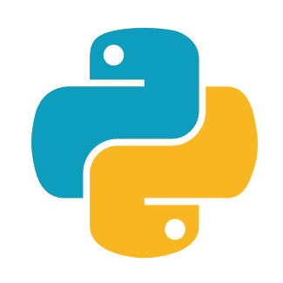

By Stephen McAleese

CASE3

18921756

Introduction
The purpose of this assignment is to compare an imperative to an object-oriented approach to a programming task. The task is to create a phone book program which stores names, numbers and addresses. New entries can be inserted, and entries can be searched or removed by supplying the number or name of the entry.

Internally, the database is implemented as two binary search trees. Two are needed to allow users to search and remove entries by name or phone number. In the first binary search tree, names are used as keys in each node. Each node also stores a number and address associated with each name. In the second binary tree, numbers are used as keys to access names and addresses associated with them.

Object-Oriented Approach
I used Python to create an object-oriented implementation of the phone book. In this implementation, the details of the binary search trees are described in classes.

class NameNode:
def __init__(self, name, number, address):
self.name = name
self.number = number
self.address = address
self.left = None
self.right = None

class NameBinaryTree:
def __init__(self):
self.root = None

Each binary search tree is an object and an instance of a tree class. Each tree contains a root node variable which is a node object. This node object has two instance variables, left and right, each of which contain one other node. Therefore, the tree is created recursively where nodes are nested in nodes like this:

node(left(left, right), right(left, right))

Methods such as insert or delete are used to carry out operations on the node objects. The name, number and address of each node are instance variables in each binary search tree object. The left and right pointers are also instance variables and they contain other node objects.

In my implementation, the search, add, delete and print methods are defined recursively though they can also be defined iteratively. These methods traverse through the tree by starting at a node and iterating deeper into the nested object structure. For example, this code traverses through the tree in order.

def r_inorderTraversal(self, node):
if node == None:
return
self.r_inorderTraversal(node.left)
print(node.name + " : " + node.number + " : " + node.address)
self.r_inorderTraversal(node.right)

Imperative Approach
I choose the C programming language to implement an imperative version of the phone book program. Declarative programming languages only require you to specify what you want the program to accomplish. C is an imperative programming language because you must also describe how the program will accomplish its goal using a sequence of statements that change the state of the program.

Unlike the object-oriented implementation, the imperative approach does not use classes or objects at all. Whereas binary search trees in the object-oriented version are defined as recursively nested objects, the imperative C version uses structs and pointers to implement binary search trees.

In the imperative C approach, each node in the binary search tree is a struct which is a composite data type that stores several other variables.

struct NameNode
{
char *name;
char *number;
char *address;
struct NameNode *left;
struct NameNode *right;
};

Unlike the object-oriented version, binary search trees are not implemented as recursively nested objects. Whereas the left and right variables store another node object in Python, in C the left and right variables are pointers which store the address of another node.

However, the C implementation also traverses through the tree recursively except that it uses pointers instead of objects in its parameters to traverse through the tree. In the code below the parameters ‘root’, ‘root->left’ and ‘root->right’ are pointers instead of objects.

void inorderTraversalName(struct NameNode *root)
{
if(root == 0)
return;
inorderTraversalName(root->left);
inorderTraversalName(root->right);
}

The following lines of code can be used to create the root node of a binary search tree in C.

struct NameNode *root = malloc(sizeof(struct NameNode));
root->name = name;
root->number = number;
root->address = address;
root->left = temp->right = 0;

The first line of code creates a new struct on the heap and assigns its memory address to a pointer named ‘root’. At the low level, a new block of memory the size of a struct is created on the heap and the memory address of the first address in this block is assigned to the variable ‘root’.

The next lines of code dereference the pointer using the arrow operator. This is necessary because ‘root’ stores the address of the first node, not the node itself. Dereferencing the pointer allows us to access the struct the pointer is pointing to so that we can assign a number, name and address to it. Because we only want to create a single node, we will set the struct’s pointers to 0 which makes them null pointers.

Running the lines of code above would produce this structure in memory:
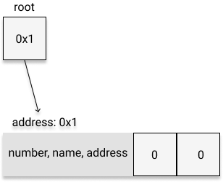

In this diagram, the boxes are pointers and the rectangle is a struct stored on the heap. The variable ‘root’ is a struct pointer which stores the address of the struct at address 0x1. The struct contains five variables: number, name, address, left and right. The variables number, name and address have the type char* because they are strings while left and right are struct pointers so that they can point to other structs in the future.
We can add more nodes to the binary tree by creating new structs on the heap and then storing the addresses of these structs in the left and right pointers of root.

This can be done using these lines of code:

struct NameNode *p1 = malloc(sizeof(NameNode));
struct NameNode *p2 = malloc(sizeof(NameNode));
root->left = p1;
root->right = p2;

The first two lines of code create new structs on the heap and assign their memory addresses to the struct pointers ‘p1’ and ‘p2’. In the last two lines of code, the arrow operator dereferences the root pointer so that we can change the struct that root points to. The last two lines assign the left and right pointers of the first struct (which were both 0 before) to the memory addresses of the two new structs.

The result is shown in the diagram below which is a binary search tree with three nodes:
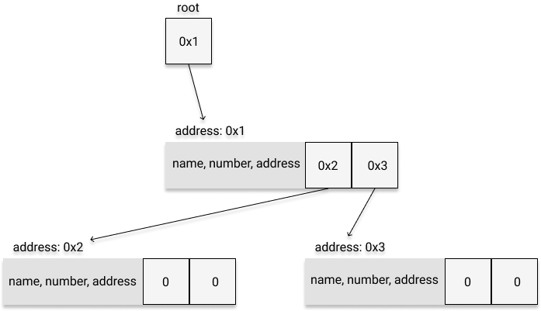

When we want to delete a node, we can call the standard library function free() to free up memory that was allocated to a struct and then set the pointers of the parent struct to 0.

For example, to delete both children of the root node above, we could run these lines of code:

free(root->left); // same as free(0x2)
free(root->right); // same as free(0x3)
root->left = 0;
root->right = 0;

The first two lines of code free up memory that was allocated on the heap for the child structs of node. We then set the two pointer variables of root to 0 because the root is no longer pointing to any other nodes. These lines of code restore the binary search tree to its initial state:

OOP vs Imperative Implementation - Other Factors

Programming Productivity
My productivity was much higher when writing Python as the language has a mature standard library, dynamic typing and automatic memory management. Conversely, C has a very small standard library, static typing and manual memory management. Writing C code requires thinking about types and memory management and sometimes involves writing new functions to supplement the small C standard library. As writing Python doesn’t involve these tasks, progress occurs faster. Unlike C, Python also supports functional programming which often results in succinct code which further increases productivity.

Performance

Memory
I found that the size of a binary search tree in Python with a single node is 48 bytes.
In the C implementation, each node contains five pointers. Therefore each node uses up at least 40 bytes not including the information that these pointers point to.

However, C is more memory efficient in other ways. C has primitives such as ‘int’ which only take up 4 bytes whereas a Python integer is 24 bytes in size. In Python, there are no primitives as all data types are implemented as objects which require more memory.

Speed
C is known to be extremely fast as it is a low-level, compiled language which is directly translated into assembly. Although the Python programming language is written in C, it is slower than C because it is an interpreted language. It must be first compiled into bytecode which is then executed by the Python interpreter. From my experience, I’ve found that C is about 50 times faster than Python.

