quiz

1. A set of data are put in numerical order, and a statistic is calculated that divides the data set into two equal parts. Which of the following statistics was computed?
a. mean
b. interquartile range
c. standard deviation
d. median

2. Create five quiz scores that provide a mean of 10 and a standard deviation of 0.

3. Can a standard deviation be negative. Why or why not? Explain your answer.

4. The following counts of raisins were obtained in a class activity. Summarize and describe this data set.
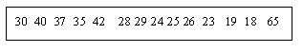

5. Which of the following is most sensitive to outliers?
a. interquartile range
b. standard deviation
c. median
d. mode

6. Statisticians often use the term "robust" when referring to a statistical measure or test. Which of the following is an example of a robust measure of center?
a. Mean, because it is the most commonly used measure of center.
b. Median, because it is resistant to outliers.
c. Mode, because it can be used with observational or quantitative data.

7. Can any of the measures of spread ever be negative? Why or why not?

8. A town contains three elementary schools. School A has a mean class size of 30 pupils for its three fifth-grade classrooms. School B has a mean class size of 25 pupils in its two fifth-grade classrooms. School C has 20 pupils in its only fifth-grade lassroom. What is the average class size for fifth-grade classrooms in this town?
a. 12.5
b. 25
c. 26.7
d. Can not be determined

9. Explain how it could happen that if one person moves from city A to city B, it is possible for the average (mean) IQ in both cities to increase.

10. The following data are the weights in grams of 35 male house sparrows that survived a severe winter storm and of the 24 male sparrows that perished in the same storm. Analyze these data to determine whether the data provide evidence that sparrows that survived the storm tended to weigh more than those that perished.
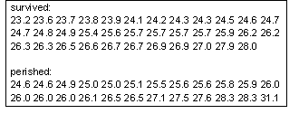

11. Suppose two distributions have exactly the same mean and standard deviation. Then the two distributions have to look exactly alike. Is this True or False? Explain the reason.

12. Why is the median considered to be a RESISTANT measure of center?

13. If a data set has a small standard deviation, what does that tell you?

14. Consider the two histograms displayed below. The histogram labeled "Var5" has a mean of 54 and the histogram labeled "Var6" has a mean of 53. Please indicate which one has a larger standard deviation and WHY that histogram has the larger standard deviation and WHY that histogram has the larger standard deviation.
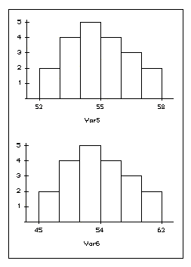

Item 15 refers to the following situation:
This table presents the fall grade point average (GPA) for 100 college freshman. Each student has an ID number that is presented in the left column with fall GPAs listed in the right column.
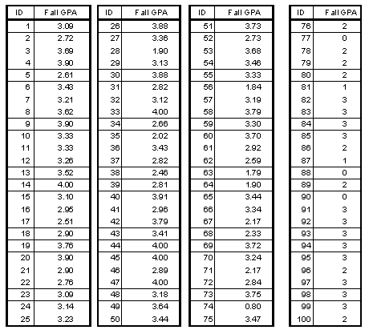

15. Calculate the sample mean () for these five Fall GPA values.

Items 16 and 17 refer to the following situation:
A test to measure aggressive tendencies was given to a group of teenage boys who were members of a street gang. The test is scored from 10 to 60, with a high score indicating more aggression. The histogram represents the results for these 28 boys.
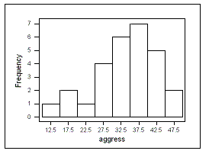

16. Which do you think will be larger, the mean or the median score? Or do you think they will be similar? Explain.

17. Which would you recommend as a measure of spread here, the range, the standard deviation, or the interquartile range? Explain.

Items 18 to 32 refer to the following situation:
A psychologist is studying the effect of drug and electroshock therapy on a subject's ability to solve simple tasks. The number of tasks completed in a 10-minute period is recorded for subjects who have been randomly assigned to compare four treatment groups: drug with electroshock, drug without electroshock, no drug with electroshock, and no drug/no electroshock. Sixty-four subjects were randomly selected students from a large local university.
18. Identify the observational units.

19. Identify the population and the sample.

20. Identify the explanatory and response variables, making sure to state them as variables.

21. Identify each variable as quantitative or categorical.

22. Was this study an observational study or an experiment? Explain.

23. If this was an observational study, explain how it could be conducted as an experiment. If this was already an experiment, explain how randomization was used.

24. Explain the goal of the randomization described in the previous part.

25. Researchers are interested in comparing the mean number of tasks completed among the four treatment groups. Results from this study are summarized below. Write a few sentences comparing and contrasting these treatments based on this output.
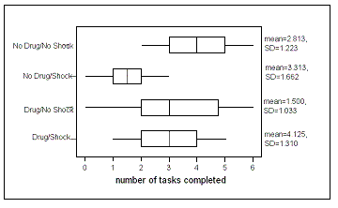

26. State the null and alternative hypotheses for the researchers.

27. Presented are the results from an Analysis of Variance run on these data. Explain to the psychologist what can be concluded from this analysis and how your conclusion follows from this output (assuming the technical conditions are met).
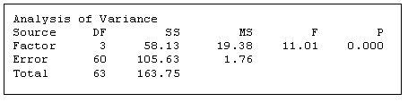

28. Carefully explain what the p-value measures by finishing one of the two following phrases, "the p-value is the probability of ... or "the p-value indicates how often ...î.

29. The psychologist is also interested in directly comparing the two no drug treatments - with and without electroshock. What statistics would the psychologist need in order to construct a 90% confidence interval to estimate the difference in the mean number tasks completed between these two treatments?

30. State the technical conditions required for the confidence interval procedure and discuss whether or not you believe they are met with this study.

31. Does your confidence interval indicate a statistically significant difference in the mean number of tasks completed between these two treatments? Explain.

32. Explain what is meant by the phrase "90% confidence" (without using the words "confidence" or "sure"!) in this context.

Items 33 to 42 refer to the following situation:
Data were collected in an investigation of environmental causes of disease. Variables include the annual mortality rate per 100,000 for males, averaged over the years 1958-1964 (think average number of deaths per year), and the calcium concentration (in parts per million) in the drinking water supply for a random sample of 61 large towns in England and Wales. (The higher the calcium concentration, the harder the water.) Another variable is whether or not the town is north of Derby (with towns at least as far north as Derby identified by a 1).
33. Identify the observational units in this research.

34. Below is a histogram of the calcium concentrations. Summarize the key features of this graphical display.
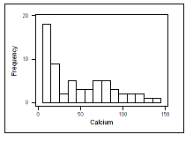

35. Below is a scatterplot of the mortality rates vs. the calcium concentrations. Summarize the key features of this graphical display.
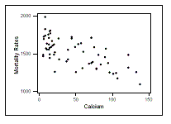

36. Suggest one feature that is evident in the scatterplot, that is not evident in the histogram.

37. Below are graphical and numerical summaries of the calcium concentrations for towns north of Derby and towns not north of Derby. Summarize how the two groups compare.
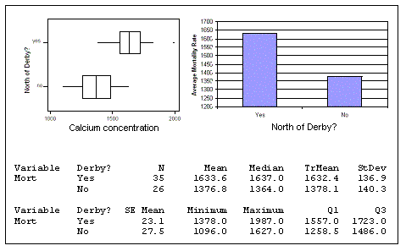

38. Based on these data is there evidence of a significantly higher mortality rate for towns North of Derby? State your hypotheses in symbols and in words, state and check the technical conditions, identify and perform an appropriate test, report the test statistic and p-value, make a decision, and state your conclusion in context.

39. Construct a 90% confidence interval to estimate the difference in mean mortality rates between towns north of Derby and towns that are not north of Derby.

40. Explain in your own words what is meant by "90% confidence" in this context.

41. Based on these data, is there evidence of a statistically significant relationship between the calcium concentration of the water and the town's mortality rate? State your hypotheses in symbols and in words, (you can assume the technical conditions are met), identify and perform an appropriate test, report the test statistic and p-value, make a decision, and state your conclusion in context.

42. Are you willing to conclude that increasing the calcium concentration in the town's water will lower the mortality rate based on the results of this study? Clearly explain why or why not.

Items 43 to 48 refer to the following situation:
A study was planned to examine the length of a certain species of fish on Gull Lake. The initial plan was to take a random sample of 100 fish from this lake using a special net, and examine our results. Numerical summaries on lengths of the fish measured in this study are given. Use them to answer the questions.
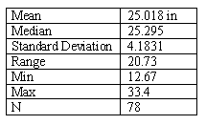

43. Notice there were only 78 fish that were actually sampled. This may result in some bias in the fish lengths. Which direction, if either, do you think the bias may be, and why?

44. Discuss roughly what the histogram of fish lengths from this sample would look like if we were to make one.

45. What is your best, most informative estimate of the average fish length for the entire lake, based on information from this sample?

46. By how much do you expect the sample means to vary, if we were to take many many samples of the same size? (use n=78). Explain your answer.

47. We want to be more accurate about our estimate of the average fish length in Gull Lake. We want to be within .25 inches, in fact. How many fish need to be sampled in order for this to happen?

48. The fish lengths in Lake Monster have a standard deviation that is twice as big as that on Gull Lake. Suppose you still wanted to get an accurate estimate of the mean fish length for Lake Monster (within .25 inches). Select the answer that best describes the sample size we need:
a. A larger sample is needed for Lake Monster than Gull Lake
b. A smaller sample is needed for Lake Monster than Gull Lake
c. About the same size sample
d. Not enough information to tell

Items 49 to 52 refer to the following situation:
The highway patrol wants to know what percentage of motorists drive while wearing seatbelts.
49. Who should participate in this study?

50. How should the participants be selected?

51. What specific data would need to be collected?

52. What type of visual display would be appropriate for displaying the data?

Items 53 to 59 refer to the following situation:
Two random samples were taken to determine left foot length of female versus male bears based on measuring their tracks. Numerical summaries of the data are given. Use them to answer the questions.
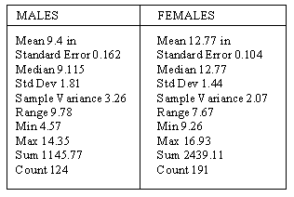

53. Approximately half of the foot sizes of males are less than what value?

54. Using the summary statistics provided, give your best estimate as to what two values contain most of the foot sizes of males.

55. If we could see a histogram of the data for males, what shape would it have?

56. Which of the two groups, males or females, tended to have larger foot lengths? Explain briefly how you determined this.

57. Which of the two groups, males, or females, had more variability? Explain briefly how you determined this.

58. Briefly describe the results found in a way that a park ranger would understand, focusing mainly on the comparison of males to females.

59. What kind of graph would be most useful in comparing the two data sets of foot lenghts (Male versus Female)?
a. Bar graphs
b. Boxplots
c. Dot plots
d. Pie charts

Items 60 and 61 refer to the following situation:
Consider the following samples of quiz scores and answer the questions without doing any calculations.
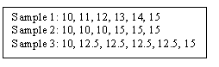

60. Which sample has greatest variability? Why?

61. Which sample has the smallest variability? Why?

Items 62 and 63 refer to the following situation:
The graph came from the USA Today Snapshots: Commuting Time.
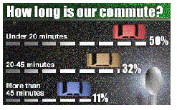

62. What is wrong with this graph? List two things.

63. What would you do to fix it?

Item 64 refers to the following situation:
This list of test scores has a mean of 50. Estimate whether the standard deviation is closest to 0, 1, 2 or 10. (This problem requires NO arithmetic.)
64. LIST C: 48, 51, 49, 52, 47, 52, 46, 52, 53, 51
a. 0
b. 1
c. 2
d. 10

Items 65 to 67 refer to the following situation:
This is a distribution of how much money was spent per week for a random sample of college students. The following statistics were calculated: mean = $31.52; median = $30.00; interquartile range = $34.00; standard deviation = $21.60; range = $132.50.
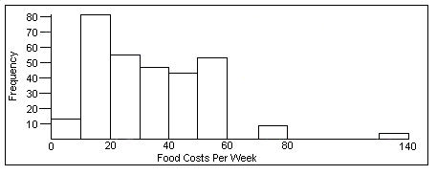

65. The distribution of food costs basically looks bell-shaped, with one outlier.
a. Agree, it looks pretty symmetric if you ignore the outlier.
b. Agree, most distributions are bell-shaped.
c. Disagree, it looks more skewed to the left.
d. Disagree, it looks more skewed to the right.
e. Disagree, it looks more bimodal.

66. The median food cost tells you that a majority of students spend about $30 each week on food.
a. Agree, the median is an average and that is what an average tells you.
b. Agree, $30 is representative of the data.
c. Disagree, a majority of students spend more than $30.
d. Disagree, the median tells you only that 50% spent less than $30 and 50% spent more.

67. The high value of $133 should be removed from the data set before analyzing the data.
a. Agree, it is so different from the other values that it must be an error.
b. Agree, you should remove any value that will bias the results.
c. Disagree, you shouldn't drop a data value without first considering what you're going to do with the data.

Items 68 to 70 refer to the following situation:
This is a histogram of how much money was spent per week on reading material by a random sample of college students.
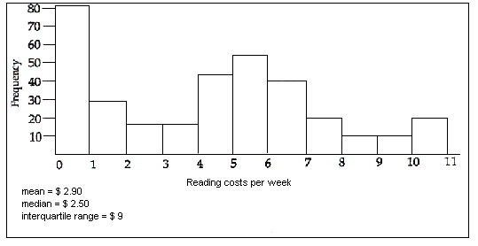

68. Based on the data and graph, what do you think of this statement: The mean is a poor indicator of average and the median should be used instead to represent the "average" amount of money spent on reading material.
a. Agree, the median is better to use here because it's not sensitive to outliers.
b. Agree, the median is better to use with nonsymmetric distributions like this one.
c. Disagree, the median lacks accuracy because it is just the middle value.
d. Disagree, the mean is better because it takes all the amounts of money into consideration and none are left out.
e. Disagree, the mean is a more accurate measure.

69. Based on the data and graph, what do you think of this statement: This distribution looks "bimodal," and one may learn more about this data set if the data are divided into two sub-groups, based on a different variable.
a. Agree, everyone has different spending habits.
b. Agree, there might be two sub-groups because there are two peaks in the data set.
c. Disagree, you need to look at the entire group of students together.
d. Disagree, there is not a big enough space between the peaks to indicate the presence of two different groups.

70. Look at the graph and statistics and consider the following question: An error was made in computing the interquartile range
a. Agree, it should be lower because the mean and median are low.
b. Agree, it must be wrong because most students spend $0 on reading.
c. Agree, the data looks too grouped together to have such a high interquartile range.
d. Disagree, it is possible that someone could spend $9.
e. Disagree, because the range is $11.
f. Disagree, the data are rather spread out and therefore the quartiles will be farther apart.

Items 71 to 73 refer to the following situation:
Consider the question of whether women tend to pay more for a haircut than do men. Students were asked to report the total cost of their most recent haircut. A total of 17 men and 15 women responded. Their results follow with the amounts recorded in dollars; notice that these values have been ordered.
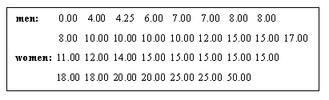

71. Find the median haircut price for the men who responded and the median haircut price for the women who responded.

72. The lower and upper quartiles for the men's haircut prices are $6.50 and $11.00; the lower and upper quartiles for the women's haircut prices are $15.00 and $20.00. Use this information to construct (on the same scale) boxplots of the haircut prices for both sexes.

73. Write a few sentences comparing and contrasting the distributions of haircut prices between men and women. Indicate whether the data support the proposition that women tend to pay more for haircuts than do men. Also comment on whether every woman pays more for a haircut than does every man.

Items 74 to 76 refer to the following situation:
Suppose that a company employs five men and five women. Construct a hypothetical example which demonstrates that even though the mean salary for men is much higher than the mean salary for women, it is possible for most of the women in the company to earn more than most of the men. List five hypothetical men's salaries and five hypothetical women's salaries for which the following conditions hold:
74. The mean salary for men is higher than the mean salary for women.

75. The mean salary for men is higher than the mean salary for women and four of the five lowest salaries in the company belong to men.

76. The mean salary for men is higher than the mean salary for women and four of the five highest salaries in the company belong to women.

Items 77 and 78 refer to the following situation:
Your local running club has its own track and keeps accurate records of each member's age and individual best lap time around the track, so members can make comparisons with their peers. Here are graphs of these data.
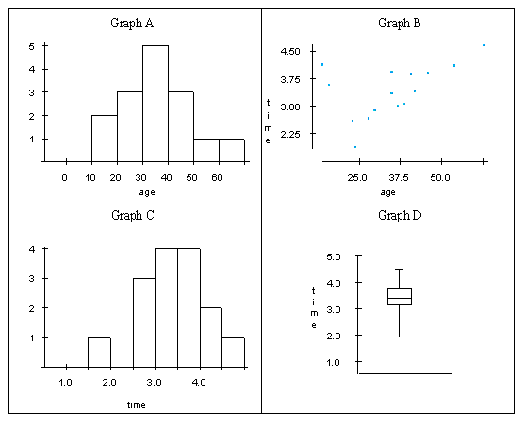

77. Suppose you were interested in how running times tend to change as people get older. Which graph would you use to get an idea of what this trend looks like?
a. Graph A
b. Graph B
c. Graph C
d. Graph D
e. none of the above

78. Suppose you wanted to show a group of new members how much joining this team improves people's running times. Which of the four graphs would you use?
a. Graph A
b. Graph B
c. Graph C
d. Graph D
e. none of the above

Items 79 and 80 refer to the following situation:
In January 2003, it was reported that 2440 homes were sold in the Twin Cities area in December of 2002. The sale prices of each home are displayed in the histogram, and measures of center and spread associated with this data set are also displayed.
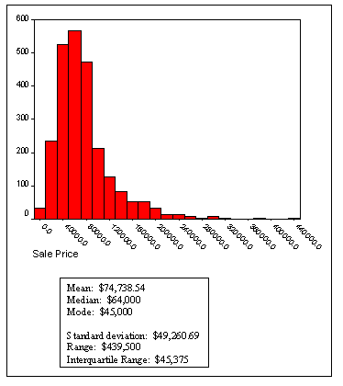

79. Describe the shape of the distribution.

80. Describe which measures of center and spread would be most appropriate to report for this distribution and WHY.

Items 81 to 83 refer to the following situation:
Think about the difference between "good" and "bad" graphs. Now consider this graph. A Gallup Poll survey was conducted and the results from 800 American adults are displayed in the graph. The survey was conducted in order to assess Americans' opinions about the current state of movies.
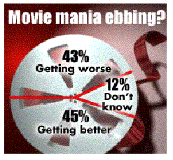

81. What type of graph is this?

82. What kind of information is displayed in this graph?

83. Please discuss one "good" thing about this graph and one "bad" thing about this graph.

Items 84 to 86 refer to the following situation:
Mr. Smith teaches American History at Kennedy High School. He believes he can use student scores on the midterm exam to predict how well they will perform on the final exam. The scatterplot displays midterm and final exam scores for 20 of Mr. Smith's most recent students.
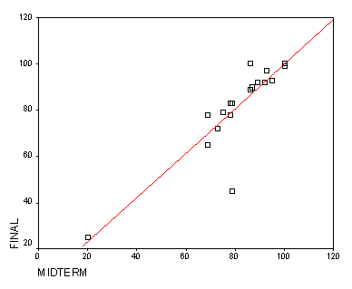

84. There are two points on the scatterplot that would be considered "outliers", for different reasons. Circle these two points, and put a "1" next to one of the points and a "2" next the other point.

85. Imagine that point "1" (as you labeled it) was removed from the scatterplot but point "2" was left in. How would the correlation between midterm and final exam scores change without point "1" in the analysis?

86. Now, imagine that point "2" (as you labeled it) was removed from the scatterplot and point "1" was left in. How would the correlation between midterm and final exam scores change without point "2" in the analysis?

Items 87 and 88 refer to the following situation:

87. Give an example of a distribution for a variable when it is more appropriate to use a mean, rather than a median, as a measure of center. Describe the variable and sketch a possible graph for the data. Explain why a mean is more appropriate. Which measure of variability would you use? Why?

88. Give an example of a distribution for a variable when it is more appropriate to use a median than a mean as a measure of center. Describe the variable and sketch a possible graph for the data. Explain why the median is more appropriate. Which measure of variability would you use for these data? Why?

Items 89 and 90 refer to the following situation:
A health insurance company is interested in the cholesterol levels for individuals ages 40 or older. A random sample of 100 individuals was chosen from the target population. The following information was obtained from the sample: average = 158 mg, median = 159 mg, s.d. = 20 mg.
89. Based on the given information, the shape of the cholesterol distribution is more likely to be approximately: (a) skewed to left, (b) mounded-shaped, or (c) skewed to right? Explain.

90. An individual has their cholesterol level represented by a standard z-score of .5. Without computing, which of the following has to be this individual's original cholesterol level: (a) 158 mg, (b) 148 mg, or (c) 173 mg? Explain why.

Items 91 to 93 refer to the following situation:
In "Ages of Oscar-Winning Best Actors and Actresses" (Mathematics Teacher Magazine) by Richard Brown and Gretchen Davis, the authors compare the ages of actors and actresses at the time they won Oscars. The results for recent winners from each category are listed in the following table.
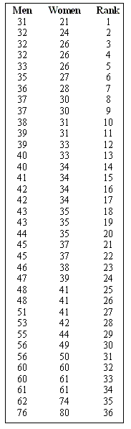

91. Make a graph that allows you to answer this question: which group tends to have older Oscar winners, men or women? Explain the reason for your conclusion.

92. Which group seems to have more variability? Why?

93. What ages for men and women appear to be outliers? Why?

Items 94 and 95 refer to the following situation:
Consider the following quiz scores: 3,7,8,4,4,2,5,6,6
94. Add 2 more scores to the distribution so that the new mean will be the same as the old mean. Explain how you selected these 2 additional scores.

95. Explain how you would determine a way of adding 22 scores to the distribution so that the new standard deviation will be the same as the old standard deviation.

Items 96 to 98 refer to the following situation:
These histograms describe the values taken by three sample statistics in several hundred samples from the same population. The true value of the population parameter is marked on each histogram.
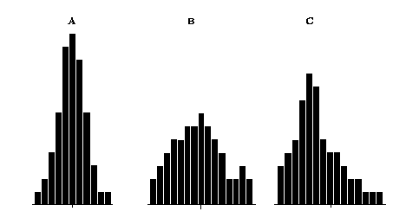

96. Identify which statistic(s) (A, B, C) has/have the largest bias? If you think the bias is equal in two statistics, mention that. Clearly explain how you are deciding this.

97. Identify which statistic(s) (A, B, C) has the lowest variability. If you think the variability is equal in two statistics, mention that. Clearly explain how you are deciding this.

98. Based on the performance of the three statistics in many samples, which is preferred as an estimate of the corresponding parameter? Explain.

Items 99 and 100 refer to the following situation:
Two distributions of test scores are presented below. For each distribution, select the one descriptor that best represents the shape of the distribution.
99.
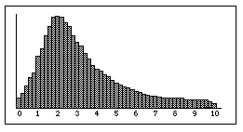

a. Normal
b. Skewed
c. Bimodal
d. Uniform

100.
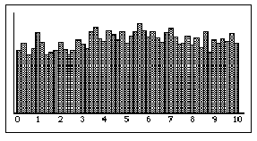

a. Normal
b. Skewed
c. Bimodal
d. Uniform

Items 101 to 103 refer to the following situation:

101. Give examples of three different ways the word sample may be used in everyday life.Give one example of how the word sample is used in a statistics course.

102. What does the word random mean to you, as you hear it used in everyday life? What does this word mean when used in a statistics class? Give an example of something that happens in a random way, using the statistical definition.

103. What does variability mean when used to describe a data set? (For example, the set of heights for a sample of high school students)

Items 104 to 108 refer to the following situation:
Select the appropriate symbol.
104. The variability of observations in a sample.
a.
b.
c.
d. s
e.

105. The variability of sample means in a sampling distribution.
a.
b.
c.
d. s
e.

106. The variability of all observation in a population.
a.
b.
c.
d. s
e.

107. The center of all observations in a population.
a.
b.
c.
d. s
e.

108. The center of all observations in a sample.
a.
b.
c.
d. s
e.

Items 109 and 110 refer to the following situation:
Jane and Paul are studying the following two data sets. Data Set A: 110, 112, 114, 115, 116, 118. Data Set B: 2, 6, 15, 28, 59, 112.
109. Explain which data set, A or B, would have the larger mean WITHOUT CALCULATING the means. Explain your answer.

110. For Data Set A, Jane and Paul find that the sample standard deviation is 42 while the sample standard deviation for Data Set B is 3. They have made a mistake in their calculations. Explain why you know that the sample standard deviation for Data Set A must be smaller than the sample standard deviation for Data Set B WITHOUT CALCULATING the standard deviations.

