HOV Alvin/RV Atlantis Data Offload System

Pipeline Cookbook

Overview
The Alvin upgrade team has developed a shipboard data offload system with emphasis on two things: meeting delivery requirements, and making the SSSG technician pool’s job no harder than it had already been. Toward that end, SSSG technicians have been involved in the design and implantation process since early stages.

Delivery requirements included the following:
- A well-organized, clean product that can be readily used by science during and after cruise.
- Presentation of large quantities of data in a timely manner, after dives and at the end of a cruise. Data quantities are substantially larger than before the upgrade.
- Secure data staging and archival procedures.
- An infrastructure on which the science party can review current cruise data.
- An infrastructure on which the science party can add value to data for themselves and on behalf of the wider community, such as video editing.

Technician requirements included the following:
- Similar time demands for a technician to produce a cruise data package, as compared to demands prior to Alvin’s upgrade.
- Security of data against act-of-god loss and operator misadventure, primarily through data duplication.
- Isolation of the system from established ship’s networks to protect those networks from high volume transfers, and to reduce exposure of data to harm.

These notes provide specific implementation details. It is a living document- please maintain and share with all technicians and NDSF data manager.

Ways requirements were met
- Use of flexible unix-based data transfer utilities and scripts, largely possible because most in-sphere computers use the linux operating system.

- Purchase of a video duplication and staging system from a vendor that focuses on this particular market, and provides specialized equipment and software that performs automatic duplication and transfer verification.

- Use of PowerShell scripts to perform post-processing on video, allowing video to remain in a secure staging area.

Reference documentation
1Beyond documentation
MAM cookbook for administrators
MAM cookbook for science party
PowerShell scripts Reference Manual
Axle User’s Guide and Administrator’s Guide
Sysadmin and Security Notes
Data deliverables description
Alvin Data Records Formats spreadsheet

Data pipeline overview
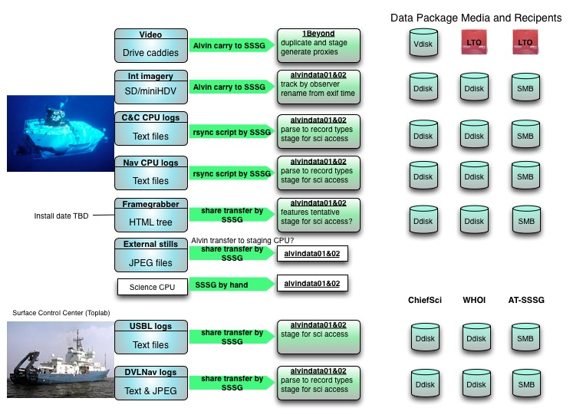
Figure 1: Summary depiction of data deliverable pathways from source (Alvin or Atlantis Toplab) to cruise package media (disk or tape). Note that is the Rolling Deck to Repository (R2R) program does not support Alvin-related data, and therefore underway data from ship’s sensors are a separate product.

Suggestion…
As has for years been the case, the data offload and assembly process described herein is comprised of variety of steps, roughly a dozen of them. Few of the steps take more than a couple moments of a technician’s time to accomplish or invoke them. Because of the volumes of data involved, completion of a step can take minutes and, sometimes, hours (figure 2). It is left to shipboard technicians to develop the roadmap for efficiently completing these steps.

Offloading, Sharing, and Packaging of Non-External-Video Data- Overview
While video from Alvin’s external video cameras is the most voluminous and perhaps most popular data deliverable, there are several valuable sources of data from Alvin. Collection methods from these sources vary, from network transfers to offloading of flash cards to use of outdated video tape.

With the exception of MiniDV tape cassettes from the in-sphere handheld video cameras, all of these varied data are compiled onto the hosts called ‘alvindata01’ (199.92.162.242) and ‘alvindata02’. ‘alvindata01’ is connected to the AlvinNet subnet; ‘alvindata02’ is connected to the ScienceNet subnet. There is an additional private subnet connecting the two of them together; periodic rsyncs mirror content from ‘alvindata01’ to ‘alvindata02’. Use ‘alvindata01’ to collect data from the operational machines in the sphere and in Toplab. A short time later the data will be staged on ‘alvindata02’ to provide access to the science party on a share called ‘data_on_alvin’.

Offloading logs from the in-sphere linux computers
There are four logging computers in the sphere: Command and Control (C+C), Navigation (Nav), Sonar, and Science. All are dual-boot. The C+C and Nav computers primarily run linux, and the Sonar and Science computers primarily run Windows. For details of handling data from the Windows computers, proceed to the next section.

In general, logs are real time captures of sensor records as they are produced at native rates. Aggregate collection rate of sensors reporting to the C+C computer is 100MB/hr uncompressed. Aggregate collection rate of sensors reporting to the Navigation computer is 250 MB/hr uncompressed. The C+C computer will situationally run loggers dedicated to individual sensors, resulting in files holding records from one sensor. These will be identified by the file extension.
These logs are copied to the shipboard host ‘alvindata01’ over network connection into the sphere on the Alvin subnet. Scripts utilizing the ‘rsync’ utility perform the transfer. These scripts will/can also separate the aggregate logs into files of record type, or types grouped by similar function. (Appendix 1). The working directory for these logs is ‘~alvindata/Public/<CruiseID>/<DiveID>’.

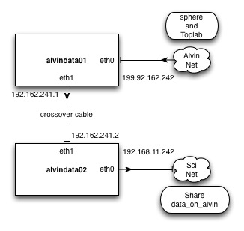
Figure 2: Block diagram of the networking for hosts handling Alvin non-video data

These logs and post-processed products are subsequently copied to host ‘alvindata02’ using another script that invokes ‘rsync’. This script is invoked by ‘crontab’ every fifteen minutes; the script looks for prior invocations and does not run if an earlier invocation is still working. It mirrors ‘alvindata01’ content under ‘~alvindata/Public/<CruiseID>/<DiveID>’ into the same directory on ‘alvindata02’. The pathway between the two machines is a separate subnetwork (192.168.241.) applied to each system’s ‘eth1’ network interface.

Once transferred to a second host (from ‘alvindata01’ to ‘alvindata02’), logs are to be removed from in-sphere computers to provide disk space for future dives. There is no provision for an in-sphere safety backup such as existed pre-upgrade.

At the end of a cruise the cruise content under ‘~alvindata/Public’ should be moved to each host’s archive drive, under ‘/data/Alvin/<CruiseYR>/<CruiseID>’.

#!/bin/bash

# Script to retrieve Alvin in-sphere engineering and sensor data from
# the in-sphere command and control computer.
#
# Scott McCue, WHOI NDSF
# smccue@whoi.edu, 508.289.3462

# Usage:
# get_alvin_dive_c+c <DiveID>, where diveID is of form AL1234 or 1234.
# Run this script on the client that will receive the data.

# Requires:
# linux with zenity and rsync

# Time and date zones are imposed by in-sphere computers, and should be GMT.
#
# Set CRUISEID variable here, or as an environment variable in your .profile

#CRUISEID='AT26-12'
#diveID='AL4679'

if [ $# != 0 ] ; then

echo "Usage: get_alvin_dive_c+c"
echo "No command line arguments"
exit 1

else

CRUISEID=$(zenity --entry --window-icon='question' --title='Alvin C&C Offload' --text="Enter CruiseID" --entry-text=$CRUISEID)
if [ $? == 0 ] ; then
if [[ $CRUISEID =~ ^AT ]] ; then
diveID=`zenity --entry \
--window-icon='question' \
--title='Alvin C&C Offload' \
--text="Enter Dive Number (include 'AL')" \
--entry-text="AL0000"`
if [ $? == 0 ]; then
destdir=/home/alvindata/Public/$CRUISEID/$diveID/c+c
echo "Target directory for *.VDAT is $destdir"
if [ -d $destdir ]; then
do_anyway=`zenity --question --title='Alvin C&C Offload' --text="Directory $destdir already exists" --cancel-label="Quit" --ok-label="Continue"`
if [ $? == 1]; then
# quit button was pushed
exit 1
elif [ $? == 5]; then
echo "Timed out- quitting"
exit 1
else
echo "Continuing"
fi

else
mkdir -p $destdir
echo "Creating directory $destdir"
echo "Performing rsync -av alvin@199.92.162.100:/data/*.VDAT $destdir"
#rsync -av alvin@199.92.162.100:/data/*.VDAT $destdir
echo "Repeating rsync to confirm all files have been transferred."
#rsync -av alvin@199.92.162.100:/data/*.VDAT $destdir
fi # test of continue question

echo "Download from command and control computer completed"

##### Parsing section- grep primary file into files by record type
echo "Separating primary command and control files into specific record types"
# cd $destdir
# mkdir veh-eng
# mkdir veh-sci
# grep PKT *.VDAT > $diveID.pkt
# grep VOS *.VDAT > $diveID.vos
# grep ROCT *.VDAT > $diveID.roct
# grep OCT *.VDAT | grep -v OCT > $diveID.oct
# grep BVS *.VDAT > $diveID.bvs
# grep DEP *.VDAT > $diveID.dep
# grep CGL *.VDAT > $diveID.cgl
# grep AWS1 *.VDAT > $diveID.aws1
# grep SYS *.VDAT ? $diveIS.sys
# grep WER *.VDAT > $diveID.wer
# grep AHS[12] *.VDAT > $diveID.ahs
# grep APM *.VDAT > $diveID.apm
# grep WMV *.VDAT > $diveID.wmv
# grep BBS *.VDAT > $diveID.bbs
# grep AVBD *.VDAT > $diveID.avbd

# echo "Separation into record types complete"
fi # test of diveID entry return status
fi # test of cruiseid regexp
fi # test of cruiseid entry return status
fi # argument count

Should something prevent the parsing section of the above scripts to fail, you can apply ‘parse_c+c/sh’ or ‘parse-nav.sh’ to accomplish the same thing.

Shares from in-sphere Science and Sonar computers, External Still Camera
These computers run Windows7, so network shares have been set up on them to allow access for offload and to make data backups on them.

The Science computer will also log files in a variety of forms (ASCII, binary, hierarchical) in response to instrument and commercial software behavior.

User:password for all are Alvin:atlantis
Sonar Computer:
\\199.92.162.109\Data
\\199.92.162.109\Backup
Science Computer:
\\199.92.162.110\Data
\\199.92.162.110\Backup

External Still Camera (SubC 1Cam Alpha with internal networking and Windows sharing):
\\199.92.162.220\

Stills from internal cameras
Data offload from these handheld units requires carrying of SD cards from sphere to the SSSG technician, then use of a card reader that’s attached to host ‘alvindata01’ to offload. The respective image collections should be copied into ‘~alvindata/Public/<CruiseID>/<DiveID >/IntStills/camera[123]’.

There are SD card readers with USB cables available in SSSG inventory. Attach one of these to host alvindata01, most easily done via the USB port on the comp lab KVM. Copy card content into one of the three pre-made directories under the IntStills directory.

Rename the files using the script alvindata01:~alvindata/bin/rename_photos.sh. The script performs a simple check for creation dates from image metadata and asks the user if the dates are reasonable. If the user approves, the files are renamed. If approval is denied, then the original filenames are retained.

Stills from external camera
The core component of the SubC 1Cam Alpha external still camera is a prosumer HD video camera. As appears typical with this class of camera, the accompanying remote interface software impedes automated processing. It does not support non-interactive connection and offload, and requires some level of patience and experience to succeed with the offload.
Temporary procedure: Alvin techs will offload the dive’s collection into a share on the computer (199.92.162.3) in the ET shop. Pull the collection into ‘~alvindata/Public/<CruiseID>/<DiveID>/ExtStills.

Rename the images from the generic camera-given name to one based on timestamps using the script?

FrameGrabber
This software system periodically captures still images and co-registers them with sensor data, presenting the results in a web browser environment. Porting of Framegrabber from its pre-upgrade code base is required but not yet accomplished. Its installation date is unknown. When available, the data from this product is an HTML tree that can be transferred under the control of a script.

Video Post-Processing Goals- Summary
- A reliable process for duplication, shipboard staging, and archival of original video files from in-sphere hard drive recorders, and their inclusion into the cruise data package.
- Generation of proxy videos in a format that users will find more routinely usable than the format of the original recordings.
- Generation of metadata about the media, which records the organization of LTO tapes, portable hard drives, and the data content carried by them.
- Installation of the original videos into a shipboard media asset management (MAM) system, which the cruise science party will use to interface to the video.
- Collection of all cruise video and metadata products into data packages that will be transferred to the science party and to on-shore archives.

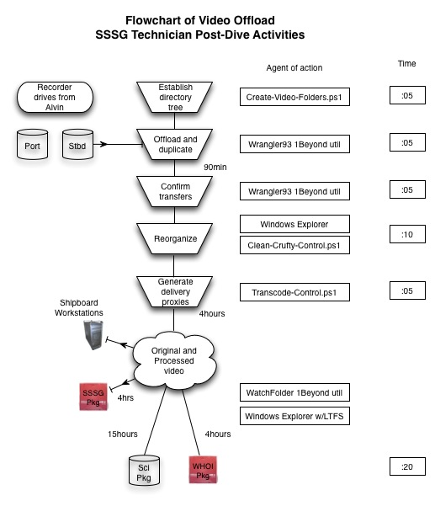
Figure 3: Step-by-step summary of video offload from delivery of drives out of in-sphere recorders though to transfer onto delivery media.

00. Some background information
There are two hard drive recorders in the sphere. Camera streams are fed into a video router that allows the observers to rotate through the list of cameras. As they do this, stream discontinuities cause the recorders to close the current clip file and start a new one. Depending on how often the observers select new streams, the collections of clips will be a mixture of good recordings and short, useless clips. Tracking and naming of clips is according to the recorder, not camera. A single drive per recorder will be enough for an Alvin dive when the normal codec (Apple ProRes422LT) is used. Use of a higher bandwidth codec should have pre-cruise approval, and may require the science party pay a storage surcharge.

01. UPS Troubleshooting
We have seen some examples in which the UPSes in the 1Beyond rack don’t connect cleanly with AC power at startup, perhaps due to the unusual ground presented by the ship. Best troubleshooting success has come by
    - Turning off the UPS
    - Unplugging the UPS from AC power
    - Turning on the UPS
    - Waiting roughly 30 seconds
    - Replugging to AC power while the units are powered on.

Note that each 1Beyond Wrangler Rack/IntelliRAID set is on a separate UPS, and power draws require that each UPS is connected to a separate AC circuit of ship’s power. Both UPSes together will probably overload a 15A circuit.

1. Beginning of cruise preparation
- Confirm that the shipboard copy of media that duplicates the data package from the previous cruise has been catalogued and archived. [These media will be recycled once the to-WHOI package has been verified and duplicated.]
- If down, power the 1Beyond offload gear that is housed in the Computer Lab equipment rack. First start the IntelliRAID chassis and Niagara network switch using the rackmount switches, then boot the Wrangler Rack computers using their front panel buttons.
- Organize spinning disk storage on the 1Beyond offload system.
  - Confirm that the two RAID systems are mounted and cross-mounted to their respective Wrangler Rack computers. Each system is named by its serial number.
    - RAID6 system 1B3858 is directly mounted to Wrangler 1B3823 at mount pt D:
    - RAID6 system 1B3859 is directly mounted to Wrangler 1B3824 at mount pt D:
    - RAID6 system 1B3858 is network-mounted to Wrangler 1B3824 at mount pt Z:
    - RAID6 system 1B3859 is network-mounted to Wrangler 1B3823 at mount pt Z:
  - Free up storage by purging data from previous cruises, as needed.
- Organize media that will be used to transport and archive the cruise data package. This media includes LTO generation #5 (LTO5) tape and external USB hard drives. In general, LTO tape will be used for internal WHOI archiving and USB hard drives will be used for delivery to the science party. This is because LTO5 tape is the superior method in terms of long-term performance and cost, but is less convenient for the science party.
  - Early estimates for data volumes per average dive are:
    - 700GB of video data
    - 4GB (~5MB/image) of images from the external digital still camera
    - ___ from the three internal digital still cameras
    - One or zero miniHDV tapes from the internal video camera
    - 20GB of sensor records from the Command&Control and Navigation computers
    - 10GB from the Toplab computers
    - Framegrabber
  - Video data, not sensor logs or science data, will be placed on LTO5. LTO5 capacity is about 1.35TB, so early expectations are that video from two dives will fit on on LTO5 tape. See section ___. LTO5 tapes must be formatted before use with the LTFS filesystem. Media will be pre-labeled with bar codes and alphanumerics. Use the alphanumerics identities when logging dive package inventories.
  - The science party’s copy of video will be placed on 2TB external USB hard drives. Because video clip filesizes van get large, these drives must be formatted with the ExFAT filesystem. These drives have identifiers of form “AlVid000”. Use these identities when logging dive package inventories.
  - Find the file Alvin_Video_Media_Log_Template.xls and make a new copy named <cruiseID>_Video_Media_Log.xls. Use this to record labels for both LTO tape media and USB hard drive.
- Start a fresh folder hierarchy that will house data from upcoming dives, on both Wrangler Rack systems.
  - Using Windows Explorer (security permissions at the top level of D: and Z: make it necessary to run as administrator by invoking with right-click), create the top folders on D: and Z: and name them for the cruise, e.g., “AT26-05”. Quit Windows Explorer.
  - Edit the file D:\Alvin.ini, which currently defines two parameters: cruiseID and DiveID. Subsequently, run Powershell scripts on the Wrangler Rack that sees this updated Alvin.ini as being on D:.
  - Run Windows PowerShell basic console or ISE per your preference. Invoke the PowerShell script “Create-Video-Folders”. This script creates a number of directories for receiving results from offload and post-processing. Under each dive on each of D: and Z: will be folders called “OriginalVideo”, “ProxyVideo”, and “OriginalVideoCruft”. Under each of these will be folders named “PortRecoder” and “StbdRecorder”. “OriginalVideo” will be populated during the offload step, “ProxyVideo” and “OriginalVideoCruft” will be populated during post-processing steps. Quickly confirm that the script succeeded in creating full directory trees on each RAID array.

- Set up a new User under the Axle media asset management (MAM) system, currently served by Mac Pro #1 (192.168.1.20). Do this by accessing the system through the Safari web browser (http://192.168.1.20/axle) and logging in as ‘administrator’ (same password as MacPro sysyadmin account). Please use account identities (typically cruiseID) that will be obvious if and when MAM-related content is reconstructed for on-shore servers.
- Orient science party to deliverables and video system abilities at an appropriate time. Supporting primer.

2. Post-dive offload procedures
- For every dive of the cruise, perform step 1.4b to set up the hierarchy for fresh material.
- Remove the 2.5” drives containing original video files from their caddies, securing the four screws. As of 2014 there are two recorders writing to one drive each per dive, totaling two drives. These two drives will fit into one Wrangler. If four drives are produced, then you have the option of using other Wrangler also. Insert the drives into the receiver slots of the Wrangler Racks.
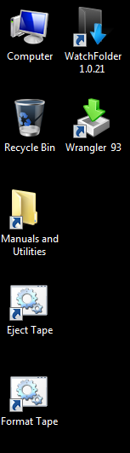
- Insert a recorder drives into the 2.5” slots mid-height right hand side of a Wrangler Rack. One slot will be mounted as E:, the other as F:. Do not expect each slot to always map to the same mount point. tracking info in the spreadsheet as well. Mount points E: and F: should now be connected to the drives.
- The Samurai video recorders are set to have positional info in clip names (“port” or “stbd”) to support tracking of recorder/clip pairing.
- Invoke the Wrangler93 utility. Invoke menu item “Options”. In the ensuing popup change the destination paths (on both D: and Z) to copy to the folder that you created for this dive’s collection of videos, i.e., [DZ]:\<cruiseID>\<ALxxxx>. Note that each drive will be offloaded into a Wrangler93-named folder with name that includes timestamp and source mount point info. Should you wish to make tracking even less ambiguous, you may find the following from 1Beyond tech support to be useful:
‘If your desire is to track which drive the data came from -- you could select the setting in Wrangler software that "prompts for prefix" (this is available in the latest version of Wrangler v. 102).
When you insert a drive, it will prompt you for a string of characters that it will use to preface the date-time-stamp folder name with.
So, currently, when you copy from drive E, you are getting a folder with name: "date-time-E"
With "prompt for prefix", if you entered "cam1" for the prefix, the folder would be named "cam1-date-time-E"’ 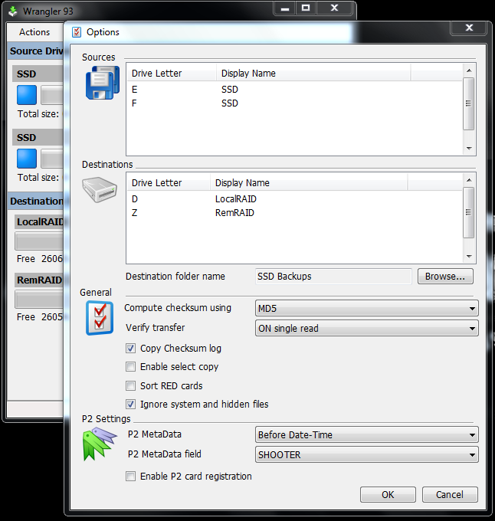
Figure 4: Options window for the Wrangler93 offload utility. Set the Destination folder name, close, and start the copy/duplication. The typical Destination folder name will be <cruiseID>\<diveID>
- Once you’ve set options, start the Wrangler93 offload. Both drives will be copied to both RAID arrays, generally in under two hours. It will automatically perform file-by-file checksum verification. Use Wrangler93’s report to verify that the offloads were error-free and therefore successful. 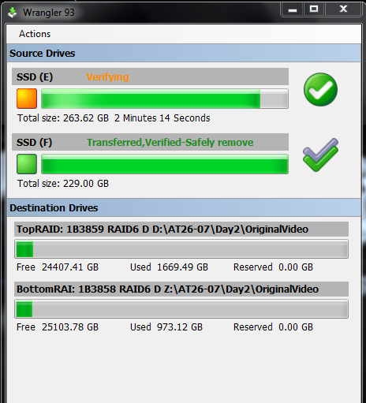
- Gently remove the recorder drives and rehouse them in their caddies, leaving the video content intact. You should/are supposed to have sufficient inventory to leave it intact until this material is stored off onto LTO tape.
- Move (drag-n-drop with Windows Explorer is easiest) the clips from the Wrangler93 destination directory, named with timestamp and mount point, to the appropriate recorder folder: “PortRecorder” or “StbdRecorder” under the “OriginalVideo” folder. After confirming all clips were moved, delete the temporary Wrangler93 folder. The Wrangler93 checksum logs should be placed in the “OriginalVideo” folder.
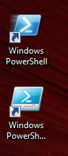
- Run a PowerShell console, basic or ISE.
- ‘cd’ to <cruiseID>\<diveID>\OriginalVideo.
- Run the script Clean-Crufty-Control.ps1 . This script examines the timecode stream of each clip and retrieves the clip’s duration. Clips that are too short (8-10 seconds depending on setting) and therefore worthless are moved to the “OriginalVideoCruft” tree. Remember that this script uses the initialization info you edited into D:\Alvin.ini, so make sure cruise and dive info are up to date. Also be sure to run the script on the CPU that sees Alvin.ini on mount point D:, not on Z:.
- Confirm that Clean-Crufty-Control was successful.
- Run Transcode-Control.ps1. Same rules about Alvin.ini. This script will take several hours to finish.

Transferring to Media
- Please familiarize yourself with Alvin LTO tape handling procedures, Appendix 2. Format fresh LTO tapes for LTFS operation. Be sure to use the utilities provided by 1Beyond by invoking the desktop icons. Please confirm that the bar code label of the tape going to WHOI belongs is numbered in the range of 10000 to19999. Confirm that the local backup is a tape labeled with ID 19000 to 19999. Maintaining a contiguous sequence of tapes is desirable but not critical. Use the <cruiseID>_Video_Media_Log spreadsheet.
- If you wish, use both Wrangler Racks simultaneously to write tapes. If the content of the staging RAID filesystems differs, be sure to archive the material from the one with the mature material. This may mean archiving material from D: on one Wrangler Rack and Z: on the other.
- Copy the same mature material to an external USB hard drive, which will be placed in the science data package. Log its identity in the <cruiseID>_Video_Media_Log.xls spreadsheet.

Step 4: Delivering the video data with the cruise data package.
- One LTO tape that goes back to WHOI for archival.
- Another LTO tape that stays on board as a backup for LTO tape #1. This tape will later be overwritten when data managers @ WHOI confirm that the content have been safely transported to the archival destination.
- Science party video onto an external USB hard drive.

Appendix 1: Wrangler 93 configuration

Appendix 2: Alvin LTO Tape Procedures
LTO tape will be used to transport a cruise video package to WHOI, where it will be placed in the Data Library and Archives. Some simple procedures have been put in place to enhance data protection and organization.

How many tapes?
Early on, it appears that each dive will generate between 600GB and 1TB of video related data per routine dive. Most of this is pre-compressed by video codec algorithms. We will learn more about generated file volumes as operations ensue.

Video material will be duplicated on two LTO tapes. One of these copies will be sent to WHOI for long-term archival. One will remain on the ship as backup. This latter copy will be preserved until the archival copy is verified and duplicated on shore, at which time the media is free to be reused.

An LTO generation 5 tape will hold 1.5TB of compressed data. An LTO deck compresses/decompresses on-the-fly, so it may appear at operating system level that larger volumes are being stored. They aren’t. Pre-compressed files are little changed when written to tape, and file sizes at OS level are close to their tape usage requirement.

All Alvin LTO tapes will be formatted using Long Term FileSystem (LTFS), which makes tape much more convenient to use. Presentation becomes much more like a hard drive. Despite this, remember that underneath the presentation you’re dealing with a linear-access medium and not a random-access one like a true hard drive.

Formatting under LTFS uses a portion of the raw tape, and LTO5 capacity is reduced to about 1.4TB.

So, depending on realized file volumes once operations are in full swing, we can expect that the video products from two dives will fit on one LTO5/LTFS tape.

Tape Handling Procedures
The 1Beyond offload equipment was built to streamline these handling. Each Wrangler Rack CPU houses an LTO drive, and specialty softwares for using these decks and LTO media were included.

From the Wrangler Rack desktop, use the utility accessed via the “Format Tape” icon to impose the LTFS filesystem on fresh media.

Apply the “Eject Tape” icon to properly rewind, unmounts, and eject a tape from the drive. Don’t use the drive’s eject button!

Copying by drag and drop, or Watchfolder?

Before ejecting a tape, log details about its content and identity in the cruise’s video metadata spreadsheet. Use this information to make sure that both copies store the same content.

Please use common sense to decide whether to split dives across units of tape media. LTO5 media is not free but it is not expensive ($30 per unit). It costs SSSG Tech time to figure how to shoehorn a tape full by fragmenting dive data hierarchies. It costs data manager and archivist time to reconstruct fragmented data on shore. If tape packing efficiency can be increased by broad strokes at a point high in the data hierarchy, then it is sensible to make the split. Otherwise it is not. Remember that splitting details must be logged by you in metadata records at duplication time, and then these details must be verified and perhaps reversed back on shore.

Two copies of LTO tape, one as a medium term (months) backup on Atlantis, the other to send to shore.

To avoid conflict with other potential producers of LTO tape collections, Alvin LTO tape IDs have been arbitrarily assigned to be in the 10,000 to 19,999 range. Units meant to go back to shore will be in the 10,000 to 18,999 range. Units that stay on Atlantis as medium range backup will be in the 19,000 to 19,999 range. Please verify that units are directed to the proper destination.

Please coordinate media needs with shore. If for some reason media purchases are made from the ship, please use the following information:
There are only a couple manufacturers of LTO media, and most brands are the same units no matter what price is asked. For now, we have no marked brand preference and generally look for a good price. Quantum brand tapes has been the choice to date. Fuji brand is inexpensive, but they’re also the lone wolf manufacturer and we’re staying away from them for that reason.
Labels should be purchased with the media, and the vendor will usually apply the labels for you. Labels must include barcode encoding specific to a vendor/model of robot tape library. As of November 2013 and until further notice, this encoding should be for the Quantum Scalar i80 library.

Please use media with generally contiguous IDs, but don’t sweat the small stuff. The primary concern is that the system promotes unambiguous organization of the data, with no data unarchived, no duplication of media identifiers, and high quality metadata describing the content of data packages.

