1. Determination of miRNA–target site K_{D} values from Equilibrium AGO-RBNS Bind-N-Seq
We determined K_{D} values for each miRNA-target site type relative to RNA molecules lacking a site by maximum likelihood estimation (MLE). This is a statistical method by which the parameters values theta corresponding to a particular mathematical model are determined according to their greatest agreement with associated data. More formally, the element-wise values of theta are chosen to maximize the log-likelihood function
where lnp(y|x(theta)) is the probability of observing the sequencing count data y given the model-simulated abundances x(theta) (itself a function of theta). We first describe the derivation of x(theta), and then f_{cost}(x), a cost function scaling monotonically with lnp(y|x(theta)), and therefore having a minimum value coincident with the MLE parameter estimates. We then derive the gradient for the overall cost function
allowing for the efficient, stable solution of large sets of (>50,000) of K_{D} values via the L-BFGS-B method (using the optim package in R).

2. Derivation of x(theta)
The function x(theta) calculates x_{j} = (x_{1j}, x_{2j}, …, x_{nj}), the concentration of each site type containing RNA i recovered within equilibrium binding reaction sample j, where 1 ≤ i ≤ n and 1 ≤ j ≤ 5. This function takes as input, the K_{D} value corresponding to each site K = (K₁, K₂,…, K_{n}), the total concentration of each of the site types l = (l₁, l₂, …, l_{n}), the stock concentration (i.e. the concentration at which it was stored prior to dilution into an binding reaction) of the AGO–miRNA complex a (hereafter referred to as “AGO”), the concentration of library RNA recovered nonspecifically by nitrocellulose filter binding, b, and the integer j designating which sample within the dilution series is to be simulated. The vector of total target–site type concentrations are fixed prior to the optimization routine, and are given by
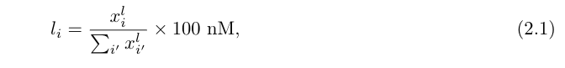
where x_{i}^{l} is the read count corresponding to site i in the input library. In order to allow the optimization routine to proceed unconstrained (i.e., to allow the parameter values to be anywhere in the range from –∞ to +∞, in addition to the range of orders of magnitudes the parameter values may occupy, theta is parameterized in terms of natural logarithm of the biochemical parameters used in the model function x(theta), such that
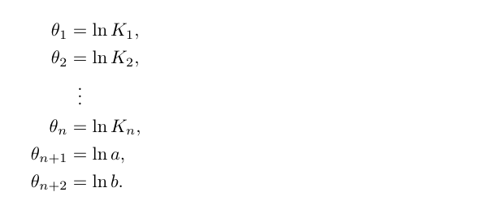
The recovered concentration of site i in sample j is given by
where c_{ij} and g_{ij} are the concentration of the AGO–bound and nonspecifically recovered forms of the site, respectively. By making the assumption that only the unbound sites can be nonspecifically recovered in the binding reaction, and that the total concentration (and therefore amount) of nonspecific recovered library RNA b is constant across all five samples, x_{ij} can be written as
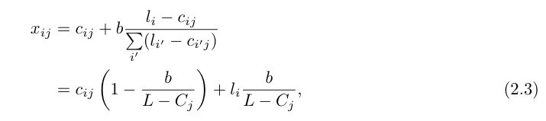
where c_{ij} and (l_{i} – c_{ij}) represent the bound and unbound form of site i in sample j, L = sum(l)(= sum_{i}(l_{i})) represents the total concentration of the random library in the reaction (experimentally set to 100 nM), C_{j} = sum(c) represents the total concentration of bound target sites (equivalent to the bound AGO), and b = exp(theta_{n+2}), as per the logarithmic parameterization of theta described above. To solve for c_{ij}, we apply the definition of K_{D}:
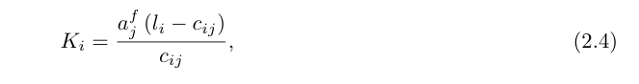
which contains c_{ij} and (l_{i} – c_{ij}) as in equation (2.2), as well as a_{j}^{f} representing the concentration of unbound AGO in sample j, and rearrange it to
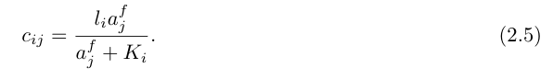
Since K is embedded in the parameter vector theta, and since l is a fixed quantity in the analysis, determination of c_{j} requires only the determination of a_{j}^{f}, which is a latent, unobserved quantity within the binding reaction. While there is no explicit equation by which to calculate this value, it is absolutely specified by the constraint:
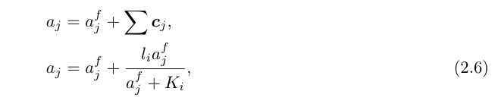
which requires that the sum of concentration of unbound AGO a_{j}^{f} and the bound form of every site c_{ij} (for which each is a function of a_{j}^{f}) is equal to the known, total amount of AGO in the binding reaction a_{j}. This value is related to the parameter value theta_{n+1} according to
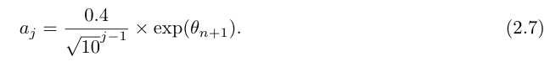
We note that the prefactor in equation (2.7) relates the sample concentration index j to the percentage dilution of AGO into that binding reaction (i.e. j = 1 yields 40%, j = 2 yields 12.65%, etc.). Substitution of (2.5) into (2.3) yields:
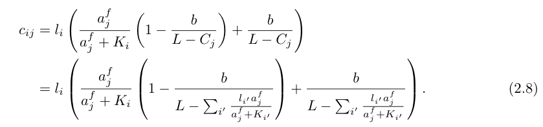
where K_{i} = exp(theta_{i}) for 1 ≤ i ≤ n. This is the final form of the function, taking as inputs the optimization parameter vector theta, the fixed parameter vector l (and its sum L), and the free AGO concentration terms a_{j}^{f}, which are computed for each dilution sample from theta and l using equation (2.5).

3. Derivation of f_{cost}(x)
The cost function f_{cost}(x) is derived from the product of the negative log multinomial probability density function for each column j
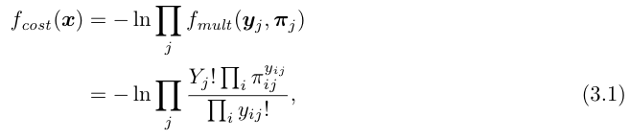
where pi_{ij} is the expected frequency of each site type i in sample j according to the model parameters, and Y_{ji} = sum(y_{j}). Each expected frequency vector pi_{j} is trivially given by x_{j} / X_{j}, thereby providing the link between the model simulation and subsequent likelihood estimation. Substituting pi_{ij} and distributing the natural log yields
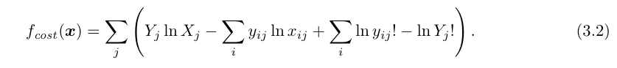
We discard the third and fourth terms in equation (3.2) as neither contains any terms of x_{j}, and are therefore unrelated to the MLE estimation of theta. The final cost function for our optimization routine is thus
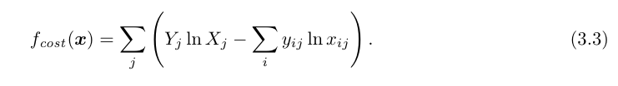

4. Derivation of f_{grad}(theta)
The function f_{grad}(theta) returns the derivative of the cost function with respect to each component of theta:
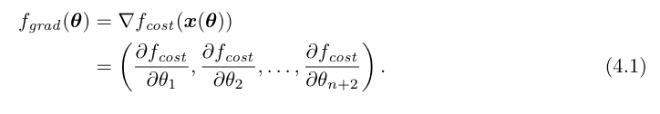
Invoking a new subscript k, for which 1 ≤ k ≤ n + 2, we derive df_{cost}/dtheta_{k} via chain rule:
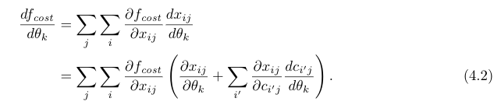
∂f_{cost}/∂x_{ij} is obtained by differentiating equation (3.3)
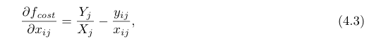
and both ∂x_{ij}/∂theta_{k} and ∂x_{ij}/∂c_{i'j} are obtained by differentiation of equation (2.3)
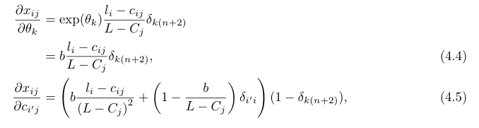
where delta_{ab} (or equivalently delta_{a(b)}) is the Kronecker delta function, defined as:
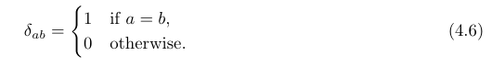
Substituting (4.3) and (4.4) into (4.2) and rearranging yields
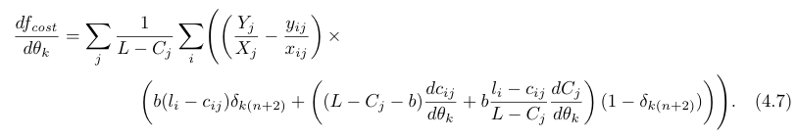
Inspection of the Kronecker delta functions in equation (4.7) reveals that the derivatives associated with the K_{D} and AGO concentration in the reaction will only use the second term in the last factor, while by contrast the parameter describing the nonspecifically recovered RNA will only use the first term, simplifying the calculation of the derivatives. Proceeding in the ordering of the parameter vector theta, we first solve for the derivative with respect to the K_{D} associated with each site-type, or theta_{k} for 1 ≤ k ≤ n. This requires solving for dc_{ij}/dtheta_{k} and dC_{j}/dtheta_{k}. dc_{ij}/dtheta_{k} is found by differentiating equation (2.7):
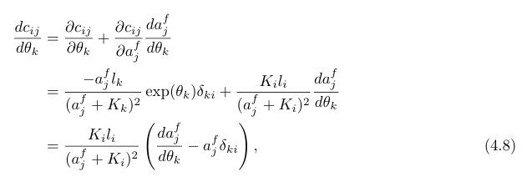
where delta_{ki} is a Kronecker delta function. Differentiation of equation (2.8) yields
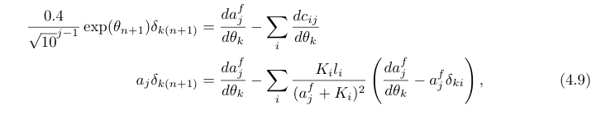
an implicit solution for da_{j}^{f}/dtheta. We rearrange (4.9) to arrive at
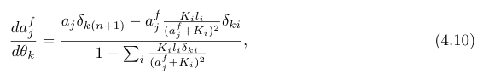
which automatically provides a solution for dCj/dtheta_{k}, since da_{j}^{f}/dtheta_{k} = –dC_{j}/dtheta_{k}. Substituting (4.8) into (4.7) and restricting the derivative index to 1
≤ k ≤ n yields
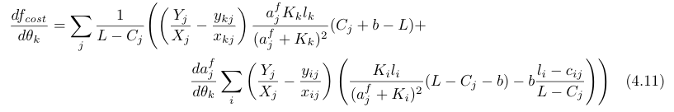
which, when further substituted with (4.9) yields
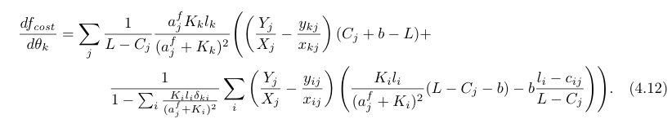
Proceeding similarly for df_{cost}/dtheta_{n+1}, we obtain
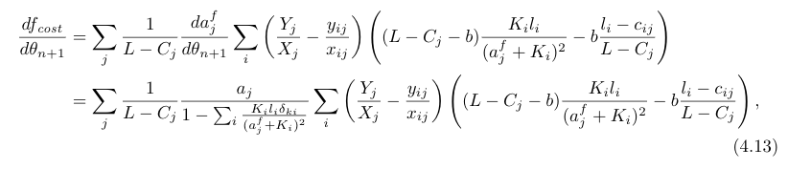
and for df_{cost}/dtheta_{n+2}
