Most Searched Players

Back to [Fortnite Ping](https://www.fortniteping.com)

***Last updated November 2, 2019***

We started tracking player searches on Fortnite Ping in mid October 2019. As of now, 4,089 players have been searched in more than 13,703 searches. Here is the breakdown of searches by region. The relatively large number of searches in NA East may be due to the it being used to organize scrims.

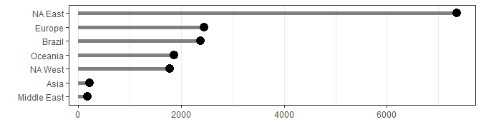

Here is a breakdown of the players who have more than 15 searches. Note that we don’t track who was doing the searching, only who was searched.

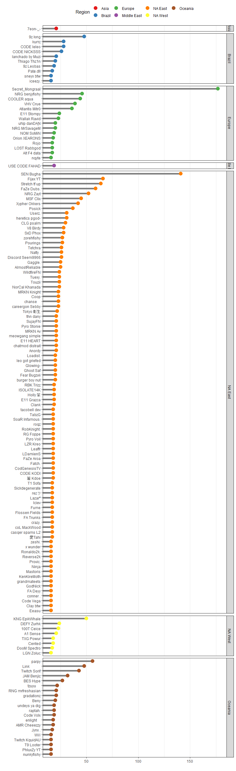 Breakdown of number of searches each day by region