Guidewire Cloud CDA publishes Parquet extracts to Amazon S3, the files are transferred to Azure Data Lake Storage Gen2, and then loaded into Azure Synapse Dedicated SQL Pool using Apache Spark/Scala notebooks.
High Level Design Document
Guidewire Cloud CDA to Azure Data Platform
1. Document Control
Item | Description
Document Name | Guidewire Cloud CDA – Azure Data Platform High Level Design
Document Type | High Level Design (HLD)
Version | 1.0
Status | Draft
Author | Data Architecture
Source System | Guidewire Cloud CDA
Target Platform | Azure Data Lake Storage Gen2 / Azure Synapse Analytics
Processing Technology | Apache Spark / Scala
Target Database | Azure Synapse Dedicated SQL Pool

2. Executive Summary
The objective of this solution is to establish a scalable and secure data integration platform for extracting data from Guidewire Cloud CDA, transferring the extracted Parquet files from the Guidewire-provided Amazon S3 bucket into Azure Data Lake Storage Gen2 (ADLS Gen2), transforming and validating the data using Apache Spark/Scala notebooks hosted in Azure Synapse, and loading the curated data into Azure Synapse Dedicated SQL Pool for enterprise reporting, analytics and downstream consumption.
The solution follows an ELT architecture, where data is first landed in Azure Data Lake Storage in its source format and subsequently transformed and loaded into the target Synapse Dedicated SQL Pool structures.
The proposed architecture separates the solution into distinct layers:
- Guidewire Cloud CDA / Amazon S3 – Source extract layer.
- ADLS Gen2 Landing/Raw Layer – Immutable landing zone.
- Spark Processing Layer – Data validation, transformation and standardisation.
- Synapse Dedicated SQL Pool – Curated relational data layer.
- Consumption Layer – Power BI, downstream applications and analytical workloads.
The architecture is designed to provide scalability, security, auditability, data quality, operational monitoring and the ability to onboard additional Guidewire CDA datasets with minimal changes to the overall platform.

3. Business Objectives
The solution will provide the following capabilities:
- Integrate data extracted from Guidewire Cloud CDA into the Azure data platform.
- Automate the transfer of Parquet files from Amazon S3 to Azure Data Lake Storage.
- Maintain an immutable copy of source data for audit and reprocessing purposes.
- Process large-volume Parquet datasets using distributed Apache Spark processing.
- Apply data validation and transformation rules before loading into the relational target.
- Load curated data into Synapse Dedicated SQL Pool.
- Provide reliable and repeatable incremental data processing.
- Support historical and incremental data loads.
- Provide operational metadata and audit information.
- Support enterprise reporting and analytics.
- Provide a scalable architecture for additional Guidewire datasets.
- Minimise dependency on traditional row-by-row ETL processing.

4. Scope
4.1 In Scope
The solution includes:
- Guidewire Cloud CDA extract files.
- Amazon S3 source bucket.
- Secure extraction/copy of Parquet files.
- Azure Data Lake Storage Gen2.
- Landing/raw data storage.
- Apache Spark processing.
- Scala notebooks in Azure Synapse.
- Data validation.
- Data transformation.
- Data standardisation.
- Data quality checks.
- Synapse Dedicated SQL Pool.
- Target staging and curated tables.
- Incremental processing.
- Metadata and audit logging.
- Error handling.
- Operational monitoring.
- Security and access control.
- Data retention strategy.
4.2 Out of Scope
The following are outside the scope of this HLD unless specifically required:
- Changes to Guidewire Cloud CDA extraction processes.
- Guidewire application configuration.
- Detailed Power BI semantic model design.
- Detailed report/dashboard design.
- Business-specific data transformation rules.
- Detailed physical database design.
- Detailed Spark code implementation.
- Detailed CI/CD pipeline implementation.
- End-user reporting requirements.

5. Current State
Guidewire Cloud CDA provides data extracts in Parquet format through an Amazon S3 bucket.
The current/proposed integration requirement is to make these extracts available within the organisation's Azure data platform.
The target architecture therefore introduces an Azure-based data pipeline that:
Guidewire Cloud CDA
|
v
Amazon S3
|
| Parquet files
v
Azure Data Lake Storage Gen2
|
v
Apache Spark / Scala
|
| Validate
| Transform
| Standardise
v
Synapse Dedicated SQL Pool
|
v
Reporting / Analytics / Downstream Consumers

6. Proposed Solution Architecture
6.1 High-Level Architecture
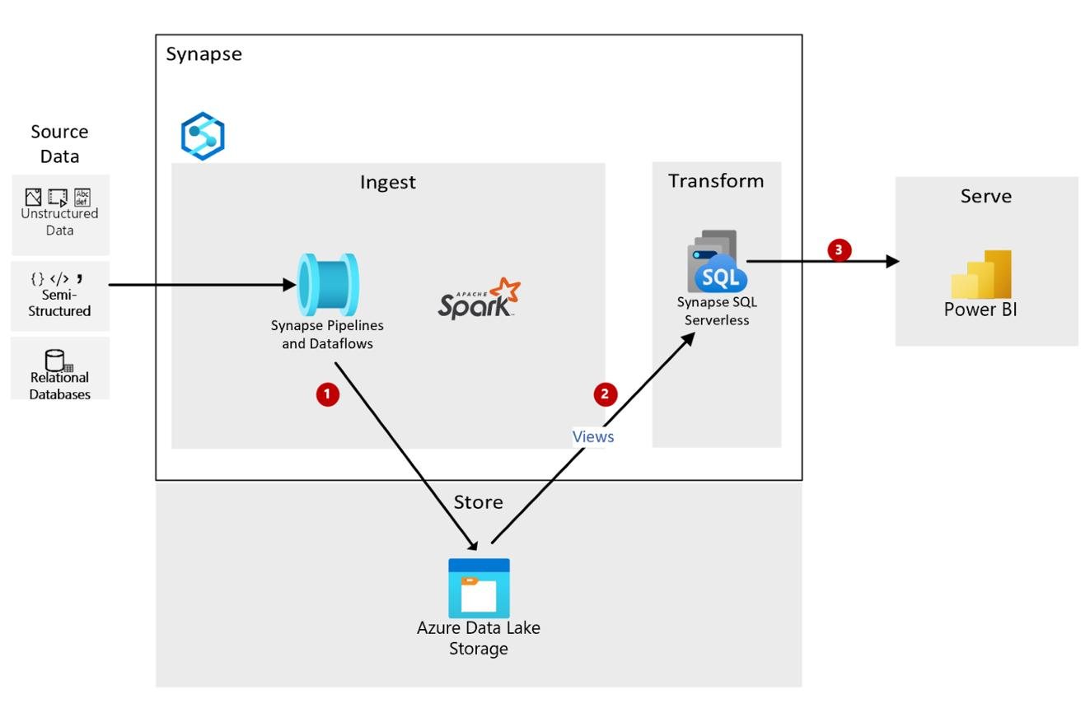
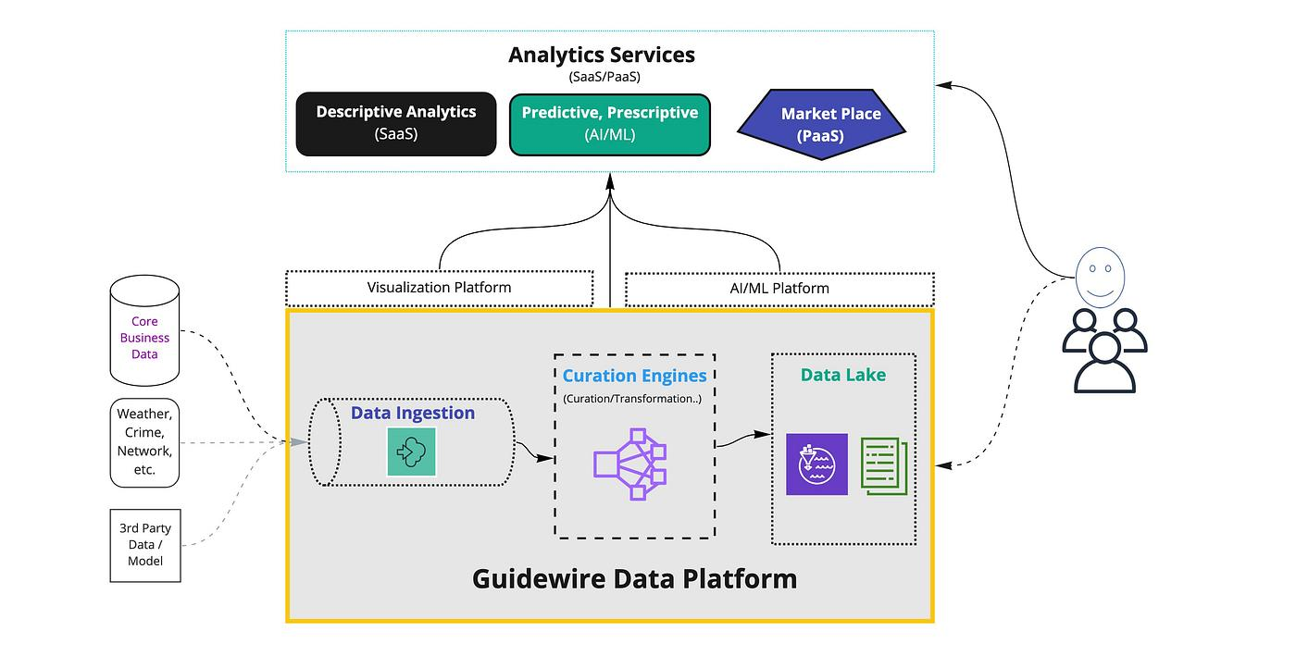
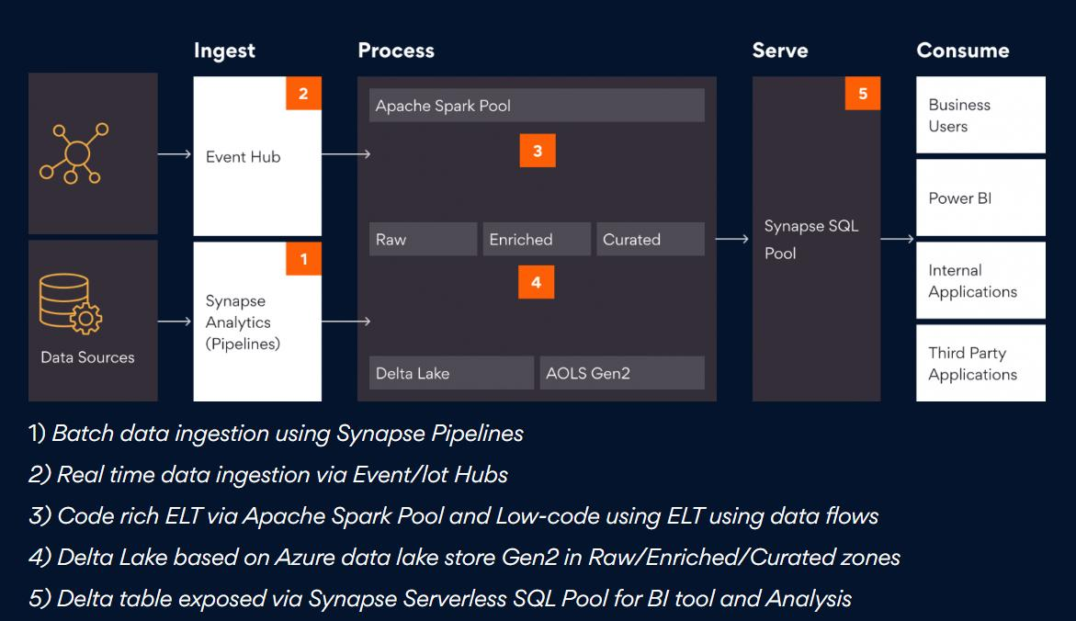
5
The proposed architecture consists of the following major components:
Component | Responsibility
Guidewire Cloud CDA | Produces data extracts
Amazon S3 | Source location for Parquet extracts
ADLS Gen2 | Azure landing and processing storage
Azure Synapse Workspace | Data processing and orchestration platform
Apache Spark | Distributed data processing
Scala Notebooks | Data extraction, validation and transformation logic
Synapse Dedicated SQL Pool | Enterprise relational data warehouse
Metadata/Audit Store | Processing and operational metadata
Monitoring | Pipeline and processing monitoring
Power BI / Consumers | Data consumption

7. Logical Data Flow
The end-to-end data flow is:
Step 1 – Guidewire Extraction
Guidewire Cloud CDA generates Parquet extract files based on the configured extraction schedule.
Example:
Guidewire CDA
|
+-- policy.parquet
+-- claim.parquet
+-- customer.parquet
+-- payment.parquet
The files are made available in the designated Amazon S3 bucket.

Step 2 – S3 to ADLS Transfer
The solution securely copies the Parquet files from the Amazon S3 bucket to ADLS Gen2.
The original Parquet structure should be preserved where practical.
Example:
ADLS
/
guidewire
/raw
/policy
/2026
/08
/04
policy.parquet
/claim
/2026
/08
claim.parquet
The landing layer should be treated as immutable.
Source files should not be overwritten after successful ingestion unless there is a clearly defined retention/reprocessing strategy.

8. ADLS Data Lake Architecture
The ADLS structure should use logical data zones.
Recommended structure:
ADLS Gen2
|
+-- guidewire
|
+-- landing
|
+-- raw
|
+-- processed
|
+-- rejected
|
+-- archive
Landing
Contains files copied directly from Amazon S3.
Purpose:
- Source preservation.
- Reprocessing.
- Audit.
- Recovery.
Raw
Contains validated source data in a standardised lake representation if required.
Processed
Contains transformed/standardised datasets ready for loading.
Rejected
Contains files or records failing validation.
Archive
Contains historical source files according to the agreed retention policy.

9. ELT Processing Architecture
The solution follows an ELT approach.
Extract
|
v
S3
|
v
Load
|
v
ADLS Landing
|
v
Transform
|
v
Spark / Scala
|
v
Load
|
v
Synapse Dedicated SQL Pool
The primary principle is to avoid unnecessary transformation during the initial file transfer.
The source Parquet data should be copied to Azure first, preserving the source data as much as possible.
Transformations are subsequently performed using Spark.

10. Apache Spark / Scala Processing
Apache Spark running within Azure Synapse will be used as the primary processing engine.
Scala notebooks will perform:
- File discovery.
- File validation.
- Schema validation.
- Data type standardisation.
- Null handling.
- Data cleansing.
- Business transformations.
- Deduplication.
- Incremental processing.
- Data quality validation.
- Partition management.
- Target preparation.
- Synapse loading.
Example conceptual processing:
Read Parquet
|
v
Schema Validation
|
v
Data Quality Checks
|
v
Standardisation
|
v
Business Transformations
|
v
Deduplication
|
v
Target Preparation
|
v
Synapse Dedicated SQL Pool

11. Spark Notebook Design
A modular notebook approach should be adopted rather than creating one large notebook containing all processing logic.
Recommended notebooks:
NB_01_File_Ingestion
NB_02_File_Validation
NB_03_Schema_Validation
NB_04_Data_Transformation
NB_05_Data_Quality
NB_06_Synapse_Load
NB_07_Audit_Update
Alternatively, notebooks can be organised by domain:
Guidewire
|
+-- Policy
| +-- policy_ingestion
| +-- policy_transformation
| +-- policy_load
|
+-- Claim
| +-- claim_ingestion
| +-- claim_transformation
| +-- claim_load
|
+-- Customer
+-- customer_ingestion
+-- customer_transformation
+-- customer_load
The final implementation should balance reusability against operational simplicity.

12. Metadata-Driven Processing
A metadata-driven approach is recommended.
A control table can contain information such as:
Attribute | Example
Source System | Guidewire
Source Object | Claim
S3 Location | /claim/
ADLS Location | /guidewire/raw/claim/
Target Table | dbo.FactClaim
Load Type | Incremental
Business Key | Claim ID
Partition Column | Claim Date
Last Successful Load | Timestamp
Active Flag | Y
This allows the processing framework to support additional Guidewire datasets without requiring significant changes to the core framework.

13. Incremental Load Strategy
The solution should support incremental processing wherever Guidewire CDA provides suitable incremental indicators.
Potential mechanisms include:
- Extract date.
- File creation date.
- File modification timestamp.
- Source business date.
- Source change timestamp.
- CDA-provided incremental extract indicator.
The preferred approach is to maintain an ingestion/control watermark.
Example:
Last Successful Watermark
|
v
Identify New Files
|
v
Copy to ADLS
|
v
Process New Data
|
v
Load Synapse
|
v
Update Watermark
The watermark should only be updated after successful completion of the target load.

14. Synapse Dedicated SQL Pool Architecture
The Dedicated SQL Pool should contain logical layers.
Recommended:
Dedicated SQL Pool
|
+-- Staging
|
+-- Integration
|
+-- Presentation
Staging
Used for initial loading from Spark.
Example:
stg_claim
stg_policy
stg_customer
Integration
Contains cleansed and integrated data.
Example:
int_claim
int_policy
int_customer
Presentation
Contains data structures optimised for reporting and analytics.
Example:
dim_customer
dim_policy
fact_claim
fact_payment
The exact dimensional model should be defined during the Low Level Design phase.

15. Loading Strategy into Dedicated SQL Pool
Spark will prepare the data before loading into Synapse Dedicated SQL Pool.
For large-volume datasets, the implementation should favour bulk-oriented loading patterns rather than row-by-row inserts.
The loading process should support:
- Load to staging.
- Validate load.
- Perform insert/update or CTAS-based processing as appropriate.
- Apply target transformations.
- Validate record counts.
- Commit successful processing.
- Update audit metadata.
Example:
Spark
|
v
Synapse Staging
|
v
Validation
|
v
Target Transformation
|
v
Curated Tables
The physical loading mechanism should be finalised during LLD based on expected data volumes, concurrency, performance requirements and Synapse workload configuration.

16. Data Quality Framework
Data quality checks should be performed before data is promoted to the curated layer.
Recommended checks:
File-Level
- File exists.
- File is readable.
- File is not corrupted.
- File size is greater than expected minimum.
- File has not already been processed.
Schema-Level
- Expected columns exist.
- Data types are compatible.
- Required columns are present.
- Unexpected schema changes are detected.
Record-Level
- Mandatory fields populated.
- Business keys not null.
- Duplicate records identified.
- Invalid dates identified.
- Invalid numeric values identified.
Reconciliation
Compare:
Source Record Count
vs
ADLS Record Count
vs
Synapse Record Count
Any significant discrepancy should generate an operational alert.

17. Error Handling
Errors should be categorised into:
Technical Errors
Examples:
- S3 connectivity failure.
- ADLS unavailable.
- Spark failure.
- Synapse connection failure.
- SQL execution failure.
Data Errors
Examples:
- Invalid schema.
- Invalid data type.
- Missing mandatory field.
- Duplicate business key.
- Corrupt Parquet file.
Business Rule Errors
Examples:
- Invalid status.
- Invalid date relationship.
- Invalid reference data.
Failed processing should not result in the source files being deleted.
Rejected files/records should be retained for investigation and reprocessing.

18. Reprocessing Strategy
The architecture should support replay of failed processing without requiring the source system to regenerate the data.
Because the original Parquet files are retained in ADLS, Spark processing can be restarted from the landing/raw layer.
Example:
S3
|
v
ADLS Landing
|
+------> Successful processing
|
+------> Failed processing
|
v
Reprocess
This is an important architectural benefit of maintaining an immutable landing zone.

19. Audit and Operational Metadata
An audit framework should capture at least:
Attribute | Description
Batch ID | Unique processing identifier
Source System | Guidewire
Source Object | Claim/Policy/etc.
File Name | Source file
File Size | File size
File Timestamp | Source timestamp
Start Time | Processing start
End Time | Processing completion
Source Records | Number of source records
Target Records | Number loaded
Status | Success/Failed
Error Message | Error details
Notebook | Processing notebook
Watermark | Incremental processing value
Example status:
STARTED
|
v
FILE_RECEIVED
|
v
VALIDATED
|
v
TRANSFORMED
|
v
LOADED
|
v
RECONCILED
|
v
COMPLETED

20. Security Architecture
Security should follow Azure enterprise security principles.
Identity
Use Microsoft Entra ID and managed identities wherever supported.
Avoid storing:
- Passwords.
- Access keys.
- Client secrets
directly in notebooks.
Secrets
Secrets and credentials should be stored in Azure Key Vault where required.
ADLS Security
Implement:
- RBAC.
- ADLS ACLs.
- Private endpoints where required.
- Encryption at rest.
- Secure transfer.
Synapse Security
Implement:
- Microsoft Entra authentication.
- Least-privilege database roles.
- Separate processing and consumer identities.
- Appropriate schema-level permissions.

21. Network Architecture
Where enterprise security requirements apply, the solution should use private connectivity.
Conceptual architecture:
Guidewire / AWS
|
| Secure transfer
v
Azure Network
|
+-- ADLS Gen2
|
+-- Synapse Workspace
| |
| +-- Spark
| +-- Dedicated SQL Pool
|
+-- Key Vault
Private endpoints should be considered for:
- ADLS Gen2.
- Synapse.
- Key Vault.
- Other supporting Azure services.
Network requirements should be confirmed with the enterprise networking/security teams.

22. Authentication and Authorisation
Recommended identity model:
Component | Authentication
S3 | Approved AWS authentication mechanism
ADLS | Managed Identity / Entra ID
Synapse | Managed Identity / Entra ID
Key Vault | Managed Identity
Spark | Synapse Managed Identity
Monitoring | Managed Identity / Entra ID
Access should follow the principle of least privilege.

23. Data Encryption
Data should be encrypted:
In Transit
Use TLS/HTTPS for communication between components.
At Rest
Azure Storage and Synapse provide encryption at rest.
Additional customer-managed keys may be considered if required by organisational security policy.

24. Performance and Scalability
The architecture is designed to support large-volume Guidewire extracts.
Performance considerations include:
ADLS
- Appropriate Parquet partitioning.
- Avoid excessive small files.
- Appropriate folder structure.
Spark
- Partition data appropriately.
- Avoid unnecessary shuffles.
- Use predicate pushdown.
- Select only required columns.
- Avoid collecting large datasets to the driver.
- Tune Spark executors according to workload.
Synapse Dedicated SQL Pool
- Select appropriate distribution strategy.
- Use appropriate table types.
- Partition large fact tables where appropriate.
- Maintain statistics.
- Minimise data movement.
- Use CTAS/bulk loading patterns where appropriate.
The exact DWU/Spark sizing should be established through performance testing rather than fixed in the HLD.

25. Data Retention
The retention policy should be defined for:
Layer | Proposed Retention
S3 | As agreed with Guidewire/Source Team
ADLS Landing | X months
ADLS Raw | X months
ADLS Processed | X months
Rejected | X months
Synapse Staging | Short-term
Synapse Curated | Business-defined
Audit Metadata | X years
Retention periods should comply with enterprise data governance and regulatory requirements.

26. Monitoring and Alerting
Monitoring should cover the complete data flow.
File Monitoring
- Expected file received.
- File count.
- File size.
- Missing files.
- Duplicate files.
Spark Monitoring
- Notebook execution.
- Execution duration.
- Records processed.
- Failed jobs.
- Executor/resource issues.
Synapse Monitoring
- Load status.
- Query duration.
- Failed loads.
- Resource utilisation.
- Data skew.
- Concurrency.
Alerts
Alerts should be generated for:
- Missing expected extract.
- Failed ingestion.
- Failed Spark notebook.
- Schema change.
- Data quality failure.
- Synapse load failure.
- Reconciliation failure.
- Processing SLA breach.

27. Availability and Resilience
The solution should be designed so that individual processing failures do not result in data loss.
Key principles:
- Immutable source landing.
- Idempotent processing.
- Batch-level audit.
- Retry mechanism.
- Reprocessing capability.
- No deletion of source files before successful processing.
- Recovery from the last successful watermark.
The solution should also leverage Azure service-level availability capabilities appropriate to the organisation's requirements.

28. Idempotency
The processing framework should be idempotent.
If the same file or batch is processed twice, the target should not contain duplicate records.
A combination of:
Source File ID
+
Batch ID
+
Business Key
+
Processing Status
can be used to identify previously processed data.
This is particularly important when retries occur following a partial failure.

29. Schema Evolution
Guidewire extract schemas may evolve over time.
The solution should detect:
- New columns.
- Removed columns.
- Data type changes.
- Renamed columns.
- Changes in nullable attributes.
Schema changes should be captured in the audit framework and should not automatically break production processing unless the change is classified as incompatible.
Recommended approach:
New Schema
|
v
Schema Comparison
|
+---- Compatible ---> Continue
|
+---- Breaking ------> Reject / Alert

30. DevOps and Deployment
All Spark/Scala notebooks and configuration should be maintained under source control.
Recommended flow:
Developer
|
v
Azure DevOps Git
|
v
Development
|
v
Test
|
v
UAT
|
v
Production
Deployment should be automated using CI/CD.
Environment-specific configuration should not be hard-coded into notebooks.
For example:
DEV
TEST
UAT
PROD
should have separate configuration values for:
- Storage paths.
- Database names.
- Workspace settings.
- Key Vault references.
- Processing parameters.

31. Logging
Application-level logging should capture:
- Notebook name.
- Batch ID.
- Source object.
- File name.
- Processing stage.
- Start/end timestamps.
- Record counts.
- Error details.
- Execution status.
Logging should be centralised where practical.

32. Disaster Recovery
The DR design should address:
- ADLS data recovery.
- Synapse recovery.
- Metadata recovery.
- Notebook/source-code recovery.
- Configuration recovery.
- Reprocessing from source/landing data.
The architecture should avoid making Synapse staging data the only copy of the source information.
ADLS should provide the persistent recovery point for source extracts.

33. Non-Functional Requirements
The following NFR categories should be defined during detailed design:
Category | Requirement
Performance | Complete daily load within agreed SLA
Scalability | Support increasing Guidewire data volumes
Availability | Meet agreed platform availability
Security | Enterprise security standards
Recoverability | Ability to replay failed batches
Auditability | End-to-end processing audit
Maintainability | Modular Spark framework
Extensibility | Easy onboarding of additional datasets
Data Quality | Reconciliation and validation
Compliance | Follow organisational data governance

34. Key Architectural Principles
The solution should follow these principles:
- Cloud-first architecture
- ELT rather than traditional ETL
- Immutable source landing
- Metadata-driven processing
- Idempotent processing
- Least-privilege security
- Managed identity wherever possible
- Separation of storage and compute
- Reusable Spark processing framework
- Automated monitoring and auditing
- Source-to-target reconciliation
- Infrastructure and code managed through DevOps
- Schema-change detection
- Failure isolation and reprocessing
- Scalable Parquet-based data processing

35. Key Design Decisions
The HLD should explicitly document the following decisions:
Decision | Proposed Approach
Source format | Parquet
Source platform | Guidewire Cloud CDA / Amazon S3
Azure landing | ADLS Gen2
Processing | Apache Spark
Notebook language | Scala
Processing platform | Azure Synapse Spark
Target | Synapse Dedicated SQL Pool
Architecture | ELT
Landing principle | Immutable
Processing | Metadata-driven
Authentication | Managed Identity where supported
Secrets | Azure Key Vault
Source control | Azure DevOps Git
Deployment | CI/CD
Monitoring | Azure monitoring/logging
Data quality | Automated validation/reconciliation

36. Assumptions
The following assumptions should be confirmed during detailed design:
- Guidewire CDA provides the required data extracts in Parquet format.
- The organisation has appropriate access to the Guidewire S3 bucket.
- The S3 data can be securely transferred to Azure.
- Required Azure subscriptions and resources are available.
- Synapse Dedicated SQL Pool is the approved analytical target.
- Synapse Spark is approved for Scala processing.
- Required network connectivity can be established.
- Required identity permissions will be provisioned.
- Source data volumes and expected growth will be provided.
- Data retention requirements will be confirmed.
- Data classification requirements will be provided by the data governance team.
- Business transformation rules will be defined during detailed design.

37. Dependencies
Key dependencies include:
- Guidewire CDA extract availability.
- AWS/S3 connectivity.
- Azure networking.
- ADLS Gen2 availability.
- Synapse Workspace.
- Synapse Spark pool.
- Synapse Dedicated SQL Pool.
- Microsoft Entra ID.
- Key Vault.
- Azure DevOps.
- Enterprise security approval.
- Data governance approval.
- Source-to-target mapping.
- Business data quality rules.

38. Risks and Mitigations
Risk | Impact | Mitigation
S3 extract unavailable | High | File arrival monitoring and alerting
Large extract volumes | High | Spark distributed processing
Schema changes | High | Automated schema validation
Duplicate files | Medium | File-level idempotency
Spark failure | Medium | Retry/reprocessing
Synapse performance | High | Distribution/partitioning optimisation
Data quality issues | High | Automated validation
Network failure | Medium | Retry and resilient transfer
Credential expiry | High | Managed identity where possible
Data skew | Medium/High | Spark and Synapse performance tuning

39. Open Questions
The following questions should be resolved before the LLD:
Source
- What is the frequency of CDA extracts?
- What is the expected file size?
- What is the daily data volume?
- Are extracts full or incremental?
- How are incremental changes identified?
- What is the S3 folder structure?
- What is the S3 retention period?
Data
- What are the source schemas?
- What are the business keys?
- What are the expected relationships?
- What are the mandatory attributes?
- What are the data quality rules?
- How should deletes be handled?
Azure
- What is the expected ADLS retention?
- What Synapse DWU capacity is required?
- What Spark pool size is required?
- Is private networking mandatory?
- Which authentication mechanism is approved?
Target
- What tables are required?
- Which tables are facts and dimensions?
- What distribution strategy should be used?
- What partition strategy should be used?
- What are the reporting SLAs?

40. Recommended HLD Architecture Diagram
For the actual HLD, I would use the following architecture as the primary architecture diagram:
┌──────────────────────────┐
│ Guidewire Cloud CDA │
│ │
│ Data Extracts │
└─────────────┬────────────┘
│
│ Parquet
▼
┌──────────────────────────┐
│ Amazon S3 │
│ Guidewire Source │
└─────────────┬────────────┘
│
│ Secure File Transfer
▼
╔════════════════════════════════════════════╗
║ Azure Data Platform ║
║ ║
║ ┌──────────────────────────────────────┐ ║
║ │ ADLS Gen2 │ ║
║ │ │ ║
║ │ Landing → Raw → Processed → Archive │ ║
║ └──────────────────┬───────────────────┘ ║
║ │ ║
║ ▼ ║
║ ┌──────────────────────────────────────┐ ║
║ │ Azure Synapse Spark │ ║
║ │ │ ║
║ │ Apache Spark / Scala Notebooks │ ║
║ │ │ ║
║ │ • Validation │ ║
║ │ • Transformation │ ║
║ │ • Data Quality │ ║
║ │ • Deduplication │ ║
║ │ • Incremental Processing │ ║
║ └──────────────────┬───────────────────┘ ║
║ │ ║
║ ▼ ║
║ ┌──────────────────────────────────────┐ ║
║ │ Synapse Dedicated SQL Pool │ ║
║ │ │ ║
║ │ Staging → Integration → Presentation │ ║
║ └──────────────────┬───────────────────┘ ║
║ │ ║
╚═════════════════════╪══════════════════════╝
│
▼
┌─────────────────┐
│ Power BI / BI / │
│ Downstream Apps │
└─────────────────┘

┌──────────────────────────────┐
│ Cross-Cutting Services │
│ │
│ • Microsoft Entra ID │
│ • Key Vault │
│ • Monitoring │
│ • Audit / Metadata │
│ • Azure DevOps / CI-CD │
│ • Security / Networking │
└──────────────────────────────┘
41. HLD Document Structure — Final Recommended Table of Contents
For an enterprise-quality architecture document, I recommend using this structure:
- Document Control
- Executive Summary
- Business Objectives
- Scope
- Current State
- Architecture Overview
- Proposed Solution
- Logical Data Flow
- Source System – Guidewire CDA
- Amazon S3 Integration
- ADLS Gen2 Architecture
- Spark/Scala Processing Architecture
- ELT Processing Framework
- Metadata-Driven Processing
- Incremental Load Strategy
- Synapse Dedicated SQL Pool Architecture
- Data Model Overview
- Data Quality
- Error Handling & Reprocessing
- Audit & Operational Metadata
- Security Architecture
- Identity & Access Management
- Network Architecture
- Encryption
- Performance & Scalability
- Monitoring & Alerting
- Data Retention
- Availability & Resilience
- Schema Evolution
- DevOps & CI/CD
- Disaster Recovery
- Non-Functional Requirements
- Architectural Principles
- Key Design Decisions
- Assumptions
- Dependencies
- Risks & Mitigations
- Open Questions
- Appendix – Data Flow / Architecture Diagrams
Architectural recommendation: keep the HLD focused on what the architecture is, why it is designed that way, the major components, interfaces, responsibilities, security, NFRs and key decisions. Put detailed Scala code, individual table definitions, column mappings, Spark tuning parameters, SQL scripts, pipeline activities and exact network/firewall configuration into the Low Level Design (LLD). This separation will make the document much more useful for architecture review and approval.

Today 4:52 PM
Apache spark scala notebooks are provided by vendor. include this information in the HLD

Yes. This is an important architectural constraint and should be explicitly captured in the HLD because the Apache Spark/Scala notebooks are vendor-provided rather than developed and owned by the internal data engineering team.
I would update the HLD in the following areas.
1. Add to Executive Summary
Add the following paragraph:
The solution uses vendor-provided Apache Spark/Scala notebooks to perform the transformation and loading of Guidewire CDA data within Azure Synapse. The notebooks are supplied by the solution/vendor team as part of the Guidewire CDA integration and are responsible for processing the Parquet data landed in Azure Data Lake Storage and loading the transformed data into Synapse Dedicated SQL Pool.
The internal data platform team will provide and manage the required Azure platform components, connectivity, security, monitoring, operational controls and supporting infrastructure. The vendor-provided notebooks will be deployed and executed within the approved Azure Synapse environment in accordance with the agreed deployment, support and change-management processes.
2. Update the Architecture Overview
The architecture should make the ownership boundary clear:
┌───────────────────────────┐
│ Guidewire Cloud CDA │
│ │
│ Vendor Managed │
└─────────────┬─────────────┘
│
│ Parquet
▼
┌───────────────────────────┐
│ Amazon S3 │
│ │
│ Vendor / Source │
└─────────────┬─────────────┘
│
│ Secure Transfer
▼
╔══════════════════════════════════════════════════════╗
║ AZURE DATA PLATFORM ║
║ ║
║ ┌────────────────────────────────────────────────┐ ║
║ │ ADLS Gen2 │ ║
║ │ │ ║
║ │ Landing / Raw / Processed / Archive │ ║
║ └──────────────────────┬─────────────────────────┘ ║
║ │ ║
║ ▼ ║
║ ┌────────────────────────────────────────────────┐ ║
║ │ Azure Synapse Spark │ ║
║ │ │ ║
║ │ VENDOR-PROVIDED SCALA NOTEBOOKS │ ║
║ │ │ ║
║ │ • Read Parquet │ ║
║ │ • Validate │ ║
║ │ • Transform │ ║
║ │ • Data Quality │ ║
║ │ • Prepare Target Data │ ║
║ │ • Load Synapse │ ║
║ └──────────────────────┬─────────────────────────┘ ║
║ │ ║
║ ▼ ║
║ ┌────────────────────────────────────────────────┐ ║
║ │ Synapse Dedicated SQL Pool │ ║
║ │ │ ║
║ │ Staging / Integration / Curated │ ║
║ └──────────────────────┬─────────────────────────┘ ║
║ │ ║
╚═════════════════════════╪════════════════════════════╝
│
▼
┌─────────────────┐
│ BI / Reporting / │
│ Data Consumers │
└─────────────────┘
3. Add a "Vendor Responsibility" Section
I recommend adding a dedicated section because this will be important during architecture governance and operational handover.
Vendor-Provided Components and Responsibilities
The Apache Spark/Scala notebooks used within the solution are provided by the vendor as part of the Guidewire CDA integration solution. The notebooks are not developed as bespoke application code by the internal Azure data engineering team.
The vendor-provided notebooks are responsible for the core data processing required to transform the Guidewire CDA Parquet extracts and prepare/load the resulting data into the target Azure Synapse Dedicated SQL Pool structures.
Vendor Responsibilities
The vendor is responsible for:
- Providing the Apache Spark/Scala notebooks.
- Providing the required notebook dependencies and configuration requirements.
- Providing documentation for notebook execution and configuration.
- Providing the expected source and target schemas.
- Providing the transformation logic implemented within the notebooks.
- Providing guidance on Spark pool sizing and execution requirements.
- Supporting defects associated with the vendor-provided notebook code.
- Providing updated notebook versions where required.
- Communicating changes to notebook functionality or source/target schemas.
- Supporting investigation of vendor-specific processing failures.
Internal Data Platform Responsibilities
The internal Azure data platform/data engineering team is responsible for:
- Providing the Azure Synapse Workspace.
- Providing the required Spark pool.
- Providing ADLS Gen2 storage.
- Providing Synapse Dedicated SQL Pool resources.
- Configuring required networking and connectivity.
- Configuring identity and access management.
- Providing appropriate permissions for the vendor notebooks.
- Managing secrets and credentials through approved enterprise mechanisms.
- Deploying the vendor-provided notebooks into the approved environment.
- Managing environment-specific configuration.
- Monitoring notebook execution and data loads.
- Managing operational alerting.
- Managing Azure platform availability and capacity.
- Managing CI/CD and deployment processes where applicable.
- Coordinating vendor support for notebook-related issues.
- Ensuring appropriate audit and operational controls are implemented.
Shared Responsibilities
The following activities require collaboration between the vendor and internal teams:
- Initial notebook deployment.
- Integration testing.
- Performance testing.
- Data reconciliation.
- Schema change management.
- Production deployment.
- Incident investigation.
- Disaster recovery testing.
- Release management.
- Resolution of data quality issues.
4. Add to the Solution Component Table
Update the component table to explicitly identify ownership:
Component | Responsibility | Ownership
Guidewire Cloud CDA | Generates data extracts | Vendor/Guidewire
Amazon S3 | Source extract storage | Vendor/Guidewire
ADLS Gen2 | Azure landing/storage | Internal
Synapse Workspace | Processing platform | Internal
Spark Pool | Spark execution environment | Internal
Scala Notebooks | Data transformation/loading | Vendor-provided
Dedicated SQL Pool | Data warehouse | Internal
Metadata/Audit | Operational metadata | Internal
Monitoring | Platform and process monitoring | Internal
Azure DevOps | Source/deployment management | Internal / Shared
Key Vault | Secret management | Internal
Microsoft Entra ID | Identity/access | Internal
5. Modify the ELT Processing Section
The previous wording suggesting that the internal team develops the Spark framework should be changed.
Use:
ELT Processing Model
The solution follows an ELT processing model in which Guidewire CDA Parquet extracts are first transferred from the vendor-managed Amazon S3 environment into Azure Data Lake Storage Gen2. The source data is retained in the Azure landing layer before processing.
The subsequent transformation and target loading activities are performed using vendor-provided Apache Spark/Scala notebooks running on Azure Synapse Spark.
The high-level processing flow is:
Guidewire CDA → Amazon S3 → ADLS Gen2 → Vendor Scala Notebooks → Synapse Dedicated SQL Pool
The internal data engineering team is responsible for providing the execution environment and operational controls for the notebooks, while the vendor retains responsibility for the notebook processing logic.
The internal team should avoid making direct modifications to vendor-provided notebook code unless formally agreed with the vendor. Any required changes to the vendor processing logic should preferably be managed through the vendor's supported release/change process.
6. Add Vendor Notebook Lifecycle Management
This is particularly important from a Data Architecture and governance perspective.
Vendor Notebook Lifecycle and Change Management
Vendor-provided notebooks shall be treated as a managed third-party software component within the Azure data platform.
The notebooks should be version-controlled and associated with a specific vendor release/version. Production deployments should use an approved and tested version of the notebooks.
The following controls should be implemented:
- Record the vendor notebook version deployed to each environment.
- Maintain a controlled copy of the approved vendor notebooks.
- Prevent uncontrolled changes to production notebooks.
- Document vendor dependencies and required Spark/runtime versions.
- Perform regression testing when a new vendor notebook version is received.
- Validate source and target schema compatibility.
- Perform data reconciliation following notebook upgrades.
- Conduct performance testing for significant changes.
- Maintain rollback procedures for failed vendor releases.
- Record vendor release/change references in the deployment documentation.
Any modification made internally to vendor-provided notebooks should be formally documented and agreed with the vendor where the modification affects supported vendor functionality.
7. Add a Key Architectural Decision
ADR | Decision
AD-01 | Vendor-provided Spark/Scala notebooks will be used for Guidewire CDA data processing rather than internally developed Spark transformation code.
Rationale | Reduces duplication of vendor-supported transformation logic and aligns the implementation with the Guidewire CDA integration solution.
Impact | Internal teams have reduced control over transformation implementation and have a dependency on vendor releases, notebook compatibility and vendor support.
Mitigation | Version control, regression testing, release management, monitoring, documentation and defined vendor support processes.
8. Add this Risk
Risk | Impact | Mitigation
Dependency on vendor-provided notebooks | High | Establish formal vendor support, version control, regression testing and release management
Vendor notebook incompatibility with Synapse runtime | High | Maintain approved Spark/runtime versions and perform compatibility testing
Limited internal knowledge of notebook implementation | Medium/High | Obtain vendor technical documentation and conduct knowledge transfer
Vendor notebook change affects data processing | High | Formal change management and regression testing
Vendor support dependency during production incidents | High | Define SLA, escalation process and operational runbooks
9. Important Architecture Boundary
I would also add this statement to the HLD:
The internal Azure Data Platform owns the platform; the vendor owns the provided processing logic.
This distinction is useful during architecture review, operational handover, incident management, change management and support model definition.
The HLD should therefore show two ownership boundaries:
Vendor-managed
- Guidewire CDA
- Amazon S3
- Scala/Spark notebooks
- Notebook transformation logic
- Vendor-specific processing defects
Internal Azure platform
- ADLS Gen2
- Synapse Workspace
- Spark infrastructure
- Dedicated SQL Pool
- Security
- Networking
- Monitoring
- Azure DevOps/deployment
- Operational support
That makes the HLD substantially stronger than simply showing Spark as an internally developed component.

