Mae Tao Clinic Laboratory

LAboratory Test Results System: LATRS

Retrieving software updates. (v1.1)

Contents

Installation assumptions 1

Development and Production 1

The procedure 1

Stopping services 1

Pulling changes 1

Running commands 1

Starting services 1

If you encounter any problems 1

Mae Tao Clinic installation details 1

Installation assumptions
This document assumes you already have installed LATRS on a windows machine. If you haven’t, please read the Installation document found at the same location you got this one from.

Development and Production
There are 2 installations of the LATRS system, LATRS for production and LATRS-dev for development. The development system is used for practice, testing and training. The production system is for “real world” use - for entering actual test results.

When performing a system update, first update the development system and test it, to make sure everything is working correctly. The sort of tests to make are things like creating a new form, doing data entry, and running reports.

Once you are happy the update works correctly, you can then update the production system. This should be done when nobody is using the production system. You should inform the Lab staff when a production update is being done, as the system will be unavailable during this time.

The procedure
Whenever I have updated the system, these updates can be retrieved via the Internet. All you have to do is:

  - Stop the LATRS (or LATRS-dev) service
  - Pull the changes from github
  - Run a command from the command prompt
  - Start the LATRS service you stopped in step 1

Stopping services
All versions of windows these days will have an Administrative tools section in the Control Panel:
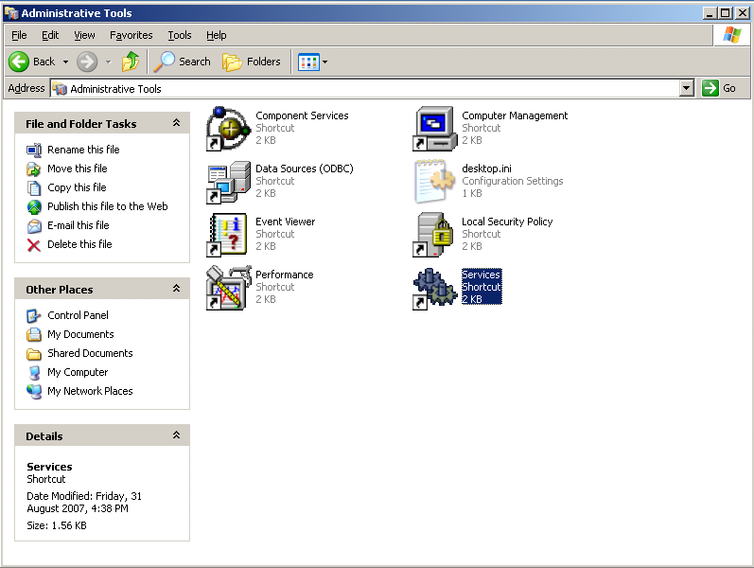
Open this by double-clicking, and find the LATRS and LATRS-dev services. Services are listed alphabetically. To stop a service, click the stop link once you have selected it
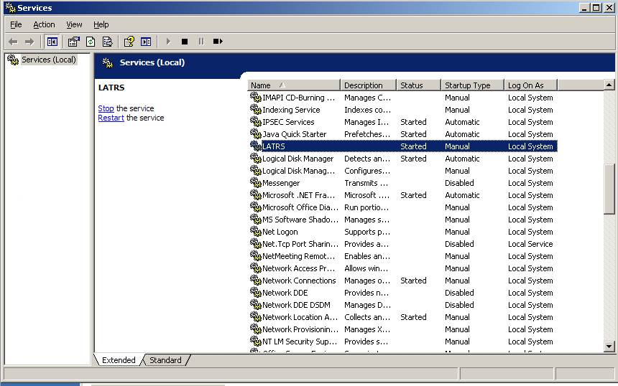

Pulling changes
The easiest way to retrieve changes is using SmartGit. Open SmartGit and select the correct project. If you have a development and production installations, choose the correct one using the black triangle next to the Directories label shown below. Then, click the Pull button in the menu.
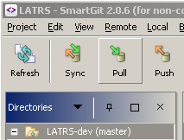
That’s it!

Running commands

Sometimes an update will require some command line usage. This will not be very often, and detailed instructions will be provided in an email.

To open a command prompt, click the Run... item under the Start menu, or hold down the Windows key and the r key at the same time:

In the text box, type cmd and press the enter key:

Now, go to the location where LATRS is installed. At Mae Tao Clinic, this is d:\latrs and
d:\latrs-dev. To get there, first type in the drive letter: d:, and hit enter. Next type cd, then press the space bar, then type the rest of the location, with a leading backslash: cd \latrs or cd \latrs-dev

You can now run the commands as specified in the email. These will most likely be one (or all) of the following:

  - rake db:migrate
  - bundle install

Starting services
Starting the services back up again is just the reverse of stopping them. Locate the services, and click the start link.

Once you have done this, you can test the update by accessing the system in the usual way.

If you encounter any problems
If there is a problem with pulling the changes, email me the details: which files were said to be in conflict? Email me those files.

If the service starts, but the system cannot be accessed (or if the service fails to start), make a zip file of the log directory under the application installation (ie: d:\latrs\log) and email it to me.

Mae Tao Clinic installation details
At the Mae Tao Clinic, a development installation was done at d:\latrs-dev, and a production installation was done at d:\latrs. The machine using IP adress 192.168.1.20 was used, with the production installation using a MySQL database configured to use port 4306.

