Mae Tao Clinic Laboratory

LAboratory Test Results System: LATRS

System architecture documentation. (v1.0)

Contents

System background and design 1

Technical information: software and hardware considerations 1

System diagrams 1

From templates to test results 1

Entity-Relationship (ER) diagram 1

System background and design
LATRS was developed to store medical laboratory test result data. Requests for medical tests are initiated from departments.

Tests may have a patient attached (in the case of HIV, they don’t, due to privacy concerns).

Tests are undertaken by a staff member.

The date and time of when the request is received (time in) and results are returned (time out) can be recorded.

Tests store different data depending on their type: an HIV test has different information from a Malaria test. Instead of statically defining all types of tests, a templating system was devised, where users can define what pieces of information can be stored for each type of test.

Tests are created in the data entry section of the system. Templates are created in the administration section

These test templates are identified by their name, and have an associated colour, which is used as the background colour when displaying the form for that test. Templates also have a description field.

Templates can have many fields, which can be put into groups (which aids data entry by splitting up fields visually).

Fields are identified by name, and can be flagged as a required field. Fields can be flagged as storing numbers or text. A label can be attached to a field, which is displayed after the form input element in data entry.

Input for a field can be made into a selectable list instead of a text box by defining a set of limits for the field. When limits exist, one can be made the default option. Additionally, fields can be flagged as accepting multiple values when limits exist.

Fields can have subfields. Subfields are displayed in data entry as being “children” of the main field. They can be displayed inline (next to) or underneath the parent field. Subfields can also be hidden from view, only being displayed when the parent value is within an upper and lower limit.

The level of subfields is infinite: subfields can have subfields of their own, and so on.

Templates can also have subtests. These are other templates that can be filled out at the same time, reducing the need to specify department, patient, staff and time data individually. Patients are usually tested for many things at once, and subtests helps make data entry quicker in this regard.

Reporting is an important part of any data collection system. Reports can be run on any type of test, providing a breakdown by patient age, gender and ethnicity. Department and staff breakdowns are also available. Finally, test-specific data (for example, the range of Haemoglobin values) are also available for the reporting set.
Patients are an important part of the system. Mae Tao Clinic has an electronic patient registry system managed by Health Information Services (HIS). The system retrieves patient data from this system using a Registration Number (RN), which all patients are given. When filling out a form in data entry, the user only needs to supply an RN, and all relevant patient data (name, age, gender, ethnicity, location) are automatically migrated. Furthermore, the system can retrieve a patient’s history for all tests recorded in the system.

The danger with custom-built systems for data collection is “lock in”: the raw data can be difficult to extract from the system in its entirety. This system provides a data export feature (in XML and Spredsheet format). This means all information stored in the system can easily be extracted for a variety of uses: sharing with other organisations / individuals, or migrating to a new system in the future.

Technical information: software and hardware considerations
LATRS has been developed using Ruby on Rails, a software framework well suited to web applications. It is cross -platform, allowing for easy installation on Windows, UNIX and Mac environments. In a development mode, a simple database system (Sqlite) is used, while MySQL is used in production.

Git has been used to manage software control during the development of LATRS, and the entire codebase is available online via https://github.com/smcphill/LATRS. This allows software updates to be made available and deployed very easily.

For more information on the actual code, refer to the codebase documentation which can be generated using the rdoc utility.

System diagrams

From templates to test results
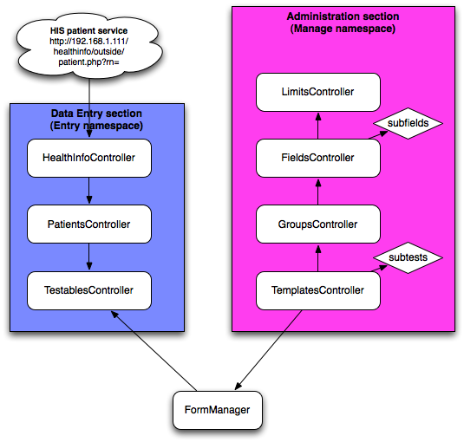
Templates are created in the administration section. Active templates are registered with the FormManager, which in turn is used by the Data Entry section to know which types of tests can be created. The HealthInfoController class provides the link to the external patient registry, creating Patients are required.

Entity-Relationship (ER) diagram
