Mae Tao Clinic Laboratory

LAboratory Test Results System: LATRS

Administration training. (v1.2)
August 3, 4 2011.
Presented by Daraporn Prakunwisit and Steven McPhillips

Contents

About LATRS 1

About Administration 1

Administration Home 1

Basic Forms 1

Forms: create a new form 1

Example: HCT Form 1

HCT & Blood Group: limited fields 1

Complex Forms 1

Subfields 1

Copying fields 1

Subtests 1

Grouping fields together 1

Patients, Departments and Staff 1

Data Export 1

About LATRS
LATRS is a new application to store laboratory test results. It has been built especially for use at the Mae Tao Clinic Laboratory. LATRS can store any sort of test results, and report on them. LATRS will make reporting of test results much quicker and easier.

LATRS can be accessed from any computer connected to the Mae Tao Clinic network. To access the system, visit:

http://192.168.1.20:3000

For training, a practice version of the system will be used. This system is available at:

http://192.168.1.20:3030

LATRS works best in the Google Chrome browser, or the Firefox browser. There are problems using the Internet Explorer browser. Please always use Google Chrome or Firefox!



About Administration

Administration is just one part of the LATRS system. It is where you can:

  - Define new forms for data entry
This only appears on the training system
  - Export data to Microsoft Excel
  - Manage staff, patients and departments
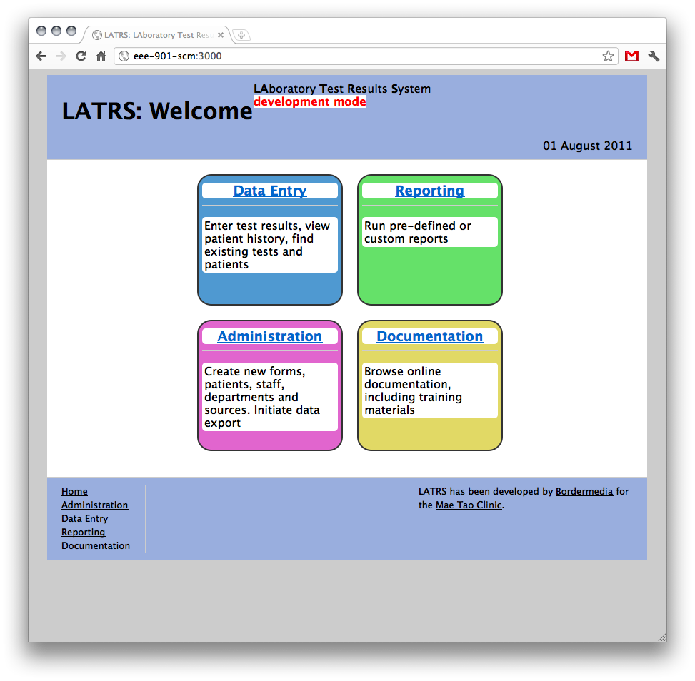

Administration Home

There are 5 parts to the Administration section.

Forms lets you describe the sort of information you need to store for each Lab test.

Patients, Staff and Departments let you create, edit or delete each type from the lists shown in Data Entry.

Data Export lets you save all LATRS information as a Microsoft Excel spreadsheet, or XML.
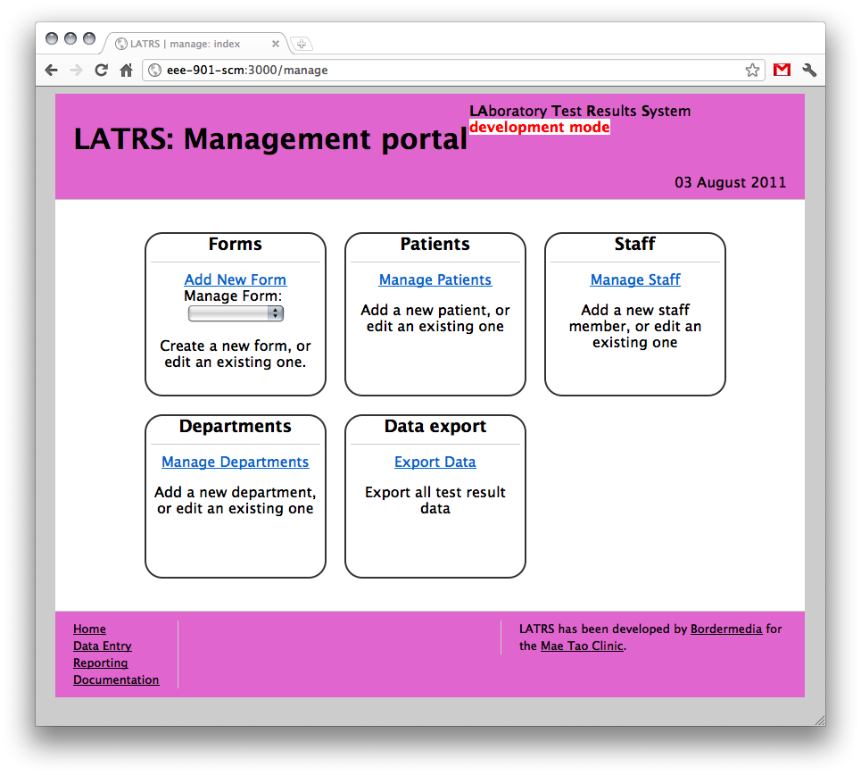

Basic Forms

For people to be able to enter data into LATRS, we need to describe what pieces of information we need to store. Without a form, no data can be entered into the system!
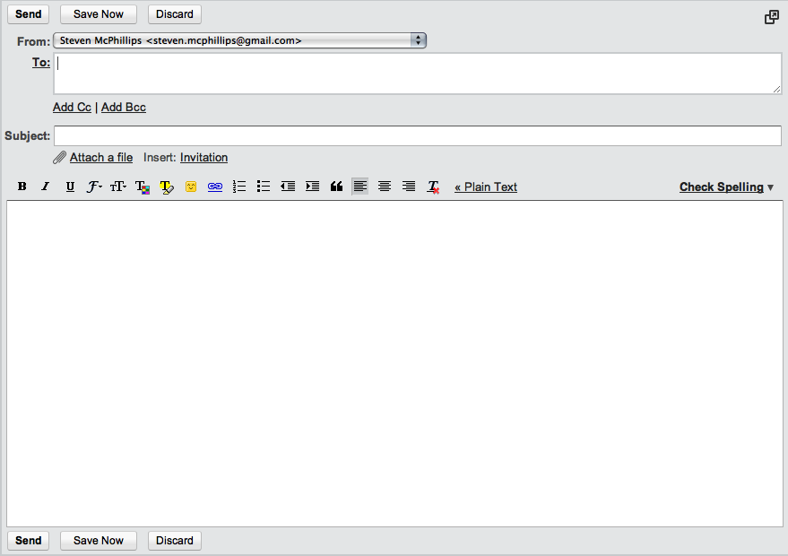
Example form: Sending an Email

An Email is created using a Form, and has 3 main fields:

  - To (the person or people we are sending the Email to)
  - Subject (what the email is about)
  - Body (the actual message)

In LATRS, our Forms aren’t for sending Email. They are for recording test results.

Forms: create a new form

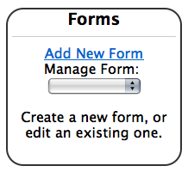
To create a new form, first click the “Add New Form” link.

All Forms in LATRS have 3 basic attributes, or pieces of information:
  - Name (identifies the form)
  - Description (describes what the form is used for)
  - Colour (provides a colour for the form to be displayed with)
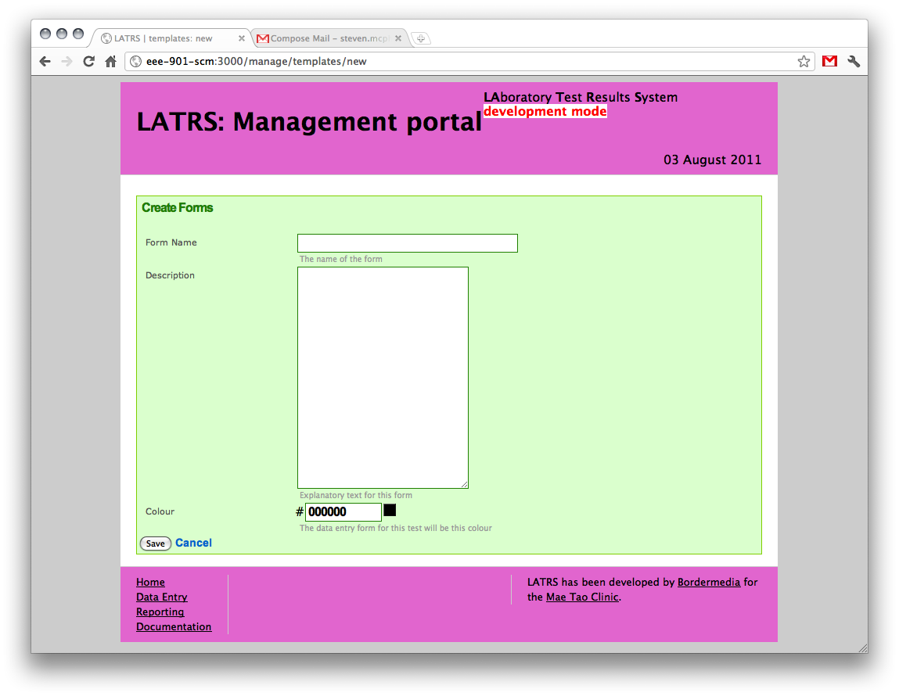
To choose a colour, click the square to the right of the colour field, and click on the colour you want to use. Click “OK” to return to the main form:
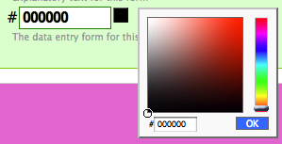

Example: HCT Form

Let’s make a simple form to store information from an HCT test.

We will need 1 field to store this information: HCT Value.

What do we know about the type of information that goes into this field?

  - Is it a number, or text?
  - Is it required? That is, is the test result meaningful without it?

HCT Value is a percentage, and holds a number. It is a required field.

Now, let’s create our form. Add a new form, and call it “HCT by [your name]”. Mine will be “HCT by Steven”
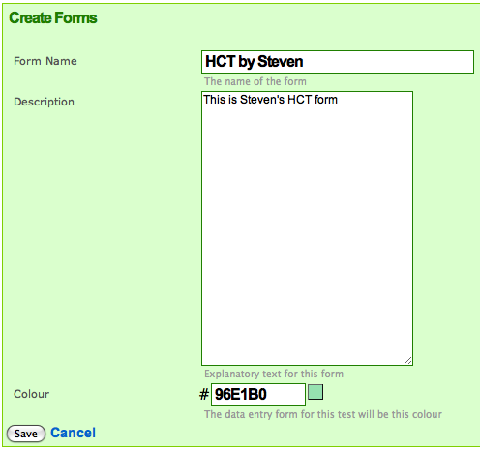
When you are ready, click the save button
You should now see a screen like this
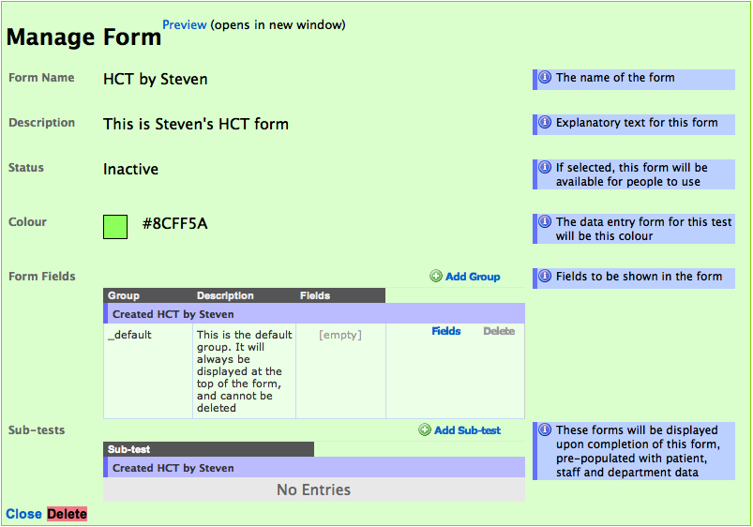
Click the Preview link, and you can see what the form will look like. You can do this at any time.
This is the link to the preview box
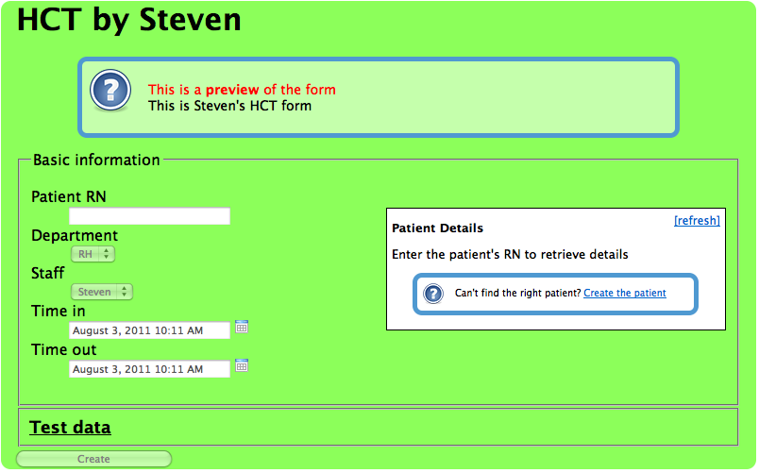
For our form to be of any use, we need to add our field. Halfway down the page, there is the Form fields section:
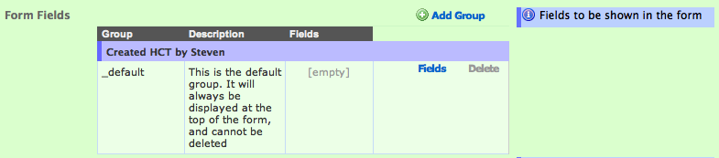
Fields are put into Groups. Groups are a way to split up lots of fields, making it easier for the data entry people to complete the form. For most forms, we will use the default group.

To add fields into a group, click the Add Field link next to that group:
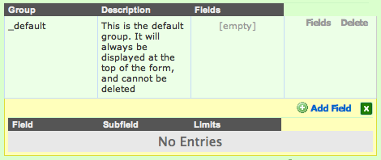
There is a lot of information to describe a field:
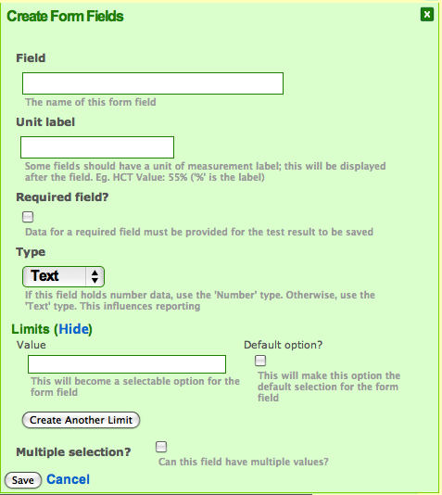
Remember:

  - Our field name is HCT Value
  - Our field will store a percentage, so add a % label to it
  - Our field is required
  - Our field will store numbers. Set it’s type to Number

You should have something that looks like this:
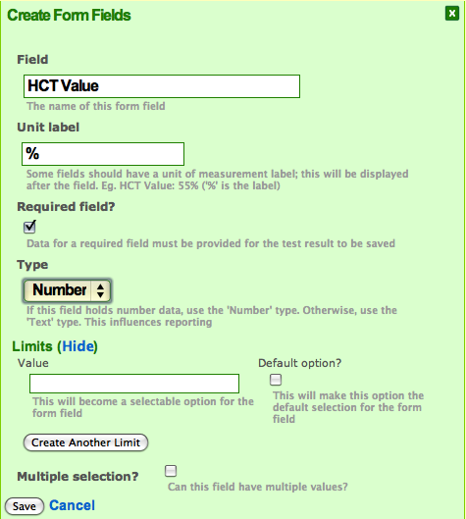
Save this field, and you should see it listed:
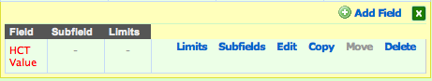
The field is listed in red because it is required.

Preview the form again, and see if it looks correct.
Before the form can be used, it must be activated. Do this by setting its status:
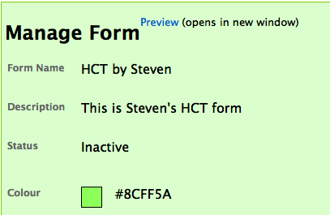
To change that status, click the text, select the new value, then click save:
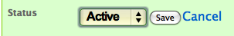
Tests are inactive to start. This lets you set up the form completely before anyone can start using it for data entry.

If you ever need to change an existing active form, you should deactivate it first, then activate it once you have finished making your changes.

Congratulations! you have just created your first form. It can now be used for data entry. To test, go to the Data Entry section, and it should be listed as a test to create:
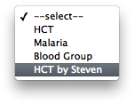

HCT & Blood Group: limited fields
Let’s look at creating some different types of fields. Go back to the Administration section, and select your form to edit:
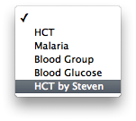
Let’s change this form to store Blood Group information as well as the HCT Value. To begin, we should update the form’s name.

Change the name to HCT & Blood Group by [your name]. To edit this, just click the text, make your changes and click the save button:
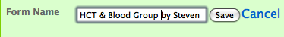
Now, let’s think about blood groups. What do we know about them?

  - Are they numbers, or text?
  - Are their a limited number of types?
  - Is there any other information that is important to “Blood Group” other than the type?

The blood group field:

  - Stores text, not numbers
  - Can have the values:
    - A
    - B
    - O
    - AB
  - Can only have 1 value
  - Is a required field
  - Has no label
So let’s create the field. Add a new field to the default group again:
To make the field a selection list, we need to add limits to the field:
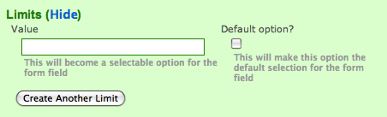
To add more than one limit, click the Create Another Limit button, which makes more text boxes to fill out. We don’t want any of these values to be set automatically, so don’t make any of them the default option.

Create limits of A, B, AB and O:
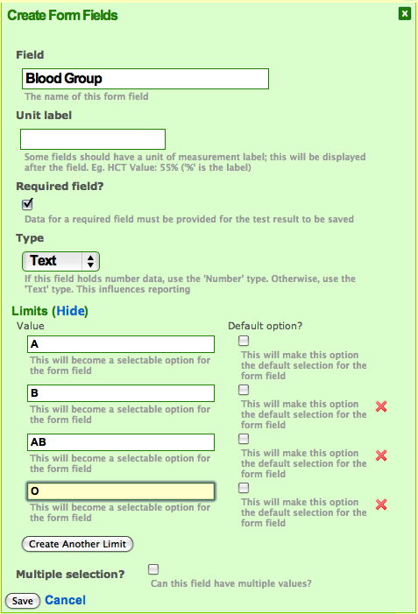
And now save the field:
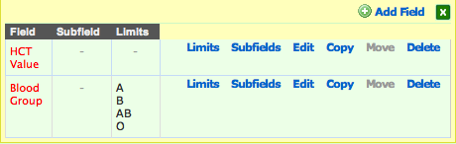
Oops! I forgot to add some limits. We are missing A-, B-, AB- and O-. To add them, click the Limits link next to Blood Group:
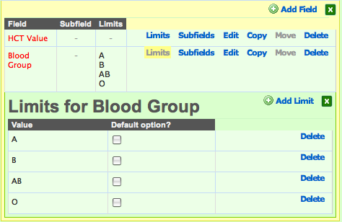
We will need to add 3 limits. Do this by clicking the Add Limit link, and creating limits for A-, B- AB- and O-. Once done, the limits should look like this:
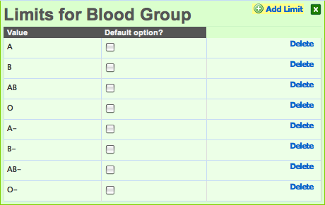
The order of these limits here will be the same as the order they are shown in the actual form.

To change the order, move the mouse over the name of the value, then move it just to the right, until the cursor changes to this:

Hold the mouse button down, then drag the limit to the correct position. Change the order so it is like this:

  - O
  - O-
  - A
  - A-
  - B
  - B-
  - AB
  - AB-
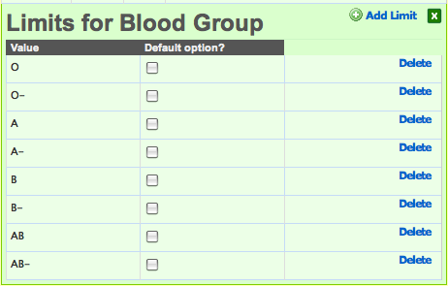
If you can’t move something, reload the page. Sometimes the browser gets “stuck”...

To change the name of a limit, click its name and update it, just like we did for the form name. Try it out, but just cancel, instead of saving.
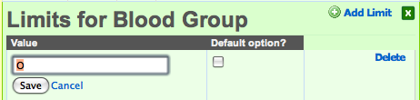
Close the limits box now. Use the green cross in the right corner to do this.
We can change the order of fields in same way.Move HCT Value underneath Blood Group:
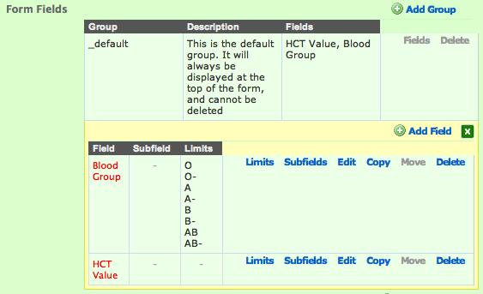
Preview the form to see what it looks like.

Imagine it was possible for a patient to have more than one blood type. We can change the field to accept multiple values. Edit the Blood Group field by clicking the edit link:
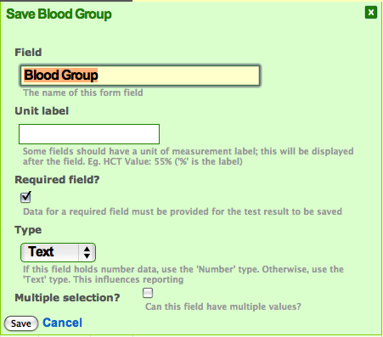
Check the Multiple selection? box, and save. Now preview the form again.
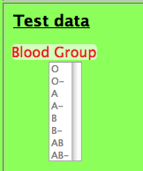
That is a bit silly, so lets change it back. Edit the field and uncheck the multiple selection box.

Complex Forms
So far we have looked at some basic types of fields. Sometimes the test being performed requires more complex fields to capture the information.

Consider the Malaria test. The test itself can be Negative or Positive. Positive tests need to record the strains or Malaria found, and their strength. Each strain can be in stages, and strong levels also require an RBC Infection value.

This is too much information to fit into a single field. Luckily, we can create subfields.

Let’s create a sample Malaria test. Call it Malaria by [your name], and add a PV field, with limits of:

  - Rare
  - +
  - ++
  - +++
  - ++++

PV is not a required field, so it doesn’t display in red text:
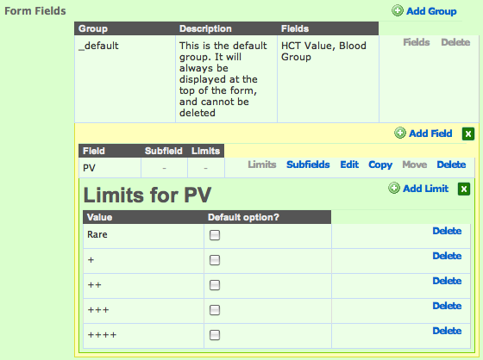
Close the limits for PV by clicking the green box to the right.

Subfields
Subfields are just like normal fields, except they belong to another field.

We want to create 2 subfields for PV:

  - Stage
  - RBC Infection

Stage has limits of s, t and g, and can have multiple values. It is not required

RBC Infection is a percentage, so give it a label of %. It stores numbers, and is not required. It has no limits.

To create these subfields, click the subfields link next to the PV field, and add them, just like you would a normal field.

You should have something like this:
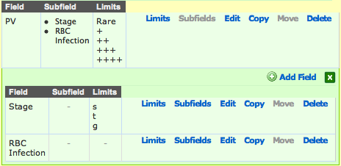
With subfields, there is extra information we can supply. This will change the way the form displays these fields. Edit the RBC Infection subfield, and you will see these new options:

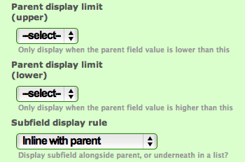
The parent display limit lets us show this subfield only when the parent field (in this case, PV) is inside a certain value.

We only want to display RBC Infection when the PV value is +++ or ++++. Set the upper limit to ++++ and the lower limit to +++:
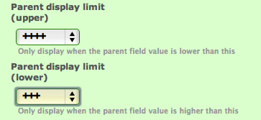
We can also decide to display the subfield next to the parent field, or underneath. Try setting both subfields to Listed underneath parent:
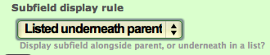
Once you have done this, preview the form. It should look like this:
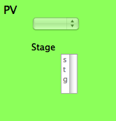
Where is the RBC Infection subfield? Remember that we set a display limit on this. It won’t show unless the PV value is +++ or ++++.

Edit the PV field, and set its default limit to ++++:
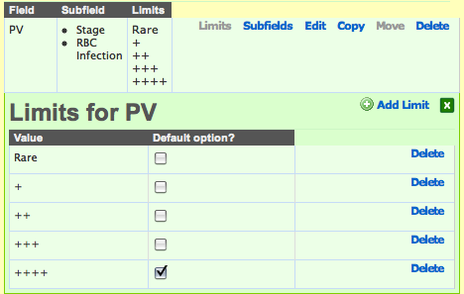
Now preview the form again:
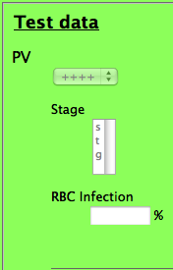
Good, that’s working! Now, go back and remove the default option from the ++++ limit. Also, change the subfield to display inline with parent.

Copying fields

The Malaria test has 4 strains:

  - PV
  - PF
  - PM
  - PO

And they all have the same settings. Once we have create one field, we can copy it. This will copy all of its subfields and limits as well.

Make 3 copies of the PV field by clicking the copy link next to it. You should have something like this:
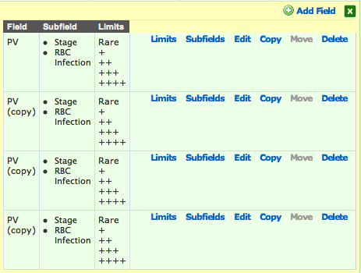
Edit the 3 copies, and change the names to PF, PM and PO:
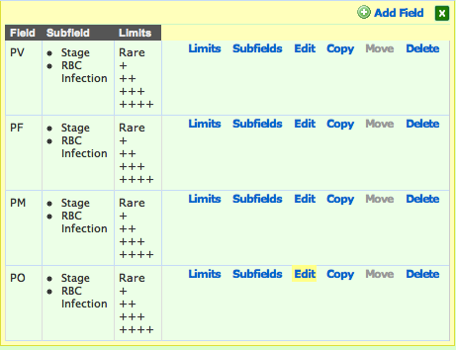
The only other field that Malaria requires is one to say whether the test was Positive or Negative.
Create a field called Outcome. It is a required field, with limits of Positive and Negative. We want Negative to be the default option:
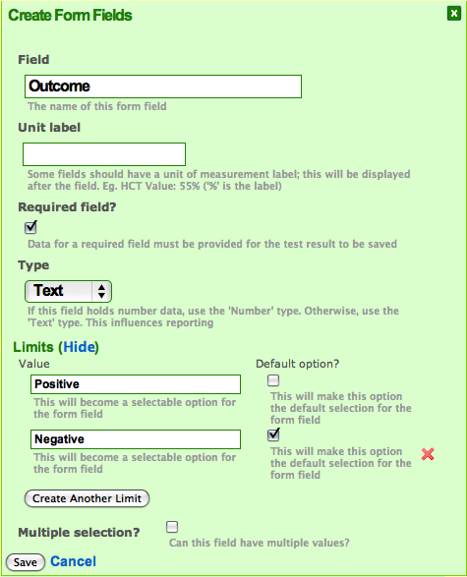
Position this field at the top of the list:
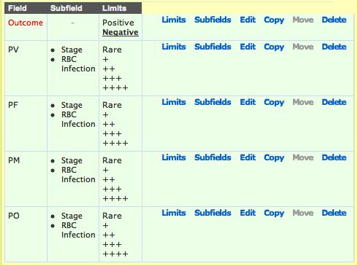

Subtests
All tests can have subtests attached to them. This is an easy way to create more than one type of test for a patient at the same time.
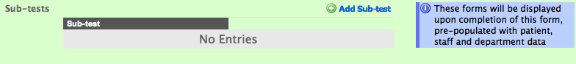
To add a subtest, click the Add Sub-test link to the right, near the bottom of the page. Then, select the test you want to add.

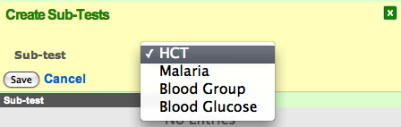

Grouping fields together

Sometimes, forms will have lots of fields. This can be confusing for the user. We can split fields up into groups, each with a name and a description that will make it easier for data entry.

Manage our Malaria form, and create a new Group called Strains. This is just like creating a field, but with fewer options:
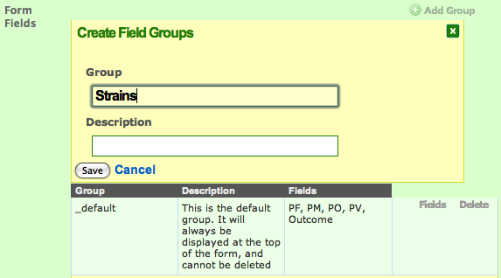
We can create fields in this new group, or we can move fields into this group. Lets move all of the P fields into the new Strains group. (You will have to close and re-open the fields for all groups first)
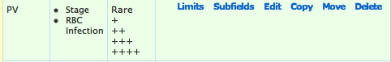
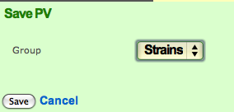
Once all the P fields have been moved, preview the form:
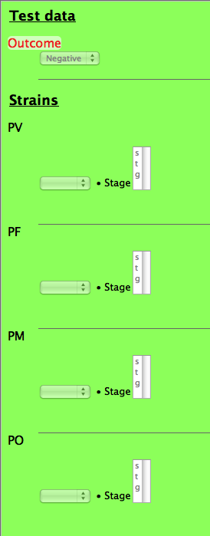
Now, activate the form, and it’s ready for use!

Patients, Departments and Staff

Test results are linked to Patients, Departments and Staff.

Patients can be created manually from the administration section. However, it is best to let the system retrieve patient information from the HIS Patient registry instead. This is an automated process when a patient is selected during data entry.

Departments and Staff are managed the same way. Clicking on the manage links from the Administration homepage will retrieve a page like this:

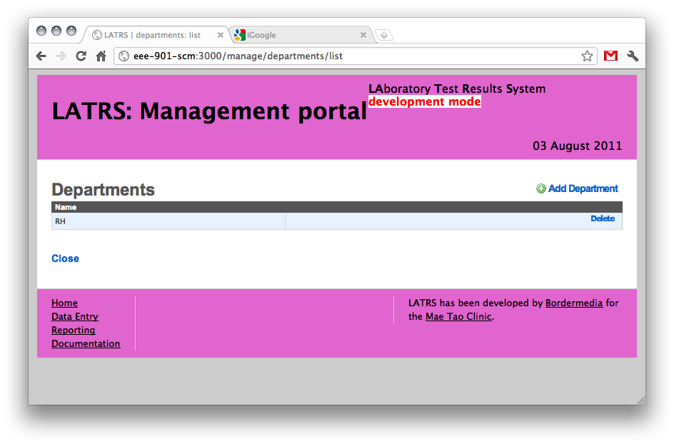
To edit existing records, just click the name and make the change:
Creating a new record is very easy. Just click the Add link to the right:
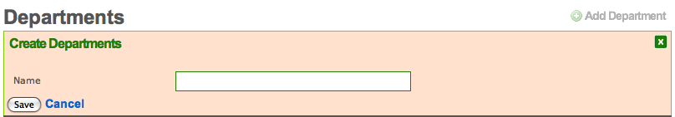

Data Export

LATRS can export all of its data to an Excel Spreadsheet, or to XML (a computer format). This is useful for getting all of the system data into a format that can be shared with other people, organisations or systems.

Access the data export section from the Administration homepage.
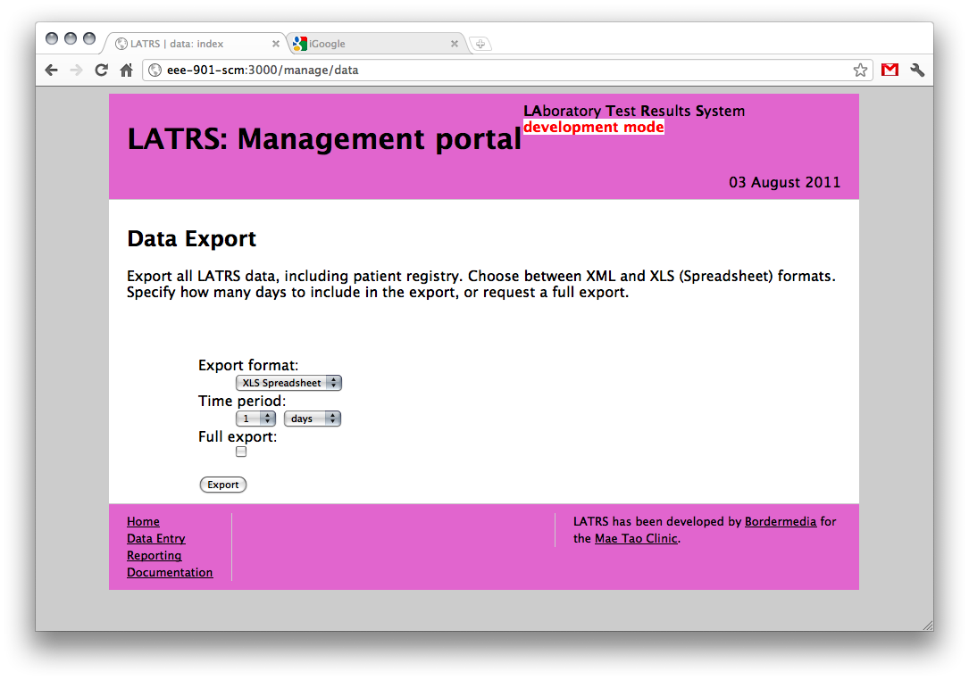
You can export everything, or just the past few days using the form above.

Each type of test (eg: Malaria, CBC) will create a new sheet in the spreadsheet, with all the test results inside. There is another sheet added to the end of the spreadsheet that holds all the patient information the system knows about.

