Mae Tao Clinic Laboratory

LAboratory Test Results System: LATRS

Data Entry training. (v1.1)
August 1,2 2011.
Presented by Daraporn Prakunwisit and Steven McPhillips

Contents

About LATRS 1

About Data Entry 1

Data Entry Home 1

Enter new test results 1

New test: Basic information 1

New test: data 1

New test: Malaria 1

Subtests 1

Test Results 1

Test Results: sorting and searching 1

Test results: show 1

Deleting a test 1

Tests: Subtests 1

Patients 1

Patients: sorting and searching 1

Patients: show 1

Patients: history 1

About LATRS

LATRS is a new application to store laboratory test results. It has been built especially for use at the Mae Tao Clinic Laboratory. LATRS can store any sort of test results, and report on them. LATRS will make reporting of test results much quicker and easier.

LATRS can be accessed from any computer connected to the Mae Tao Clinic network. To access the system, visit:

http://192.168.1.200:3000

For training, a practice version of the system will be used. This system is available at:

http://192.168.1.200:3030

LATRS works best in the Google Chrome browser, or the Firefox browser. There are problems using the Internet Explorer browser. Please always use Google Chrome or Firefox!



About Data Entry

Data Entry is just one part of the LATRS system. Data Entry is how information gets into the LATRS system. From the Data Entry section, you can also search for previous tests and patients, and look up a patient’s test history.
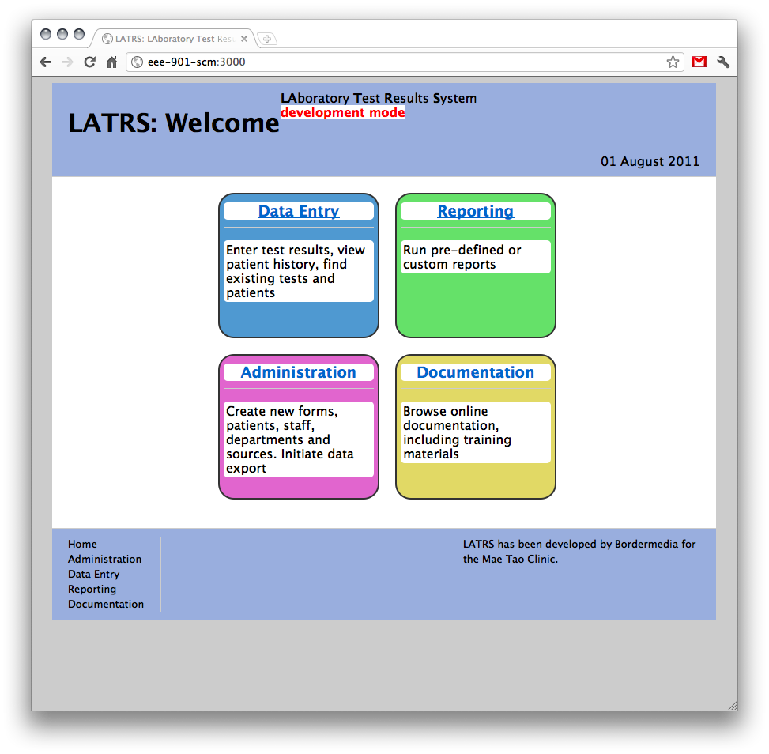

Data Entry Home

There are 3 parts to the Data Entry section: Entering a new set of test results, viewing patients, and viewing existing test results:
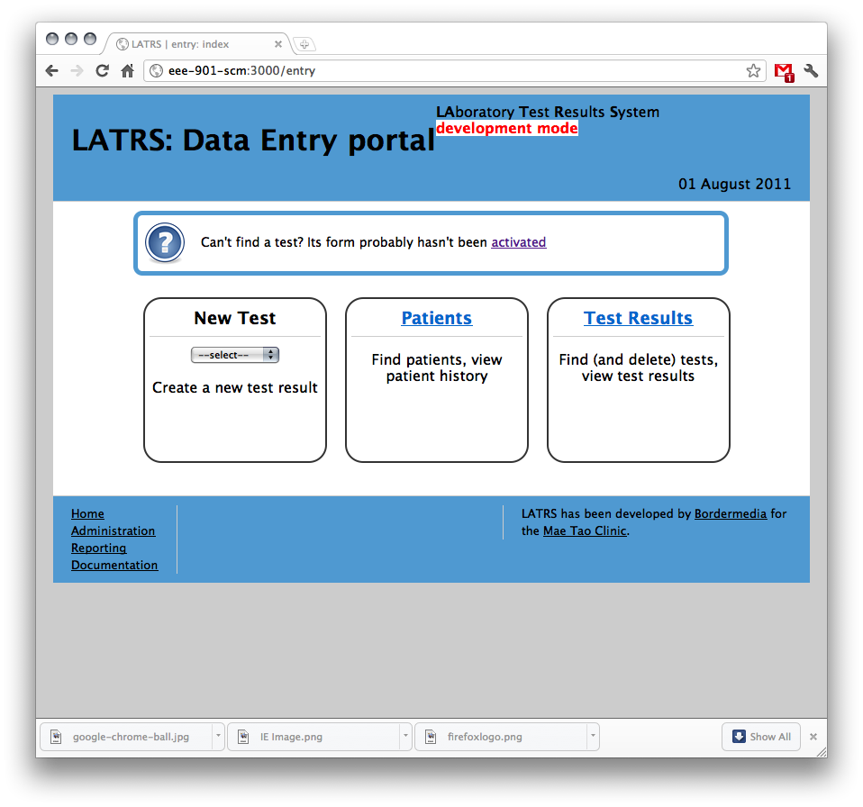

Enter new test results

Select the type of test to enter results for. To begin, we will choose a very simple one: HCT
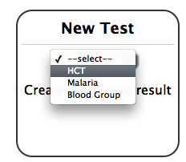
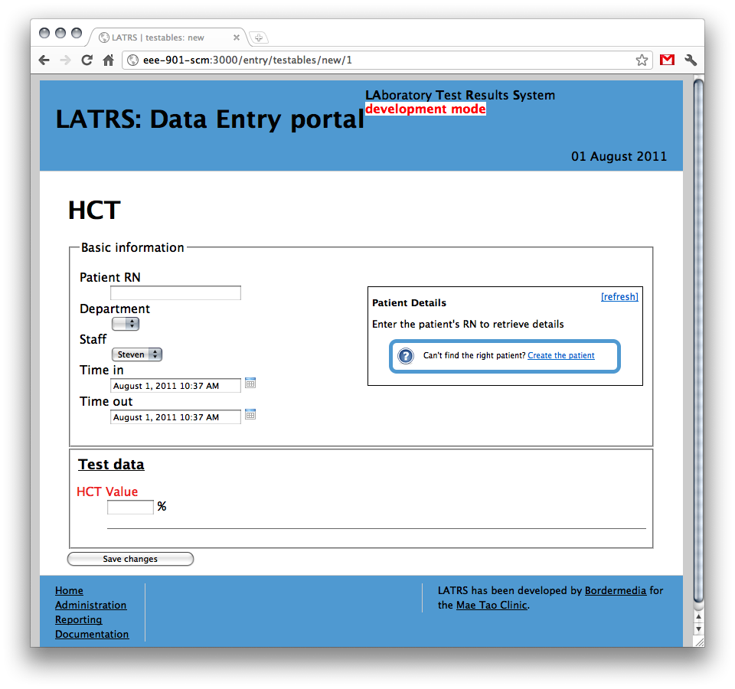

New test: Basic information

All tests require the same basic information:
  - Patient (by RN)
  - Department (by name)
  - Staff / tester (by name)
  - Time in (date and/or time)
  - Time out (date and/or time)

Start by entering the Patient’s RN. LATRS uses the HIS patient registry for patient information

Enter the first 3 numbers and the system will look up matching RNs automatically:

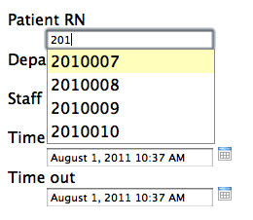
Select the right one, and the patient details are displayed to the right:

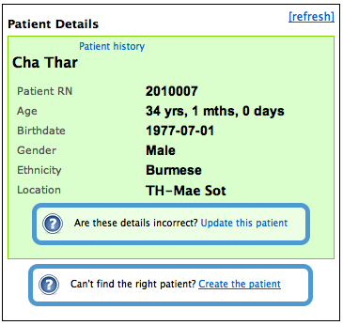
If the RN cannot be found, you will be informed, and can create one manually:
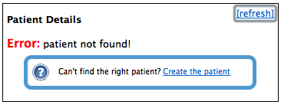
If the details aren’t correct, you can manually update them, BUT it would be better to inform HIS.

Once a patient is selected, LATRS looks for the last test result entered for this patient, and will automatically update the Department, Staff and Time fields with the information provided last time. This can save some time in entering new tests. You can change these though!

The “time in” and “time out” fields are not required - you can leave them blank. Speak to your supervisor to find out what you should do.

The time fields will always default to the time and date right now. To change this information, click the calendar icon to the right of the field:
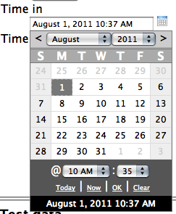
You can now choose any date and time you want. To just store a date, and not the time, select “-” as the hour. To clear the field, use the “Clear” link. When you are ready, click the “OK” link.

New test: data
The data specific to this test will be entered underneath the basic information:
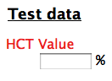
Some forms have lots of information to enter. HCT has only one - the HCT Value:
This is a required field - you must supply a value for this field. All required fields will be listed in red text.

When you have entered all the information, click the “save changes” button at the bottom of the form:
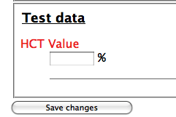
If you don’t supply a value for a required field, the test will not be saved, and you will be told why:
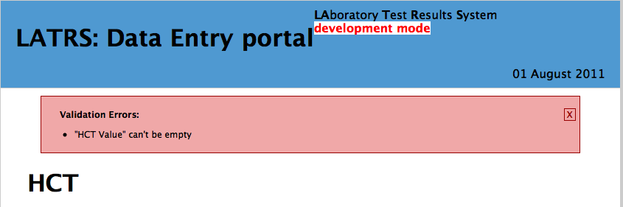
The HCT value also has to be a number. If you don’t supply a number, you will get a different sort of error:
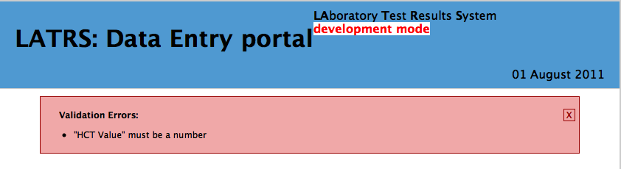
You can remove the error message by clicking the red cross on the right. You still need to fix the problem though!

When you have saved the test correctly, you will be returned to the Data Entry homepage:

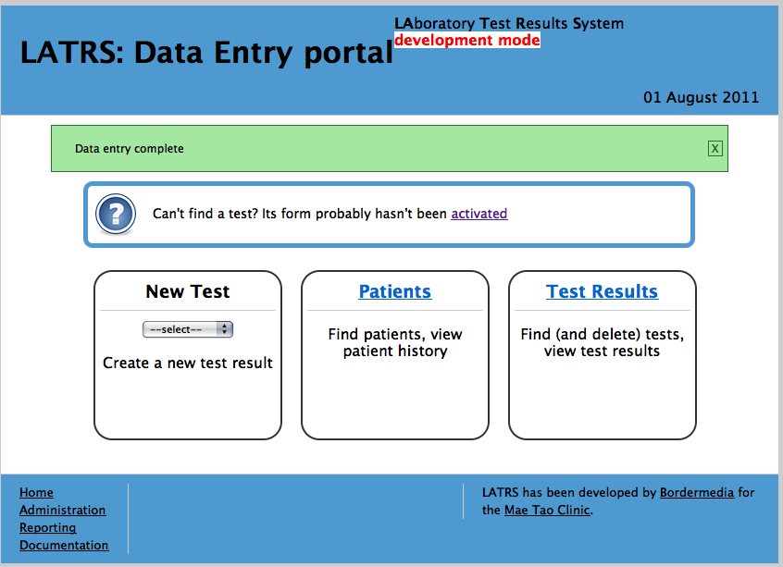
New test: Malaria

The Malaria test is a bit more complex. Let’s create one now:
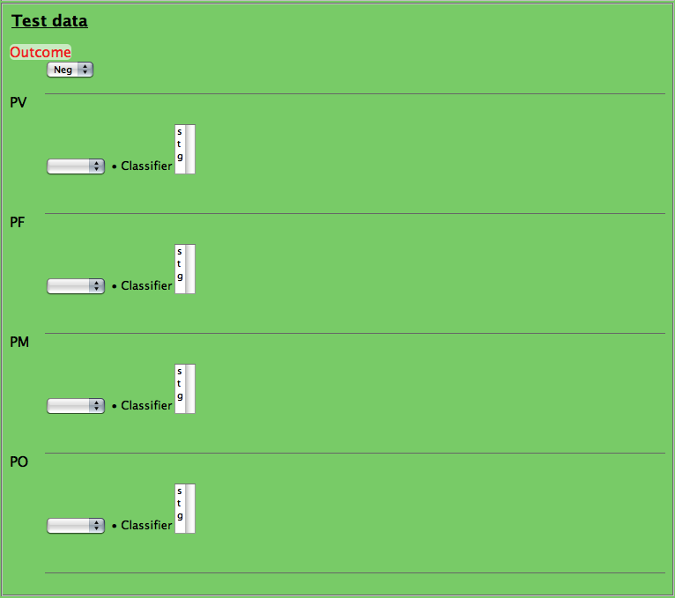
There are actually more fields available. Each P field has and RBC Infection field, but it will only show when the P value is +++ or ++++:
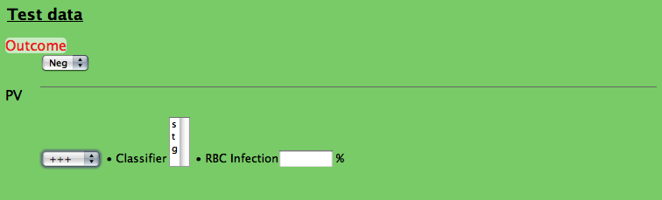
The classifier field is interesting as well. It can have multiple selection. To select s AND g, click one, then hold down the CTRL button, and click the other one.
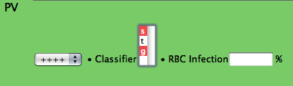

REMEMBER: these are examples ONLY. “Classifier” will not be the only field that can have multiple selections. “RBC Infection” is not the only field that will appear and disappear. “HCT Value” is not the only required field.

Subtests

It is very common for a patient to have more than one type of test done at a time. To make entering results for a patient even easier, some tests have subtests. These are the same as normal tests, but they don’t require the “basic information” (Patient, Department, Staff, Time In, Time Out) to be repeated all the time.

In the example below, “HCT” is a subtest. Subtests are disabled by default.

This means the system will not expect you to enter data for subtests unless you want to.

Enable the test by clicking the “Enable” link, or the title of the subtest:
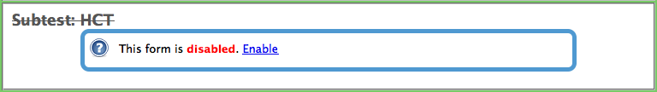
Enabled tests can be disabled as well. Just click the link, or the title again:
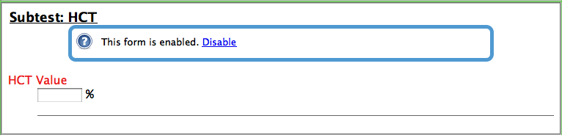
Enabled subtest will be automatically saved with all the correct “basic information”. The information being saved in these subtests will be checked for correctness, just like a normal test. The “HCT Value” field is red, so if this subtest is enabled, you must supply a value for this field.

Test Results
Let’s go back to the Data Entry homepage, and view the test results in the system:

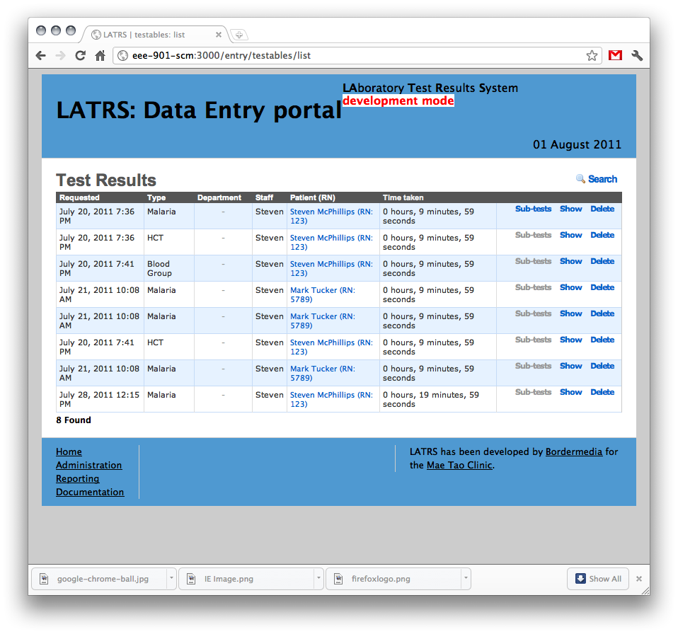
Test Results: sorting and searching

From here we can view test results. We can sort the list of tests by clicking on the column title: click on Requested to sort all tests by the “time in” date .

We can also search through all tests. Click the search link to the right:
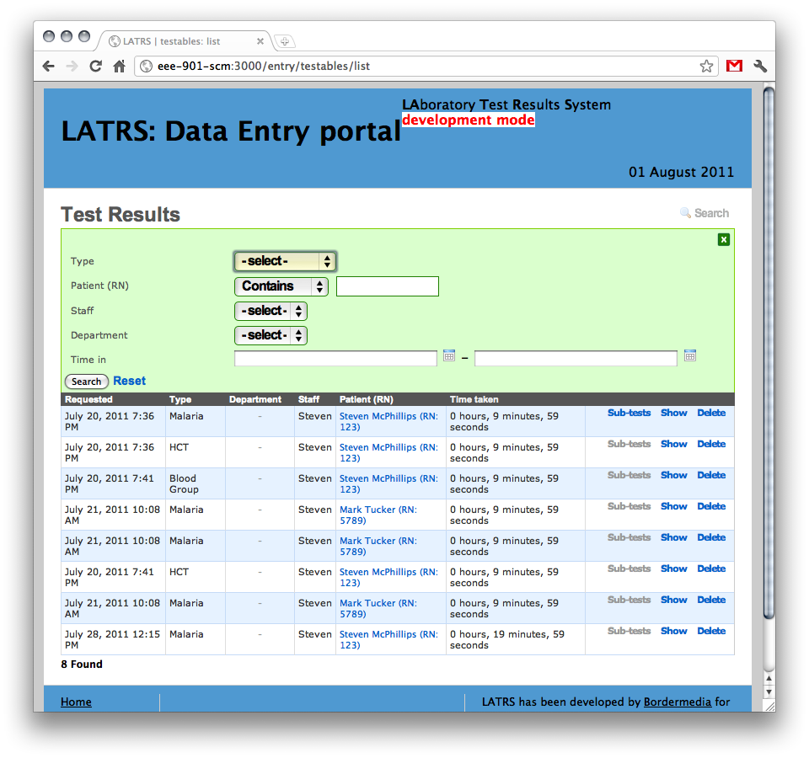
Click the “search” button to perform the search. You can click the “Reset” link to view all tests again. To close the search box, use the green cross to the right.

Test results: show

The main window only shows some of the information for each test result. To see all the information, click the “Show” link for that test:
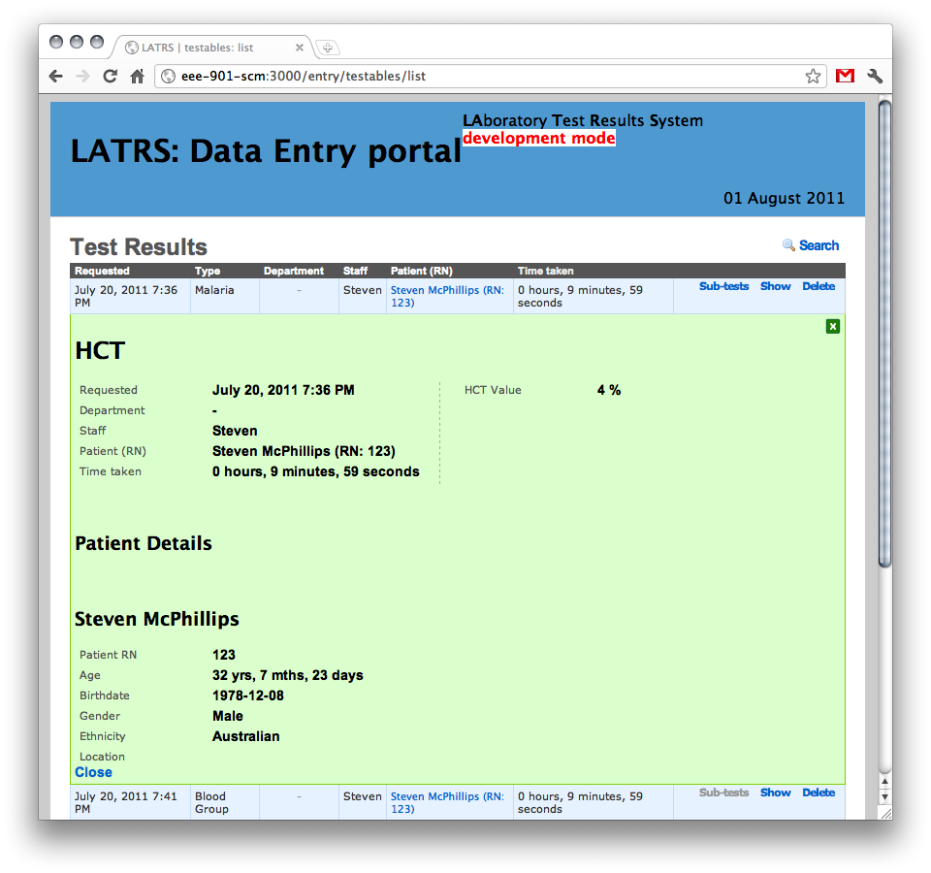
All the basic test information will be displayed on the left, with the other information being on the right.

Patient details are also displayed below.

Click the green cross to the right to return to the normal list view.

Deleting a test

If you have entered a test incorrectly, you can always delete it from this page. Find the test you want to delete, and click the delete link next to it.

Be careful; once a test is deleted, it cannot be recovered. There is no “undo”!

To make sure you are not deleting the wrong test, the system will ask for confirmation:
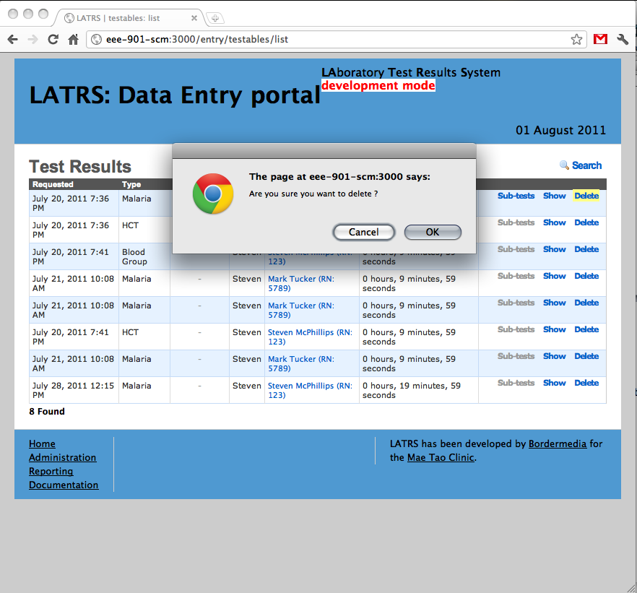

Tests: Subtests

Remember how some tests had subtests you could use? When viewing test results, we can also see which subtests were created at the same time. Click on the “subtests” link to get a list of subtests. If the link is grey, there are no subtests available.
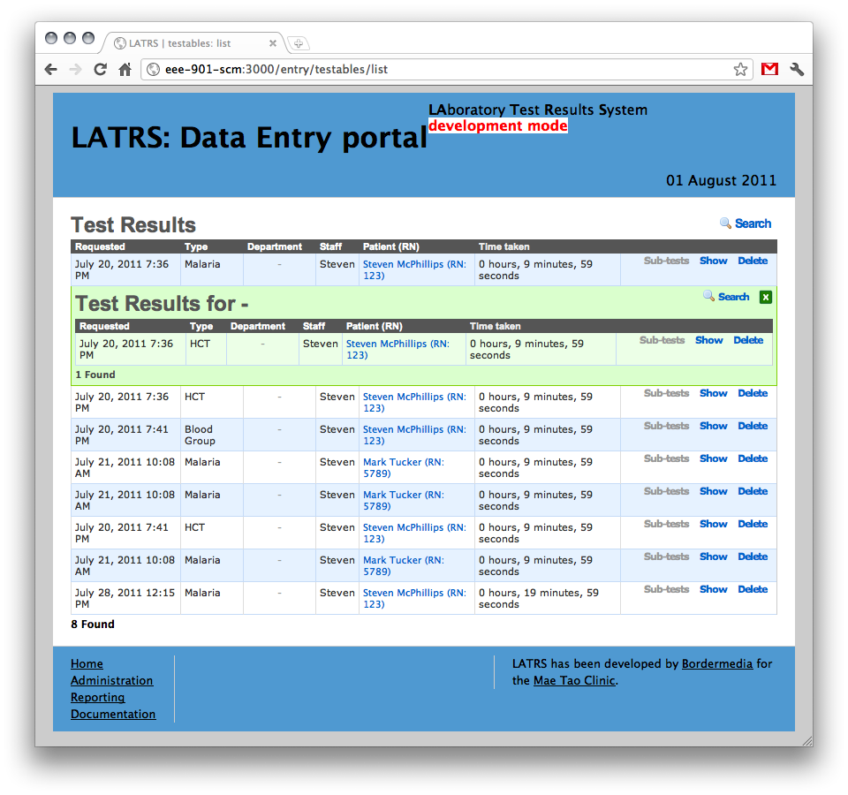

The list of subtests can be sorted, searched and opened just like the main list of tests.

Patients

Let’s go back to the Data Entry homepage, and view the patients in the system:

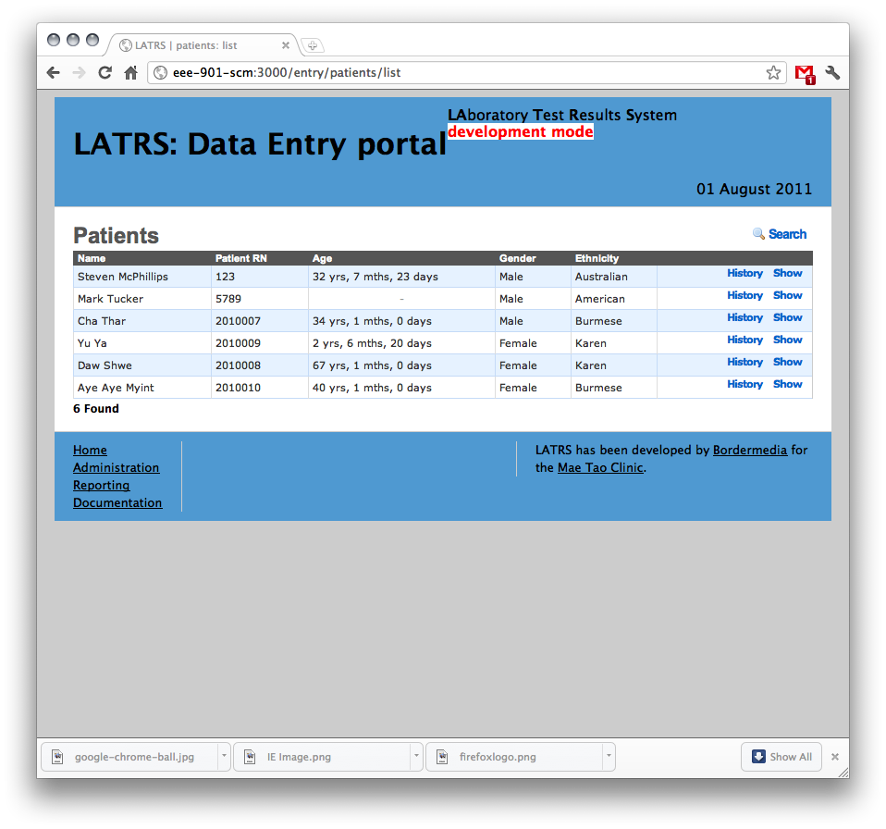
Patients: sorting and searching

From here we can view patient information, including patient history. We can sort the list of patients by clicking on the column title: click on Name to sort all patients by name.

We can also search through all patients. Click the search link to the right:
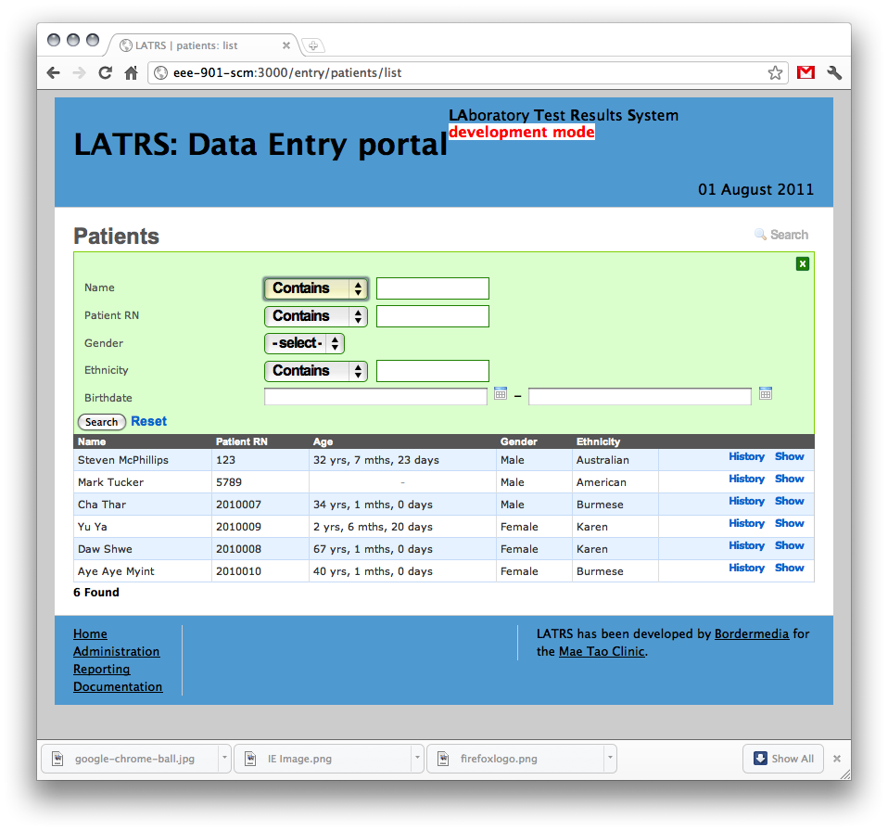
Click the “search” button to perform the search. You can click the “Reset” link to view all patients again. To close the search box, use the green cross to the right.

Patients: show

The main window only shows some of the information for each patient. To see all the information, click the “Show” link for that patient:
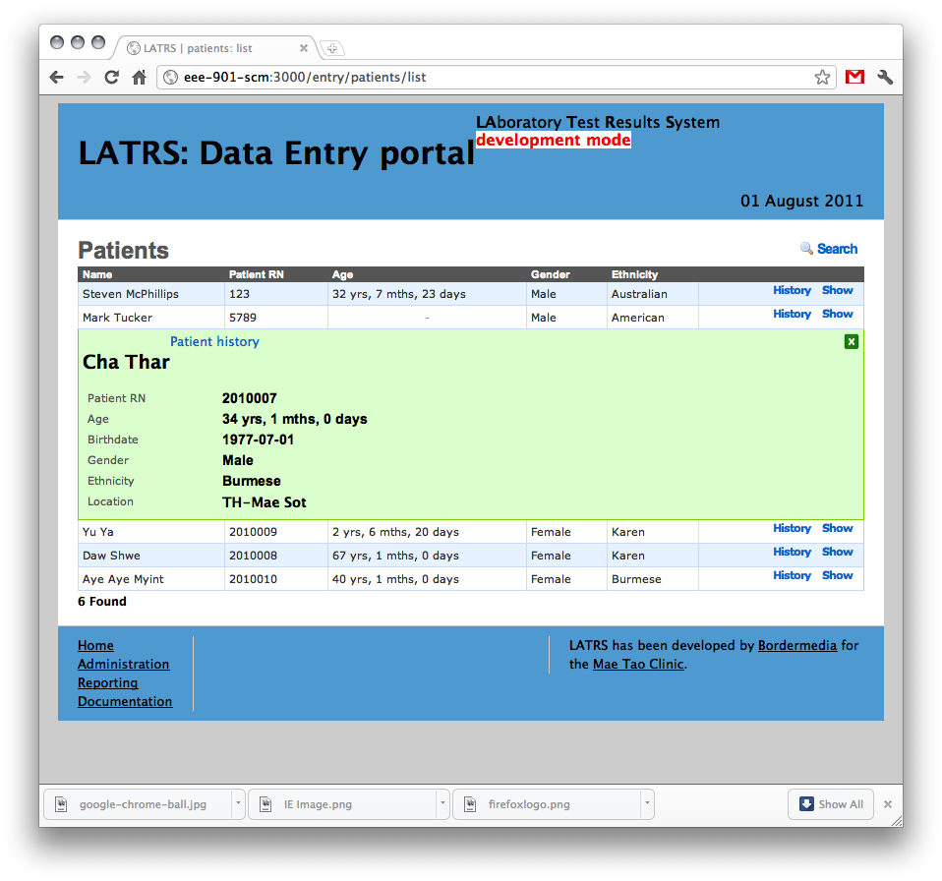
Click the green cross to the right to return to the normal list view.

Patients: history

You can view a patient’s history by clicking the “History” link. This will show a list of all test results recorded for that patient:
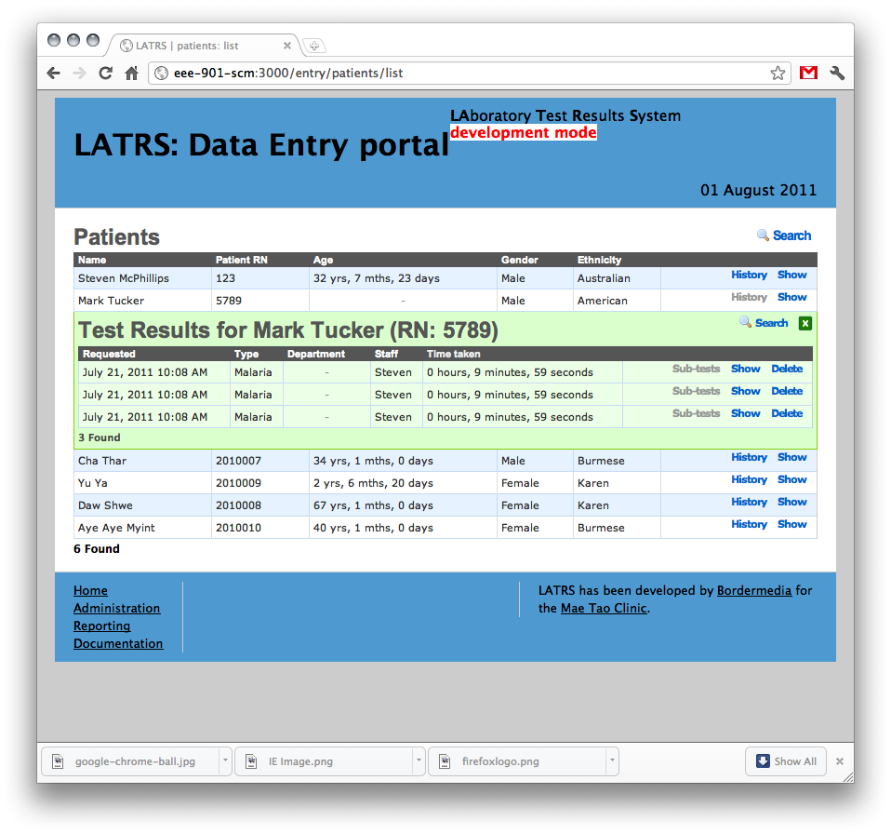
You can sort, search, show and delete tests from here, just like in the main “Test results” section.

