**Test Cases Results**

**(green meaning passed)**

TC01

TC06

**Expected Results:**

| **Component** | **Expected Range** |
| --- | --- |
| **Sum of Deposits** | €7,200 |
| **Building Savings Premium** | €108.00 - €258.00 |
| **Interest (Zinsen)** | €47.47 - €951.71 |
| **Capital Gains Tax (KESt)** | 25% of Interest (range: €11.87 - €237.94) |
| **Account Management Fee** | Fixed at €49.80 |
| **Total Assets After KESt** | €7,293.80 - €8,121.97 |

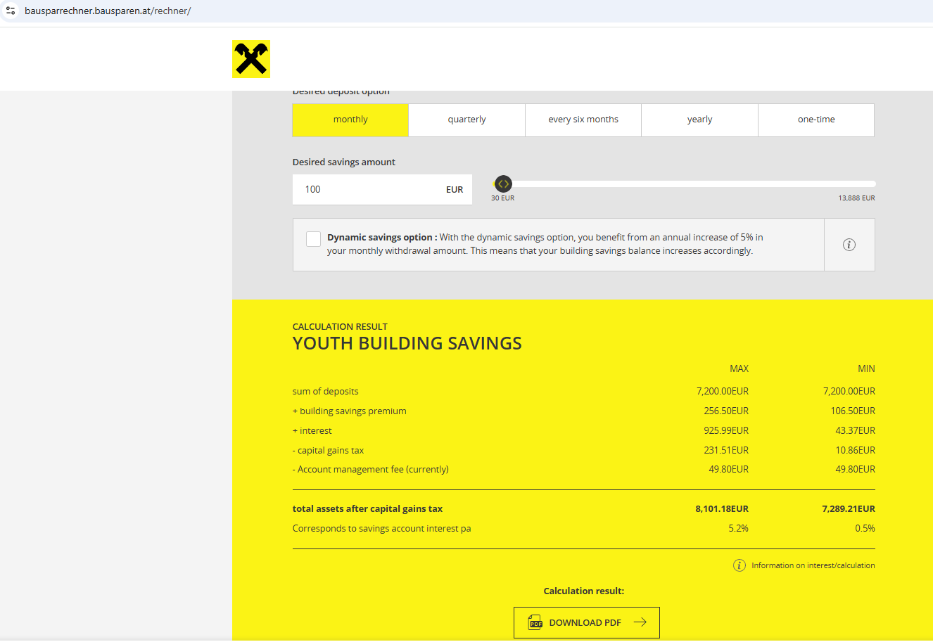

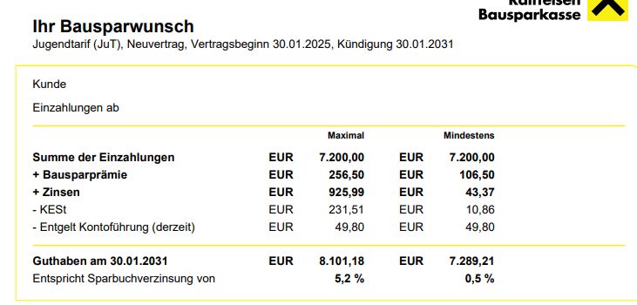

TC02

TC08

Expected Results:

| **Component** | **Expected Range** |
| --- | --- |
| **Sum of Deposits** | €7,200 |
| **Building Savings Premium** | €108.00 - €258.00 |
| **Interest (Zinsen)** | €47.47 - €951.71 |
| **Capital Gains Tax (KESt)** | 25% of Interest (range: €11.87 - €237.94) |
| **Account Management Fee** | Fixed at €49.80 |
| **Total Assets After KESt** | €7,293.80 - €8,121.97 |

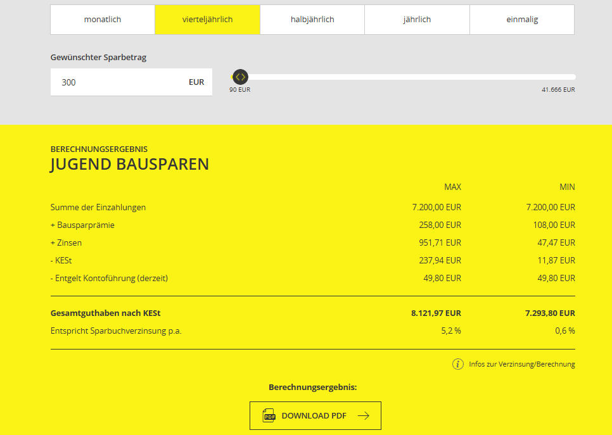

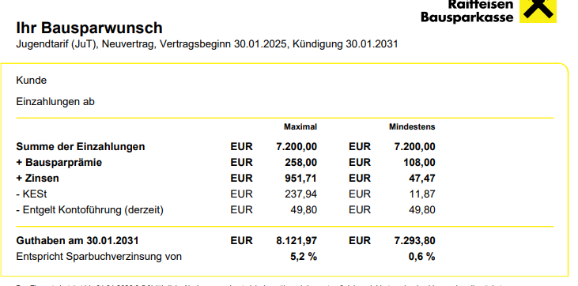

TC03

TC09

Expected results:

| **Component** | **Expected Range** |
| --- | --- |
| **Sum of Deposits** | €7,200 |
| **Building Savings Premium** | €108.00 - €258.00 |
| **Interest (Zinsen)** | €47.47 - €951.71 |
| **Capital Gains Tax (KESt)** | 25% of Interest (range: €11.87 - €237.94) |
| **Account Management Fee** | Fixed at €49.80 |
| **Total Assets After KESt** | €7,293.80 - €8,121.97 |

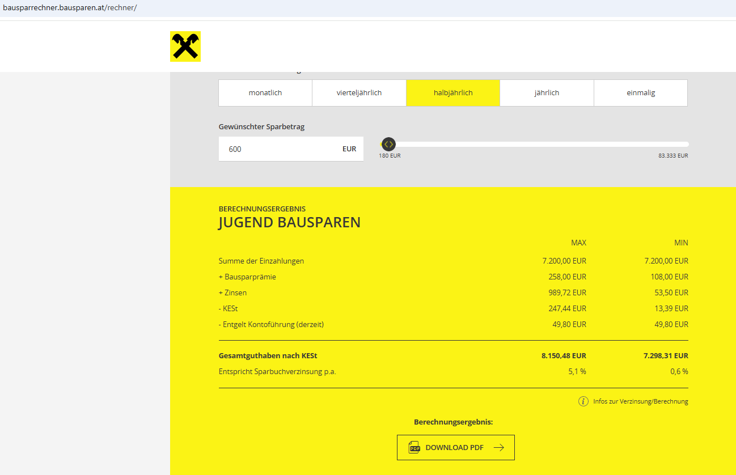

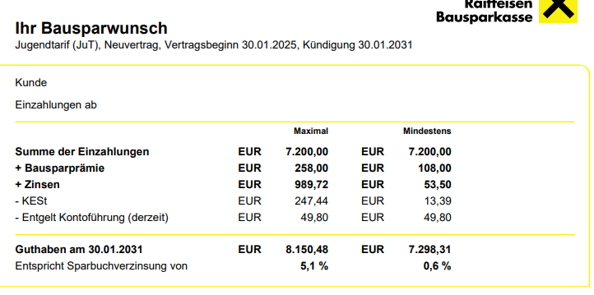

TC04

Expected results:

| **Component** | **Expected Range** |
| --- | --- |
| **Sum of Deposits** | €7,200 |
| **Building Savings Premium** | €108.00 - €258.00 |
| **Interest (Zinsen)** | €47.47 - €951.71 |
| **Capital Gains Tax (KESt)** | 25% of Interest (range: €11.87 - €237.94) |
| **Account Management Fee** | Fixed at €49.80 |
| **Total Assets After KESt** | €7,293.80 - €8,121.97 |
|  |  |

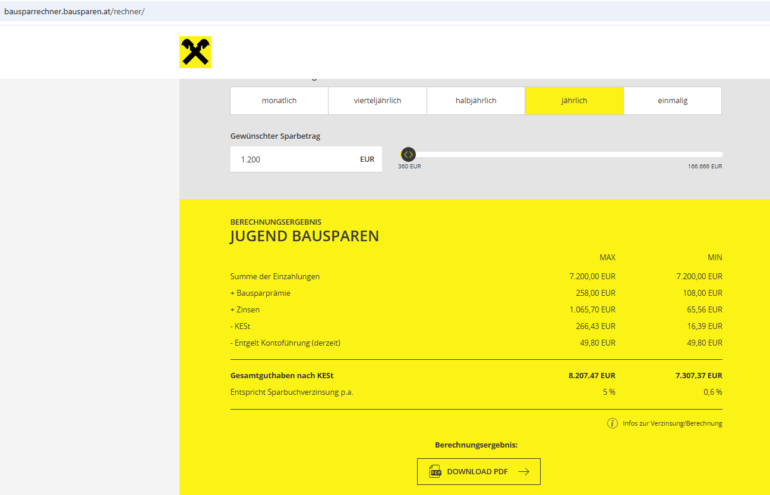

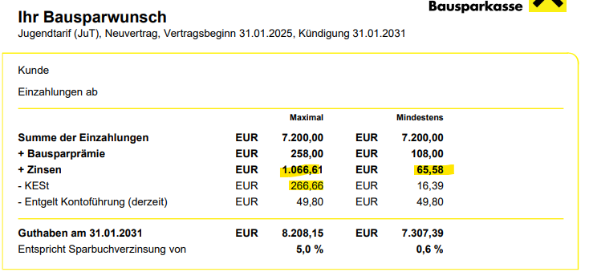

TC05

Expected results:

| **Component** | **Expected Range** |
| --- | --- |
| **Sum of Deposits** | €7,200 |
| **Building Savings Premium** | €108.00 - €258.00 |
| **Interest (Zinsen)** | **Higher than previous cases due to lump sum deposit** |
| **Capital Gains Tax (KESt)** | 25% of Interest (higher than previous cases) |
| **Account Management Fee** | Fixed at €49.80 |
| **Total Assets After KESt** | **Higher than previous cases due to early full deposit** |

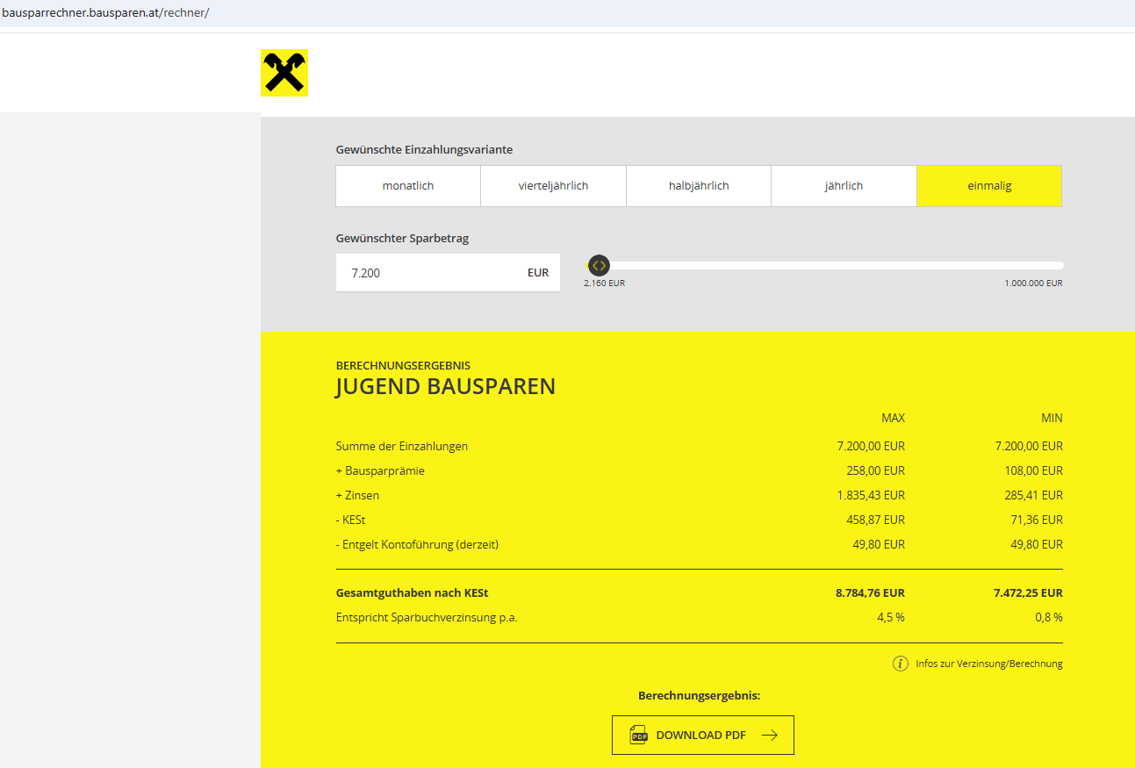

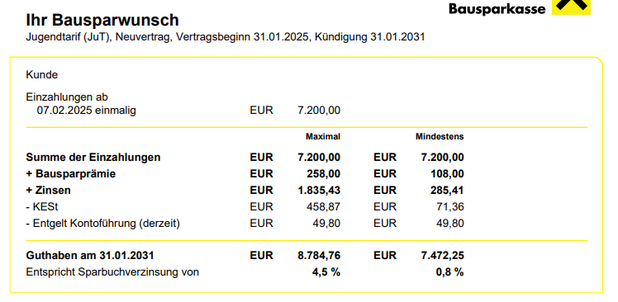

TC07

TC12

Expected results:

| **Component** | **Expected Range (Higher than TC01 due to dynamic increase)** |
| --- | --- |
| **Sum of Deposits** | Higher than €7,200 |
| **Building Savings Premium** | Slightly higher than static case |
| **Interest (Zinsen)** | Higher than static case |
| **Capital Gains Tax (KESt)** | 25% of increased interest |
| **Account Management Fee** | Fixed at €49.80 |
| **Total Assets After KESt** | Higher than static case |

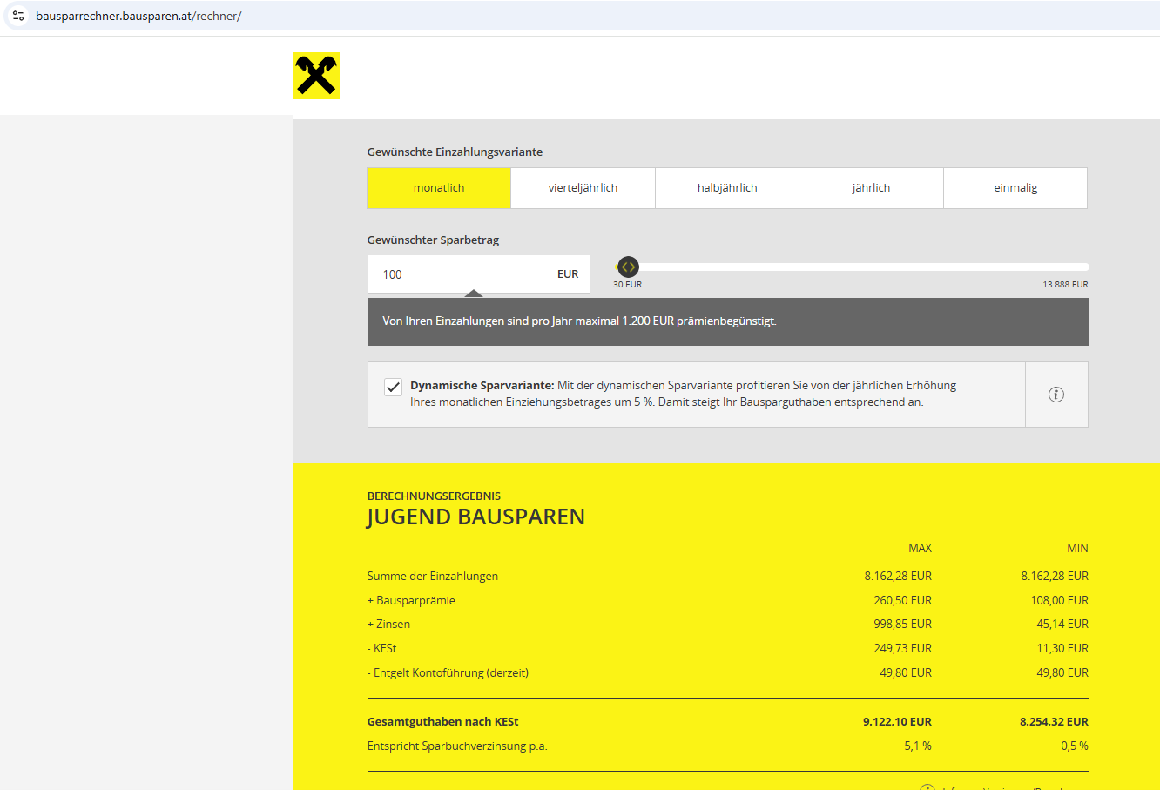

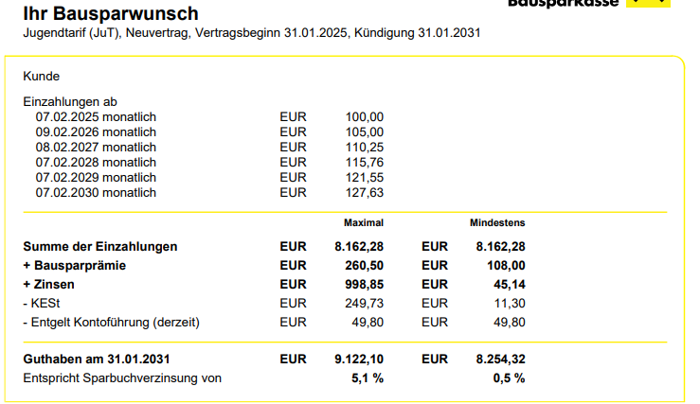

TC10

TC13

Expected results:

| **Component** | **Expected Outcome** |
| --- | --- |
| **Sum of Deposits** | €999,936 (Maximum Allowed) |
| **Building Savings Premium** | Capped at the maximum premium limit |
| **Interest (Zinsen)** | **Significantly high compared to lower deposits** |
| **Capital Gains Tax (KESt)** | **25% of earned interest** (substantial value) |
| **Account Management Fee** | Fixed at €49.80 |
| **Total Assets After KESt** | Should be the highest among all test cases |

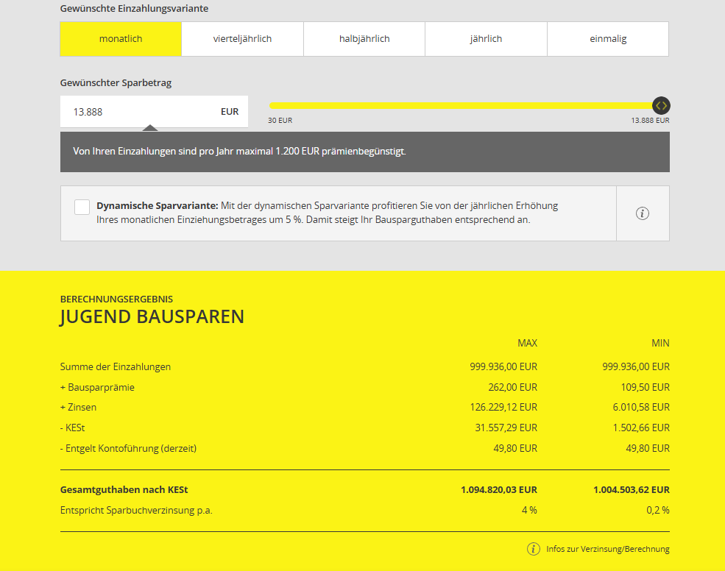

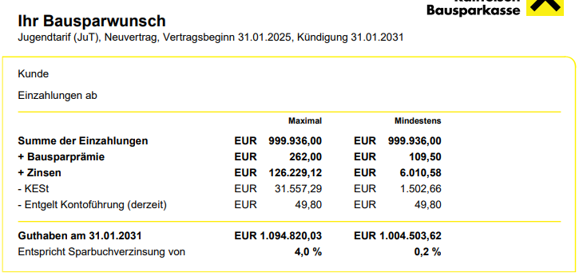

TC011

Expected results:

| **Component** | **Expected Outcome (Lower than higher deposits)** |
| --- | --- |
| **Sum of Deposits** | €2,160 (Minimum deposit applied correctly) |
| **Building Savings Premium** | Lower than higher deposits |
| **Interest (Zinsen)** | Significantly lower compared to higher deposits |
| **Capital Gains Tax (KESt)** | Lower tax due to lower interest earned |
| **Account Management Fee** | Fixed at €49.80 |
| **Total Assets After KESt** | Lowest among test cases due to small deposit amount |

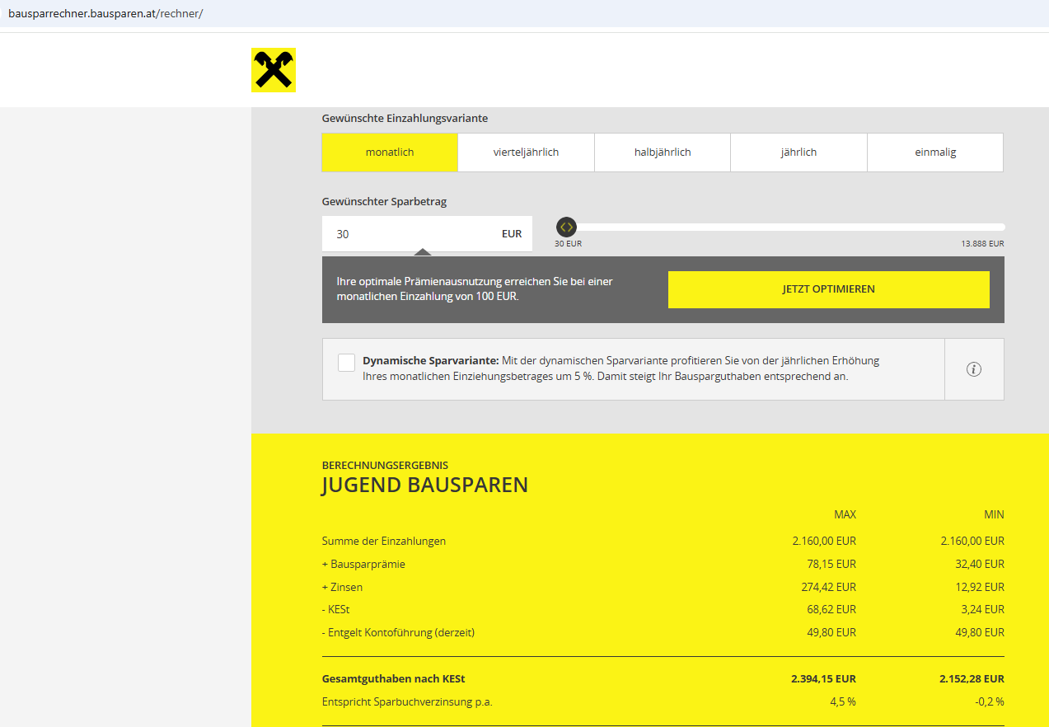

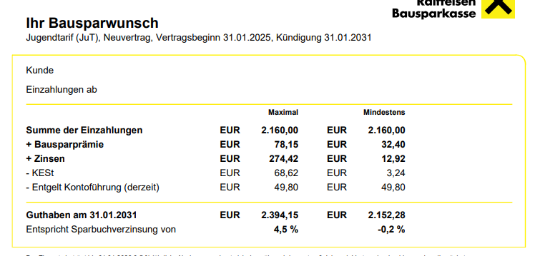

TC014

In all Desired deposit options after tying non-numeric savings amount automatically turns to 0 and results in this message error:

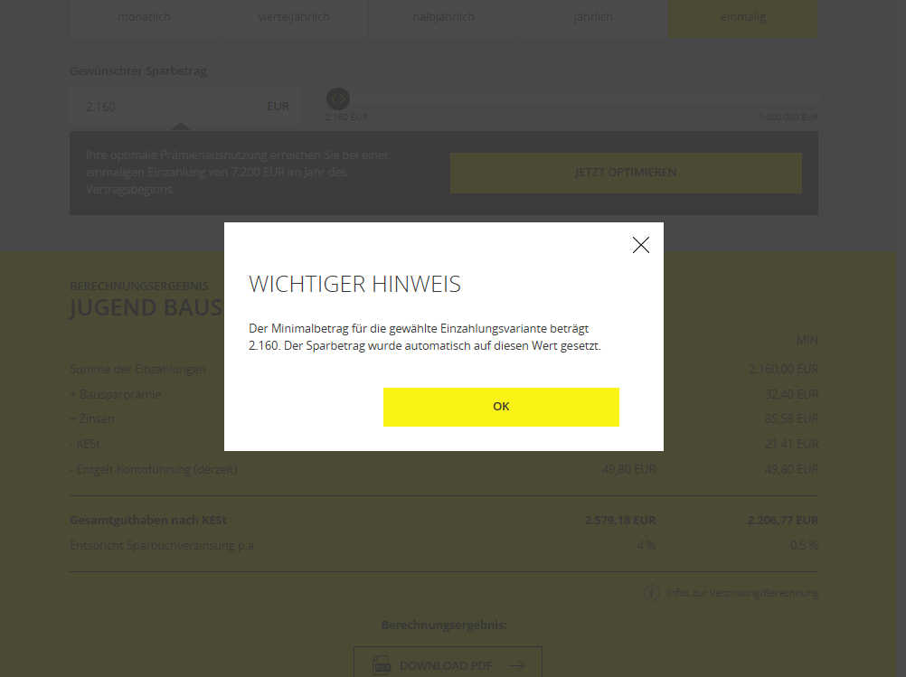

TC015

TC016

In all Desired deposit options after tying special characters in saving amount doesn’t allow any and goes back to the previously number or already existing.

Same goes for negative deposit since it considers (-) as a special character.

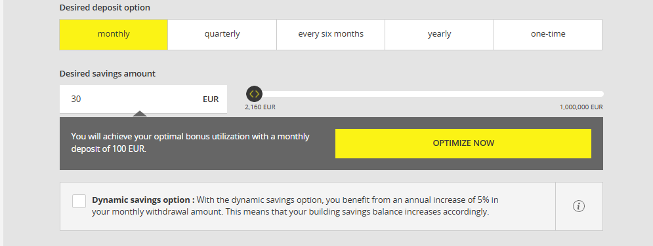

TC017

Expected results:

| **Component** | **Expected Outcome** |
| --- | --- |
| **System Behavior** | The system should reject deposits below €30 per month. |
| **Error Message** | A clear notification should inform the user that the minimum deposit amount is €30 and automatically adjust it. |
| **Deposit Adjustment** | If a lower value is entered, the system should automatically reset it to €30. |
| **Calculation Behavior** | The system should only proceed with calculations once a valid deposit amount is set. |

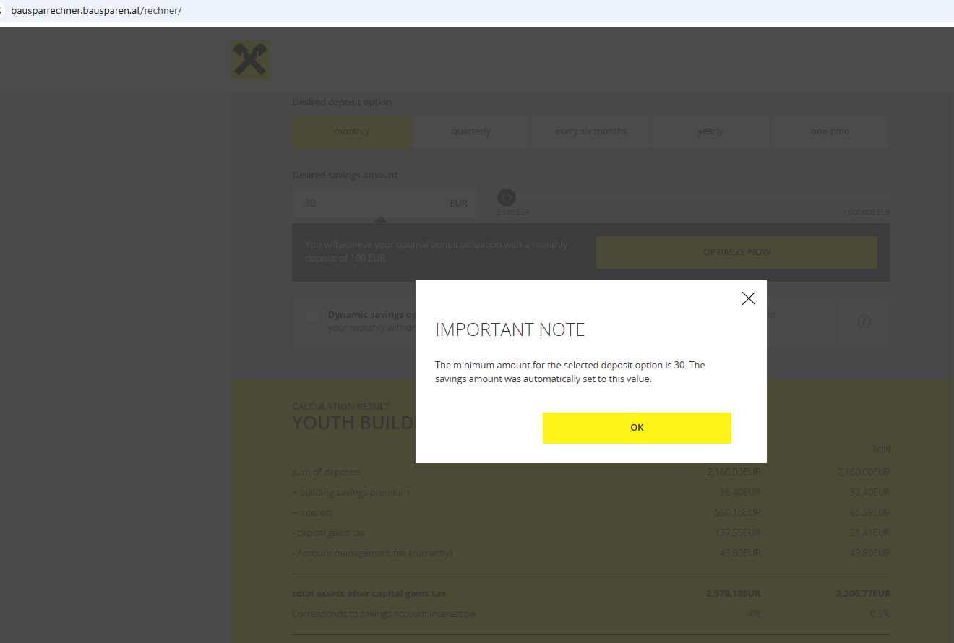

TC018

TC020

Expected results:

| **Component** | **Expected Outcome** |
| --- | --- |
| **System Behavior** | The system should reject deposits above the maximum allowed limit. |
| **Error Message** | A clear notification should inform the user that the entered amount exceeds the maximum limit. |
| **Deposit Adjustment** | If a higher value is entered, the system should automatically reset it to the maximum limit. |
| **Calculation Behavior** | The system should only proceed with calculations once a valid deposit amount is set. |

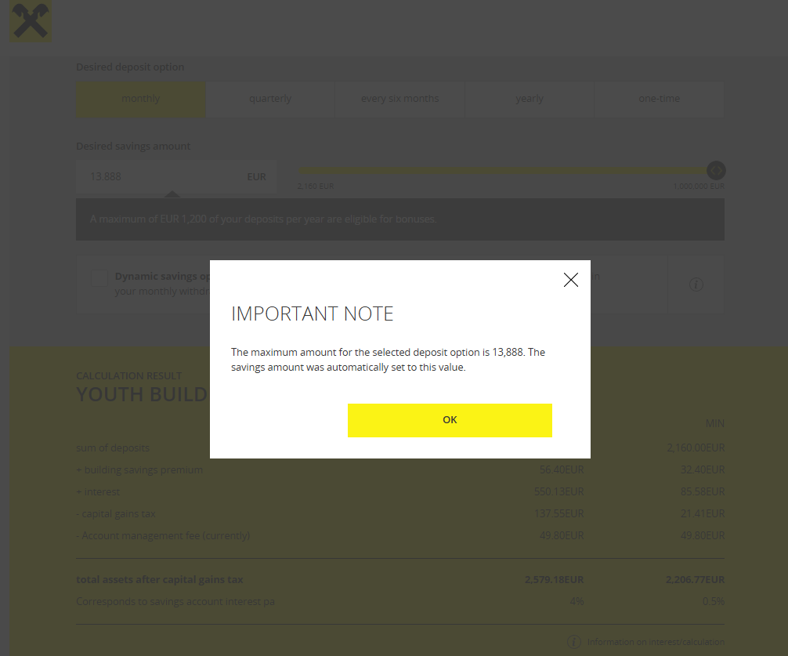

TC019

TC021

Expected results:

| **Component** | **Expected Outcome** |
| --- | --- |
| **System Behavior** | The system should prevent PDF download if no calculation has been performed. |
| **Error Message** | A clear notification should inform the user that they must enter data and perform a calculation first. |
| **Download Restriction** | The "Download PDF" button should be disabled or an error should be displayed upon clicking. |

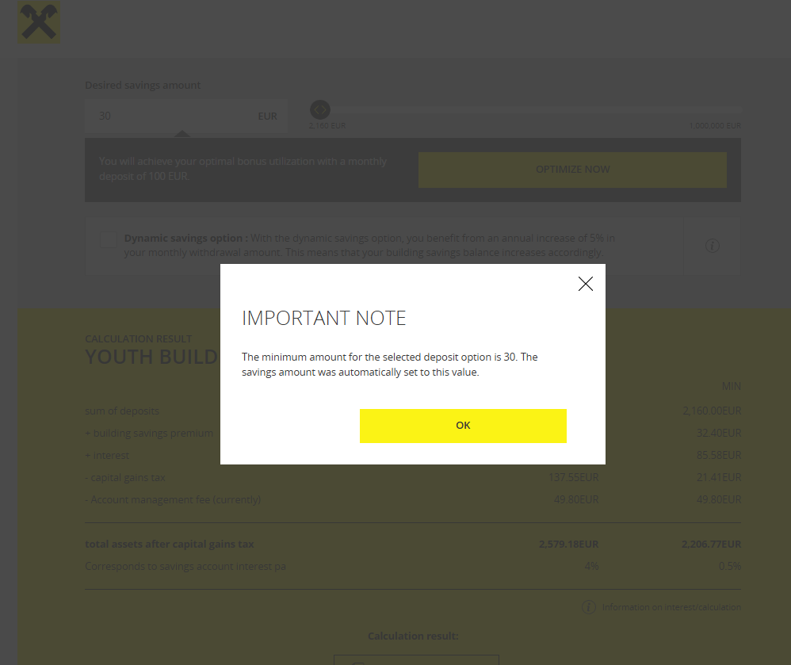

TC022

Expected results:

| **Component** | **Expected Outcome** |
| --- | --- |
| **Page Load Time** | Slower than normal, but should not crash. |
| **Calculation Speed** | Takes longer to process but should complete without errors. |
| **Displayed Calculation Results** | Should remain accurate despite slow connection. |
| **Error Handling** | If a timeout occurs, an error message should appear instead of a freeze. |
| **PDF Download** | Should work but may take longer. |

