1. When you run node server.js, open sqlite dbs and check that the users is empty:

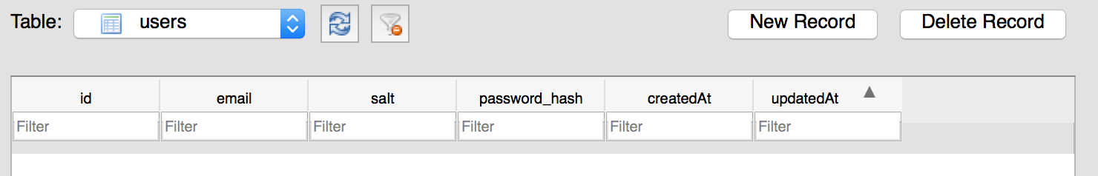

1. Make a POST request in order to add a new user:

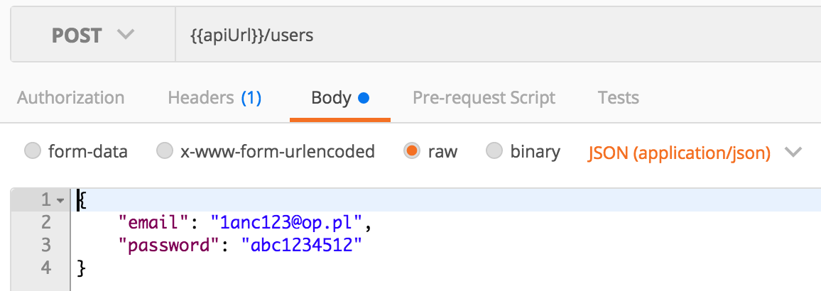

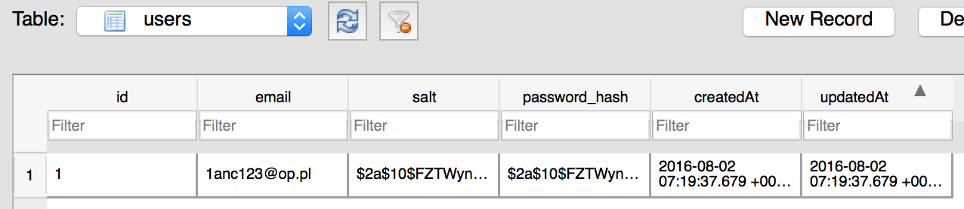

1. Make a POST request win order to login the user

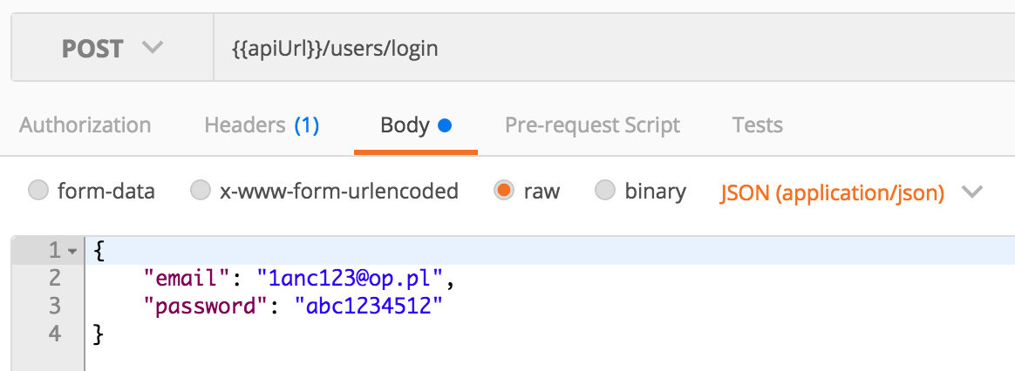

When this response is send off, check what Headers are returned – there should be a Auth header -> copy and add that to all of your future requests

Or do something like this in order to make your life easier (manage environments)

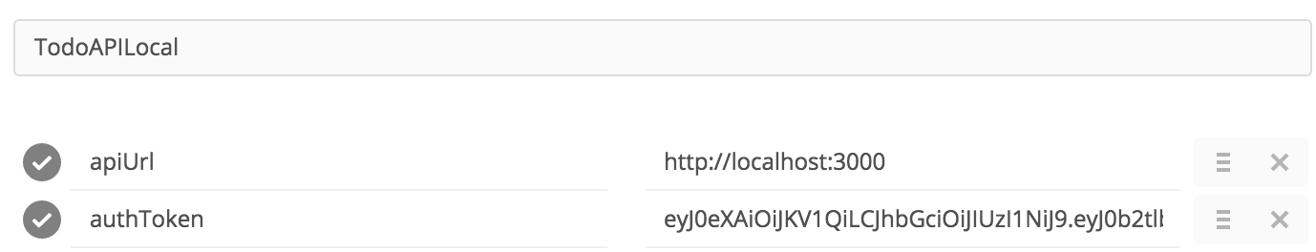

Your dbs will also save the token:

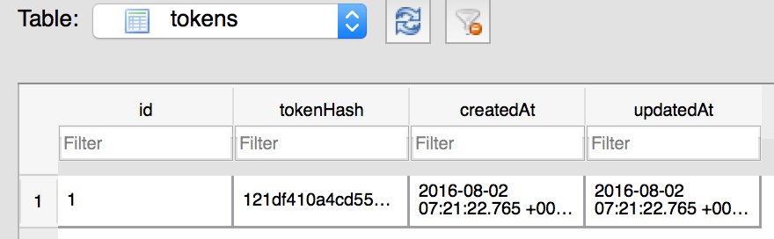

1. You can then post your first todo item:

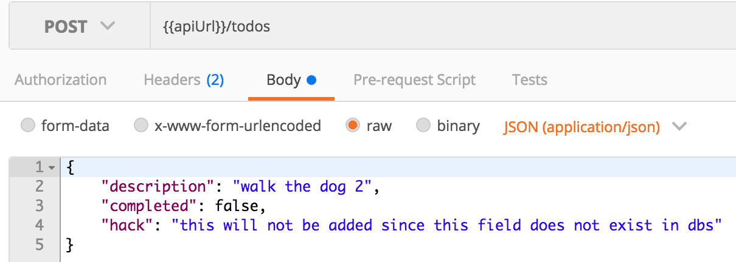

* ‘hack’ will not be added to the dbs, as it is not a specified field: so your dbs will look something like this:

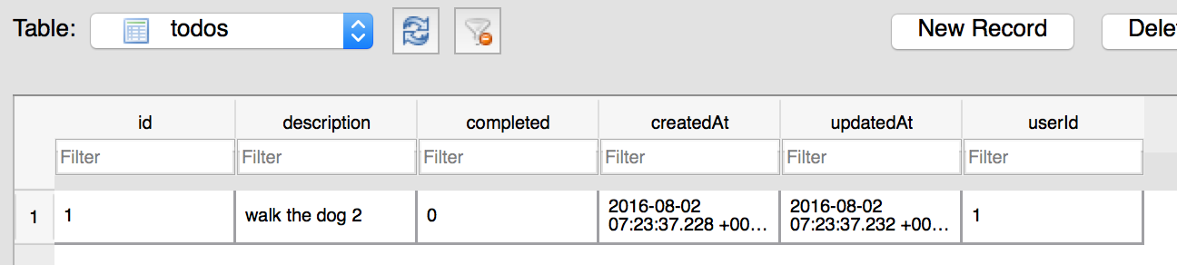

Where the todo item is linked to a specific user by ‘userId’

GET all of the todo items:

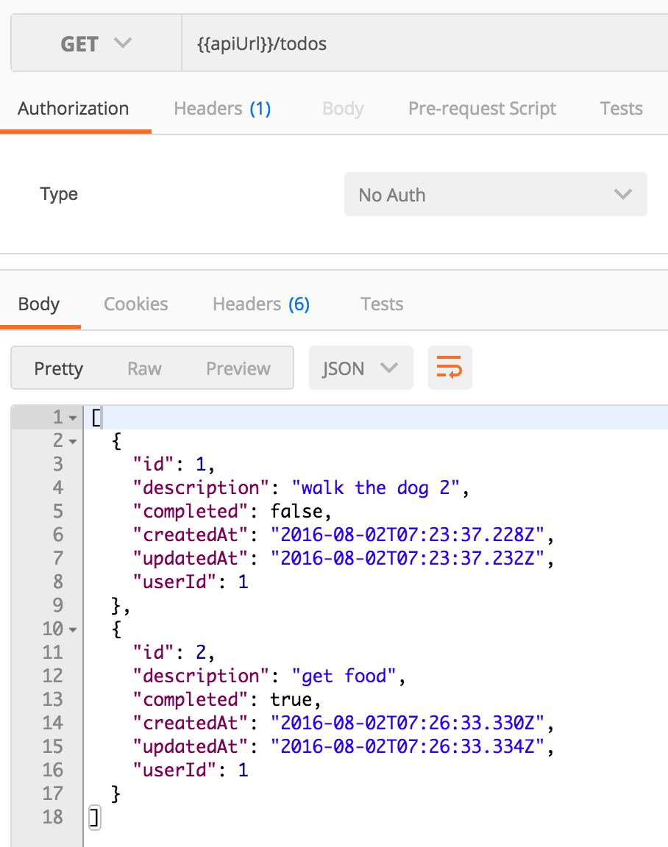

Update a todo item by the item id:

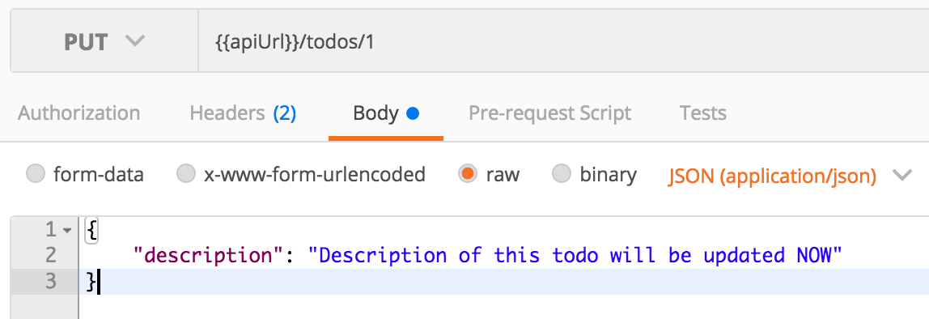

In order to logout, do a DELETE call to:

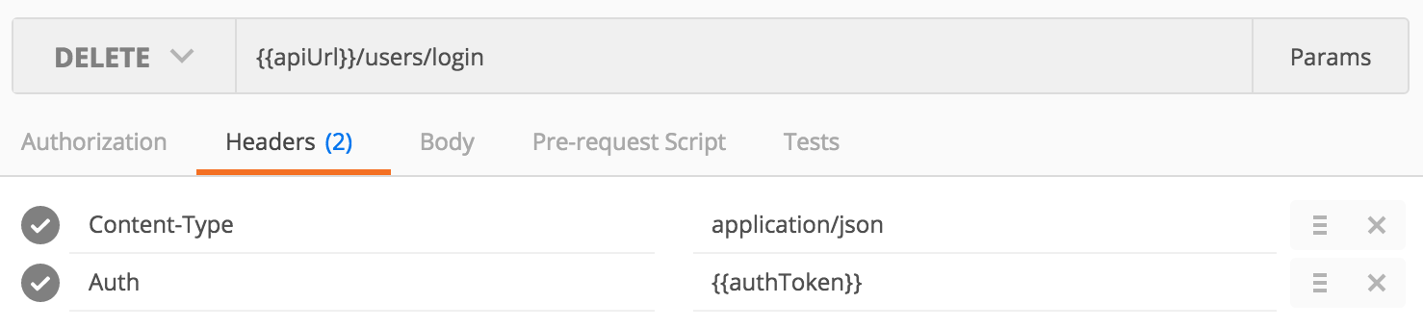

Which will delete the token from the dbs and log the user out – The users account is still valid to login again!