Report: Optimising NYC Taxi Operations

Include your visualisations, analysis, results, insights, and outcomes. Explain your methodology and approach to the tasks. Add your conclusions to the sections.

## Data Preparation

* 1. Loading the dataset
     1. **Sample the data and combine the files**

**Sample the data**

df = pd.read_parquet('../trip_records/2023-1.parquet')

df.head()

**Result**

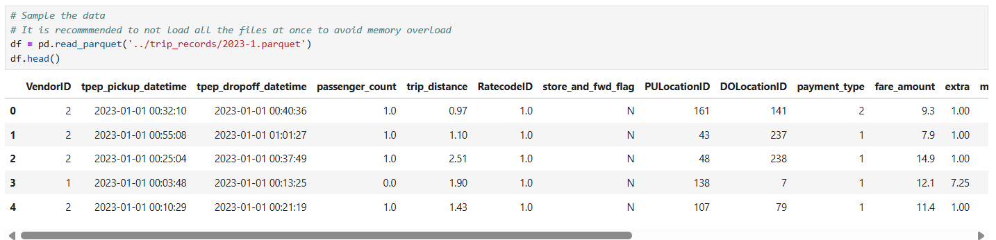

**Combine the files**

# Select the folder having data files

import os

import glob

# Select the folder having data files

# os.chdir('../trip_records/')

# Create a list of all the twelve files to read

# file_list = os.listdir()

file_list = sorted(glob.glob("../trip_records/*.parquet"))

print(file_list)

# initialise an empty dataframe

df = pd.DataFrame()

# iterate through the list of files and sample one by one:

for file_name in file_list:

try:

# file path for the current file

file_path = os.path.join(os.getcwd(), file_name)

# Reading the current file

data = pd.read_parquet(file_path)

#data.columns = data.columns.str.strip().str.lower()

# Filter for 2023 only

data = data[data['tpep_pickup_datetime'].dt.year == 2023].copy()

# Extract date and hour

data['date'] = data['tpep_pickup_datetime'].dt.date

data['hour'] = data['tpep_pickup_datetime'].dt.hour

# We will store the sampled data for the current date in this df by appending the sampled data from each hour to this

# After completing iteration through each date, we will append this data to the final dataframe.

sampled_data = pd.DataFrame()

# Loop through dates and then loop through every hour of each date

for date in data['date'].unique():

day_data = data[data['date'] == date]

# Iterate through each hour of the selected date

for hour in range(24):

hour_data = day_data[day_data['hour'] == hour]

# Sample 5% of the hourly data randomly

if not hour_data.empty:

sampled_hour = hour_data.sample(frac=0.008, random_state=42)

sampled_data = pd.concat([sampled_data, sampled_hour], ignore_index=True)

# add data of this hour to the dataframe

# Concatenate the sampled data of all the dates to a single dataframe

df = pd.concat([df, sampled_data], ignore_index=True)

except Exception as e:

print(f"Error reading file {file_name}: {e}")

print(df.shape)

# Store the df in csv/parquet

df.to_csv('../trip_records/uncleaned_nyc_2023.csv', index=False)

**Result**

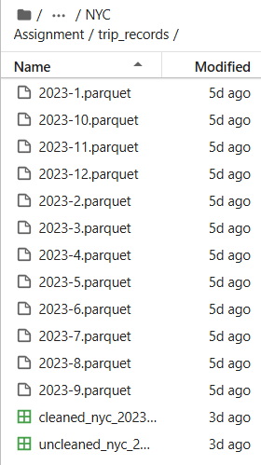

## Data Cleaning

### Fixing Columns

* + 1. **Fix the index**

# Load the new data file

final_df = pd.read_csv('../trip_records/uncleaned_nyc_2023.csv')

final_df.shape

final_df.reset_index(inplace=True, drop=True)

Note: The dataframe was saved with parameter index=false, which will not add index values as new column

* + 1. **Combine the two airport_fee columns**

# Combine the two airport fee columns

final_df['airport_fee'] = final_df['Airport_fee'].combine_first(final_df['airport_fee'])

final_df.drop(columns=['Airport_fee'], inplace=True)

### Handling Missing Values

* + 1. **Find the proportion of missing values in each column**

missing_proportion = final_df.isna().mean()

print(missing_proportion)

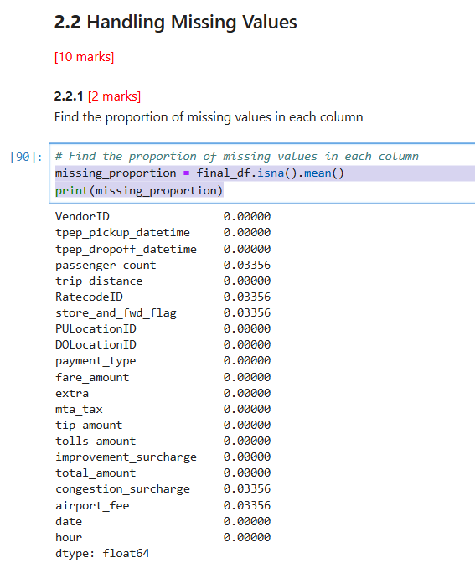

* + 1. **Handling missing values in passenger_count**

**Missing Values**

final_df['passenger_count'].value_counts(dropna=False)

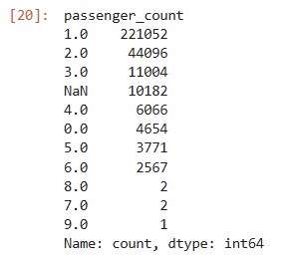

Note: We also impute 0 with mode value, by converting first it into NaN

**Convert zeros to NaN values**

final_df.loc[final_df['passenger_count'] == 0, 'passenger_count'] = np.nan

**Now impute all NaN values with mode value**  
mode_val = final_df['passenger_count'].mode()[0]

print('mode value ', mode_val)

final_df['passenger_count'] = final_df['passenger_count'].fillna(mode_val)

* + 1. **Handle missing values in RatecodeID**

**Missing Values**

final_df['RatecodeID'].value_counts(dropna=False)  
  
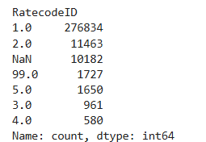

Note: 99 is not a valid value, assuming it as 6 as per dictionary provided

**Replace 99 to 6**

final_df.loc[final_df['RatecodeID'] == 99.0, 'RatecodeID'] = 6.0

**Now impute all NaN values with mode value**

mode_val = final_df['RatecodeID'].mode()[0]

print(mode_val)

final_df['RatecodeID'] = final_df['RatecodeID'].fillna(mode_val)

* + 1. **Impute NaN in congestion_surcharge**

**Missing Values**  
final_df['congestion_surcharge'].value_counts(dropna=False)

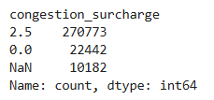

**Now impute all NaN values with mode value**

mode_val = final_df['congestion_surcharge'].mode()[0]

print(mode_val)

final_df['congestion_surcharge'] = final_df['congestion_surcharge'].fillna(mode_val)

### Handling Outliers and Standardising Values

* + 1. **Check outliers in payment type, trip distance and tip amount columns**  
       **Payment type**

final_df['payment_type'].value_counts()

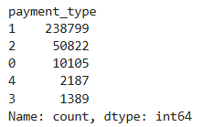

Note: payment_type is 0 (there is no payment_type 0 defined in the data dictionary)

**Remove the records with zero payment type**

final_df = final_df[~(final_df['payment_type'] == 0)]

**Trip Distance**

**trip_distance > 250 are outliers**

analysis3 = final_df[(final_df['trip_distance'] >250 )]

analysis3.loc[:,]

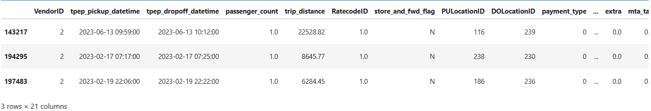

There are three rows, remove them from the dataframe

final_df = final_df[~(final_df['trip_distance'] >250 )]

**Tip Amount**

Remove those records where tip_amount is greater than fare_amount

final_df = final_df[~(final_df['tip_amount'] > final_df['fare_amount'])]

Remove those records where tip_amount is greater than 60 as there are very few records

final_df = final_df[~(final_df['tip_amount'] > 60)]

## Exploratory Data Analysis

### General EDA: Finding Patterns and Trends

* + 1. **Classify variables into categorical and numerical**

**Categorical Variables**

VendorID, RatecodeID, PULocationID, DOLocationID, payment_type

**Numerical Variables**

fare_amount, extra, mta_tax, tip_amount, tolls_amount, improvement_surcharge, total_amount, congestion_surcharge, airport_fee, tpep_pickup_datetime, tpep_dropoff_datetime, passenger_count, trip_distance, trip_duration, pickup_hour

* + 1. **Analyse the distribution of taxi pickups by hours, days of the week, and months  
         
       Taxi pickups by hours**

sns.barplot(cleaned_df["hour"].value_counts(), errorbar=None)

plt.title('Ride Count by Hour of Day')

plt.xlabel('Hour of Day')

plt.ylabel('Number of Rides')

plt.show()

**Result**

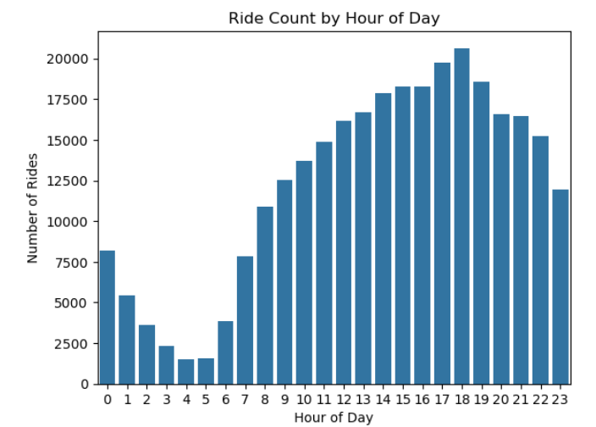

**Taxi pickups by days of the week**

cleaned_df['day_of_week'] = cleaned_df['tpep_pickup_datetime'].dt.day_name()

# plt.figure(figsize=(10, 5))

cleaned_df['day_of_week'].value_counts().reindex(['Monday','Tuesday','Wednesday','Thursday','Friday','Saturday','Sunday']).plot(kind='bar')

plt.title('Ride Count by Day of Week')

plt.xlabel('Day of Week')

plt.ylabel('Number of Rides')

plt.xticks(rotation=45)

plt.show()

**Result**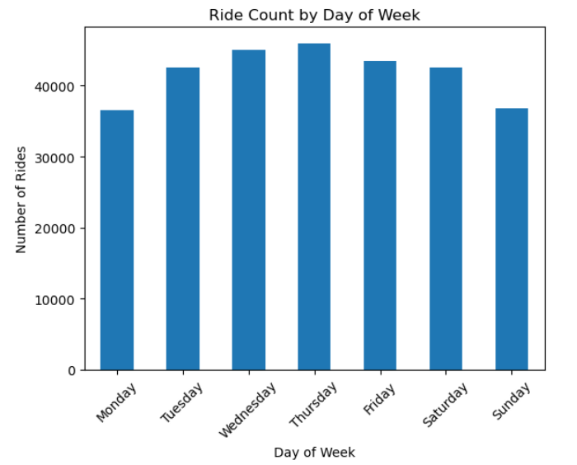

**Taxi pickups by months**

cleaned_df['month'] = cleaned_df['tpep_pickup_datetime'].dt.month_name()

cleaned_df['month'].value_counts().reindex(['January','February','March','April','May','June','July','August','September','October','November','December']).plot(kind='bar')

plt.title('Ride Count by Month')

plt.xlabel('Month')

plt.ylabel('Number of Rides')

plt.show()

**Result**

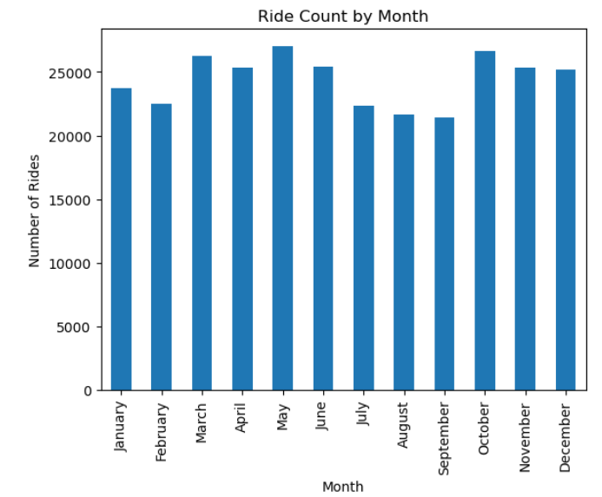

* + 1. **Filter out the zero/negative values in fares, distance and tips**# final check for negative values

cols_to_check = [

'fare_amount', 'tip_amount',

'total_amount', 'trip_distance'

]

for col in cols_to_check:

zero_count = (cleaned_df[col] == 0).sum()

print(f"Zero values in '{col}': {zero_count}")

**Result**

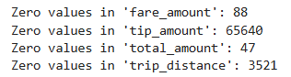

**Create a df with non zero entries for the selected parameters.**

sliced1 = cleaned_df[(cleaned_df['fare_amount'] > 0) & (cleaned_df['tip_amount'] > 0) & (cleaned_df['total_amount'] > 0) & (cleaned_df['trip_distance'] > 0)]

* + 1. **Analyse the monthly revenue trends**month_order = ['January', 'February', 'March', 'April', 'May', 'June',

'July', 'August', 'September', 'October', 'November', 'December']

sliced1.loc[:,'month'] = pd.Categorical(sliced1['month'], categories=month_order, ordered=True)

monthly_revenue = sliced1.groupby(sliced1['month'], observed=True)['total_amount'].sum()

print(monthly_revenue)

monthly_revenue.plot(kind='line', marker='o', figsize=(10,5))

plt.title('Monthly Revenue Trend')

plt.xlabel('Month')

plt.ylabel('Total Revenue ($)')

plt.grid(True)

plt.xticks(rotation=45)

plt.tight_layout()

plt.show()

**Result**

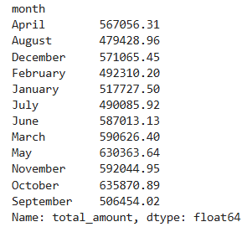

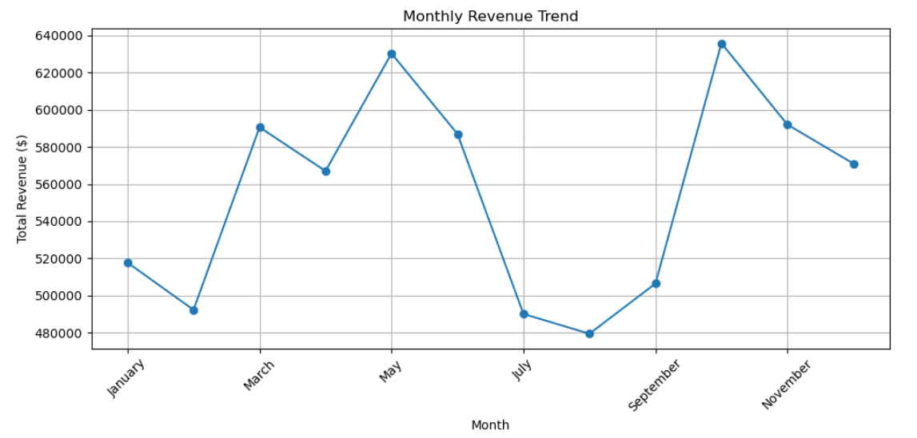

* + 1. **Find the proportion of each quarter’s revenue in the yearly revenue**

sliced1.loc[:,'quarter'] = sliced1['tpep_pickup_datetime'].dt.to_period('Q')

quarterly_revenue = sliced1.groupby('quarter', observed=True)['total_amount'].sum()

revenue_proportion = (quarterly_revenue / quarterly_revenue.sum()) * 100

print(revenue_proportion)

**Result**

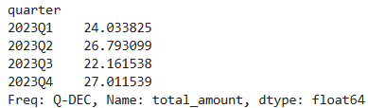

* + 1. **Analyse and visualise the relationship between distance and fare amount**plt.figure(figsize=(10, 6))

sns.scatterplot(data=sliced1, x='trip_distance', y='fare_amount')

plt.title('Trip Distance vs Fare Amount')

plt.xlabel('Trip Distance (miles)')

plt.ylabel('Fare Amount ($)')

plt.grid(True)

plt.show()

**Result**

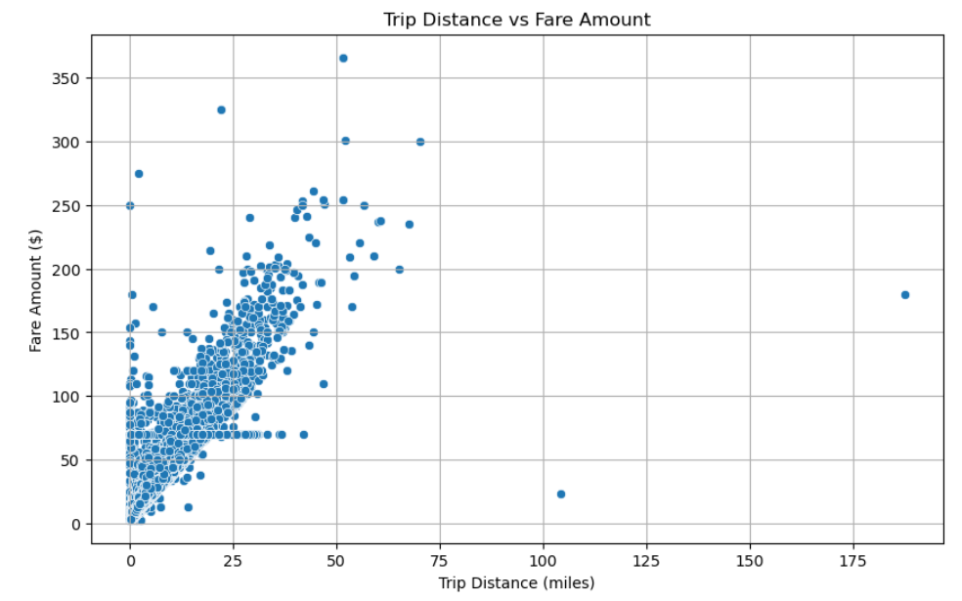

* + 1. **Analyse the relationship between fare/tips and trips/passengers**

**Show relationship between fare and trip duration**

sliced1.loc[:,'trip_duration'] = sliced1['tpep_dropoff_datetime'] - sliced1['tpep_pickup_datetime']

correlation = sliced1[['fare_amount', 'trip_duration']].corr()

# print(f"Correlation between trip duration and fare_amount: {correlation:.4f}")

plt.figure(figsize=(6, 5))

sns.heatmap(correlation, annot=True, cmap='coolwarm', fmt=".2f")

plt.title("Correlation Heatmap: Fare Amount vs Trip Duration")

plt.tight_layout()

plt.show()

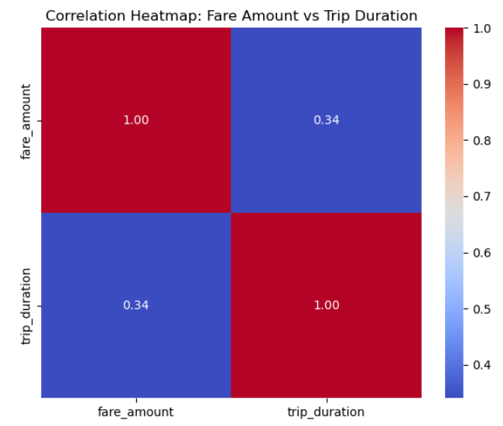

**Show relationship between fare and number of passengers**

correlation = sliced1[['fare_amount', 'passenger_count']].corr()

plt.figure(figsize=(6, 5))

sns.heatmap(correlation, annot=True, cmap='coolwarm', fmt=".2f")

plt.title("Correlation Heatmap: Fare Amount vs Trip Duration")

plt.tight_layout()

plt.show()

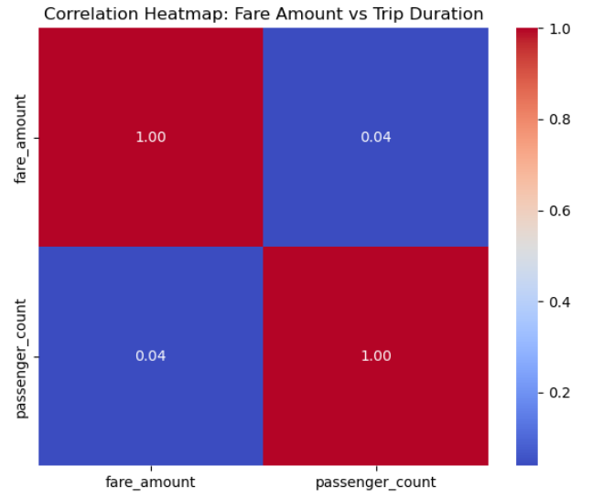

**Show relationship between tip and trip distance**

correlation = sliced1[['tip_amount', 'trip_distance']].corr()

# print(f"Correlation between number of passengers and fare_amount: {correlation:.4f}")

plt.figure(figsize=(6, 5))

sns.heatmap(correlation, annot=True, cmap='coolwarm', fmt=".2f")

plt.title("Correlation Heatmap: Fare Amount vs Trip Duration")

plt.tight_layout()

plt.show()

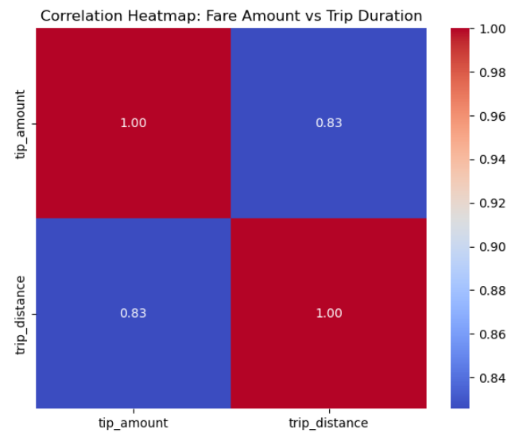

* + 1. **Analyse the distribution of different payment types**

payment_counts = sliced1['payment_type'].value_counts().sort_index()

#Map numeric codes to readable labels if applicable

payment_labels = {

1: 'Credit Card',

2: 'Cash',

3: 'No Charge',

4: 'Dispute',

5: 'Unknown',

6: 'Voided Trip'

}

payment_counts.index = payment_counts.index.map(payment_labels)

sns.barplot(x=payment_counts.index, y=payment_counts.values)

plt.title("Distribution of Payment Types")

plt.xlabel("Payment Type")

plt.ylabel("Number of Trips")

plt.xticks(rotation=45)

plt.tight_layout()

plt.show()

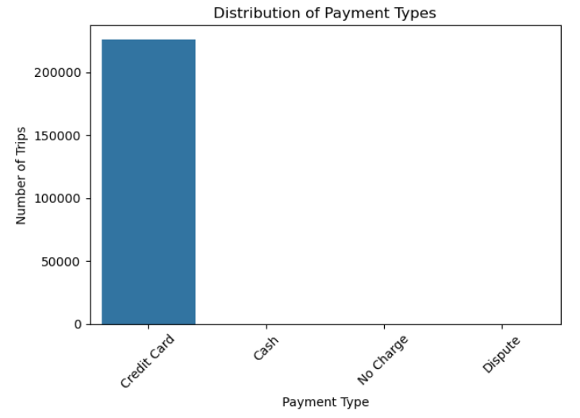

Note: The values of cash, No Charge, Dispute were less to be displayed on the graph

* + 1. **Load the taxi zones shapefile and display it**import geopandas as gpd

# Read the shapefile using geopandas

zones = gpd.read_file('../taxi_zones/taxi_zones.shp')

zones.head()

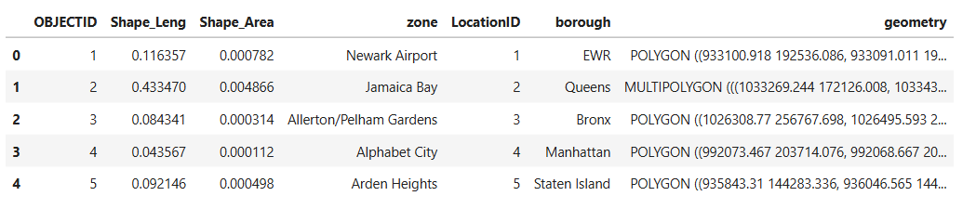

zones.plot()

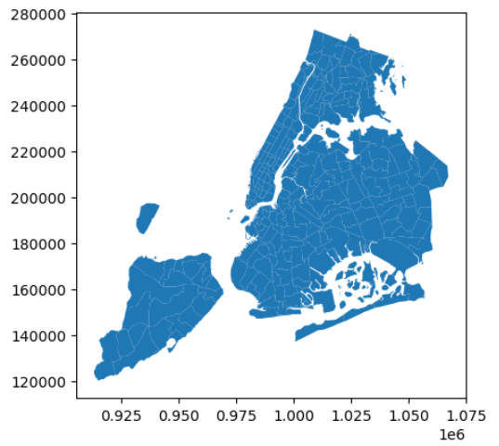

* + 1. **Merge the zone data with trips data**merged_sliced_zones = pd.merge(sliced1, zones, how='left', left_on='PULocationID', right_on='LocationID')

merged_sliced_zones.head()

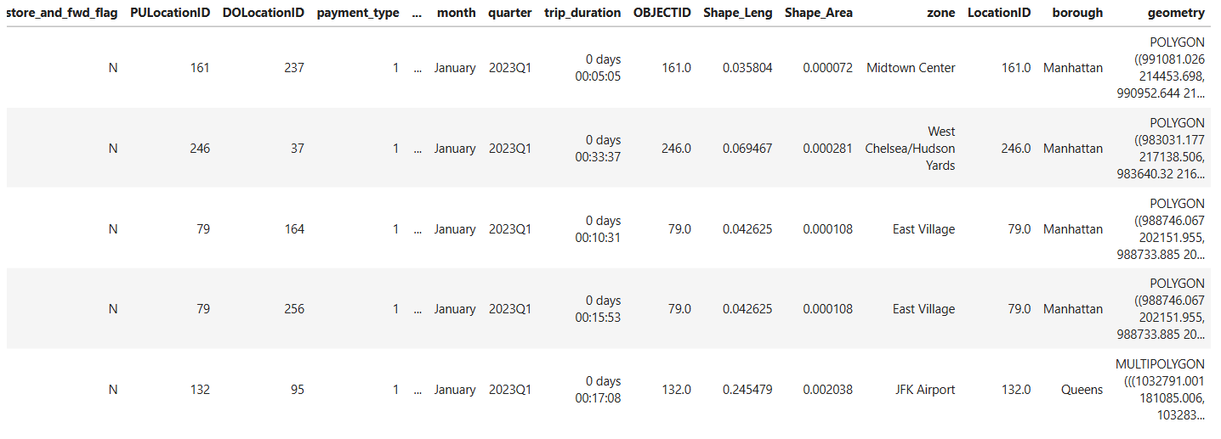

* + 1. **Find the number of trips for each zone/location ID**

pickup_counts = merged_sliced_zones.groupby('LocationID').size()

.reset_index(name='trip_count')

pickup_counts = pickup_counts.sort_values(by='trip_count', ascending=False)

pickup_counts.head()

**Result**

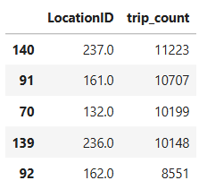

* + 1. **Add the number of trips for each zone to the zones dataframe**# Merge trip counts back to the zones GeoDataFrame

merged_zones_trips = pd.merge(zones, pickup_counts, how='left', left_on='LocationID', right_on='LocationID')

merged_zones_trips.head()

**Result**

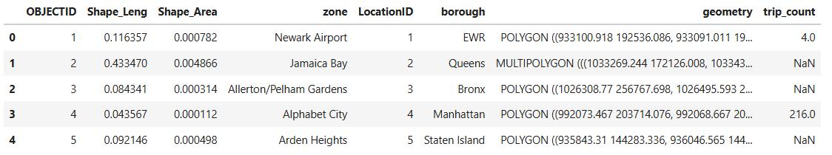

* + 1. **Plot a map of the zones showing number of trips**

fig, ax = plt.subplots(1, 1, figsize=(12, 10))

# Plot the map and display it

merged_zones_trips.plot(

column='trip_count', # Data to color by

ax=ax, # Axis to draw on

legend=True, # Show color legend

cmap='OrRd', # Color palette

legend_kwds={

'label': "Number of Trips",

'orientation': "vertical"

},

edgecolor='black', # Outline for each zone

linewidth=0.5 # Border thickness

)

# Step 6: Clean up and display

ax.set_title('NYC Taxi Trips by Pickup Zone', fontsize=16)

ax.axis('off') # Hide axes

plt.tight_layout()

plt.show()

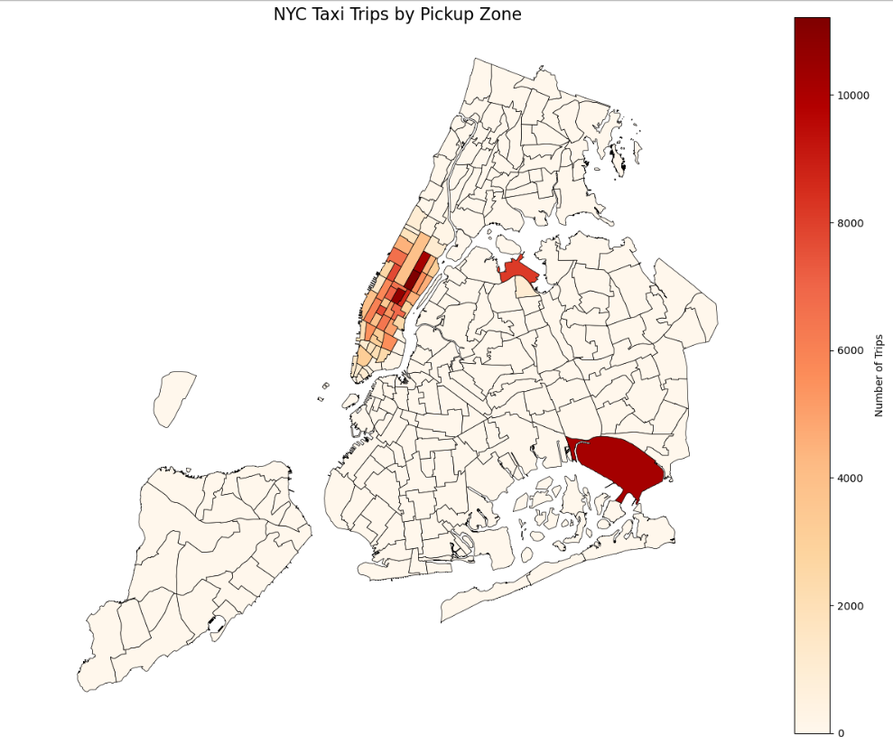

* + 1. **Conclude with results**Busiest hours, days and months

**Hours**:

* Peak demand occurs during:
  + Morning rush hour (7-9 AM)
  + Evening rush hour (5-7 PM)
* Lowest demand: Late night (12-4 AM)

**Days**:

* Weekdays show consistently high demand (especially Wednesday-Friday)
* Weekends show slightly lower overall demand, but with:
  + Higher evening/night demand (social activities)
  + Lower morning demand (no work commutes)

**Months**:

* Highest demand: September-November (fall season)
* Moderate demand: March-May (spring)
* Lower demand: December-February (winter months)
* Summer months (June-August) show slightly reduced demand

Trends in revenue collected

**Monthly Revenue**:

* Revenue follows similar patterns to trip volume
* Highest revenue months: September-November
* Notable revenue dip in summer (July-August)
* Steady increase from January through November

Trends in quarterly revenue

**Quarterly Revenue**:

* Q4 (Oct-Dec): 27.01% of annual revenue (peak quarter)
* Q2 (Apr-Jun): 26.79%
* Q1 (Jan-Mar): 24.03%
* Q3 (Jul-Sep): 22.16% (lowest quarter)

How fare depends on trip distance, trip duration and passenger counts

**Trip Distance**:

* Strong positive correlation (≈0.8) between distance and fare
* Base fare visible as y-intercept
* Linear relationship for most trips, with some longer trips showing higher variability

**Trip Duration**:

* Moderate positive correlation (≈0.6) with fare
* Longer trips generally cost more, but relationship isn't as strong as with distance

**Passenger Count**:

* Very weak correlation (≈0.1) with fare
* Number of passengers doesn't significantly affect fare amount

How tip amount depends on trip distance

**Tip Amount:**

With the increase in trip distance the tip amount increases also shows strong correlationship

Busiest zones

**Top Pickup zones**

LaGuardia Airport

Midtown Center

Upper East Side South

Midtown East

Upper East Side North

**Top Dropoff zones**

Upper East Side North

Upper East Side South

Midtown Center

Upper West Side South

Murray Hill

### Detailed EDA: Insights and Strategies

* + 1. **Identify slow routes by comparing average speeds on different routes**

sliced1['trip_duration_min'] = (sliced1['tpep_dropoff_datetime'] - sliced1['tpep_pickup_datetime']).dt.total_seconds() / 60

sliced1['pickup_hour'] = sliced1['tpep_pickup_datetime'].dt.hour

grouped = sliced1.groupby(['PULocationID', 'DOLocationID', 'pickup_hour'])

route_stats = grouped.agg({

'trip_duration_min': 'mean',

'trip_distance': 'mean'

}).reset_index()

route_stats['avg_speed_mph'] = (route_stats['trip_distance'] / route_stats['trip_duration_min']) * 60

route_stats = route_stats[(route_stats['trip_duration_min'] > 0) & (route_stats['avg_speed_mph'] < 100)]

merged_pickup_locs = pd.merge(slow_routes, zones, how='left', left_on='PULocationID', right_on='LocationID')

merged_pickup_locs = merged_pickup_locs.rename(columns={'zone': 'Pickupzone'})

merged_pickup_dropoff_locs = pd.merge(merged_pickup_locs, zones, how='left', left_on='DOLocationID', right_on='LocationID')

merged_pickup_dropoff_locs = merged_pickup_dropoff_locs.rename(columns={'zone': 'Dropoffzone'})

merged_pickup_dropoff_locs.loc[:, ["PULocationID", "Pickupzone", "DOLocationID", "Dropoffzone", "pickup_hour", "trip_duration_min",

"trip_distance", "avg_speed_mph"

]].sort_values('avg_speed_mph', ascending=False)[0:10]

**Result**

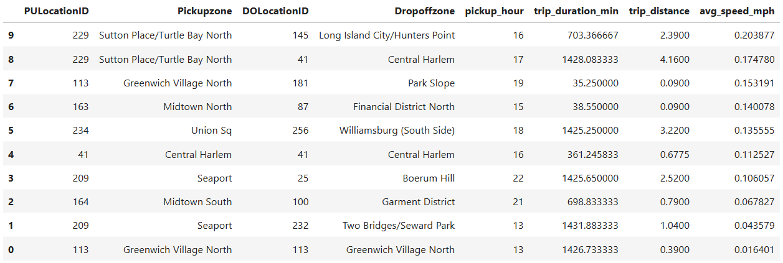

* + 1. **Calculate the hourly number of trips and identify the busy hours**sliced1['pickup_hour'] = sliced1['tpep_pickup_datetime'].dt.hour

trips_per_hour = sliced1['pickup_hour'].value_counts().sort_index()

busiest_hour = trips_per_hour.idxmax()

busiest_count = trips_per_hour.max()

plt.figure(figsize=(12, 6))

trips_per_hour.plot(kind='bar', color='skyblue', edgecolor='black')

plt.title('Number of Trips per Hour of Day')

plt.xlabel('Hour of Day (0–23)')

plt.ylabel('Number of Trips')

plt.xticks(rotation=0)

# plt.grid(axis='y', linestyle='--', alpha=0.7)

# Highlight busiest hour

plt.bar(busiest_hour, busiest_count, color='orange', edgecolor='black', label='Busiest Hour')

plt.legend()

plt.tight_layout()

plt.show()

**Result**

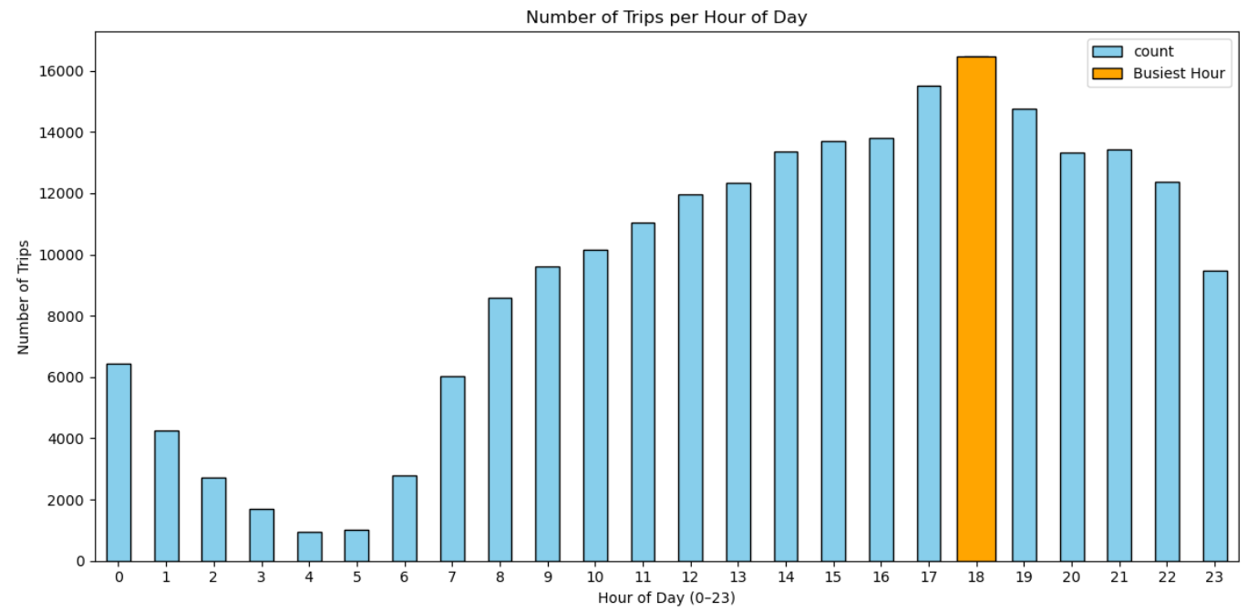

* + 1. **Scale up the number of trips from above to find the actual number of trips**sample_fraction = 0.008

trips_per_hour sliced1['pickup_hour'].value_counts().sort_values(ascending=False)

top5_sample = trips_per_hour.head(5)

top5_actual = (top5_sample / sample_fraction).astype(int)

print("Estimated number of trips in the 5 busiest hours:")

print(top5_actual)

**Result**

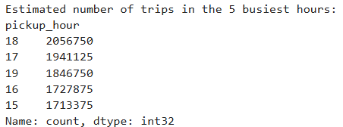

* + 1. **Compare hourly traffic on weekdays and weekends**

weekdays = sliced1[~(sliced1['day_of_week'].isin(['Saturday', 'Sunday']))]

print(weekdays['day_of_week'].unique())

weekends = sliced1[(sliced1['day_of_week'].isin(['Saturday', 'Sunday']))]

print(weekends['day_of_week'].unique())

weekday_traffic = weekdays.groupby(['pickup_hour']).size()

weekend_traffic = weekends.groupby(['pickup_hour']).size()

weekday_traffic.plot(kind='line', label='Weekdays', title='Hourly Traffic Pattern: Weekdays vs Weekends')

weekend_traffic.plot(kind='line', label='Weekends')

plt.xlabel('Hour of the Day')

plt.ylabel('Number of Pickups')

plt.legend()

plt.show()

**Weekdays**

['Monday' 'Tuesday' 'Wednesday' 'Thursday' 'Friday']

**Weekends**

['Sunday' 'Saturday']

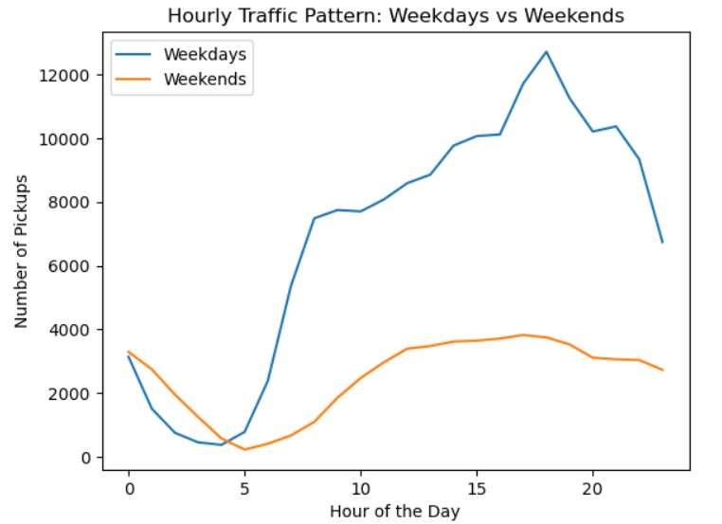

* + 1. **Identify the top 10 zones with high hourly pickups and drops**

**Top 10 zones with high hourly pickups**

pickup_locs = sliced1.groupby(['PULocationID', 'pickup_hour']).size().reset_index(name='counts')

merged_pickup_locs = pd.merge(pickup_locs, zones, how='left', left_on='PULocationID', right_on='LocationID')

Plot_pickups = merged_pickup_locs.loc[:, ["PULocationID", "zone", "pickup_hour", "counts"]].sort_values('counts', ascending=False)[0:10]

**Result**

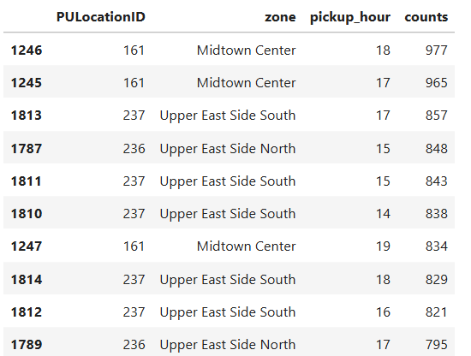

**# Top 10 pickup zones overall**

top_pickup_zones = sliced1['PULocationID'].value_counts().head(10).index

pickup_trends = pickup_locs[pickup_locs['PULocationID'].isin(top_pickup_zones)]

pickup_trends = pd.merge(pickup_trends, zones, how='left', left_on='PULocationID', right_on='LocationID')

plt.figure(figsize=(12,6))

sns.lineplot(data=pickup_trends, x='pickup_hour', y='counts', hue='zone')

plt.title('Hourly Pickup Trends for Top 10 Pickup Zones')

plt.xlabel('Hour of Day')

plt.ylabel('Number of Pickups')

plt.legend(title='Pickup Zone')

plt.show()

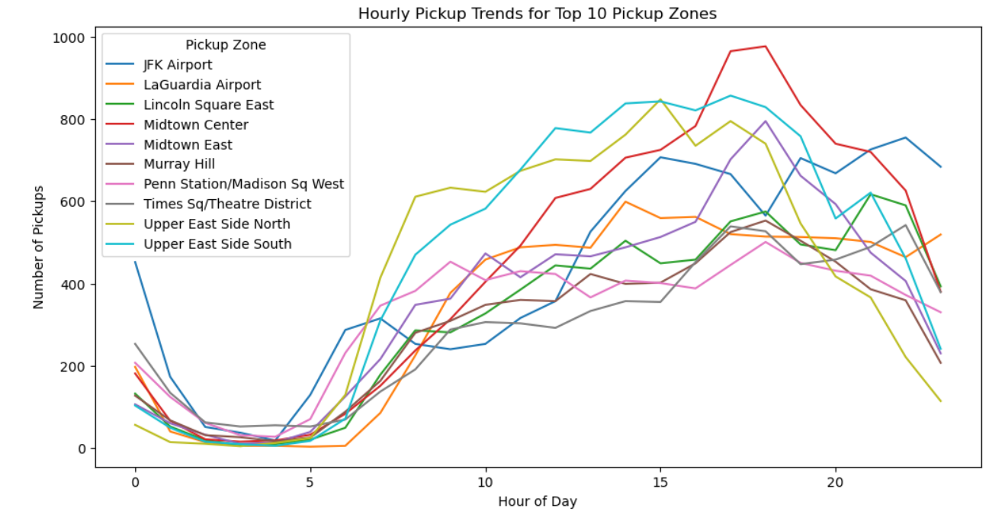

**Top 10 zones with high hourly drops**

dropoff_locs = sliced1.groupby(['DOLocationID', 'pickup_hour']).size().reset_index(name='counts')

merged_dropoff_locs = pd.merge(dropoff_locs, zones, how='left', left_on='DOLocationID', right_on='LocationID')

Plot_dropoffs = merged_dropoff_locs.loc[:, ["DOLocationID", "zone", "pickup_hour", "counts"]].sort_values('counts', ascending=False)[0:10]

**Result**

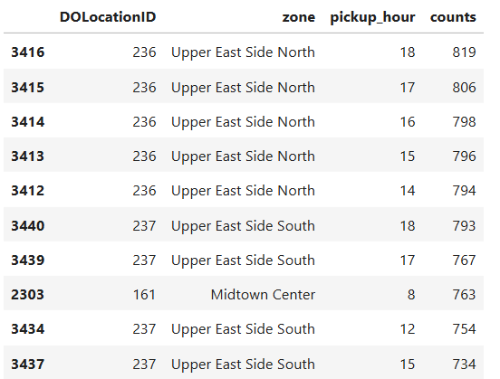

**# Top 10 dropoff zones overall**

top_dropoff_zones = sliced1['DOLocationID'].value_counts().head(10).index

dropoff_trends = dropoff_locs[dropoff_locs['DOLocationID'].isin(top_dropoff_zones)]

dropoff_trends = pd.merge(dropoff_trends, zones, how='left', left_on='DOLocationID', right_on='LocationID')

plt.figure(figsize=(12,6))

sns.lineplot(data=dropoff_trends, x='pickup_hour', y='counts', hue='zone')

plt.title('Hourly Dropoff Trends for Top 10 Dropoff Zones')

plt.xlabel('Hour of Day')

plt.ylabel('Number of Dropoffs')

plt.legend(title='Dropoff Zone')

plt.show()

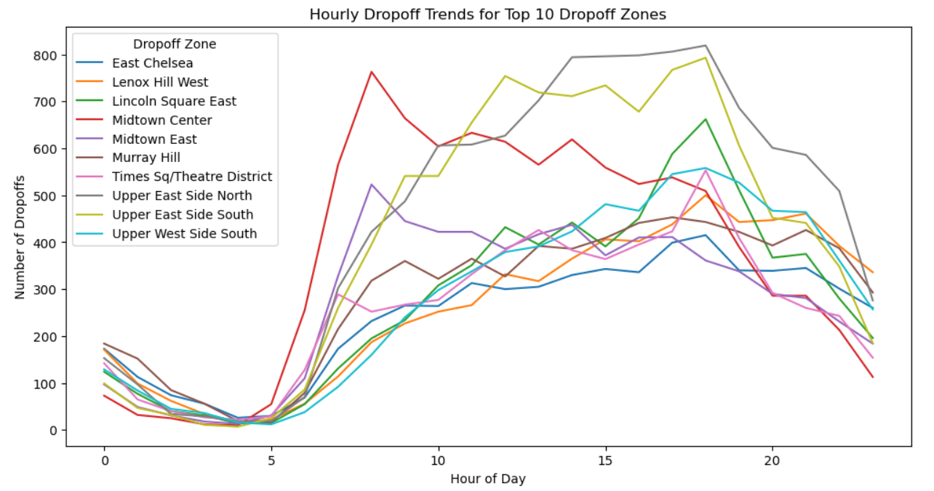

* + 1. **Find the ratio of pickups and dropoffs in each zone**# Find the top 10 and bottom 10 pickup/dropoff ratios

# Step 1: Count pickups and dropoffs

pickup_counts = sliced1.groupby('PULocationID').size().reset_index(name='pickup_count')

dropoff_counts = sliced1.groupby('DOLocationID').size().reset_index(name='dropoff_count')

# Step 2: Merge pickup and dropoff counts

zone_ratios = pd.merge(pickup_counts, dropoff_counts,left_on='PULocationID', right_on='DOLocationID', how='outer')

# Step 3: Handle missing values

zone_ratios['pickup_count'] = zone_ratios['pickup_count'].fillna(0)

zone_ratios['dropoff_count'] = zone_ratios['dropoff_count'].fillna(0)

# Step 4: Create unified zone_id column

zone_ratios['zone_id'] = zone_ratios['PULocationID'].combine_first(zone_ratios['DOLocationID'])

# Step 5: Compute pickup/dropoff ratio

zone_ratios['pickup_dropoff_ratio'] = zone_ratios['pickup_count'] / (zone_ratios['dropoff_count'] + 1e-6)

# Step 6: Merge with zone names

zone_ratios = pd.merge(zone_ratios, zones, left_on='zone_id', right_on='LocationID', how='left')

# Step 7: Get top and bottom 10 by ratio

top10 = zone_ratios.sort_values('pickup_dropoff_ratio', ascending=False).head(10)

bottom10 = zone_ratios.sort_values('pickup_dropoff_ratio').head(10)

# Step 8: Display

print("Top 10 Pickup/Dropoff Ratios by Zone:")

print(top10[['zone', 'pickup_count', 'dropoff_count', 'pickup_dropoff_ratio']])

**Result of top 10 pickup/dropoff ratios**

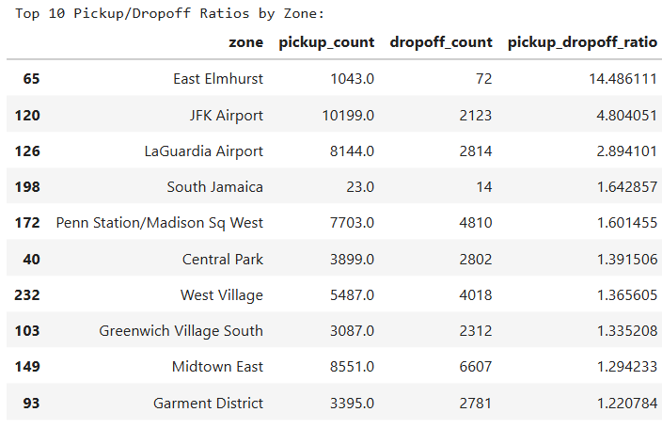

print("\nBottom 10 Pickup/Dropoff Ratios by Zone:")

print(bottom10[['zone', 'pickup_count', 'dropoff_count', 'pickup_dropoff_ratio']])

**Result of bottom 10 pickup/dropoff ratios**

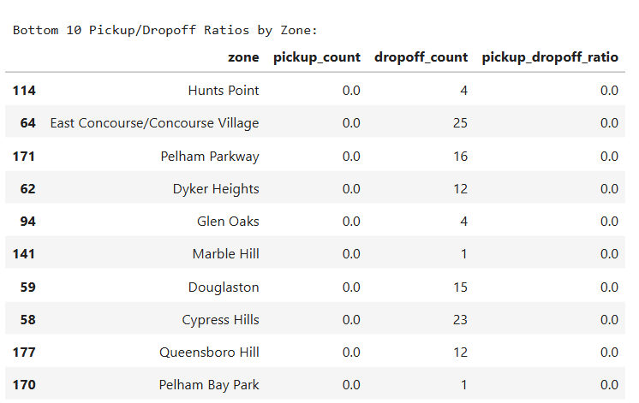

* + 1. **Identify the top zones with high traffic during night hours**# During night hours (11pm to 5am) find the top 10 pickup and dropoff zones

# Note that the top zones should be of night hours and not the overall top zones

night_hours = [23, 0, 1, 2, 3, 4, 5]

night_data = sliced1[sliced1['pickup_hour'].isin(night_hours)]

night_pickups = (

night_data.groupby('PULocationID')

.size()

.reset_index(name='night_pickup_count')

)

night_dropoffs = (

night_data.groupby('DOLocationID')

.size()

.reset_index(name='night_dropoff_count')

)

night_traffic = pd.merge(

night_pickups, night_dropoffs,

left_on='PULocationID', right_on='DOLocationID',

how='outer'

)

night_traffic['zone_id'] = night_traffic['PULocationID'].fillna(night_traffic['DOLocationID'])

night_traffic['night_pickup_count'] = night_traffic['night_pickup_count'].fillna(0)

night_traffic['night_dropoff_count'] = night_traffic['night_dropoff_count'].fillna(0)

night_traffic['total_night_traffic'] = night_traffic['night_pickup_count'] + night_traffic['night_dropoff_count']

night_traffic = pd.merge(night_traffic, zones, left_on='zone_id', right_on='LocationID', how='left')

top_night_zones = night_traffic.sort_values('total_night_traffic', ascending=False).head(10)

print("Top 10 Zones with Highest Nighttime Traffic (11PM–5AM):")

top_night_zones[['zone', 'night_pickup_count', 'night_dropoff_count','total_night_traffic']]

**Result**

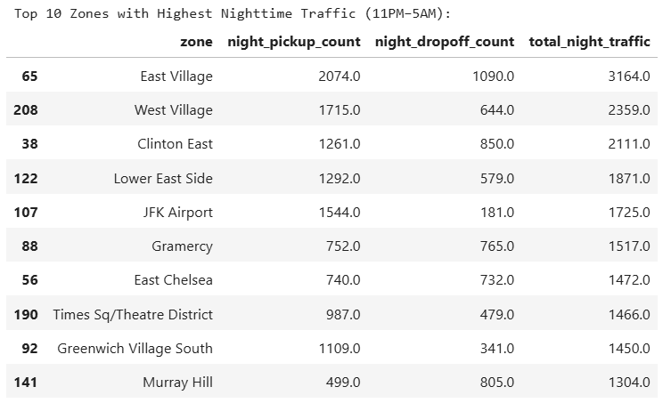

* + 1. **Find the revenue share for nighttime and daytime hours**

# Filter for night hours (11 PM to 5 AM)

night_hours = [23, 0, 1, 2, 3, 4, 5]

day_hours = [6, 7, 8, 9, 10, 11, 12, 13, 14, 15, 16, 17, 18, 19, 20, 21, 22]

# Filter nighttime and daytime data

nighttime_data = sliced1[sliced1['pickup_hour'].isin(night_hours)]

daytime_data = sliced1[sliced1['pickup_hour'].isin(day_hours)]

nighttime_revenue = nighttime_data['total_amount'].sum()

daytime_revenue = daytime_data['total_amount'].sum()

total_revenue = nighttime_revenue + daytime_revenue

nighttime_share = nighttime_revenue / total_revenue * 100

daytime_share = daytime_revenue / total_revenue * 100

print(f"Nighttime Revenue Share: {nighttime_share:.2f}%")

print(f"Daytime Revenue Share: {daytime_share:.2f}%")

**Result  
**

* + 1. **For the different passenger counts, find the average fare per mile per passenger**# Analyse the fare per mile per passenger for different passenger counts

sliced1['fare_per_mile'] = sliced1['fare_amount'] / sliced1['trip_distance']

sliced1['fare_per_mile_per_passenger'] = sliced1['fare_per_mile'] / sliced1['passenger_count']

average_fare_per_passenger = sliced1.groupby('passenger_count')['fare_per_mile_per_passenger'].mean().reset_index()

print(average_fare_per_passenger)

**Result**

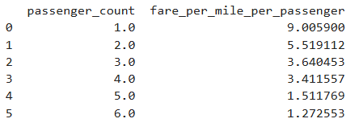

* + 1. **Find the average fare per mile by hours of the day and by days of the week**

sliced1['fare_per_mile'] = sliced1['fare_amount'] / sliced1['trip_distance']

average_fare_by_hour = sliced1.groupby('pickup_hour')['fare_per_mile'].mean().reset_index()

average_fare_by_day = sliced1.groupby('day_of_week')['fare_per_mile'].mean().reset_index()

print("Average Fare per Mile by Hour of the Day:")

print(average_fare_by_hour)

**Result**

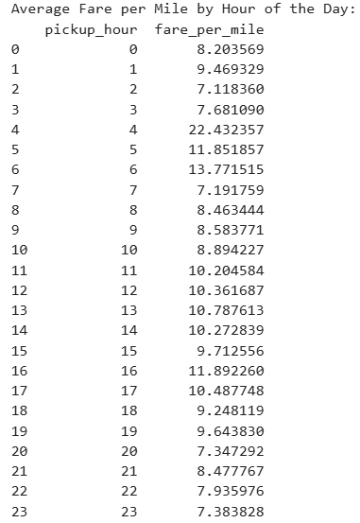

print("\nAverage Fare per Mile by Day of the Week:")

print(average_fare_by_day)

**Result**

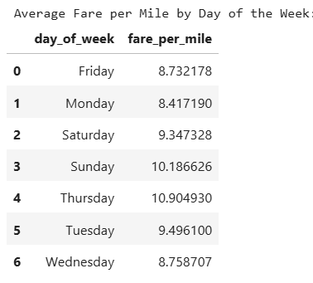

* + 1. **Analyse the average fare per mile for the different vendors**# Compare fare per mile for different vendors

sliced1['fare_per_mile'] = sliced1['fare_amount'] / sliced1['trip_distance']

average_fare_by_vendor_hour = sliced1.groupby(['VendorID', 'pickup_hour'])['fare_per_mile'].mean().reset_index()

print("Average Fare per Mile by Vendor and Hour of the Day:")

print(average_fare_by_vendor_hour)

**Result**

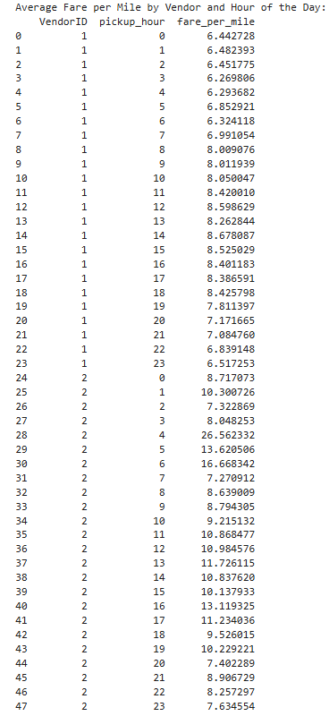

* + 1. **Compare the fare rates of different vendors in a distance-tiered fashion**

sliced1['fare_per_mile'] = sliced1['fare_amount'] / sliced1['trip_distance']

conditions = [

(sliced1['trip_distance'] <= 2),

(sliced1['trip_distance'] > 2) & (sliced1['trip_distance'] <= 5),

(sliced1['trip_distance'] > 5)

]

labels = ['Up to 2 miles', '2 to 5 miles', 'Above 5 miles']

sliced1['distance_range'] = pd.cut(sliced1['trip_distance'], bins=[0, 2, 5, float('inf')], labels=labels)

average_fare_by_vendor_range = sliced1.groupby(['VendorID', 'distance_range'])['fare_per_mile'].mean().reset_index()

print("Average Fare per Mile by Vendor and Distance Range:")

print(average_fare_by_vendor_range)

**Result**

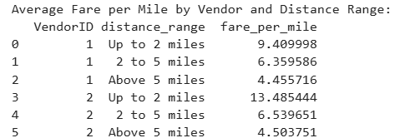

* + 1. **Analyse the tip percentages**

sliced1['tip_percentage'] =

(sliced1['tip_amount'] / sliced1['fare_amount']) * 100

conditions = [

(sliced1['trip_distance'] <= 2),

(sliced1['trip_distance'] > 2) & (sliced1['trip_distance'] <= 5), (sliced1['trip_distance'] > 5) ]

labels = ['Up to 2 miles', '2 to 5 miles', 'Above 5 miles']

sliced1['distance_range'] = pd.cut(sliced1['trip_distance'], bins=[0, 2, 5, float('inf')], labels=labels)

average_tip_by_distance = sliced1.groupby('distance_range')['tip_percentage'].mean().reset_index()

print("Average Tip Percentage by Distance Range:")

print(average_tip_by_distance)

**Result**

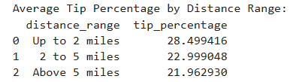

* + 1. **Analyse the trends in passenger count**

average_tip_by_passenger_count = sliced1.groupby('passenger_count')['tip_percentage'].mean().reset_index()

print("\nAverage Tip Percentage by Passenger Count:")

print(average_tip_by_passenger_count)

**Result**

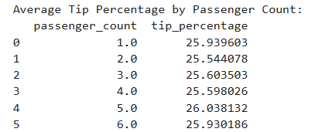

* + 1. **Analyse the variation of passenger counts across zones**average_tip_by_pickup_hour = sliced1.groupby('pickup_hour')['tip_percentage'].mean().reset_index()

print("\nAverage Tip Percentage by Pickup Hour:")

print(average_tip_by_pickup_hour)

**Result**

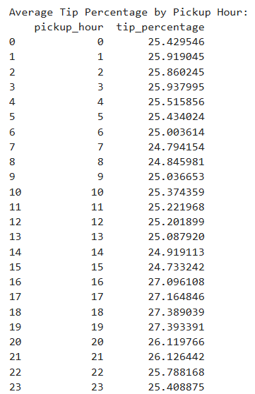

* + 1. **Analyse the pickup/dropoff zones or times when extra charges are applied more frequently.**

# pickup zone

pickup_with_zone = sliced1.merge(zones, how='left', left_on='PULocationID', right_on='LocationID')

zone_extra_stats = pickup_with_zone.groupby('zone').agg(

total_count=('extra', 'count'),

extra_applied_count=('extra', lambda x: (x > 0).sum())

).reset_index()

zone_extra_stats['percent_with_extra'] = (zone_extra_stats['extra_applied_count'] /

zone_extra_stats['total_count']) * 100

zone_extra_stats = zone_extra_stats.sort_values(by='extra_applied_count', ascending=False)

zone_extra_stats.head()

**Result**

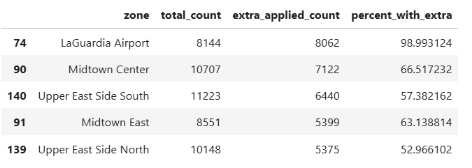

## Conclusions

### Final Insights and Recommendations

* + 1. **Recommendations to optimize routing and dispatching based on demand patterns and operational inefficiencies.**

**Optimize Routing & Dispatching Based on Demand Patterns**

**Key Insights**:

Peak Demand Hours:

Morning Rush: 7–9 AM

Evening Rush: 5–7 PM

Lowest Activity: 12–4 AM

**Weekly Trends**:

High demand on weekdays, especially Wednesday to Friday

Evenings & nights on weekends show spikes (linked to social activity)

**Monthly/Quarterly Trends**:

* + September–November: Highest trip volumes and revenues
  + Q4 (Oct–Dec): 27.01% of annual revenue (peak quarter)
  + Summer months (July–August) show notable dips

#### **Recommended Actions**:

* **Time-Aware Dispatching**:
  + Scale up driver availability during rush hours and evening peaks.
* **Slow Route Avoidance**:
  + Use historical route-speed data to reroute around bottlenecks.
* **Quarterly Adjustments**:
  + Expand fleet and coverage in Q4.
  + Offer driver incentives during low-earning quarters like Q3.
* **Predictive Analytics Integration**:
  + Feed this temporal demand data into dispatch models to anticipate spikes and pre-allocate resources.

### **Optimization Strategies:**

**Dynamic Routing**: Deploy intelligent route planning using historical average speeds. Avoid the slowest routes during peak hours and suggest alternatives using live traffic overlays.

**Time-Aware Dispatching**: During rush hours, prioritize short, quick trips to maximize turnover. During off-peak hours, target longer-distance rides with potentially higher revenue per trip.

**Demand Forecasting**: Integrate hourly/weekly/monthly demand data into dispatch algorithms to pre-position vehicles before demand spikes (e.g., near Midtown from 4–6 PM on weekdays).

* + 1. **Suggestions on strategically positioning cabs across different zones to make best use of insights uncovered by analysing trip trends across time, days and months.**

**Insights from Temporal-Zonal Analysis:**

* **Top Pickup Zones**: LaGuardia Airport, Midtown Center, and Upper East Side(north and south), Midtown East
* **Top Dropoff Zones**: Upper East Side(north and south), Midtown Center, Upper West Side South, Murray Hill
* **Night Hour Traffic Zones (11 PM–5 AM)**: Significant activity persists, especially around nightlife districts.

### **Recommendations:**

**Zone-Based Allocation**:

* + **Airport Strategy**: Maintain higher cab availability around **LaGuardia** and **JFK** during peak arrival hours (typically early morning and late evening).
  + **Midtown & UES**: Position more cabs here between **3 PM–8 PM**, matching both end-of-workday and early evening demand.

**Time-Zone Heatmaps**:

* Use trip data to maintain a **live map of high-traffic zones by hour**.

**Night Strategy**:

* + Focus late-night deployments (11 PM–3 AM) in zones like **East Village**, **Midtown**, and **Uptown** nightlife areas.
  + Use **historical night pickup volume** to adjust driver shifts accordingly.

**Ratio-Based Rebalancing**: Use the **pickup/dropoff ratio analysis** to identify zones with an imbalance (e.g., more drop-offs than pickups) and **redistribute idle cabs** toward high-pickup zones dynamically.

* + 1. **Propose data-driven adjustments to the pricing strategy to maximize revenue while maintaining competitive rates with other vendors.**

#### **Revenue Patterns**:

* Mirrors volume trends: High in Sep–Nov, lower in summer
* Nighttime revenue is substantial despite lower volume
* Fare per mile varies by vendor and distance tier

#### **Correlation Insights**:

* Distance vs. Fare: Strong positive correlation (~0.8) — nearly linear
* Duration vs. Fare: Moderate correlation (~0.6)
* Passenger Count vs. Fare: Very weak correlation (~0.1)
* Tip Amount vs. Distance: Strong correlation — longer trips yield higher tips

#### **Recommended Actions**:

* Dynamic Pricing:
  + Raise base fare slightly during night hours (11 PM–5 AM)
  + Introduce seasonal surge rates during high-revenue months (Q4)
* Distance-Tiered Fare Structuring:
  + Slightly higher rates for trips <2 miles (high frequency)
  + Discounted per-mile rates for long-distance trips (>5 miles) to encourage ridership
* Tip Optimization:
  + Promote tipping on long rides
  + Train drivers for better engagement, especially on longer trips
* Vendor Benchmarking:
  + Continue comparing fare-per-mile across vendors and adjust to maintain competitiveness without sacrificing revenue.