FOOD WASTE REDUCTION PLATFORM
SE Project — Team D-5

PHASE III
Software Design Document

Team Name | Food Waste Reduction Platform
Team Leader | Sabien Mecaj
Members | Migena Lami — Tester & Deployment Manager  Rovena Rama — Backend Developer  Sibora Gurra — Frontend Developer
Development Model | Agile (Scrum)
Technology Stack | HTML / CSS / JavaScript • Node.js (Express) • MySQL
Date | May 2026

1. Introduction

1.1 Purpose of This Document
This document constitutes Phase III of the Software Engineering project for the Food Waste Reduction Platform. It provides the complete software design specification, translating the functional and non-functional requirements defined in Phase II into concrete technical design artifacts. The primary purpose is to serve as the authoritative blueprint for the implementation team during development.
The document covers four major design areas: the overall software architecture using a component diagram, a class diagram showing the data model, three sequence diagrams describing key interaction flows, and two algorithmic flowcharts detailing decision logic for critical user processes.

1.2 Project Background
Food waste is a critical global problem. According to the Food and Agriculture Organization of the United Nations, approximately one-third of all food produced for human consumption is lost or wasted each year. This represents not only a massive economic loss but also a serious environmental burden, as decomposing food produces methane — a greenhouse gas far more potent than carbon dioxide.
The Food Waste Reduction Platform addresses this problem by providing a digital intermediary layer between food providers (restaurants, supermarkets, and households) and food recipients (individuals, charities, and community organizations). By enabling real-time listing and discovery of surplus food, the platform creates a mechanism for efficient redistribution before food reaches the point of waste.

1.3 Scope
The scope of this Phase III document is limited to the software design of the system. It does not include implementation code, test cases, or deployment instructions. The design documented here covers the following system boundaries:
- User registration, authentication, and profile management.
- Food listing creation, editing, browsing, searching, and filtering.
- Notification delivery to recipients and charity organizations.
- Administrative functions for platform moderation and user management.
- Password recovery and account security mechanisms.

1.4 Definitions and Abbreviations
Term | Definition
API | Application Programming Interface — a set of rules that allows the Frontend to communicate with the Backend.
JWT | JSON Web Token — a compact, URL-safe token used for stateless authentication between client and server.
REST | Representational State Transfer — an architectural style for distributed hypermedia systems used for the API design.
SQL | Structured Query Language — the language used to communicate with the MySQL database.
UML | Unified Modeling Language — the standardized notation used for all diagrams in this document.
Bcrypt | A password hashing algorithm designed to be computationally expensive, used to protect user passwords at rest.
HTTPS | Hypertext Transfer Protocol Secure — encrypted HTTP communication using TLS/SSL certificates.
CRUD | Create, Read, Update, Delete — the four fundamental database operations.

2. Development Model

2.1 Agile (Scrum) Overview
The project follows the Agile Scrum methodology. Scrum divides the development lifecycle into short, fixed-length iterations called sprints, typically lasting two weeks. At the end of each sprint, a potentially shippable product increment is produced. This approach was selected for the Food Waste Reduction Platform because the requirements involve user feedback loops (e.g., from charities and recipients), and Agile allows the team to adapt the system based on real-world testing.

2.2 Sprint Plan
Sprint | Duration | Goals
Sprint 1 | Weeks 1–2 | Project setup, database schema, authentication endpoints (register/login)
Sprint 2 | Weeks 3–4 | Food listing CRUD, search and filter API, home page frontend
Sprint 3 | Weeks 5–6 | Notification system, charity alert service, profile management
Sprint 4 | Weeks 7–8 | Admin panel, content moderation, password reset flow
Sprint 5 | Weeks 9–10 | Testing, bug fixing, performance optimization, final deployment

2.3 Team Roles in Scrum
Within the Scrum framework, each team member holds a defined role that maps to both the Scrum methodology and the technical responsibilities of the project:
- Sabien Mecaj (Project Manager & Research Lead) — acts as the Product Owner and Scrum Master. Responsible for maintaining the product backlog, prioritizing user stories, and facilitating sprint planning and retrospective meetings.
- Rovena Rama (Backend Developer) — responsible for implementing all server-side logic in Node.js/Express, designing the REST API endpoints, and managing database interactions via MySQL.
- Sibora Gurra (Frontend Developer) — responsible for implementing all client-side interfaces in HTML, CSS, and JavaScript, ensuring responsiveness and connecting the UI to backend API endpoints.
- Migena Lami (Tester & Deployment Manager) — responsible for writing and executing test cases, performing usability testing, managing the GitHub repository, and handling deployment to the production environment.

3. Stakeholders and User Stories

3.1 Stakeholder Analysis
A stakeholder is any person or group with a direct interest in the system. The following stakeholders have been identified for the Food Waste Reduction Platform:

Stakeholder | Role | Primary Interest
Recipients | Search, browse, and request surplus food listings. | Easy access to available food near their location.
Food Providers | Restaurants, stores, and households that list surplus food. | Fast, simple listing creation and confirmation of pickup.
Charities / Organizations | Monitor listings and coordinate food collection for redistribution. | Real-time notifications and bulk listing access.
Admin | Monitor platform activity and manage users and content. | System security, data integrity, and moderation tools.
Development Team | Design, implement, test, and maintain the system. | Clear requirements, maintainable architecture, stable deployment.

3.2 User Stories
User stories are written from the perspective of each stakeholder to define what the system must allow them to do and why. All user stories follow the standard format: "As a [role], I want to [action] so that [benefit]."

Recipient User Stories
- As a recipient, I want to create an account and log in using my email and password so that I can securely access the platform and save my preferences.
- As a recipient, I want to browse all available food listings on the home page so that I can quickly see what is available near me without searching.
- As a recipient, I want to search and filter listings by keyword, location, and food category so that I can find food that matches my specific needs.
- As a recipient, I want to view the full details of a listing — including quantity, location, ingredients, and allergens — so that I can make an informed decision before requesting.
- As a recipient, I want to receive real-time notifications so that I do not miss newly posted food listings before they expire.
- As a recipient, I want to save listings to a personal saved list so that I can revisit them later.
- As a recipient, I want to report inappropriate or fraudulent listings so that the platform remains safe and trustworthy.
- As a recipient, I want to reset my password through a secure email-based process so that I can regain access to my account if I forget my credentials.

Food Provider User Stories
- As a food provider, I want to create and publish surplus food listings with full details (type, quantity, location, ingredients, available until) so that the food reaches people instead of being wasted.
- As a food provider, I want to edit or delete my listings so that I can update information or remove food that has already been claimed.
- As a food provider, I want to receive confirmation when a recipient requests my listing so that I can prepare the food for pickup.

Charity User Stories
- As a charity organization, I want to receive automatic notifications whenever new listings are posted in my registered area so that I can act quickly and coordinate food collection.
- As a charity, I want to view the full history of listings I have collected so that I can track impact and report on our activities.

Admin User Stories
- As an admin, I want to manage all user accounts (view, suspend, delete) so that I can maintain platform security and integrity.
- As an admin, I want to review and remove reported listings so that the platform remains free of fraudulent or inappropriate content.
- As an admin, I want to view platform analytics (number of listings, active users, requests) so that I can monitor platform health.

4. Requirements Summary

4.1 Functional Requirements
Functional requirements define what the system must do. They are derived directly from the user stories and stakeholder analysis in Section 3.

ID | Category | Requirement
FR-01 | Authentication | The system shall allow users to register using a unique email address and a password.
FR-02 | Authentication | The system shall authenticate users via email and password and issue a JWT token upon success.
FR-03 | Authentication | The system shall allow users to reset their password via a secure email link.
FR-04 | Profile | The system shall allow users to view and edit their profile information.
FR-05 | Listings | The system shall allow food providers to create listings with title, quantity, location, ingredients, and expiry time.
FR-06 | Listings | The system shall allow providers to edit and delete their own listings.
FR-07 | Search | The system shall allow recipients to search listings by keyword, location, and category.
FR-08 | Listings | The system shall display detailed listing information including allergen data.
FR-09 | Notifications | The system shall automatically notify charities when new listings are published in their area.
FR-10 | Notifications | The system shall allow users to view all their unread and historical notifications.
FR-11 | Requests | The system shall allow recipients to submit a request for a listed food item.
FR-12 | Admin | The system shall allow admins to suspend or delete user accounts.
FR-13 | Admin | The system shall allow admins to remove listings that violate platform policies.
FR-14 | Reporting | The system shall allow recipients to report listings as inappropriate.

4.2 Non-Functional Requirements
Category | Metric | Requirement
Performance | Page load < 2 seconds | The system shall load all pages within 2 seconds under normal traffic conditions.
Performance | Action response < 5 seconds | All user-initiated actions (search, post, request) shall complete within 3–5 seconds.
Reliability | 99% uptime | The system shall maintain at least 99% uptime on a monthly basis.
Security | JWT + bcrypt + HTTPS | All communication shall use HTTPS. Passwords shall be hashed with bcrypt. Access shall be controlled via JWT.
Usability | Intuitive UI | The interface shall require no user training and shall be navigable by non-technical users.
Scalability | Horizontal scaling | The backend shall be stateless and support horizontal scaling to handle increasing user loads.
Maintainability | Modular services | Each backend service shall be independently modifiable without affecting other services.

5. Use Case Diagram

5.1 Overview
The Use Case Diagram provides a high-level view of the interactions between external actors and the system. It identifies all major use cases supported by the Food Waste Reduction Platform and maps them to the actors who initiate them. This diagram is used to validate completeness of functional requirements before detailed design begins.

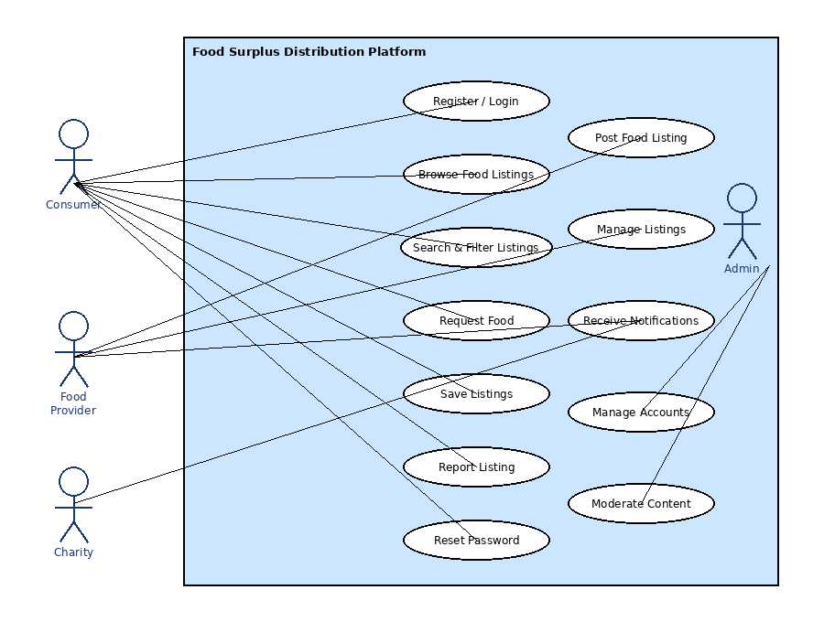
Figure 1 — Use Case Diagram: Food Waste Reduction Platform

5.2 Actor Descriptions
- Recipient — A registered individual user who browses the platform to find and request surplus food listings. The recipient interacts with the largest number of use cases, including registration, search, request, save, and report.
- Food Provider — A restaurant, supermarket, or household that has surplus food to distribute. The provider creates and manages food listings on the platform.
- Charity — A registered charitable organization that monitors listings and coordinates food collection. The charity receives automatic notifications and can access listing history.
- Admin — An internal platform administrator with elevated privileges to manage accounts, moderate content, and view system analytics.

5.3 Key Use Cases
Use Case | Actor(s) | Description
Register / Login | Recipient, Provider, Charity | User creates an account or authenticates using email and password.
Browse Food Listings | Recipient, Charity | User views all available food listings on the home page.
Search & Filter Listings | Recipient | User applies keyword, location, and category filters to find specific food.
Request Food | Recipient | User submits a food request for a selected listing.
Post Food Listing | Food Provider | Provider creates and publishes a new surplus food listing.
Manage Listings | Food Provider | Provider edits or deletes their own existing listings.
Receive Notifications | Recipient, Charity | System sends alerts when new listings are published in the user's area.
Manage Accounts | Admin | Admin views, suspends, or deletes user accounts as required.
Moderate Content | Admin | Admin reviews reported listings and removes those that violate policies.

6. Class Diagram

6.1 Overview
The Class Diagram models the static structure of the system's data model. It defines the entities (classes) in the system, their attributes, their methods (operations), and the relationships between them. This diagram forms the foundation for the database schema and for the data transfer objects used in the API layer.

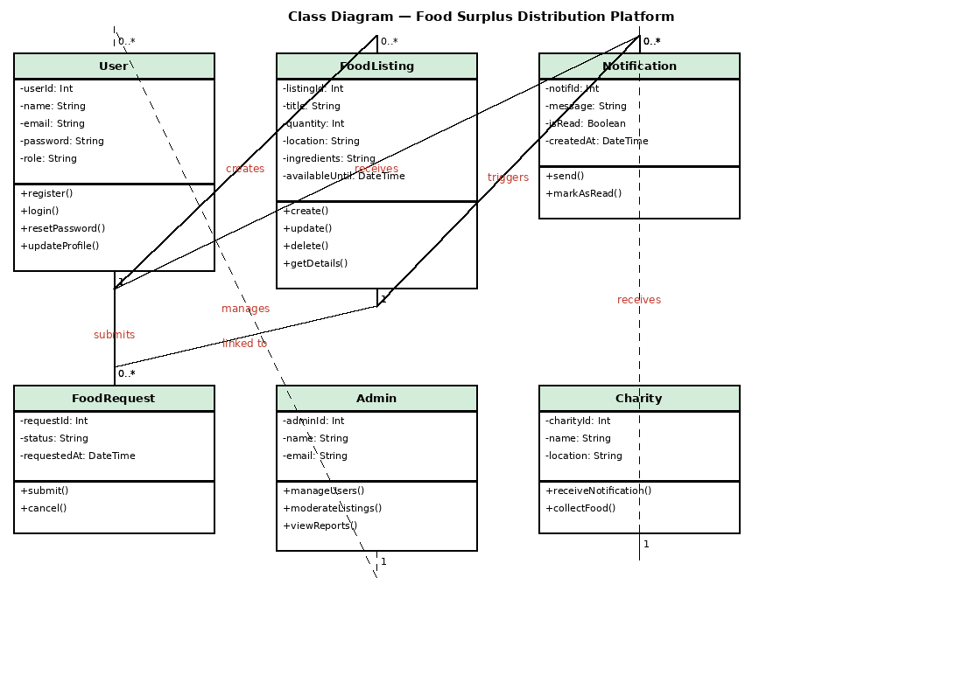
Figure 2 — Class Diagram: Food Waste Reduction Platform Data Model

6.2 Class Descriptions
User
The User class represents all registered accounts on the platform. The role attribute differentiates between recipients, food providers, charities, and admins. All other entities are linked to a User via foreign key relationships.
Attribute | Type | Description
userId | Integer (PK) | Unique auto-incremented user identifier.
name | String | Full name of the registered user.
email | String (UNIQUE) | Email address used for login and notifications. Must be unique.
password | String (hashed) | bcrypt-hashed password. Never stored in plain text.
role | Enum | One of: consumer, provider, charity, admin.

FoodListing
The FoodListing class represents a surplus food item posted by a provider. It contains all the information a recipient or charity needs to evaluate whether to request the food.
Attribute | Type | Description
listingId | Integer (PK) | Unique listing identifier.
title | String | Short descriptive name of the food item.
quantity | Integer | Available quantity (e.g., number of portions or kilograms).
location | String | Address or area where food can be collected.
ingredients | Text | Full ingredient list, used for allergen identification.
availableUntil | DateTime | Expiry timestamp after which the listing is automatically hidden.
providerId | Integer (FK) | Foreign key reference to the User who created this listing.

FoodRequest
The FoodRequest class links a recipient to a specific food listing. It tracks the status of a request from submission through to fulfillment or cancellation.

Notification
The Notification class stores alert records that are generated automatically when new listings are published. Each notification is linked to both a user (recipient) and the listing that triggered it.

6.3 Relationships
- User creates FoodListing — One-to-Many. A single user with the provider role may create zero or more food listings. Each listing must belong to exactly one provider.
- User submits FoodRequest — One-to-Many. A recipient may submit zero or more food requests. Each request belongs to one recipient.
- FoodListing is linked to FoodRequest — One-to-Many. A single listing may receive multiple requests. Each request references one listing.
- FoodListing triggers Notification — One-to-Many. When a listing is published, one notification is generated per subscribed charity in the area.
- User receives Notification — One-to-Many. A user (recipient or charity) may have many notifications in their inbox.

7. Software Architecture

7.1 Architectural Pattern: Component Diagram
The system is designed using a Three-Tier Architecture divided into three distinct, independently deployable layers. The Component Diagram below uses standard UML notation (component boxes with the component icon, lollipop interfaces, and dashed dependency arrows) to show how the Frontend, Backend, and Database components are structured and how they communicate.

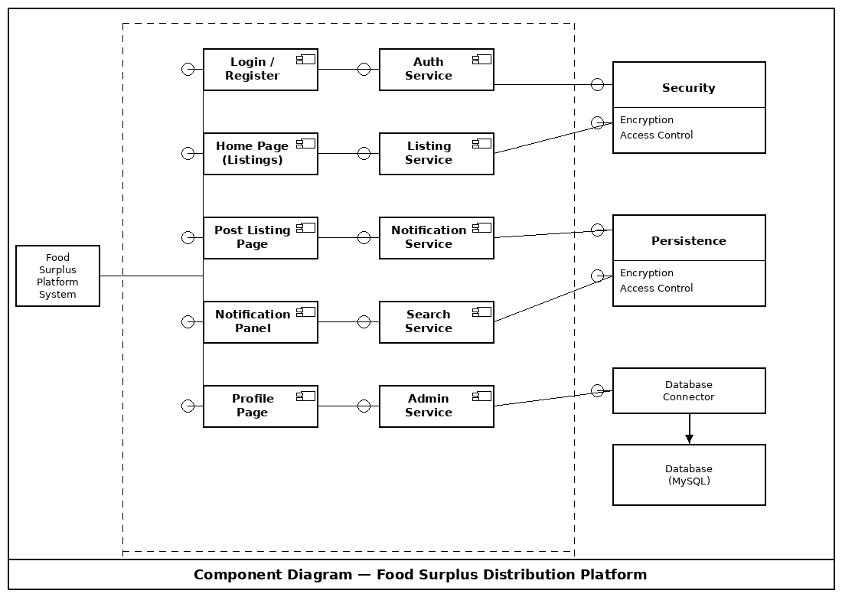
Figure 3 — Component Diagram: Food Waste Reduction Platform

7.2 Layer Descriptions
Presentation Layer — Frontend
The Frontend is implemented using HTML5, CSS3, and vanilla JavaScript. It is served as static files from a web server and executes entirely in the user's browser. The Frontend is responsible for all visual rendering, form handling, input validation (client-side), and dynamic content updates via API calls.
The Frontend communicates with the Backend exclusively through asynchronous HTTP requests (using the Fetch API) over HTTPS. All requests and responses use the JSON format. JWT tokens received from the Backend are stored in memory or HTTP-only cookies and included in the Authorization header of all protected requests.

Application Layer — Backend
The Backend is implemented using Node.js with the Express framework. It is a RESTful API server that processes all incoming requests from the Frontend, enforces business rules, validates input data, checks authentication and authorization, and communicates with the Database. The Backend is stateless — all session state is encoded in JWT tokens — which allows it to be horizontally scaled.
The Backend is divided into five logical services, each responsible for a distinct domain of functionality. These services share the same Node.js process in the current implementation but are structured to be extractable into microservices if needed in the future.

Data Layer — Database
The Data Layer consists of a MySQL relational database. The Backend communicates with the database using the mysql2 Node.js driver with parameterized queries to prevent SQL injection attacks. The database is normalized to at least the Third Normal Form (3NF) to eliminate data redundancy.

7.3 Backend Service Breakdown
Service | Endpoints | Responsibilities
Auth Service | POST /api/register  POST /api/login  POST /api/reset-password | Handles registration, login, password hashing with bcrypt, JWT issuance and verification, and password reset via email link.
Listing Service | GET /api/listings  POST /api/listings  PUT /api/listings/:id  DELETE /api/listings/:id | Manages the full CRUD lifecycle of food listings. Validates input data, enforces ownership rules, and triggers notification events on creation.
Search Service | GET /api/listings?keyword=&location=&category= | Builds and executes parameterized SQL SELECT queries with dynamic WHERE clauses based on user-provided filter parameters.
Notification Service | GET /api/notifications  PATCH /api/notifications/:id/read | Generates notification records when listings are published, delivers them to subscribed users, and marks them as read.
Admin Service | GET /api/admin/users  DELETE /api/admin/users/:id  DELETE /api/admin/listings/:id | Provides privileged endpoints accessible only to users with the admin role. Supports account suspension and content removal.

7.4 Database Schema
Table | Primary Key | Foreign Keys | Key Columns
users | user_id (INT) | — | name, email (UNIQUE), password_hash, role, created_at
food_listings | listing_id (INT) | provider_id → users | title, quantity, location, ingredients, available_until, created_at
food_requests | request_id (INT) | consumer_id → users  listing_id → food_listings | status (pending/confirmed/cancelled), requested_at
notifications | notif_id (INT) | user_id → users  listing_id → food_listings | message, is_read (BOOL), created_at
sessions | session_id (INT) | user_id → users | token_hash, expires_at (for JWT revocation)

8. Sequence Diagrams
Sequence diagrams show the time-ordered flow of messages between system participants for the three most critical operations in the platform. The diagrams use standard UML sequence diagram notation: stick figures represent human actors; dark blue filled rectangles represent system components; vertical dashed lines are lifelines; solid arrows are synchronous requests; dashed arrows are responses; and activation bars (white rectangles on lifelines) show when a component is actively processing.

8.1 Sequence Diagram 1: User Registration and Login
This diagram covers two closely related flows: account creation and subsequent login. These two flows are shown together because they share the same data path through the Auth Service and users table, and because login immediately follows registration in the typical first-use scenario.

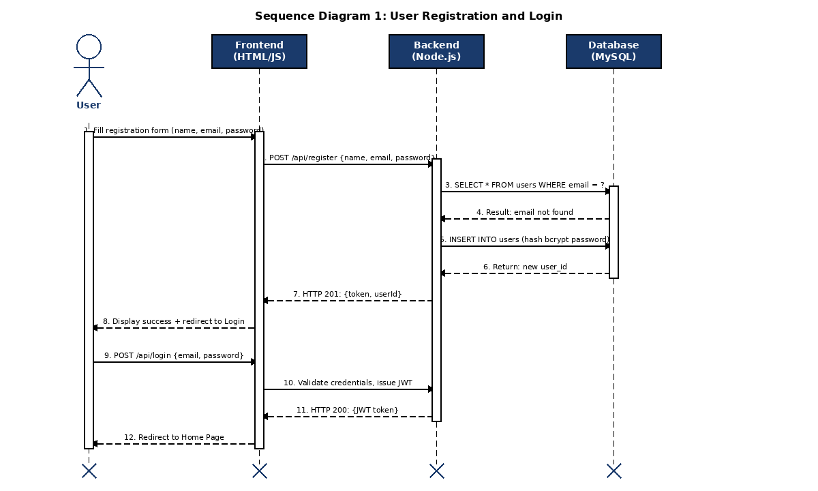
Figure 4 — Sequence Diagram 1: User Registration and Login

Registration Flow — Step by Step
Step | Description
1 | The user navigates to the Register page and fills in the form fields: full name, email address, and password.
2 | The Frontend validates the form client-side (non-empty fields, valid email format, password minimum length). If valid, it sends a POST /api/register request with the data in the JSON body.
3 | The Backend Auth Service receives the request. It performs server-side validation, then sends a SELECT query to the database to check whether the provided email already exists.
4 | The database executes the query and returns the result. If the email is not found, processing continues. If found, the Backend immediately returns HTTP 409 Conflict.
5 | The Backend hashes the password using bcrypt with a minimum of 10 salt rounds and executes an INSERT INTO users statement with the hashed password.
6 | The database confirms the record was inserted and returns the generated user_id.
7 | The Backend generates a signed JWT token containing the user_id and role, then returns HTTP 201 Created with the token and userId in the response body.
8 | The Frontend receives the response, stores the JWT, displays a success message, and redirects the user to the Login page.

Login Flow — Steps 9–12
- Step 9: The user submits the login form with their email and password.
- Step 10: The Frontend sends a POST /api/login request. The Backend retrieves the user record, compares the provided password against the stored bcrypt hash using bcrypt.compare(), and if valid, issues a new JWT token.
- Step 11: The Backend returns HTTP 200 OK with a signed JWT token.
- Step 12: The Frontend stores the token, then redirects the user to the Home Page where they can browse listings.

8.2 Sequence Diagram 2: Food Provider Posts a Surplus Listing
This diagram covers the full lifecycle of a food listing creation event, including JWT authentication validation, database insertion, and the automatic notification dispatch to subscribed charity organizations. The alt frame shows the contrasting behavior when authentication fails.

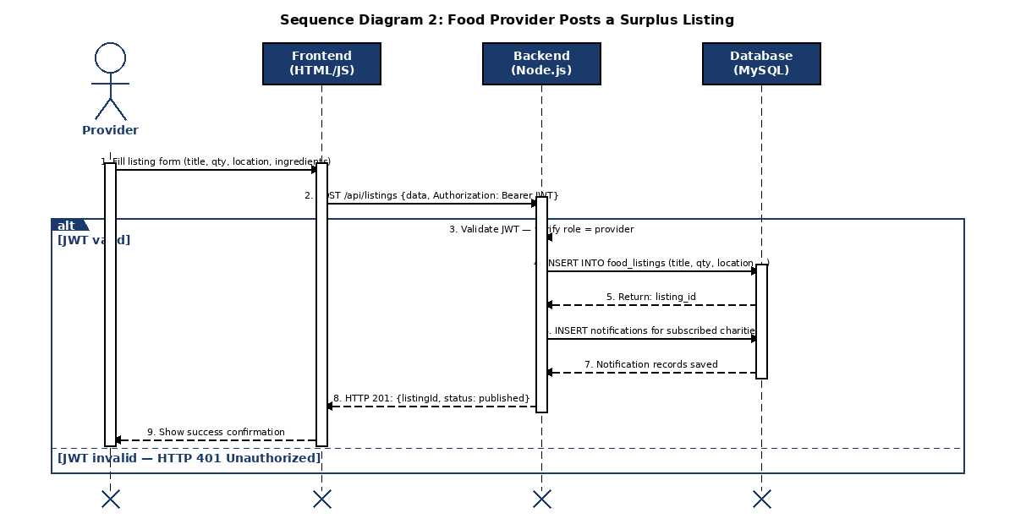
Figure 5 — Sequence Diagram 2: Food Provider Posts a Surplus Listing

Post Listing Flow — Step by Step
Step | Description
1 | The food provider navigates to the Post Listing page and fills in the listing details: title, quantity, location, ingredients, allergen notes, and availability end time.
2 | The Frontend sends a POST /api/listings request. The Authorization header contains: "Bearer {JWT token}" to authenticate the request.
3 | The Backend Auth middleware intercepts the request. It verifies the JWT signature and expiry. It confirms the decoded role is "provider". If the JWT is invalid or expired, the Backend immediately returns HTTP 401 Unauthorized — no database access occurs.
4 | If authentication succeeds, the Listing Service validates the listing data (title not empty, quantity > 0, valid future date for availability). It then executes an INSERT INTO food_listings statement.
5 | The database inserts the record and returns the auto-generated listing_id.
6 | The Notification Service is triggered. It queries the database for all users with role = "charity" whose registered location matches the listing's location field, then inserts one notification record per matching charity.
7 | The database confirms the notification records are saved.
8 | The Backend returns HTTP 201 Created with {listingId, status: "published"} in the response body.
9 | The Frontend displays a success confirmation message to the provider and may redirect to the listing detail page.

8.3 Sequence Diagram 3: Recipient Searches for Food Listings
This diagram shows the search and filter flow. It demonstrates how the Backend dynamically constructs SQL queries based on the filter parameters provided by the Frontend, and how results are rendered into the listing card grid on the Home Page.

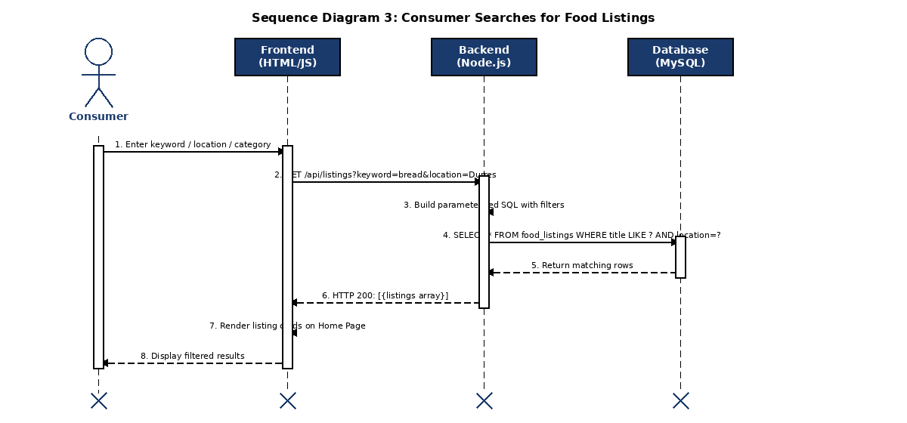
Figure 6 — Sequence Diagram 3: Recipient Searches for Food Listings

Search Flow — Step by Step
Step | Description
1 | The recipient types a search term and/or selects a location and category from the filter controls on the Home Page.
2 | The Frontend sends a GET /api/listings request with query parameters appended to the URL, e.g. ?keyword=bread&location=Durres&category=bakery.
3 | The Search Service on the Backend parses the query parameters. It constructs a parameterized SQL SELECT statement. Only parameters that are actually present in the request are added to the WHERE clause, so that a search with no filters returns all listings.
4 | The SQL query is executed against the food_listings table. The query uses LIKE %keyword% for keyword matching and exact match for location and category. Only listings whose available_until timestamp is in the future are returned.
5 | The database returns all rows matching the filter conditions.
6 | The Backend serializes the result rows into a JSON array and returns HTTP 200 OK. If no rows match, it returns an empty array (not a 404 error).
7 | The Frontend iterates over the array and renders a listing card for each item, showing the title, location, quantity, and time remaining.
8 | The recipient sees the filtered listing cards and can click any card to view the full listing details or submit a food request.

9. Algorithmic Flowcharts
Flowcharts describe the step-by-step decision logic for two core user processes. The notation follows standard flowchart conventions: rounded rectangles (or pill shapes) for START/END terminals; rectangles for process steps; parallelograms for input/output operations; and diamonds for binary decision points with YES/NO labeled branches.

9.1 Flowchart 1: User Registration Algorithm
This flowchart models the complete algorithm executed when a new user attempts to register on the platform. It includes two decision points: one for input validation and one for duplicate email detection. Both decision branches are fully traced to their outcomes.

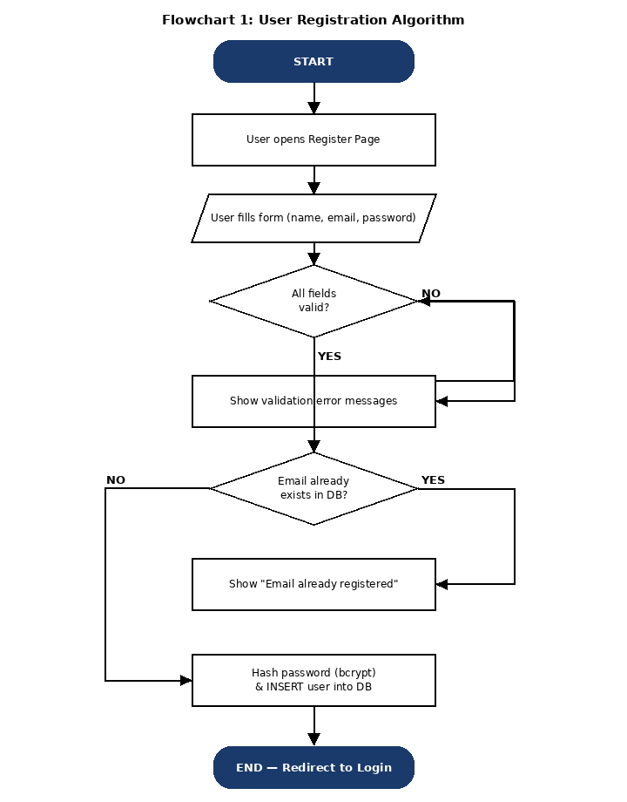
Figure 7 — Flowchart 1: User Registration Algorithm

Detailed Algorithm Trace
Step | Node Type | Description
1 | Terminal (START) | Process begins. User opens the Register page in their browser.
2 | Process | The Register page is loaded and displayed to the user.
3 | Input/Output | User enters name, email address, and password into the form fields.
4 | Decision: All fields valid? | System checks: are all fields non-empty? Is the email format correct (contains @ and domain)? Is the password at least 8 characters? If NO to any: go to Step 5. If YES to all: go to Step 6.
5 | Process (NO branch) | Validation error messages are shown next to the failing fields. The user corrects the input and the algorithm returns to Step 4.
6 | Decision: Email exists in DB? | Backend executes SELECT COUNT(*) FROM users WHERE email = ? If the count is > 0: go to Step 7. If 0: go to Step 8.
7 | Process (YES branch) | Backend returns HTTP 409 Conflict. Frontend displays "This email address is already registered." The user must provide a different email.
8 | Process (NO branch) | Backend hashes the password using bcrypt (10 salt rounds) and executes INSERT INTO users. New user record is created in the database.
9 | Terminal (END) | Registration is complete. The user is redirected to the Login page with a success message.

9.2 Flowchart 2: Browse and Request Food Listing Algorithm
This flowchart models the complete algorithm a recipient follows from opening the Home Page to successfully submitting a food request. It includes an authentication guard at the entry point and a results-check after search execution.

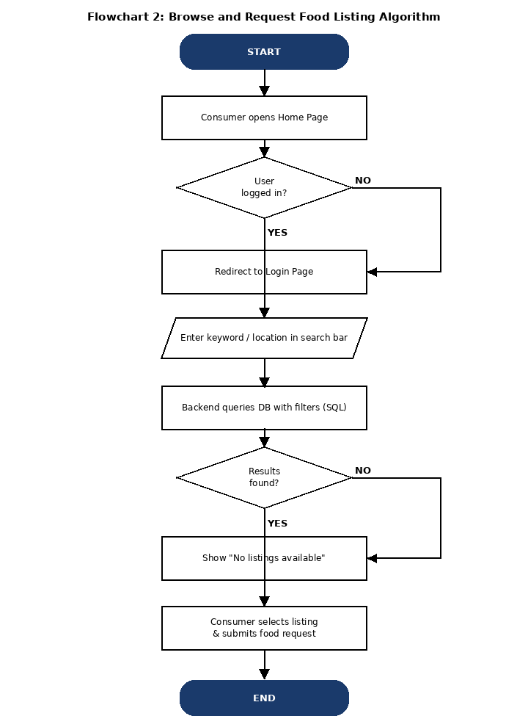
Figure 8 — Flowchart 2: Browse and Request Food Listing Algorithm

Detailed Algorithm Trace
Step | Node Type | Description
1 | Terminal (START) | Process begins. Recipient opens the platform and navigates to the Home Page.
2 | Process | The Home Page is loaded. The Frontend checks whether a valid, non-expired JWT token is present in storage.
3 | Decision: User logged in? | If NO: user is immediately redirected to the Login page. They cannot browse listings without authentication. If YES: continue to search.
4 | Input/Output | Recipient types a keyword and/or selects a location or category filter in the search bar and submits the query.
5 | Process | The Backend receives the GET /api/listings request, constructs a parameterized SQL query with the active filters, and executes it against the food_listings table.
6 | Decision: Results found? | If NO: the Frontend displays a "No listings available for your search criteria" message and invites the user to modify the filters. If YES: continue.
7 | Process (YES branch) | Matching listing cards are rendered on the page. Each card shows the food title, location, available quantity, and time remaining.
8 | Process | Recipient clicks a listing card and views the full details (ingredients, allergens, provider contact, pickup instructions).
9 | Process | Recipient clicks "Request Food". The Frontend sends a POST /api/requests request to the Backend with the listing_id and the recipient's JWT.
10 | Terminal (END) | The food request is recorded in the food_requests table. A confirmation notification is sent to the recipient. The provider is also alerted. Process ends.

10. Security Design

10.1 Authentication and Authorization
The system uses JSON Web Tokens (JWT) for stateless authentication. When a user successfully logs in, the Backend signs a JWT using a secret key stored in an environment variable. The token payload contains the user's user_id and role. The token is valid for 24 hours by default.
Every protected API endpoint checks for a valid JWT in the Authorization header before processing the request. Role-based access control (RBAC) is enforced at the service layer: for example, only users with role = "provider" may call POST /api/listings, and only users with role = "admin" may call DELETE /api/admin/users/:id.

10.2 Password Security
Passwords are never stored in plain text. The bcrypt algorithm is used with a work factor of 10 salt rounds. This means each hash computation takes a measurable amount of time, making brute-force and rainbow table attacks computationally impractical. The hashed value stored in the database looks like: $2b$10$... and cannot be reversed to obtain the original password.

10.3 Input Validation and SQL Injection Prevention
All user input is validated on both the client side (Frontend JavaScript) and the server side (Backend Express middleware). The server-side validation is authoritative. The system uses parameterized queries via the mysql2 driver for all database interactions. Parameterized queries ensure that user-supplied values are always treated as data, never as executable SQL code, completely preventing SQL injection attacks.

10.4 HTTPS
All communication between the browser and the server uses HTTPS with TLS encryption. This ensures that credentials, JWT tokens, and listing data cannot be intercepted by a network-level attacker. HTTP requests are automatically redirected to HTTPS.

11. User Interface Design

11.1 Design Principles
The UI design of the Food Waste Reduction Platform follows four core principles:
- Simplicity — The interface presents only the information and controls needed for the current task. Clutter is avoided. Navigation is consistent across all pages.
- Responsiveness — The layout adapts to screen sizes from mobile phones (320px wide) to desktop monitors. CSS Flexbox and media queries are used to achieve this.
- Accessibility — Font sizes, color contrast ratios, and button target sizes comply with WCAG 2.1 Level AA guidelines to ensure usability for all users.
- Consistency — A shared component library (navigation bar, listing card, notification badge, form inputs) is used across all pages to ensure a uniform visual language.

11.2 Page Inventory
Page | Accessible By | Key Elements
Register / Login | All visitors | Email + password form, validation messages, "Forgot password" link.
Home Page | Authenticated users | Search bar, category filters, listing card grid, notification badge.
Listing Detail Page | Authenticated users | Full listing details, ingredients, allergens, "Request Food" button.
Post Listing Page | Providers only | Multi-field form for listing creation, image upload, availability picker.
Profile Page | Authenticated users | User info editor, saved listings list, request history.
Notification Panel | Authenticated users | Chronological list of unread/read notifications with timestamps.
Admin Dashboard | Admins only | User management table, reported listings queue, platform statistics.

12. Technology Stack and Justification
Technology | Layer | Justification
HTML5 / CSS3 | Frontend | Universal browser support. No build tools required for basic implementation. Semantic HTML5 improves accessibility and SEO.
JavaScript (ES6+) | Frontend | Native browser language. Fetch API enables asynchronous API calls without page reloads. No framework dependencies reduces complexity.
Node.js | Backend | Non-blocking event-driven I/O model is well-suited for a platform where many concurrent users browse and request listings simultaneously.
Express.js | Backend | Minimal, unopinionated web framework for Node.js. Provides routing, middleware support, and is widely documented.
MySQL | Database | Relational database ensures data integrity through foreign key constraints. ACID compliance guarantees that requests and listings are recorded reliably.
bcrypt | Security | Industry-standard adaptive hashing algorithm. Work factor can be increased as hardware improves, future-proofing password security.
JSON Web Tokens | Security | Stateless authentication eliminates the need for server-side session storage, enabling horizontal scaling of the backend.
GitHub | Version Control | Centralized repository with branch-based development, pull request reviews, and issue tracking. Used by all four team members.

13. Design Summary and Conclusion

13.1 Summary of Design Decisions
This Phase III document has presented a complete and detailed software design for the Food Waste Reduction Platform. The key design decisions made in this phase are summarized below:
- Three-Tier Architecture: The decision to separate the system into Frontend, Backend, and Database tiers ensures that each layer can be independently developed, tested, and scaled. The Backend's stateless JWT-based authentication specifically supports horizontal scaling.
- RESTful API Design: Using REST with JSON over HTTPS as the communication protocol between Frontend and Backend is a universally understood standard that simplifies debugging, testing, and future integration with mobile apps or third-party services.
- Relational Database with Foreign Key Constraints: MySQL with proper relational constraints ensures data integrity. For example, deleting a user will cascade to their listings and requests, preventing orphaned records.
- Role-Based Access Control: The role attribute on the User entity, enforced at the API middleware level, ensures that providers cannot delete other users' listings, recipients cannot access the admin panel, and unauthenticated visitors cannot access protected resources.
- Parameterized Queries: The use of parameterized SQL queries for all database interactions completely prevents SQL injection, one of the most common web application vulnerabilities.

13.2 Traceability Matrix
The following table traces each major design artifact back to the functional requirements it satisfies, demonstrating that the design is complete with respect to the requirements.
Design Artifact | Functional Requirements Addressed
Use Case Diagram | FR-01 through FR-14 (all functional requirements at system level)
Class Diagram | FR-01, FR-04, FR-05, FR-06, FR-09, FR-11 (data model for all major entities)
Component Diagram | FR-01 through FR-14 (architecture supporting all functional areas)
Sequence Diagram 1 (Register/Login) | FR-01, FR-02, FR-03 (authentication flows)
Sequence Diagram 2 (Post Listing) | FR-05, FR-09 (listing creation and notification dispatch)
Sequence Diagram 3 (Search) | FR-07, FR-08 (search, filter, and listing detail display)
Flowchart 1 (Registration Algorithm) | FR-01 (detailed decision logic for account creation)
Flowchart 2 (Browse & Request Algorithm) | FR-07, FR-11 (search result handling and food request submission)

13.3 Conclusion
The Phase III Software Design for the Food Waste Reduction Platform provides a complete, consistent, and technically sound blueprint for implementation. The design is driven by the user stories and requirements established in Phase II and is expressed through standard UML artifacts that can be directly translated into code by the development team.
The use of a Three-Tier Architecture with a RESTful API, role-based JWT authentication, parameterized database queries, and bcrypt password hashing ensures that the platform meets its non-functional requirements for security, scalability, and reliability. The sequence diagrams and flowcharts provide sufficient procedural detail for developers to implement the core workflows without ambiguity.
This document serves as the definitive reference for Phase IV implementation and Phase V testing. Any changes to the design during implementation must be reflected in an updated version of this document to maintain consistency between design and code.

