# Stephanie Mecham

2/14/18

# **Lab #3**

# **Population dynamics of directly transmitted diseases**

Note: Throughout this lab I am using *β* to represent the transmission rate. The notation used by H. Hethcote is *λ*, which he calls the contact rate. There are subtle distinctions between these two parameters as we discussed in lecture. Hethcote's state variables, S and I, are in fractions, and Anderson and May's state variables are in numbers of individuals. Therefore, *λ* = *β*\*N, where N is the number of individuals simulated. In MATLAB, since Greek letters are not used, I have used the following convention:

*b* = *β*, *g* = *γ*, *m* = *μ*, *d* = *δ*..

# **I. The SIS Model.**

The first model we will explore is an SIS model that includes vital dynamics. This model describes diseases for which 1) infection does not confer immunity, and 2) individuals recover and return to the susceptible state once the infectious period is over. One demographic assumption of this model is that the population is constant, and therefore births and natural deaths occur at equal rates. The two state variables used in this model are *S* and *I*, the fraction of susceptibles and infected respectively Given that everyone in the population belongs to either the state *S* or the state *I*, *S* + *I* = 1.

Here are the equations for the model.

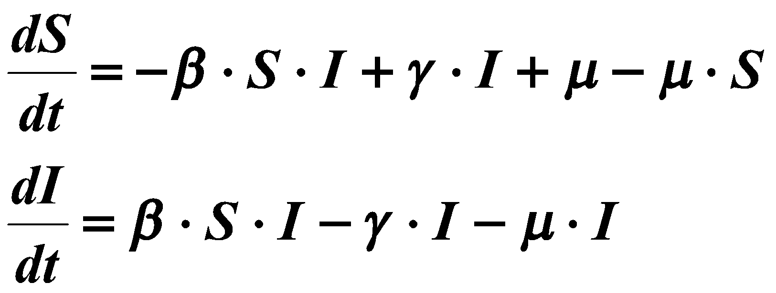

Analogous to the two-species model that we used in Lab 2, the following is a simulink model of the SIS infection process, where the output is directed into the workspace. You will find this model in **sis.mdl**.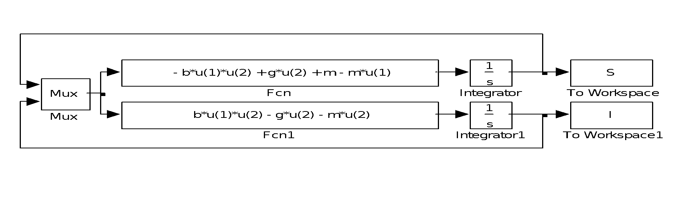

Note: 1) The initial conditions for *S* and *I* are set by double clicking on each of the integrators (remember that *S* and *I* are fractions); 2) the parameter values for b, g, and m can be assigned in the workspace; and 3) the simulation time is set by selecting simulation/parameter on the menu when in the model diagram window or by using the ‘sim’ function in the workspace (type help sim for more information).

**Tasks:**

1. **What is d*S*/dt + d*I*/dt equal to? Why?**

Equal to zero because in the formula dS/dt = μ-μ(S-I), we know that S+I quantity evaluates to 1 (you are either susceptible or infected). This simplifies to μ-μ=0. dS/dt + dI/dt = 0 because in this model, people can only be susceptible or infected and our population size is constant.

1. Simulate the model for each of the following parameter sets, keeping track of the associated steady-state values for the state variables. Set the initial conditions for *S* and *I* to 0.9 and 0.1 respectively. Remember to set the simulation time sufficiently long so that the solution reaches steady-state.

|  |  |  |  |  |  |
| --- | --- | --- | --- | --- | --- |
| b | g | m | S∞ | I∞ | Time to 90% SS |
| 0.9 | 0.1 | 0.1 | .2222 | .7778 | 7.4996 |
| 0.9 | 0.2 | 0.1 | .3334 | .6666 | 8.3549 |
| 0.9 | 0.2 | 0.2 | .4446 | .5554 | 8.4901 |
| 0.1 | 0.1 | 0.1 | .9999 | 0 | 23.8628 |
| 9.0 | 1.0 | 0.1 | .1222 | .8778 | .6498 |
| 2.0 | 1.0 | 0.1 | 0.1 | 0.9 | 4.8331 |
| 1.0 | 1.0 | 0.1 | 1.00 | 0 | 19.0048 |

Using the above equations for the SIS model solve for the steady state (or equilibrium points) and verify your S∞ and I∞ values are correct.

**What is the parametric constraint for obtaining an endemic condition (i.e. *I*∞ > 0)? Show that this is consistent with the above table. How does this relate to the reproductive number?**

The transmission has to be greater than the sum of deaths and recovery of infected individuals in a population. This is consistent with the above table because the criteria for an endemic condition to occur is that b/(g+m) must be greater than 1, and the two sets of conditions above where that criteria is not met (highlighted in green) ends up having an *I*∞ of 0. This relates to the reproductive number because when a disease is endemic, that means that the reproductive number has to be greater than one (if one case generated on average less than one new case throughout the course of its reproductive lifetime, the disease would die out).

One of the features of gonorrhea epidemiology is that the time series of the number of susceptibles and infected shows a rapid response to epidemiologic changes.

1. How do the parameters, b, g, and m, affect the time it takes to reach equilibrium (i.e., which parameters increase/decrease the rate of change in prevalence)? To answer this question, add an additional column to the above table to record the time to 90% of steady-state value, based on your simulations.

Hint: The following is useful code for calculating the time to 90% of steady state value (make sure you run your simulation to steady state). First, the steady state value for S and I respectively are:

steadyS = S(size(S,1)); % selects the steady state value of S

steadyI = I(size(I,1)); % selects the steady state value of I

Second, you want to find the index of the vector when I crosses the 90% value. If I increases towards steady state in the simulation the index is:

index = find( I >= ( ( ( steadyI – 0.1 ) * 0.9 ) + 0.1 ) );

If I decreases towards steady state the index is:

index = find(S >= ( ( ( steadyS – 0.9) * 0.9 ) + 0.9 ) );

Here we are assuming that 0.1 is the initial condition for I and 0.9 is the initial condition for S

Third, the time to 90% and the S and I values are:

T90 = tout( min(index) );

I90 = I( min(index) );

S90 = S( min(index) );

An increase in b will cause a relatively big decrease in the time it takes to reach steady state. An increase in g causes an increase in the time it takes to reach steady state. An increase in m causes a very slight increase in the time it takes to reach steady state.

# **II. Modeling gonorrhea incidence data using an SIS Model.**

The reported incidence of gonorrhea in the United States has oscillated seasonally ever since data collection was started in 1919. The maximum incidence has always occurred between August and October and is usually 20% higher than the minimum incidence between February and May. Hethcote was interested in exploring whether these oscillations are due to seasonal changes in sexual contact rates. Hethcote postulated that the peak contact rate would occur in the summer when students and other people often move and change sex partners. Here you will use as SIS model to explore the implications of changing contact rates. We will assume that the transmission rate parameter will vary seasonally like the contact rate.

**Tasks:**

Use a revised SIS model (**sis_p.mdl**) that allows the contact rate to vary in time. The model is parameterized as follows:

* g = 3.65 y-1 (duration of infectious period = 100 days)
* m = 0 (deaths rate over this short time period is insignificant)
* b = 5.11 - 0.25sin(2πt) (Remember that in MATLAB when entering in the frequency value in the dialog box of the sine wave function, you are entering in the angular frequency, which is represented by ω in the function sin(ωt). The relationship between linear frequency and angular frequency is f = ω/2π. Therefore, if we want a linear frequency of 1 /year, we need to enter in 2π=6.28 for the angular frequency)
* S(0) = 0.9 and I(0) = 0.1

These parameter values come from Hethcote (1984)

1. Describe the meaning of the parameters b(t) and g and provide their units. What is the value of *R0*?

b(t) is the rate of transmission in cases/year and g is the duration of the infectious period in units of 1/year.

1. Simulate the model and graphically show the relationship between the transmission rate parameter and prevalence. Interpret this relationship. Why do you see this relationship in an SIS model? See the description of the incidence and contact pattern data described in Hethcote 1984. 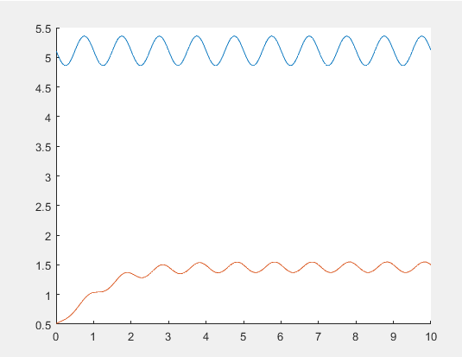 The oscillations seen in this graph represent the seasonality of gonorrhea transmission. There is a slight delay between transmission and prevalence because there is a time-lag between when cases contract the disease and when they begin spreading it to other susceptibles.

# **III. The SIR Model, without vital dynamics (the epidemic model)**

The following are the equations for the SIR model without vital dynamics. This model describes diseases for which infection does confer long-term immunity; i.e., individuals recover and remain immune to reinfection for life. We will use this model to explore epidemic phenomena on a short time scale, thus not requiring the need to model birth and death processes

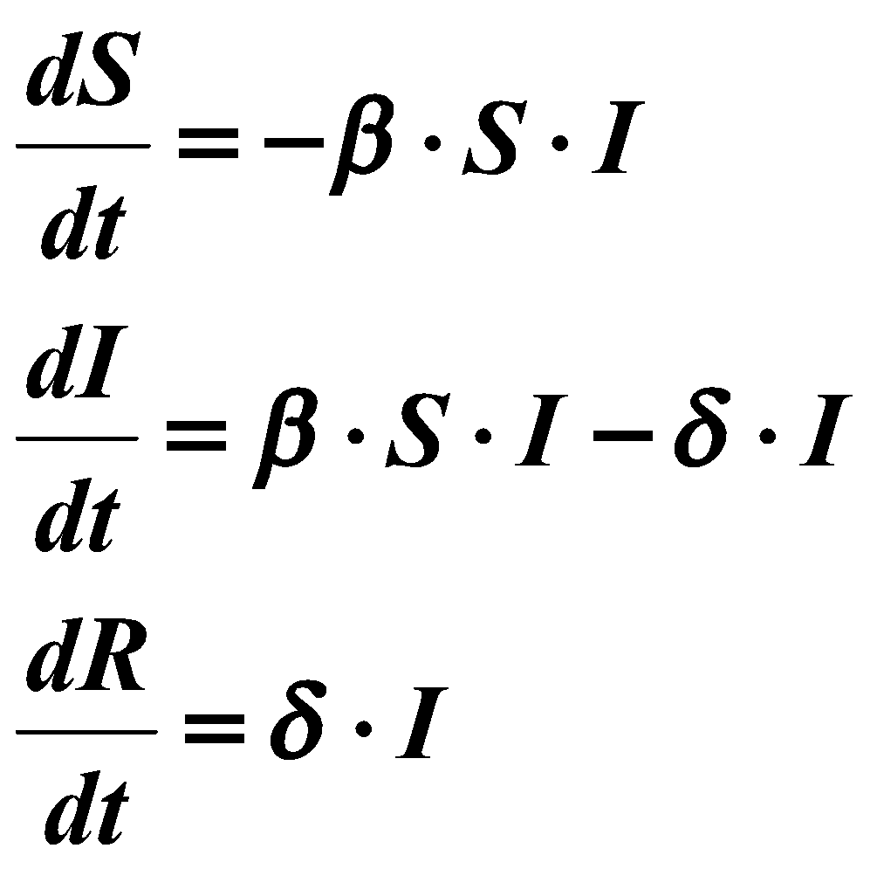

Open up the model **sir.mdl**.

Again we will assume that our state variables are fractional quantities so that *S* + *I* + *R* = 1. Analogous to the Reed-Frost model, the characteristics of an epidemic are a function of the parameter values, *β* and *δ*, as well as the initial conditions *So*, *Io*, and *Ro*.

**Tasks:**

1. Explore the relationship between the parameter values (b and g), the fraction of initial susceptibles (So), the existence of an epidemic, the time to peak fraction of cases (TImax), the maximum fraction of cases (Imax), and the fraction of susceptibles that remain after the end of the epidemic (S∞).   
   Explain how the two parameters and one initial condition affect these four output variables. Use the following table as a guide, though you don’t necessarily need to be limited to these selections.

Note: A given curve is defined as an epidemic if the time to reach *Imax* is greater than zero. Remember that *Io* + *So* + *Ro* = 1. For simplicity keep *Ro* = 0 (therefore *Io* = 1 - *So*).

You can use the *max* and *find* function in Matlab to obtain *TImax* and *Imax*.

|  |  |  |  |  |  |  |
| --- | --- | --- | --- | --- | --- | --- |
| b | g | So | Epidemic (Y/N) | TImax | Imax | S∞ |
| 1 | 2 | 0.9 | N | 1 | 0.10 | 0.8243 |
| 1 | 1 | 0.9 | N | 1 | 0.10 | 0.6084 |
| 1 | 0.5 | 0.9 | Y | 7 | 0.1973 | 0.1717 |
| 1 | 0.1 | 0.9 | Y | 7 | 0.6804 | 0 |
| 0.2 | 0.1 | 0.9 | Y | 13 | 0.2058 | 0.1717 |
| 1 | 0.5 | 0.5 | N | 1 | 0.5 | .0789 |
| 2 | 0.5 | 0.5 | Y | 6 | 0.5767 | .0095 |
| 3 | 0.5 | 0.5 | Y | 6 | 0.6495 | .0013 |

# As b increases, Imax increases, TImax increases, and S∞ decreases.

# As g increases, Imax decreases.TImax decreases, and S∞ increases

As So increases, Imax decreases.TImax increases and S∞ increases.

Epidemics were not occurring if the Tmax occurred at the very beginning of the simulation (i.e. Timax = 1). Everything besides that shows us an epidemic was occurring.

# **IV. The SIR Model with vital dynamics (the endemic model).**

To study the long-term trends of diseases that confer long-term immunity we need to add vital dynamic to our model; i.e., incorporate birth and death processes. As with the SIS model, we assume that the population is constant, and therefore that births and natural deaths occur at equal rates.

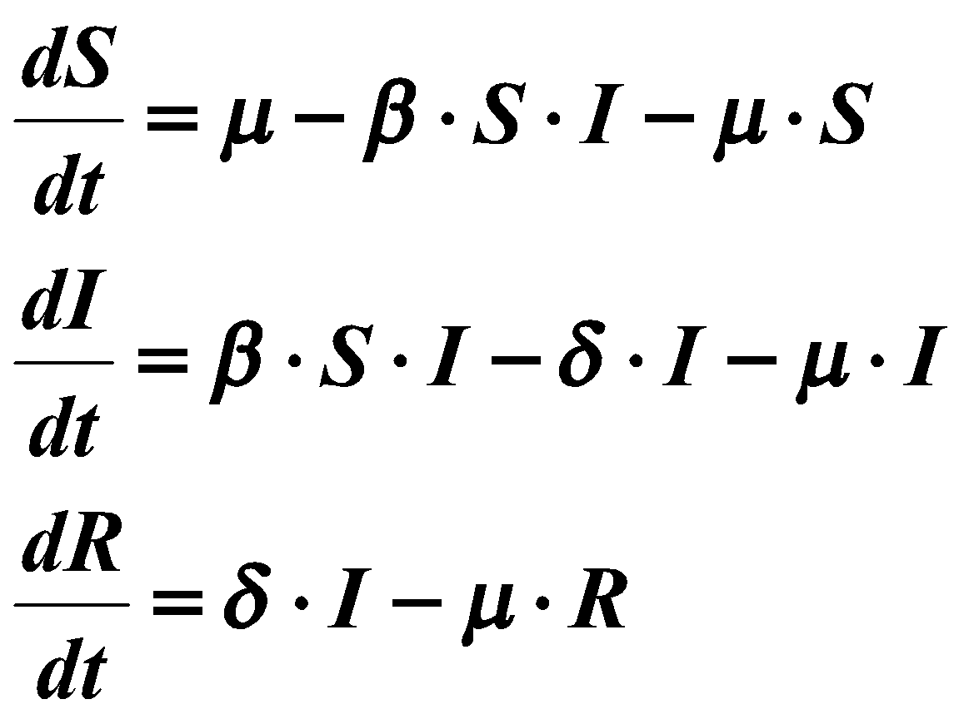

Assume that the life expectancy is 70 years (i.e., *μ* = 1/70 = 0.0143 y-1), that the duration of infectiousness is 1.2 months or 0.1 years (i.e., *δ* = 10 y-1), and that the contact rate, *β* = 20.

**Tasks:**

1. Open the **sir_vd.mdl** file and simulate this SIR model using the above parameter values and a simulation time of 200 years.   
   Plot the output, and provide a biological explanation for the timing of the outbreak (hint: compare the time scale for the spread of infection with the demographic time scale; i.e, the rate of the replenishment of susceptibles).

Note: This model is considered stiff; i.e., they contain multiple time scales (demographic and transmission) that differ by orders of magnitude. It therefore will require a stiff numerical solver to successfully simulate to steady state.

1. Solve the following equations, which come from setting dS/dt = 0 and dI/dt = 0:

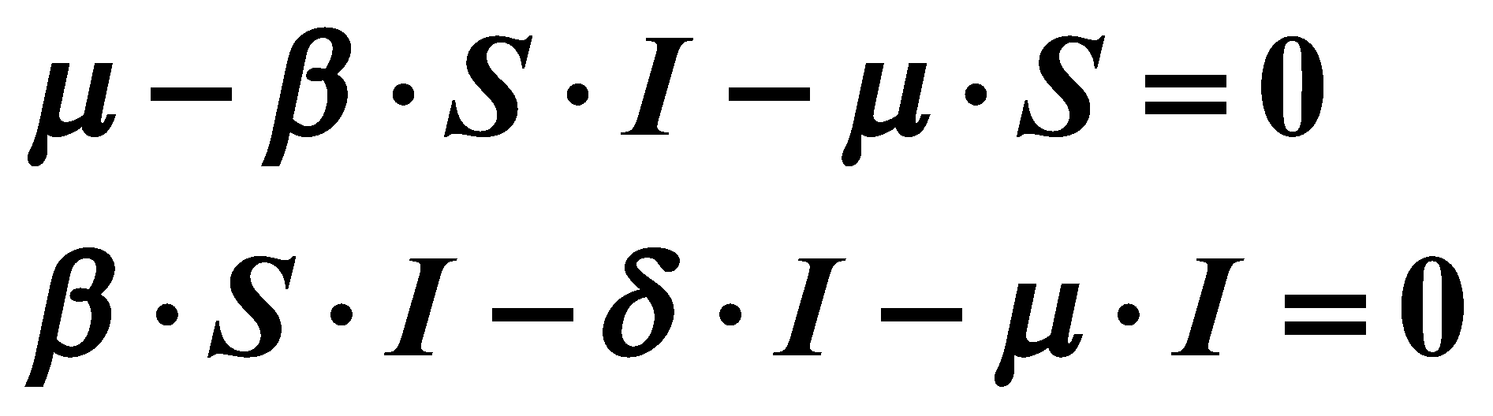

The solution for *S* and *I* are steady-state solution for the number of susceptibles and infected as time increases to infinity. Solve for I* and S* (the steady-state solutions). Plug in the parameter values used in the above simulation to verify that the simulated and calculated steady-state values are the same.