# Stephanie Mecham

2/21/18

# **Lab #4**

# **Population dynamics of directly transmitted diseases**

# **I. The SEIR Model.**

The SEIR model is defined as follows

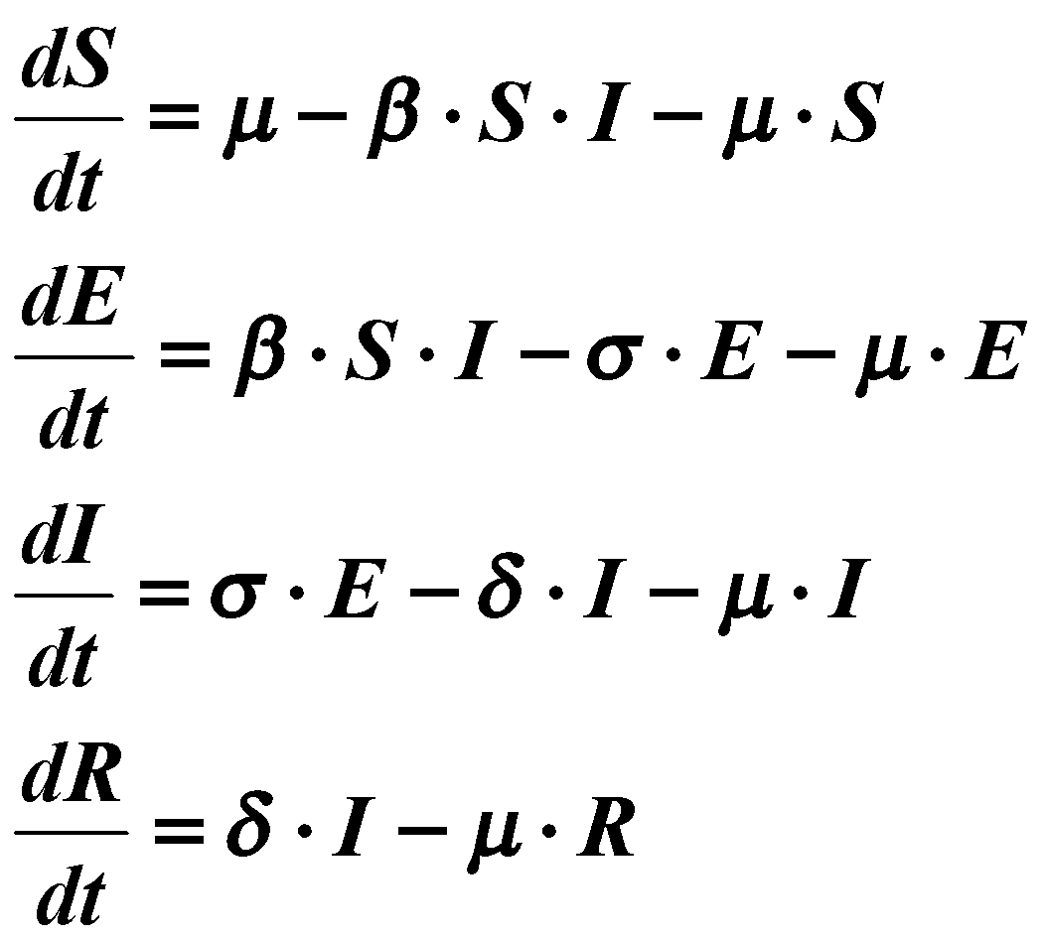

Remember that *S*, *E*, *I*, and *R* are fractions; ie., *S* + *E* + *I* + *R* = 1

**Tasks:**

1. Calculate steady state value for the susceptible population from the above equations.

  

Substituting for E equation 2 gives us S = ((δ + μ)(σ + μ)) / (σβ)

β=1, δ=0.1, μ=0.1, σ=0.1 → S∞=0.4

β=1, δ=0.1, μ=0.1, σ=0.2 → S∞=0.3

β=1, δ=0.1, μ=0.2, σ=0.1 → S∞=0.9

β=1 δ=0.2 μ=0.1 σ=0.1 → S∞=0.6

β=0.5 δ=0.1 μ=0.1 σ=0.1 → S∞=0.8

β=0.3 δ=0.1 μ=0.1 σ=0.1 → S∞=1.0

1. Verify this calculation by running some simulations using the following parameter values (model is located in file **seir_vd.mdl**).

|  |  |  |  |  |
| --- | --- | --- | --- | --- |
| **B** | **d** | **m** | **s** | **S∞** |
| 1 | 0.1 | 0.1 | 0.1 | 0.4000 |
| 1 | 0.1 | 0.1 | 0.2 | 0.3000 |
| 1 | 0.1 | 0.2 | 0.1 | 0.9000 |
| 1 | 0.2 | 0.1 | 0.1 | 0.6000 |
| .5 | 0.1 | 0.1 | 0.1 | 0.8000 |
| .3 | 0.1 | 0.1 | 0.1 | 1.0000 |

These match the calculations from part 1.

Remember that any parameter combination that gives a steady-state value of greater than one is not biologically feasible since we are dealing with fractions. Note: the initial condition for these simulations should be ( *S*(0), *E*(0), *I*(0), *R*(0) ) = ( 0.99, 0, 0.01, 0 ).

1. What is the algebraic formula for the endemic threshold value (i.e., the transition from eradication to endemic conditions)? Run simulations to show what happens under endemic conditions and under conditions for eradication. Also, for endemic conditions, show what happens for different values of So, the initial proportion of susceptible individuals. How does the inclusion of the E state affect the threshold value?

 is the endemic threshold from eradication to endemic conditions in the SIR model.

 s the endemic threshold from eradication to endemic conditions in the SEIR model.

Adding E is what adds the term () to the SEIR model, which represents the proportion of individuals that survive the latency period.

Endemic:

, , 0.8000

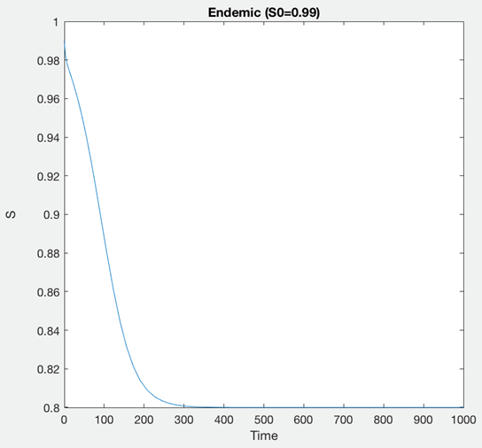

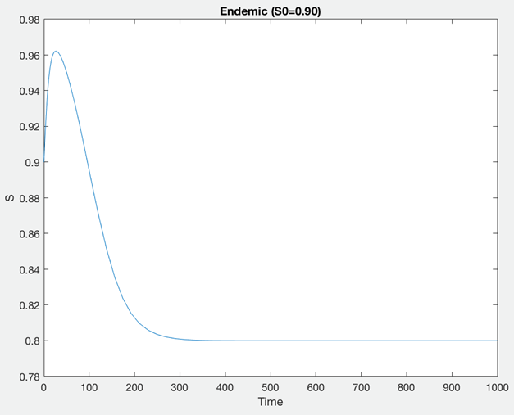

, , 

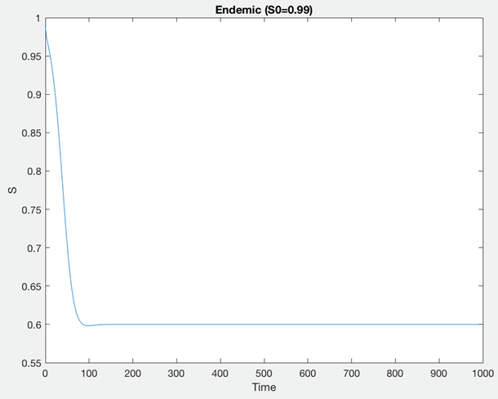

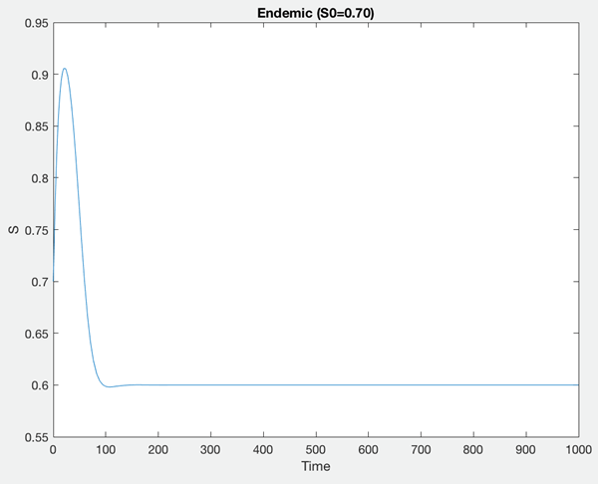

The initial condition of S does not affect the final condition of S.

Eradication:

, , 

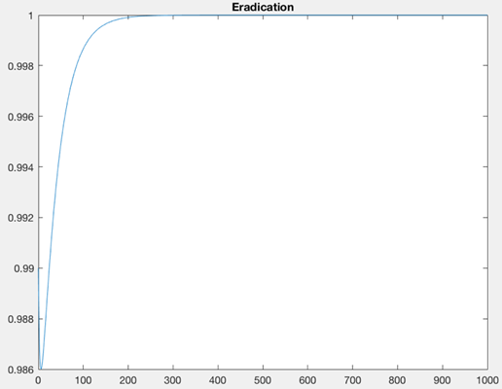

The following table lists epidemiologic data for different diseases (L = expected life span = 70 y), where d = days, and y=years.

|  |  |  |  |  |  |
| --- | --- | --- | --- | --- | --- |
| **Disease** | **Incubation period (d)** | **Latent period (d)** | **Infectious period (d)** | **Avg. age @ infection, A (y)** | **Reproductive Number ( = L/A + 1 )** |
| Measles | 10 | 6 | 6 | 5 | 15 |
| Smallpox | 12 | 9 | 2 | 15 | 5.6 |
| Polio | 9 | 2 | 17 | 14 | 6 |

Using these data we can estimate the parameters values of the model. Although the parameters σ and δ are directly identifiable from the data, the contact rate, λ, is not. Using an approximate relationship between the reproductive rate, R, the average lifespan and average age to infection (see above), the contact rate can be estimated ( remember that R = βσ/(σ+μ)(δ+μ) ).

1. Why is incubation period not a useful piece of data for this model?

Because this model focuses solely on host’s ability to transmit the pathogen; therefore even if the host is not expressing symptoms (incubation period), they can still be transmitting/shedding the pathogen and aiding in transmission.

1. Provide parameter values for measles, smallpox and polio, assuming *μ* = 0 (short-term dynamics). Notice the units.

Conversion:

(Days/365.25)*12 → months

β μ= (R(σ+μ)(δ+μ))/σ −−• β= (R∗σ∗δ)/σ.

|  |  |  |  |  |
| --- | --- | --- | --- | --- |
| **Disease** | **β (mo-1)** | **σ (mo-1)** | **δ (mo-1)** | **μ (mo-1)** |
| Measles | 76.14 | 5.076 | 5.076 | 0 |
| Smallpox | 84.85 | 3.378 | 15.152 | 0 |
| Polio | 10.73 | 15.152 | 1.789 | 0 |

1. What are the different epidemic characteristics for these three diseases; e.g., peak incidence level, time to peak incidence level? Using the above parameterization plot epidemic curves for measles smallpox and polio.

|  |  |  |
| --- | --- | --- |
| Disease | Peak Incidence | Time to Peak |
| Measles | 0.462 | 0.328 |
| Smallpox | 0.607 | 0.092 |
| Polio | 1.041 | 0.473 |

**MEASLES**

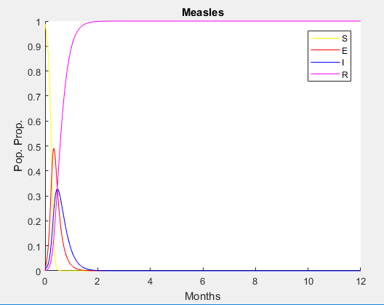

**SMALLPOX**

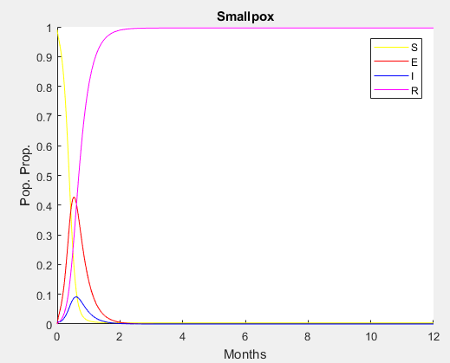

**POLIO**

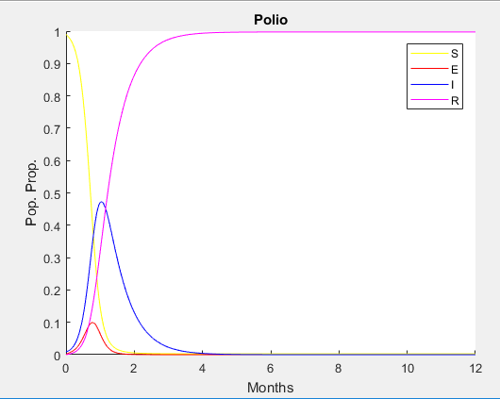

1. What are two characteristics of measles as compared with smallpox that would make it a more difficult disease to eradicate? How does polio compare to measles and smallpox?

Compared to smallpox, measles has a shorter latent period and longer infectious period, meaning that the disease begins shedding and capable of transmitting disease faster than smallpox. Measles also has a bigger reproductive number, which means that on average more people will be infected by one person shedding measles than one person shedding smallpox.

Compared to measles and smallpox, polio has the shortest latent period and longest infectious period, but the average age to infection is higher than measles and is close to smallpox, so the reproduction number/average number of people infected by one case of polio will be more similar to smallpox than to measles.

The force of infection or incident rate is equal to the instantaneous *per capita* rate of change of the number of individuals at risk of infection.

1. For μ = 0 mo-1 what is the force of infection for the SEIR model?

i= - (dS/dt)(1/S)

Force of infection for the SEIR model is equivalent to β times I.

The effective reproduction ratio, *Re*, is the average number of secondary infections produced per infected individual, and is calculated by multiplying the productive rate of 2° infections (**β***.S* ) by both the life span of the disease ( 1/(μ+δ) ) and by the proportion surviving the incubation period ( σ/(σ+μ) ).

Reffective = (β*\*S\**σ) / ((μ+δ)∗(σ+μ))

Reffective = Ro * S

1. Produce one plot each for measles and polio that contain two curves: 1) the force of infection (incidence) vs. time and 2) the effective reproductive ratio vs. time. Interpret these curves. Re-plot this graph using the polio parameter values, with μ = 1.0 mo-1. What is the endemic incident rate and effective reproduction ratio?

**MEASLES**

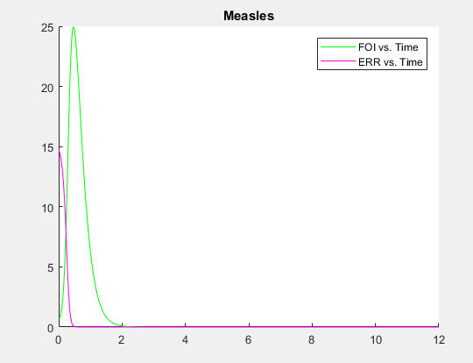

**POLIO**

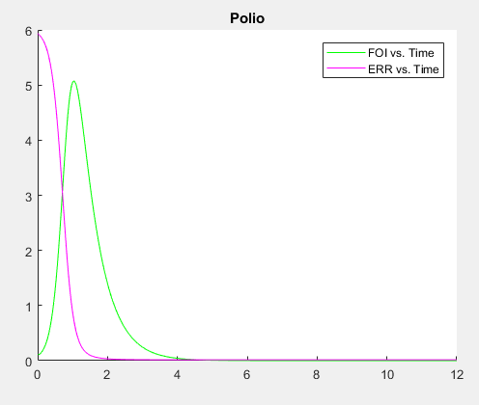

Interpretations: The force of infection in both measles and polio increase, peak, and then decrease back down to zero as the population of susceptibles is depleted and the effective reproductive ratio dips lower than 1. Essentially everyone in the population gets infected with the disease because of the high R0 values. The Reffective is a scaled measure of the susceptible population, which decreases as the number of susceptibles also decreases.

Polio when mu=1 → new beta is 17.84 from the equation β= (R(σ+μ)(δ+μ))/σ.

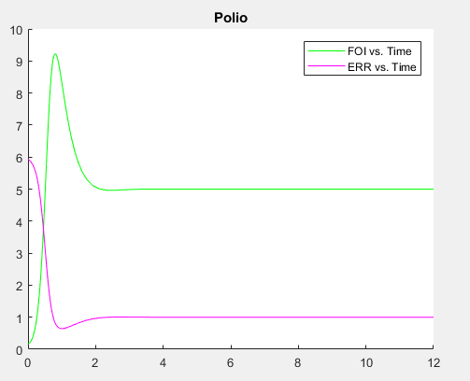

Endemic incidence rate is 5 and the effective reproduction ratio is 1.

The attack rate (AR), the number of individuals that become infected over a period of time over the initial number of susceptibles, is given as a function of the reproduction ratio.

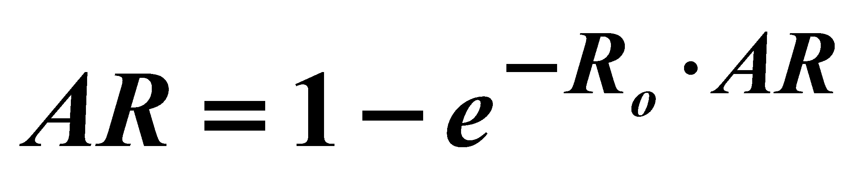

1. Plot the attack rate vs. the reproduction ratio (Hint: Ro = -log(1-AR) ./ AR). Using this plot, explain why the simulated epidemic curves you ran for measles, smallpox, and polio resulted in the susceptible population being exhausted.

**AR=(0.99-S)./0.99**

**MEASLES**

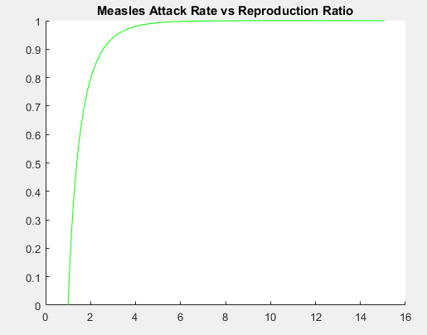

**SMALLPOX**

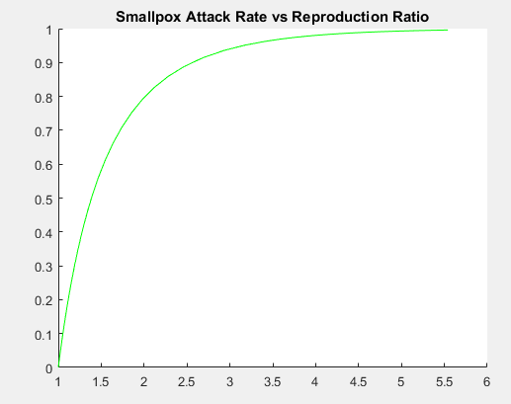

**POLIO**

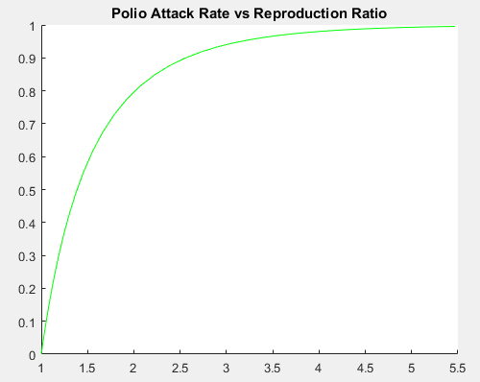

The lower our reproduction ratio, the closer to zero our attack rate becomes. This makes sense given our epidemic curves we ran earlier, because a low reproduction ratio means each case is not spreading the disease to very many people, and thus our attack rate is lowered accordingly. The susceptibles get depleted as more people in the population become infected and then recover (they irreversibly get removed from the population of susceptibles).