# Steph Mecham

# **Lab #6**

# **Vaccinations**

In this lab we will explore how mass immunization affects transmission dynamics, and how models can be used to explore different vaccination strategies. Throughout this lab we will use the SIR model in which a proportion, *p*, of the susceptible population is shunted to the immune class. The following equations define the model:

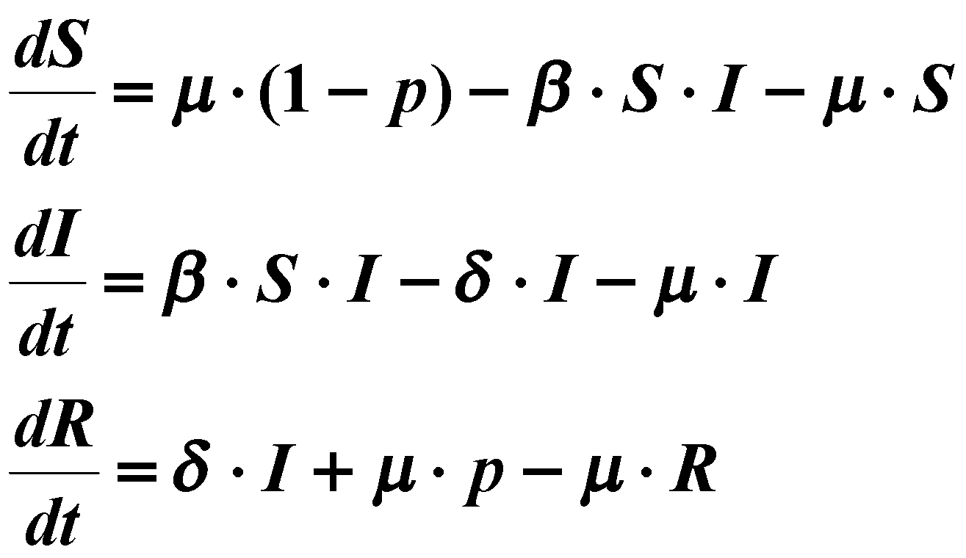

Modified:

S = (𝛿 + μ)/β and S= μ(1-p)/(βI + μ)

I = μ (1-p-S)/βS and I = -μ (p-R)/𝛿

R = p + 𝛿I/μ

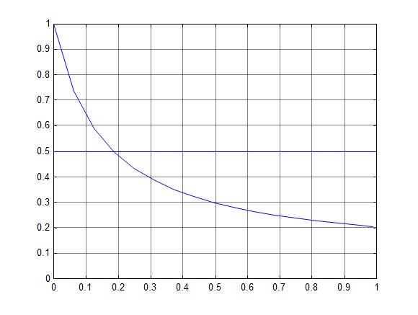

**Tasks**

1. By calculating the steady-state and drawing the nullclines, verify the following properties:
2. The total number of susceptibles remaining after mass vaccination is roughly the same as before.

From the modified equations above, we can see that in the event of a mass vaccination where the infected population becomes zero, the only force affecting the susceptible population is μ (births and deaths). Therefore the number of susceptibles would increase as immune or recovered individuals die or leave the population and susceptible individuals are born into or immigrate into the population.

1. The critical vaccination level (proportion of the susceptible population vaccinated) for eradication is 1 - (δ+μ)/β.

From the modified equations above, the susceptible population is S= (𝛿 + μ)/β. 1 - the susceptible population represents the critical vaccination level in order to eradicate the disease. This is 1-(δ+μ)/β, which matches the critical vaccination level listed above.

What is the steady-state value for *I*?



Given the following information identify the parameter values μ, δ, and β (Use years as the time unit) prior to applying the vaccination.

L=50 years

D=2 weeks → .0385 years

A=4.92 years

1. Life expectancy is 50 years.

μ = 1/L = 1/50 = 0.02 years-1

1. Duration of infectiousness is 2 weeks.

δ = 1/D = 1/.0385 = 25.974 years-1

1. Average age at infection is 4.92 years (when p = 0).

R0 = (L/A) +1 = (50/4.92) +1 = 11.163

R0= (βN/μ+δ) → β= R0(δ + μ)

β = (11.163)(0.02+25.974) = 290.17 years-1

1. What is the critical vaccination level for this set of parameter values?

1 - [(δ+μ)/β]

= 1 - [(0.02+25.974) / 290.17]

= 0.910

To simulate this model, open the file **sir_vac.mdl**. This model uses a new function block, the step function. This function can take on two values, one prior to the “step time” and one after. There are two ways in which to simplify the function to a constant: 1) by setting the initial and final values equal to each other; or 2) by setting the “step time” equal to 0 and assigning the final value to the desired constant.

Parameterize the model using values presented in Task 3 and the initial conditions as follows: *S* = 0.09, *I* = 0.01, *R* = 0.9. Set the simulation time to 75 years.

1. Simulate the model for *p* = 0.
2. Plot S and I. 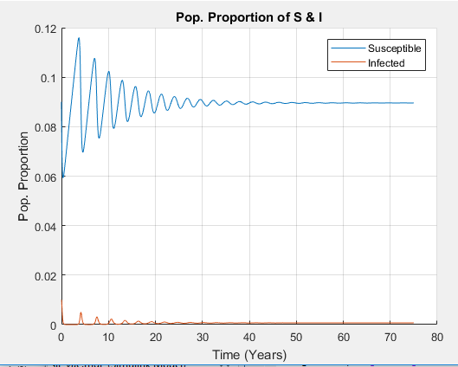
3. Verify that the steady-state *S* and *I* agree with you calculations above.



I* =( .02/290.17)[((290.17/(25.974+.02) - 1] {p is zero in this case}

I* = .0007

S* = (mu + delta) / beta = (.02 + 25.974) / 290.17

S* = 0.090

1. What is the inter-epidemic period and how does it compare with the analytic calculation shown in lecture?

Inter-epidemic period, as appears in the red line of the graph above, appears to be approximately every 2-3 years.

 =

= 2 * pi * (4.92 * 0.0385) ^ ½

= 2.734. This corroborates with our results from the graph.

1. Next simulate the model for *p* = 0 till time 20 and thereafter *p* = 0.85 (to simulate an 85% vaccination coverage). Again, set the simulation “stop time” to 75 and use the ode23t (mod. stiff/ Trapezoidal) algorithm (you may get an integration error from MATLAB if you simulate for a longer period of time).
2. Plot the number of infectious cases vs. time.

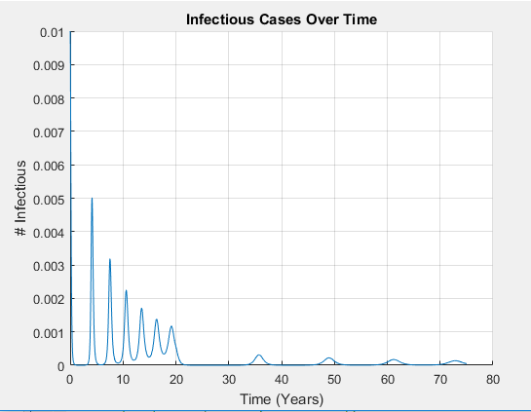

1. What is the period from time of vaccination to the resurgence of the epidemics?

Time from vaccination to resurgence is approx. 15 years, looking at the graph above.

1. Calculate from equations, new values for the following (you wont be able to see this from the plot)
2. The number of infectious cases (at steady-state).



I* = (.02/290.17) [(290.17/(.02+25.974)) *(1-0.85) - 1]

I* = 0.00005

1. The average age at infection.



R0’ = (L/A) + 1

A =( L/R0’ -1)

A = 74.18 years-1

1. The inter-epidemic period



T = 2 * pi * (74.18 *.038)^½

T= 10.55 years-1

1. Show through simulations, that by increasing the fraction vaccinated to the critical value eliminates the resurgence of epidemics, eradicating the disease.

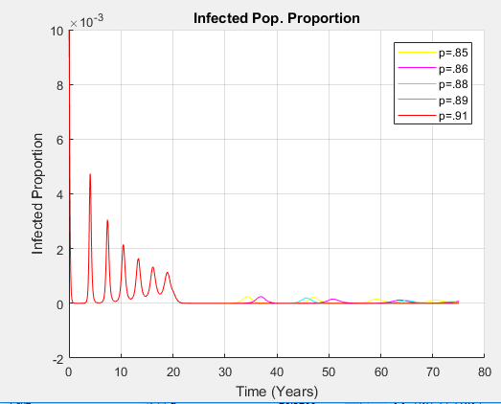

We can see that when the critical threshold of vaccination is reached (at 0.90, aka the red line in the graph), the epidemic dies out (aka there are no resurgences past the 20 year mark, unlike the other lines which represent vaccination thresholds below the critical value).

**Eradication for different diseases in different regions.**

In Africa the life expectancy is 45 years. Age-incidence data from the 1970s suggested that the mean age at infection for measles was 2.5 years whereas for smallpox it was 17 years. However, in India the mean age at infection for smallpox was 12.5 years, and the life expectancy is 60 years. As in lab 5, the infectious period for measles and small pox is 6 and 2 days respectively.

1. Using these data calculate the resulting prevalence of
2. Smallpox in India

L= 60 years

D= 2 days → .00548 years

A=12.5 years

μ = 1/L = 1/60 = .0167

δ = 1/D = 1/.00548 = 182.48

R0 = (L/A) + 1 = (60/12.5)+1 = 5.8

β = R0 (δ+μ) = 5.8(.0167 + 182.48) = 1058.48

1 - (1/R0) = .828

1. Smallpox in Africa

L= 45 years

D= 2 days → .00548 years

A=17 years

μ = 1/L = 1/45 = .0222

δ = 1/D = 1/.00548 = 182.48

R0 = (L/A) + 1 = (45/17)+1 = 3.65

β = R0 (δ+μ) = 3.65(.0222 + 182.48) = 666.133

1 - (1/R0)= .726

1. Measles in Africa

L= 45 years

D= 6 days → .0164 years

A=2.5 years

μ = 1/L = 1/45 = .0222

δ = 1/D = 1/.0164 = 60.976

R0 = (L/A) + 1 = (45/2.5)+1 = 19

β = R0 (δ+μ) = 19(.0222 + 60.976) = 1158.97

1 - (1/R0)= 0.947

prior to and after a mass vaccination program that resulted in a 75% vaccine coverage. Discuss the difference among these three conditions.

|  |  |  |  |  |  |  |
| --- | --- | --- | --- | --- | --- | --- |
|  | μ | δ | β | Pc (%) | I* per 100,000 (p=0) | I* per 100,000 (p=0.75) |
| Measles, Africa | .0222 | 60.976 | 1158.97 | 0.947 | 34.48 | 7.18 |
| Smallpox, Africa | .0222 | 182.48 | 666.133 | 0.726 | 8.83 | 0.29 |
| Smallpox, India | .0167 | 182.48 | 1058.48 | 0.828 | 7.57 | 0.71 |

Where for the 4th column, Pc represents the critical vaccine coverage, the 5th column corresponds to the prevalence prior to the implementation of the vaccine program, and the 6th column corresponds to the prevalence after the vaccine program was implemented.

p=0

p=0.75



For p = 0:

Measles, Africa

I* = .0222/1158.97 * [(1158.97/(60.976+.0222)) - 1]

I* = .0003448 * 100,000

I* = 34.48

Smallpox, Africa

I*= .0222/666.133 * [(666.133/(182.48+.0222)) -1]

I* = .0000883 * 100,000

I* = 8.83

Smallpox, India

I*= .0167/1058.48 * [(1058.48/(182.48+.0167)) -1]

I* = .0000757 * 100,000

I* = 7.57

For p = 1:

Measles, Africa

I* = .0222/1158.97 * [(1158.97/(60.976+.0222) * (1-0.75) - 1]

I* = .0000718 * 100,000

I* = 7.18

Smallpox, Africa

I*= .0222/666.133 * [(666.133/(182.48+.0222) * (1-0.75) -1]

I* = .0000029 * 100,000

I* = 0.29

Smallpox, India

I*= .0167/1058.48 * [(1058.48/(182.48+.0167) * (1-0.75) -1]

I* = .0000071 * 100,000

I* = .71

Looking at our results in the chart above, we can see that the critical vaccine threshold was met for smallpox in Africa but not for measles in Africa or smallpox in India (because their Pc values were greater than 0.75). This pattern occured because the measles in Africa had a higher transmission rate and lower recovery rate compared to smallpox, meaning that more people would have to become vaccinated to halt transmission. India had a lower all-cause mortality and higher transmission rate of smallpox compared to the smallpox in Africa, which also means they would require a higher threshold of population vaccinated to achieve eradication.