# Steph Mecham

# **Lab #7**

# **Waterborne pathogens**

In previous labs we have worked with models that characterized transmission directly from person-person. In this lab we will explore some of the unique aspects of waterborne pathogen transmission. The follow equations describe a basic waterborne pathogen model which includes three transmission pathways: person-person, person-environment-person, and environment-person.

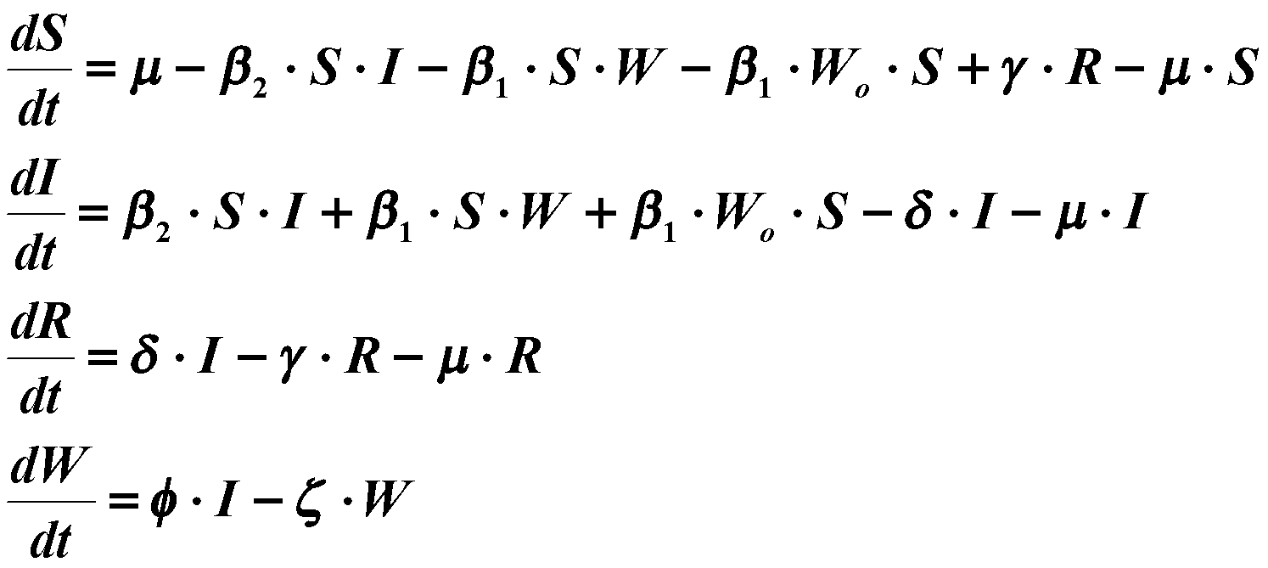

R= ẟI/(ɣ+μ)

W= ɸI / 𝜁

S= (μ+γ(δI/(γ+μ)))/(β2 I+β1(φI/ζ)+μ)

**Tasks**

1. Derive the expression for Ro when there is no external (environment-person) transmission; i.e., Wo=0 (Hint: solve for dW/dt=0 and dR/dt=0 first and then substitute the results into the dS/dt and dI/dt equations).
2. This model structure accounts for two transmission pathways: person-person transmission, which we have been modeling throughout the class; and person-environment-person transmission, which accounts for pathogens surviving outside of the host. One example of the person-environment-person route is sewage contaminating the drinking water source. How does the Ro for this model compare with the Ro for the basic SIR model?

The Ro for this model will have an extra transmission term compared to the Ro for the basic SIR. Based on the manipulation of the equations above, we know that R0 for this model is(β2 + β1ɸ/𝜁)/(ẟ+μ), whereas the Ro for the basic SIR model is (β/(ẟ+μ)). The ɸ/𝜁 term represents the transmission in and out of the W compartment (where W is the number of pathogens in the environmental exposure).



1. Pathogens can come from external sources such as animals or from villages upstream. How does a small external input affect the threshold criteria; i.e., what happens to the expression of Ro when we add an environment-person transmission term? (Hint: plot the S and I nullclines).

S=(μ+γ(δI/(γ+μ)))/(β2 I+β1 (φI/ζ)+β1W0+μ)

S=(I(δ+μ))/(β2 I+β1 φI/ζ+β1 W0 )

R=δI/(γ+μ)

W=φI/ζ



Based on the equations we manipulated above, we can see that adding the external input causes the I to remain in the calculation of R0. R0 in this case depends not just on parameters but also on the population of infectious individuals.

A more realistic representation for the fate and transport of a pathogen in the environment is a distributed delay, based on the following equations:

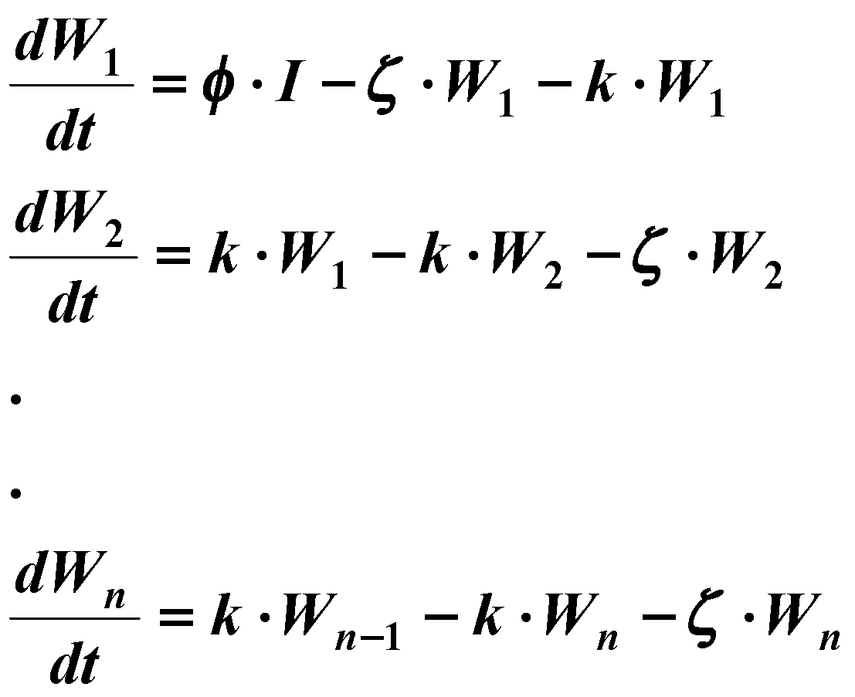

The basic property of this distributed delay is that the mean delay from contamination to exposure is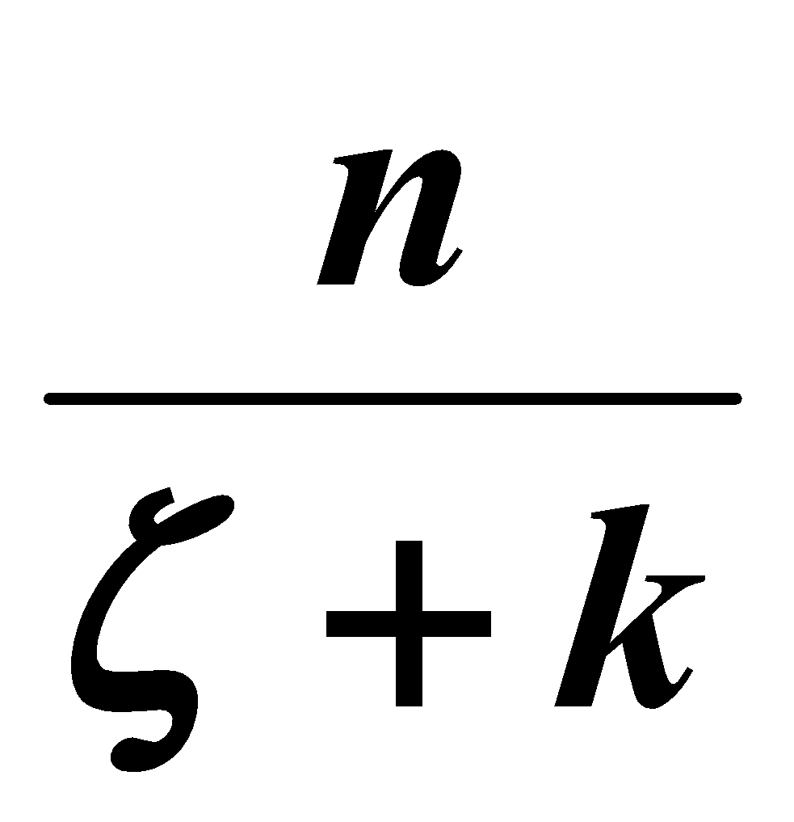, with a variance of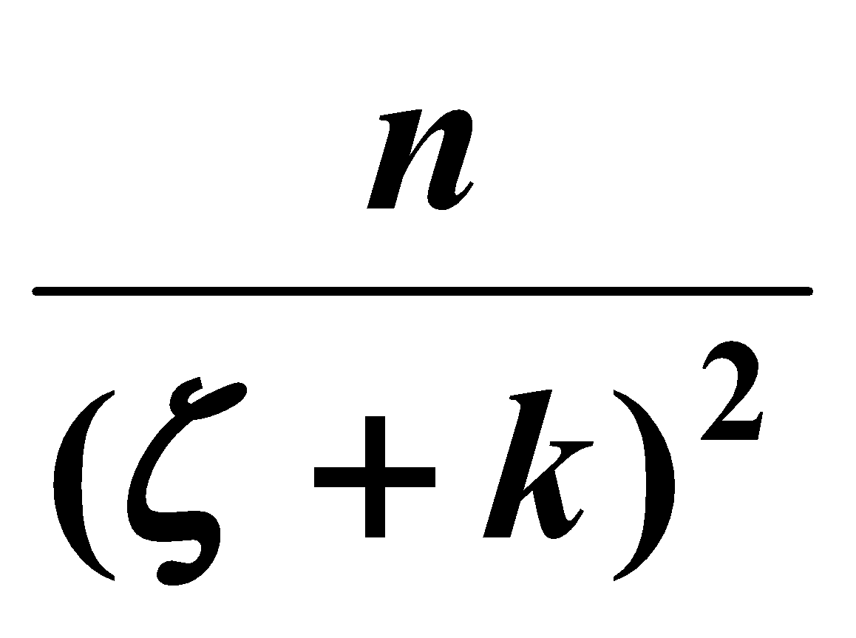. That is, if a number of pathogens contaminate the wastewater stream at time t1, these pathogens would arrive at the drinking water exposure site at a mean time of, some arriving earlier and some later. The distribution of arrival times is gamma distributed.

1. If we substitute the dW/dt equation with the above equations (where n=4), replacing the term W with W4 in the dS/dt and dI/dt equations, how does this effect Ro? Set Wo = 0.
2. What model configuration would provide for a pure delay (i.e., a situation in which all pathogens arrive at the exposure site at the same time)?

R0=([(β2+β1k3 φ)/[(k+ζ)]4 )/((δ+μ)). The R0= (β2+(β1φ/ζ) )/(δ+μ) with a single W compartment. Adding more compartments (n) would cause the term kn-1/(k+ζ)n-1 . In our case, n=4 so the n-1 term is equal to 3.

S=(μ+γ(δI/(γ+μ)))/(β2I+β1 (k3φI)/([(k+ζ)]4 )+μ)

S=(δ+μ)/β2+β1k3φ/(k+ζ)]4

W1=φI/(k+ζ)

W2=(kW_1)/(k+ζ)

W3=(kW_2)/(k+ζ)

W4=(kW_3)/(k+ζ)

W4=(k3 (φI))/(k+ζ)4

The model configuration from part 1-A provides pure delay (when the model has only W compartment).

1. Download the distdelay.mdl model and the delay.m script. This simulink model uses the state space function block to provide a convenient way to construct a large number of linear differential equations. The script defines three of the above parameters n, k, s ( ζ ). The input parameter φ is assumed to be zero. Instead the script sets up an initial condition for W1; i.e., W1(0) = 1.
2. Using n=4, k=0.25, and s=0 verify through simulations that the model indeed provides for a delay with the appropriate mean and variance. The script calculates the mean and variance from the time series data.

Mean from simulink: 15.9705

Mean from equation: n/(ζ + k) = 4/(0+0.25) = 16

Variance from simulink: 64.2942

Variance from equation: n/(ζ + k)2 = 4/(0+0.25)2 = 64

1. Vary n and k so that the transport time has: i) twice the mean value but the same variance; ii) the same mean value but a variance that is decreased by a factor of 0.01. Warning: if you use simulink to estimate 'ii' the model fails due to round off errors. To solve this issue you can truncate any value less than 0.001.

i.) n=15.8683 and k=0.4968

ii.) n = 4.0068 and k= 0.2509

1. Set s=0 and plot the last state variable as a function of time (for n=4 and k=0.25). Next set s=0.25 and again plot the last state variable. What two properties of the process does a non-zero value for *s* affect?

s=0

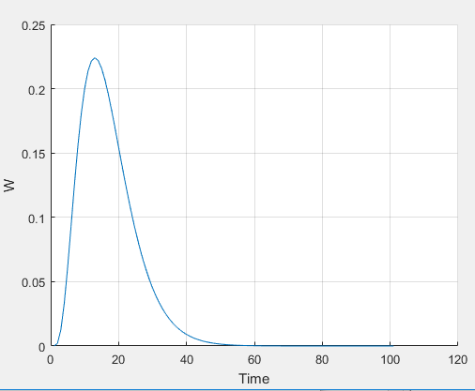

s=0.25

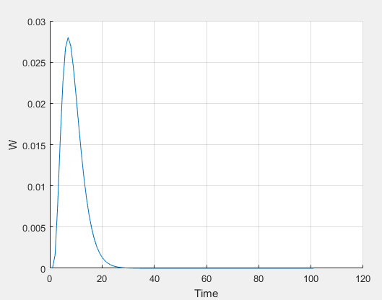

As s increases above 0, the peak W (the amount of pathogens that get transmissed to humans) and peak time to W (the rate at which pathogens die in the environment) both decrease.

1. Download the waterborne.mdl model and water.m script. This model represents the equations on the first page modified to include the distributed delay process. For the next task let g = 3 mo-1, m = 0.1 mo-1, k = 1 mo-1, s = 1 mo-1, f = 1 mo-1, So = 0.9, Io = 0.1, and Ro = 0.
2. First simulate an endemic condition with no waterborne transmission (f = 0, b1=0). Find the value for b2 so that Ro=1.6. What is the steady-state prevalence?

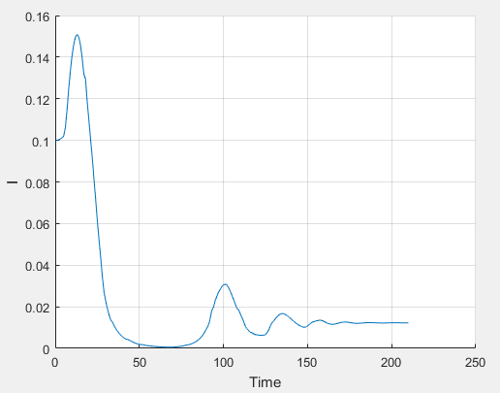

R0 = 1.6 when b2 = 5. The steady-state prevalence is .0122

1. Next simulate a condition in which: 1) there is no person-person transmission, b2 = 0; 2) the rate of contamination, f = 8 mo-1; 3) the mortality rate of the pathogen, s = 1 mo-1; 4) the rate of movement of the pathogen in the environment, k = 1 mo-1; 5) the number of compartments, n = 4; and 6) the environment-person transmission rate, b1=5. What is the mean transport time? Show that the disease dies out and discuss why.

The mean transport time is 2 months. The disease dies out because there is no more direct person-person transmission (i.e. b2=0), so becoming infected depends on susceptible encountering pathogens in the environment rather than encountering other infected individuals. The rate of pathogens dying exceeds the rate of pathogen shedding and the contact between susceptibles with pathogens in the environment, which means that the disease will eventually die out eventually. This reflects why R0 is 0.8065 (less than one).

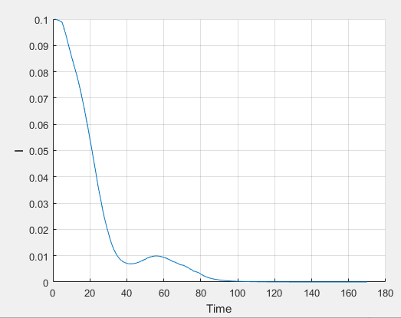

1. Next add in enough person-person transmission to the model described in 4b so that the endemic prevalence is the same as in 4a.

To get the same endemic prevalence (0.0122), we would need the same R0 (1.6065). b1=5 and b2=2.48 satisfies these conditions (work shown below).

Attenuation = ( f / (k+s) ) * ( k(n-1) / (k+s)(n-1) ) = 0.

R0= ( b2 / (g+m) ) + ( ( b1 / (g+m) ) * Attenuation )

1.6=b2/3.1 + (5/3.1 *.5)

b2=2.46

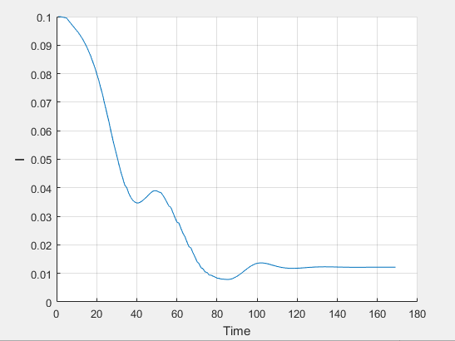

1. Next find the minimum increase in the mean transport time needed to the 4c model for the disease to die out.

When b1=5 and b2=2.48 (as in the model from 4c), the disease will die out when the mean transport time is increased from 2 to 3.5 (i.e. the minimum increase is 1.5). N has to be increased to 7 for these conditions to be fulfilled.

