Savita Medlang

EECS 325

Project 2

1. **Results in a table**

|  |  |  |  |  |  |  |
| --- | --- | --- | --- | --- | --- | --- |
| **Hostname** | **Ip** | **Round trip time** | **Hops** | **Matching datagram bytes** | **Round trip time2** | **Distance in km** |
| Google.com | 172.217.12.206 | 28.659 | 15 | 0 | 28.659 | 3648 |
| Aeo.com | 12.32.250.215 | 245.54 | 13 | 520 | 245.54 | 3459 |
| Facebook.com | 31.13.69.228 | 19.238 | 9 | 520 | 19.238 | 283 |
| Youtube.com | 172.217.12.206 | 38.24 | 15 | 0 | 38.24 | 3648 |
| Rockthevote.com | 52.216.130.66 | 109.104 | 17 | 0 | 109.104 | 240 |
| Gmail.com | 172.217.10.101 | 28.517 | 15 | 0 | 28.517 | 3648 |
| Salesforce.com | 96.43.145.26 | 76.05 | 10 | 0 | 76.05 | 3664 |
| Tirerack.com | 23.216.151.231 | 37.139 | 5 | 520 | 37.139 | 743 |
| Github.com | 192.30.253.112 | 35.111 | 9 | 520 | 35.111 | 3665 |
| Shazam.com | 176.74.189.5 | 141.942 | 7 | 520 | 141.942 | 355 |
| Lenovo.com | 23.217.170.94 | 51.823 | 11 | 520 | 51.823 | 743 |

1. **RTT vs. numHops plot**

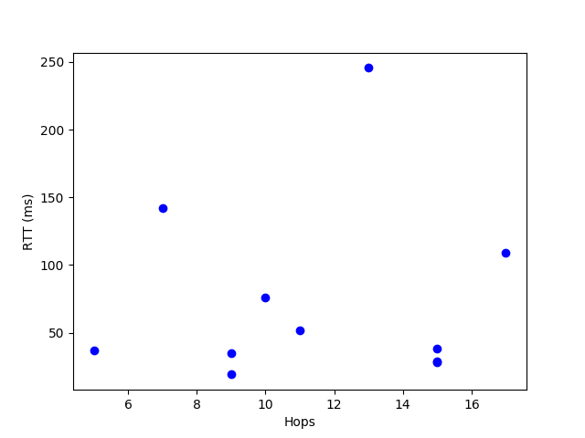

**Correlation: 0.0697**

1. **Ways to match the probe**
   1. First, check that the ICMP type and code are the correct error, so I know that they reached the destination.
   2. Then, unpack and check the received ICMP packet.
   3. Then, check that the source IP matches the IP of the sent datagram, and the destination IP matches the local IP.
   4. Last, check that the received datagram’s message matches the initial message.
2. **Ways of not getting correct answer**
   1. Lost/corrupt sent UDP packet
   2. Lost/corrupt ICMP packet on the way back
   3. Timeout
   4. Target does not respond
   5. Firewall
   6. Incorrect hostname (unable to locate)
3. **Output (code)**

bash-3.2# sudo python3 distMeasurement.py

Data for [google.com](http://google.com/), [172.217.12.206](http://172.217.12.206/):

hops: 15

RTT in ms: 28.659105

Number of bytes of original datagram = 0

15 28.65910530090332

Data for [aeo.com](http://aeo.com/), [13.32.250.215](http://13.32.250.215/):

hops: 13

RTT in ms: 245.543003

Number of bytes of original datagram = 520

13 245.5430030822754

Data for [facebook.com](http://facebook.com/), [31.13.69.228](http://31.13.69.228/):

hops: 9

RTT in ms: 19.238234

Number of bytes of original datagram = 520

9 19.23823356628418

Data for [youtube.com](http://youtube.com/), [172.217.12.206](http://172.217.12.206/):

hops: 15

RTT in ms: 38.240910

Number of bytes of original datagram = 0

15 38.240909576416016

Data for [rockthevote.com](http://rockthevote.com/), [52.216.130.66](http://52.216.130.66/):

hops: 17

RTT in ms: 109.104156

Number of bytes of original datagram = 0

17 109.10415649414062

Data for [gmail.com](http://gmail.com/), [172.217.10.101](http://172.217.10.101/):

hops: 15

RTT in ms: 28.517962

Number of bytes of original datagram = 0

15 28.517961502075195

Data for [salesforce.com](http://salesforce.com/), [96.43.145.26](http://96.43.145.26/):

hops: 10

RTT in ms: 76.050997

Number of bytes of original datagram = 0

10 76.05099678039551

Data for [tirerack.com](http://tirerack.com/), [23.216.151.231](http://23.216.151.231/):

hops: 5

RTT in ms: 37.139177

Number of bytes of original datagram = 520

5 37.139177322387695

Data for [github.com](http://github.com/), [192.30.253.112](http://192.30.253.112/):

hops: 9

RTT in ms: 35.111904

Number of bytes of original datagram = 520

9 35.11190414428711

Data for [shazam.com](http://shazam.com/), [176.74.189.5](http://176.74.189.5/):

hops: 7

RTT in ms: 141.942024

Number of bytes of original datagram = 520

7 141.94202423095703

Data for [lenovo.com](http://lenovo.com/), [23.217.170.94](http://23.217.170.94/):

hops: 11

RTT in ms: 51.823139

Number of bytes of original datagram = 520

11 51.82313919067383

1. **GeoDistance Output**

bash-3.2# sudo python3 geoDistance2.py

Self:

Latitude: 40.4354

Longitude: -79.6193

Latitude: 37.4192

Longitude: -122.0574

Host: [google.com](http://google.com/)

IP address: 172.217.6.238

Distance: 3648.7552958367364 km

Latitude: 47.6344

Longitude: -122.3422

Host: [aeo.com](http://aeo.com/)

IP address: 13.33.74.31

Distance: 3459.0886301530136 km

Latitude: 38.6582

Longitude: -77.2497

Host: [facebook.com](http://facebook.com/)

IP address: 31.13.69.228

Distance: 283.23015379827604 km

Latitude: 37.4192

Longitude: -122.0574

Host: [youtube.com](http://youtube.com/)

IP address: 172.217.10.110

Distance: 3648.7552958367364 km

Latitude: 39.0481

Longitude: -77.4729

Host: [rockthevote.com](http://rockthevote.com/)

IP address: 52.216.162.58

Distance: 239.5774264774901 km

Latitude: 37.4192

Longitude: -122.0574

Host: [gmail.com](http://gmail.com/)

IP address: 172.217.10.101

Distance: 3648.7552958367364 km

Latitude: 51.2993

Longitude: 9.491

Host: [spreadshirt.com](http://spreadshirt.com/)

IP address: 138.201.247.255

Distance: 6567.323567904302 km

Latitude: 37.7898

Longitude: -122.3942

Host: [salesforce.com](http://salesforce.com/)

IP address: 96.43.145.26

Distance: 3663.840883111638 km

Latitude: 42.3626

Longitude: -71.0843

Host: [tirerack.com](http://tirerack.com/)

IP address: 23.216.151.231

Distance: 742.6072086995677 km

Latitude: 37.7697

Longitude: -122.3933

Host: [github.com](http://github.com/)

IP address: 192.30.253.113

Distance: 3664.4649412418194 km

Latitude: 43.623

Longitude: -79.3937

Host: [shazam.com](http://shazam.com/)

IP address: 209.15.194.41

Distance: 354.71113126271774 km

Latitude: 42.3626

Longitude: -71.0843

Host: [lenovo.com](http://lenovo.com/)

IP address: 23.217.170.94

Distance: 742.6072086995677 km

1. **Comparisons Between Distance and Numhops and RTT**

**Correlation: 0.03749**

**Correlation = -0.0216**

1. **Conclusions**

Seeing that the correlation coefficients are rather low, there is no definite correlation with any of the metrics (num hops, time, or distance). However, we expect that with an increase in hops and distance, it will take more time. That being said, other factors can cause an increase in time, such as congestion at specific routers. This could explain why the correlation between high numHops and high time and distance.