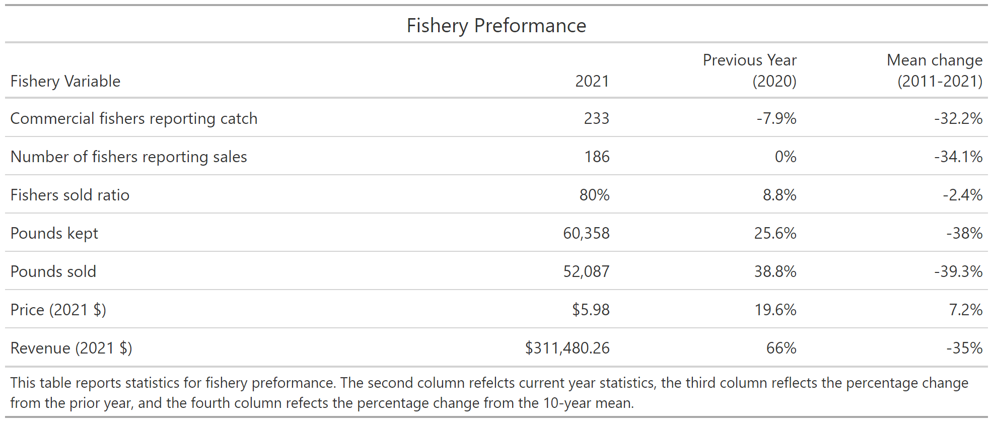

Fishery observation 2021

Fishery Observations 2021

F

Fishery Observations 2021

* Fishers reported less uku targeting due to a productive ‘ahi and onaga season
* Abundance of uku at select O‘ahu bottomfishing spots
* Unusually large aggregation of uku late season (October) on the Penguin Banks
* Shark depredation remains an issue

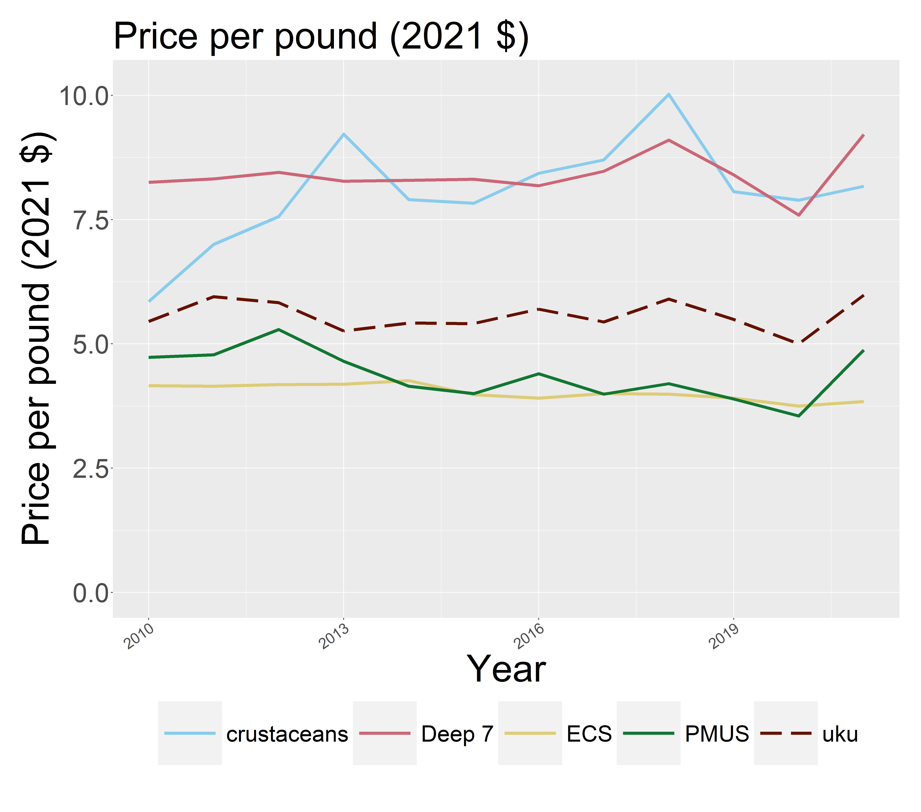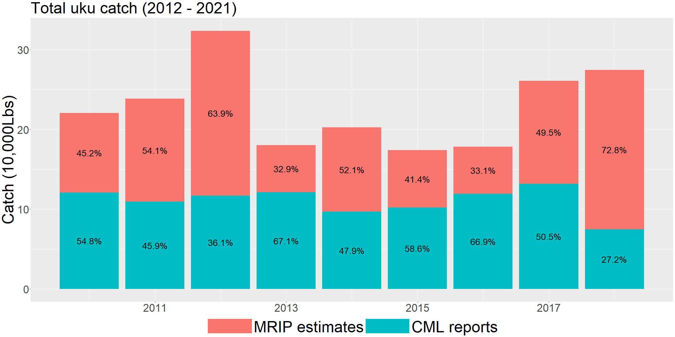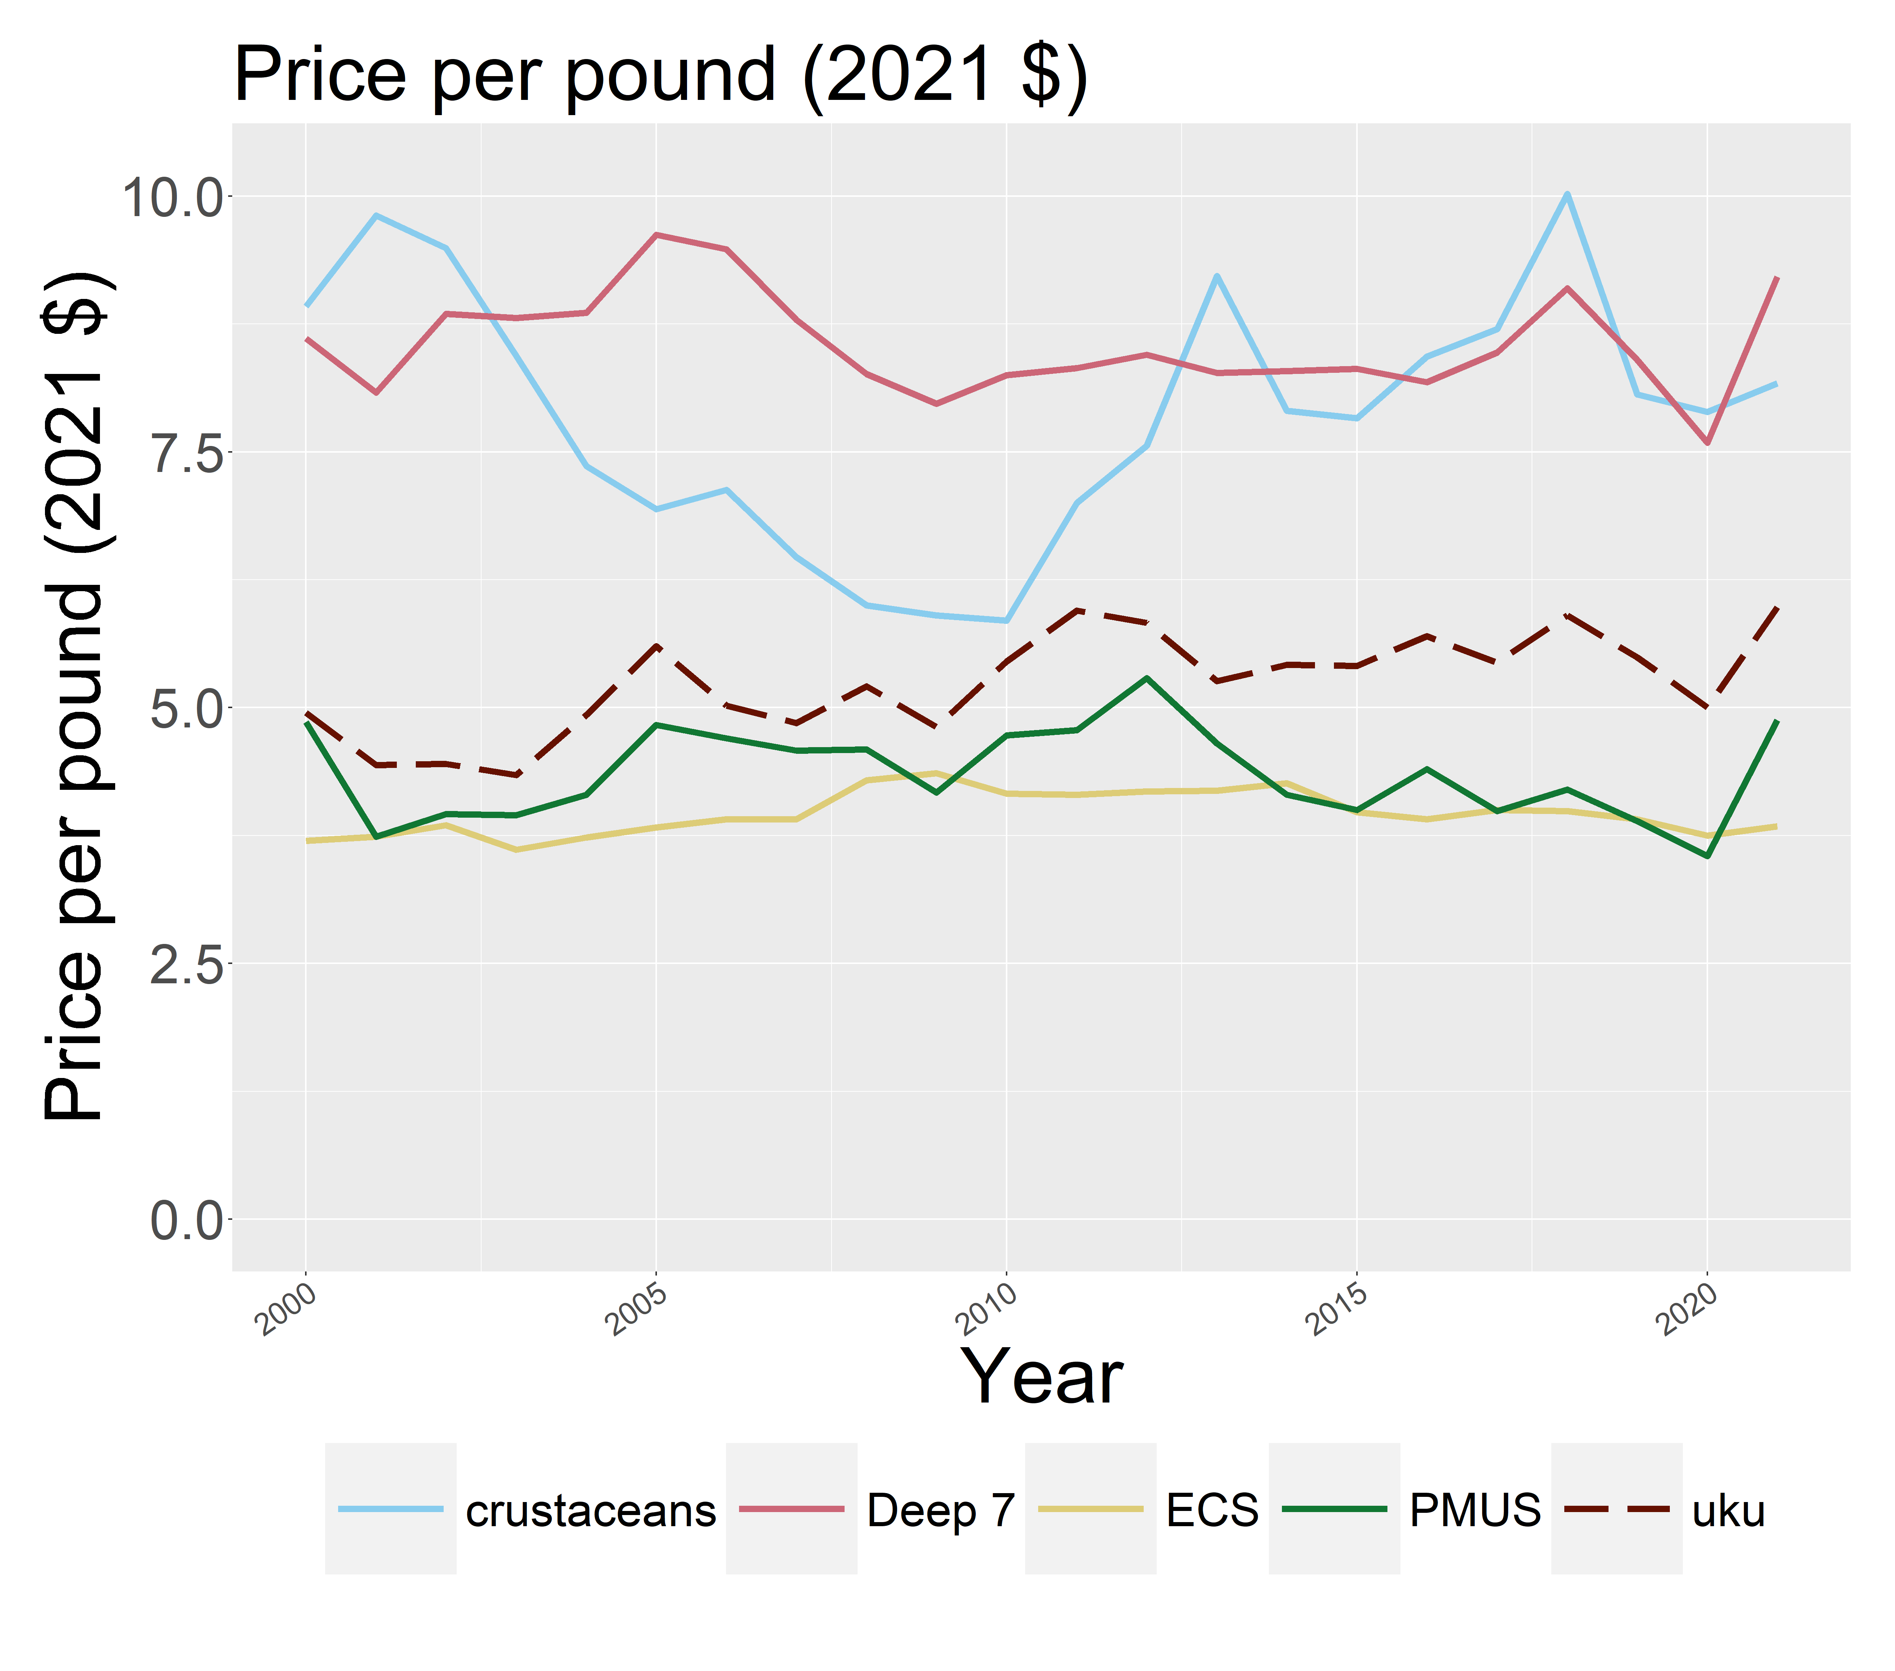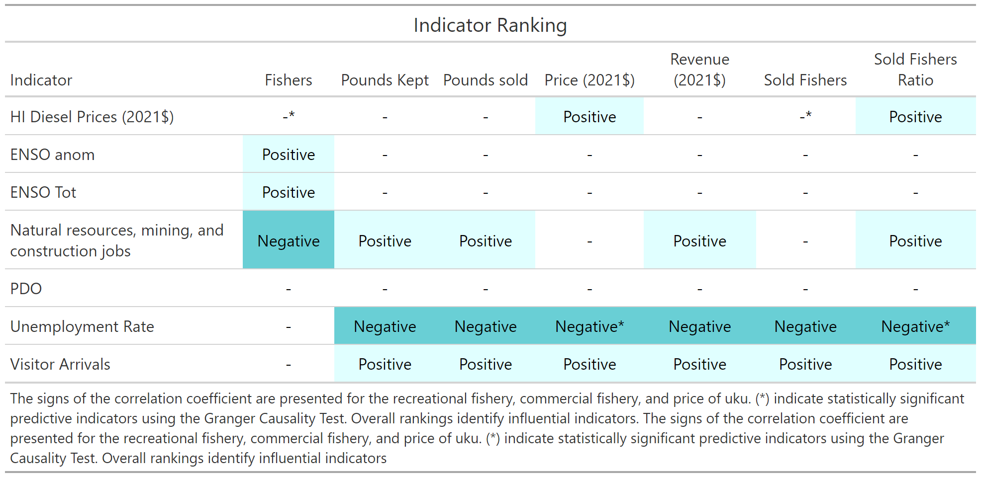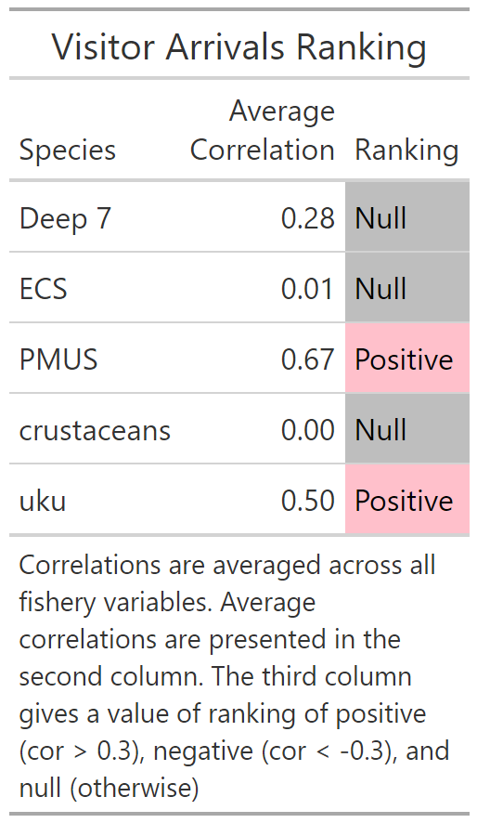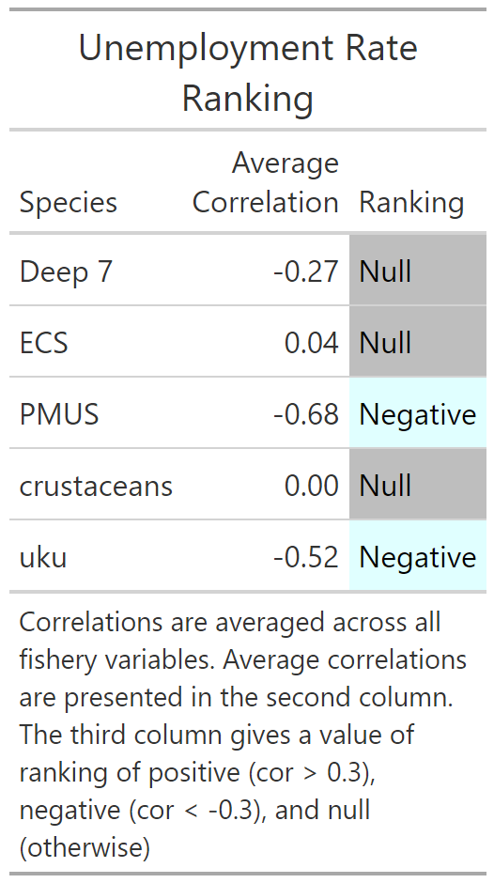

Socioeconomic consideration

The relationship between socioeconomic and ecological indicators are presented for uku, deep 7, ECS, PMUS, and crustaceans. Average correlations are calculated across five fishery variables and are ranked based on their strength. Average correlations that exceed 0.3 are ranked as “positive”, values smaller than -0.3 are ranked as “negative”, and all other values are given a “null”.

Unemployment was the most negatively correlated with uku and GDP was among the most positively correlated with uku. Both these indicators have a strong relationship with PMUS species but do not have a relationship with the remaining species groups

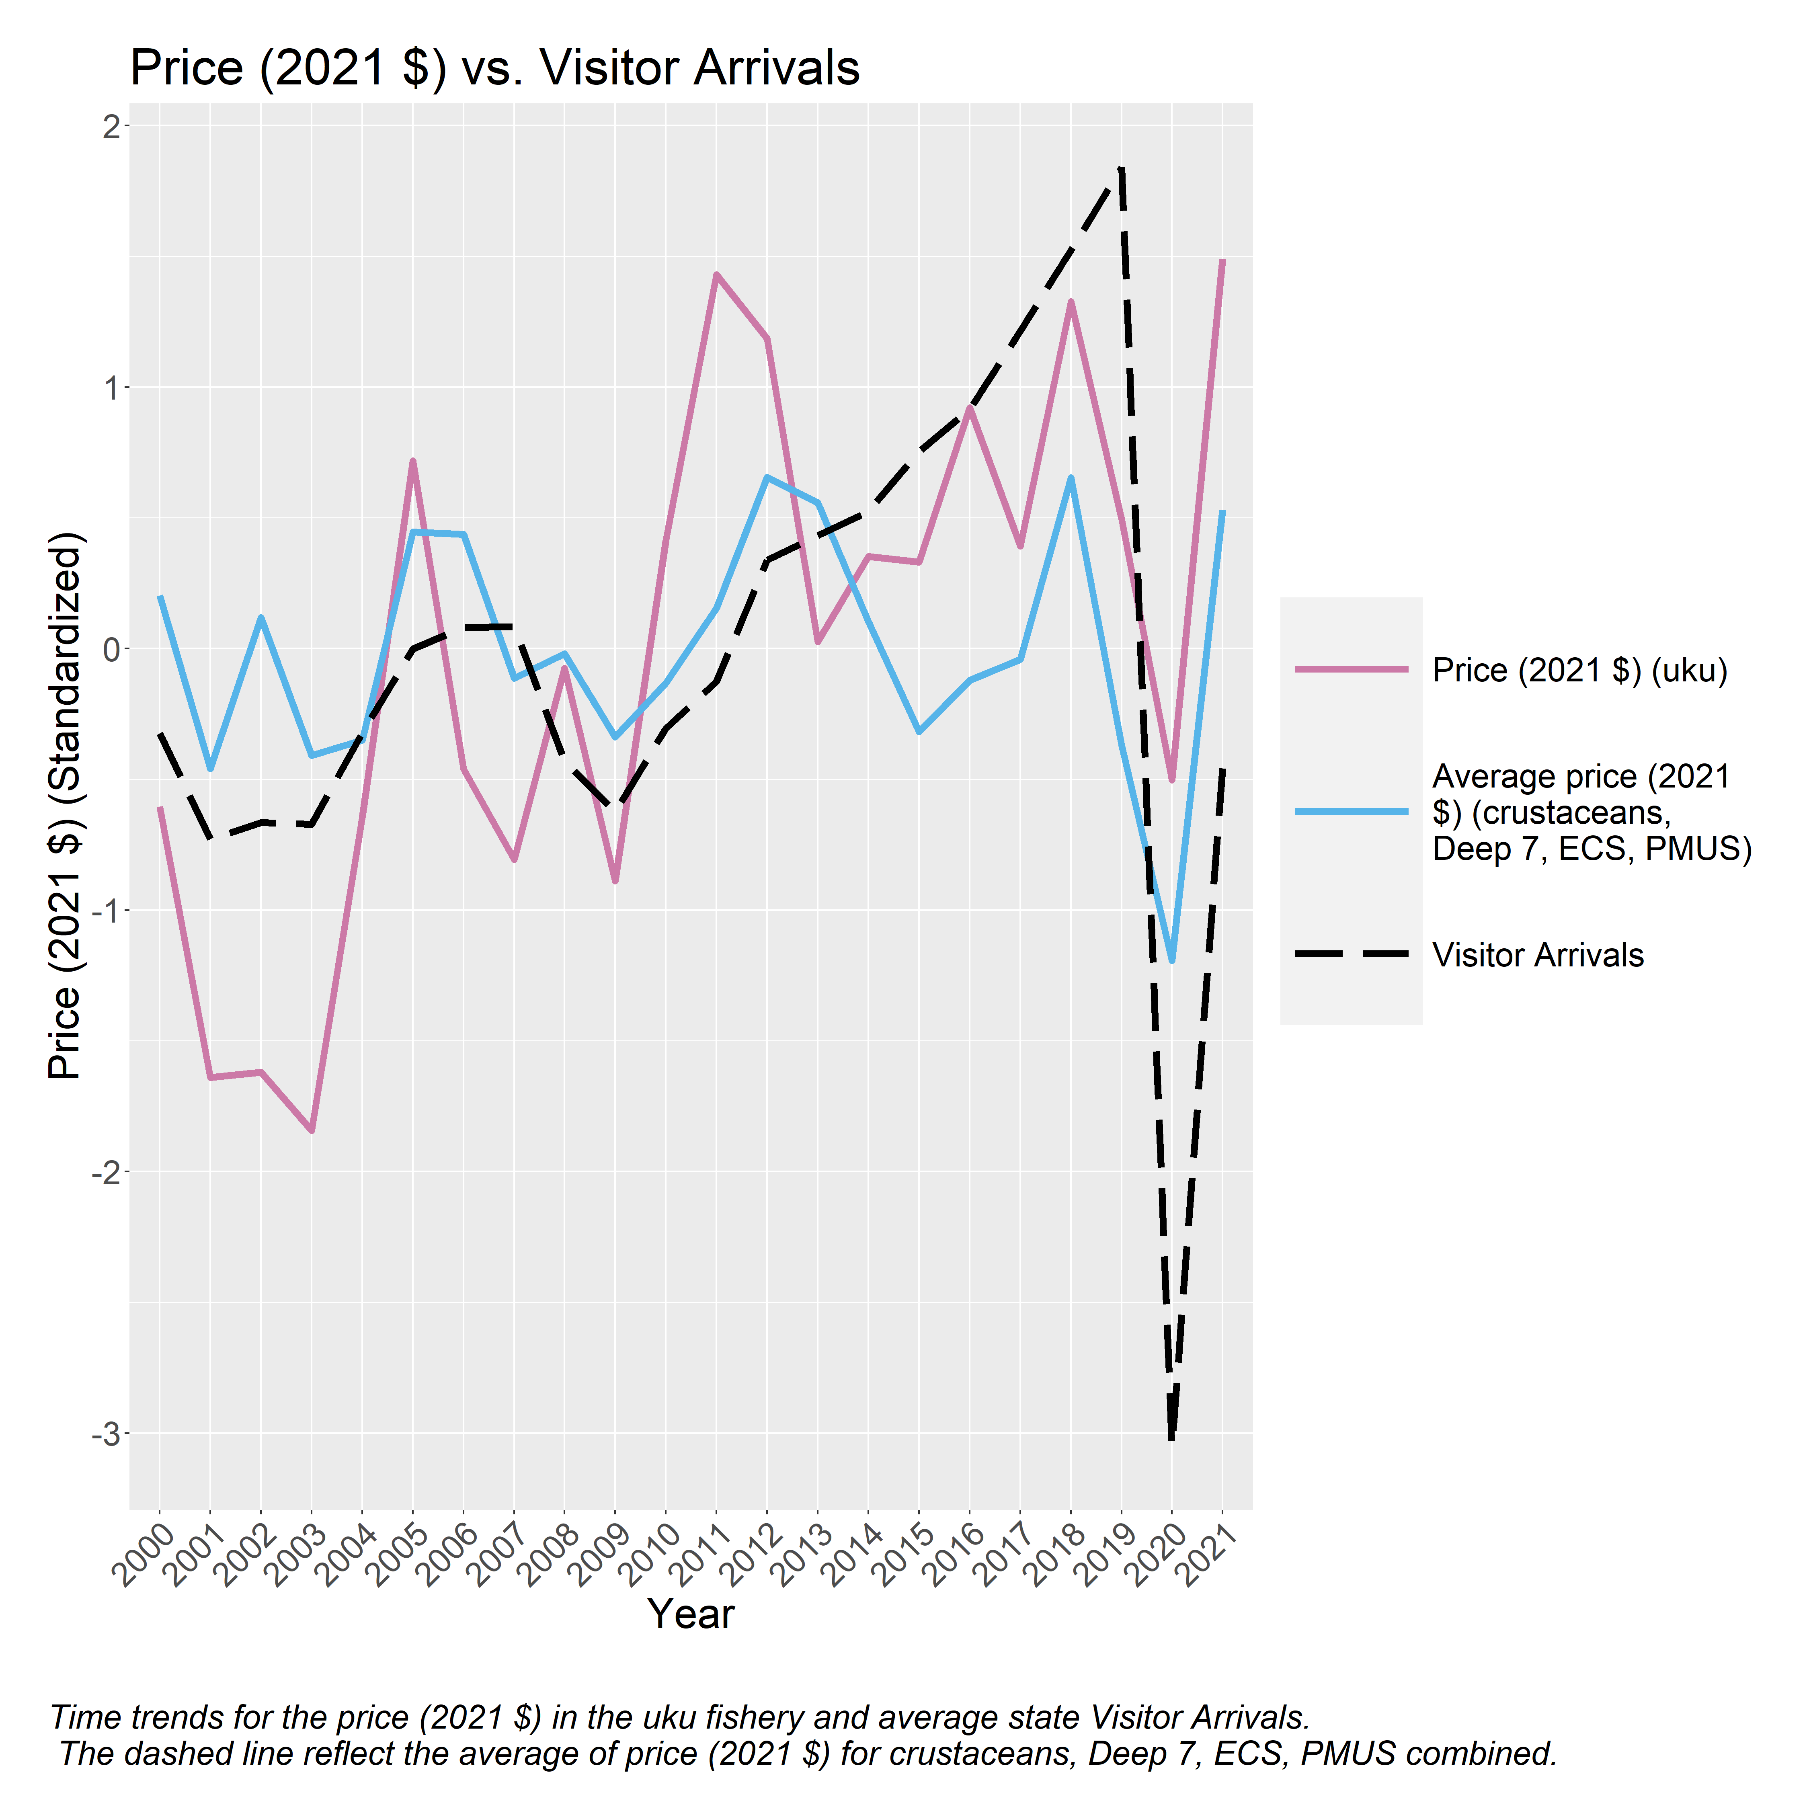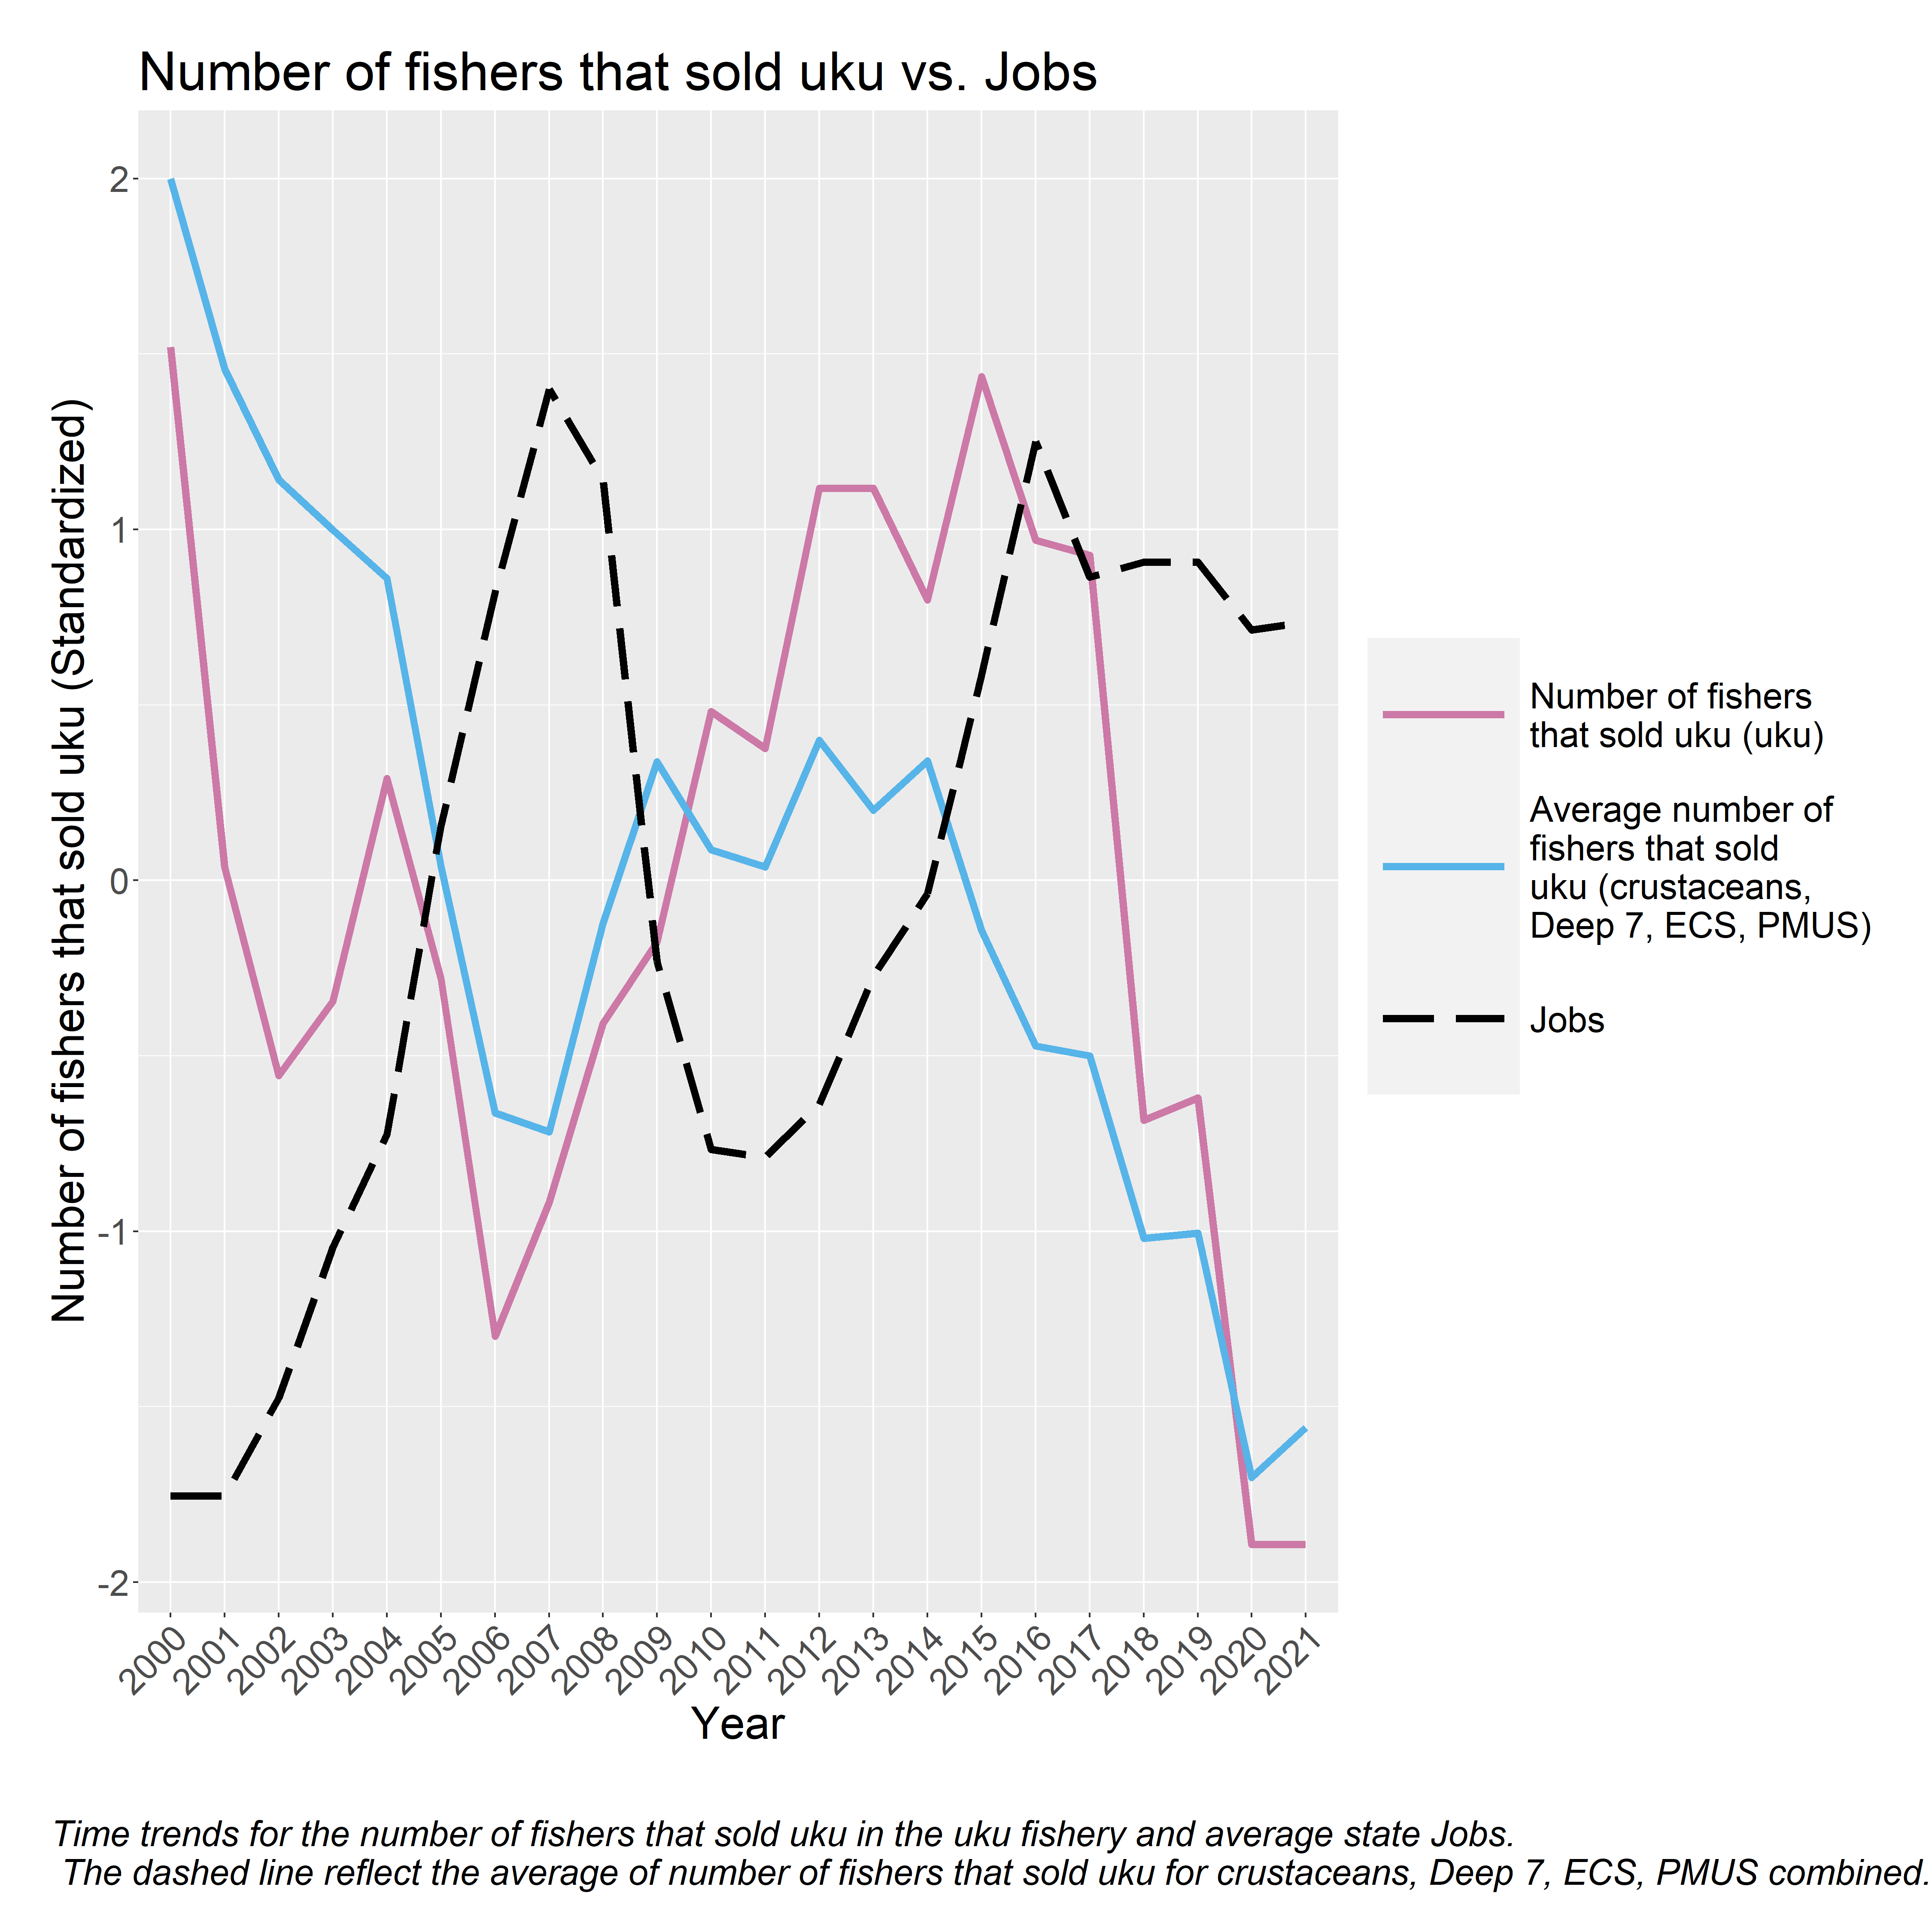

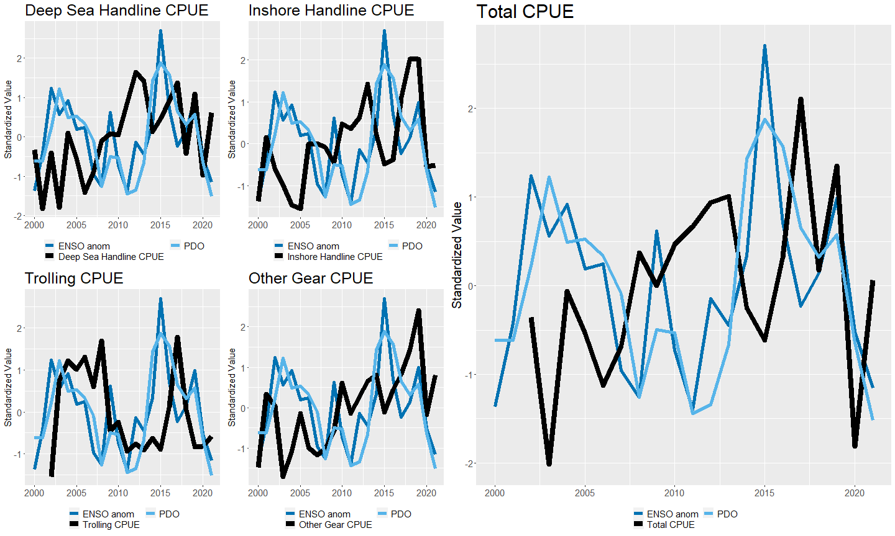

Ecological consideration

Yearly average trends of ENSO and PDO (dashed black line) are plotted with yearly average trends of pounds kept of uku (purple) and the yearly average trends of pounds kept across crustaceans, Deep 7, ECS, and PMUS).

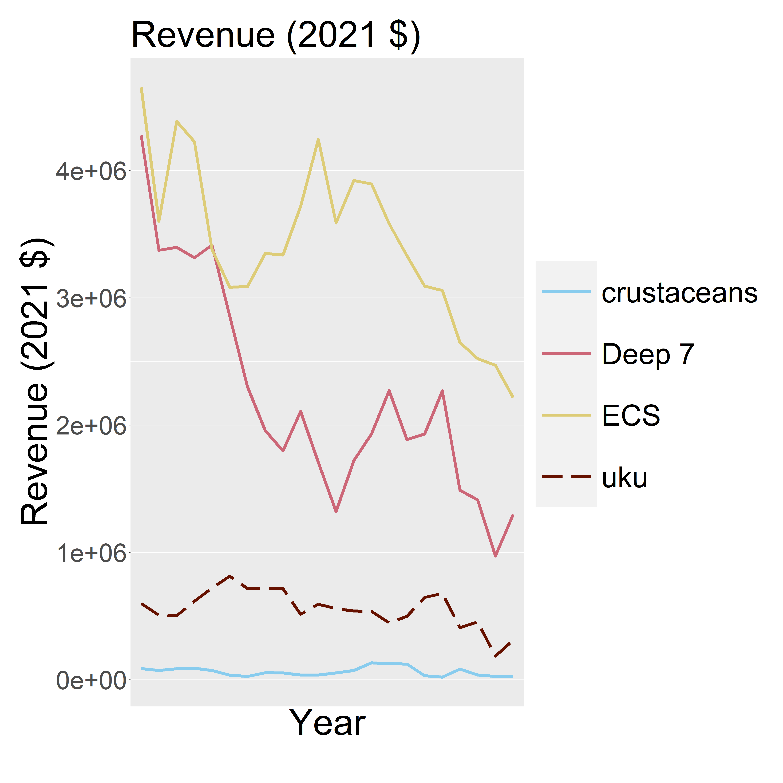

Trip trends

Yearly average trends of ENSO and PDO (dashed black line) are plotted with yearly average trends of pounds kept of uku (purple) and the yearly average trends of pounds kept across crustaceans, Deep 7, ECS, and PMUS).

