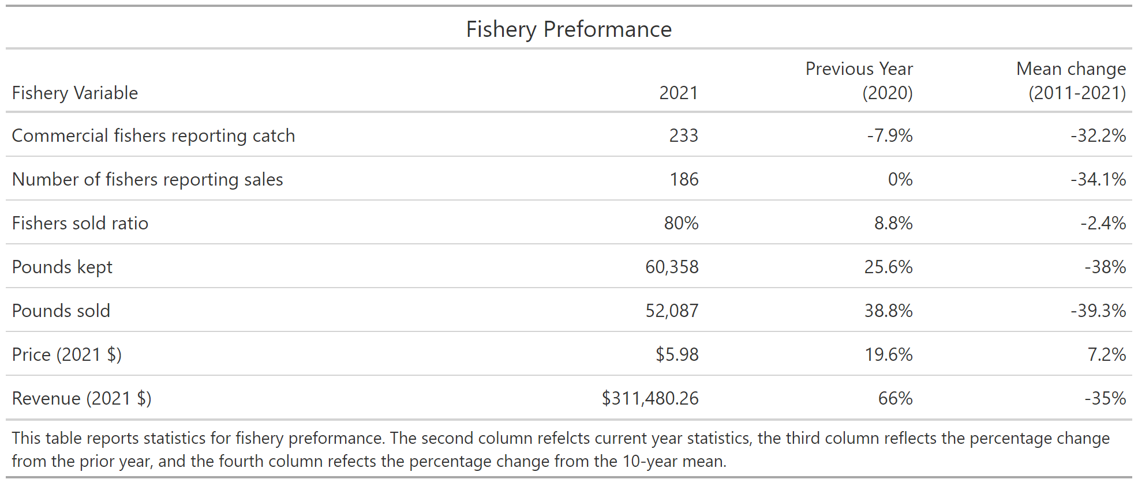

Fishery observation 2021

Fishery Observations 2021

F

Fishery Observations 2021

* Fishers reported less uku targeting due to a productive ‘ahi and onaga season
* Abundance of uku at select O‘ahu bottomfishing spots
* Unusually large aggregation of uku late season (October) on the Penguin Banks
* Shark depredation remains an issue

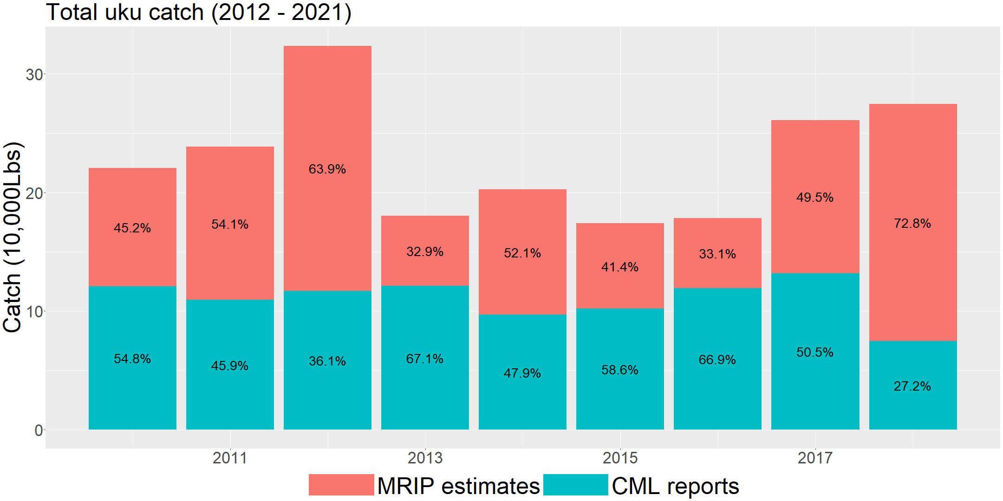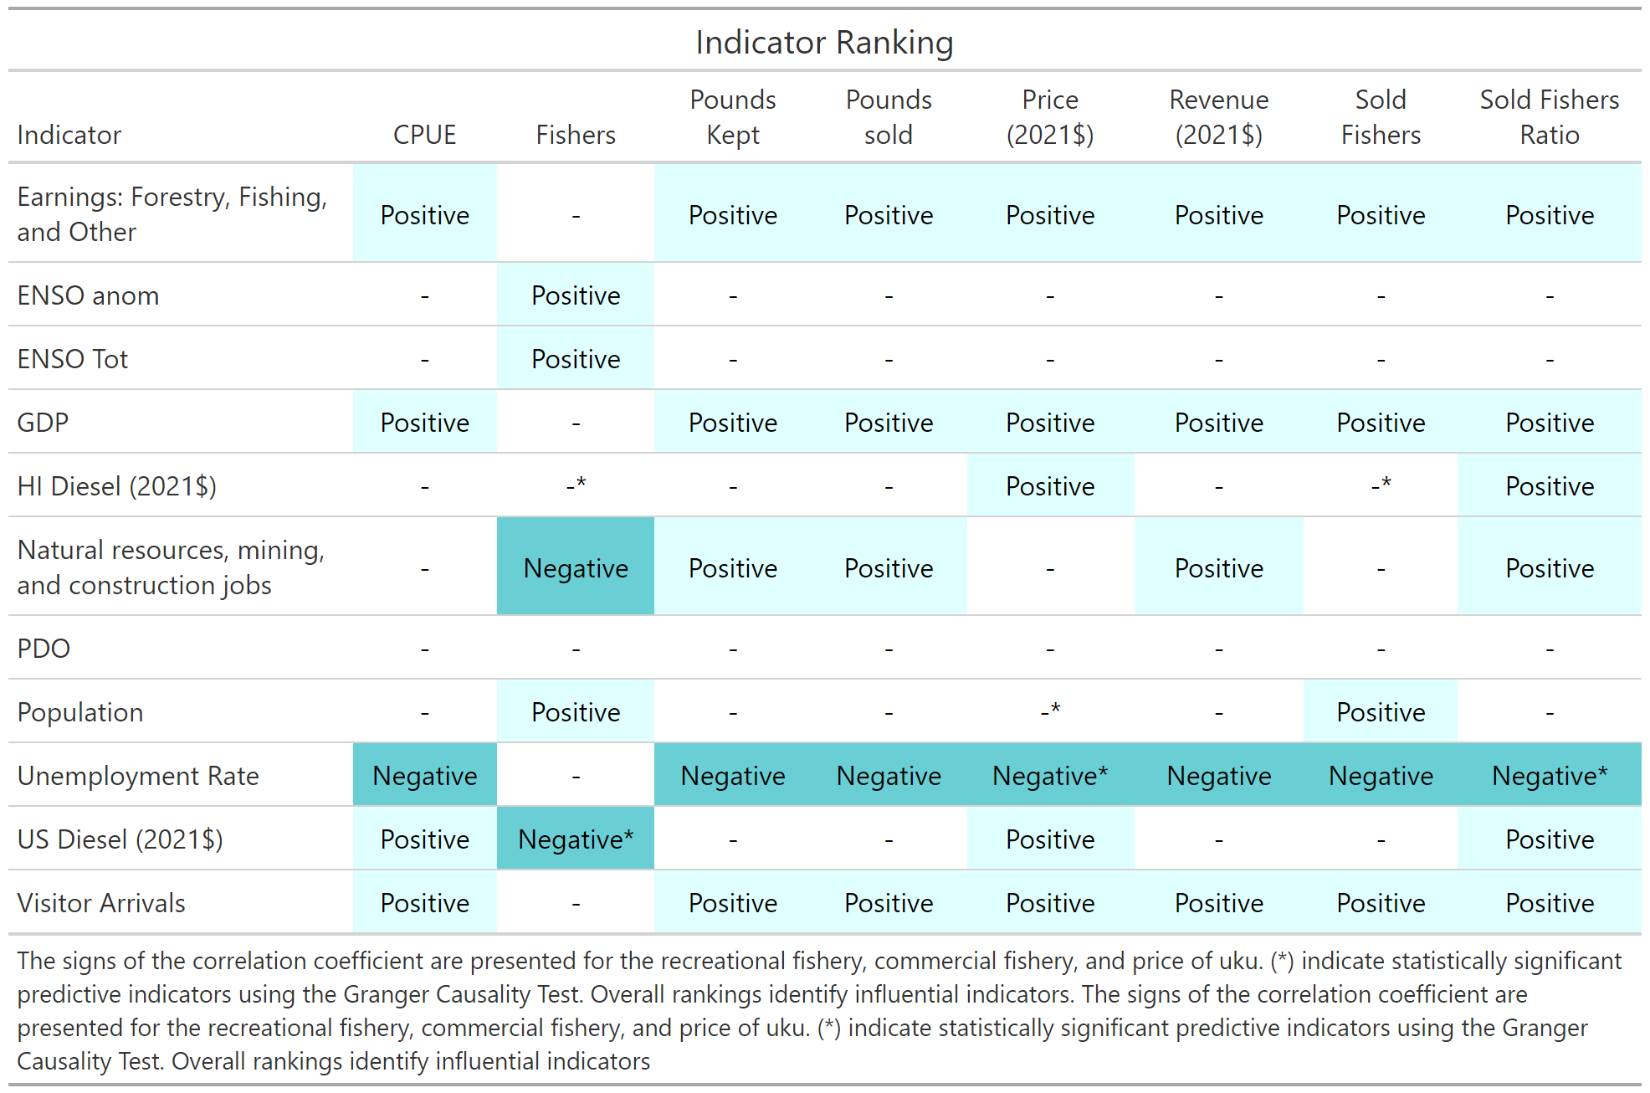

Fishery indicators

Socioeconomic and ecological indicators are tracked against fishery characteristics. A “Positive” value indicates two variables are move in the same direction through time. A “Negative” value indicates two variables move in the opposite direction. A (-) indicates a null relationship. An (*) is given to those indicators that are potential predictors of the corresponding fishery characteristic variable.

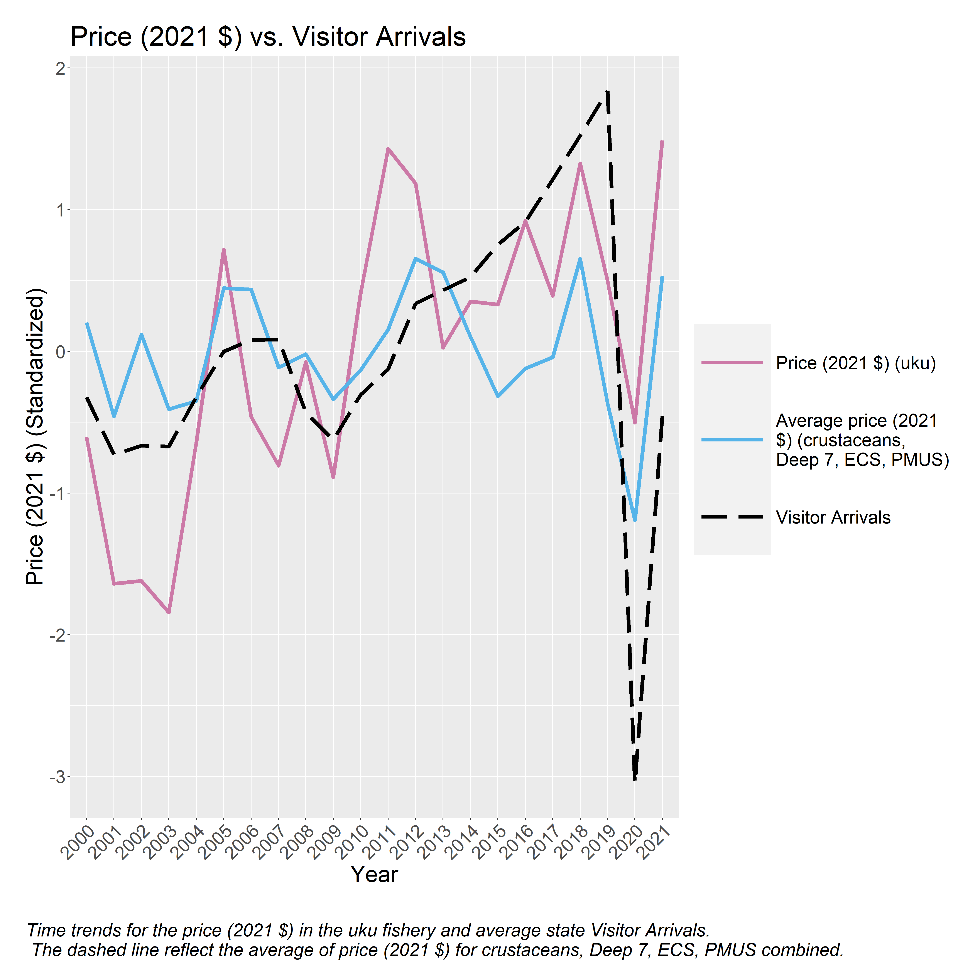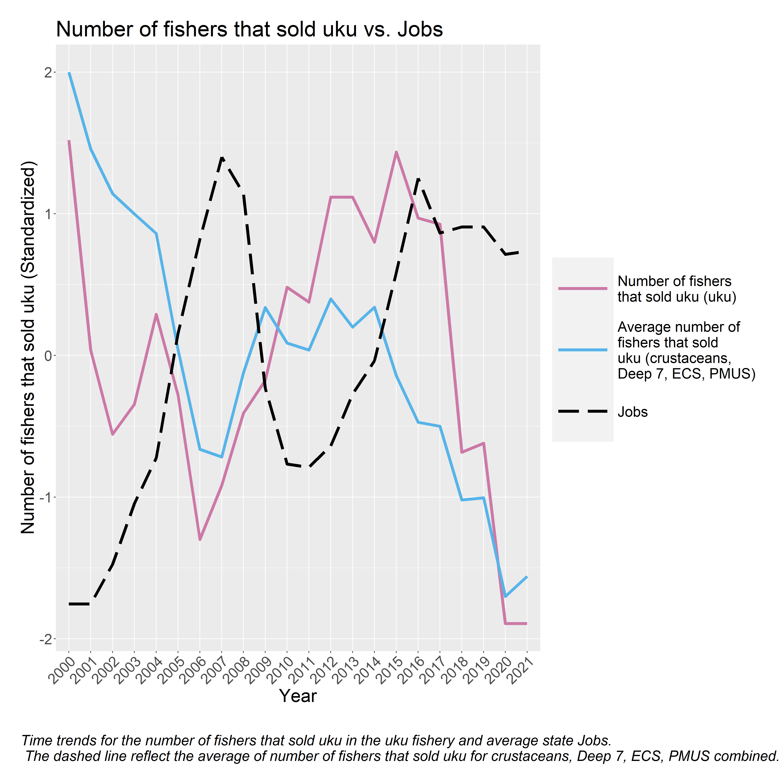

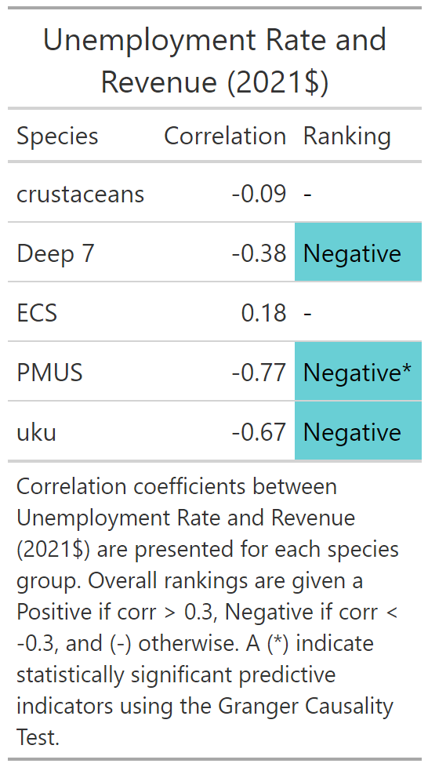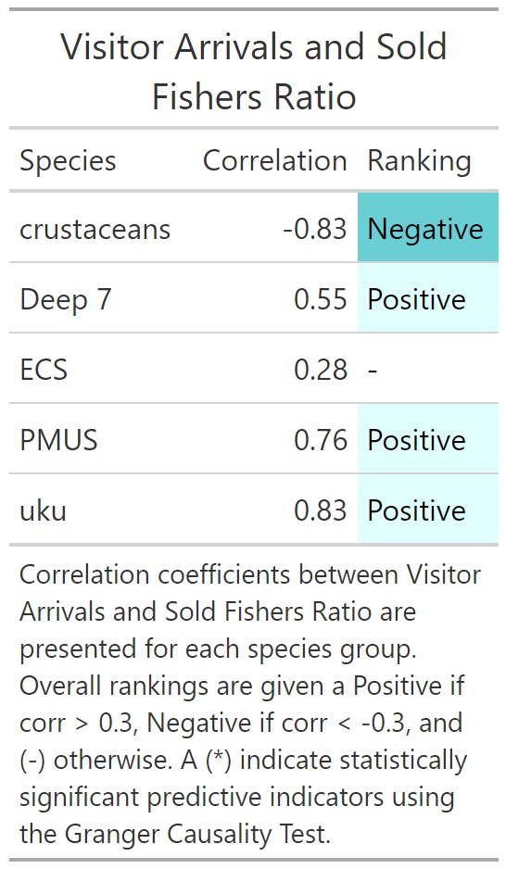

Socioeconomic consideration

Visitor arrival count and unemployment rate were identified as having the strongest relationship with characteristics of the uku fishery. The relationship between *Visitor arrival* and *Sold fisher ratio,* and the relationship between *Unemployment* and *Real revenue* are further examined relative to other fisheries. Correlation coefficients are ranked and assigned a “Positive” and “Negative depending if the coefficient exceeds 0.3 or is below -0.3. All other values are null and assigned a (-).

Time trends between *Number of fishers selling uku* and *Farm fishing, and other jobs* and time trends between *Real price* and *Visitor arrival* are shown. Each indicator is shown as a dashed black line, the uku fishery characteristic is shown in pink, and the average fishery characteristics for crustaceans, Deep 7, ECS, and PMUS is shown in blue.

Ecological consideration

Yearly average trends of ENSO and PDO (dashed black line) are plotted with yearly average trends of pounds kept of uku (purple) and the yearly average trends of pounds kept across crustaceans, Deep 7, ECS, and PMUS).

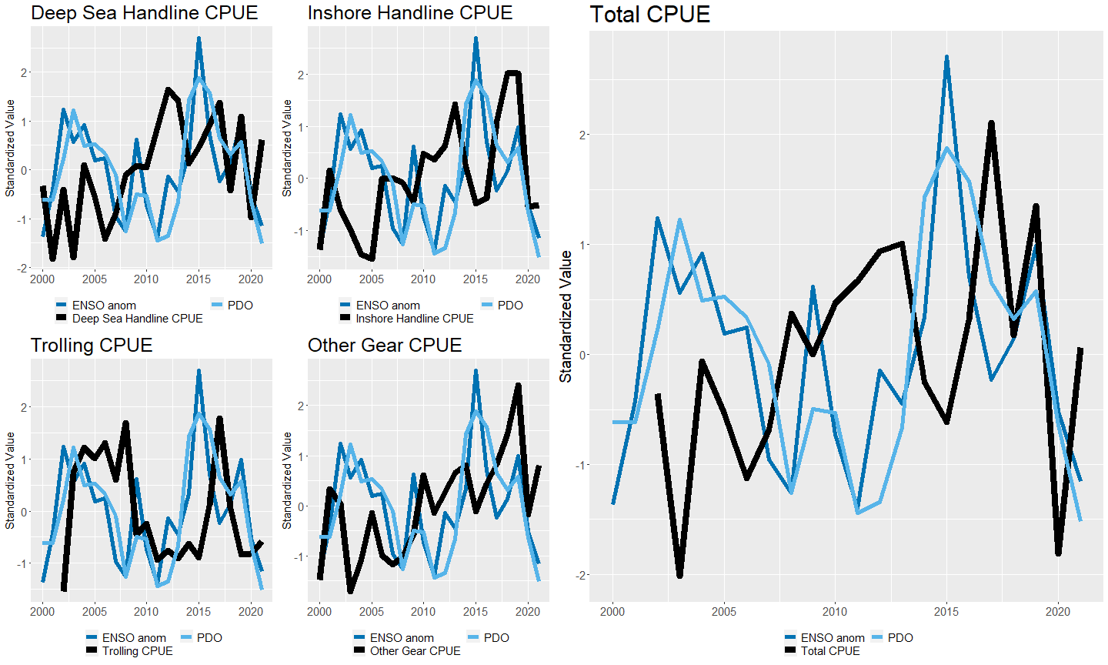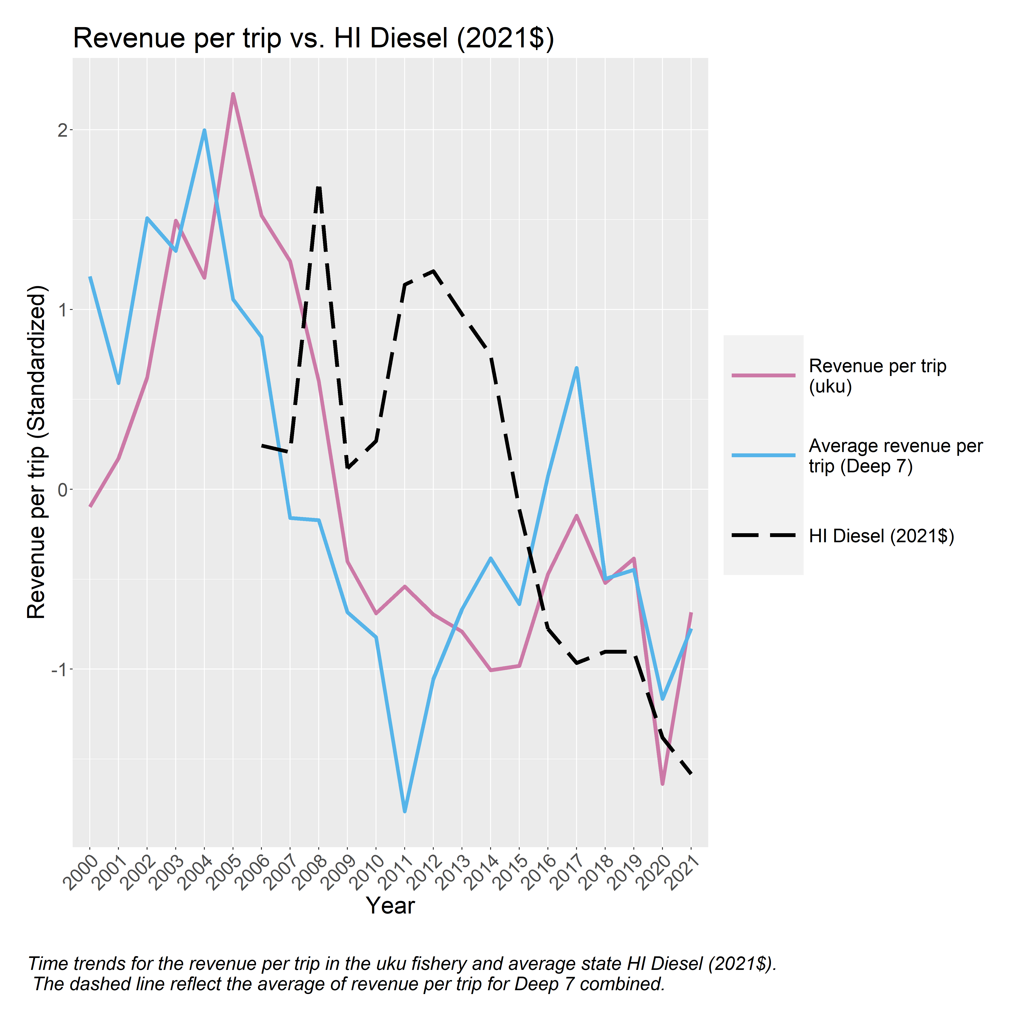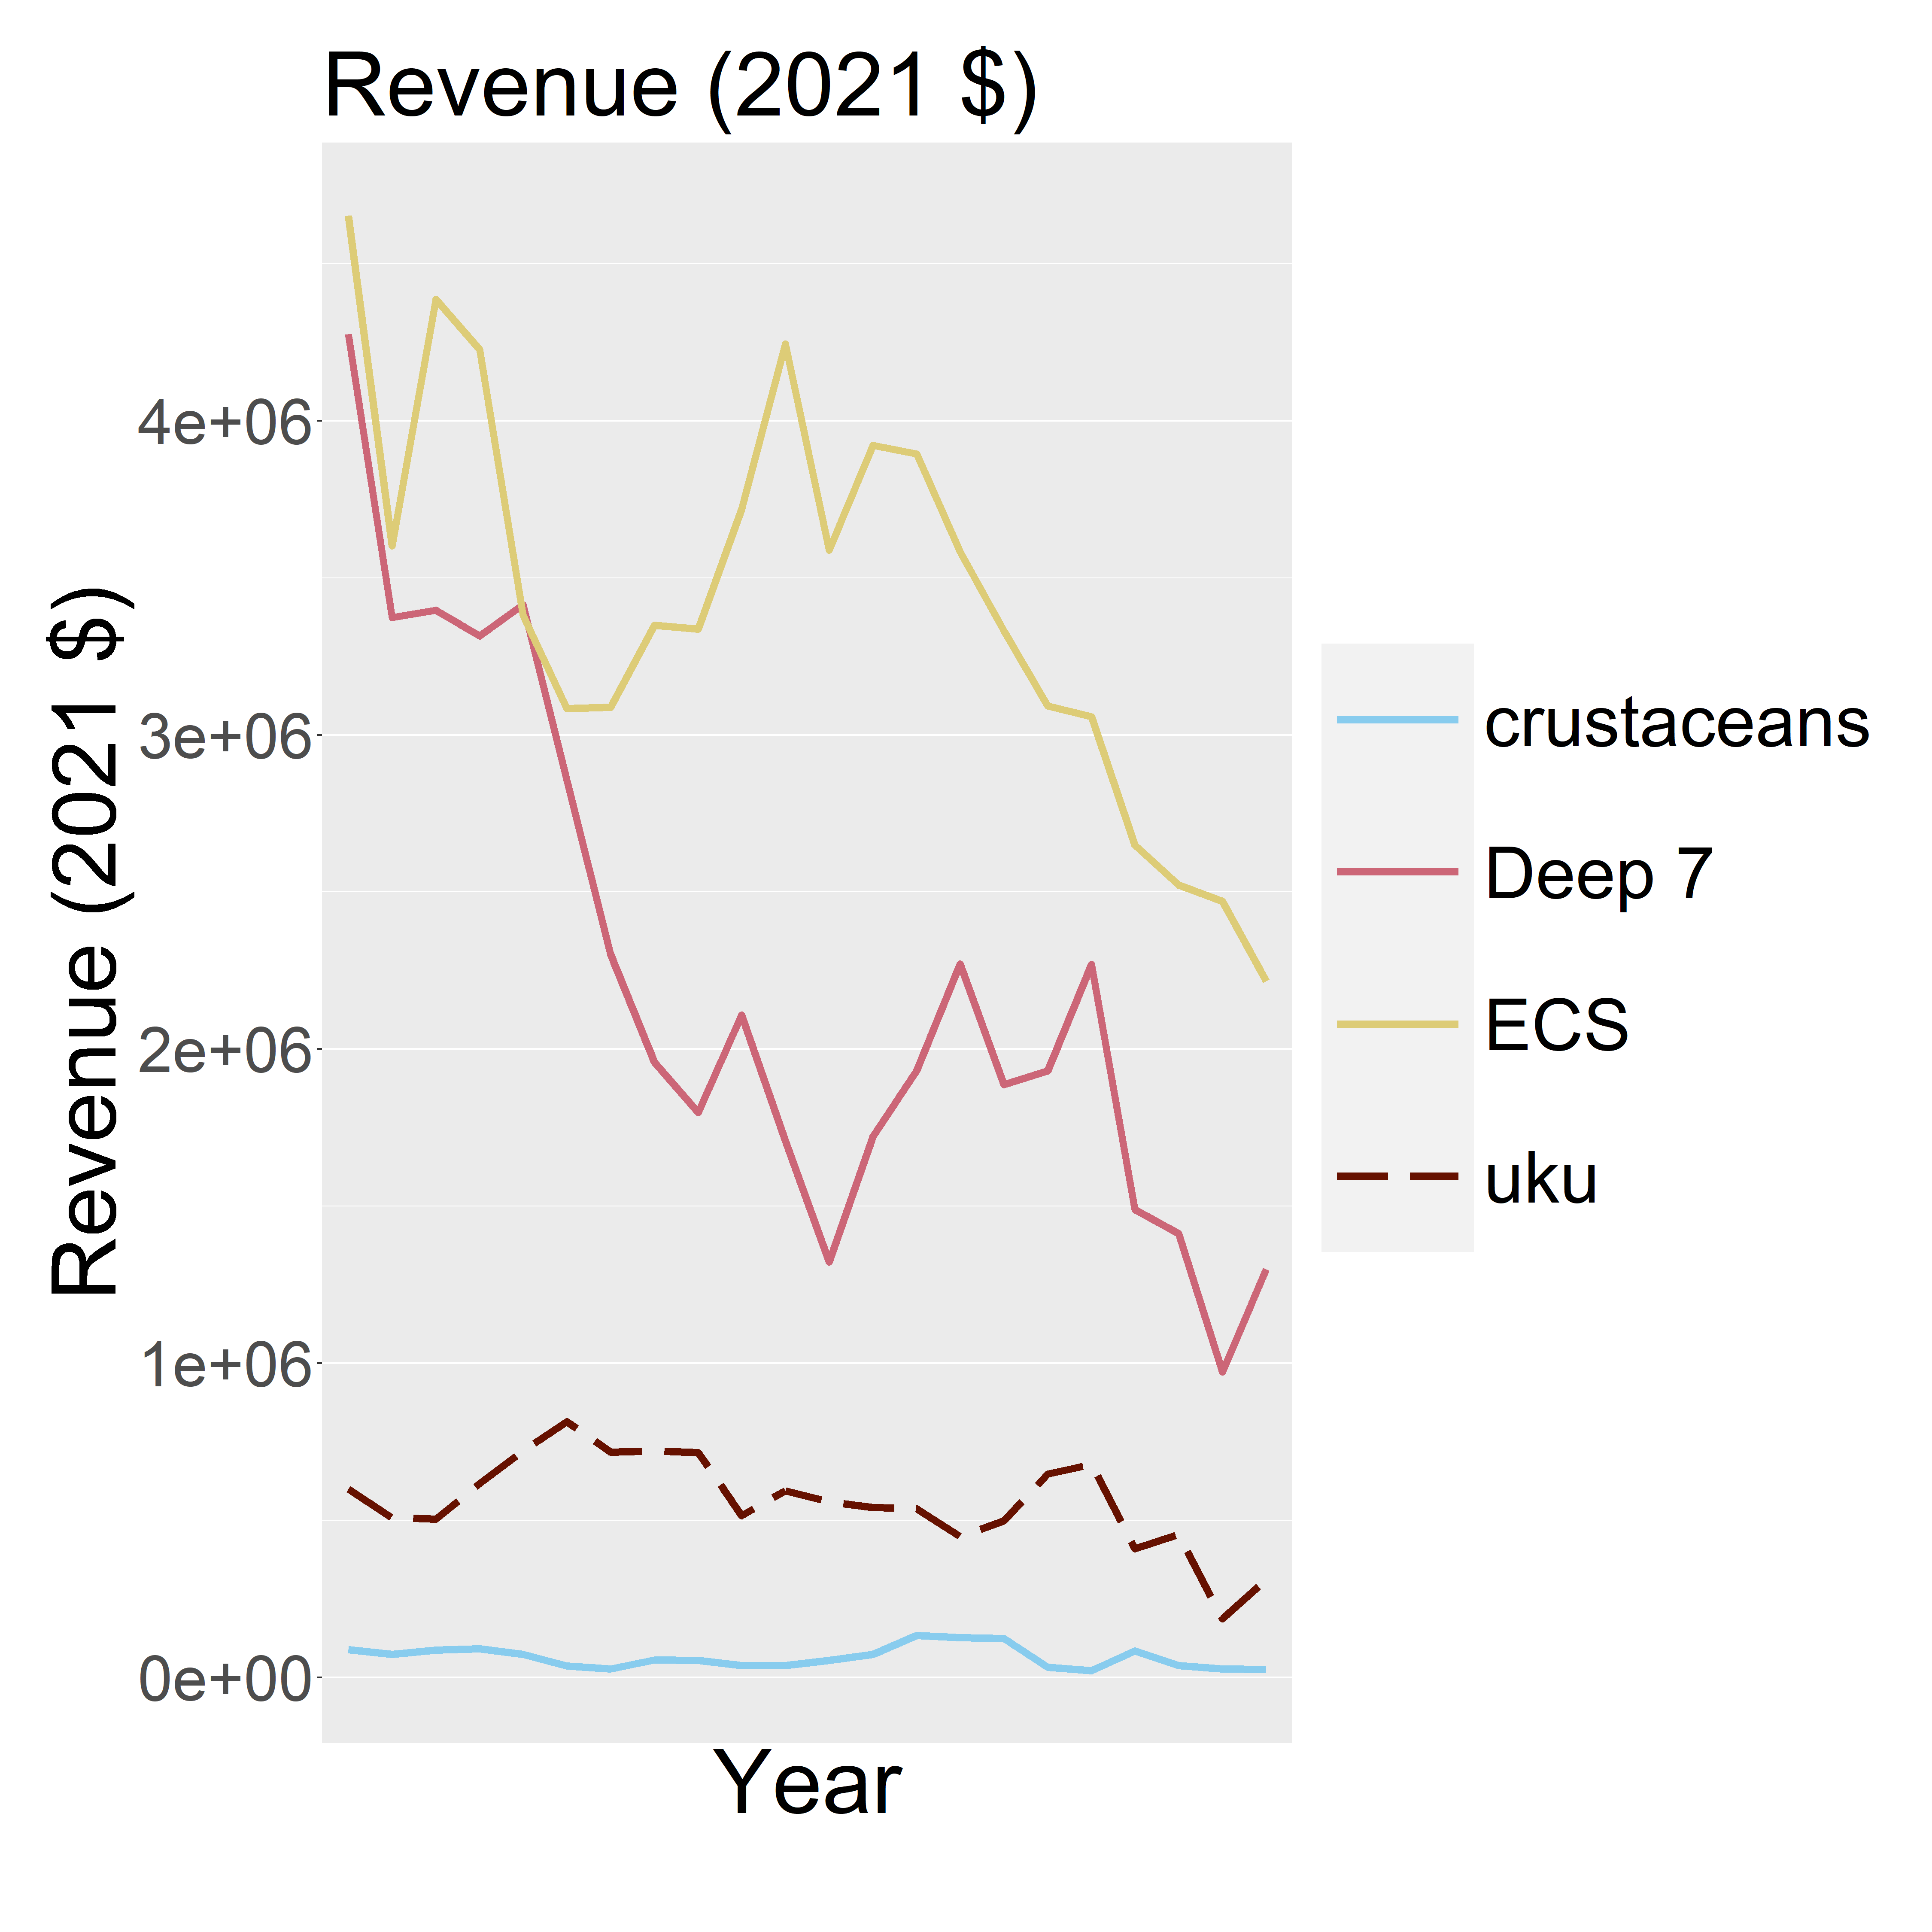

Trip trends

Yearly average trends of ENSO and PDO (dashed black line) are plotted with yearly average trends of pounds kept of uku (purple) and the yearly average trends of pounds kept across crustaceans, Deep 7, ECS, and PMUS).