MTN Vision for 2025 – Workshop Summary and Feedback

https://mtn-investor.com/mtn-ir2023/our-ambition-2025-strategy.php

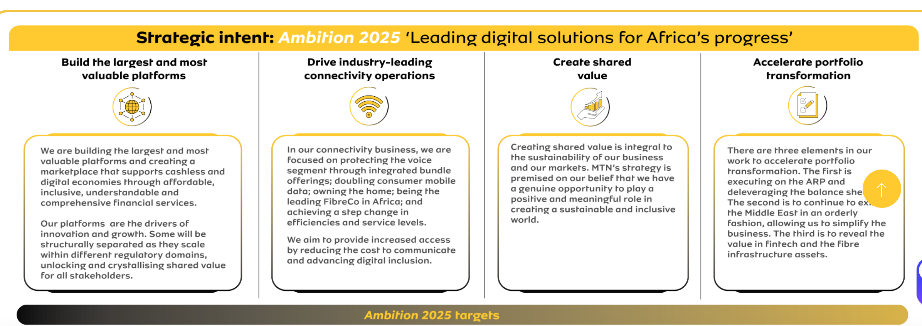

Performance
- Subscribers - up 2.2% to 290.9m (Mtn-investor.com, 2024)
- Active Data Subscribers - up 7.7% to 157.8m (Mtn-investor.com, 2024)
- Mobile Money (MoMo) monthly active users (MAU) up 0.9% to 63.1m (Mtn-investor.com, 2024)

Financials – Q1 2025
- Service revenue for Q1 grew 10.4% year‑on‑year, or 19.8% at constant currency, reaching ZAR 47.37 billion (~US$2.6 billion)—largely driven by Nigeria (+40%) and Ghana (+39.5%), which now contribute 27.5% and 14% to group revenue respectively (Nqobile Dludla, 2025)
- Fintech revenue surged 25.2%, with advanced services up 36.5%, and mobile money (MoMo) transaction volume increasing 17.5% (value +78%)

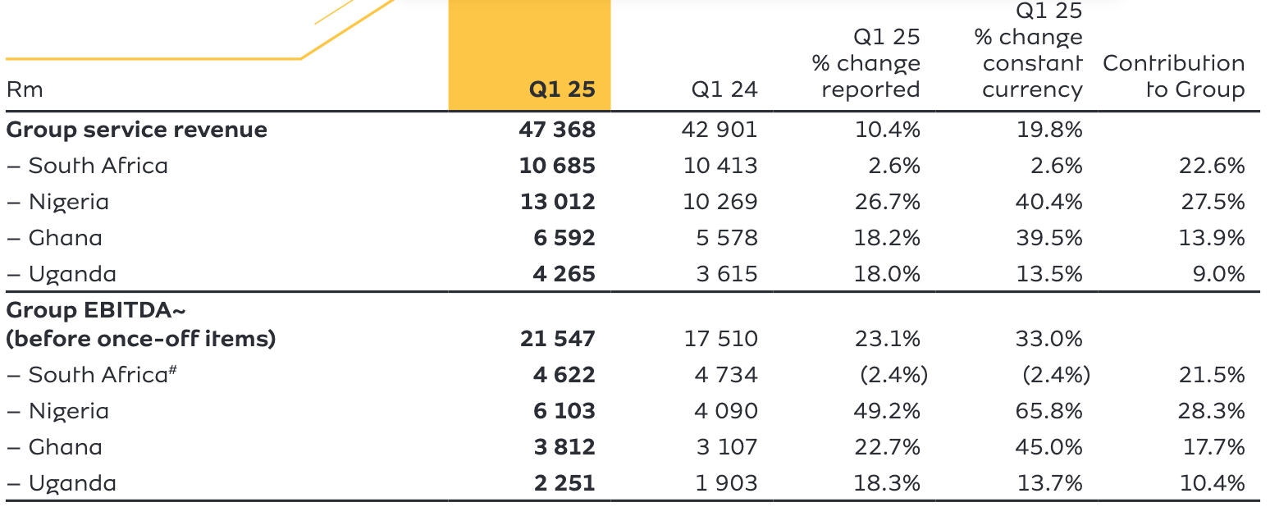

(Leading digital solutions for Africa’s progress MTN Group Limited, 2025)
Key points
- All financials quoted in constant currency
- Nigeria and Ghana contribute the most to group revenue strength
- Data and Fintech offerings are growing strongly.

MTN – Strategic Agility

Strengths:

- Large amounts of data
- Great organisational culture
- Ample human resources

Weaknesses
- No central data repository (this is in the process of being developed)
- Insufficient data capacity
- Teams may be lacking tools and technical skillsets, particularly in AI & ML.
- Poor prioritisation – the praxis
- Exposed to currency fluctuations across its various markets (Nigeria, Ghana, Iran, South Africa)

Threats
- MTN is seen by the participants as a bureaucratic organisation. This is perceived to slow the delivery of change through the organisation.
- Silos – multiple technology teams exist and they often operate in isolation to each other.

Ideas
- Partnerships with government/military organisations to provide intelligence on movements and events in underserved areas i.e. Northern Nigeria
- Identity Management – using MTN coupled with things like NIN(https://nimc.gov.ng/nin )
- Augmented reality systems to provide training for government employees in various disciplines.
- Learning Systems
- AI Co-pilot roll out across the organisation – this is apparently being considered by senior leadership

Issue 1 – Agile Process is not working for engineering teams
- MTN uses a mature implementation of agile. Engineers are split into teams which belong to tribes. Tribe leaders provide guidance on agile methodology and processes and meet to discuss impediments across teams and tribes. They also report delivery status to senior leadership. They reported that team leads are unwilling to attend sprint planning and status meetings. As a result, no estimates are provided on stories and planning has become about pushing the engineering team to hit deadline dates, rather than increasing confidence in a team velocity. Engineering leaders confessed to “not seeing the value” in agile ceremonies and meetings, and to avoiding them altogether.

Suggestions
- Strategic re-alignment

Environment | Dynamic, continuously changing demands and highly competitive
Strategy | Scaled agile to support connected outcomes for customers and innovation and cross functional delivery for employees
Competencies | The core agile competencies appear to be understood by mid senior strategic leadership
Organisation | - The people, processes, culture and structure of the organisation do not support the strategy.  People were unaware or unimpressed with the strategic vision  - Processes were not enforced by systems and gates and were not adhered to.  - Culture appears to encourage management intervention and micro management to achieve outcomes, rather than using the processes to deliver.

- They may benefit from an outside agile advisor to attend certain ceremonies
  - Agile drop-in sessions/workshops amongst tech leads to improve understanding
  - Analysis of existing ceremonies to ensure all are being sued appropriately
- Communication advice around the value and necessity of the agile process. MTN leadership may need advice on:
  - Enhanced communications to create a sense of urgency
- Open Strategy
  - A “Strategy Jam” drawing in senior management, management and individual contributor layers of the organisation would increase engagement and improve communications on strategy. These would be off-site exercises where the executive and management layers would focus on key strategic questions:
    - Where does MTN want to go?
    - How best should it get there?
    - Which processes are working, and which are not?
  - The goal is to join high level thinking to tangible actions with implicit buy in from contributors at all levels of the organisation. It would also highlight where teams/groups ate fundamentally misaligned with the strategy so resourcing decisions can be made.
- Issue tracking software should be used to validate Scrum steps i.e.
  - Workflow validation to ensure appropriate statuses exist i.e.
    - Logged > In Refinement > Ready > In Delivery > Complete > In QA > Release Ready > Released
    - Only ready items are available to be selected for any sprint.
  - Validation:
    - “Ready” items must have a story point estimate (mandatory field)
  - Code Management:
    - Jira feature branches should be created from within the Jira ticket alone (via Jira integration)
    - When feature branches are merged to main, the feature should be set to “Complete”
- Embedding the changes will require more accurate measurement of key metrics:
  - Attendance of ceremonies
  - Stories estimated during ceremonies
  - Story points delivered per sprint
- Scrum radiator should be created to report on key metrics around the engineering team’s delivery. This should be Realtime and used to provide line of sight for senior leadership.

Issue 2 – Employees feel that concerns over reputational harm due to high risk innovation projects creates challenges for the firm.

Engineering leaders report that speculative projects within the firm i.e. FinTech projects are delivered via the same teams that are delivering BAU changes to the firm’s core offerings. This creates tension when resource intensive innovation efforts draw more time and attention than BAU efforts. MTN is perceived to impair its brand equity when media source report on innovation “failures” being MTN failings.

Suggestions

Create distance between the core brand and the innovation group.
Concerns about reputational harm when an MTN product/platform doesn’t perform as expected create the perception of reputational harm to the MTN brand, which is unacceptable. A separate product/brand entity i.e. MTN Labs, should own responsibility for all innovation efforts, while MTN has the right to own IP created and take delivery of products once completed. The lab receives exposure to MTN users and data, MTN receives market ready products, without the risks to its processes, balance sheet or reputation.

Ring-fence Innovation Group resources and leadership
A separate innovation group with its own:
- Resource pool
- Balance sheet/PnL
- CEO (to choose which ideas to focus on)
could be free from BAU and ROI delivery pressures and might deliver faster and better value over time. Autonomy is key here, and the right leadership.

Define Incubator groups to drive innovation by reducing bureaucracy
“Incubators: Incubators operate like small, lean startups nes- tled inside the company. They are staffed by intrapreneurs, a special breed of innovators who have an entrepreneurial spirit and capabilities but can also leverage corporate strengths. Incu- bators use prototyping to test new business models and tech- nologies and learn which ones are winners. They experiment at a clock speed that is four to ten times faster than in traditional” (Davila, Epstein and Shelton, 2012)

MTN personnel believe that the risk first approach taken by MTN means ideas take a long time to reach the marketplace. Even if they are “shelf ready”, there are reportedly many compliance and authorisation steps pre-requisite to a new feature reaching real customers and providing real feedback. An innovation focused group with reduced bureaucracy could deliver much in their opinion.

Agile Readiness - Survey Results

The Agile readiness survey demonstrated that challenges exist within the areas of Organisational Culture and Structural Flexibility

Teams felt cultural habits and the decision making/collaboration processes of the teams do not support strategic agility. If you would like suggestions on approaches to remediating these please let me know and we can discuss how I can assist DeployFlow Further

