Calcdalton: A Tool for Easy Multiplex Genotyping Primer Design for Single Base extension Reactions using Cleavable Primers

Several methods for mass spectrometry based single nucleotide polymorphism detection involve genotyping primers containing linkers which can be cleaved chemically or by exposure to UV-light. Linkers allow better detection and open a conveniant way for multiplexing reactions. However, for succesful genotyping many paramaters need to be considered when placing the linker into the primer. Here we present a java based software tool to optimise these positions in a multiplex reaction in order to achieve optimal detection in the MALDI-analysis. The software comprises an intuitive graphical user interface and accounts for the resolution of the MALDI-device, cationic by-products, matrix effects and preferred usage order of the photolinkers. It is freely available at http://192.168.0.9/~sdienst/calcdalton.jnlp.

Matrix assisted laser desorption – ionisation mass spectrometry (MALDI-MS) is now one of the most automated and efficient single nucleotide polymorphism (SNP) detection methods. It delivers highly accurate results with exceptional reliability (PMID 12666148 noch lesen, sekundaärzitat aus PMID 15766735). However, a problem in MALDI nucleic acid detection arises from the negatively charged sugar phosphate backbone leading to adducts with cations. (PMID 12164776) Methods were developed to account for this issue. One strategy to overcome this is to cleave the genotyping primer at a specific site decreasing the number of negative charges. Additionally, analysis of smaller fragments increases sensitivity, resolution and accuracy (Pharmacogenomics 2002). The introduction of cleavable sites allows flexible spacing of primer signals in the MALDI-detection because the size of the fragments is directly related to the position of the cleavable linker. Technical aspects of related methods have been already described in detail (Quote GenoSNIP (PMID 14565470), NH-3 (cleavage chemie PMID11557819), phophatchemie PMID 10380766). However, figuring out the optimal photolinker positions - especially for higher multiplex numbers – is quite cumbersome. Many parameters, e.g. resolution and mass range of the MALDI-device, the formation of residual cationic by-products, matrix effects and preferred usage order of the photolinkers need to be considered. To make calculations convenient and efficient while accounting for these paramters, we have developed a java based software tool called calcdalton. The aim of the program is to position linkers in every primer and to subdevide them into appropriate multiplex reactions. The program comprises with an easy and intuitive to use graphical user interface (Fig.1). The user can specify the applied cleavable linker, maximum and minimum mass range of the MALDI-device, excluded mass ranges (e.g. important for mass ranges where matrix signals are expected to occur). The resolution of the instrument is taken into account by the specification of a minimal peak distance. To avoid interference with cationic adducts, excluded distances between peaks can be defined. The available mass range can be used more efficiently by allowing the primer, but not the genotyping products, to be within excluded peak distances. A favoured usage order of linker positions can be defined. After calculating, multiple solutions being equal in respect to the favoured photolinker order are shown. To assess the suitability of the solution, all mass differences occurring in the result are calculated and a preview of a typical MALDI-spectrum resulting from the outcome of the calculation is drawn.
Sometimes it s not possible to include all reactions in one multiplex. In these cases the user can choose between two possibilities: First, a multiplex with a maximum number of primers is generated. Remaining primers are grouped in one or more subsequent reactions. Second, a number of multiplex reactions that tend to have an approximately equal number of primers.
The program is entirely written in Java™ 1.4 and available via Java™ WebStart at http://192.168.0.9/~sdienst/calcdalton.jnlp. It is distributed under the GNU public licence. Minimum requirements are an installed Java™ Runtime Environment of at least version 1.4. It can be found at http://www.java.com. Three different algorithms are implemented: The standard algorithm can provide the best possible solution by testing all possible solutions via brute force. It looks for the optimal solution by depth-first traversation of the solutions tree . To increase speed some branches are pruned if it is for sure that the subsolutions these subtrees represent aren't valid in combination with the subsolutions found on lower depths.
Different algorithms are applied in case of the situation mentioned above where more than one multiplex is necessary to accommodate all primers. Here the problem is equivalent to partitioning a graph into several disjoint cliques. Nodes represent possible primers and connecting edges an incompatibility between those primers. In case of the search for a sub-multiplex accommodating as many primers as possible, the reverse of the entire graph is generated. A Max-clique algorithm defines the maximal subset being compatible with each others. The algorithm was taken from the paper “Exact Coloring of Real-Life Graphs is Easy” from Olivier Coudert written in 1997 (http://portal.acm.org/citation.cfm?id=266047). In the case of finding a subset with as few multiplex reactions as possible with rather equally distributed numbers of primers a graph colouring algorithm is applied. These two problems are so called NP-complete problems, that means that there are no known algortihms that can solve these problems for bigger problem instances in justifiable time. The only way to get solutions is to be satisfied with suboptimal solutions and to use approximative algortihms. In our case we use the exact algorithms but restrict their cpu time to some fixed time what in fact makes them approximate.
The design applies the Jgoodies Looks package (http://www.jgoodies.com/freeware/looks/) and the preview of a typical MALDI-spectrum is generated using the JFreeChart package (http://www.jfree.org/jfreechart/index.php).
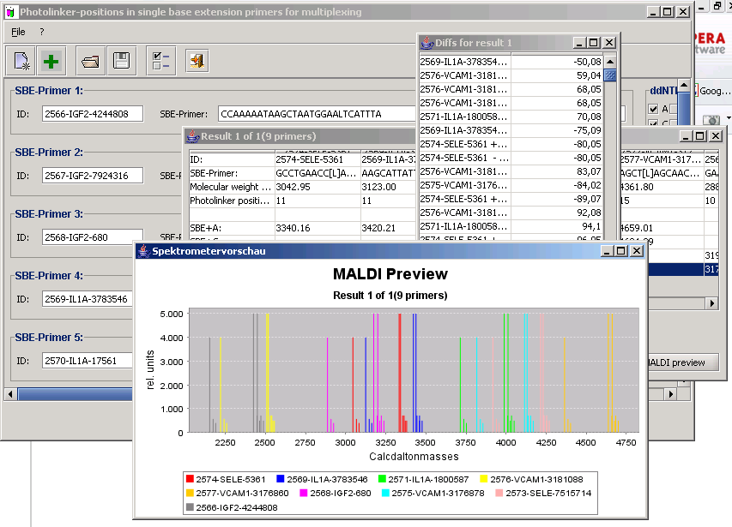
Fig. 1 Calcdalton is a java based software tool for facilitate multiplexing of cleavable primers for MALDI based SNP genotyping. The software comprises an intuitive graphical user interface

Acknolodgments:
I love you all

References:
8 Stück insgesamt ca 700 wörter

Requirements contents:
Was ich reinbringen will
Maldi ist toll

Genosnip ist cool

Multiplex ist wichtig, aber aufwendig, laut

Hier kommt calcdalton

Bla Bla bestimmte features.

Blab bla bestimmter Algorythmus

Wergebnisse: So typische plexzahlen, die man schaffen kann. --> das ist settingsabhängig, und somit schwierig zu sagen --> besser in optischen Bild dies suggerieren.

Weitere Ziele --> (Mini-SBE)

Availability

Stufenweises multiplexen beachten als vorteil von calcdalton (kostenersparniss durch gemeinsames aufreinigen)

Warum ich das sauer paper noch nicht mit hineingenommen habe:
- Charge tags berücksichtigen --> gänge vielleicht, wenn man das O-ME als Mass modifierer variable gestalten bzw. sie überhaupt ersteinmal hineinnehmen würde. Das wäre aber ohnehin ganz gut für uns.
- Massen vom Good assay noch nicht herausbekommen. Da kann man kostrzewa frgen
- Bei GOOD keine Na und K --> prieview müßte modifiziert werden.

Requirements design:

BENCHMARKS (maximum of 2 journal pages; limit of 1000 words, 1-2 small figures, and about
15 references) are brief communications that offer brief but substantive modifications of existing
methods or concise new methods. For manuscripts involving improvements to existing methods,
authors must show significantly improved results compared to the standard protocol, or
equivalent results with substantial time or cost savings. Benchmarks do not contain abstracts or
subsections but a summary for review purposes will be required during manuscript submission.
Authors are encouraged to provide brief enumerated protocols when appropriate.

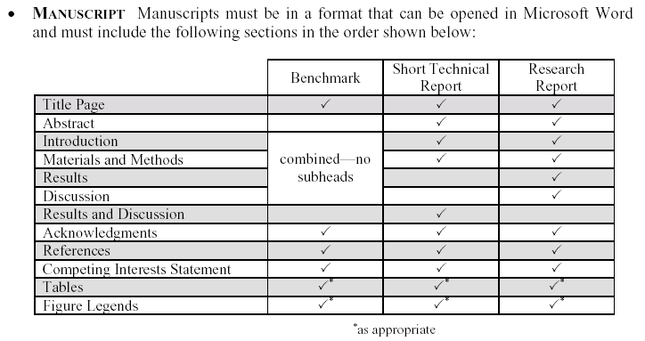

TODO list Steffen Calcdalton:

TODO

Sachen, die imperfekt sind:
- beim Start heisst es "Eingabe" und "Abrechen" statt "input" und "Cancel" Liegt an der Spracheinstelung von windows, kann ich nicht aendern
- wenn man excluded mass range auf 2000 bis 8000 setzt, gibt es bei eingabe von AAAAAAAAAAAAAAAAAAAAAAAAAAAAAAAAA
ein ergebnis, was im bereich zwischen 2523 und 2836 liegt.
in work, liegt an einem vor urzeiten eingebauten spezialfall, dass eingabe nur eines primer einfach kalkulieren sein sollte, passt nicht mehr ins konzept
- Auch die Fehlermeldung sollte spezifischer sein.
in work - hier Fehlermeldung: "Primer [Nummer oder Name primer] sequence is within excluded mass range"
- der knopf "allow for all extension products" macht bei mir gar nichts.i.e es hat keine auswirkung, obich ihn pushe oder nich. Gut wäre, wenn er so wie in minisbe funzt, also, er berücksichtigt in der internen calculation alle SNPs?, wenn er angeklickt ist wobei aber im preview nur die angegebenen ddNTPs berücksichtigt werden.
--> in arbeit, nicht erwartete ergebnisse werden sogar eingeklammern
- Calcdalton kann sich nicht die angeklickten SNP-typen merken, wenn es die Primer speichert
in work

Sachen, die wir für die Publikation evtl noch gebrauchen könnten.

wichtig
- Angehängte Massen der Nukleotide bzw. des Photolinkerbruchstücks als Eingabeparameter in den Settings in neuer Registrierkarte
- Umstellen auf GNU incl. hinweis beim Start
in work
- Frage maximales subset oder gleichmässiges subset (MAxClique? oder Graffärbung)wenn keine perfekte lösung möglich ist.
- logfile rausnehmen oder nur clever intern starten
als parameter, in work
- Vorgabe eines Mass ranges, in dem die primer liegen dürfen (ähnlich wie excluded, nur eben andersrum) --> du kannst das ja rein grafisch lösen, indem du "Lower limit (Da):" und "Upper Limit (Da):" einführst und intern es als excluded Mass range betrachtest, der von 0 bis "lower limit" und "upper limit" bis 999999999 reicht.

nicht ganz so wichtig
- settings fenster geht in den hintergrund und kommt nur mit alt-tab wieder
gesagt, lässt sich vielleicht ändern oder ist windows problem
- Einfügen mit rechter Maustaste
vorgewarnt
- Abfrage ähnlich wie bei MiniSBE, ob man bei beenden die primer speichern möchte.
- ein ganz wildes feature: "O-Methyl-modifiziertes"G bzw O-Methylmodifiziertes A". Jedes A oder G, was in Richtung 3' des Photolinkers liegt, also mit abgespalten wird, kann genau eine O-Methylmodifikation bekommen. Ich kann auch einfacher sagen, dass man fakultativ noch 30D an die A oder G hängen kann, die mit abgespalten werden, was die Multiplexkapazität noch weiter erhöht. Bzgl der lieblingsfotolinkerreihenfolge würde gelten, möglichst wenig PL, die möglichst in der lieblingsreihenfolge weit unten liegen, verwenden.

