# **Technical Document**

## Server Informations

The **IP address** of the server is the **same as** the **machine** which its running in.

The **port** on which the server will listen for client’s connection is always the **45007**.

* To run the server you just have to click on the “Start” button.

## Client Informations

Any user **should create a folder in “C:”** before launching the application :

* First, a **“VSFY”** folder

Then inside the VSFY Folder create :

* **“FilesToSend”** folder
  + This will be the folder that contains the client’s song.
  + These song’s names are sent to the server when the client will connect.
* **“FilesToReceive”** folder
  + This is where the files are stored after they’ve been sent by the server.

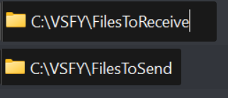

Figure 1 : Final paths user should have