|  |
| --- |
| **FIG**  VSFY – User Manual |
| Distributed Programming, Module 633-2  Jannuary 2022 |

Produced by : Emilie Teodoro Do Nascimento & Mégane Solliard

Teacher in Charge : Antoine Widmer

Table des matières

1. Program functionality 2

2. Important information 2

3. Folder structure 2

4. Running the two applications 3

4.1. Launch the server 3

4.1.1. How to close the server 4

4.2. Launching the Client interface 4

4.3. Client Navigation 5

4.3.1. Client’s Dashboard 5

4.3.2. Client’s Playlist 5

4.3.3. Song Detail Window 5

5. Problems 6

1. Program functionality

VSFY is a peer-to-peer audio streaming application with a synchronization server using JavaSocket.

1. Important information

Before starting anything, you should create a VSFY folder in the C and create two other folder inside VSFY named FilesToSend and FilesToReceive. The folder names are key-sensitive so write it like written above.

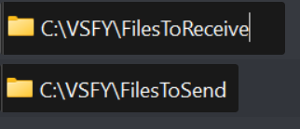

In the folder FilesToSend you have to put all the song you want to sent to the server.

When the server runs it takes the IP address of the machine. It always listen on port 45007

1. Folder structure

In the “Client” folder we have all the classes regarding the client side of the application, and same for the “Server” folder. For the .jar files they are stored in the “out” folder.

1. Running the two applications

## Launch the server

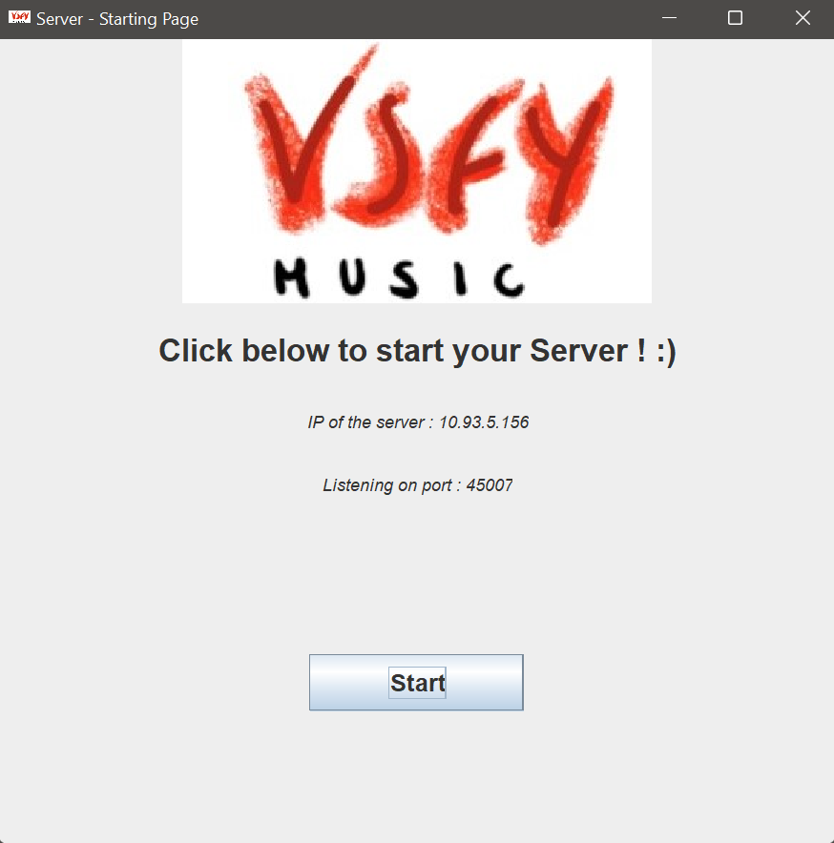

* Click on the “Start” button to launch the server. It will wait for client’s connection.

* The list of all connected client will be displayed
* You will also see with which IP address the server use and on which port he is listening.

### How to close the server

* 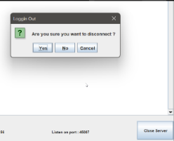To close the entire server, you have to click on “Close Server”
* A Pop-up will appear to have a confirmation of want you want to do
* By clicking yes it will close all client’s connection and the server socket

## Launching the Client interface

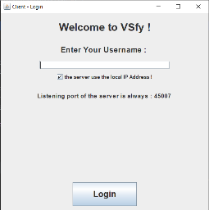If the server run on the same machine as the client :

* Enter your username
* Keep the box checked
* Then click on login

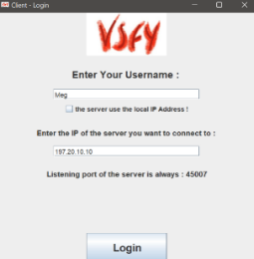

If the server is running on another machine :

* Enter your username
* Unchecked the box & Enter the IP of the server
* Then click on login

## Client Navigation

### Client’s Dashboard

* You can access your playlists
* Access to other users
* Logout

### Une image contenant texte Description générée automatiquementClient’s Playlist

* You can go back to the menu
* You can select a song by clicking on it
* If there are a lot of song to display a scroll bar will appear in the right side of the list.
* When you select a song a pop-up is displayed to have the confirmation from the user.
  + 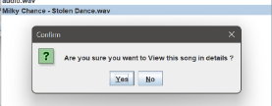if you choose *“Yes”* , the song detail will be displayed

### Song Detail Window

When this frame is displayed the song begins.

* You can play and pause the song as you want
* You can use the slider to turn put/down the volume
* Go back to playlist
* Go back to menu

1. Problems