
Project Report Template

INTRODUCTION: 1.1 Overview * Customer Relationship Management is a strategy that companies use to manage interactions with customers and potential customers.CRM helps organizations streamline process,build customer relationships,increase sales,improve customer service,and increase profitability

1.2 Purpose

* A CRM platform connects insights campus-wide instead of creating data silos,making it easier for insyitions to quickly support new business models as constituent needs evolve over time.

- Problem Definition & Design Thinking

2.1 Empathy Map

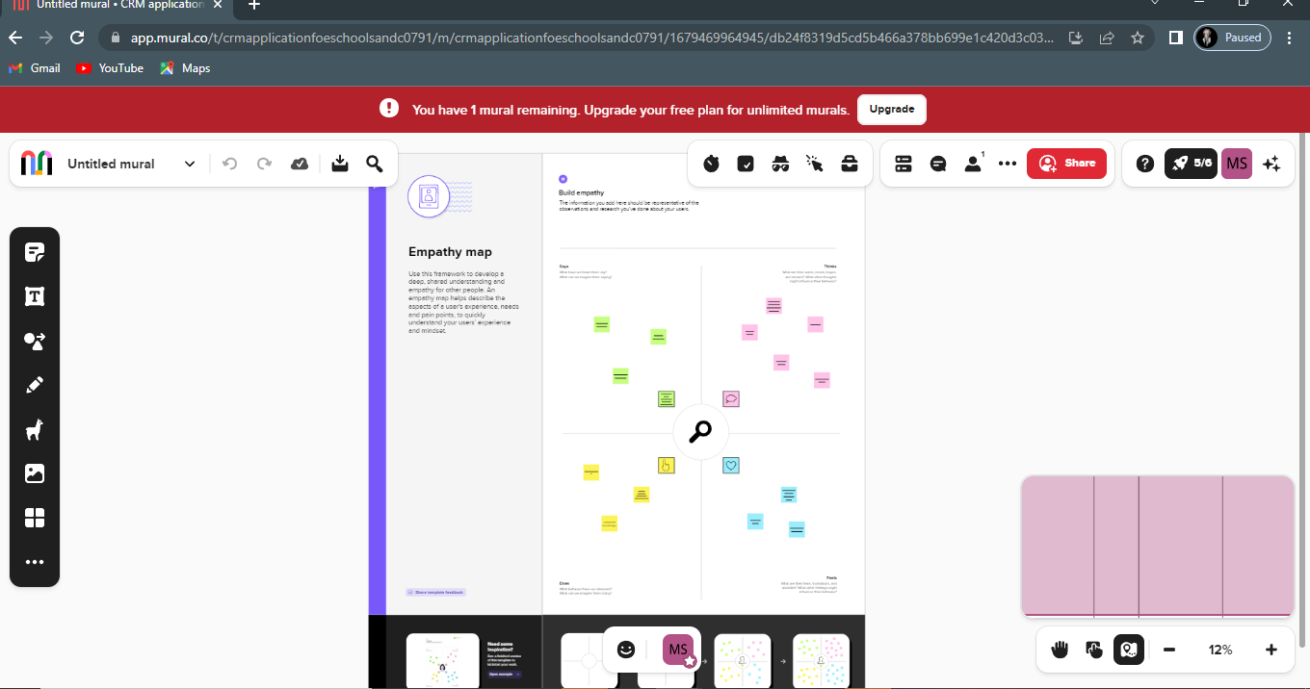 2.2 Brainstroming and Ideation Map 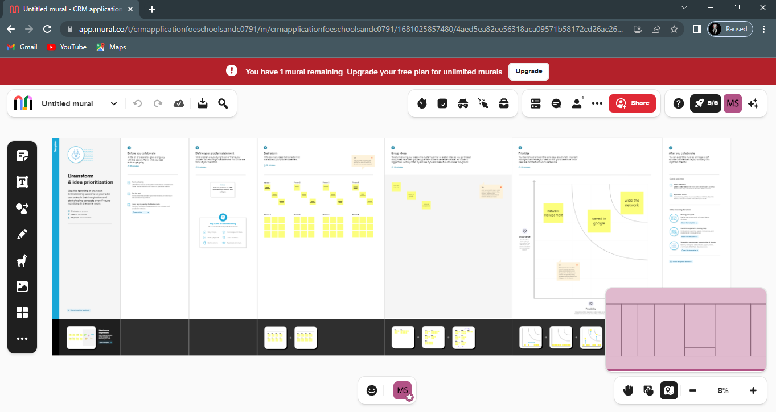

- RESULT

3.1 Data Model:

Object name | Fields in the Object
obj1:
ATTENDEES |  | Field label | Data type
 |  | Enter id | Auto number
 |  | Phone | Phone
obj2:
 |  | Field label | Data type
SPEAKER |  | Enter Bio | Text Area
 |  | Email | e-mail

3.2 Activity & Screenshot :

Milestone-2:object
Activity: 1

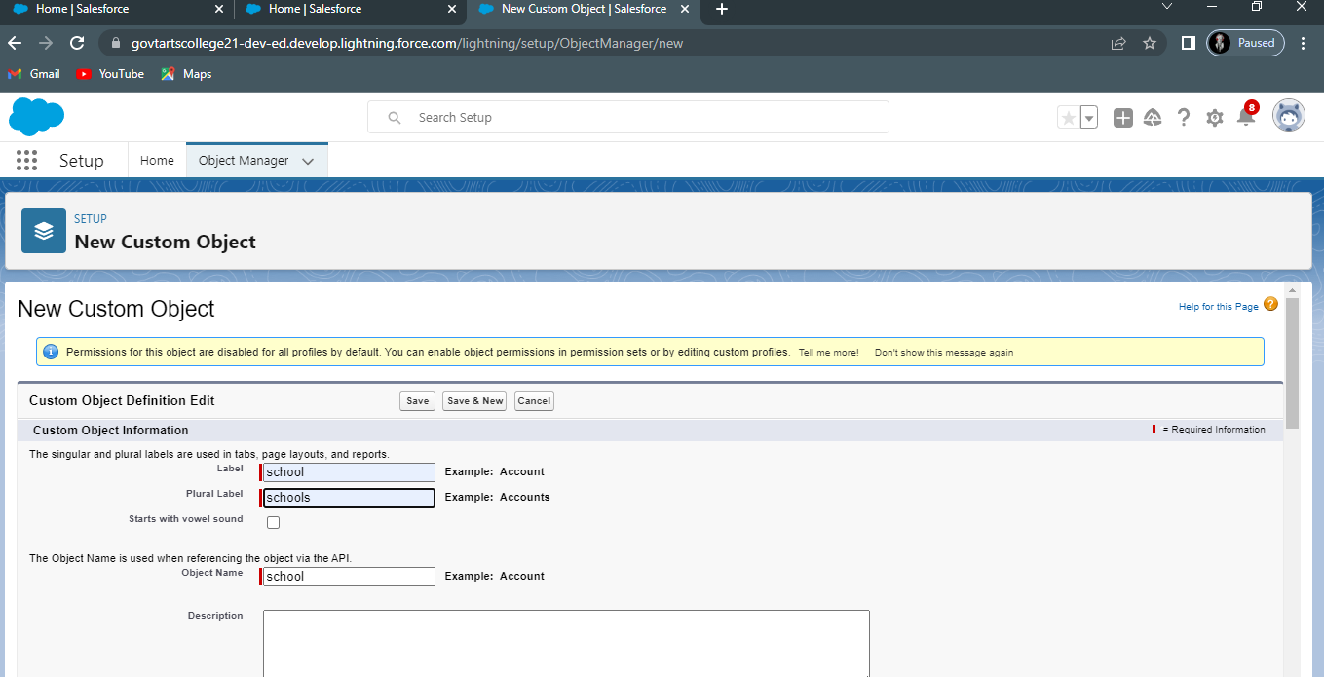

Milestone:3 Lightning App
Activity: create the school management app

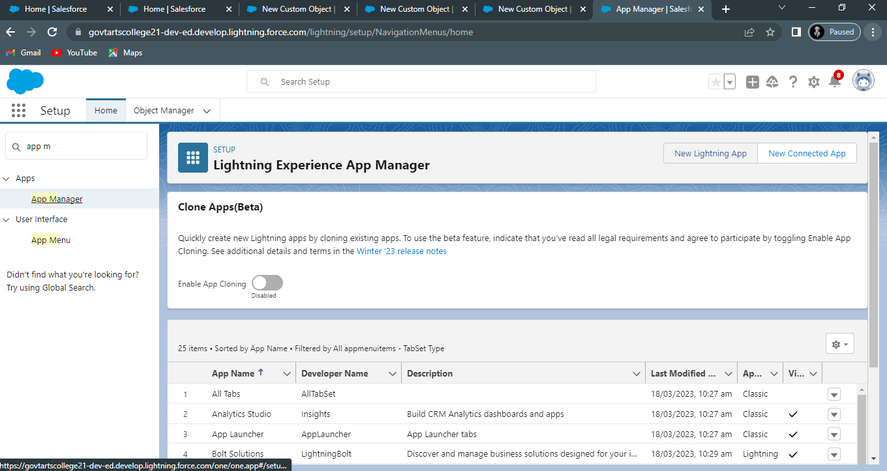

Milestone:4 Fields and Relationship
Activity: 1

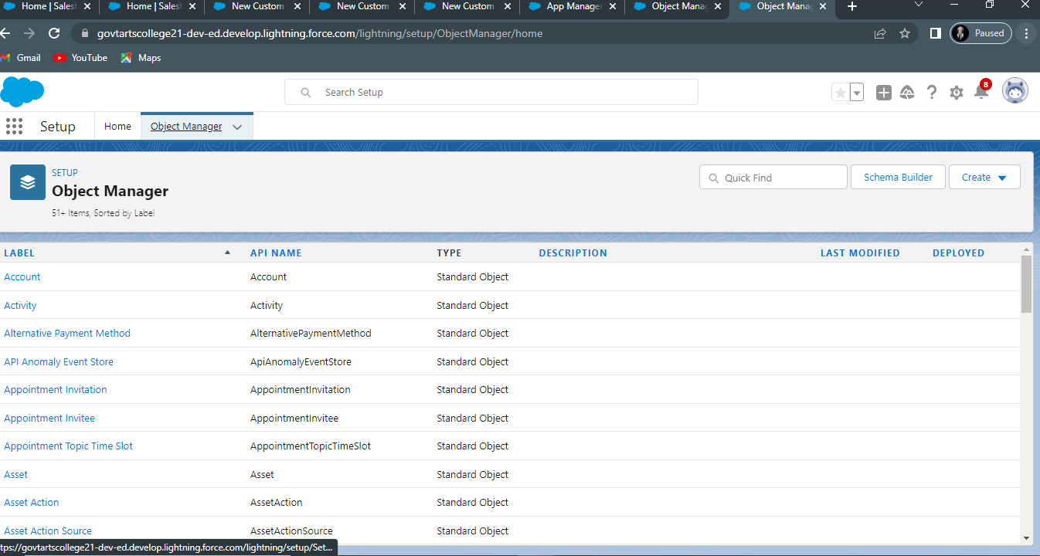

Milestone:5 Profiles
Activity : 1 creation on profile

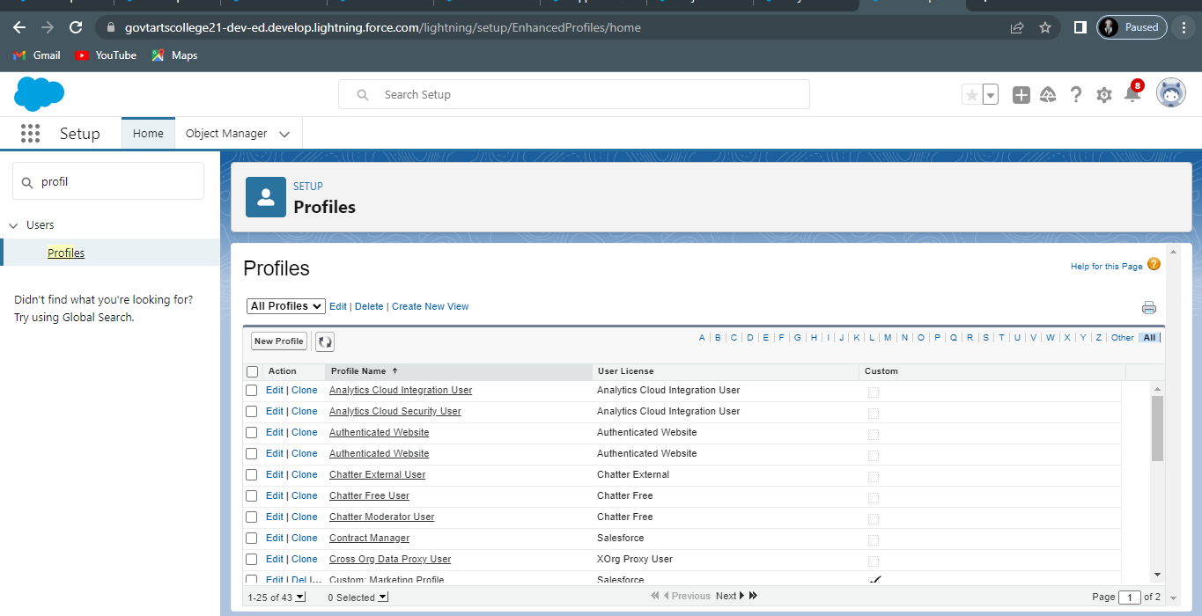
Milestone:6 Users
Activity : 1 creating a uers

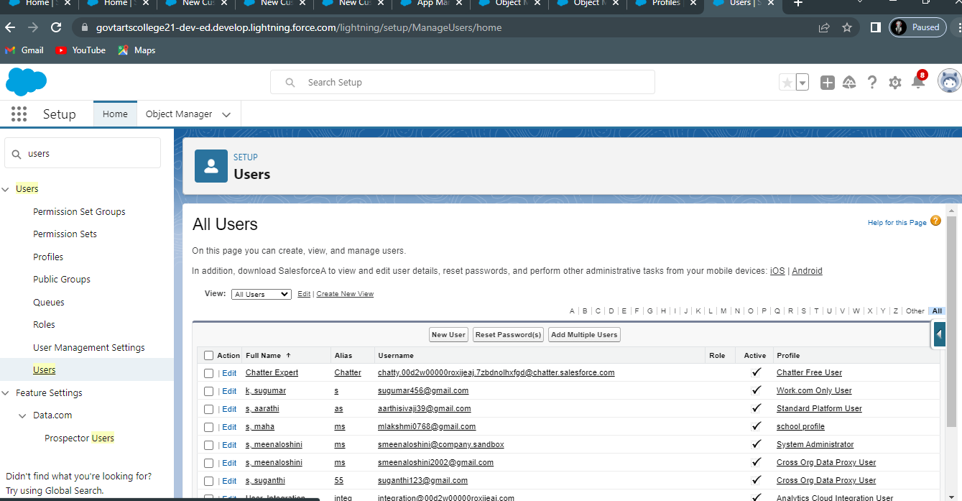

Milestone:7
Activity : 1

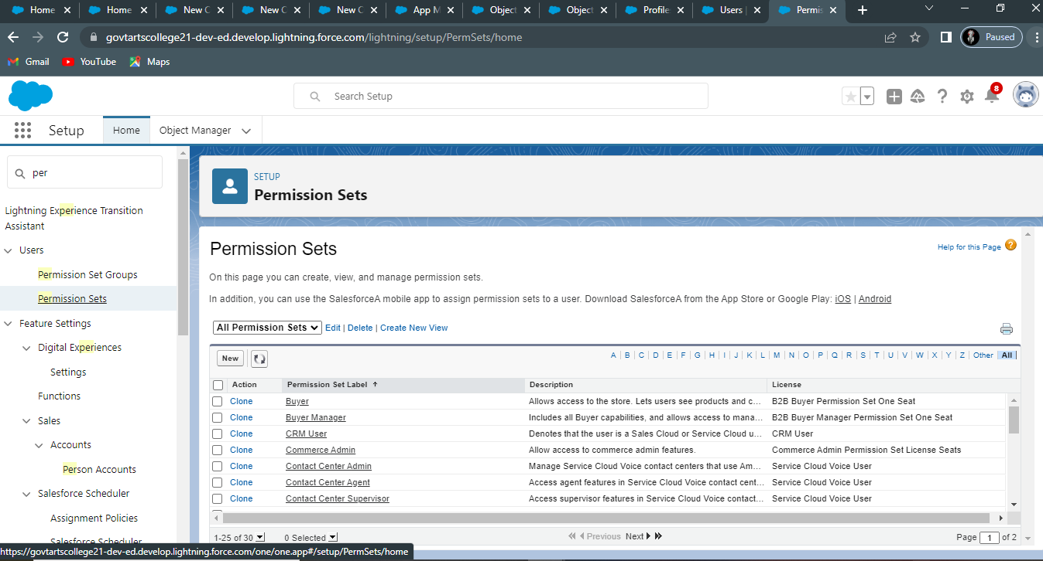
Milestone:8 Reports
Activity : 1

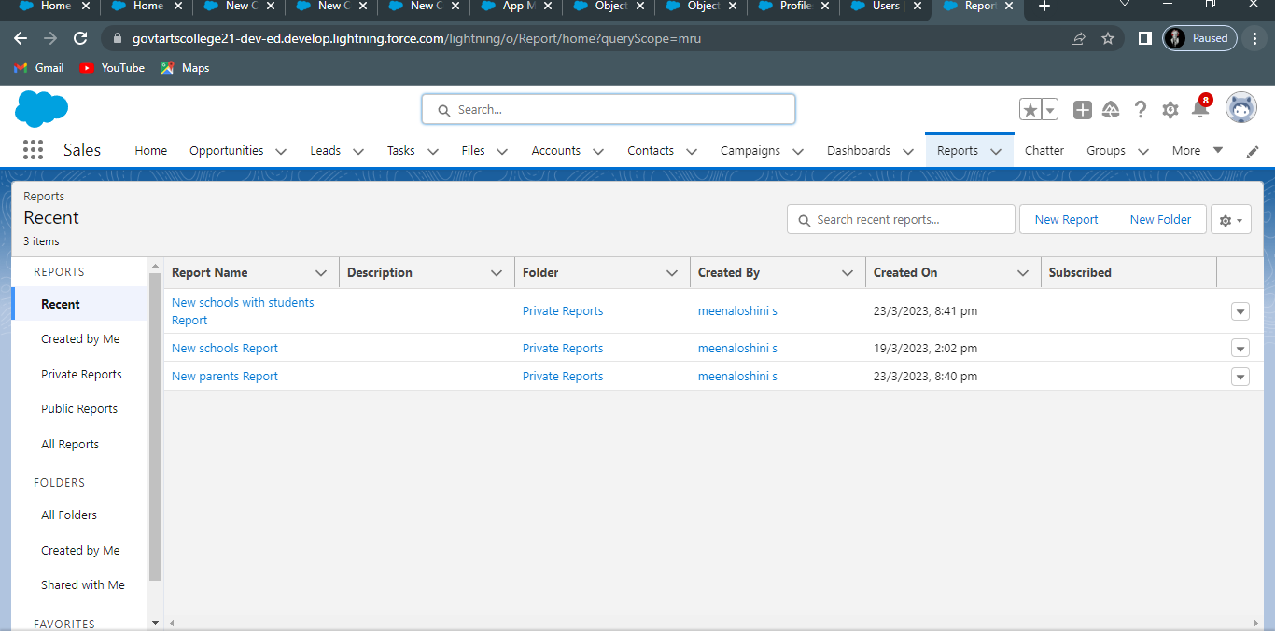

- Trailhead Profile Public URL :

Team Leader-Meenaloshini.s
Team Member 1 – aarthi.S

Team Member 2 –Devi.v
Team Member 3 –Mahalalshmi.S Team member 4- Mythili.T.R

- ADVANTAGES & DISADVANTAGE :

Advantages:

1.Work at anywhere

2.Organisation and details

3. Easy to learn by communicating

4. Timeliness And Flexibility. ...

5. Our mistake has been verified successfully. Disadvantages : 1.Difficult to handle
2. Time consuming process.
3. More human power required.

- APPLICATIONS :

1.Promote Your Event. Sounds strange, right? ...

2. Sell Event Tickets. ...

3 Targeted Digital Marketing. ...

4 Drive Pre-event Engagement. ...

5. Push Notifications. ...

6.Enables Effective Communication. ...

7.Establish An Attendee Network.
..
8. Event Apps Help With Branding.

Project Report Template

- CONCLUSION

- Customer Relationship Management System is user friendly and cost effective system

- it is customized with activities related to event management
life style
.

- FUTURE SCOPE

1. It involves management, creation and development of events such as corporate conferences, wedding, festivities, formal parties etc…
2.. It involves a lot of research about the brand, target audience and the concept of the event before planning the actual event.

