**SYNOPSIS:**

The outlined task expects an object detection algorithm to educate the machine for identifying the type of image given in real time.

Object detection is a computer vision technique that allows us to identify and locate objects in an image or video. With this kind of identification and localization, object detection can be used to count objects in a scene and determine and track their precise locations, all while accurately labelling them.

* Image classification involves assigning a class label to an image
* object localization involves drawing a bounding box around one or more objects in an image.
* is more challenging and combines these two tasks and draws a bounding box around each object of interest in the image and assigns them a class label.

Together, all of these problems are referred to as object recognition.

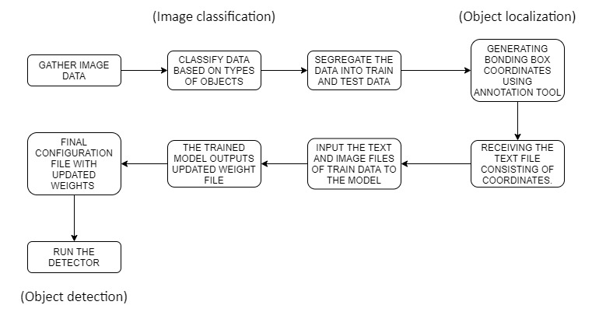

**Work-Flow:**

1. The need for training and testing of the model can be accomplished using various forums and community websites (e.g. Kaggle, deeplearning.net, etc.).
2. Annotation tool:

Before feeding data to YOLO model, the data needs to be processed using such tool. YOLO annotation tool is specifically designed for processing data for YOLO model.

Its basic function is to load some images in, allow user to create bonding box around a specific object which is to be detected and store their x and y coordinates in the textual format. This text file is further used by model for training purpose.

1. Training:

It would require a .txt file for each image with a line for each ground truth object in the image. The .txt and weights file are fed to the model.

Train the model, which would consume much of the time as image is parsed with its dimensions provided in the text file.

1. Testing:

and after receiving the updated weights file, run the detector on the test data to infer the results.

**Model:**

You Only Look Once or YOLO is one of the popular algorithms in object detection used by the researchers around the globe. According to the researchers at Facebook AI Research, the unified architecture of YOLO is extremely fast in manner. The base YOLO model processes images in real-time at 45 frames per second, while the smaller version of the network, Fast YOLO processes an astounding 155 frames per second while still achieving double the map of other real-time detectors. This algorithm outperforms the other detection methods, including DPM and R-CNN, when generalising from natural images to other domains like artwork.