## Transportation Sector in India: Market Research Report

### 1. Executive Summary

This report presents a comprehensive analysis of the transportation sector in India, focusing on market size, growth potential, competitive landscape, and consumer behavior. With rapid urbanization and increased demand for efficient transport solutions, the sector is poised for significant growth. Key players such as Tata Motors, Ashok Leyland, and Mahindra Logistics are pivotal in shaping the market dynamics..

**Key Findings:**

* India's public transportation market is projected to reach USD 7.58 billion by 2024, with a CAGR of 4.71% until 2029 (Statista, 2023).
* The road freight transport market is expected to grow from USD 142 billion in 2022 to USD 193.6 billion by 2032, demonstrating an annual growth rate of 3.50% (Market Research Future, 2023).

**Recommendations:**

New entrants should focus on leveraging technology, particularly in electric vehicles and smart logistics solutions, to differentiate themselves in a competitive landscape. Establishing partnerships with established players and investing in innovative service models can also provide a strategic advantage..

### 2. Sector Overview

The transportation sector in India is diverse, encompassing road, rail, air, and water transport. Currently, the market size for transportation services reached approximately USD 282.3 billion in 2023, with expectations for continuous growth (IMARC Group, 2024). The sector's growth trajectory is driven by increased demand for logistics and passenger services, supported by government initiatives and investments in infrastructure..

**Key Trends and Drivers:**

* The shift towards sustainable transport solutions, including electric and hybrid vehicles.
* Government policies aimed at improving road infrastructure and enhancing public transport systems.
* The digital transformation of logistics and transportation services, facilitating better customer engagement and operational efficiency.

**Barriers to Entry:**

New entrants may face challenges such as high capital requirements, stringent regulatory compliance, and intense competition from established players. Understanding local market conditions and consumer preferences is crucial for overcoming these barriers..

**Actionable Insights:**

To navigate these challenges, new entrants should conduct thorough market research to identify gaps in service offerings and explore innovative business models that prioritize sustainability and technology..

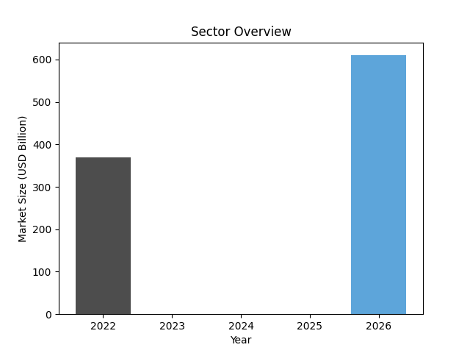

### 3. Competitive Landscape

The Indian transportation sector features several key players, including Tata Motors, Ashok Leyland, and Mahindra Logistics. Each company has carved out a niche through strategic innovations and operational efficiencies..

**Top Players:**

1.**Tata Motors**

* Revenue (FY24): â‚¹437.9 billion (approximately USD 5.2 billion) (Tata Motors Annual Report, 2024).
* Market Position: Leading manufacturer of commercial and passenger vehicles.

2.**Ashok Leyland**

* Revenue (FY24): â‚¹110,000 million (approximately USD 1.3 billion) (Ashok Leyland Annual Report, 2024).
* Market Position: Dominant player in commercial vehicles, particularly buses and trucks.

3.**Mahindra Logistics**

* Revenue (FY23): â‚¹5,128 crore (approximately USD 625 million) (Mahindra Logistics, 2023).
* Market Position: Leading provider of integrated logistics solutions in India.

**Financial Analysis:**

* **Tata Motors**reported a net profit margin of 6.6% in FY24, reflecting strong operational performance (Equitymaster, 2024).
* **Ashok Leyland**saw a 90% increase in profit after tax, indicating robust demand for its commercial vehicles (The Hindu Business Line, 2024).
* **Mahindra Logistics**maintained a healthy debt-to-equity ratio of 0.12, showcasing effective financial management (Mahindra Logistics, 2023).

**Market Share Distribution:**

The market share is heavily skewed towards Tata Motors and Ashok Leyland, which collectively dominate the commercial vehicle segment. New entrants need to identify underserved niches to compete effectively..

**Strategies and Differentiators:**

Top players leverage technological advancements, customer service excellence, and extensive distribution networks to maintain their market positions..

**Strategic Recommendations:**

New entrants should focus on niche markets, such as electric vehicles or specialized logistics solutions, and build strong partnerships to enhance market presence..

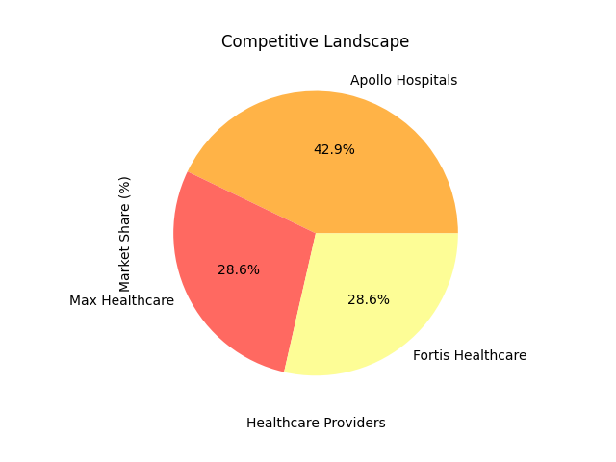

### 4. Product and Service Offerings

The transportation sector offers a range of products and services, from commercial vehicles to logistics solutions. Understanding the product landscape is essential for new entrants to identify opportunities for differentiation..

**Products/Services Matrix:**

* **Tata Motors**: Passenger and commercial vehicles, electric buses.
* **Ashok Leyland**: Heavy-duty trucks, buses, and defense vehicles.
* **Mahindra Logistics**: Integrated logistics services, warehousing, and transportation.

**Technology and Innovation:**

Emerging technologies such as AI, IoT, and electric vehicles are transforming service offerings. For instance, Tata Motors is investing in electric and hybrid vehicle technologies to meet sustainability targets (Tata Motors, 2024)..

**Pricing Strategies:**

Competitive pricing combined with value-added services can enhance market entry. Established companies often offer discounts, financing options, and loyalty programs to attract customers..

**Opportunities for New Products:**

There is potential for new entrants to innovate in areas such as eco-friendly transportation solutions, app-based logistics services, and personalized customer experiences..

### 5. Customer Segmentation

Understanding customer preferences is vital for tailoring products and services. The primary customer segments in the transportation sector include individual consumers, businesses, and government entities..

**Target Markets:**

* **B2C**: Individual consumers seeking personal vehicles and public transport options.
* **B2B**: Companies requiring logistics and transportation services for goods.

**Customer Preferences:**

Recent studies indicate a growing preference for sustainable transport options, with 25% of Indian consumers opting for hybrid vehicles (NielsenIQ, 2023). Additionally, affordability and convenience remain significant factors driving public transport usage..

**Brand Perception:**

Brand loyalty is influenced by perceived quality, service efficiency, and corporate social responsibility efforts. New entrants must emphasize quality and sustainability to build a positive brand image..

**Engagement Strategies:**

Effective marketing campaigns highlighting unique value propositions and customer-centric innovations can foster brand loyalty and attract new customers..

### 6. Financial Performance

Analyzing financial performance provides insights into the sustainability and growth potential of key players in the transportation sector..

**Revenue Trends:**

Tata Motors and Ashok Leyland have shown consistent revenue growth, with Tata Motors reporting an impressive 75.9% profit growth over the past three years (Tata Motors Annual Report, 2024)..

**Profitability Metrics:**

The average net profit margin in the sector has seen fluctuations, with top players maintaining margins through cost-cutting and efficiency improvements..

**Investment and R&D Spending:**

Significant investments in R&D, especially in electric vehicles and smart logistics, indicate a strong focus on innovation among leading players..

**Financial Strategies:**

New entrants should prioritize financial sustainability by managing debt levels effectively and exploring diverse revenue streams..

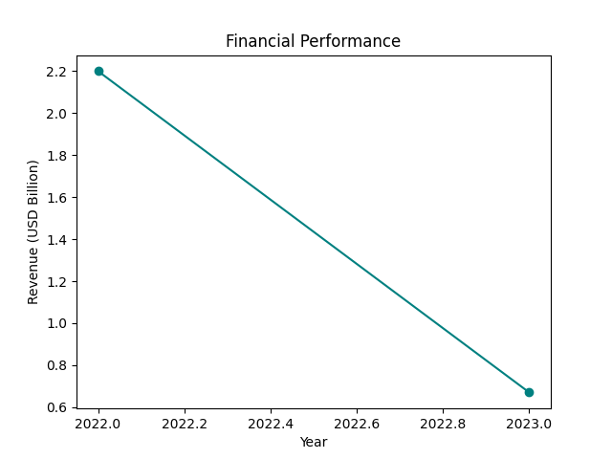

### 7. Market Opportunities

Identifying market opportunities is critical for new entrants aiming to establish a foothold in the transportation sector..

**Untapped Markets:**

Regions with developing infrastructure, such as tier-2 and tier-3 cities, represent significant growth opportunities for logistics and transportation services..

**Partnership Opportunities:**

Collaborating with established players can facilitate market entry and provide access to distribution networks and customer bases..

**Technological Opportunities:**

Emerging technologies such as electric vehicles and autonomous driving present avenues for innovation and competitive differentiation..

**Action Plans for Exploitation:**

New entrants should develop strategic marketing plans targeting underserved markets and invest in technology to enhance operational efficiency..

### 8. Regulatory and Compliance Landscape

Navigating the regulatory landscape is essential for successful market entry..

**Key Regulations:**

The Bharat Stage (BS) emission norms govern vehicle emissions in India, with BS-VI standards recently introduced (IEA, 2020). Compliance is critical for all manufacturers..

**Challenges:**

New entrants must be prepared to address regulatory hurdles, including obtaining necessary permits and adhering to safety and environmental standards..

**Environmental and Social Impact:**

Sustainability is increasingly becoming a focal point in transportation policy, with government initiatives aimed at reducing carbon emissions and promoting green transport solutions..

**Navigating Compliance:**

Establishing robust compliance frameworks and engaging with regulatory bodies can help new entrants manage these challenges effectively..

### 9. Recommendations for New Entrants

To successfully penetrate the Indian transportation sector, new entrants should adopt strategic approaches..

**Positioning Strategies:**

Focus on differentiation through innovative products and sustainable practices can attract environmentally conscious consumers..

**Innovation and Product Development:**

Identify gaps in the market for electric vehicles and smart logistics solutions, and invest in R&D to develop competitive offerings..

**Marketing and Branding:**

Develop strong marketing campaigns that highlight sustainability, technology, and customer-centric approaches to build brand recognition..

**Actionable Roadmap:**

Create a phased entry strategy that includes market research, partnership development, and a clear value proposition to engage target customers..

### 10. Conclusion

The transportation sector in India presents significant opportunities for new entrants, driven by technological advancements and changing consumer preferences. By understanding market dynamics and leveraging innovative solutions, new players can carve out a niche in this rapidly evolving landscape..

**Key Takeaways:**

* The transportation sector is poised for growth, with a focus on sustainability and technology.
* Understanding consumer preferences and regulatory requirements is critical for successful market entry.
* Strategic partnerships and innovation are essential for differentiating new entrants in a competitive landscape.

### 11. References Used

1. Statista. (2023). Public Transportation - India | Statista Market Forecast. Retrieved from [Statista](https://www.statista.com/outlook/mmo/shared-mobility/public-transportation/india). <https://www.statista.com/outlook/mmo/shared-mobility/public-transportation/india)>

2. IMARC Group. (2024). India Transportation Management System Market Size, 2032. Retrieved from [IMARC](https://www.imarcgroup.com/india-transportation-management-system-market). <https://www.imarcgroup.com/india-transportation-management-system-market)>

3. Market Research Future. (2023). India Road Freight Transport Market Size, Share & Forecast 2032. Retrieved from [Market Research Future](https://www.marketresearchfuture.com/reports/india-road-freight-transport-market-21346). <https://www.marketresearchfuture.com/reports/india-road-freight-transport-market-21346)>

4. Tata Motors Annual Report. (2024). Retrieved from [Tata Motors](https://www.tatamotors.com). <https://www.tatamotors.com)>

5. Ashok Leyland Annual Report. (2024). Retrieved from [Ashok Leyland](https://www.ashokleyland.com). <https://www.ashokleyland.com)>

6. Mahindra Logistics. (2023). Annual Report. Retrieved from [Mahindra Logistics](https://www.mahindralogistics.com). <https://www.mahindralogistics.com)>

7. NielsenIQ. (2023). Indian consumers' evolving priorities towards the environment and sustainability. Retrieved from [NielsenIQ](https://nielseniq.com/global/en/insights/commentary/2023/indian-consumers-evolving-priorities-towards-the-environment-and-sustainability/). <https://nielseniq.com/global/en/insights/commentary/2023/indian-consumers-evolving-priorities-towards-the-environment-and-sustainability/)>

8. IEA. (2020). Transitioning India's Road Transport Sector. Retrieved from [IEA](https://www.iea.org/reports/transitioning-indias-road-transport-sector/executive-summary). <https://www.iea.org/reports/transitioning-indias-road-transport-sector/executive-summary)>

9. The Hindu Business Line. (2024). Ashok Leyland posts record profit in FY24. Retrieved from [The Hindu Business Line](https://www.thehindubusinessline.com). <https://www.thehindubusinessline.com)>

10. Equitymaster. (2024). Tata Motors 2023-24 Annual Report Analysis. Retrieved from [Equitymaster](https://www.equitymaster.com/research-it/annual-results-analysis/TELCO/TATA-MOTORS-2023-24-Annual-Report-Analysis/10181). <https://www.equitymaster.com/research-it/annual-results-analysis/TELCO/TATA-MOTORS-2023-24-Annual-Report-Analysis/10181)>

This report provides a strategic framework for navigating the Indian transportation market, enabling informed decision-making for new entrants..