Legal Ease : AI-Powered Legal Document Generator

Project Description:
Legal Ease leverages state-of-the-art Generative AI to simplify the creation of legal documents by providing customizable, accurate, and editable templates for a wide range of use cases. Users can generate employment contracts, lease agreements, NDAs, and more—all tailored to their specific inputs like involved parties, effective dates, and key terms.
Built with Fast API and integrated with a powerful AI core, Legal Ease ensures users receive professional-grade legal documents that maintain formatting standards, include custom branding (such as logos and fonts), and support features like editable previews and automatic term tables. With secure handling of sensitive user data and seamless document export options (.PDF, .DOCX, .TXT), the platform bridges the gap between accessibility and legal professionalism.
Legal Ease empowers entrepreneurs, professionals, and individuals to generate reliable legal content confidently—without needing a legal background.

Scenarios:

Scenario 1: A startup founder enters details about a new hire and selects "Employment Contract" as the document type. Legal Ease generates a comprehensive agreement with clauses for roles, responsibilities, compensation, and confidentiality. The user customizes the final wording, adds their company logo, and downloads the document as a branded PDF.
Scenario 2: A freelancer needs a Non-Disclosure Agreement for a potential client. By specifying the parties, scope of confidentiality, and effective date, they instantly receive a structured and legally sound NDA.
Scenario 3: A landlord uses Legal Ease to draft a residential lease agreement. By inputting the property address, tenant details, and lease terms, the platform creates a formatted document with editable sections and a downloadable version in .DOCX format.

Pre-requisites
1. Fast API Framework Knowledge: Fast API Documentation
2. Google Gemini API Familiarity: Google Generative AI Documentation
3. Stream lit for Frontend: Stream lit Documentation
4. Python Programming Proficiency: Python Official Docs
5. Environment Setup: pip install fast Api unicorn stream lit python-docx f pdf Pillow requests google-generative ai python-doting

Project Workflow
Activity 1: Model Selection and System Architecture
- 1.1: Research and select the Model: Gemini 1.5 Pro model from Google Generative AI for legal document generation.
- 1.2: Define architecture:
      - Frontend: Stream lit for user input and document download.
- Backend: Fast API (main.py, routes.py) to handle API requests.
- AI Integration: Gemini 1.5 API used inside ai-core/gemini_generator.py.
- 1.3: Set up development environment with .env file containing the Gemini API key.

Activity 2: Core Functionalities Development
- 2.1: Implement core generation features:
- Legal document creation
- Editable text preview
- Format & export as .txt, .docx, and .pdf
- 2.2: Build Fast API backend:
- Endpoint /generate to process POST requests
- Accepts document _type, parties, terms, dates
- Returns generated text from Gemini
Activity 3: main.py & API Logic
- 3.1: Create and configure main.py:
- Initialize Fast API app o Route / for home
- Include router from routes.py
- 3.2: Handle document generation logic in routes.py:
- Define Pedantic model Document Request
- Call Gemini Document Generator. Generate _document(...)

Activity 4: Frontend with Stream lit
- 4.1: Design user-friendly Stream lit interface:
- Input fields for all required data
- Responsive layout with title and logo
- 4.2: Dynamic document generation preview:
- Show styled editable output
- Option to export as .txt, .docx, or .pdf

Activity 5: Deployment
- 5.1: Prepare deployment:
- Install production-ready dependencies
- Set up Proc file, requirements.txt, or Docker file if needed
- 5.2: Deploy application:
- Options: Render, Railway, Deta, Stream lit Community Cloud (frontend), Fly.io or VPS for backend

Activity 6: Conclusion
- Finalize and test:
- Ensure end-to-end functionality
o Test Gemini integration under different input combination

MILESTONE 1: Model Selection and Architecture – Legal Ease
In this milestone, we focus on selecting the optimal generative AI model for creating personalized and accurate legal documents using Google’s Gemini model via the Google Generative AI SDK. We also define the system architecture and set up the development environment to support document generation, editing, and exporting in various formats (.docx, .pdf, .txt).
Activity 1.1: Research and Select the Appropriate Generative AI Model
- Understand the Project Requirements
- Legal Ease must generate structured legal documents (e.g., contracts, NDAs, agreements) based on user inputs such as:
- Document type
- Parties involved
- Terms and conditions
- Effective dates
2.Explore Gemini Model Documentation
- Visit Google Generative AI Documentation to evaluate available Gemini models.
- Review capabilities of gemini-1.5-pro, especially:
- Long context window (up to 1 million tokens)
- Structured prompting with multi-part content
- Fast generation speed and legal-domain compatibility
3. Evaluate Model Performance
- Benchmarks indicate that gemini-1.5-pro is capable of handling complex formatting, reasoning, and structured text generation, making it suitable for legal content generation.
4. Select the Optimal Model Selected: gemini-1.5-pro
- Best suited for drafting formal documents with clear sections and legal jargon.
- Capable of understanding and generating clauses based on user inputs dynamically.
Activity 1.2: Define the Architecture of the Application
1.Architectural Diagram
Components:
- Frontend: Stream lit for user interaction (document input, preview, editing, downloads)
- Backend: Fast API app (routes input to Gemini model and returns generated content)
- AI Core: Gemini integration for content generation
- Formatting Modules: DOCX, PDF, TXT generators
Formatted output (.txt,.dox,.pdf
Gemini1.5 GOOGLE API

Fast API Backend (main.py)
User interface(stream lit)

Document Generator(gemini_generator.py)

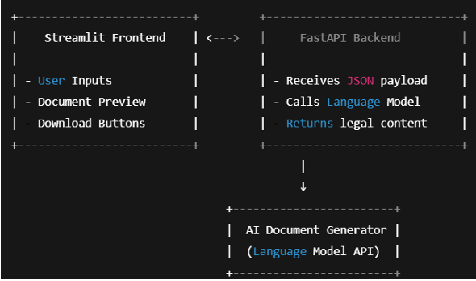

- Frontend Functionality
- Users provide inputs via:
- Text Input for document type and dates
- Text Area for parties and terms
- Buttons:
- o "Generate Document"
- o "Edit Document"
- o "Download as TXT / DOCX / PDF"
- Styled HTML preview of the generated legal document

- Backend Responsibilities
- Expose POST /generate endpoint (via Fast API)
- Accept JSON input (document_ type, parties, terms, dates)
- Route to Gemini Document Generator
- Return structured document text
- AI Integration Points
- Gemini Document Generator forms a structured prompt and sends it to Gemini via generate_ content
- Receives generated text and returns to Fast API
- Frontend displays and allows editing or exporting

Activity 1.3: Set Up the Development Environment
- Install Python and Pip
Ensure Python 3.10+ is installed along with pip for dependency management.
2. Create a Virtual Environment
3. Install Fast API and Unicorn (Backend Server)
pip install fast Api unicorn
4.Install Stream lit (Frontend UI)
pip install stream lit
5.Install Google Generative AI SDK
pip install google-generative ai
6.Install Additional Libraries
pip install python-docx f pdf Pillow requests python-dote nv
7. Set Up Application Structure
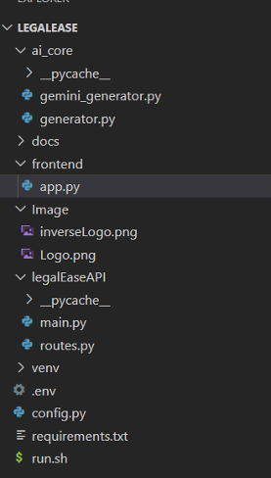

MILESTONE 2: Core Functionalities Development

Activity 2.1: Develop the core functionalities
- Legal Document Generation
Functionality: Generate legal documents (e.g., contracts, agreements) based on user inputs (document type, parties, terms, and dates).

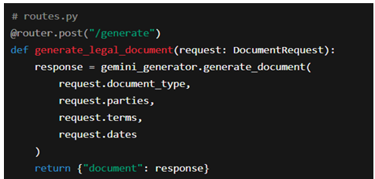

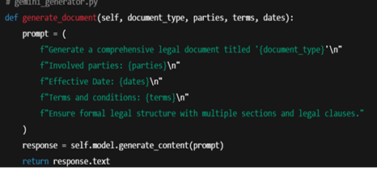

- Document Output Formatting
Functionality: Convert raw AI-generated text into structured .docx, .pdf, .txt files with legal formatting, logos, tables, and footers.

- format_ docx(text, doc_ type)
- format _pdf(text, doc_ type)
- format_ html _preview(text)
These use:
- docx for Microsoft Word formatting (includes logo, Times New Roman font, terms as table, footer).
- f pdf for clean, branded PDF documents with headers/footers.
- HTML Preview with Stream lit styling.

- User Interaction & Recommendations
Functionality: Accept user preferences through the Stream lit interface and reflect them in the AI-generated legal content.

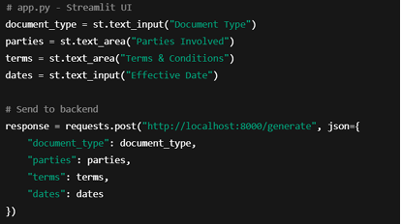
- Editable Document & Download
Functionality: Provides editable text area, allows download in .txt, .docx, .pdf formats.

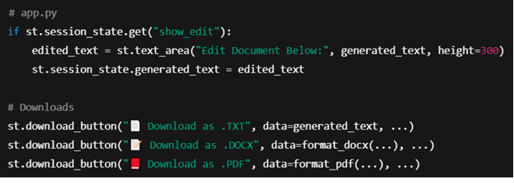

Activity 2.2: Implement the Fast API Backend
- Define Routes in Fast API (Instead of Flask)

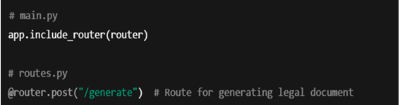

- Process User Input
Handled via Pedantic & Stream lit Forms:

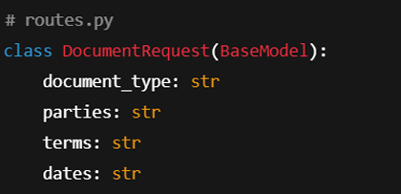
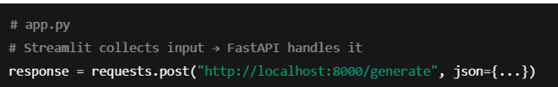

- Integrate Grow (Gemini) API Calls

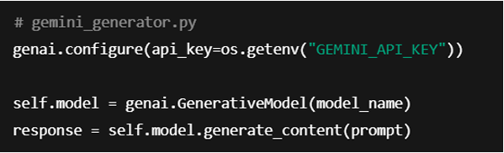

MILESTONE 3: API Logic Integration

In Milestone 3, the focus shifts to designing and integrating the backend API logic that powers document generation using the Gemini 1.5 Pro model. This milestone ensures a functional bridge between frontend inputs and the AI-powered document generation, which is the core of the Legal Ease project.

Activity 3.1: Create and Configure main.py

This step involves initializing the Fast API application, setting up the base endpoint for health-checks, and including modular API routes.

Steps:

- Initialize the Fast API app
- Define a root (/) endpoint to verify the service is running
- Include routes from the routes.py module
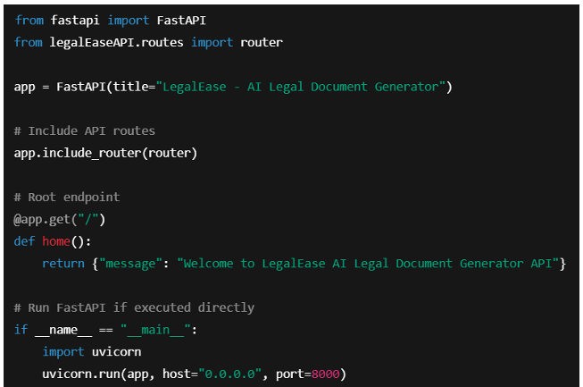

Activity 3.2: Handle Document Generation Logic in routes.py
This task handles user inputs from the frontend and sends them to the Gemini model for document generation.

Steps:
- Define a Py dan tic Document Request model to validate incoming data.
- Initialize the Gemini Document Generator from ai_core.gemini_generator.
- Create a POST endpoint (/generate) to accept user input and return generated legal content.

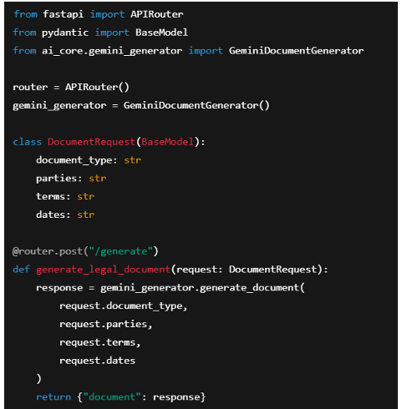

MILESTONE 4: Frontend Development – Legal Ease
Milestone 4 focuses on creating a responsive and user-centric web interface for Legal Ease using Stream lit. This milestone enables users to easily input legal details, generate AI-powered documents, preview the results, make inline edits, and download documents in multiple formats (TXT, DOCX, PDF) with rich formatting and embedded branding.

Activity 4.1: Designing and Developing the User Interface
Step 1: Stream lit Page Configuration and Layout Setup
- Configured Stream lit app with:

- Added a three-column layout using st .columns to centre -align the company logo

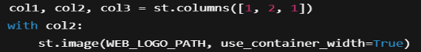

Step 2: Header and Title
- Displayed a subtle centre-aligned title under the logo:

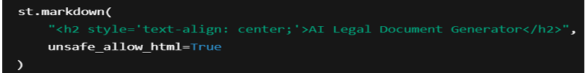

Step 3: User Input Interface
- Created intuitive inputs for:
- Document _type: type of legal document
- parties: involved stakeholders o terms: semicolon-separated clauses
- dates: effective date

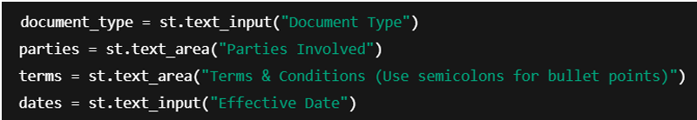

Activity 4.2: Creating Dynamic Previews and Export Options
Step 1: Generate Document with Backend AI
- On clicking "Generate Document", a POST request is sent to the Fast API backend:
- AI-generated content is sanitized and displayed dynamically:
Step 2: HTML Preview Rendering
- The output is previewed in an elegant dark-themed scrollable card with semantic HTML:
Step 3: Editable Document Preview
- The user can click "Edit Document" and modify the generated content using a text area:
Step 4: Multi-Format Download Options
- Users can download the document as: o .txt (Plain Text)
- .docx (Formatted Word Document with logo, headings, and table)
- .pdf (Branded PDF with logo and footer)

Core Functions & Utilities
sanitize_ text(text)
- Removes special characters and typographic quotes to ensure clean formatting.
format_ docx(text, doc _type)
- Uses python-docx to:
- Embed logo
- o Add titles, paragraph formatting
- o Auto-generate a Terms table from semicolon-separated input
format _pdf(text, doc _type)
- Utilizes FPDF with custom header/footer:
- Centre - aligned logo
- Bold headings for sections
- Bullet-style terms
format_ html _preview(text)
- Converts output to stylized HTML blocks for inline display.

MILESTONE 5: Deployment
In Milestone 5, the focus is on deploying the Legal Ease application locally using Fast API as the backend and Stream lit as the frontend. This milestone involves setting up a virtual environment, configuring dependencies, and verifying that all modules— from the Gemini API integration to document generation and downloads—work seamlessly in a real-world local environment. This ensures your system is production ready and paves the way for cloud deployment in future stages.

Activity 5.1: Preparing the Application for Local Deployment
Step 1: Set Up a Virtual Environment
To ensure environment isolation and consistent dependency management, create and activate a virtual environment:
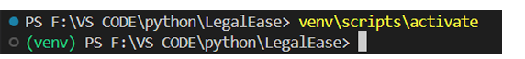
Step 2: Install Dependencies
Ensure that the backend (Fast API) and frontend (Stream lit) dependencies are installed from a requirements.txt:

pip install -r requirements.txt
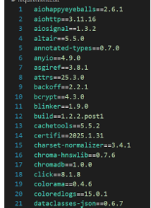

Step 3: Configure Environment Variables
Create a .env file to securely store your Gemini API key
Activity 5.2: Testing and Verifying Local Deployment
Step 1: Launch the Fast API Backend
Start the backend server using Uv icon:

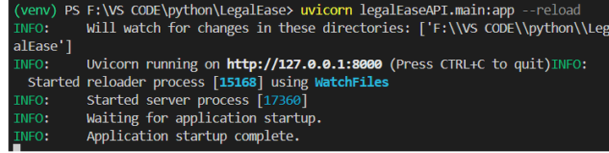

Step 2: Launch the Stream lit Frontend
Run the app.py file to start the Legal Ease UI:
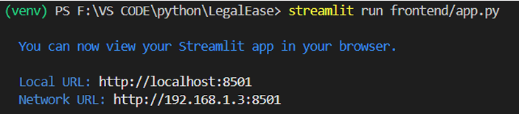

Step 3: Test All Functionalities
- Input document type, parties, terms, and date.
- Press Generate Document to get AI-generated legal content from Gemini.
- Use built-in options to:
- Preview in dark mode HTML o Edit the text
- Download in .txt, .docx, and .pdf formats
- Check for:
- Proper layout with logo and footer
- Clean formatting of bullet points
- Correct embedding of terms in the document
Exploring Legal Ease
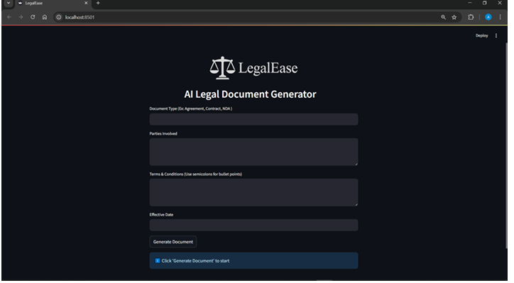
- Document Type
Purpose: Type of legal document to generate.
Examples:
- Agreement
- Contract
- NDA (Non-Disclosure Agreement)
- Lease Agreement
- Employment Offer Letter
Example input: Freelance Work Contract

- Parties Involved Purpose:

Names and roles of the individuals or entities involved in the document. Examples:
- John Doe (Freelancer), ABC Corp (Client)
- Alice Smith (Tenant), XYZ Realty (Landlord)

Example input: Jane Doe (Service Provider), Tech Nova Inc. (Client)

- Terms & Conditions (Use semicolons for bullet points)
Purpose: Specific clauses or rules that define the agreement. Separate each bullet point using a semicolon.
Examples:
- Payment to be made within 30 days of invoice;
- The provider agrees to deliver work by the agreed deadline;
- Confidentiality must be maintained at all times; •
- Either party may terminate with 15 days notice
4.Effective Date
Purpose: The date when the agreement becomes legally valid.
Examples:
- April 10, 2025
- 10/04/2025
- April 15, 2025

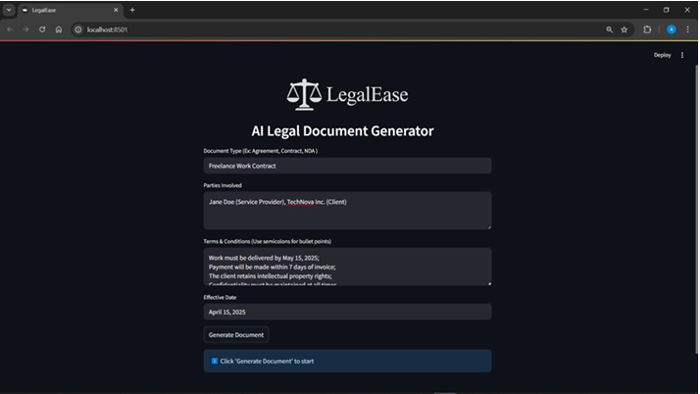

Document Generated
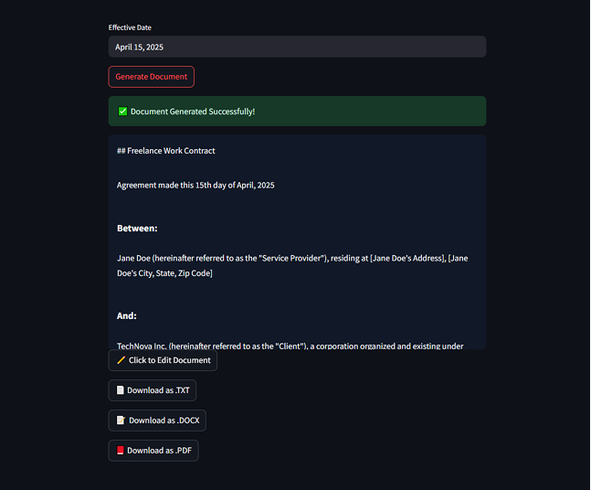
Editing the Document
If the user wants to edit the document, they can do so by clicking on the “ Click to Edit Document” Botton. A new window opens up where the document can be edited.
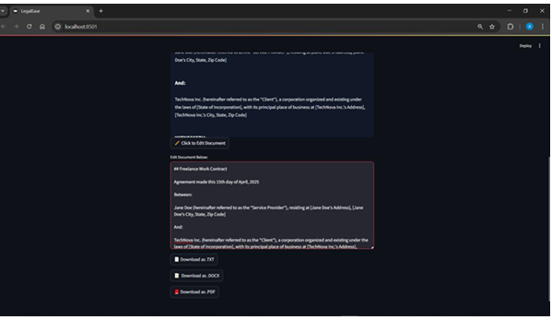
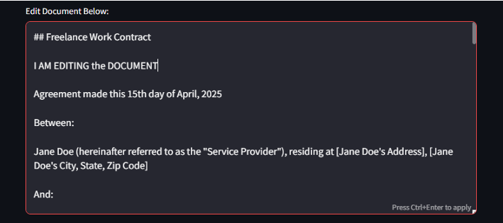
Downloading/ Saving the Generated Document
We can Download and save the documents in any of the following formats.
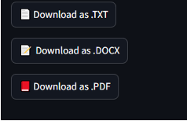
  - .txt

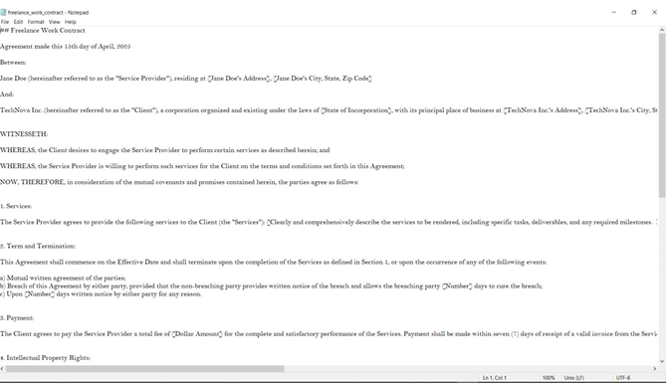

- .docx The document provided inculcates the use of the logo (front page) as well as the footer in the last page

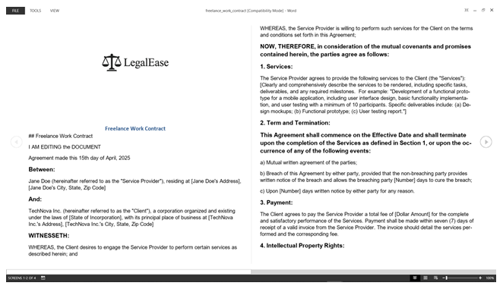

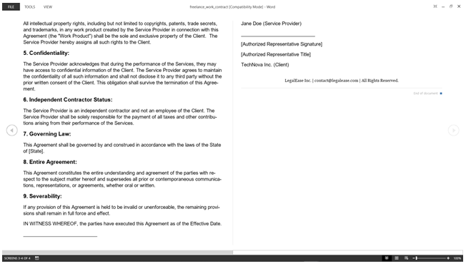

- .pdf This format provided the user with a well formatted and ready to use legal document with Logo and Footer on all the pages.

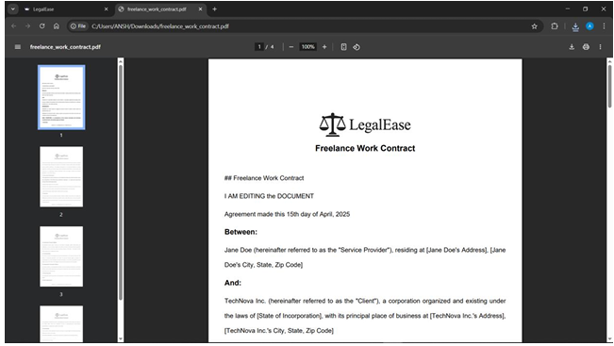

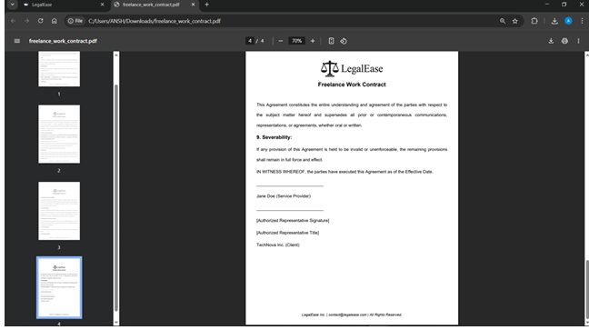

Conclusion
Legal Ease represents a transformative step in bridging the accessibility gap in legal services through the power of artificial intelligence. This project demonstrates how emerging technologies can simplify complex legal language, providing users—regardless of legal background—with a clear, concise understanding of legal documents. By integrating advanced natural language processing (NLP) models with user-centric design, Legal Ease empowers individuals to navigate legal content with confidence, thereby promoting inclusivity and informed decision-making.

The platform's ability to analyse and simplify legal text, highlight key clauses, and provide plain-language summaries enhances comprehension and reduces dependency on costly legal consultations for basic understanding. This democratization of legal knowledge is critical in a world where legal literacy remains low, especially among marginalized populations. Furthermore, Legal Ease supports multilingual capabilities, ensuring broader reach and utility across different regions and demographics.

From a technical standpoint, Legal Ease showcases efficient integration of backend AI models, including document parsing, summarization algorithms, and user-friendly web interfaces. The project's architecture is designed to ensure scalability, data privacy, and real-time responsiveness—key elements for any modern SaaS solution. Through iterative development, testing, and feedback, the system has been refined for optimal performance and user satisfaction.
In conclusion, Legal Ease is more than a technological tool—it is a catalyst for legal empowerment. By fostering transparency, accessibility, and understanding, it upholds the principle that legal information should be a public good, not a privileged resource. Future enhancements could include deeper contract analysis, integration with legal databases, and personalized recommendations. With continued innovation and support, Legal Ease has the potential to revolutionize how people interact with the law, making justice more approachable for all.

