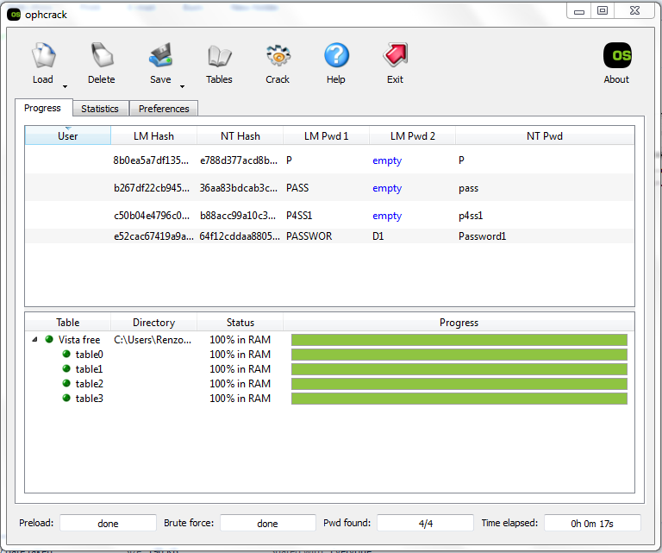

**P**

Complexity category: single-case alpha

Length: 1

Crack time: <1s

LM Hash: 8b0ea5a7df135b03aad3b435b51404ee:e788d377acd8b4cafba02cc864d5e4db

**pass**

Complexity category: single-case alpha

Length: 4

Crack time: 4s

LM Hash: b267df22cb945e3eaad3b435b51404ee:36aa83bdcab3c9fdaf321ca42a31c3fc

**p4ss1**

Complexity category: single-case alphanum

Length: 5

Crack time: 7s

LM Hash: c50b04e4796c0ec2aad3b435b51404ee:b88acc99a10c3e3863b5f62a708a4703

**Password1**

Complexity category: mixed-case alphanum

Length: 9

Crack time: 14s

LM Hash: e52cac67419a9a2238f10713b629b565:64f12cddaa88057e06a81b54e73b949b

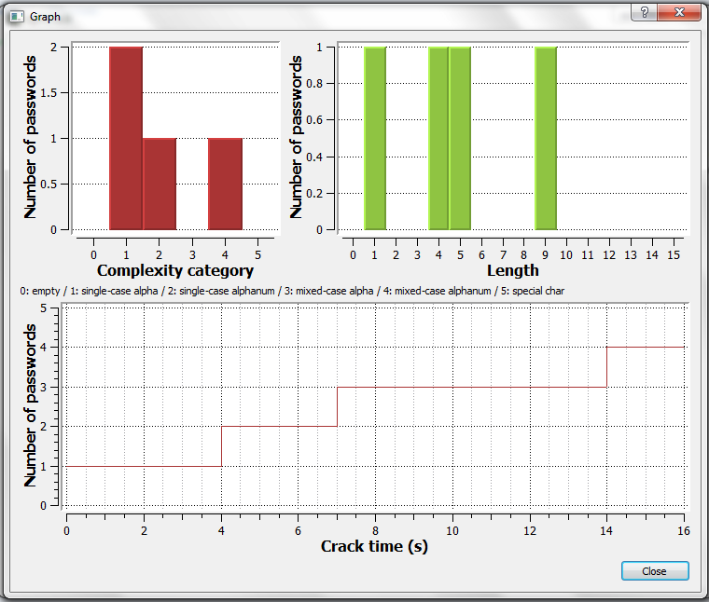

Based on this data, the following were observed:

* the crack time for single-case alpha passwords is equal to its length
* the longer the length of the password, the longer the crack time
* the harder the complexity of the password, the longer the crack time
* the crack time of both single-case and mixed-case alphanum passwords is around 1.5x its length