# Study Design

## Purpose

The purpose of this study is to gauge the intuitiveness of the ZeroShop user interface. The user interface and user experience must accomidate customers in finding and purchising items from the ZeroShop website. Design that makes these tasks difficult or confusing needs to be changed to better accommodate stakeholders.

We expect the results from this study to help us improve the ZeroShop interface. Currently the user interface is on its second iteration with basic functionality and provisional graphic design. Users will be asked to complete a series of tasks involving the interface and functions of the site and interviewed about thier expeirence to gauge intuitivness, ease of use, and usefulness.

The overall design of the interface is still highly fluid and radical changes to both the look-and-feel and layout of the interface can still be made, if nessisary.

## Concerns and Goals

1. Concerns
   * Navigation
   * Registration
   * Browsing the product catalog
   * Using the cart
   * Checking out
2. Goals
   * Navigation
     + The user will be able to navigate to any item within three clicks and within 5 seconds.
     + The user will be able to acess the cart from any page with one click and within 3 seconds
   * Registration
     + The user will be able to register an account without encourntering any errors.
     + The user will be able to log-out of the site without losing thier place.
   * Browsing the product catalog
     + The user will be able to view any product within 10 seconds of seeing the main page.
   * Using the cart
     + The user will be able to determine the total cost of the purchace (sans tax) immediatly.
   * Checking out
     + The user will be able to checkout within 2 minutes from viewing the cart (including inputing information.)

## Tasks

## Scenarios

1. It's your friend's birthday and you wated to the last minute to buy them something. You know they're a bit of a nerd and a bit of a hipster. During a Bing search for "Ironic programmer shirts" you come across ZeroShop and are turned on by their self-depricating sense of humor. Your goal is to browse for a bad programming shirt under $20 and buy it.

## Measurements

## Test Methods

# Study Script

1. Greeting the participant
   * Greeting and Proposition
     + Hello, how are you?
     + Thank you for agreeing to participate.
     + I need to test my website’s design for usability.
     + You just need to click around the website to accomplish tasks for my checklist, while I ask for your opinion.
     + It will take 5 to 10 min at most.
   * Preliminary Interview
     + This is the background info you will need for this study:
     + For UI, I designed a website for an online store.
     + We are testing the website, not you
     + This is to test how intuitive, useful and efficient the design is.
     + Please feel free to voice your opinion of the design and features.
   * Warm up questions
     + We would like to find out a little about you before you begin
     + Have you ever used shopped online before? If so, for how long?
     + How old are you?
     + Do you use the mobile version of an online store if ever?
     + Do you prefer using sites on your phone or a computer?
     + If you had to choose, would you rather shop online or shop in an actual store?
     + On a scale from 1-10 how comfortable are you shopping online?
     + Thank you for answering those questions
     + For testing purposes, we’d like to record your age and major. Do you mind giving me that info?
       - How old are you?
       - What is your major?
     + Thank you. Now we can begin testing the site.
2. Testing portion: Providing Instructions
   * These are the instructions for you to follow:
     + Please type this into the URL: www.zeroshop.ga
     + Starting now, I’m going to give you tasks to accomplish on this site.
     + There is no right or wrong way of completing the tasks. Some have multiple ways of completion. We are testing which method is more intuitive for users.
     + Please think out loud so I can hear your thought process for each task.
     + If you are ever confused, just ask me and I will try to answer any concerns/questions if it does not conflict with the study.
     + Your opinion is very valuable so do not hesitate to share your input.
     + After completing one task, I will give you another until the study is complete.
     + Do you have any questions?
   * Orient the participant to the screen objects and test elements (but not too much! Remember you may want to test learnability. First impressions are important.)
   * Conduct the test:
     + Register for an account
     + Log out
     + Log back in
     + View your cart (should be empty)
     + Go back to the home page
     + Go to the full products list
     + Open an items product view (This view should hold the description and an option to purchase)
     + Change the quantity of items to buy (can be any number)
     + Add the item to your cart
     + Find the featured “items”
     + Add a featured item to your cart.
     + Go to your cart and check out.
3. Debriefing the Participant
   * Thank you for participating, this completes our study.
   * Do you have any questions?
   * Was there anything that seemed unnecessarily difficult?
   * Did anything seem confusing?
   * Have you used other software like this?
   * If so, how would you compare this software with that other software?
   * Do you have any recommendations for how we can improve the design?
   * Do you have any last words/opinions of the site?
   * Thank you again for being a part of the study.
   * Have a good day.

# Results

This section covers the results of the usability tests our team conducted.

## Graphs

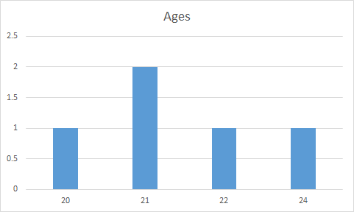 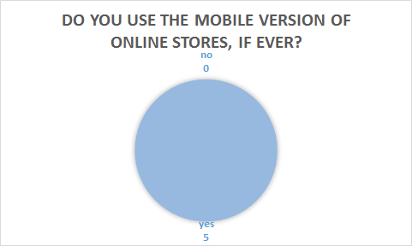 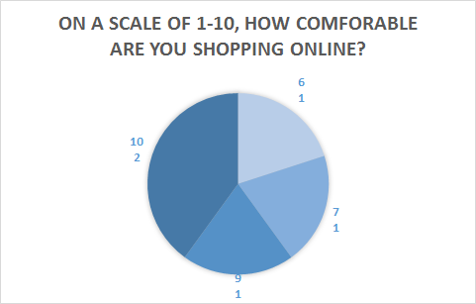 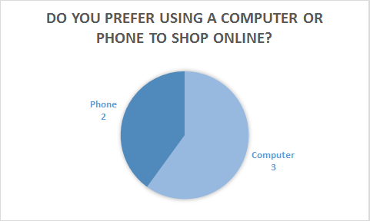 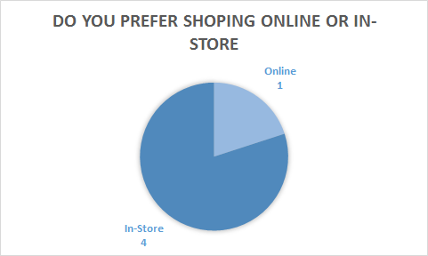

## User Input

* Account creation and checkout processes were easy
* Clicking the account email to view the account information does nothing
* Images of the products should be larger
* *on mobile version:* menu options should be centered instead of being aligned to the right
* Viewing the cart items was a little confusing
* "Featured" items should be added as a category
* There should be more color
* Dropdown menus should be added to the menu bar so that you can choose a category of product items from any page

## Identify Problems:

1. When clicking on “products” user didn’t get the number of items displayed of the screen. Error of omission: User could still see all the products, but there was lack of information. (Low severity)
2. User expected website to show product image from multiple angles after clicking on product to see it description. Error of omission: User can still add product to the cart, but wanted more information on product. (Low severity)
3. User got the error “Please login or sign up to use cart”. User didn’t know they have to login or signup in order to add product to the cart. Error of commission: User had to go back and signup to use the cart. (medium severity)
4. User didn’t get the option to clear whole cart. Error of omission: User clicked “Remove from cart” on each individual item to remove them for cart. (High severity)
5. User clicked on logout instead of cart. Error of commission: User had to login again to check the cart. (Low severity)
6. User clicked “Add to cart” and got redirected to the Product main page instead of previous page. Error of omission: User had to go back to “shirt” page again to continue browsing. (high severity)
7. User clicked “submit” button on checkout page without adding full information. Error of commission: User had to go back and add information to complete the order. (high severity)

## Prioritize Problems:

Highest to lowest priority

1. (d) Clear cart option
2. (g) “Submit” button issue.
3. (f) “Add to cart” button redirect to product main page.
4. (c) login or signup before adding items to cart
5. (a) user doesn’t know how many products are displayed on screen
6. (b) User wanted to see more information on product including more (images).
7. (e) Logout button issue.

## Theorized Reasons:

1. (a) We believe its user preference issue. User wanted product page information to be displayed a certain way. User expected to see the number of products displayed on the page.
2. (b) This is another user preference issue. User expected to see more images of product when clicked on product.
3. (c) We didn’t convey the information properly. User believed they can order items as a guest and therefore didn’t try to sign up before adding items to the cart.
4. (d) This was the oversight on our part during the creation of the website. We wanted to add the clear whole cart button but got around to doing it during implementation phase.
5. (e) This was a user error. Because the cart and logout button are very close to each other the user clicked on logout button instead of cart button. User probably couldn’t tell they clicked on the wrong button until it was too late.
6. (f) This is another oversight on our part during the implementation of the website. User expected to stay on the same page or return to previous page but instead got redirected to the products main page.
7. (g) This was oversight on our part. User forgot to add full information on checkout screen before clicking “Submit” button and didn’t get the warning about incomplete info.

## Theorize Solutions:

1. This problem can easily be solved by adding the count of number of product displayed on screen on top and bottom.
2. This problem can be solved by adding multiple images of the product on product description page.
3. There are multiple ways we can solve the problem. We can display a message on main page about signing up or login to add products to the cart or we don’t let user to browse product page until the login or signup.
4. We can add the clear cart button to clear the whole cart so users don’t need to remove one items at a time if they want to clear the while cart.
5. We believe the best was to solve this problem is add a “Are you sure you want to logout” message when user clicks logout button.
6. To solve this problem we can make it so that if user clicked “add to cart” button user stay on the same page.
7. This problem can be solved by giving user error message if user has put incomplete information on checkout page.

## Identify Successes:

The team, like I’m sure many other teams had in mind, followed a very simple and minimalistic design for the site. Our opinion on online stores is that they are usually very cluttered and distracting when trying to browse ALL items. We liked the design of https://www.supremenewyork.com/ and tried to follow in their footsteps. There aren’t many options other than viewing items and each item page has a basic description, sizing, prices, and alternative color options, with a few other miscellaneous details. Following this design pattern would ensure that customers find items quickly and eliminate any room for confusion.

## Identify Areas of uncertainty:

Fortunately we didn’t encounter many issues with our design upon testing. Users like the simple and quickness to view items without many distractions or sorting methods. However, we believe this is was the case because, like Supreme, a limited catalog to work with. If the site was intended to sell 100+ items then our design would fail, as it would take a very long time to browse items without any sorting mechanism. Customers would have to waste time browsing items that don’t pertain to them (i.e. different gender or age group). Development issues luckily did not limit our vision for the site. We only had minor issues/headaches with linking buttons, setting up databases, and sizing item pages.