### Kid’s items

* Library of classic children’s books
* Baby clothes
* Week of soccer camp
* Board games

### Dining

* Dinner at McDonalds
* Dinner at Canlis
* Lunch with the principal
* Two months home delivery of organic vegetables
* Two cases of fine wine

___________

### Sports

* Two BMX racer bikes
* Ski equipment
* Golf with the mayor
* Volleyball set

### Art supplies

* Art easel
* Professional photography session
* Beginner’s scrapbooking kit

___________

### Household decor

* Vintage dresser
* Potted plants
* Raised bed kit for patio
* Box of household tools

___________

### Luxury

* Trip to Hawaii
* Weekend at spa

___________

### Tech gadgets

* Classic Macintosh
* Several software titles
* MP3 player loaded with music
* 42” plasma screen wall television

__________

**Bid on**

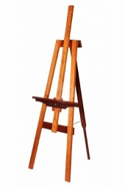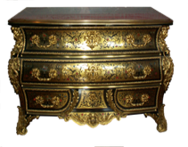

[This Photo](http://jinifur.deviantart.com/art/Antique-furniture-in-png-5-151045387) by Unknown Author is licensed under [CC BY-NC-ND](https://creativecommons.org/licenses/by-nc-nd/3.0/)

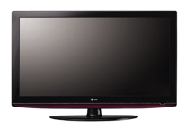

[This Photo](http://woikr.com/howto/how-to-build-an-entry-level-home-theater-and-gaming-system-part-1/) by Unknown Author is licensed under [CC BY-SA](https://creativecommons.org/licenses/by-sa/3.0/)

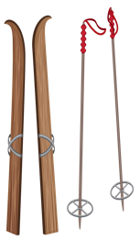

[This Photo](http://pngimg.com/download/38261) by Unknown Author is licensed under [CC BY-NC](https://creativecommons.org/licenses/by-nc/3.0/)



[This Photo](http://www.pngall.com/scroll-png) by Unknown Author is licensed under [CC BY-NC](https://creativecommons.org/licenses/by-nc/3.0/)

* WE accept cash, Checks, Visa and American Express
* Appetizers and beverages served
* Silent auction with tables closing every hour beginning at 7 pm
* Must be 18 to bid
* Open to the public

**Big Charity Auction**



[This Photo](http://victorian-lady.deviantart.com/art/Scrollwork-10-Gold-633570873) by Unknown Author is licensed under [CC BY](https://creativecommons.org/licenses/by/3.0/)

**Friday, June 10, 6 pm to 9 pm**

**—First Hill Pre-School—**



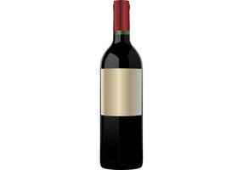

[This Photo](http://www.vecteezy.com/backgrounds-wallpaper/22485-bleeding-pipe-dreams) by Unknown Author is licensed under [CC BY-SA](https://creativecommons.org/licenses/by-sa/3.0/)