Carkit-project for arduino

Tatu Piippo, Petri Virkkunen, Aripekka Nikupeteri TVT14SNO  
School of Engineering, Information Technology, Software Engineering

**Introduction** Carkit-projekt consists of a small car which is controlled by an Arduino. The car can be controlled with a IR-controller or with bluetooth.

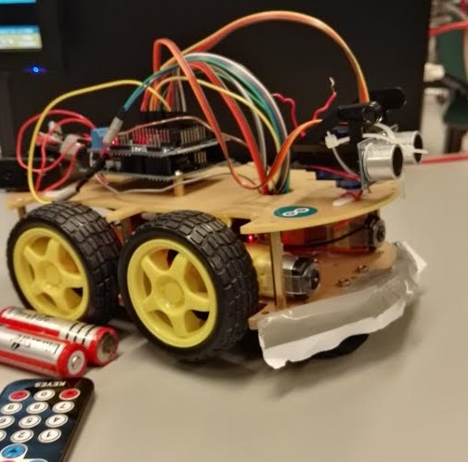

FIGURE 1. Car, fully connected

# Objectives

The objective was to create a car that could be controlled with IR or Bluetooth and also had automatic drive mode that would avoid obstacles or follow a line on the ground.

Thesis

ECTS credits: 15

Date of publication: 2016, Autumn

Instructor: Juha Alakärppä

# Components

The carkit has 4 motors for the wheels. A motor driver board to control the motors. A servomotor and an ultrasound sensor for obstacle detecting. Bluetooth adapter and a IR-receiver for the remote controls. And also an Arduino to process the commands and driving logic.

# Methods

The Arduino was programmed using Arduino programming software. Bluetooth controlling was done with android studio.



FIGURE 2. Project leader Tatu Piippo

**Results** New Android application was created. In future, same source code base can be used to build application for other platforms.

New information services can be easily added to the application and server.

# Conclusions

Web technologies can be successfully used in implementation of mobile device applications. However, there may be challenges in this approach from performance requirements of the software. To adapt the solution in other projects, it is necessary to evaluate how technology suits the application requirements.

**References** https://www.arduino.cc/en/