1. Draw the A-on-N network (above left). Include EST, LST, duration and float for each node in your drawing. State the total duration. Mark all critical path arrows by double-slashing: --//--->  
   Total duration is 4, critical paths: DIG, DIH and E.
2. What is project maturity? What would low project maturity lead to? Name a project maturity model.

**The term "maturity" relates to the degree of formality and optimization of processes. CMMI Capability Maturity Model, used in the IT industry (5 levels: initial, repeatable, defined, managed, optimizing)**

1. An error does not cause ‘consumer terrorism’, Maylor wrote. What does and how can it be avoided?

**This attempt to eliminate these ‘repeat concerns’ was highly effective and showed a level of commitment to the issue of quality at a high level. Moreover, it is a realistic approach – mistakes do happen – most customers accept this (albeit grudgingly). It is the actions that follow that determine whether or not the event becomes a cause for ‘consumer terrorism’ (customers who gladly tell everyone the problems that they had with a firm) or an opportunity to get closer to the customer.**

**The organization does have a choice in this respect. The stages in the management of failure are as follows:**

**● identify that something has gone wrong;**

**● contain the situation – accept that there is a problem, prevent further damage or escalation of the problem;**

**● put in place recovery actions to regain the customer’s confidence;**

**● ensure that practices are changed so that this incident does not occur again.**

1. What is FMEA analysis? Give an example. (p. 223)

**How risky is an event or activity? Failure Mode Effect Analysis FMEA is a qualitative approach, which differs from the traditional approach (assess probability and impact) and considers three elements of each activity or path through the activities. It includes hideability. This is because it is often noted that the reasons for failure of projects are not the mainstream risks that were identified during analysis but ones that have emerged. This factor measures how easy it would be for one party to the project to conceal the fact that the things were going very wrong with part of the project. This would mean that the problems cannot be detected until it is too late.   
(probability)x(impact)x(hideability)**

1. Describe the Earned Value method and give an example.

**For complex projects where warning of problems and an ability to predict final costs and**

**times at completion is required, the use of the concept of earned value can be most useful.**

**This measure brings together time and cost performance elements into a monetary**

**quantity – a unit that is easily understood.   
A project has ten activities to be performed over a period of 10 weeks.**

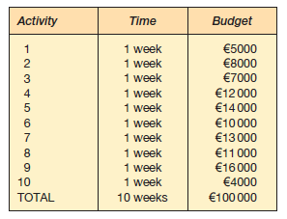

**After 5 weeks, it is found that activities 1–4 have been completed, and that the spend to this time is a36000. Using a measure that simply looked at the spend, the target was to have completed five activities during this time and therefore the spend should be:**

**5000 + 8000 + 7000 + 12000 + 14000 = 46000**

**We have spent only a36000, so this is good, isn’t it? Planned spend of a46000, actual spend of a36000 means that we are running a10000 under budget. Don’t start to plan the post-project party just yet. The earned value measures tell us a different story. The project manager does the following calculations. The first is to determine the earned value. ‘Value’ is ‘earned’ by the completion of activities and the budget for each activity is the value that is earned. In this case it would be the sum of the budgets for the completed activities 1–4:**

**Earned value after completion of activities 1–4 = 5000 + 8000 + 7000 + 12000 = 32000  
  
Actual spend: 36000**

**Planned spend: 46000  
Earned value: 32000  
  
Earned value is 4000 less. Calculate variance of 4000. Then ration of the two measures (cost performance indicator):  
32000 / 36000 = 0.889  
  
It is possible to calculate the estimated cost at completion = original budget / cost performance indicator**

1. WBS is so common in project management that it is often used only as an abbreviation. What does the abbreviation mean? Why is WBS important? Give an example of WBS.

**Work breakdown structure technique consist in breaking down large activities into comprehensible or manageable units (How do you eat an elephant? Just one slice at a time). It is a fundamental part of project management. WBS facilitates financial control activities, as individual parts can have their consumption of resources tracked.   
The role of a WBS is to create a linked, hierarchical series of activities, which are independent units, but at the same time still part of the whole, and here lies the major problem with WBS. Whatever type of structure you choose, there are inevitable conflicts (communication problems).**

1. Describe the Student Syndrome.

**Student syndrome is identified as where, despite people being given extra time (slack) for an activity, the extra time is wasted at the front end, and they often won’t start the activity until the latest possible time.**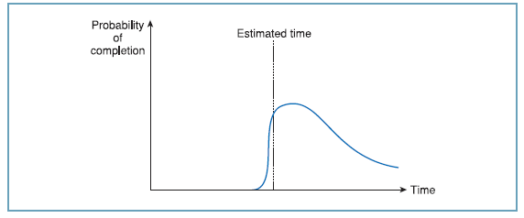

1. A chapter deals with PV, NPV, FV, IRR, DCF, and cash flow considerations. (No, you don’t have to explain them each, but) explain why concepts like these have relevance to project management, and when (according to the 4D model) they would be used.

**Chapter 8.   
PV = present value  
NPV = net present value  
FV = future value  
IRR = internal rate of return  
DCF = discounted cash flow**

**The financial appraisal of project proposals will consider the potential rewards of carrying out a project against the predicted costs.   
Once the cost of completing the project has been determined from the WBS (ground-up) or senior management (top-down) system the justification is that the return will at least exceed the amount spent. This return or payback can be analyzed in a number of ways to determine feasibility or net benefit: payback analysis, DCF, IRR**

1. Draw a Gantt chart of activities B, E, F, G, H, and K in question 1 (above).

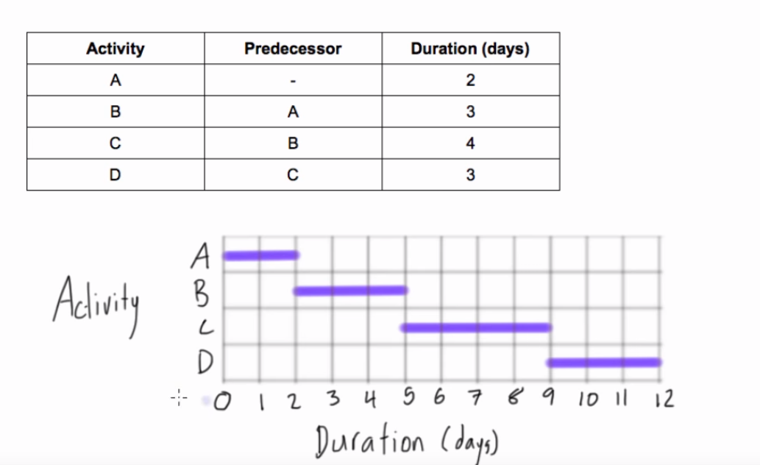

1. What does closing down the project systems mean, and why would one do it?

**The level of activity falls off as the project nears completion. This is accompanied by a slowdown in the spending rate, on both labor and materials. As people leave the project team it must be remembered that the systems, in particular the accounting and quality systems, are still operational.  
Finishing the activities so that resources can be released for other work and minimizing the costs incurred during the close-down phase are vital.**

1. Describe the lifecycle of quality circles.

**Quality circles have been a very popular management tool for encouraging people from all parts of organisations to work together to solve problems.**

1. For each of (a) and (b), name the 4D phase that contains it: (a) improving project performance, and (b) supply chain issues.  
   Name and order the 4D phases.

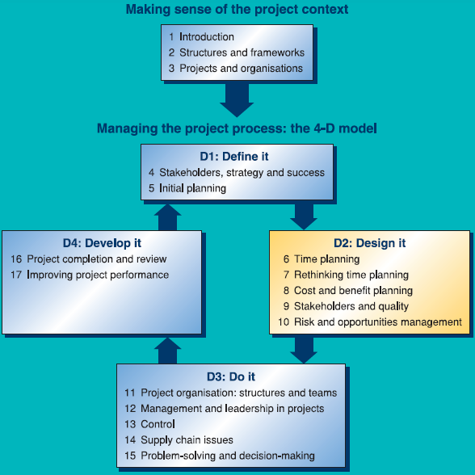

1. Describe the stage-gate system.

**It is part of the role of the planner to determine the nature and objectives of each phase (part) of the project. The use of check-points or gates between the phases provides the most basic opportunity to review progress (or otherwise). Most importantly, you do not have to wait until the project budget or time allowance expires to find out that there is a fundamental problem.**

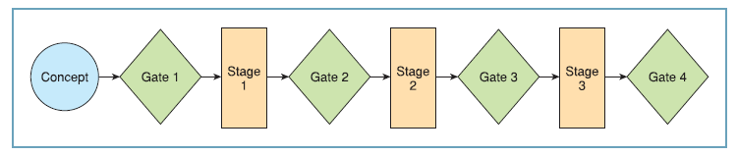

1. Explain the differences between performance and conformance.

**The first consideration is to determine the nature of the three key objectives. As minimum, the project manager must define these and then put in place a project process to ensure that these objectives are met. This approach stresses conformance to the stated objectives and can be identified as:  
- can the project be delivered in time?  
- will the project finish in budget?  
- will the project meet the specified level of quality?  
Going beyond the minimalistic approach (just by achieving conformance), it is possible to reach level of excellence defined in terms of real performance which can be identified as:  
- shortest possible project duration?  
- lowest possible cost?  
- highest level of quality achievable?  
  
Attributes: time cost quality**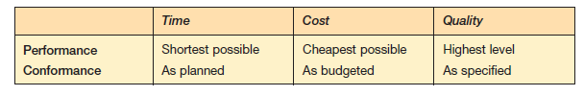

1. A commonly used activity-on-node linkage is the finish-to-start linkage, but there are also three others. Name and draw those three.

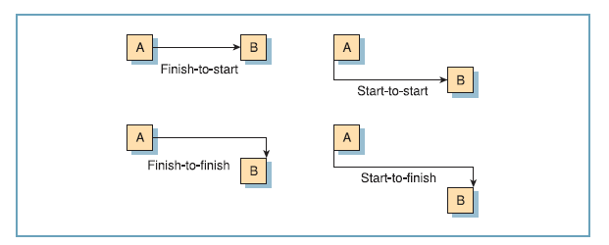

1. Which are the necessary components in a business case?  
   **Business case: justification for undertaking a project, in terms of evaluating the benefits, cost and risk of alternative options and rationable for the preferred solution.**
2. What is a dotted-line responsibility, according to Maylor?  
   **In order to try to enforce communication between departments, many organisations use dotted-line responsibility. Here an individual may have a responsibility to one functional manager, with a dotted-line responsibility to another. This device has been used frequently to ensure that certain individuals do not engage in empire-building.**
3. What characterizes a project in the collection phase?  
   **The bringing together of individuals into a group with a collective task or problem to solve. The participants have a degree of eagerness and initial enthusiasm and generally rely on the authority and hierarchy to provide a degree of certainty in this uncertain environment. They will use this initial phase to establish themselves and find what is expected of them.**
4. Describe Scientific Management, also known as Taylorism. For which kind of work is it best applicable?  
   **The principles of scientific management or ‘Taylorism’ are most applicable to repetitive work. They are as follows.**

**● Work should be studied scientifically to determine in quantitative terms how it should be divided and how each segment should be done. The aim is to maximise efficiency of the activity and is achieved through measurement, recording and subsequent analysis.**

**● The worker should be matched scientifically to the job, e.g. where a task has a physical**

**input to it, the physique of the individual should match the requirements of that task by, for example, using a well-built person to move heavy loads.**

**● The person carrying out a task should be trained to do it as per the results of the analysis – it must be carried out exactly as designed and closely supervised.**

**● The person carrying out the task should be rewarded for following the prescribed method exactly by a substantial monetary bonus.**

**The result of Taylorism is the separation of the work task from any thinking process by**

**the individual. Any attempt at motivation is purely financially based. Support activities**

**are carried out by trained individuals. The advantage of the system for working is that**

**the task is made very simple, which means that an individual can become very proficient**

**at it and can be replaced with relative ease. The downsides are considerable, however,**

**with the person being alienated from the task they are doing and having no real input   
to the conversion process. This alienation can be passive in the form of losing interest in   
the process (‘don’t care’ attitude) ranging to destructive.**

1. What is scope creep and how do you need to manage it, according to Maylor?  
   **The original purpose was subtly changed on many subsequent occasions until it no longer resembled the original concept. The result was disastrous – the product was a flop and all the firms involved lost substantial sums of money. Managing product scope creep clearly needs to be a role for the project manager. Similarly, the process scope needs managing right from the start.**
2. What does deconstruction of a project mean and why would it be important?  
   **The objectives for the production of plans are twofold. First, it must provide an opportunity for the planner to *analyse the project process*, to *reveal opportunities for improvements* and *problem prevention*, and *setting out the basis* on which the project will proceed. Second, the benefits of plans are only realised when they are *communicated*.   
   Having prepared the overview models, it is now the task of the planner to put in place the detail. Graphical techniques are preferred.**
3. In which method is buffer penetration a core concept, and what does it mean?

;)

1. What is a cost-plus contract?  
   **This is where the customer agrees to reimburse whatever costs the supplier incurs on a project, plus a margin for profit. This was until relatively recently the preferred form of contract for many military development and procurement projects.**