GitHub Link - <https://github.com/smen249/LabTestOne>

4 – Every Second Cube Now a Sphere

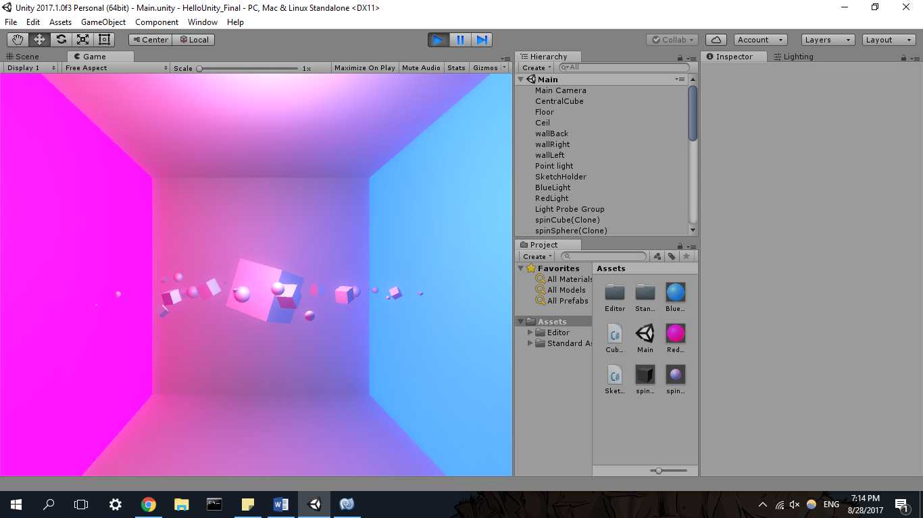

5 -