Pedometer in HTML5 for Firefox OS/Firefox for Android

Introduction
Nowadays,the connected devices are increasingly present. They are especially the "stars" of the latest Consumer Electronics Show 2014 (Las Vegas, NV, USA) . Among these devices, there is one who knows a revival: pedometer. For a long time, pedometer has established in hiking field. But it has suffered in comparison with geolocation which can offers greater simplicity (no setting) and greater accuracy in distance measurements. However, geolocation can be a complement to the pedometer since only the pedometer can measure the number of steps. With the accession of smartphones, all these measures can easily be performed with the same device. For example, there is a version for Android pedometer under GNU GPLv3 license [1].
However, it seems that the future of mobile technologies tends to turn to web technologies based on HTML5. Two projects of operating system arouse: Firefox OS developed by the Mozilla Foundation and Tizen developed by Linux Foundation. Note that web scripts can be added to programs in C++ through Qt Library. These factors led me to develop a pedometer in HTML5 under the GNU GPLv3 License.
The recent development of new functionality enables to get information from gyroscopes easily. The web browser will calculate the acceleration in three smartphone axes x, y and z. From these three signals, when a person has a smartphone in the pocket, the steps can be detected. This web application is based on measures of digital accelerometer [2].

Orientation and motion data explained
Author: Sheppy (Mozilla Contributor).
Creative Commons Attribution-ShareAlike license (CC-BY-SA)
The web application has been tested on a Geeksphone Peak (Madrid, Spain) with Firefox OS 1.3 Prerelase. Note that Firefox for Android, the web application works but no benchmark has been achieved in this platform.

Acceleration and Walking
The measurement principle is described in the block diagram given in the following figure. When a person walks, the smartphone in his pocket undergoes accelerations and decelerations. A step corresponds to a pseudo-period of the signal with acceleration variations. Counting the number of steps is therefore to increment a counter for pseudo-period performed.
The first step is to merge information of the three accelerations d²x/dt², d²y/dt² and d²z/dt². The other advantage of this operation is to eliminate the absence of information on the position in the pocket, because the acceleration during walking can not be predicted. The simplest fusion is to compute the norm of the vector acceleration:
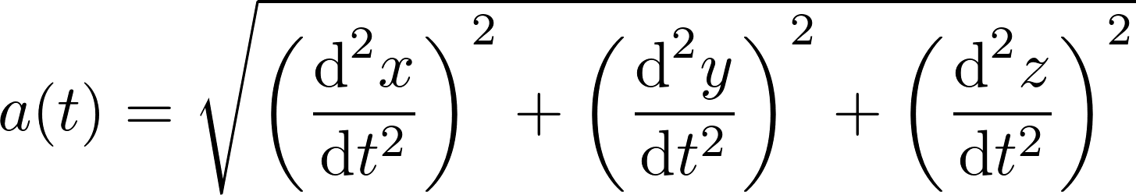
where t is the discrete time.
To improve the robustness of detection, the steps are not directly counted on the standard acceleration a(t). A denoising step is applied from a Kalman filter [3] by using the following equations.
(Optimal Kalman gain)
(Updated acceleration estimated)
(Updated covariance estimated)

with is the error covariance matrix, the signal estimated at time t, the matrix of the estimation model and the covariance of the noise mesured. Note that all parameters are initialized at 1 at the beginning of the computation.

This filter could be applied before the norm calculation on each three accelerations d²x/dt², d²y/dt² and d²z/dt². However by applying the Kalman filter on the acceleration a(t), the computation cost can be reduced. In this case, the dimension of the matrix are therefore one. Finally, we hypothesized that the signal without noise is sinusoidal with a variance of 0.5. By measuring the variance of acceleration a(t), we can deduce the noise variation.

The detection is made on this denoised signal. A step is then detected if the acceleration cut an adaptive threshold. This threshold corresponds to the average of the extreme acceleration values on a window of 2 seconds. Several conditions are also added to reduce false positives. First, it is necessary that the difference between the extrema exceeds to the sensitivity. This sensitivity is the double of the noise variance normalized. Moreover, to count a single step per pseudo-period, a condition on the derivative is added: the detection is performed only when the acceleration exceeding the threshold falls below this threshold. Finally, to reduce the risk of detecting false quick step, the minimum time between two step detection has to be 200 ms (13.6 km/h).
From these measurements, we deduce the instantaneous speed as an average speed on a window of 2 seconds. The calories burned are therefore computed [2]:
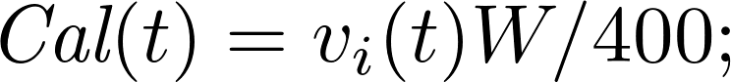

References
[1] Pedometer for Android : https://code.google.com/p/pedometer/
[2] Zhao, N. Full-featured pedometer design realized with 3-Axis digital accelerometer. Analog Dialogue, 2010, vol. 44, no 6, p. 1-5.
[3] Kalman, R. E. A New Approach to Linear Filtering and Prediction Problems. Journal of basic Engineering, 1960, vol 82 (Series D), no 1, p. 35-45.

Web Interface
La page principale indique la distance parcourue, votre vitesse moyenne et instantannées ainsi que les calories brûlées. Dans la version actuelle, l'écran de verrouillage ne doit pas se lancer sous Firefox OS. Lorsque cette application fonctionne, l'écran de verrouillage est donc automatiquement bloqué.
A partir du menu, il est possible régler la taille des pas pour déterminer la distance totale parcourue. Nous conseillons de compter vos pas sur une grande distance connue. Le rapport entre la distance et le nombre de pas vous donnera la taille de votre pas. Il est également possible de régler son poid pour le calcul des calories brûlées.
Enfin on peut également acceder à l'aide de l'application.

Conclusion

Cette première version du podomètre fonctionne correctement sur mon Geeksphone Peak. Elle démontre les capacités de traitement du signal temps-réels pour une application HTML5.
Dans une future version, la distance et les vitesses pourront être proposées à partir des données GPS pour augmenter la précisions. Toutefois, elle ne sera qu'une option pour que le podomètre puisse continuer de fonctionner même lorsque la réception GPS est mauvaise.

Confidentialité

L'application ne nécessite pas une connexion internet. L'historique de vos statistiques est stocké sur votre smartphone. Aucune donnée n'est transférée.
L'application est libre sous Licence GPL v3.

