Screenshots:
- View existing entries in expense sheet, then adding an expense and Viewing the entries again
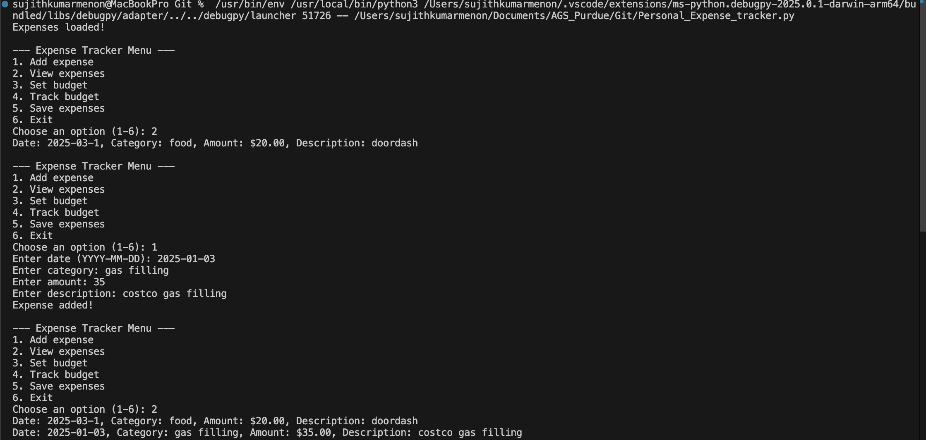

- Setting and tracking budget
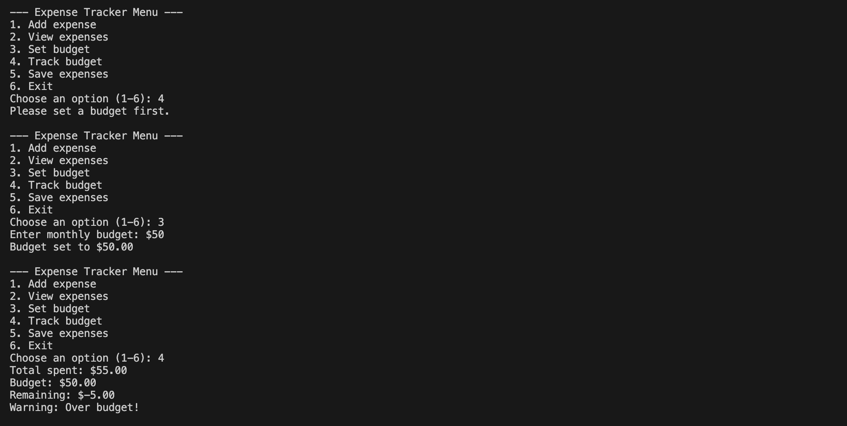

- Saving the expenses, viewing them .
