HarvardX: PH125.9x Data Science  
Capstone MovieLens Project

Srinivasan Menon

June 10, 2019

Table of Contents

# Overview

This project is related to the HervardX: PH125.9x Data Science: Capstone course MovieLens Project. The present report start with a general idea of the project and by representing its objectives.

Then the given movie lens dataset will be loaded and setup. An exploratory data analysis is carried out in order to develop a machine learning algorithm that could predict movie ratings until a final model. Results will be explained. Finally the report ends with some concluding remarks.

## Introduction

Recommendation systems use ratings that users have given to items to make specific recommendations. Companies that sell many products to many customers and permit these customers to rate their products, like Amazon, are able to collect massive datasets that can be used to predict what rating a particular user will give to a specific item. Items for which a high rating is predicted for a given user are then recommended to that user.

The same could be done for other items, as movies for instance in our case. Recommendation systems are one of the most used models in machine learning algorithms. In fact the success of Netflix is said to be based on its strong recommendation system. The Netflix prize (open competition for the best collaborative filtering algorithm to predict user ratings for films, based on previous ratings without any other information about the users or films), in fact, represent the high importance of algorithm for products recommendation system.

For this project we will focus on create a movie recommendation system using the 10M version of MovieLens dataset, collected by GroupLens Research.

## Aim of the project

The aim in this project is to train a machine learning algorithm that predicts user ratings (from 0.5 to 5 stars) using the inputs of a provided subset (edx dataset provided by the staff) to predict movie ratings in a provided validation set.

The value used to evaluate algorithm performance is the Root Mean Square Error, or RMSE. RMSE is one of the most used measure of the differences between values predicted by a model and the values observed. RMSE is a measure of accuracy, to compare forecasting errors of different models for a particular dataset, a lower RMSE is better than a higher one. The effect of each error on RMSE is proportional to the size of the squared error; thus larger errors have a disproportionately large effect on RMSE. Consequently, RMSE is sensitive to outliers. Four models that will be developed will be compared using their resulting RMSE in order to assess their quality. The evaluation criteria for this algorithm is a RMSE expected to be lower than 0.8775. The function that computes the RMSE for vectors of ratings and their corresponding predictors will be the following:



Finally, the best resulting model will be used to predict the movie ratings.

## Dataset

The MovieLens dataset is automatically downloaded

• [MovieLens 10M dataset] <https://grouplens.org/datasets/movielens/10m/>

• [MovieLens 10M dataset - zip file] <http://files.grouplens.org/datasets/movielens/ml-10m.zip>

#############################################################  
# Create edx set, validation set, and submission file  
#############################################################  
# Note: this process could take a couple of minutes for loading required package: tidyverse and package caret  
if(!require(tidyverse)) install.packages("tidyverse", repos = "http://cran.us.r-project.org")  
if(!require(caret)) install.packages("caret", repos = "http://cran.us.r-project.org")  
#dl <- tempfile()  
#download.file("http://files.grouplens.org/datasets/movielens/ml-10m.zip", dl)  
  
#ratings <- read.table(text = gsub("::", "\t", readLines(unzip(dl, "ml-10M100K/ratings.dat"))),  
# col.names = c("userId", "movieId", "rating", "timestamp"))  
  
#movies <- str_split_fixed(readLines(unzip(dl, "ml-10M100K/movies.dat")), "\\::", 3)  
#colnames(movies) <- c("movieId", "title", "genres")  
  
#movies <- as.data.frame(movies) %>% mutate(movieId = as.numeric(levels(movieId))[movieId],  
# title = as.character(title),  
# genres = as.character(genres))  
#movielens <- left_join(ratings, movies, by = "movieId")  
edx <- readRDS("C:/DS/Capstone/edx.rds")  
validation <- readRDS("C:/DS/Capstone/validation.rds")

In order to predict in the most possible accurate way the movie rating of the users that haven’t seen the movie yet, the he MovieLens dataset will be splitted into 2 subsets that will be the “edx”, a training subset to train the algorithm, and “validation” a subset to test the movie ratings. “edx’ and”validation" dataset were downloaded from edX site and loaded to Studio before running this script.

# The Validation subset will be 10% of the MovieLens data.  
#set.seed(1)  
#test_index <- createDataPartition(y = movielens$rating, times = 1, p = 0.1, list = FALSE)  
#edx <- movielens[-test_index,]  
#temp <- movielens[test_index,]  
#Make sure userId and movieId in validation set are also in edx subset:  
#validation <- temp %>%  
# semi_join(edx, by = "movieId") %>%  
# semi_join(edx, by = "userId")  
  
# Add rows removed from validation set back into edx set  
#removed <- anti_join(temp, validation)  
#edx <- rbind(edx, removed)  
#rm(dl, ratings, movies, test_index, temp, movielens, removed)

Algorithm development is to be carried out on the “edx” subset only, as “validation” subset will be used to test the final algorithm.

# Methods and Analysis

## Data Analysis

To get familiar with the dataset given by edX, we find the first rows of “edx” subset as below. The subset contain the six variables “userID”, “movieID”, “rating”, “timestamp”, “title”, and “genres”. Each row represent a single rating of a user for a single movie.

## userId movieId rating timestamp title  
## 1 1 122 5 838985046 Boomerang (1992)  
## 2 1 185 5 838983525 Net, The (1995)  
## 4 1 292 5 838983421 Outbreak (1995)  
## 5 1 316 5 838983392 Stargate (1994)  
## 6 1 329 5 838983392 Star Trek: Generations (1994)  
## 7 1 355 5 838984474 Flintstones, The (1994)  
## genres  
## 1 Comedy|Romance  
## 2 Action|Crime|Thriller  
## 4 Action|Drama|Sci-Fi|Thriller  
## 5 Action|Adventure|Sci-Fi  
## 6 Action|Adventure|Drama|Sci-Fi  
## 7 Children|Comedy|Fantasy

A summary of the subset confirms that there are no missing values.

## userId movieId rating timestamp   
## Min. : 1 Min. : 1 Min. :0.500 Min. :7.897e+08   
## 1st Qu.:18124 1st Qu.: 648 1st Qu.:3.000 1st Qu.:9.468e+08   
## Median :35738 Median : 1834 Median :4.000 Median :1.035e+09   
## Mean :35870 Mean : 4122 Mean :3.512 Mean :1.033e+09   
## 3rd Qu.:53607 3rd Qu.: 3626 3rd Qu.:4.000 3rd Qu.:1.127e+09   
## Max. :71567 Max. :65133 Max. :5.000 Max. :1.231e+09   
## title genres   
## Length:9000055 Length:9000055   
## Class :character Class :character   
## Mode :character Mode :character   
##   
##   
##

The total of unique movies and users in the edx subset is about 70.000 unique users and about 10.700 different movies:

## n_users n_movies  
## 1 69878 10677

Users have a preference to rate movies rather higher than lower as shown by the distribution of ratings below. 4 is the most common rating, followed by 3 and 5. 0.5 is the least common rating. In general, half rating are less common than whole star ratings.

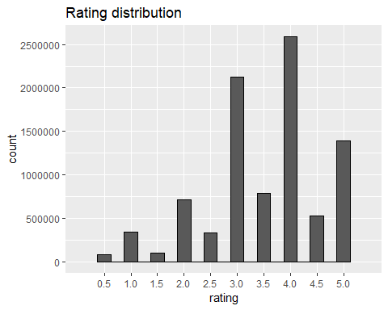

We can observe that some movies have been rated moch often that other, while some have very few ratings and sometimes only one rating. This will be important for our model as very low rating numbers might results in untrustworthy estimate for our predictions. In fact 125 movies have been rated only once.

Thus regularisation and a penalty term will be applied to the models in this project. Regularizations are techniques used to reduce the error by fitting a function appropriately on the given training set and avoid overfitting (the production of an analysis that corresponds too closely or exactly to a particular set of data, and may therefore fail to fit additional data or predict future observations reliably). Regularization is a technique used for tuning the function by adding an additional penalty term in the error function. The additional term controls the excessively fluctuating function such that the coefficients don’t take extreme values.

edx %>%  
count(movieId) %>%  
ggplot(aes(n)) +  
geom_histogram(bins = 30, color = "black") +  
scale_x_log10() +  
xlab("Number of ratings") +  
 ylab("Number of movies") +  
ggtitle("Number of ratings per movie")

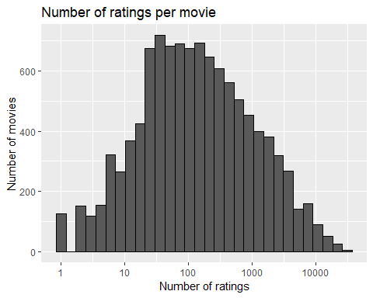

As 20 movies that were rated only once appear to be obscure, predictions of future ratings for them will be difficult.

edx %>%  
 group_by(movieId) %>%  
 summarize(count = n()) %>%  
 filter(count == 1) %>%  
 left_join(edx, by = "movieId") %>%  
 group_by(title) %>%  
 summarize(rating = rating, n_rating = count) %>%  
 slice(1:20) %>%  
 knitr::kable()

|  |  |  |
| --- | --- | --- |
| title | rating | n_rating |
| 1, 2, 3, Sun (Un, deuz, trois, soleil) (1993) | 2.0 | 1 |
| 100 Feet (2008) | 2.0 | 1 |
| 4 (2005) | 2.5 | 1 |
| Accused (Anklaget) (2005) | 0.5 | 1 |
| Ace of Hearts (2008) | 2.0 | 1 |
| Ace of Hearts, The (1921) | 3.5 | 1 |
| Adios, Sabata (Indio Black, sai che ti dico: Sei un gran figlio di…) (1971) | 1.5 | 1 |
| Africa addio (1966) | 3.0 | 1 |
| Aleksandra (2007) | 3.0 | 1 |
| Bad Blood (Mauvais sang) (1986) | 4.5 | 1 |
| Battle of Russia, The (Why We Fight, 5) (1943) | 3.5 | 1 |
| Bellissima (1951) | 4.0 | 1 |
| Big Fella (1937) | 3.0 | 1 |
| Black Tights (1-2-3-4 ou Les Collants noirs) (1960) | 3.0 | 1 |
| Blind Shaft (Mang jing) (2003) | 2.5 | 1 |
| Blue Light, The (Das Blaue Licht) (1932) | 5.0 | 1 |
| Borderline (1950) | 3.0 | 1 |
| Brothers of the Head (2005) | 2.5 | 1 |
| Chapayev (1934) | 1.5 | 1 |
| Cold Sweat (De la part des copains) (1970) | 2.5 | 1 |

We can observe that the majority of users have rated between 30 and 100 movies. So, a user penalty term need to be included later in our models.

edx %>%  
count(userId) %>%  
ggplot(aes(n)) +  
geom_histogram(bins = 30, color = "black") +  
scale_x_log10() +  
xlab("Number of ratings") +   
ylab("Number of users") +  
ggtitle("Number of ratings given by users")

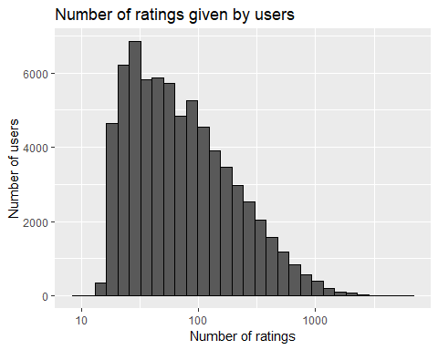

Furthermore, users differ vastly in how critical they are with their ratings. Some users tend to give much lower star ratings and some users tend to give higher star ratings than average. The visualization below includes only users that have rated at least 100 movies.

edx %>%  
 group_by(userId) %>%  
 filter(n() >= 100) %>%  
 summarize(b_u = mean(rating)) %>%  
 ggplot(aes(b_u)) +  
 geom_histogram(bins = 30, color = "black") +  
 xlab("Mean rating") +  
 ylab("Number of users") +  
 ggtitle("Mean movie ratings given by users") +  
 scale_x_discrete(limits = c(seq(0.5,5,0.5))) +  
 theme_light()

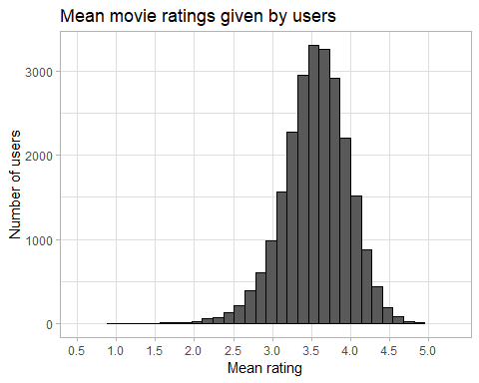

## Modelling Approach

We write now the loss-function, previously anticipated, that compute the RMSE, defined as follows:



with N being the number of user/movie combinations and the sum occurring over all these combinations. The RMSE is our measure of model accuracy. We can interpret the RMSE similarly to a standard deviation: it is the typical error we make when predicting a movie rating. If its result is larger than 1, it means that our typical error is larger than one star, which is not a good result. The written function to compute the RMSE for vectors of ratings and their corresponding predictions is:

RMSE <- function(true_ratings, predicted_ratings){  
 sqrt(mean((true_ratings - predicted_ratings)^2))  
}

The lower the better, as said previously.

### I. Average movie rating model

The first basic model predicts the same rating for all movies, so we compute the dataset’s mean rating. The expected rating of the underlying data set is between 3 and 4. We start by building the simplest possible recommender system by predicting the same rating for all movies regardless of user who give it. A model based approach assumes the same rating for all movie with all differences explained by random variation :

$$Y_{u,i}=μ+ϵ_{u,i}$$

with $ϵ_{u,i}$ independent error sample from the same distribution centered at 0 and $μ$ the “true” rating for all movies. This very simple model makes the assumption that all differences in movie ratings are explained by random variation alone. We know that the estimate that minimize the RMSE is the least square estimate of $Y_{u,i}$, in this case, is the average of all ratings: The expected rating of the underlying data set is between 3 and 4.

mu <- mean(edx$rating)  
mu

## [1] 3.512465

If we predict all unknown ratings with $μ$ or mu, we obtain the first naive RMSE:

naive_rmse <- RMSE(validation$rating, mu)  
naive_rmse

## [1] 1.061202

Here, we represent results table with the first RMSE:

rmse_results <- data_frame(method = "Average movie rating model", RMSE = naive_rmse)

## Warning: `data_frame()` is deprecated, use `tibble()`.  
## This warning is displayed once per session.

rmse_results %>% knitr::kable()

|  |  |
| --- | --- |
| method | RMSE |
| Average movie rating model | 1.061202 |

This give us our baseline RMSE to compare with next modelling approaches.

In order to do better than simply predicting the average rating, we incorporate some of insights we gained during the exploratory data analysis.

### II. Movie effect model

To improve above model we focus on the fact that, from experience, we know that some movies are just generally rated higher than others. Higher ratings are mostly linked to popular movies among users and the opposite is true for unpopular movies. We compute the estimated deviation of each movies’ mean rating from the total mean of all movies $μ$. The resulting variable is called “b” ( as bias ) for each movie “i” $b_{i}$, that represents average ranking for movie $i$:

$$Y_{u,i}=μ+b_{i}+ϵ_{u,i}$$

The histogram is left skewed, implying that more movies have negative effects

movie_avgs <- edx %>%  
 group_by(movieId) %>%  
 summarize(b_i = mean(rating - mu))  
movie_avgs %>% qplot(b_i, geom ="histogram", bins = 10, data = ., color = I("black"),  
ylab = "Number of movies", main = "Number of movies with the computed b_i")

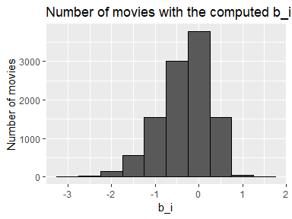

This is called the penalty term movie effect.

Our prediction improve once we predict using this model.

predicted_ratings <- mu + validation %>%  
 left_join(movie_avgs, by='movieId') %>%  
 pull(b_i)  
model_1_rmse <- RMSE(predicted_ratings, validation$rating)  
rmse_results <- bind_rows(rmse_results,  
 data_frame(method="Movie effect model",   
 RMSE = model_1_rmse ))  
rmse_results %>% knitr::kable()

|  |  |
| --- | --- |
| method | RMSE |
| Average movie rating model | 1.0612018 |
| Movie effect model | 0.9439087 |

So we have predicted movie rating based on the fact that movies are rated differently by adding the computed $b_{i}$ to $μ$. If an individual movie is on average rated worse that the average rating of all movies $μ$, we predict that it will rated lower that $μ$ by $b_{i}$, the difference of the individual movie average from the total average.

We can see an improvement but this model does not consider the individual user rating effect.

### III. Movie and user effect model

We compute the average rating for user $μ$, for those that have rated over 100 movies, said penalty term user effect. In fact users affect the ratings positively or negatively.

user_avgs<- edx %>%   
 left_join(movie_avgs, by='movieId') %>%  
 group_by(userId) %>%  
 filter(n() >= 100) %>%  
 summarize(b_u = mean(rating - mu - b_i))  
user_avgs%>% qplot(b_u, geom ="histogram", bins = 30, data = ., color = I("black"))

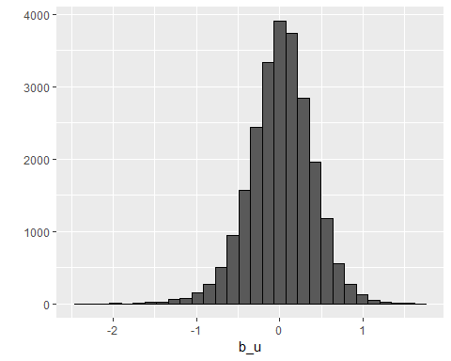

There is substantial variability across users as well: some users are very cranky and other love every movie. This implies that further improvement to our model my be:

$$Y_{u,i}=μ+b_{i}+b_{u}+ϵ_{u,i}$$

where $b_{u}$ is a user-specific effect. If a cranky user (negative $b_{u}$ rates a great movie (positive $b_{i}$), the effects counter each other and we may be able to correctly predict that this user gave this great movie a 3 rather than a 5.

We compute an approximation by computing $μ$ and $b_{i}$, and estimating $b_{u}$, as the average of

$$Y_{u,i}−μ−b_{i}$$

user_avgs <- edx %>%  
 left_join(movie_avgs, by='movieId') %>%  
 group_by(userId) %>%  
 summarize(b_u = mean(rating - mu - b_i))

We can now construct predictors and see RMSE improves:

predicted_ratings <- validation%>%  
 left_join(movie_avgs, by='movieId') %>%  
 left_join(user_avgs, by='userId') %>%  
 mutate(pred = mu + b_i + b_u) %>%  
 pull(pred)  
  
model_2_rmse <- RMSE(predicted_ratings, validation$rating)  
rmse_results <- bind_rows(rmse_results,  
 data_frame(method="Movie and user effect model",   
 RMSE = model_2_rmse))  
rmse_results %>% knitr::kable()

|  |  |
| --- | --- |
| method | RMSE |
| Average movie rating model | 1.0612018 |
| Movie effect model | 0.9439087 |
| Movie and user effect model | 0.8653488 |

Our rating predictions further reduced the RMSE. But we made stil mistakes on our first model (using only movies). The supposes “best “ and “worst “movie were rated by few users, in most cases just one user. These movies were mostly obscure ones. This is because with a few users, we have more uncertainty. Therefore larger estimates of $b_{i}$, negative or positive, are more likely. Large errors can increase our RMSE.

Until now, we computed standard error and constructed confidence intervals to account for different levels of uncertainty. However, when making predictions, we need one number, one prediction, not an interval. For this we introduce the concept of regularization, that permits to penalize large estimates that come from small sample sizes. The general idea is to add a penalty for large values of $b_{i}$ to the sum of squares equation that we minimize. So having many large $b_{i}$, make it harder to minimize. Regularization is a method used to reduce the effect of overfitting.

### IV. Regularized movie and user effect model

So estimates of $b_{i}$ and $b_{u}$ are caused by movies with very few ratings and in some users that only rated a very small number of movies. Hence this can strongly influence the prediction. The use of the regularization permits to penalize these aspects. We should find the value of lambda (that is a tuning parameter) that will minimize the RMSE. This shrinks the $b_{i}$ and $b_{u}$ in case of small number of ratings.

lambdas <- seq(0, 10, 0.25)  
  
rmses <- sapply(lambdas, function(l){  
   
 mu <- mean(edx$rating)  
   
 b_i <- edx %>%   
 group_by(movieId) %>%  
 summarize(b_i = sum(rating - mu)/(n()+l))  
   
 b_u <- edx %>%   
 left_join(b_i, by="movieId") %>%  
 group_by(userId) %>%  
 summarize(b_u = sum(rating - b_i - mu)/(n()+l))  
   
 predicted_ratings <-   
 validation %>%   
 left_join(b_i, by = "movieId") %>%  
 left_join(b_u, by = "userId") %>%  
 mutate(pred = mu + b_i + b_u) %>%  
 pull(pred)  
   
 return(RMSE(predicted_ratings, validation$rating))  
})

We plot RMSE vs lambdas to select the optimal lambda

qplot(lambdas, rmses)

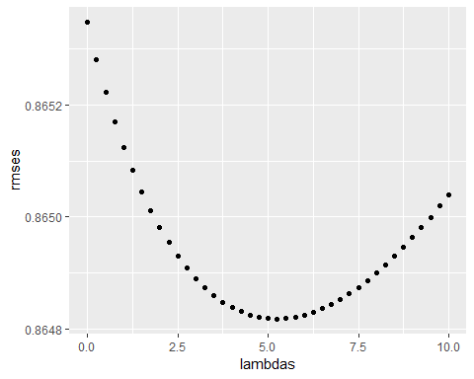

For the full model, the optimal lambda is:

lambda <- lambdas[which.min(rmses)]  
lambda

## [1] 5.25

For the full model, the optimal lambda is: 5.25

The new results will be:

rmse_results <- bind_rows(rmse_results,  
 data_frame(method="Regularized movie and user effect model",   
 RMSE = min(rmses)))  
rmse_results %>% knitr::kable()

|  |  |
| --- | --- |
| method | RMSE |
| Average movie rating model | 1.0612018 |
| Movie effect model | 0.9439087 |
| Movie and user effect model | 0.8653488 |
| Regularized movie and user effect model | 0.8648170 |

# Results

The RMSE values of all the represented models are the following:

|  |  |
| --- | --- |
| method | RMSE |
| Average movie rating model | 1.0612018 |
| Movie effect model | 0.9439087 |
| Movie and user effect model | 0.8653488 |
| Regularized movie and user effect model | 0.8648170 |

We therefore found the lowest value of RMSE that is 0.8648170.

# Discussion

So we can confirm that the final model for our project is the following:

$$Y_{u,i}=μ+b_{i}+b_{u}+ϵ_{u,i}$$

This model work well if the average user doesn’t rate a particularly good/popular movie with a large positive $b_{i}$, by disliking a particular movie.

# Conclusion

We can conclude that a machine learning algorithm is built to predict movie ratings with edX Capstone MovieLens dataset. The regularized model including the effect of user is characterized by the lower RMSE value and is hence the optimal model to use for the capstone movielens project. The optimal model characterised by the lowest RMSE value (0.8648170) lower than the initial evaluation criteria (0.8775) given by the goal of the capstone movielens project. We could also confirm that improvements in the RMSE could be achieved by adding other effect (genre, year, age,..). Other different machine learning models could also improve the results further, but hardware limitations and the main memory, are the constraints to further optimization.

# Appendix - Enviroment

print("Operating System:")

## [1] "Operating System:"

version

## _   
## platform x86_64-w64-mingw32   
## arch x86_64   
## os mingw32   
## system x86_64, mingw32   
## status   
## major 3   
## minor 6.0   
## year 2019   
## month 04   
## day 26   
## svn rev 76424   
## language R   
## version.string R version 3.6.0 (2019-04-26)  
## nickname Planting of a Tree