**Nusaiba Mahmood**

**CSIT 555_01FA2024**

**Final Project – Software Development Project - Tax Payment Tracking System**

**Term: Fall 2024**

**Assignment Due Date: Dec 14th, 2024**

**GitHub Link:** [**https://github.com/smeraldoflower/tax-payment-tracking-system**](https://github.com/smeraldoflower/tax-payment-tracking-system)

**YouTube Link:** [**https://youtu.be/WB28-GpRnRw**](https://youtu.be/WB28-GpRnRw)

**Tax Payment Tracker API**

**Base URL**

http://127.0.0.1:5000

**1. Get All Payments**

**Endpoint:**  
GET /payments

**Description:**  
Retrieves all tax payment records.

**Response:**

* 200 OK
* JSON array containing all payment records.

**Example Response:**

[

{

"id": 1,

"company": "Company A",

"amount": 1000.00,

"payment_date": "2024-01-01",

"due_date": "2024-01-15",

"status": "paid"

},

{

"id": 2,

"company": "Company B",

"amount": 2000.00,

"payment_date": "2024-02-01",

"due_date": "2024-02-15",

"status": "unpaid"

}

]

**2. Add a New Payment**

**Endpoint:**  
POST /payments

**Description:**  
Adds a new tax payment record.

**Request Body (JSON):**

| **Field** | **Type** | **Required** | **Description** |
| --- | --- | --- | --- |
| company | String | Yes | Name of the company |
| amount | Float | Yes | Payment amount |
| payment_date | String | Yes | Payment date (YYYY-MM-DD) |
| due_date | String | Yes | Due date for the payment |
| status | String | No | Payment status (default: "paid") |

**Example Request:**

{

"company": "Company Name",

"amount": 1500.50,

"payment_date": "2024-01-10",

"due_date": "2024-01-15",

"status": "paid"

}

**Response:**

* 201 Created

**Example Response:**

{

"message": "Payment added successfully!"

}

**3. Delete a Payment**

**Endpoint:**  
DELETE /payments/<int:id>

**Description:**  
Deletes a specific payment record by its ID.

**URL Parameter:**

| **Parameter** | **Type** | **Required** | **Description** |
| --- | --- | --- | --- |
| id | Integer | Yes | The ID of the payment record to delete |

**Responses:**

* 200 OK: Payment successfully deleted.
* 404 Not Found: No payment with the specified ID exists.

**Example Response:**

{

"message": "Payment with id 3 successfully deleted."

}

**Example Error Response:**

{

"error": "No payment found with id 3"

}

**4. Update a Payment**

**Endpoint:**  
PATCH /payments/<int:id>

**Description:**  
Updates one or more fields of a specific payment record.

**URL Parameter:**

| **Parameter** | **Type** | **Required** | **Description** |
| --- | --- | --- | --- |
| id | Integer | Yes | The ID of the payment record to update |

**Allowed Fields for Update:**

* company (string)
* amount (float)
* payment_date (string, YYYY-MM-DD)
* due_date (string, YYYY-MM-DD)
* status (string)

**Example Request:**

{

"amount": 2500.75,

"status": "unpaid"

}

**Responses:**

* 200 OK: Payment successfully updated.
* 400 Bad Request: No valid fields provided.
* 404 Not Found: Payment with the specified ID does not exist.

**Example Response:**

{

"message": "Payment with id 3 successfully updated."

}

**Example Error Response:**

{

"error": "No payment found with id 3"

}

**Database Table Structure**

The database stores records in the following table:

| **Field** | **Type** | **Required** | **Description** |
| --- | --- | --- | --- |
| id | INTEGER | Auto | Auto-incremented primary key |
| company | TEXT | Yes | Name of the company |
| amount | REAL | Yes | Payment amount |
| payment_date | TEXT (Date) | Yes | Date of payment (YYYY-MM-DD) |
| due_date | TEXT (Date) | Yes | Due date for the payment |
| status | TEXT | No | Payment status ("paid"/"unpaid") |

**General Notes**

1. **CORS**: Enabled to allow frontend-to-backend communication.
2. **Input Validation**:
   * Adding a new record requires company, amount, payment_date, and due_date.
   * Update requests validate for valid fields.
3. **Database**: The database file is **SQLite** (tax_payments.db), automatically initialized if it doesn’t exist.
   * Run the populate_data.py file to automatically populate the following records into the db:

**Sample Data:**

|  |  |  |  |  |  |
| --- | --- | --- | --- | --- | --- |
| id | Company | Amount | Payment date | Status | Due date |
| 1 | derm | 4100.00 | 09/26/2023 | paid | 01/15/2024 |
| 2 | derm | 4100.00 | 10/12/2023 | paid | 01/15/2024 |
| 3 | tek | 15,200.00 | 06/09/2023 | paid | 06/15/2023 |
| 4 | tek | 15,200.00 | 07/12/2023 | paid | 09/15/2023 |
| 5 | tek | 11,400.00 | 08/11/2023 | paid | 09/15/2023 |
| 6 | tek | 14,440.00 | 09/21/2023 | paid | 01/15/2024 |
| 7 | tek | 15,200.00 | 10/18/2023 | paid | 01/15/2024 |
| 8 | tek | 23,520.00 | NA | unpaid | 01/15/2024 |
| 9 | tek | 16,800.00 | NA | unpaid | 01/15/2024 |
| 10 | tek | 16,800.00 | NA | unpaid | 01/15/2024 |
| 11 | tek | 16,800.00 | NA | unpaid | 01/15/2024 |

**File Structure**

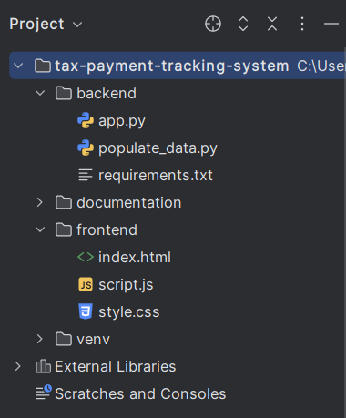

**Run app.py file to start the flask server**

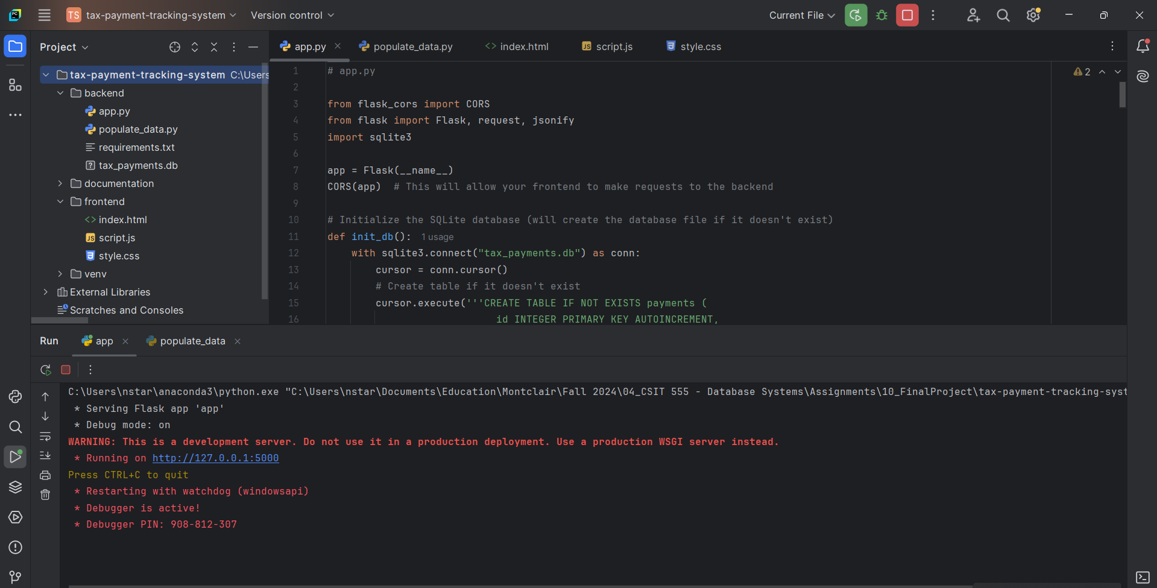

**And then run populate_data.py to populate sample data:**

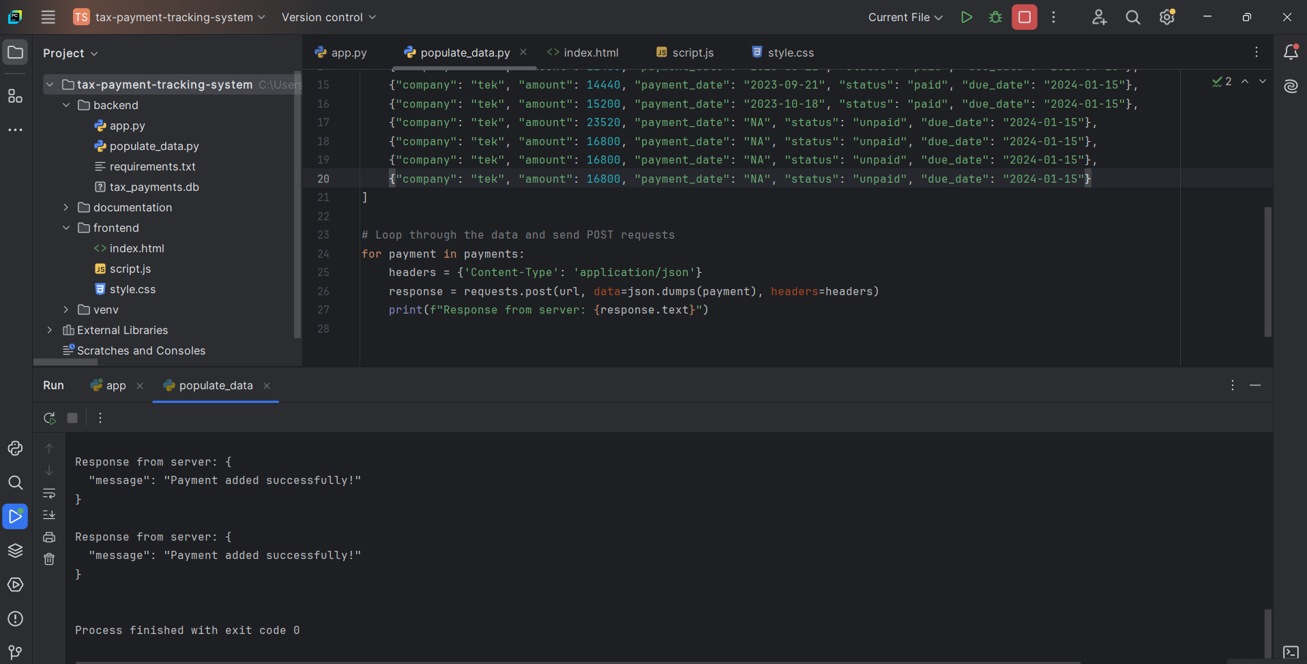

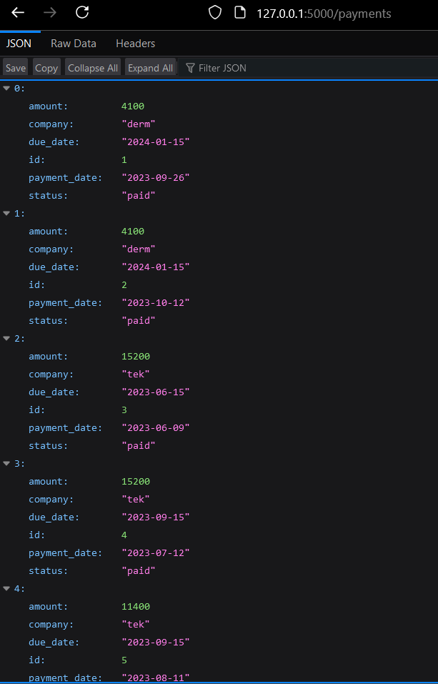

**cd into the frontend folder and run the command python -m http.server** **to serve the HTML/CSS/JS**

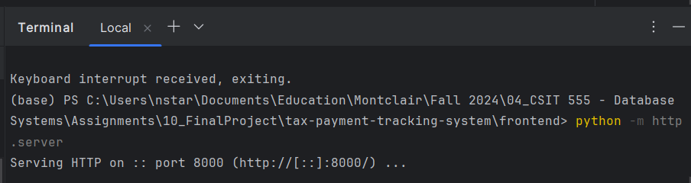

**localhost:8000 is serving the ui**

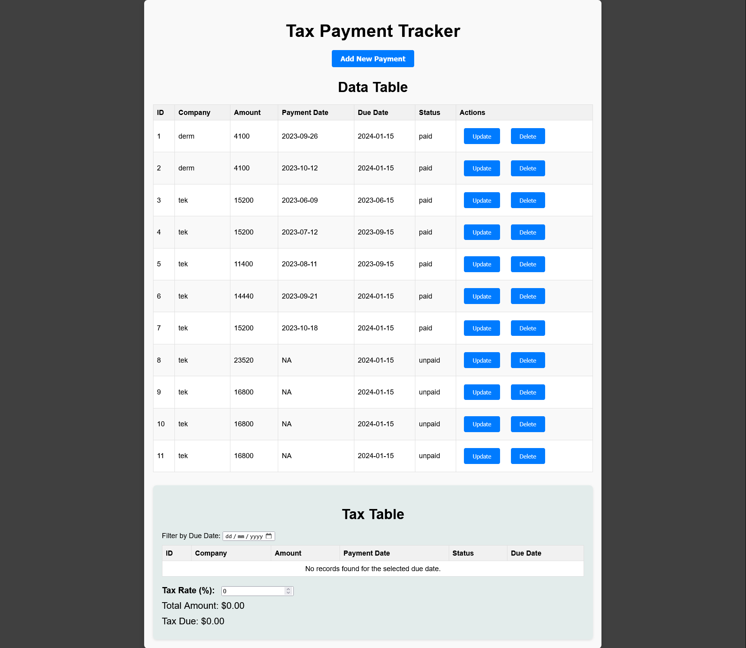

**Expand/Collapse Add New Payment Form**

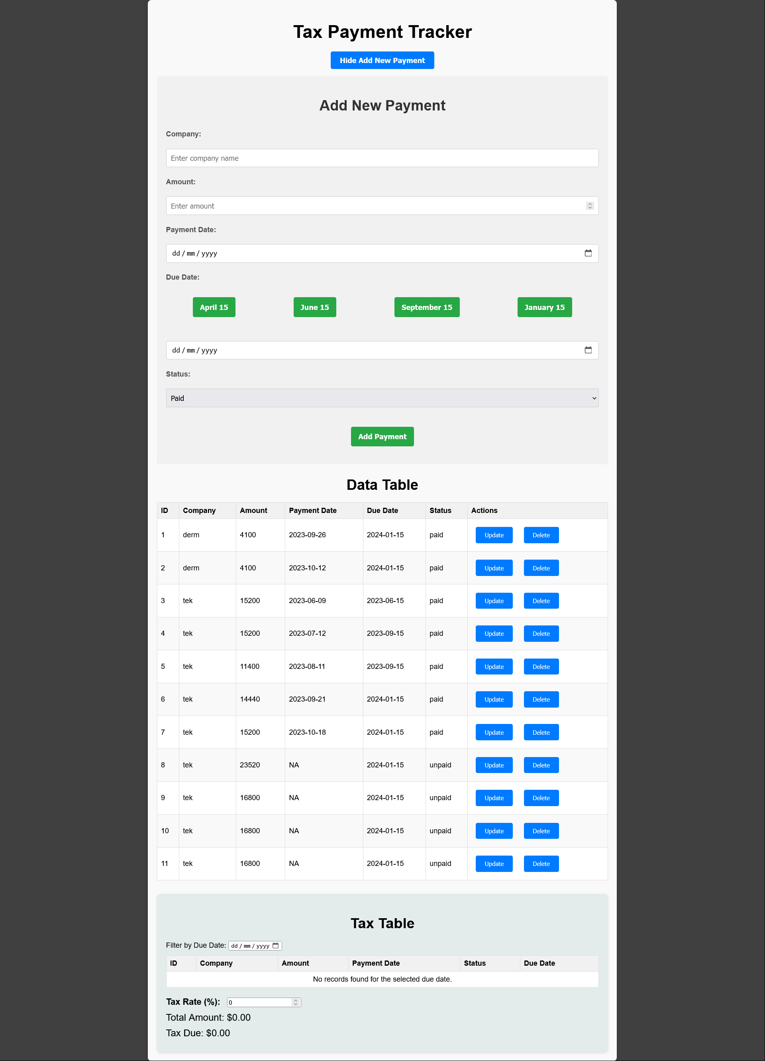

**TEST ADD**

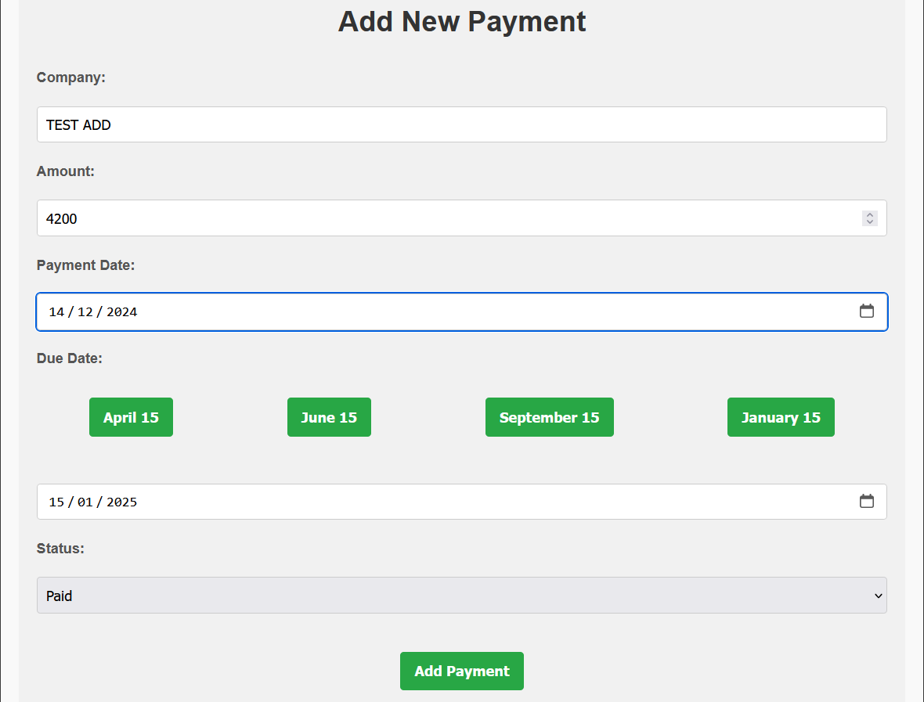

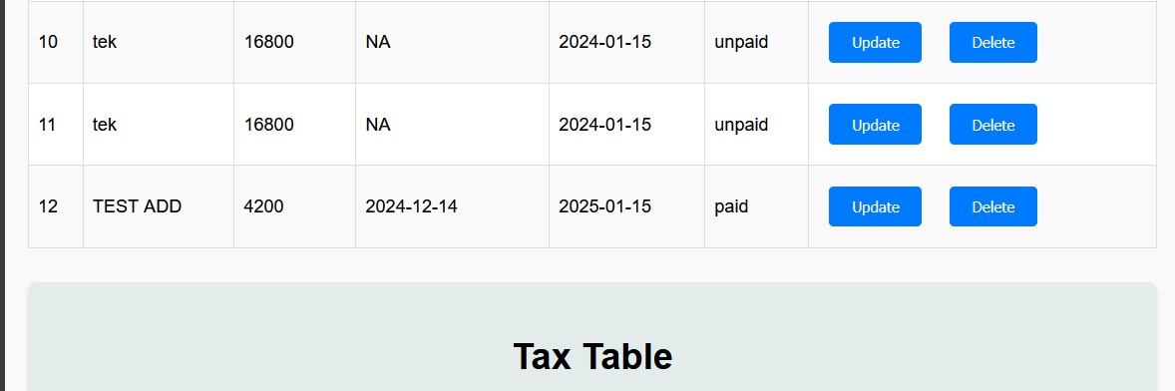

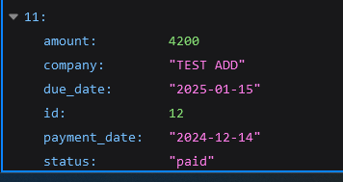

**Update**

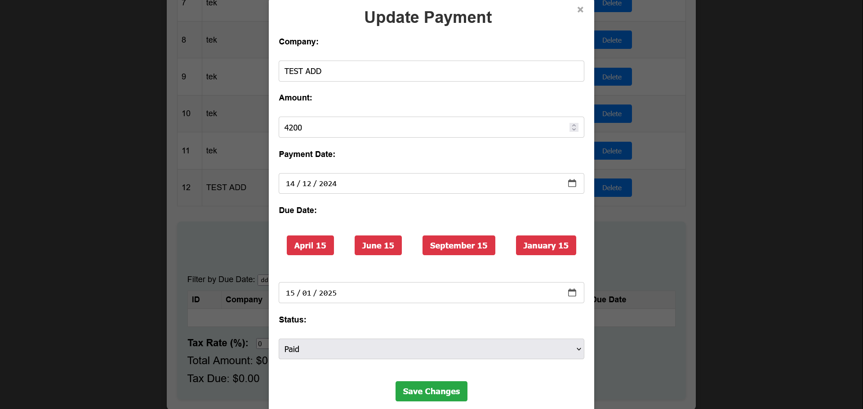

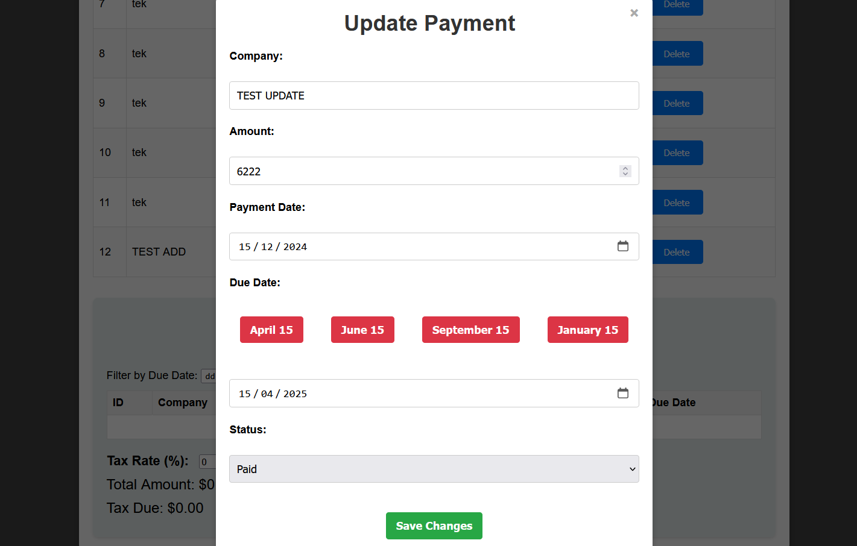

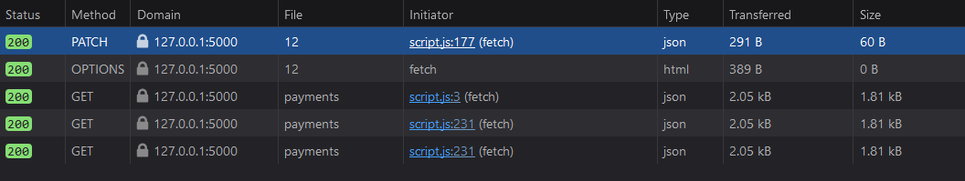

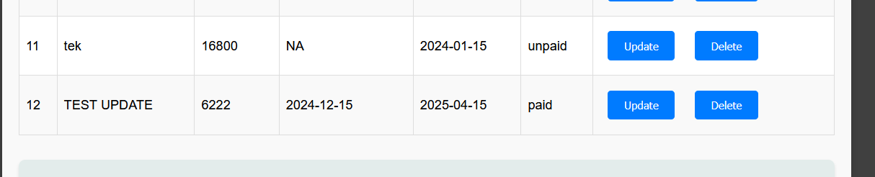

**Delete**

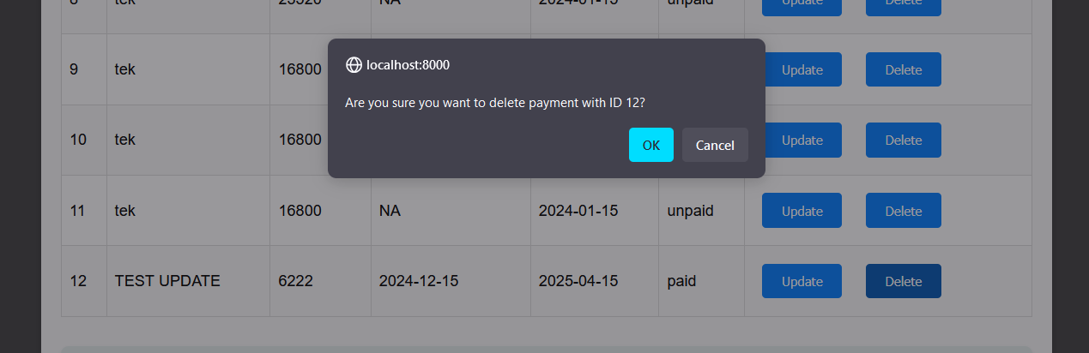

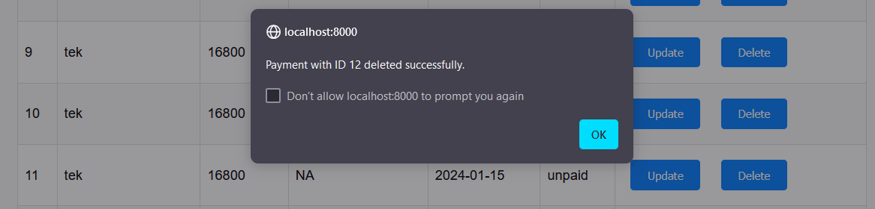

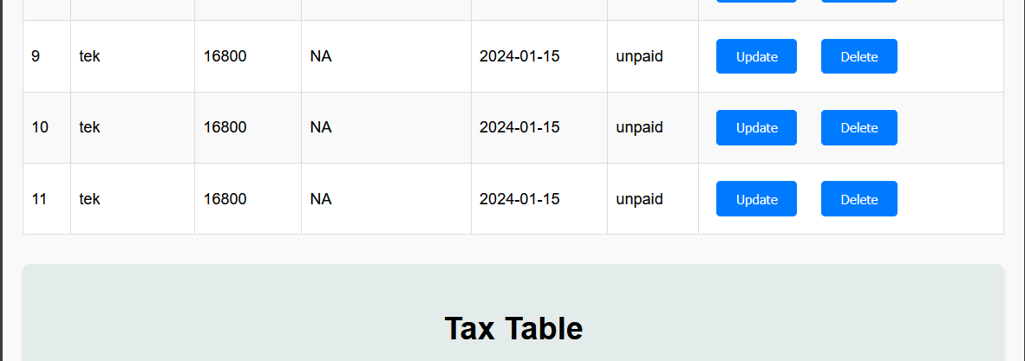

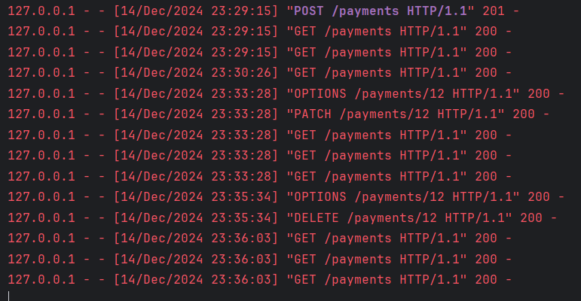

An example to illustrate this, if I entered the results in the following order, and I put the due date from the UI. Let us call it “Data Table”

|  |  |  |  |  |  |
| --- | --- | --- | --- | --- | --- |
| id | Company | Amount | Payment date | Status | Due date |
| 1 | derm | 4100.00 | 09/26/2023 | paid | 01/15/2024 |
| 2 | derm | 4100.00 | 10/12/2023 | paid | 01/15/2024 |
| 3 | tek | 15,200.00 | 06/09/2023 | paid | 06/15/2023 |
| 4 | tek | 15,200.00 | 07/12/2023 | paid | 09/15/2023 |
| 5 | tek | 11,400.00 | 08/11/2023 | paid | 09/15/2023 |
| 6 | tek | 14,440.00 | 09/21/2023 | paid | 01/15/2024 |
| 7 | tek | 15,200.00 | 10/18/2023 | paid | 01/15/2024 |
| 8 | tek | 23,520.00 | NA | unpaid | 01/15/2024 |
| 9 | tek | 16,800.00 | NA | unpaid | 01/15/2024 |
| 10 | tek | 16,800.00 | NA | unpaid | 01/15/2024 |
| 11 | tek | 16,800.00 | NA | unpaid | 01/15/2024 |



Now if in the HTML DIV of summary, let us call this section “Tax Table”. Now in the filter feature,

* In the dropdown of 04/15/2023, it should show nothing as there is no income made that is due on 04/15/2023. Show me an empty table with just table header.

|  |  |  |  |  |  |
| --- | --- | --- | --- | --- | --- |
| id | Company | Amount | Payment date | Status | Due date |

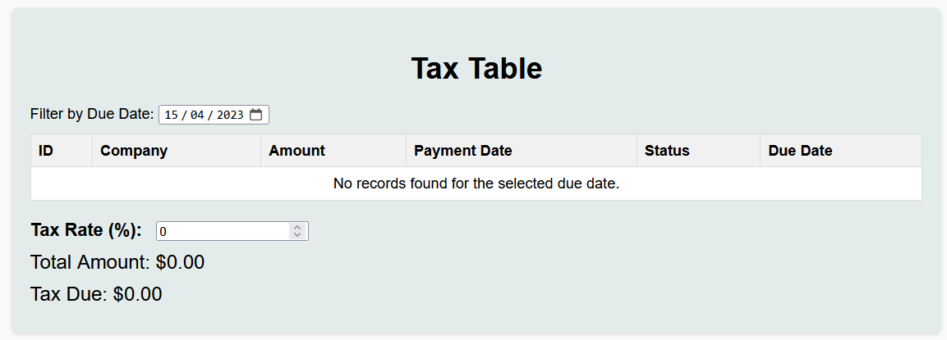

* In the dropdown of 06/15/2023, it should show me,

|  |  |  |  |  |  |
| --- | --- | --- | --- | --- | --- |
| id | Company | Amount | Payment date | Status | Due date |
| 3 | tek | 15,200.00 | 06/09/2023 | paid | 06/15/2023 |
| **Total Amount** | | | | | $15,200.00 |
| **Tax Rate:** | | | | | 6% |
| **Tax Due:** | | | | | $912 |

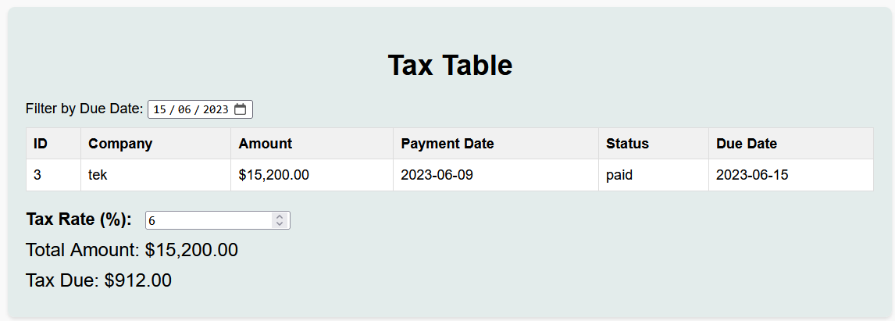

* In the dropdown of 09/15/2023, it should show me,

|  |  |  |  |  |  |
| --- | --- | --- | --- | --- | --- |
| id | Company | Amount | Payment date | Status | Due date |
| 4 | tek | 15,200.00 | 07/12/2023 | paid | 09/15/2023 |
| 5 | tek | 11,400.00 | 08/11/2023 | paid | 09/15/2023 |
| **Total Amount** | | | | | $26,600.00 |
| **Tax Rate:** | | | | | 6% |
| **Tax Due:** | | | | | $1,596 |

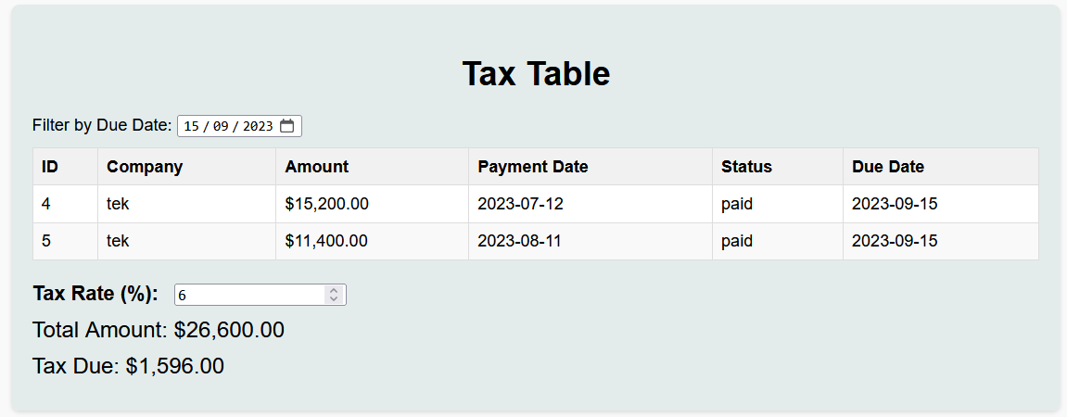

* In the dropdown of 01/15/2024, it should show me,

|  |  |  |  |  |  |
| --- | --- | --- | --- | --- | --- |
| id | Company | Amount | Payment date | Status | Due date |
| 1 | derm | 4100.00 | 09/26/2023 | paid | 01/15/2024 |
| 2 | derm | 4100.00 | 10/12/2023 | paid | 01/15/2024 |
| 6 | tek | 14,440.00 | 09/21/2023 | paid | 01/15/2024 |
| 7 | tek | 15,200.00 | 10/18/2023 | paid | 01/15/2024 |
| 8 | tek | 23,520.00 | NA | unpaid | 01/15/2024 |
| 9 | tek | 16,800.00 | NA | unpaid | 01/15/2024 |
| 10 | tek | 16,800.00 | NA | unpaid | 01/15/2024 |
| 11 | tek | 16,800.00 | NA | unpaid | 01/15/2024 |
| **Total Amount** | | | | | 111760.00 |
| **Tax Rate:** | | | | | 6% |
| **Tax due:** | | | | | $6705.6 |

