SUPERSTORE SALES ANALYSIS
Business Intelligence & Dashboard Project

Tools Used  Microsoft Excel | Google Looker Studio | Dataset Size  ~9,800 Records | Retail Domain

1. Introduction
This report presents a comprehensive analysis of retail sales data from a Superstore dataset. The project aims to uncover actionable business insights by exploring sales patterns across categories, regions, customer segments, and time periods. The findings are visualized through an interactive dashboard built in Google Looker Studio.

Objective | Derive business insights from retail sales data and present them through interactive visualizations.
Dataset | Superstore Sales Dataset (~9,800 records)
Tools | Microsoft Excel, Google Looker Studio
Domain | Retail / Business Intelligence
Deliverables | Cleaned dataset, Pivot Table analysis, Interactive Dashboard, Project Report

2. Dataset Overview
The dataset contains retail order information with the following key fields:

- Order ID, Order Date, Ship Date, Ship Mode
- Customer Name, Segment (Consumer / Corporate / Home Office)
- Region, State, City, Postal Code
- Category, Sub-Category, Product Name
- Sales

3. Phase 1 - Data Cleaning

3.1 Why Data Cleaning Matters
Data cleaning is the foundation of any reliable analysis. Raw data often contains errors, inconsistencies, and missing values that can lead to misleading conclusions. Clean data ensures that every chart, pivot table, and KPI reflects reality , not noise.
In the context of a business dashboard, inaccurate data can cause decision-makers to misallocate budgets, misread trends, or draw false conclusions about performance. Cleaning the data first guarantees the accuracy and reliability of the Looker Studio dashboard.

3.2 Cleaning Steps Performed
- Removed unnecessary columns: Row ID and Country (not required for analysis)
- Corrected date formatting for Order Date and Ship Date columns
- Handled 11 missing Postal Code entries by looking up values using corresponding City and State information
- Checked for and removed duplicate records
- Standardized text formatting in categorical columns (e.g., consistent casing in Region, Segment, Category)
- Removed extra spaces in the text

4. Phase 2 -Feature Engineering

4.1 What is Feature Engineering?
Feature engineering is the process of creating new, derived columns from existing data to improve analytical capabilities. Instead of just working with raw fields, we calculate additional attributes that make it easier to group, filter, and compare data across meaningful dimensions.
In business analytics, derived columns allow us to answer questions like 'Which quarter had the highest sales?' or 'How long does shipping take on average?' questions that cannot be answered from raw data alone.

4.2 Derived Columns Created

Column | Formula | Purpose
Shipping Days | =ABS(Ship Date - Order Date) | Measures delivery duration and shipping efficiency
Order Month | =TEXT(Order Date, "MMM") | Used for monthly trend analysis
Order Year | =YEAR(Order Date) | Used for year-wise filtering and comparison
Order Quarter | ="Q"&CEILING(MONTH(Order Date)/3,1) | Used for quarterly sales analysis

5. Phase 3 — Pivot Table Analysis

5.1 How Pivot Tables Work
A pivot table is an Excel tool that automatically summarizes large datasets. It allows the analyst to group, aggregate, and compare data across multiple dimensions — without writing any formulas manually. You simply drag fields into rows, columns, and values areas, and Excel instantly calculates the totals.
Pivot tables are invaluable for business analysis because they enable rapid exploration of patterns, comparisons across categories, and identification of top or bottom performers — all within seconds.

5.2 Analyses Performed & Insights

Pivot Analysis | Description | Key Insight
Sales by Category | Compared Furniture, Technology, and Office Supplies | Technology generated the highest total sales among all categories
Sales by Sub-Category | Identified top and bottom performing sub-categories | Phones and Chairs were top performers; Fasteners and Labels were lowest
Sales by Region | Compared East, West, Central, and South | The West region consistently showed strong sales performance
Sales by Segment | Consumer, Corporate, and Home Office | Consumer segment contributed the majority of total revenue
Monthly Sales Trend | Sales over time using Order Year and Month | Seasonal peaks were observed towards Q4, indicating year-end demand surges
Top 10 Customers | Ranked by total sales generated | A small group of customers account for a disproportionately high share of revenue
Sales by Ship Mode | Compared by total sales and order count | Standard Class was the most used shipping method by order volume

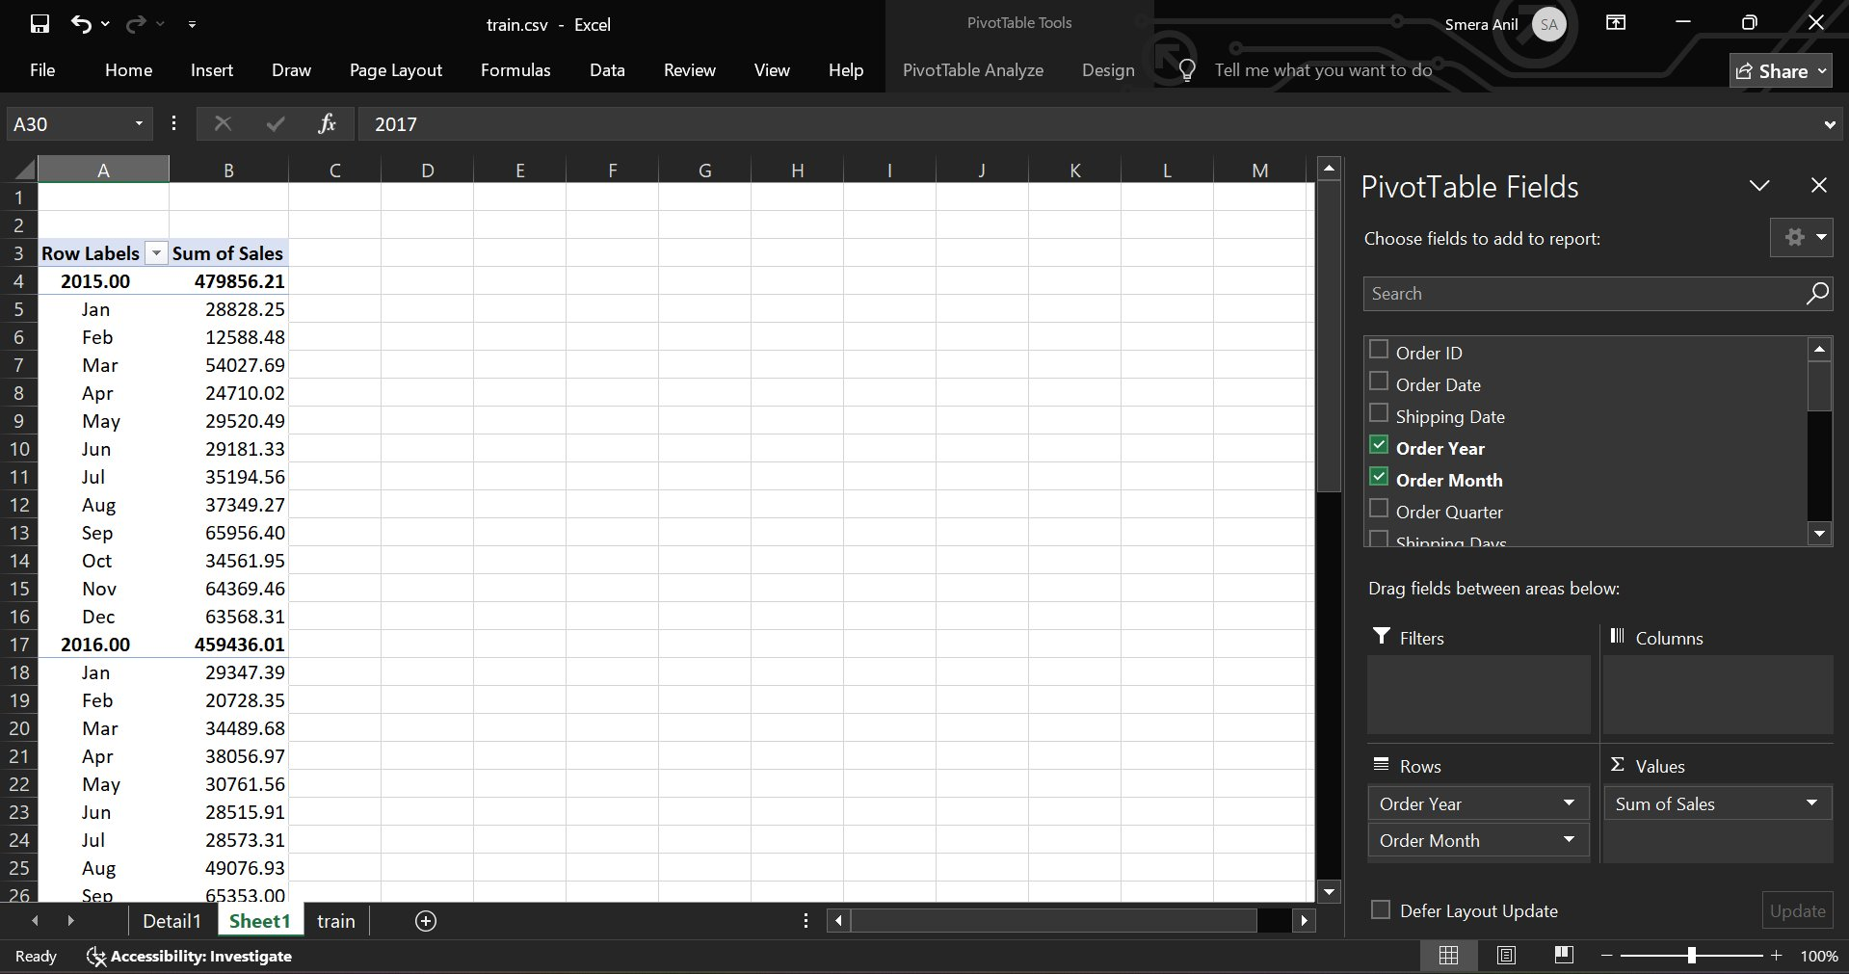
Figure 1: Monthly Sales Trend Pivot Table (Excel)
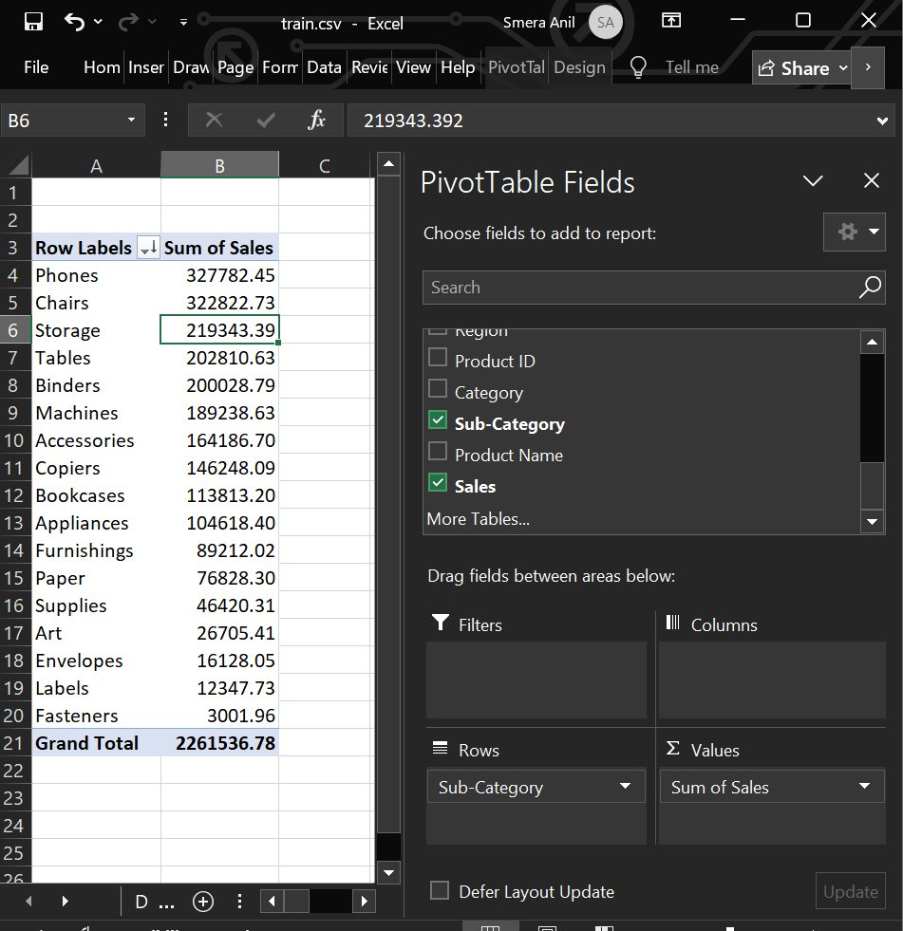
Figure 2: Sales by Sub-Category Pivot Table (Excel)
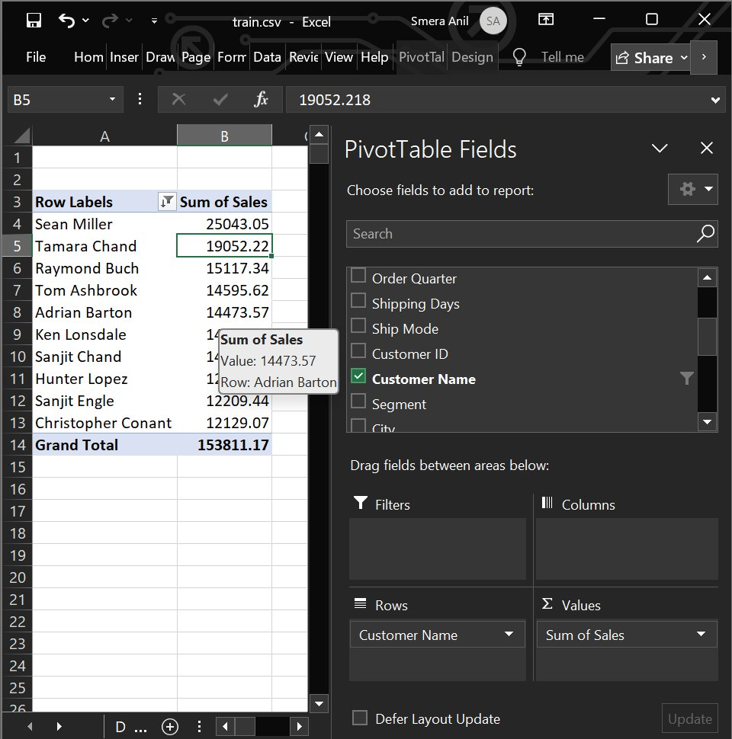
Figure 3: Top 10 Customers by Sales Pivot Table (Excel)

6. Phase 4 - Google Looker Studio Dashboard

6.1 Why Dashboards Are Important
Dashboards transform raw data and pivot table outputs into visual stories that decision-makers can understand at a glance. Instead of reading rows of numbers, stakeholders can instantly spot trends, compare performance, and make informed decisions in real time.
An interactive dashboard goes further it allows users to filter and slice the data themselves, exploring the insights most relevant to their role without needing any technical knowledge.

6.2 Why Google Looker Studio?
- Free and cloud-based
- No installation required
- Connects directly to Google Sheets, making data updates seamless
- Supports a wide variety of chart types: line, bar, donut, scorecard, and more
- Allows sharing via a public link which is ideal for portfolio and interviews
- Interactive filters make the dashboard accessible to non-technical stakeholders

6.3 Dashboard Components

Component | Type | Purpose
Total Sales, Total Orders, Avg Order Value, Avg Shipping Days | KPI Scorecards | Quick snapshot of overall business health
Monthly Sales Trend | Line Chart | Reveals seasonal patterns and growth over time
Sales by Category | Bar Chart | Compares performance across Furniture, Technology, Office Supplies
Sales by Region | Donut Chart | Shows proportional contribution of each region
Sales by Segment | Bar Chart | Highlights which customer segment drives most revenue
Top 10 Products | Horizontal Bar Chart | Identifies highest revenue-generating products (sorted descending)
Region, Category, Segment, Order Year | Interactive Filters | Allows users to dynamically drill into specific slices of data

6.4 How Filters Improve Usability
Interactive filters allow any user whether technical or not to explore the data on their own terms. For example, a regional manager can filter by their region to see only relevant data, while a product manager can filter by category. This makes the dashboard useful to a wide range of stakeholders without requiring separate reports for each audience.
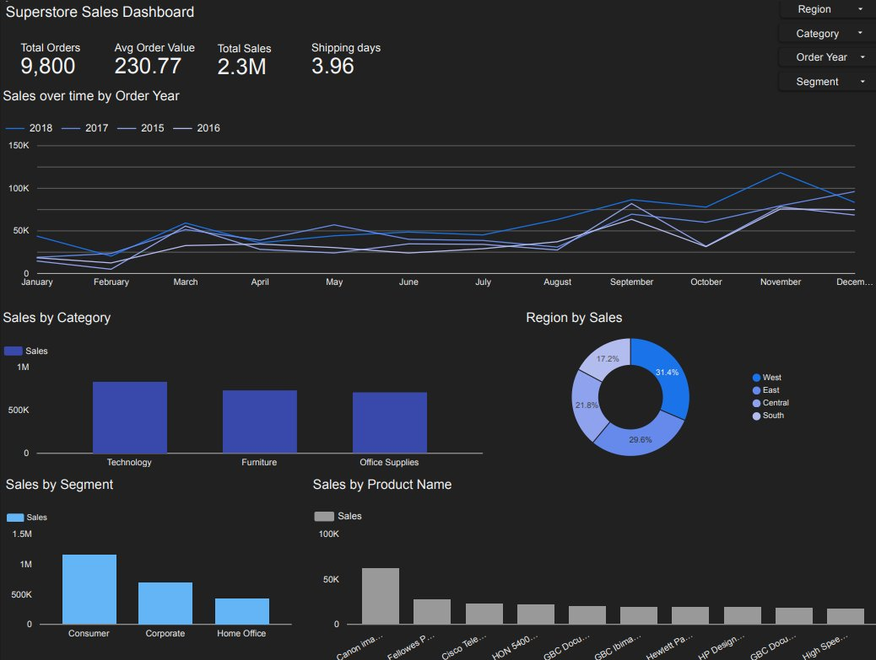
Figure 4: Interactive Google Looker Studio Dashboard

7. Phase 5 -Dashboard Testing

7.1 Why Testing Is Essential
Dashboard testing ensures that all metrics, charts, and filters display accurate data. Without verification, a visually appealing dashboard may contain incorrect values that mislead business decisions. Testing validates that the dashboard is reliable, functional, and ready for stakeholder use.

7.2 Test Cases

Test ID | Test Scenario | Steps | Expected Result | Actual Result | Pass/Fail
TC-01 | Total Sales KPI Accuracy | Sum all Sales in Excel; compare with Total Sales scorecard in Looker Studio | Values match exactly | Values matched | Pass
TC-02 | Total Orders KPI Accuracy | Count Order IDs in Excel; compare with Total Orders KPI | Count matches dashboard value | Count matched | Pass
TC-03 | Region Filter - West | Apply Region filter: West only; check all charts update | All charts show West data only | All charts updated correctly | Pass
TC-04 | Category Filter -Technology | Apply Category filter: Technology; verify charts reflect filter | Only Technology data shown | Filtered correctly | Pass
TC-05 | Segment Filter - Consumer | Apply Segment filter: Consumer; verify all visuals update | Consumer segment data only | Visuals updated correctly | Pass
TC-06 | Year Filter - Single Year | Apply Order Year filter to one year; check trend chart | Trend shows selected year only | Trend displayed correctly | Pass
TC-07 | Combined Filters | Apply Region=West + Category=Technology simultaneously | Charts reflect combined filter logic | Correct combined results | Pass
TC-08 | Top 10 Products Chart | Check top product bar chart; verify sorted descending, limited to 10 | 10 products shown, highest first | Sorted and limited correctly | Pass
TC-09 | Pivot vs Dashboard - Category Sales | Compare Category pivot total with Looker Studio bar chart values | Values align exactly | Values aligned | Pass
TC-10 | Monthly Trend Continuity | Check line chart covers all months with no gaps | Smooth trend with no missing months | No gaps found | Pass
TC-11 | Avg Order Value Formula | Verify: Avg Order Value = Total Sales / Total Orders | Formula result matches scorecard | Values matched | Pass
TC-12 | Dashboard Accessibility | Open shared public dashboard link in incognito browser | Dashboard loads without login | Loaded successfully | Pass

8. Key Business Insights
The following insights were derived from the analysis and are actionable for business decision-making:

01 | Technology is the highest-grossing category. Marketing and inventory investment should prioritize this segment.
02 | The Consumer segment accounts for the majority of revenue. Loyalty programs and targeted offers for consumers could further drive growth.
03 | The West region outperforms other regions. Strategies that work in the West should be studied and replicated elsewhere.
04 | Q4 shows consistent sales spikes. This suggests seasonal demand — operations and inventory should be scaled up ahead of Q4 each year.
05 | A small group of top customers generate a disproportionately large share of revenue. Retaining these high-value customers should be a strategic priority.
06 | Standard Class is the dominant shipping mode, indicating customers prioritize cost over speed. Promoting faster shipping could be tested with incentives.
07 | Some sub-categories (e.g., Fasteners, Labels) consistently underperform. These may warrant discontinuation or repositioning.

9. Conclusion
This project successfully demonstrated how raw retail data can be transformed into meaningful business intelligence through a structured analytical process. Starting from data cleaning and feature engineering in Microsoft Excel, through pivot table analysis, and finally to an interactive Google Looker Studio dashboard, each phase built upon the previous to deliver a complete end-to-end analytics solution.

The resulting dashboard empowers stakeholders to explore sales performance across categories, regions, customer segments, and time periods ,enabling data-driven decision making at every level of the organization.

As next steps, this analysis could be extended by incorporating profitability data (profit margins per category), customer return rates, or predictive modeling to forecast future sales trends.

