Project Rampart — Survey and Interview Instruments
Oct 31, 2026 · Prepared by [Advisor]
Six instruments give Project Rampart measured evidence on product readiness, staff awareness, supplier exposure, executive priorities, customer expectations and engineering practice. Core fieldwork runs from 2 Nov to 18 Dec 2026, inside Phase 1, so the scope register baseline (M4, 18 Dec 2026) and the Wave 1 gap analysis rest on data rather than opinion. Each instrument tab is ready to paste into Microsoft Forms, Qualtrics or Google Forms, or to run as an interview; tab 8 shows how results roll up into the KPI pack.

Objectives
Each instrument answers one research question that a programme decision depends on; no question is asked that no decision needs.
ID | Objective | Research question | Decision or output it feeds | Instrument
O1 | Baseline readiness | How far is each of the 13 product families from level 3 in each of the 10 domains, and what evidence exists? | K01 readiness index; Phase 2 gap analysis; Wave 1 risk assessments (M6); the 26.2 FTE-years remediation estimate | 2 · Readiness diagnostic
O2 | Awareness | Do staff know what the CRA asks of their role, starting with Article 14 reporting, which applies now? | WS8 training plan and K10; message timing in the Communication Pack (D05) | 3 · Staff awareness pulse
O3 | Supplier exposure | Which of the 41 in-scope suppliers can commit to vulnerability notification, SBOM delivery and support periods, and which components need an exit plan? | K09; order of clause-pack negotiations; intake-gate risk ratings; mitigation of R04 | 4 · Supplier questionnaire
O4 | Executive priorities | Where do executives agree and differ on product-risk appetite, roadmap trade-offs, notified bodies, legacy lines, reporting authority and budget? | Board decisions BD1 to BD5 on 19 Nov 2026; risks R01, R02 and R05 | 5 · Executive interviews
O5 | Customer expectations | Which CRA evidence will customers and channel partners request, by when, and how long do they keep our products in use? | Customer FAQ and trust page; Annex II content; support-period determinations; extended-support offer | 6 · Customer and channel survey
O6 | Engineering practice | Which SBOM, signing, update, testing and vulnerability-intake practices exist on each release train today? | Sizing of the shared-platform line (EUR 955k one-off, EUR 210k a year); plans for M8 and M10 | 7 · Engineering practice survey

Instrument map
Each instrument has a named owner, a fixed field window inside Phase 1 and a sample sized for the cuts reported in tab 8.
ID | Instrument | Respondents | Sample | Mode | Length | Field window | Owner
DIA | Product readiness diagnostic | Product owner, lead engineer and PSIRT or quality contact for each family | Census: 13 families (55 SKUs), one moderated record each | Live CRA Readiness Diagnostic (D08) or the offline version, then a moderation workshop | 40 statements: 12–15 min to score, 60–90 min to moderate | 9 Nov – 11 Dec 2026 | Compliance lead, with the product security officer
PUL | Staff awareness pulse | All employees | Census of 3,800; at least 349 completes overall and 272 of the 920 engineers for ±5 points at 95% confidence | Anonymous online link, English and German | 15 questions, about 6 min | 23 Nov – 4 Dec 2026; baseline reported 11 Dec 2026; repeats [Mar 2027] and [Oct 2027] | Head of engineering enablement, with internal communications
SUP | Supplier questionnaire | Security or quality lead at each supplier | Census of the 41 in-scope suppliers: wave 1 the top 15 by component risk, wave 2 the other 26 | Online form, sent with the supplier letter (D05) | 31 questions, about 40 min | Wave 1 issued 24 Nov 2026; wave 2 to all 41 in-scope suppliers by 18 Dec 2026 (task T21) | Head of procurement
INT | Executive interviews | CTO, CFO, General Counsel, three BU presidents, CISO, Head of quality & regulatory, Head of procurement | 9 core interviews, 4 optional | Semi-structured, in person or by video, two interviewers | 45 min | 2–10 Nov 2026 | Programme director
CUS | Customer and channel survey | B2B customers, integrators, distributors, importers and retail partners | Key accounts covering 80% of each BU's EU B2B revenue, plus all EU channel partners; planning assumption about 80 invitations and 40 completes | Online, personal invitation from the account manager | 12 questions, about 8 min | 23 Nov – 11 Dec 2026 | Head of customer operations, with the Head of channel
ENG | Engineering practice survey | Engineering lead of each release train | Census of release trains, at least one per family | Online form | 15 questions, about 10 min | 9–27 Nov 2026 | Head of platform engineering, with the product security officer
Every instrument is piloted with two or three respondents a week before launch, and question IDs stay fixed across waves so results can be trended. Sample sizes use the standard formula for a proportion at 50% with a finite-population correction: n = 384 / (1 + 383 / N).

Fieldwork calendar
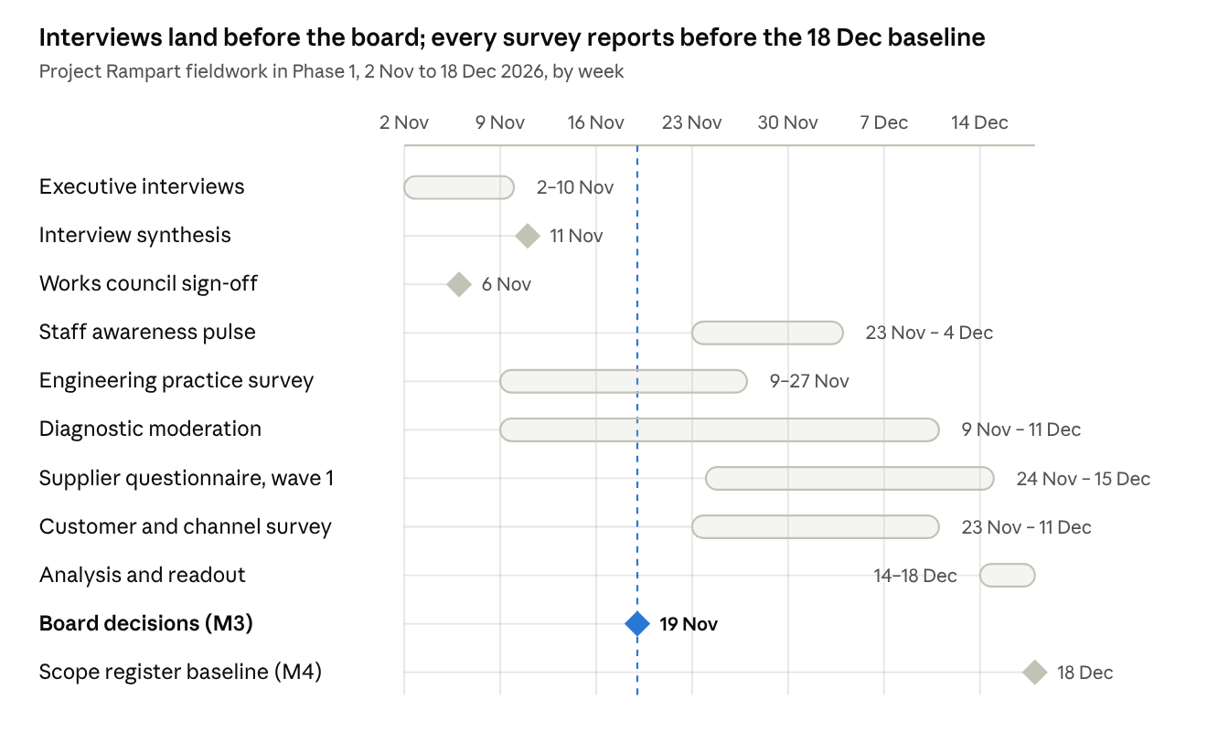
Fieldwork calendar · 8 activities and 3 gates, 2 Nov to 18 Dec 2026
The pulse launches only after works council sign-off on 6 Nov 2026 and reports its baseline on 11 Dec 2026. Supplier wave 2 takes the questionnaire to all 41 in-scope suppliers by 18 Dec 2026 (task T21), and the pulse repeats in [Mar 2027] and [Oct 2027] with the same question IDs.

Data handling
Each instrument collects only what its analysis needs, staff answers are anonymous and reported in groups of ten or more, and raw data is deleted on a fixed schedule. The data protection officer confirms every line of the table below before launch.
- Purpose limitation. Results are used only to measure CRA readiness, plan training and communications, and assess supply-chain risk. No result is used to assess an individual's performance.
- Minimisation. The staff pulse asks for role group and business unit only; it stores no name, email address, IP address or device ID.
- Pseudonymisation. The survey tool assigns a random response token and the programme never holds the key. Cells under 10 responses are merged before reporting, and free text is screened for names before it is shared.
- Works council. The pulse goes to the works council for sign-off by 6 Nov 2026. Monitoring is its stated concern (ST13); anonymity and the no-performance-use rule answer it.
- Confidential business data. Supplier and customer answers stay with procurement and customer operations; the programme receives them in scored form.
- No vulnerability details. No instrument asks for details of unfixed vulnerabilities, and every introduction tells respondents not to enter them.
Instrument | Personal data | Proposed lawful basis | Reported at | Retention
DIA | Respondent roles; names optional | Legitimate interests (programme management) | Product family | In the system of record until programme close (Dec 2027), then archived with the evidence it cites; that evidence follows Art 13(13): 10 years after placing on the market or the support period, whichever is longer
PUL | Role group, business unit, free text | Legitimate interests; participation voluntary | Role group by BU, minimum 10 responses per cell | Raw responses deleted 24 months after each wave closes; aggregates kept
SUP | Supplier contact name, role and business email | Legitimate interests (supplier management) | Supplier and component | Kept as Art 13(5) due-diligence evidence with the technical documentation it supports (Art 13(13))
INT | Name, role, notes, quotes | Legitimate interests; consent to notes and to each attributed quote | Role, never name | Notes deleted 6 months after the synthesis is accepted; synthesis kept
CUS | Contact name, business email, company | Legitimate interests (existing business relationship) | Segment; company only with consent | Raw responses deleted 24 months after close
ENG | Engineering lead name, release train | Legitimate interests | Release train | Kept with the platform sizing record until programme close
The principles applied are purpose limitation, data minimisation and storage limitation in GDPR Art 5(1)(b), (c) and (e) (Regulation (EU) 2016/679, Art 5, text as adopted). Lawful bases and retention periods are proposals for the data protection officer, not legal advice.

Analysis plan
Each instrument has one headline measure, defined before fieldwork so that results cannot be re-cut to fit a conclusion. The readiness index is the core measure:
\text{Readiness index} = \frac{1}{n}\sum_{i=1}^{n}\frac{\min(s_i,\,3)}{3}
Here s_i is the moderated score (0 to 4) of statement i and n the number of statements: 40 for a family, 4 for a domain. Level 4 does not offset a gap elsewhere, and 100% means every statement at level 3 or above. Portfolio, BU and class indices are unweighted means of the family indices; the baseline is 44% (28 Oct 2026).
- Heatmaps. Families by domains, each cell the average level to two decimals, coloured on the 0–4 maturity scale with the number always printed (tab 8, output 2).
- Cuts. DIA by BU, class, wave and conformity route; PUL by role group and BU; SUP by component risk tier; INT by role; CUS by relationship type, Member State and NIS2 status; ENG by family, artefact type and CI system. No cut identifies a person.
- Statistics. Every figure carries its base (n). Pulse proportions carry a 95% confidence interval. Likert items are reported as % favourable (agree plus strongly agree), with "Don't know" outside the base and shown separately. Knowledge items count "Don't know" as not correct. No significance tests on bases under 30.
- Benchmarks. Published surveys give context, never targets: their populations, dates and methods differ from ours.
ID | Benchmark | Value | Type | Compared with
RD01 | German companies that know what the CRA means for them (Bitkom Research, 1,003 companies with 10+ employees, Apr–Jun 2026) | 29% | Survey | PUL-03, % agree
RD02 | CRA-aware respondents unaware of CRA penalties (Linux Foundation Research 2026: 404 CRA-aware respondents of 843 surveyed) | 56% | Survey | PUL-11, % not correct among PUL-03 agreers
RD03 | Manufacturers relying passively on upstream projects for security fixes (LF 2026 manufacturer module, n=194–219) | 51% | Survey | DIA Q5.4, upstream reporting
RD04 | SME manufacturers expecting to raise prices to cover compliance (Linux Foundation Research, 2026) | 47% | Survey (small subsample), 54 SME manufacturers | CUS-10, context only
RD05 | SMEs asking for technical documentation templates (ENISA SME CRA survey, 194 responses, not representative, Jun 2026) | 73% | Survey (official) | DIA domain D9, documentation
RD06 | Firms expecting longer product development under the CRA (ONEKEY IoT/OT Cybersecurity Report, 200 German industrial firms, Sep 2026) | >60% | Vendor survey | INT question 5, roadmap
RD07 | Respondents with partly or fully automated SBOM generation (ENISA SBOM State of Play 2026: 74% of 334 respondents) | 74% | Survey (official) | ENG-05, SBOM generation

Reporting outputs
Seven outputs reach their owners between 11 Nov and 18 Dec 2026; the research readout to the programme board in the week of 14 Dec 2026 brings them together before the scope register is baselined.
Output | Built from | Audience | Due | Feeds
Interview synthesis: themes, stances, decisions implied, risks raised | INT | Executive sponsor, programme director | 11 Nov 2026 | Board pre-read; BD1 to BD5; risk register
Awareness baseline by role | PUL | Head of engineering enablement, internal communications | 11 Dec 2026 | WS8 training plan; measurement in the Communication Pack (D05)
Platform sizing note | ENG | Head of platform engineering, CTO | 4 Dec 2026 | Shared-platform line; M8 and M10 plans
Moderated readiness heatmap and family one-pagers | DIA | Programme board, product teams | 16 Dec 2026 | K01; Phase 2 gap analysis; Wave 1 risk assessments
Supplier risk register, wave 1 | SUP | Head of procurement, WS5 | 18 Dec 2026 | K09; clause-pack negotiations; intake gate
Customer evidence-demand brief | CUS | Head of customer operations, product management | 18 Dec 2026 | Customer FAQ; trust page; Annex II content; support-period records
Research readout, all instruments | All six | Programme board, then the next SteerCo | Week of 14 Dec 2026 | KPI pack; risk register; Phase 2 plan
Illustrative engagement: Example Group is a fictional client; regulatory facts verified to 30 Oct 2026. Project Rampart · Survey and Interview Instruments (D07) · v1.0 · 31 Oct 2026 · Prepared by [Advisor].

