GAME DESCRIPTION OF PHARAOHNHIET

GOAL:

Avoid enemies and collect coins as you advance toward the pyramid at the end of each level

CHARACTERS:

* Pharaoh: The playable character
* Enemies: Snakes that slither around and try to attack you

LEVELS:

There are 2 levels that demonstrate how the game works

SCREENSHOTS:  
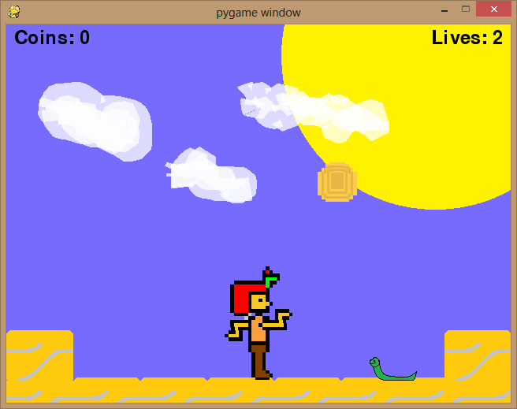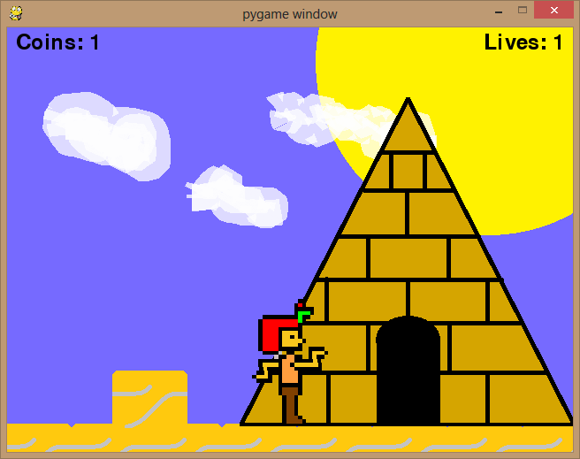 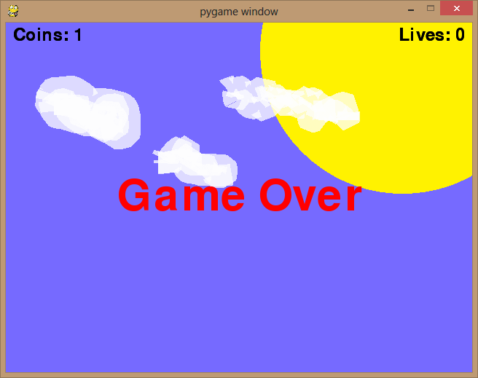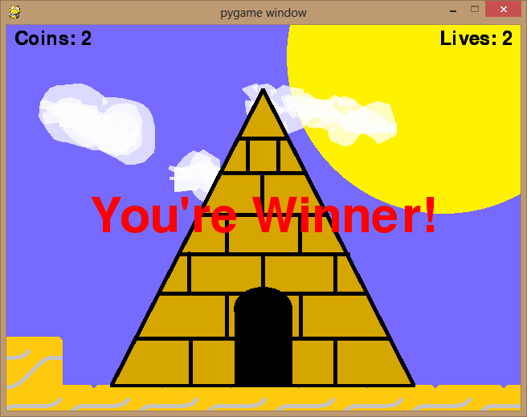

Tutorials Cover:  
Sidescrolling

All source code and tutorials:

<https://github.com/smets/PythonGames/tree/master/Games/PharaohNhiet/Python_Game_Tutorials>