# **Transfer Learning**

S M Faisal, 20-44367-3, [20-44367-3@student.aiub.edu](mailto:20-44367-3@student.aiub.edu), American International University-Bangladesh (AIUB)

## **1. Introduction**

Transfer learning is a powerful machine learning technique where a pre-trained model developed for one task is reused as the starting point for a model on a second task. This approach is especially beneficial when the second task has limited data, as it leverages the knowledge gained from the first task. Transfer learning has become a fundamental tool in fields like Natural Language Processing (NLP) and Computer Vision, where it has significantly improved the performance and efficiency of models.

### **Overview of Transfer Learning**

Transfer learning involves taking a model trained on a large, well-labeled dataset for a particular task and fine-tuning it for a different but related task. This methodology stems from the understanding that models trained on vast and diverse datasets capture general features that are useful across various tasks. In essence, transfer learning can be divided into two main approaches: feature extraction and fine-tuning. In feature extraction, the pre-trained model's weights are used as fixed feature extractors, and only the final classifier is trained on the new task. In fine-tuning, the pre-trained model is first initialized with the weights from the original task and then trained further on the new task, allowing for adaptation to the specific characteristics of the new data. One of the key advantages of transfer learning is its ability to significantly reduce the amount of labeled data required for training high-performing models. This is particularly valuable in domains where labeled data is scarce or expensive to obtain. For example, in NLP, models like BERT and GPT, pre-trained on extensive text corpora, can be fine-tuned for specific tasks such as sentiment analysis or machine translation with comparatively less data. Moreover, transfer learning facilitates faster model convergence and improves performance, as the model starts with a set of parameters that already capture relevant features from the original task. This can also lead to better generalization on the new task, as the model leverages previously acquired knowledge.

## **2. Definition and Importance**

Transfer learning enhances model performance on smaller, specific datasets by leveraging knowledge from pre-trained models on large datasets. It improves accuracy, reduces training time, and is data-efficient, making effective use of limited data. This approach also optimizes computational resources, enables cross-domain applications without extensive retraining, and facilitates rapid prototyping and deployment of new models.

### **2.1 Definition**

Transfer learning involves taking a model trained on a large dataset and fine-tuning it on a smaller, specific dataset. The key idea is that the knowledge acquired from the large dataset can be transferred to the smaller dataset, thereby enhancing the model's performance on the latter.

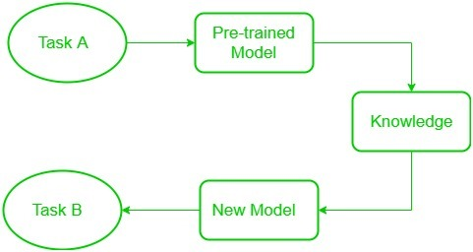

### **2.2 Importance**

Transfer learning has emerged as a cornerstone in the development of advanced machine learning models due to its numerous advantages and practical applications. Here are some key points highlighting the importance of transfer learning:

**Enhanced Accuracy:** Pre-trained models often achieve higher accuracy compared to models trained from scratch, especially when the target dataset is small.

**Reduced Training Time:** Starting with a pre-trained model can significantly reduce the time required to train a model, as the initial weights are already optimized to some extent.

**Data Efficiency:** Transfer learning allows the effective use of limited data, making it possible to achieve good performance with smaller datasets.

**Computational Efficiency:** It leverages the computational effort already invested in training large models, thus saving resources.

**Cross-Domain Applications:** Transfer learning enables the application of models to different but related domains without the need for extensive retraining.

**Rapid Prototyping:** It allows for quick development and testing of models for new tasks, facilitating rapid prototyping and deployment.

## **3. Key Concepts in Transfer Learning**

### Pre-trained models are initially trained on large datasets to capture general features. Feature extraction involves using these pre-trained layers as fixed feature extractors for new tasks. Fine-tuning retrains pre-trained models on new tasks for better adaptation. Domain adaptation allows models to be applied to different but related data distributions. Layer freezing involves keeping some layers fixed during fine-tuning to retain useful representations.3.1 Agent: The learner or decision maker

### **3.2 Types of Transfer Learning**

Inductive Transfer Learning: The source and target tasks are different, but related. The target task typically has a smaller dataset. Example: Fine-tuning a pre-trained BERT model on a specific text classification task.

Transductive Transfer Learning: The source and target tasks are the same, but the source and target domains are different. Example: Applying a pre-trained image classification model to a new set of images from a different domain.

Unsupervised Transfer Learning: Transfer learning without labeled data in the source domain. Example: Using unsupervised learning methods like clustering in the source domain and transferring the learned representations to a supervised task in the target domain.

### 4. **Process**

* Start with pre-trained network
* Partition network into:
  + Featurizers: identify which layers to keep
  + Classifiers: identify which layers to replace
* Re-train classifier layers with new data
* Unfreeze weights and fine-tune whole network with smaller learning rate

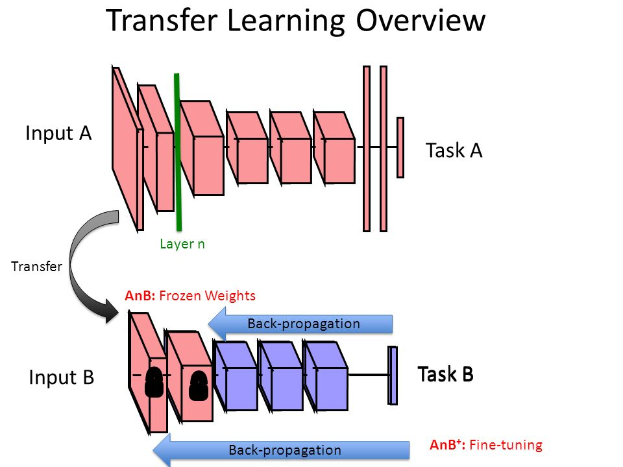

## Freezing and Fine-tuning

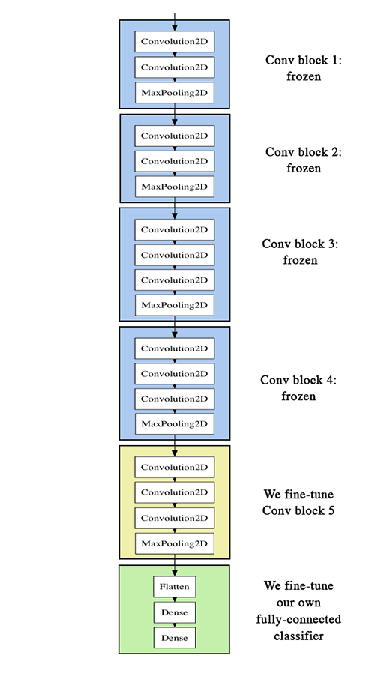

### **5. Transfer Learning Applications**

### Image classification (most common): learn new image classes

### Text sentiment classification

### Text translation to new languages

### Speaker adaptation in speech recognition

### Question answering

### 6. **Applications in NLP**

Pre-trained Language Models

* + BERT (Bidirectional Encoder Representations from Transformers): BERT is a pre-trained transformer model that can be fine-tuned for various NLP tasks like question answering, sentiment analysis, and named entity recognition.
  + GPT (Generative Pre-trained Transformer): GPT models are used for text generation, translation, and summarization tasks. They leverage large-scale pre-training on diverse text corpora to generate coherent and contextually relevant text.

Text Classification

* + Sentiment Analysis: Pre-trained models like BERT can be fine-tuned on specific datasets to classify text based on sentiment, such as positive, negative, or neutral.
  + Spam Detection: Transfer learning models can be fine-tuned to identify spam messages in emails or social media content.

Named Entity Recognition (NER)

* + Entity Extraction: Pre-trained models can be adapted to recognize and classify entities such as names, dates, and locations within text, which is crucial for information retrieval and data mining.

## **7. Applications in Computer Vision**

**Image Classification**

**ResNet (Residual Networks):** Pre-trained ResNet models can be fine-tuned for specific image classification tasks, such as identifying different types of animals or detecting specific objects in images.

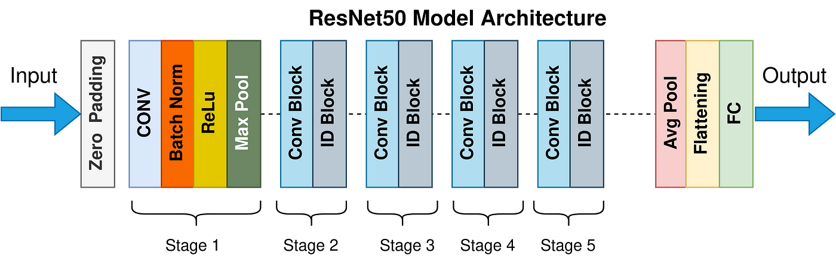

**VGGNet:** This model can be adapted to classify images into various categories by fine-tuning it on a smaller, domain-specific dataset.

**Object Detection**

**YOLO (You Only Look Once):** YOLO is a pre-trained model used for real-time object detection. It can be fine-tuned to detect specific objects in various environments.

**Faster R-CNN:** This model can be adapted for detecting and localizing objects in images, which is useful in applications like autonomous driving and surveillance.

**Image Segmentation**

**U-Net:** A pre-trained U-Net model can be fine-tuned for tasks like medical image segmentation, where it is used to delineate boundaries of organs or tumors in medical scans.

**DeepLab:** This model can be adapted for semantic segmentation, where each pixel in an image is classified into a category, useful in applications like scene understanding and autonomous driving.

## **7. Challenges and Future Directions**

Transfer learning faces challenges such as negative transfer due to data distribution differences, high computational costs, and difficulties in model interpretability and hyperparameter tuning. Future directions aim to improve algorithms, leverage self-supervised learning, enhance cross-domain transferability, and develop more efficient fine-tuning methods. Additionally, advancing model transparency and establishing standardized benchmarks are crucial for consistent evaluation and improvement. Addressing these challenges and pursuing these directions will enhance transfer learning's effectiveness and applicability.

### **7.1 Current Challenges**

Transfer learning faces challenges such as negative transfer due to data distribution differences, high computational costs, and difficulties in model interpretability and hyperparameter tuning. Future directions aim to improve algorithms, leverage self-supervised learning, enhance cross-domain transferability, and develop more efficient fine-tuning methods. Additionally, advancing model transparency and establishing standardized benchmarks are crucial for consistent evaluation and improvement. Addressing these challenges and pursuing these directions will enhance transfer learning's effectiveness and applicability.

### **7.2 Future Directions**

Future research and development in transfer learning are aimed at overcoming these challenges. Improving algorithms to better handle negative transfer and adapt more efficiently to new tasks is crucial. Leveraging self-supervised and unsupervised learning techniques for pre-training on unlabeled data can make transfer learning more effective and accessible. Meta-learning approaches are being explored to enhance models' ability to transfer knowledge across different tasks and domains. Creating more efficient fine-tuning methods can reduce computational costs, making the process more accessible. A deeper understanding of transferability is needed to identify which features and knowledge are most useful across tasks. Enhancing cross-domain transfer learning can expand its applicability to significantly different domains. Improving the interpretability and transparency of transfer learning models is also essential to ensure trust and understanding of their decisions. Establishing benchmarks and standardized evaluation protocols can help consistently compare and improve transfer learning methods. Addressing these challenges and exploring these directions can enhance the power and applicability of transfer learning, driving advancements across various fields and applications.

## **8. Conclusion**

Transfer learning has revolutionized the fields of NLP and Computer Vision by enabling the efficient use of pre-trained models to improve performance on specific tasks. By leveraging the knowledge gained from large datasets, transfer learning facilitates the development of high-performing models even with limited data and computational resources. As the availability of pre-trained models continues to grow, the potential for transfer learning to impact various domains and applications will only increase.

## References

[1] Mldds-courseware, Github, Available at: <https://lisaong.github.io/mldds-courseware/03_TextImage/transfer-learning.slides.html>

[2] <https://slideplayer.com/slide/8370683/>

[3] Introduced by He et al. in [Deep Residual Learning for Image Recognition](https://paperswithcode.com/paper/deep-residual-learning-for-image-recognition)

# [4] [Dillon Reis](https://arxiv.org/search/cs?searchtype=author&query=Reis,+D), [Jordan Kupec](https://arxiv.org/search/cs?searchtype=author&query=Kupec,+J), [Jacqueline Hong](https://arxiv.org/search/cs?searchtype=author&query=Hong,+J), [Ahmad Daoudi](https://arxiv.org/search/cs?searchtype=author&query=Daoudi,+A) et al “Real-Time Flying Object Detection with YOLOv8”, Link: https://arxiv.org/abs/2305.09972