TALLER 2 – API REST

Parte 1 – APIS Públicas

Perros: Consulta API de Perros

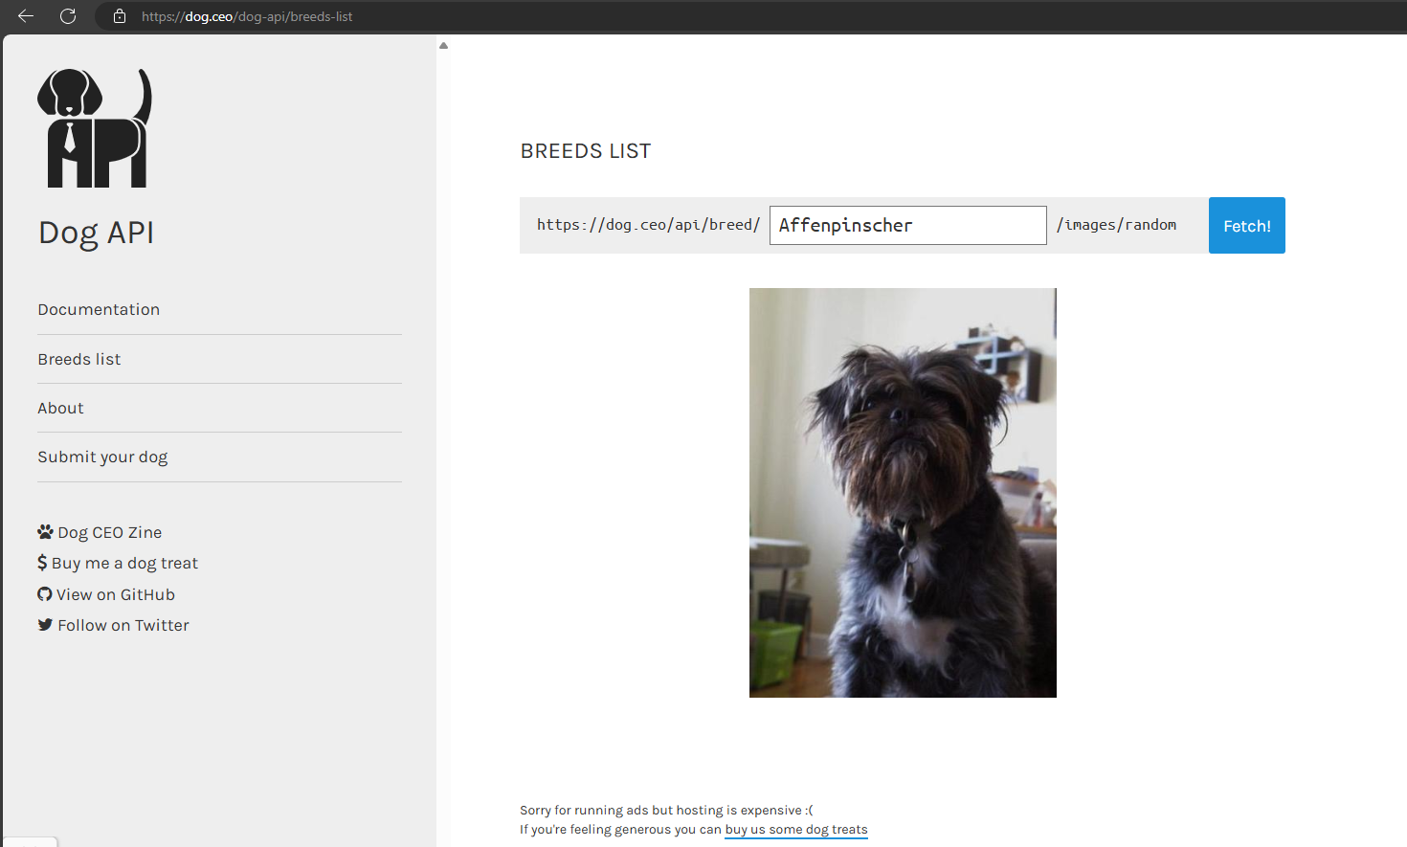

{

    "message": [

        "https://images.dog.ceo/breeds/mountain-bernese/n02107683_2521.jpg",

        "https://images.dog.ceo/breeds/mountain-bernese/n02107683_3655.jpg",

        "https://images.dog.ceo/breeds/mountain-bernese/n02107683_5333.jpg"

    ],

    "status": "success"

}

<https://dog.ceo/api/breed/mountain/bernese/images/random/3>

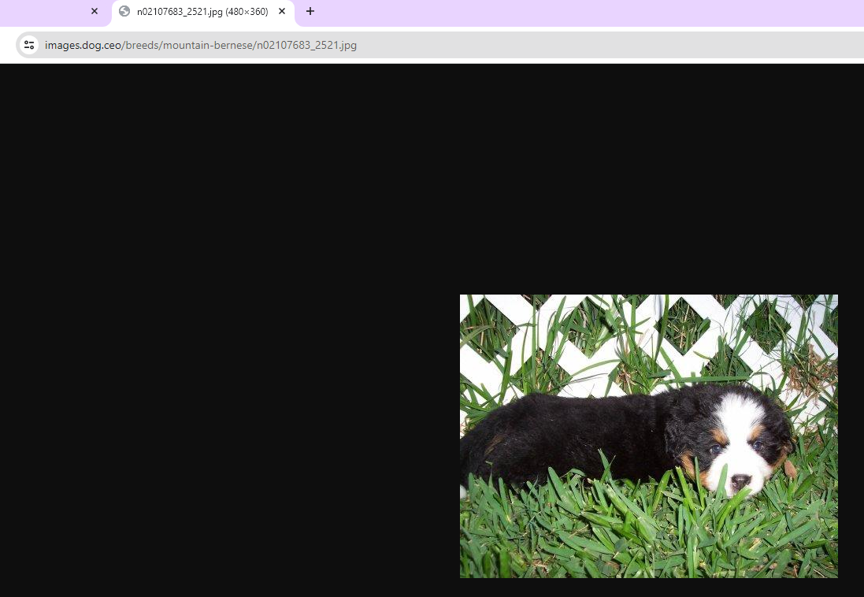

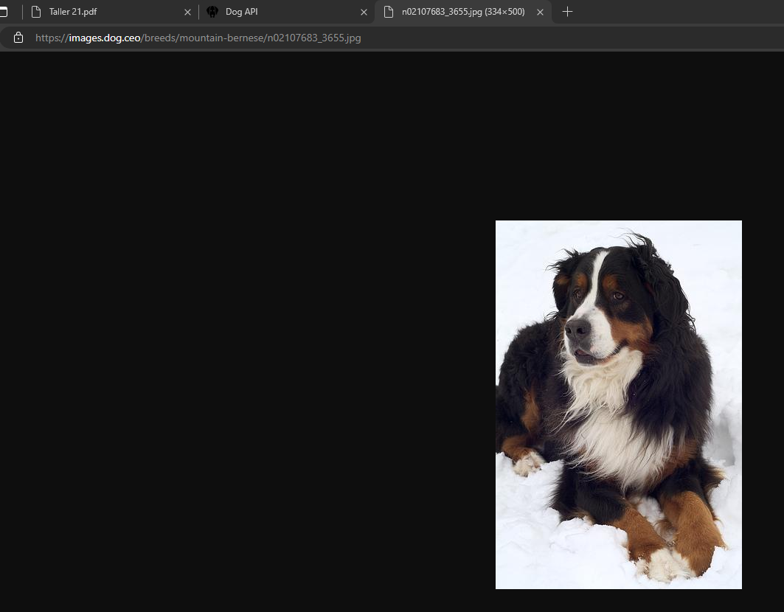

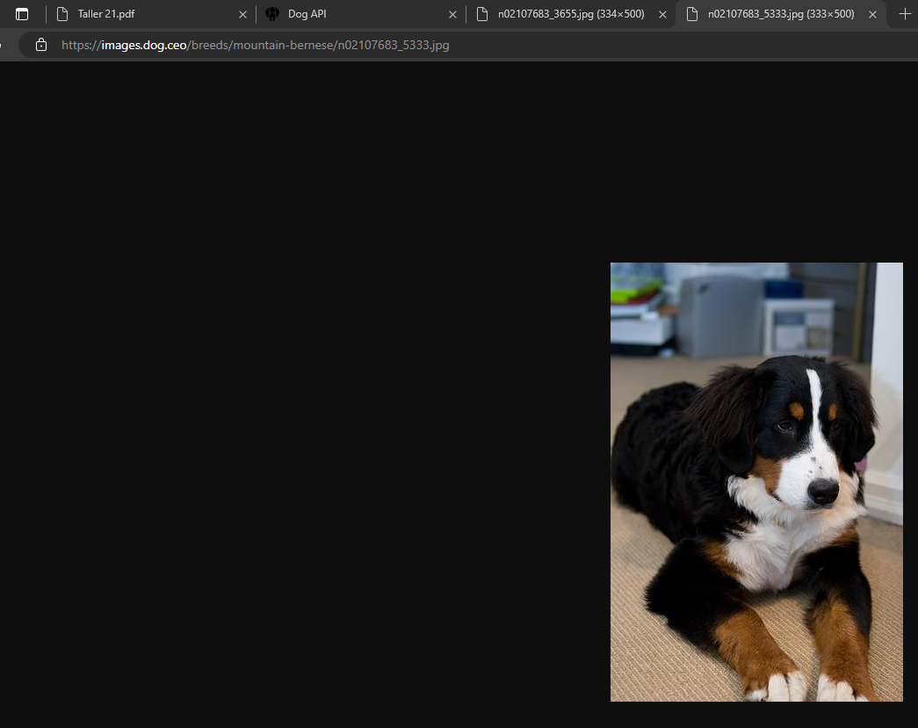

Punto 2: Pokémon

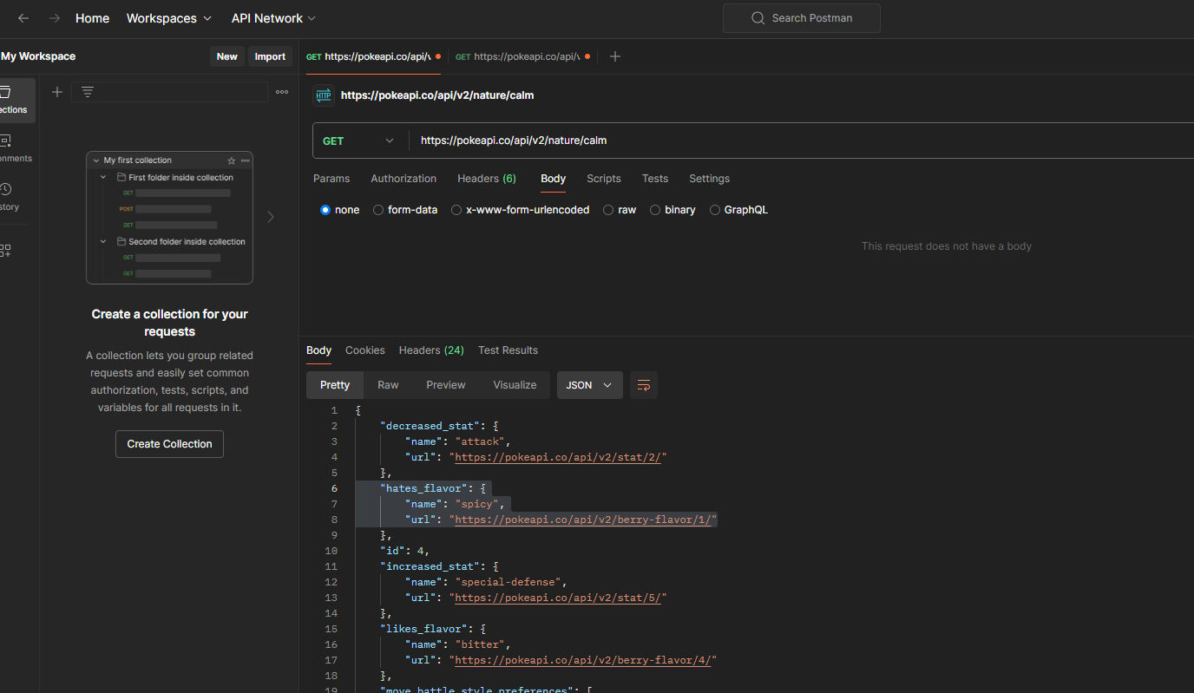

Punto 3: Rick and Morty

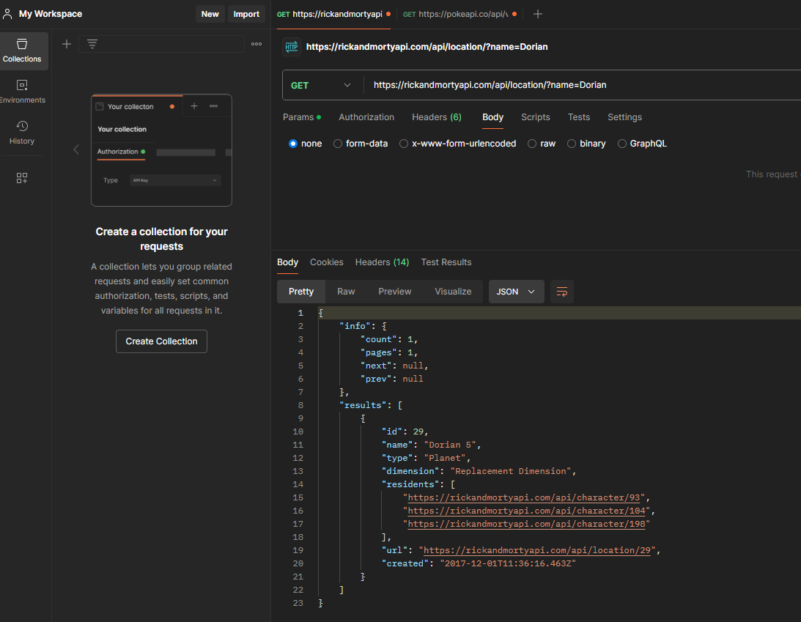

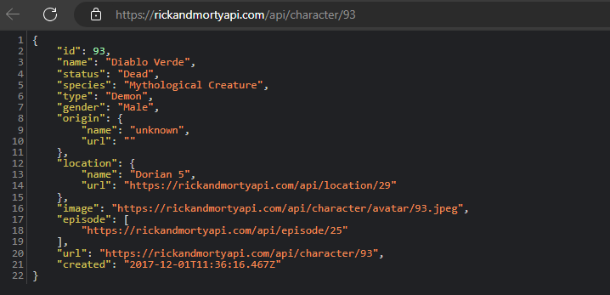

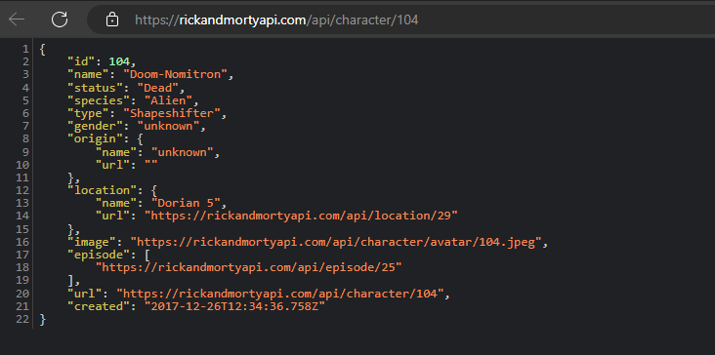

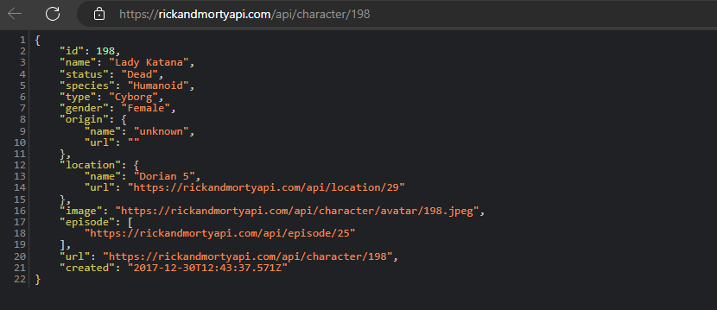

Punto 5: Nuestra propia API. Cómo hace un animal?

